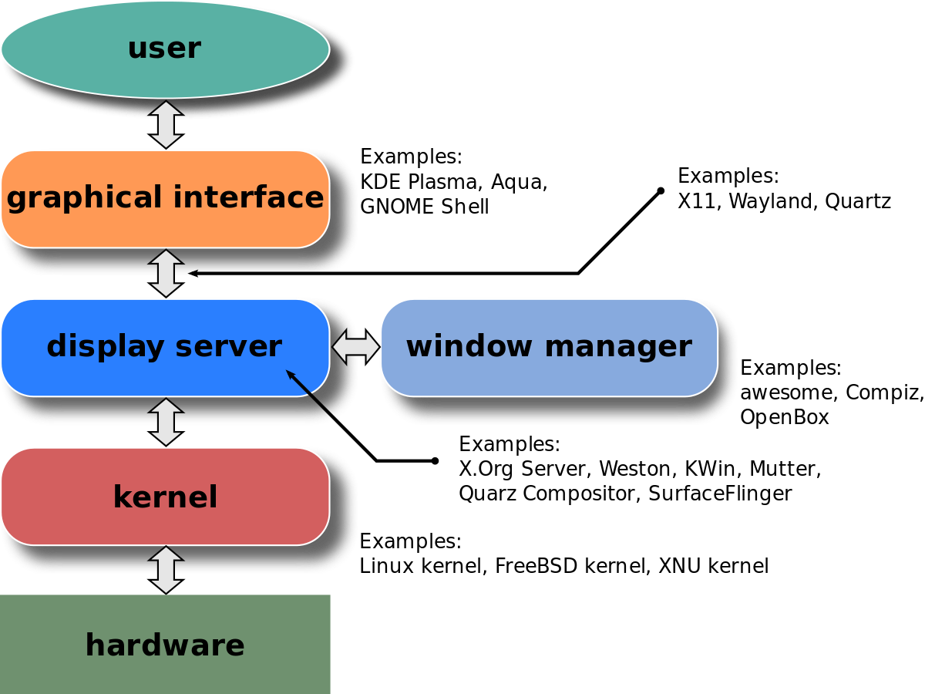
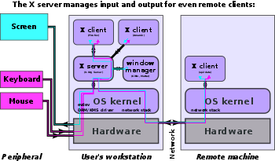

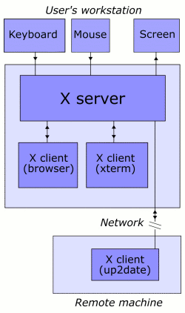

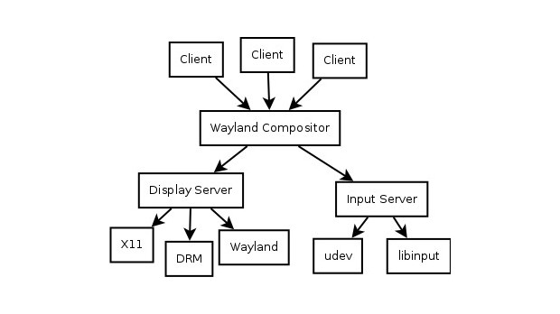

The X server provides five basic types of services: input handling, window services, graphics, text and fonts, and resource management.

Flatpak is an sandbox environment where users can run xdg application software differently

environment::::

gnome-control-center does not start without setting XDG_CURRENT_DESKTOP=GNOME.

XDG_RUNTIME_DIR this env variable is used for storing temp files in /run/usr/0/* folder as root which relate to X display server.
GNOME TERMINAL SERVICE=:1.239
this is used for allowing to invoke terminal emulators in Desktop environment.

X windows system GNOME/KDE/XDM

Xorg which is used in X windows system server. Mostly used for graphics environment which relates to hardware component.
Xming in windows can access firefox or graphics related utilities using putty of RHEL or some other OS <Wayland> display servers
which handles your mouse , graphics drawing in other system startx

This is an GUI coding for graphics display to perform every action in a one click without writing command to perform single copy paste.

Three types
1: XDM
2: GDM <XDMCP> for remote activity
3: KDM

http://archives.fedoraproject.org/pub/fedora/linux/

GNOME API and GTK developer::

gnome means graphical user interface package or graphical displpay manager.

In terminal type gnome-<Tab> will get list of gnome commands
login from local user not from root <it gives gtk error>.

Init 5 have this features GDM and uses gdm for system startup login screen gnome-panels gnome-session.

D-bus means various application talks with each other using bus topology like
IPC or RPC <interprocess communicaton >

init 3 uses X-windows for display manager using < xinit > command or startx

INIT 5 have <GNOME>-→ GDM AND <KDE>-→ KDM
set in config file etc/sysconfig/desktop

etc/X11/* contains Xmodmap file for keyboard
Xresources file for fonts

find all the gnome comands in /usr/bin/gnome*

nautils is like a file manager or manages desktop icons

Gnome <gdm > for RHEL or KDE <kde> for ubuntu is newer version and xdm is older version
System boot → /etc/init/prefdm.conf script run → /etc/sysconfig/desktop

XDM::::

rpm packages xorg-→ x11-→ xdm

change the file /etc/X11/xdm/Xaccess to any hosts

/etc/X11/xdm/xdm-config edit the conf file
!DisplayManager.requestPort: 0 ## comment out this lines < ! >

GDM::

/etc/gdm/custom.conf

ctrl+alt+f7 for graphics control
ctrl+alt+backspace for restart
change setting sshd_config file
X11Forwarding yes
X11DisplayOffset 10
X11UseLocalhost yes
KDM :

/etc/kde/kdm/kdmrc
[Xdmcp] #for remote enable setting
Enable=true
Willing=/etc/kde/kdm/Xwilling
Xaccess=/etc/kde/kdm/Xaccess
#any host can get a login window

/etc/kde/kdm/Xaccess # assign hostname or ipaddres to give access to particular user or machine

/etc/kde4/kdm/backgroundrc : background settings
- /etc/kde4/kdm/kdm.options : options for X display manager kdm
- /etc/kde4/kdm/kdmrc : kdm configuration file
- /etc/kde4/kdm/Xaccess : access control file for XDMCP connections
- /etc/kde4/kdm/Xreset : script to run as root after session exits
- /etc/kde4/kdm/Xsession : script to run as user after login of user
- /etc/kde4/kdm/Xsetup : script to run as root before the login dialog appears
- /etc/kde4/kdm/Xstartup : script to run as root before session starts
- /etc/kde4/kdm/Xwilling : output of this script is displayed in the chooser window

The following ports and protocols must be able to pass through the firewall:
- UDP: 177 (XDMCP)
- TCP: 6000-6005 (X11 protocol)
- TCP: 7100 (xfs: X font server)

Remote X server access for MS/Windows:

xming and Mobaterm tool or X-Windows Xnest command to connect

/usr/bin/X11/Xnest -query computer-node-name -geometry 1280x1024 :1

Wayland protocol and Xorg is protocol for display server or compositor which gives a connection to client.
Free and open source

client → IPC process → display server or wayland or xorg or compositor
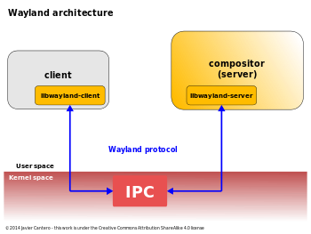

GPU is used for graphics display to the remote site.

Xorg, XFree86 and X11 are display servers. This creates the graphical environment.
Displlay manager manages system locally or remotely
windows mananger manages border layouts control decoration
Desktop environment such as XFCE, KDE, GNOME, etc
X Window System (aka X11): A network protocol encoding things such as graphic primitives, images, pointer motion, and key presses.
- X Display Server or video controller GPU (e.g. Xorg and XFree86): X server implementing X11 and providing an interface to keyboards, mice, and video cards .
- If you install the package of X11 by default device driver will be installed.
/usr/lib/xorg/modules/drivers/ .so file

udev or evdev for input driver

h/w → kernel → evdev/udev → Xserver(display servers and and windows manager{layout borders corners for resizing moving maximizing} and desktop environment{Gnome KDE etc.})

- X Display Manager (e.g. SDDM, GDM, and LightDM): Graphical login manager which starts a session on an X server from the same or another computer
- Widget/GUI toolkit/framework/library (e.g. GTK+ and Qt): Providing things such as buttons, scrollbars, edit boxes, etc.
- Window Managers (e.g. Metacity and Compiz): Decorating X window primitives and supporting various operations such as moving, resizing, and maximizing of windows.
- Desktop Environments (e.g. GNOME, KDE, XFCE, and LXDE): Providing libraries and specifications that applications use and follow in order to "play nice" with other applications.

Ibus-setup is for the input device like keyboard preference
which language ,which font , which colr ,which emoji
eg ibus ibus-daemon imsetting (.xinputrc)

