Julia for HPC
Student Setup Guide
WSL • juliaup • Julia • Packages • PDE Solvers • Slurm

Author: Course Instructor
Generated: 2026-05-03

Overview & Prerequisites
This guide walks you through setting up a complete Julia environment for scientific computing and HPC on Windows. Steps 1–3 install Julia. Step 4 introduces PDE packages. Step 5 walks the full PDE-solving workflow with worked examples for the heat, wave, Poisson, and Navier-Stokes equations and a section on unstructured meshing with Gmsh. Steps 6–8 connect to the HPC cluster.

Time Estimate
Step | Estimated Time
1 — Install WSL2 | 10–15 min
2 — juliaup + Julia | 5–10 min
3 — Install Julia Packages | 10–15 min
4 — Learn PDE Packages | 15–20 min
5 — PDE Workflow + Examples | 30–60 min
5.6 — Gmsh: mesh → matrix | 15–20 min
6 — Configure VS Code | 5–10 min
7 — HPC SSH Setup | 10 min
8 — Submit Slurm Jobs | 10–15 min
Total | ~110–175 min

Step 1 — Install WSL2
WSL2 runs a real Linux kernel inside Windows. Open PowerShell as Administrator and run:
wsl --install
# Then restart your computer when prompted
After restart, Ubuntu opens automatically; create a Linux username and password, then update the system:
sudo apt update && sudo apt upgrade -y
sudo apt install -y curl wget git build-essential

Step 2 — Install juliaup, then Julia
juliaup is the official Julia version manager — like pyenv for Python or nvm for Node.

2.1 Install juliaup
curl -fsSL https://install.julialang.org | sh
source ~/.bashrc
juliaup --version

2.2 Use juliaup to install Julia
juliaup add release # latest stable
juliaup default release # set as default
julia --version
Command | Action
juliaup add release | Install latest stable Julia
juliaup add 1.10.4 | Install a specific version
juliaup default 1.10.4 | Switch the default version
juliaup list | List installed versions
juliaup update | Update everything

Step 3 — Installing Julia Packages
Julia's package manager (Pkg) is built into the language. Press ] in the REPL to enter package mode.

3.1 Project Environments (best practice)
mkdir -p ~/julia-pde && cd ~/julia-pde
julia --project=.
# In package mode (press ]):
(@julia-pde) pkg> add DifferentialEquations Plots SparseArrays
Julia creates Project.toml and Manifest.toml — commit both to git for full reproducibility on the cluster.

Step 4 — Key Julia Packages for PDE Solving
Package | Use case
LinearAlgebra (stdlib) | Dense matrix ops
SparseArrays (stdlib) | Sparse PDE matrices
FFTW.jl | Spectral methods
DifferentialEquations.jl | ODE/PDE solver suite
MethodOfLines.jl | Auto-discretization of PDEs
KrylovKit.jl | GMRES, CG iterative solvers
Gmsh.jl | Unstructured mesh generation
Ferrite.jl / Gridap.jl | Finite element methods
Oceananigans.jl | Production CFD on HPC
Plots.jl / Makie.jl | Visualization
MPI.jl / CUDA.jl | HPC parallelism

Step 5 — The PDE Solving Workflow
Solving any PDE follows the same five-stage pipeline. Errors at early stages cascade through everything that follows.
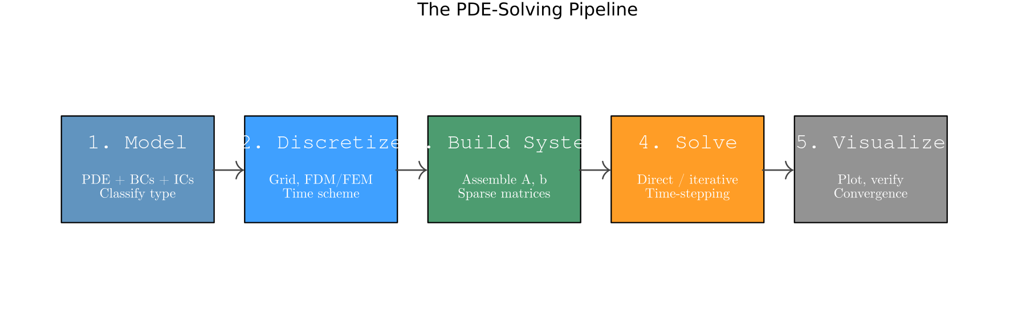
Figure 1. The five-stage PDE-solving pipeline.

5.1 Stage 1 — The Mathematical Model
Every complete PDE problem has four parts: the equation, the domain, boundary conditions, and (for time-dependent problems) initial conditions.
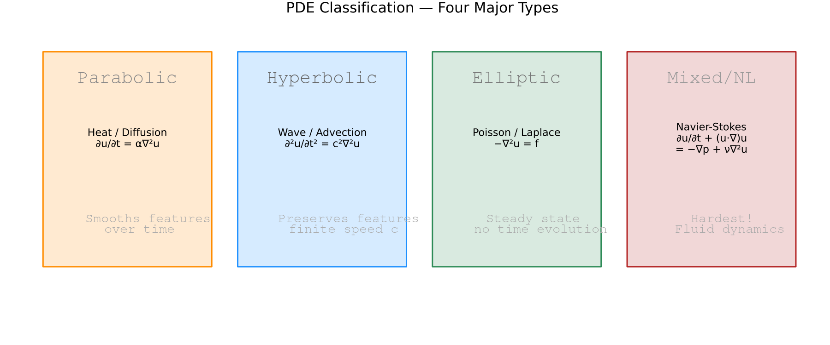
Figure 2. Four major PDE families.

5.2 Stage 2 — Discretization
Replace continuous derivatives with finite-difference stencils:
# 2nd derivative (central, 2nd-order):
# d²u/dx² ≈ ( u[i+1] - 2u[i] + u[i-1] ) / h²
# 2D Laplacian (5-point stencil):
# ∇²u ≈ ( u[i+1,j]+u[i-1,j]+u[i,j+1]+u[i,j-1]-4u[i,j] ) / h²
CFL stability for explicit schemes:
# Heat (1D, explicit Euler): dt ≤ dx² / (2α)
# Wave (1D): dt ≤ dx / c

5.3 Stage 3 — Build the System
using SparseArrays, LinearAlgebra
function laplacian_2d(N, h)
e = ones(N)
L1D = spdiagm(0 => -2*e, 1 => e[1:end-1], -1 => e[1:end-1])
I_N = sparse(I, N, N)
return (kron(I_N, L1D) + kron(L1D, I_N)) / h^2
end

5.4 Stage 4 — Choose & Run a Solver
Situation | Solver
Elliptic, N < 10⁴ | u = A \ b (sparse direct)
Elliptic, large symmetric | CG (IterativeSolvers.jl)
Elliptic, large non-sym. | GMRES + ILU
Parabolic, small N | Explicit Euler
Parabolic, stiff | Crank-Nicolson / Rosenbrock23
Hyperbolic | Leap-frog / Tsit5
Navier-Stokes | Oceananigans.jl / projection

Example A — Heat Equation (parabolic)
Parameters: N=200, α=0.010, L=1.0, T=1.0
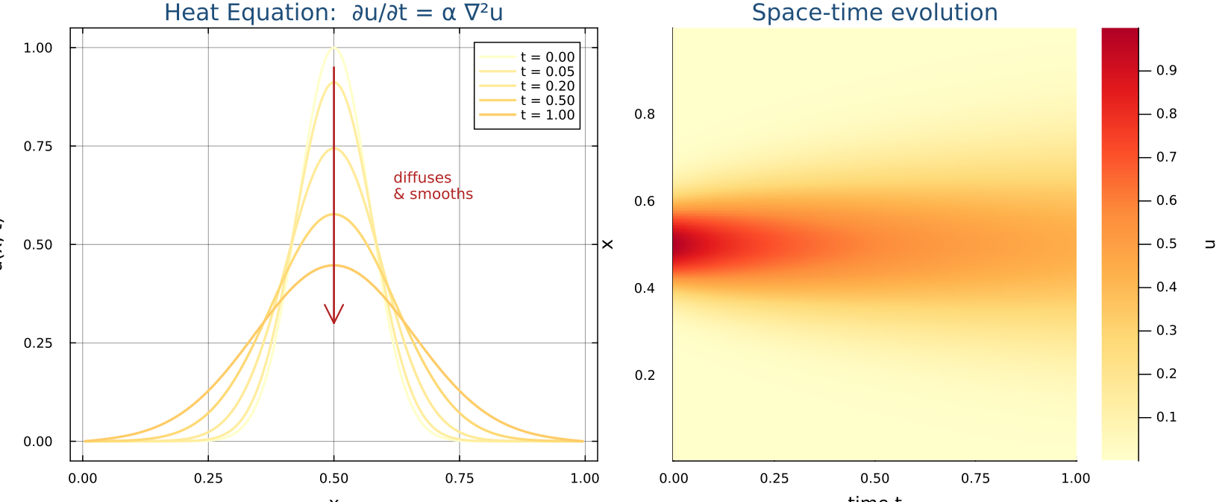
Figure 3. Heat equation: pulse diffuses and smooths over time.

Example B — Wave Equation (hyperbolic)
Parameters: N=300, c=1.0, L=1.0, T=1.5
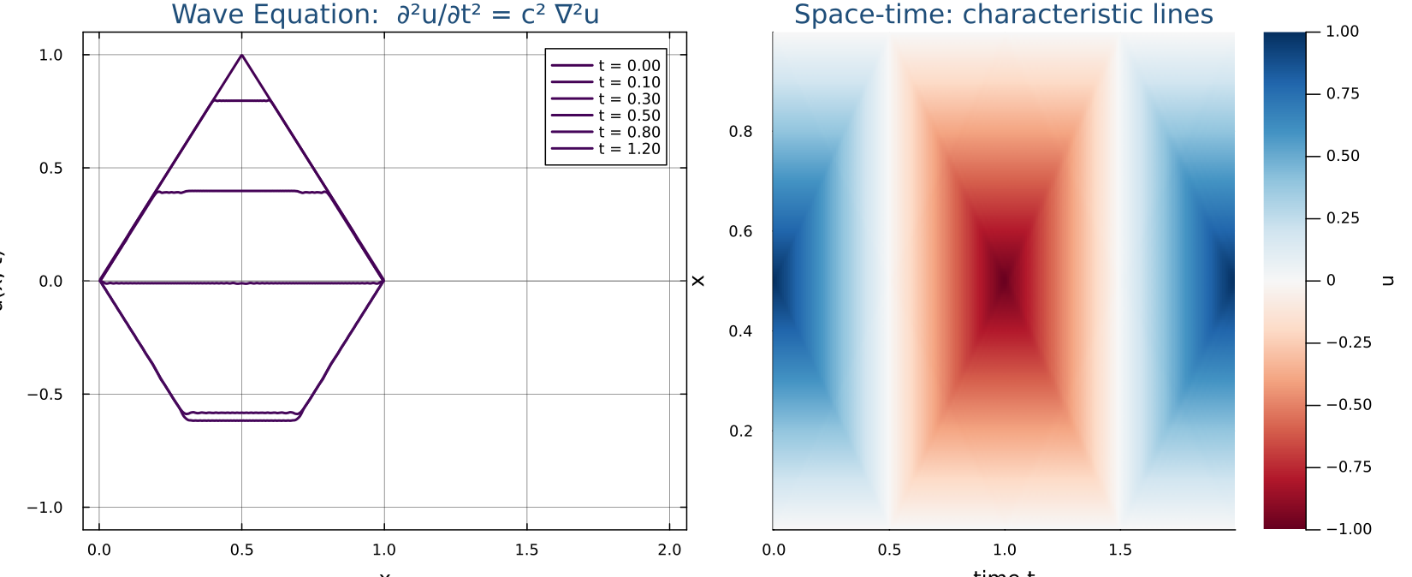
Figure 4. Wave equation: pluck splits and reflects off boundaries.

Example C — Poisson Equation (elliptic)
Parameters: N=50 (interior), L=1.0, single sparse direct solve
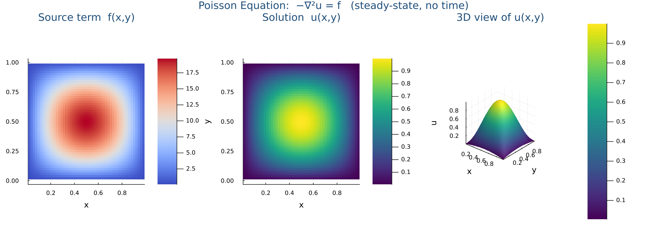
Figure 5. Poisson equation: source f → solution u, no time evolution.

Example D — Navier-Stokes (the hard one)
The Navier-Stokes equations describe how fluids flow. They are nonlinear, couple velocity and pressure, and admit turbulent solutions at high Reynolds numbers.
Equations (incompressible):
∂u/∂t + (u·∇)u = -∇p/ρ + ν∇²u + g ← momentum
∇·u = 0 ← incompressibility
Term | Meaning
∂u/∂t | Local acceleration
(u·∇)u | Convective acceleration (nonlinear!)
-∇p/ρ | Pressure gradient force
ν∇²u | Viscous diffusion (friction)
∇·u = 0 | Mass conservation / incompressibility
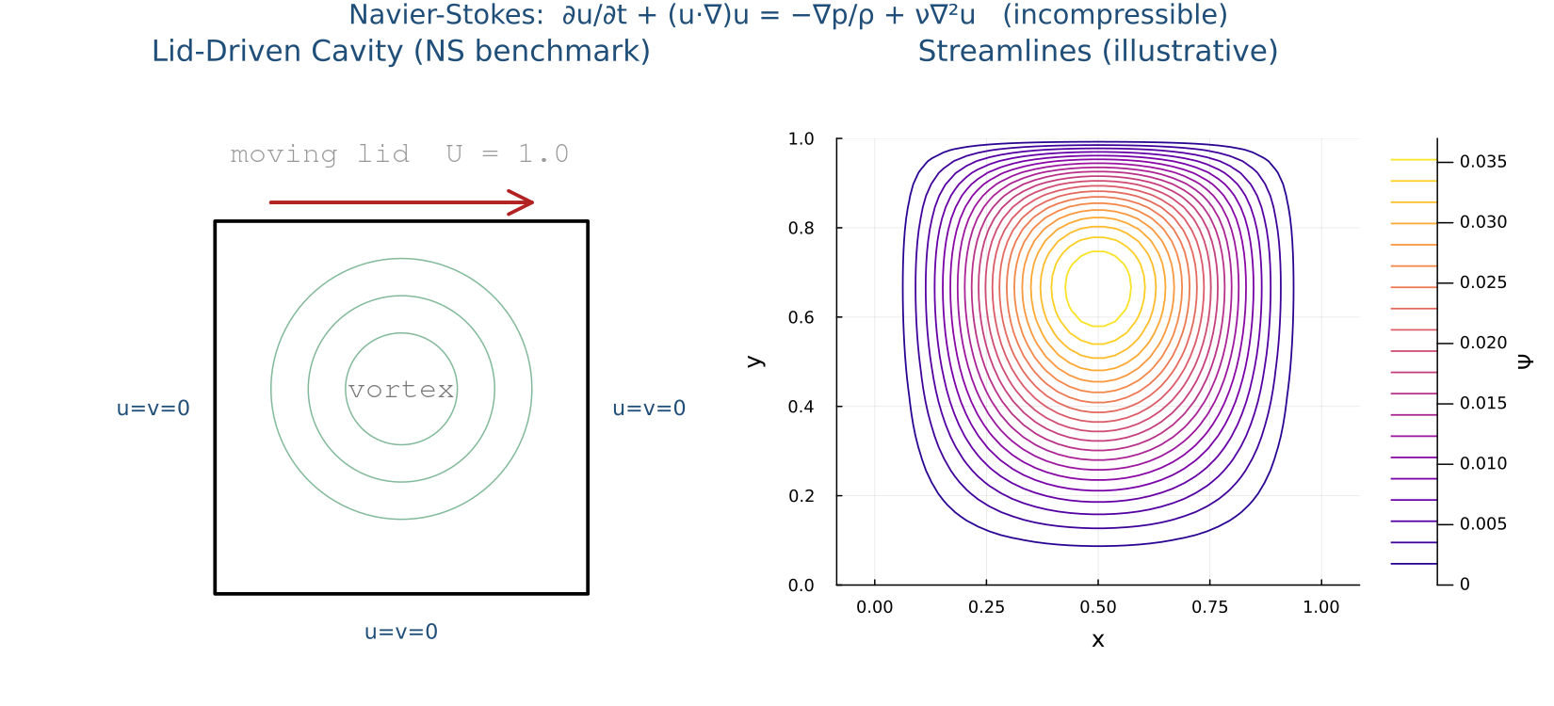
Figure 6. Lid-driven cavity at Re=100. Lid drives a primary vortex.
Why it's hard:
- Nonlinear convective term (u·∇)u — no linear superposition.
- Velocity-pressure coupling — pressure has no time derivative; must enforce ∇·u = 0 via projection methods.
- Turbulence at high Re requires very fine grids or RANS/LES/DNS.
- Millennium Prize problem — smoothness in 3D is unproven!
Recommended: use Oceananigans.jl for HPC fluid simulations — it is Slurm + MPI + GPU ready out of the box.

5.5 Stage 5 — Visualize & Verify
Three levels of checks every PDE solver should pass:
- Sanity: plot the solution; check BCs are satisfied.
- Convergence study: refine grid, check error scales as O(h²).
- Physical validation: compare against analytical solution or benchmark.
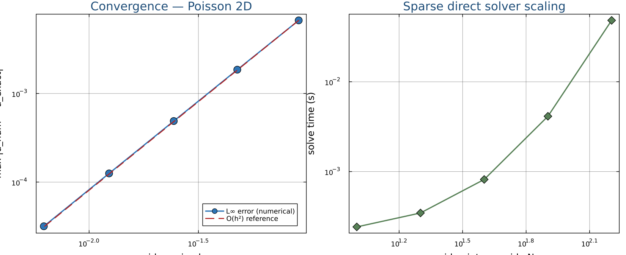
Figure 7. Left: Poisson L∞ error vs grid spacing h on a log-log scale — the slope confirms 2nd-order convergence. Right: solve time scales near-linearly in N² (sparse direct solver).

5.6 Beyond Structured Grids — Meshing with Gmsh
Finite-difference grids work for rectangles. Real geometry — L-shapes, airfoils, brain MRI, machine parts — needs unstructured meshes. Gmsh is the de-facto open-source mesher; the Julia bindings live in Gmsh.jl. The workflow has three parts: (1) describe the geometry, (2) let Gmsh triangulate it, (3) read the node coordinates and element connectivity back into Julia and assemble a sparse matrix.

Install Gmsh.jl
# In package mode (press ]):
(@julia-pde) pkg> add Gmsh

Generate a 2D triangular mesh of the unit square
This is the exact code that produced Figure 8 — running the lecture script reproduces the same mesh on the student's machine, byte-for-byte.
using Gmsh: gmsh
using SparseArrays

function gmsh_unit_square(; lc::Float64 = 0.5)
gmsh.initialize()
gmsh.option.setNumber("General.Terminal", 0)
gmsh.model.add("unit_square")

# 1. Geometry — corner points of [0,1]×[0,1], target size lc
p1 = gmsh.model.geo.addPoint(0.0, 0.0, 0.0, lc)
p2 = gmsh.model.geo.addPoint(1.0, 0.0, 0.0, lc)
p3 = gmsh.model.geo.addPoint(1.0, 1.0, 0.0, lc)
p4 = gmsh.model.geo.addPoint(0.0, 1.0, 0.0, lc)

# 2. Edges and the surface they bound
l1 = gmsh.model.geo.addLine(p1, p2)
l2 = gmsh.model.geo.addLine(p2, p3)
l3 = gmsh.model.geo.addLine(p3, p4)
l4 = gmsh.model.geo.addLine(p4, p1)
cl = gmsh.model.geo.addCurveLoop([l1, l2, l3, l4])
gmsh.model.geo.addPlaneSurface([cl])

# 3. Synchronise the CAD kernel and triangulate the surface
gmsh.model.geo.synchronize()
gmsh.model.mesh.generate(2) # 2D ⇒ triangles

# 4. Pull the mesh back into Julia
node_tags, coord, _ = gmsh.model.mesh.getNodes()
_, _, elem_node_tags = gmsh.model.mesh.getElements(2)

n_nodes = length(node_tags)
xy = reshape(coord, 3, n_nodes)[1:2, :] # drop z

# Gmsh tags can be sparse — remap them to dense 1..n_nodes
tag2idx = Dict(Int(t) => i for (i,t) in enumerate(node_tags))
flat_conn = [tag2idx[Int(t)] for t in elem_node_tags[1]]
tri_nodes = reshape(flat_conn, 3, :)

gmsh.finalize()
return xy, tri_nodes
end

xy, tri_nodes = gmsh_unit_square(lc=0.5)
# xy :: 2 × n_nodes (coordinates of every mesh node)
# tri_nodes :: 3 × n_tri (column k = global node IDs of triangle k)

From mesh to sparse matrix — element assembly
Visit every triangle, and for each pair (a, b) of its three local nodes add the local contribution at the matching global indices. With unit local entries this gives a matrix whose non-zero pattern is identical to a P1 stiffness matrix on the same mesh:
function assemble_adjacency(tri_nodes, n_nodes)
I = Int[]; J = Int[]; V = Float64[]
for k in axes(tri_nodes, 2)
nodes_k = tri_nodes[:, k] # 3 global node IDs
for a in 1:3, b in 1:3
push!(I, nodes_k[a]) # global row
push!(J, nodes_k[b]) # global column
push!(V, 1.0) # local entry value
end
end
return sparse(I, J, V, n_nodes, n_nodes) # duplicates auto-summed
end

n_nodes = size(xy, 2)
A = assemble_adjacency(tri_nodes, n_nodes)
The COO triplets (I, J, V) are the natural output of element assembly; `sparse` automatically sums duplicate (i, j) pairs, which is exactly what "adding contributions from every element touching that node" means. Replace the `1.0` with the entries of a 3×3 local stiffness matrix to get a real FEM Laplacian — the index plumbing is the same.

How mesh indices and matrix indices line up
This is the central idea behind FEM/FVM assembly — once it clicks, every other implementation detail follows:
- Each mesh node has a unique global index 1..n. That same index is its row (and column) in the matrix A.
- Each element carries a small connectivity list. For a P1 triangle that list has three node IDs.
- The element produces a small dense local matrix whose rows and columns are labelled by local node order (1, 2, 3).
- Local index a maps to global index nodes_k[a], so K_local[a, b] is added into A[nodes_k[a], nodes_k[b]].
- If two elements share a node, both contribute to the same row/column of A — A[i, j] is the sum of every element contribution touching the pair (i, j). Mesh edges become off-diagonal non-zeros; mesh nodes become diagonal entries.
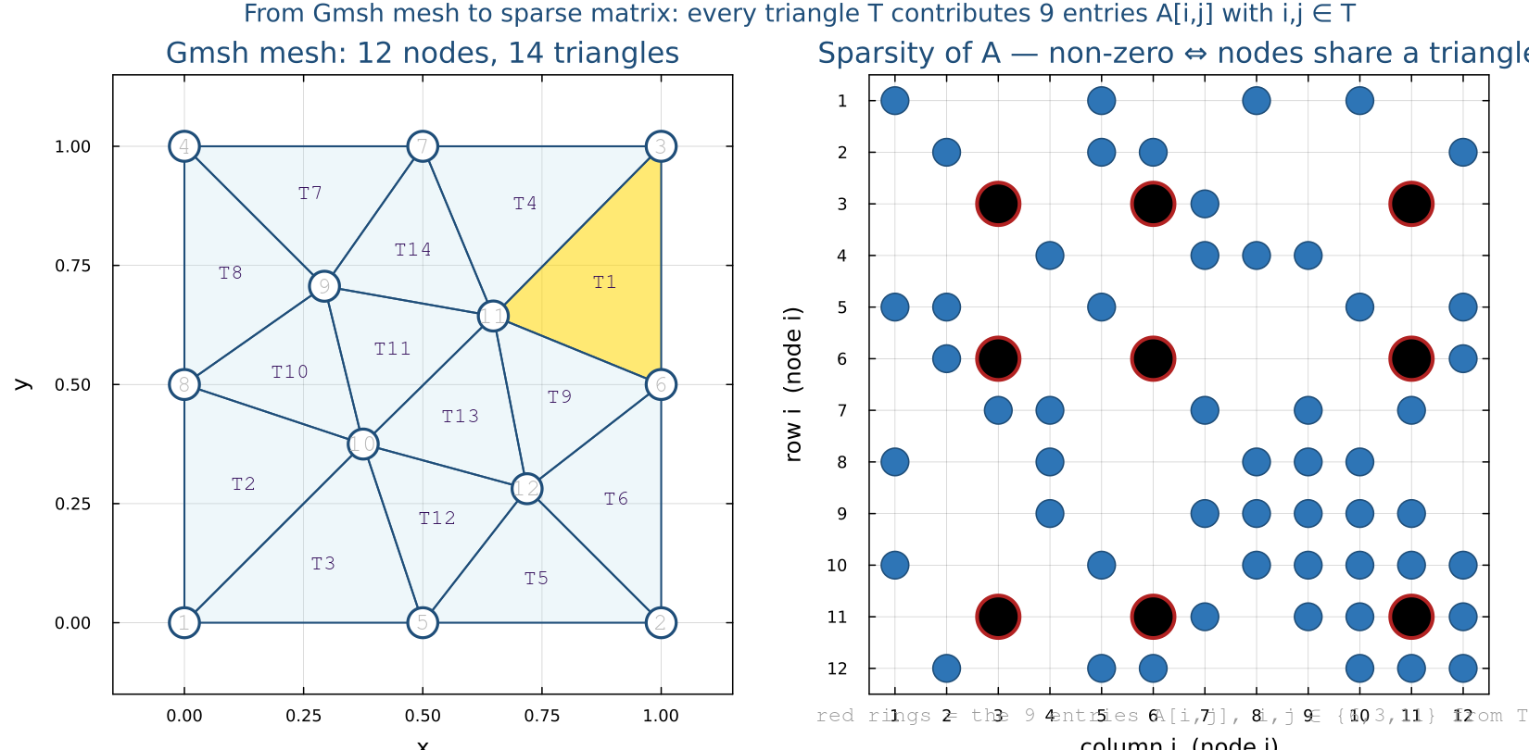
Figure 8. Left: a 9-node, 8-triangle mesh of the unit square. Right: the sparsity pattern of the assembled matrix A. An entry A[i, j] is non-zero iff nodes i and j share at least one triangle. The red rings on the right mark the nine entries contributed by triangle T1 (gold on the left), whose nodes are {1, 2, 5} — those nine entries are A[1,1], A[1,2], A[1,5], A[2,1], A[2,2], A[2,5], A[5,1], A[5,2], A[5,5].
Practical implications:
- Sparsity ≈ average node degree of the mesh — typically 6–8 neighbours in 2D, so A holds ~7n non-zeros instead of n².
- Reordering nodes (Cuthill–McKee, METIS) does not change the physics; it relabels the indices and can dramatically reduce fill-in for sparse direct solvers.
- Boundary conditions are applied by editing the rows and columns of A whose indices match the boundary node IDs — the same node-to-row mapping is reused.
- Higher-order elements (P2, P3, …) add edge/face degrees of freedom; the connectivity table just gets more rows, but the global-DOF-to-matrix-row rule is unchanged.

Step 6 — Configure VS Code for Julia + WSL
Install these VS Code extensions:
Extension | Purpose
WSL | Connect VS Code to WSL
Julia | Syntax, IntelliSense, REPL
Jupyter | Run notebooks with Julia kernel
Remote — SSH | Connect to HPC cluster

Step 7 — Connect to the HPC Cluster
ssh-keygen -t ed25519 -C "your_email@example.com"
ssh-copy-id user@cluster.example.edu
ssh user@cluster.example.edu
module load julia/1.10
julia --version
Sync your project (Project.toml + Manifest.toml) to the cluster:
rsync -avz ~/julia-pde/ user@cluster:~/julia-pde/
ssh user@cluster
cd ~/julia-pde && julia --project=. -e 'using Pkg; Pkg.instantiate()'

Step 8 — Submitting Julia PDE Jobs with Slurm
Command | Action
sbatch job.sh | Submit job
squeue -u $USER | Show your jobs
scancel JOBID | Cancel a job
sinfo | Show partitions
sacct -j JOBID | Detailed stats after run
Example heat equation job script:
#!/bin/bash
#SBATCH --job-name=heat_eq
#SBATCH --cpus-per-task=4
#SBATCH --mem=4G
#SBATCH --time=00:30:00
#SBATCH --output=heat_%j.out

module load julia/1.10
julia --threads=4 --project=. heat_equation.jl

Troubleshooting Quick Reference
Problem | Solution
wsl --install fails | Run as Admin; restart Windows
julia: command not found | source ~/.bashrc
Pkg precompile is slow | Normal first time; subsequent loads are fast
SSH publickey denied | Re-run ssh-copy-id; ask instructor
Slurm OOM kill | Increase --mem or reduce N
CFL instability (NaN) | Reduce dt; check stability condition

