Julia for HPC
Student Setup Guide
WSL • juliaup • Julia • Packages • PDE Solvers • Slurm

Author: Course Instructor
Generated: 2026-07-06

Table of Contents

Overview & Prerequisites
This guide walks you through setting up a complete Julia environment for scientific computing and HPC on Windows. Steps 1–3 install Julia. Step 4 introduces PDE packages. Step 4.5 builds the juliaPDEs package — the same one shipped in the juliaPDEs/ folder of this repo — so you have a real module with Revise live-reload and a test suite before tackling the worked examples. Step 5 walks the full PDE-solving workflow with worked examples for the heat, wave, Poisson, and Navier-Stokes equations and a section on unstructured meshing with Gmsh. Steps 6–8 connect to the HPC cluster.

Step 1 — Install WSL2
WSL2 runs a real Linux kernel inside Windows. Open PowerShell as Administrator and run:
wsl --install
# Then restart your computer when prompted
After restart, Ubuntu opens automatically; create a Linux username and password, then update the system:
sudo apt update && sudo apt upgrade -y
sudo apt install -y curl wget git build-essential

Step 2 — Install juliaup, then Julia
juliaup is the official Julia version manager — like pyenv for Python or nvm for Node.

2.1 Install juliaup
curl -fsSL https://install.julialang.org | sh
source ~/.bashrc
juliaup --version

2.2 Use juliaup to install Julia
juliaup add release # latest stable
juliaup default release # set as default
julia --version
Command | Action
juliaup add release | Install latest stable Julia
juliaup add 1.10.4 | Install a specific version
juliaup default 1.10.4 | Switch the default version
juliaup list | List installed versions
juliaup update | Update everything

Step 3 — Configure VS Code for Julia + WSL
Install these VS Code extensions:
Extension | Purpose
WSL | Connect VS Code to WSL
Julia | Syntax, IntelliSense, REPL
Jupyter | Run notebooks with Julia kernel
Remote — SSH | Connect to HPC cluster

Step 4 — Installing Julia Packages
Julia's package manager (Pkg) is built into the language. Press ] in the REPL to enter package mode.

3.1 Project Environments (best practice)
mkdir -p ~/julia-pde && cd ~/julia-pde
julia --project=.
# In package mode (press ]):
(@julia-pde) pkg> add DifferentialEquations Plots SparseArrays
Julia creates Project.toml and Manifest.toml — commit both to git for full reproducibility on the cluster.

Step 5 — Key Julia Packages for PDE Solving
Package | Use case
LinearAlgebra (stdlib) | Dense matrix ops
SparseArrays (stdlib) | Sparse PDE matrices
FFTW.jl | Spectral methods
DifferentialEquations.jl | ODE/PDE solver suite
MethodOfLines.jl | Auto-discretization of PDEs
KrylovKit.jl | GMRES, CG iterative solvers
Gmsh.jl | Unstructured mesh generation
Ferrite.jl / Gridap.jl | Finite element methods
Oceananigans.jl | Production CFD on HPC
Plots.jl / Makie.jl | Visualization
MPI.jl / CUDA.jl | HPC parallelism

Step 6 — Build the juliaPDEs Package (was Step 4.5)
Before tackling the worked examples in Step 5, package the code into a real Julia package called juliaPDEs. The same module — with src/heat.jl, src/wave.jl, and src/Navier_Stokes.jl — is what ships in the juliaPDEs/ folder of this repo. Working from a package gives you Revise live-reload, a test suite, and one stable import you can call from the REPL, from tests, and from Slurm job scripts.

4.5.1 Step A — Generate the skeleton
One command creates the folder and the boilerplate Project.toml plus module file. Add a test/ folder yourself — Julia uses it automatically:
using Pkg
Pkg.generate("juliaPDEs") # creates juliaPDEs/Project.toml + src/juliaPDEs.jl
mkdir juliaPDEs/test # add a test/ folder yourself
touch juliaPDEs/test/runtests.jl

4.5.2 Step B — Add the dependencies
Activate the new package's own environment and install everything the three solvers need. Plots is for visualization, Revise for live reload, and Oceananigans is the CFD engine called by the Navier-Stokes solver. The remaining packages match the Project.toml that ships with the repo:
cd juliaPDEs
julia --project=.
# In package mode (press ]):
(@juliaPDEs) pkg> add Plots Revise Oceananigans LinearAlgebra SparseArrays Gmsh Makie CUDA
Julia writes the deps into Project.toml and pins exact versions in Manifest.toml — commit both to git so the cluster gets the same versions you developed against.

4.5.3 Step C — The module entry point: src/juliaPDEs.jl
Everything inside `module … end` is private by default. `using` brings third-party packages into the module once. `include()` pastes a sub-file in so it sees the module's scope. `export` declares the names visible after `using juliaPDEs`:
module juliaPDEs

using Plots, Revise, Oceananigans

include("heat.jl")
include("wave.jl")
include("Navier_Stokes.jl")

export solve_heat_1d, solve_wave_1d, solve_navier_stokes,
animate_wave_1d, animate_navier_stokes

end # module juliaPDEs

4.5.4 Step D — The heat solver: src/heat.jl
A 1-D explicit Euler heat solver: Dirichlet BCs (the endpoints stay 0), Gaussian initial pulse. The CFL factor 0.4 keeps r = α·dt/dx² ≤ 0.5 so the explicit scheme is stable.
function solve_heat_1d(; N=200, α=0.01, L=1.0, T=1.0)
dx = L / (N + 1)
x = range(dx, L - dx, length=N)
dt = 0.4 * dx^2 / α # CFL: r ≤ 0.5
nsteps = ceil(Int, T / dt)
u = @. exp(-100 * (x - 0.5)^2) # Gaussian initial condition
for _ in 1:nsteps
# Explicit Euler + 3-point stencil:
# u_i^{n+1} = u_i^n + r·(u_{i+1} - 2u_i + u_{i-1})
u[2:end-1] .+= (α * dt / dx^2) .*
(u[3:end] .- 2 .* u[2:end-1] .+ u[1:end-2])
# Dirichlet BCs: u[1] = u[end] = 0 — never updated
end
return collect(x), u
end

Beginner Concept Check: Structs, Instances, and Functions
Notice how the Heat solver above uses plain keyword arguments. As simulations grow more complex, passing individual variables becomes unmanageable. Before moving to the Wave solver, let's clarify how custom data types solve this:
1. What is a Struct? A struct is a custom composite data type that bundles multiple pieces of related data (called fields) together under a single name. Instead of passing separate variables into every function, we pack them into one structured container blueprint.
2. How to create a Struct? We write the struct keyword followed by the container name, list its internal fields with their types, and end with end. Using the Base.@kwdef macro above it automatically writes a keyword constructor with convenient default values:
Base.@kwdef struct SimpleHeatConfig
L::Float64 = 1.0 # Domain length
α::Float64 = 0.01 # Thermal diffusivity
N::Int = 100 # Grid resolution
end
3. What is the variable that is the Struct (an Instance)? The code above is just a blueprint. To use it, we call the struct's name like a function to create a concrete object in computer memory, called an instance, and assign it to a variable. We can then read its internal fields using dot notation:
# Create an instance; omitted fields automatically use defaults
my_config = SimpleHeatConfig(α=0.05, N=200)

# Access individual bundled fields using a dot (.):
println("Configured diffusivity: ", my_config.α)
println("Configured grid points: ", my_config.N)
4. How to create a Function to receive the Struct? To write a function that operates on our configuration, we define a function that accepts a single argument annotated with our custom struct type. Inside the function body, we use dot notation to unpack the exact fields we need:
function print_stability_limit(config::SimpleHeatConfig)
dx = config.L / (config.N + 1)
max_dt = 0.5 * dx^2 / config.α
println("Maximum stable time step dt: ", max_dt)
end

# Pass our struct variable into the function
print_stability_limit(my_config)
5. Structs vs. Functions: Nouns vs. Verbs. A struct holds passive state and data (e.g., domain dimensions, arrays, physical constants). A function defines active behavior and logic (e.g., loops, time-stepping, mathematical updates). Structs are the materials; functions are the machines that transform them.
6. Global Scope vs. Local Scope (Crucial for Performance). Variables defined directly in the main script body live in the global scope. Because global variables can change their data type at any time, the Julia compiler cannot optimize them, making loops in global scope very slow. Variables defined inside a function body live in a local scope. The compiler knows their exact types, compiling local operations to extremely fast machine code. Best Practice: Always wrap your solver loops and computations inside functions!
7. Where do you run these scripts? Once you write your code in a file (e.g., solver.jl), you can run it in three ways: (a) Terminal execution: run 'julia solver.jl' directly from your Linux command line. (b) REPL inclusion: open the Julia REPL and type 'include("solver.jl")' to load and execute the file. (c) VS Code execution: open the file in VS Code and press Shift+Enter to run specific blocks interactively.

4.5.5 Step E — The wave solver: src/wave.jl
The wave solver groups its parameters in a WaveEquation struct so callers can mix-and-match grid size, boundary condition (:Dirichlet, :Neumann, :Periodic, :Absorbing), and initial shape independently. Base.@kwdef auto-generates a keyword constructor with defaults, so WaveEquation(nx=400, T=2.0) leaves everything else default:
Base.@kwdef struct WaveEquation
nx::Int = 300
nt::Int = 300
c::Float64 = 1.0
L::Float64 = 1.0
T::Float64 = 1.5
bc::Symbol = :Dirichlet # :Dirichlet | :Neumann | :Periodic | :Absorbing
f_init::Function = x -> sin.(pi * x)
dx::Float64 = L / (nx - 1)
dt::Float64 = T / nt
x::Any = range(0, L, length=nx)
end
The leap-frog update uses the same 3-point Laplacian stencil as the heat equation, but stepped in time with two history slots (u_prev, u_curr). CFL: λ = c·dt/dx ≤ 1.
function solve_wave_1d(problem::WaveEquation; return_history=false)
dx, dt, x = problem.dx, problem.dt, problem.x
λ = (problem.c * dt / dx)^2
u_curr = problem.f_init.(x)
apply_boundary_conditions!(u_curr, u_curr, problem; is_initial=true)
u_prev = copy(u_curr); u_next = copy(u_curr)
for i in 1:problem.nt
# Leap-frog: u^{n+1} = 2u^n - u^{n-1} + λ²·(stencil)
u_next[2:end-1] .= 2 .* u_curr[2:end-1] .- u_prev[2:end-1] .+
λ .* (u_curr[3:end] .- 2 .* u_curr[2:end-1] .+ u_curr[1:end-2])
apply_boundary_conditions!(u_next, u_curr, problem)
u_prev, u_curr = copy(u_curr), copy(u_next)
end
return collect(x), u_curr
end
The full file also defines apply_boundary_conditions! (one branch per BC symbol), animate_wave_1d (saves a GIF), and an analytic wave_1d_exact reference solution — see juliaPDEs/src/wave.jl in the repo for the complete code.

4.5.6 Step F — The Navier-Stokes solver: src/Navier_Stokes.jl
The incompressible Navier-Stokes equations are two coupled PDEs in the velocity field u(x,y,t) = (u, v) and the pressure p(x,y,t):
∂u/∂t + (u · ∇)u = -∇p + ν·∇²u # momentum
∇ · u = 0 # incompressibility
Each term has a physical meaning: (u·∇)u is advection (fluid carrying its own momentum — the nonlinear part), -∇p is the pressure gradient that enforces incompressibility, ν·∇²u is viscous diffusion, and ∇·u = 0 keeps the flow divergence-free at every step.
We solve the classic lid-driven cavity benchmark on Ω = [0,1]×[0,1]:
- Top lid (north): u = 1, v = 0 — drives the flow.
- Other walls: u = v = 0 (no-slip) — the default.
- Initial condition: u(x,y,0) = 0.
- Reynolds number: Re = U·L / ν = (1·1)/0.01 = 100, set by choosing ν = 1e-2 in ScalarDiffusivity.
Rather than discretising and writing a projection method by hand, we delegate to Oceananigans.jl. Oceananigans handles the staggered finite-volume grid, a 5th-order upwind-biased advection scheme, the divergence-free pressure projection, and a 3rd-order Runge-Kutta time integrator — all on CPU or GPU. The simulation runs for t ∈ [0, 10] with Δt = 1e-3 and pushes a snapshot of the speed field √(u² + v²) into speed_hist every 100 iterations so we can animate it later with animate_navier_stokes:
function solve_navier_stokes()
grid = Oceananigans.RectilinearGrid(size=(64, 64),
x=(0, 1), y=(0, 1), topology=(Bounded, Bounded, Flat))

# Top lid moves at speed 1
u_bcs = Oceananigans.FieldBoundaryConditions(
north = Oceananigans.ValueBoundaryCondition(1.0))

model = Oceananigans.NonhydrostaticModel(grid;
advection = Oceananigans.UpwindBiased(order=5),
timestepper = :RungeKutta3,
boundary_conditions = (u=u_bcs,),
closure = Oceananigans.ScalarDiffusivity(ν=1e-2)) # ν = 1/Re

Oceananigans.set!(model, u=0, v=0)
simulation = Oceananigans.Simulation(model, Δt=1e-3, stop_time=10.0)

speed_field = Oceananigans.Field(
sqrt(model.velocities.u^2 + model.velocities.v^2))
speed_hist = []

function save_state(sim)
Oceananigans.compute!(speed_field)
push!(speed_hist, copy(Oceananigans.interior(speed_field, :, :, 1)))
end
simulation.callbacks[:save] = Oceananigans.Callback(
save_state, Oceananigans.IterationInterval(100))

Oceananigans.run!(simulation)
return (speed_hist=speed_hist, Δt=0.1)
end

4.5.7 Step G — Load the package & run it
Pkg.develop links the package into your environment by path — no install, no version pin. Edits to src/ files take effect immediately (with Revise, see 4.5.9):
# From the directory that CONTAINS the juliaPDEs/ folder:
using Pkg
Pkg.develop(path="./juliaPDEs")

using juliaPDEs
x, u = solve_heat_1d() # heat
x, u = solve_wave_1d(juliaPDEs.WaveEquation()) # wave (defaults)
hist = solve_navier_stokes() # Navier-Stokes
animate_navier_stokes(hist) # → .gif

4.5.8 Step H — Write tests
Tests live in test/runtests.jl. Run them with `(@juliaPDEs) pkg> test`, or `julia --project=juliaPDEs -e 'using Pkg; Pkg.test()'` from the command line. Beyond basic smoke tests per solver, the suite includes a real cross-check: the generalized CoupledPDESystem, run with zero coupling, must reproduce HeatEquation.solve_implicit exactly — if it doesn't, the block-system assembly in coupled.jl has a bug:
using Test, juliaPDEs

@testset "Ind indexing" begin
d = Ind((:u, :v, :w), (4, 5))
for var in (:u, :v, :w), I in CartesianIndices((4, 5))
flat = d[var, I.I...]
(var2, I2) = d[flat]
@test var2 == var
@test I2 == I
end
end

@testset "CoupledPDESystem at K=0 ≡ HeatEquation.solve_implicit (θ=1)" begin
grid = Grid(a=(0.0,), b=(1.0,), stepsize=(0.02,))
f_init(x) = sin(pi * x)
tg = TestGrid(grid, (t -> 0.0,), (t -> 0.0,), f_init)

heat = HeatEquation(testgrid=tg, Nt=200, T=0.1, α=0.01)
sol_heat = solve_implicit(heat; θ=1.0)

sys = CoupledPDESystem(grid=grid, vars=(:u, :v), α=(0.01, 0.01),
f_init=(f_init, f_init), Nt=200, T=0.1)
sol_sys = solve(sys)

@test sol_sys.u ≈ sol_heat.u
@test sol_sys.v ≈ sol_heat.u
end

@testset "WaveEquation smoke test" begin
p = WaveEquation(N_grid=(80,), a=(0.0,), b=(1.0,), Nt=200,
T=0.2, c=1.0, f_init=x -> sin(pi * x))
sol = solve(p)
@test length(sol.u) == 80
@test all(isfinite, sol.u)
end
This turns the earlier promise — that CoupledHeatEquation is 'verified against HeatEquation.solve_implicit at κ=0' — into something Pkg.test() actually checks on every run, rather than a claim that only lived in a changelog entry.

4.5.9 Revise — live reload during development
Add Revise to your global environment so changes to src/ files take effect without restarting Julia:
(@v1.10) pkg> add Revise
Make Revise auto-load in every session by adding this to ~/.julia/config/startup.jl:
try
using Revise
catch e
@warn "Could not load Revise" exception = e
end
Then your day-to-day loop is: edit a src/*.jl file, save, call the function in the REPL — the new version runs immediately. Revise handles function bodies and module-level code; struct redefinitions and changes to top-level `using` still need a restart.

Step 7 — The PDE Solving Workflow (was Step 5)
Solving any PDE follows the same five-stage pipeline. Errors at early stages cascade through everything that follows.
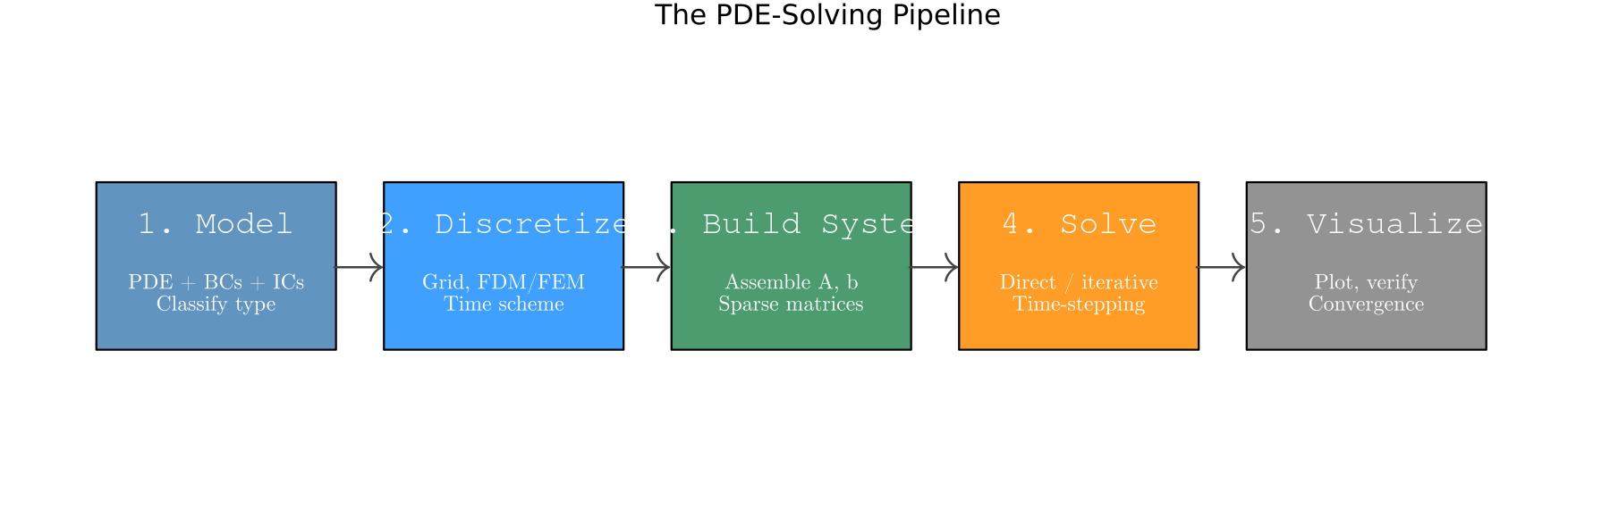
Figure 1. The five-stage PDE-solving pipeline.

5.1 Stage 1 — The Mathematical Model
Every complete PDE problem has four parts: the equation, the domain, boundary conditions, and (for time-dependent problems) initial conditions.
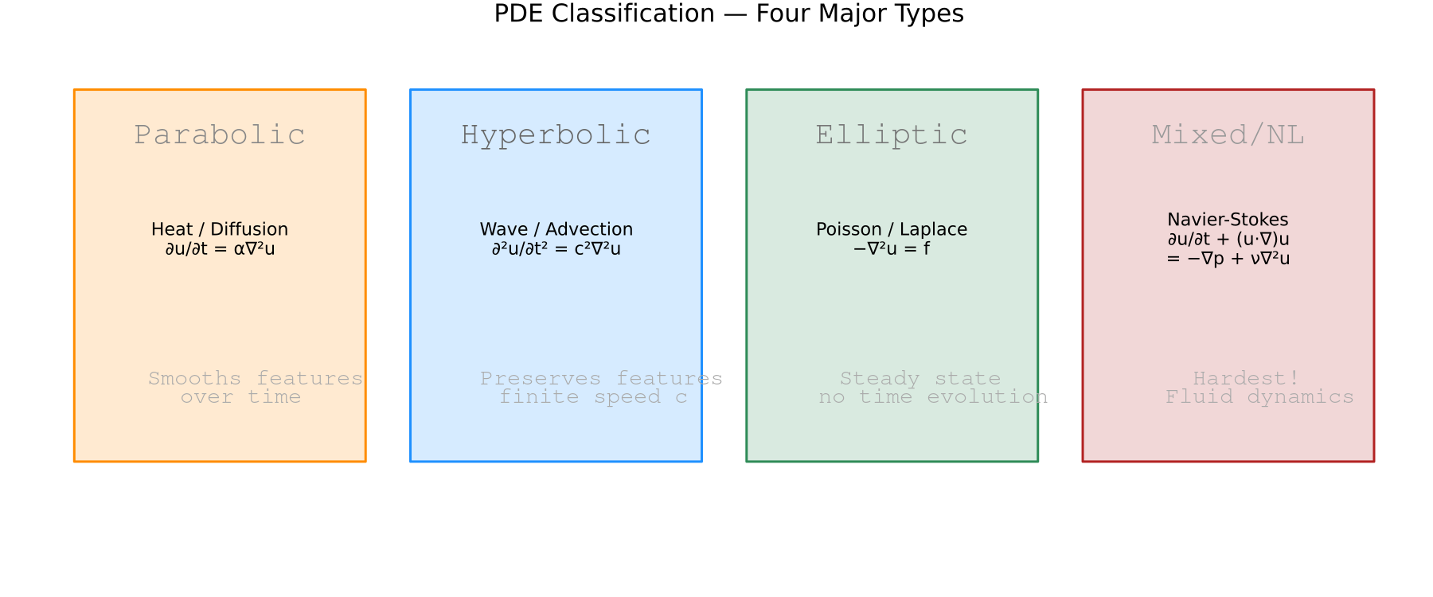
Figure 2. Four major PDE families.

5.2 Stage 2 — Discretization
Replace continuous derivatives with finite-difference stencils:
# 2nd derivative (central, 2nd-order):
# d²u/dx² ≈ ( u[i+1] - 2u[i] + u[i-1] ) / h²
# 2D Laplacian (5-point stencil):
# ∇²u ≈ ( u[i+1,j]+u[i-1,j]+u[i,j+1]+u[i,j-1]-4u[i,j] ) / h²
CFL stability for explicit schemes:
# Heat (1D, explicit Euler): dt ≤ dx² / (2α)
# Wave (1D): dt ≤ dx / c

5.3 Stage 3 — Build the System
using SparseArrays, LinearAlgebra
function laplacian_2d(N, h)
e = ones(N)
L1D = spdiagm(0 => -2*e, 1 => e[1:end-1], -1 => e[1:end-1])
I_N = sparse(I, N, N)
return (kron(I_N, L1D) + kron(L1D, I_N)) / h^2
end

5.4 Stage 4 — Choose & Run a Solver
Situation | Solver
Elliptic, N < 10⁴ | u = A \ b (sparse direct)
Elliptic, large symmetric | CG (IterativeSolvers.jl)
Elliptic, large non-sym. | GMRES + ILU
Parabolic, small N | Explicit Euler
Parabolic, stiff | Crank-Nicolson / Rosenbrock23
Hyperbolic | Leap-frog / Tsit5
Navier-Stokes | Oceananigans.jl / projection

Example A — Heat Equation (parabolic)
Parameters: N=200, α=0.010, L=1.0, T=1.0
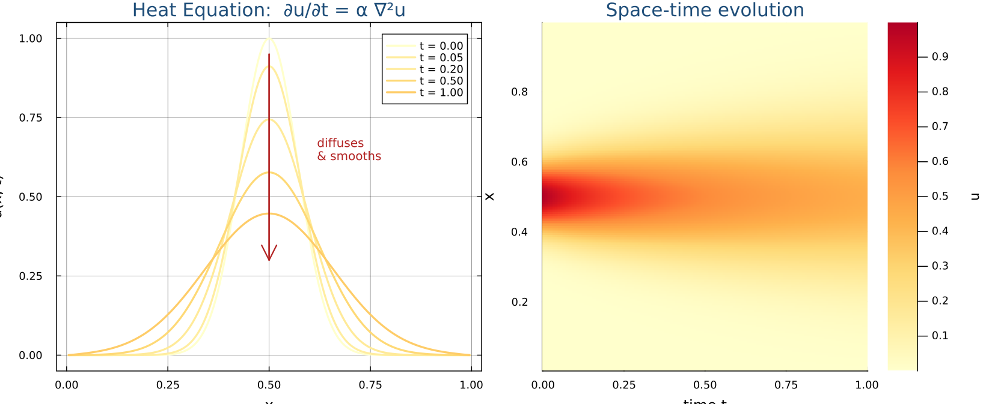
Figure 3. Heat equation: pulse diffuses and smooths over time.

Example B — Wave Equation (hyperbolic)
Parameters: N=300, c=1.0, L=1.0, T=1.5
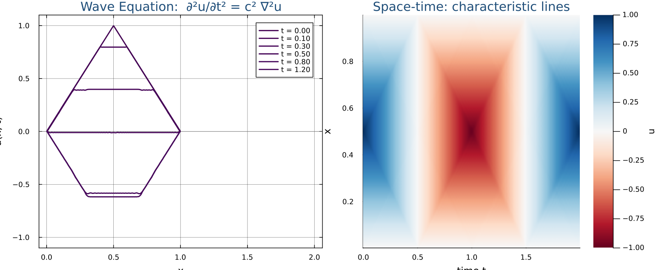
Figure 4. Wave equation: pluck splits and reflects off boundaries.

Example C — Poisson Equation (elliptic)
Parameters: N=50 (interior), L=1.0, single sparse direct solve
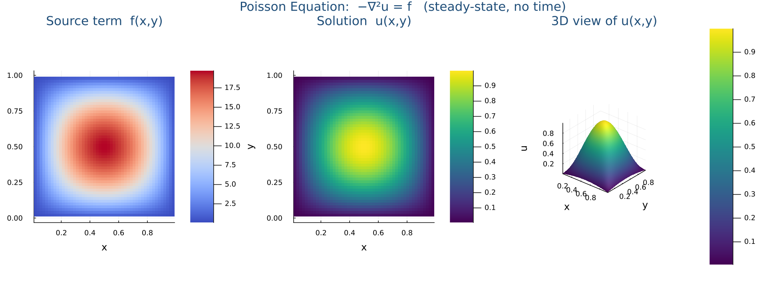
Figure 5. Poisson equation: source f → solution u, no time evolution.

Example D — Navier-Stokes (the hard one)
The Navier-Stokes equations describe how fluids flow. They are nonlinear, couple velocity and pressure, and admit turbulent solutions at high Reynolds numbers.
Equations (incompressible):
∂u/∂t + (u·∇)u = -∇p/ρ + ν∇²u + g ← momentum
∇·u = 0 ← incompressibility
Term | Meaning
∂u/∂t | Local acceleration
(u·∇)u | Convective acceleration (nonlinear!)
-∇p/ρ | Pressure gradient force
ν∇²u | Viscous diffusion (friction)
∇·u = 0 | Mass conservation / incompressibility
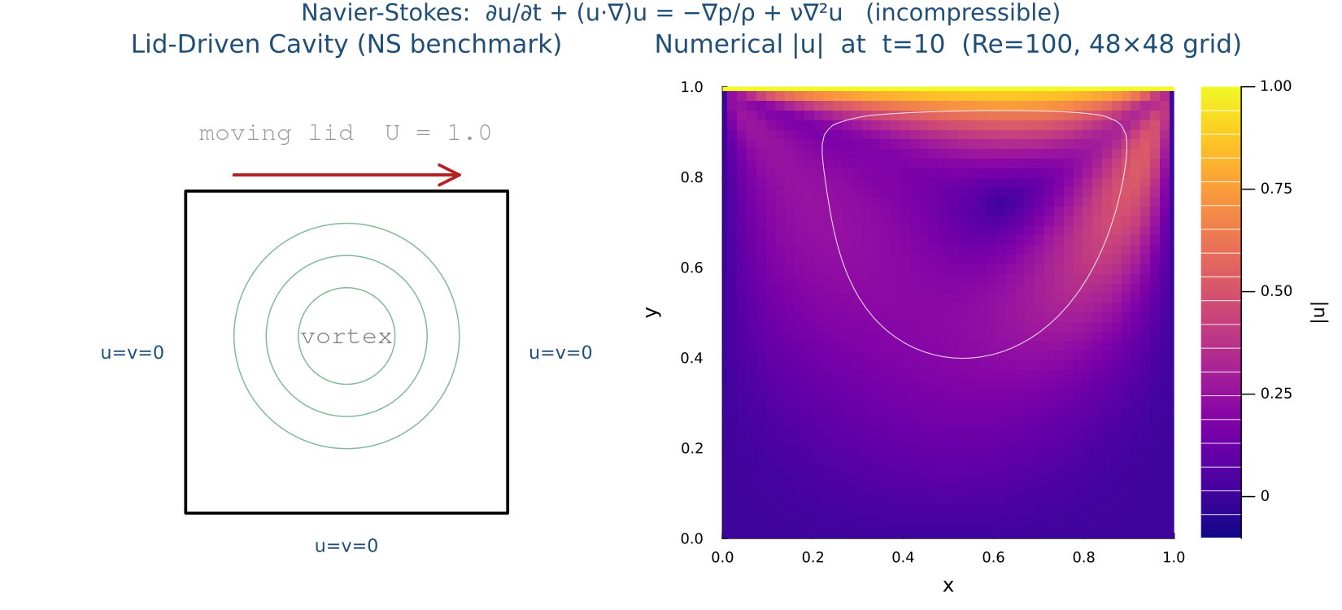
Figure 6. Lid-driven cavity at Re=100. Lid drives a primary vortex.
Why it's hard:
- Nonlinear convective term (u·∇)u — no linear superposition.
- Velocity-pressure coupling — pressure has no time derivative; must enforce ∇·u = 0 via projection methods.
- Turbulence at high Re requires very fine grids or RANS/LES/DNS.
- Millennium Prize problem — smoothness in 3D is unproven!
Recommended: use Oceananigans.jl for HPC fluid simulations — it is Slurm + MPI + GPU ready out of the box.

5.5 Stage 5 — Visualize & Verify
Three levels of checks every PDE solver should pass:
- Sanity: plot the solution; check BCs are satisfied.
- Convergence study: refine grid, check error scales as O(h²).
- Physical validation: compare against analytical solution or benchmark.
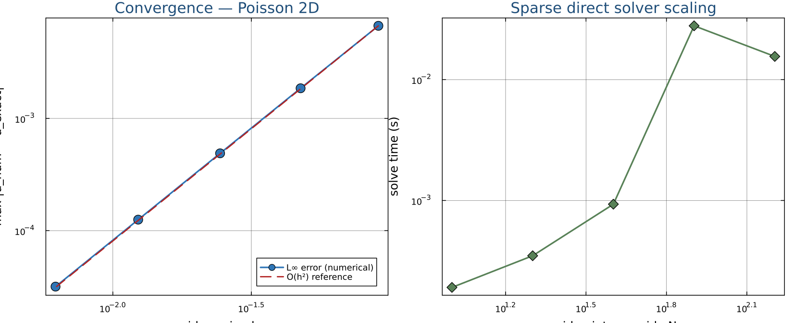
Figure 7. Left: Poisson L∞ error vs grid spacing h on a log-log scale — the slope confirms 2nd-order convergence. Right: solve time scales near-linearly in N² (sparse direct solver).

5.6 Beyond Structured Grids — Meshing with Gmsh
Finite-difference grids work for rectangles. Real geometry — L-shapes, airfoils, brain MRI, machine parts — needs unstructured meshes. Gmsh is the de-facto open-source mesher; the Julia bindings live in Gmsh.jl. The workflow has three parts: (1) describe the geometry, (2) let Gmsh triangulate it, (3) read the node coordinates and element connectivity back into Julia and assemble a sparse matrix.

Install Gmsh.jl
# In package mode (press ]):
(@julia-pde) pkg> add Gmsh

Generate a 2D triangular mesh of the unit square
This is the exact code that produced Figure 8 — running the lecture script reproduces the same mesh on the student's machine, byte-for-byte.
using Gmsh: gmsh
using SparseArrays

function gmsh_unit_square(; lc::Float64 = 0.5)
gmsh.initialize()
gmsh.option.setNumber("General.Terminal", 0)
gmsh.model.add("unit_square")

# 1. Geometry — corner points of [0,1]×[0,1], target size lc
p1 = gmsh.model.geo.addPoint(0.0, 0.0, 0.0, lc)
p2 = gmsh.model.geo.addPoint(1.0, 0.0, 0.0, lc)
p3 = gmsh.model.geo.addPoint(1.0, 1.0, 0.0, lc)
p4 = gmsh.model.geo.addPoint(0.0, 1.0, 0.0, lc)

# 2. Edges and the surface they bound
l1 = gmsh.model.geo.addLine(p1, p2)
l2 = gmsh.model.geo.addLine(p2, p3)
l3 = gmsh.model.geo.addLine(p3, p4)
l4 = gmsh.model.geo.addLine(p4, p1)
cl = gmsh.model.geo.addCurveLoop([l1, l2, l3, l4])
gmsh.model.geo.addPlaneSurface([cl])

# 3. Synchronise the CAD kernel and triangulate the surface
gmsh.model.geo.synchronize()
gmsh.model.mesh.generate(2) # 2D ⇒ triangles

# 4. Pull the mesh back into Julia
node_tags, coord, _ = gmsh.model.mesh.getNodes()
_, _, elem_node_tags = gmsh.model.mesh.getElements(2)

n_nodes = length(node_tags)
xy = reshape(coord, 3, n_nodes)[1:2, :] # drop z

# Gmsh tags can be sparse — remap them to dense 1..n_nodes
tag2idx = Dict(Int(t) => i for (i,t) in enumerate(node_tags))
flat_conn = [tag2idx[Int(t)] for t in elem_node_tags[1]]
tri_nodes = reshape(flat_conn, 3, :)

gmsh.finalize()
return xy, tri_nodes
end

xy, tri_nodes = gmsh_unit_square(lc=0.5)
# xy :: 2 × n_nodes (coordinates of every mesh node)
# tri_nodes :: 3 × n_tri (column k = global node IDs of triangle k)

From mesh to sparse matrix — element assembly
Visit every triangle, and for each pair (a, b) of its three local nodes add the local contribution at the matching global indices. With unit local entries this gives a matrix whose non-zero pattern is identical to a P1 stiffness matrix on the same mesh:
function assemble_adjacency(tri_nodes, n_nodes)
I = Int[]; J = Int[]; V = Float64[]
for k in axes(tri_nodes, 2)
nodes_k = tri_nodes[:, k] # 3 global node IDs
for a in 1:3, b in 1:3
push!(I, nodes_k[a]) # global row
push!(J, nodes_k[b]) # global column
push!(V, 1.0) # local entry value
end
end
return sparse(I, J, V, n_nodes, n_nodes) # duplicates auto-summed
end

n_nodes = size(xy, 2)
A = assemble_adjacency(tri_nodes, n_nodes)
The COO triplets (I, J, V) are the natural output of element assembly; `sparse` automatically sums duplicate (i, j) pairs, which is exactly what "adding contributions from every element touching that node" means. Replace the `1.0` with the entries of a 3×3 local stiffness matrix to get a real FEM Laplacian — the index plumbing is the same.

How mesh indices and matrix indices line up
This is the central idea behind FEM/FVM assembly — once it clicks, every other implementation detail follows:
- Each mesh node has a unique global index 1..n. That same index is its row (and column) in the matrix A.
- Each element carries a small connectivity list. For a P1 triangle that list has three node IDs.
- The element produces a small dense local matrix whose rows and columns are labelled by local node order (1, 2, 3).
- Local index a maps to global index nodes_k[a], so K_local[a, b] is added into A[nodes_k[a], nodes_k[b]].
- If two elements share a node, both contribute to the same row/column of A — A[i, j] is the sum of every element contribution touching the pair (i, j). Mesh edges become off-diagonal non-zeros; mesh nodes become diagonal entries.
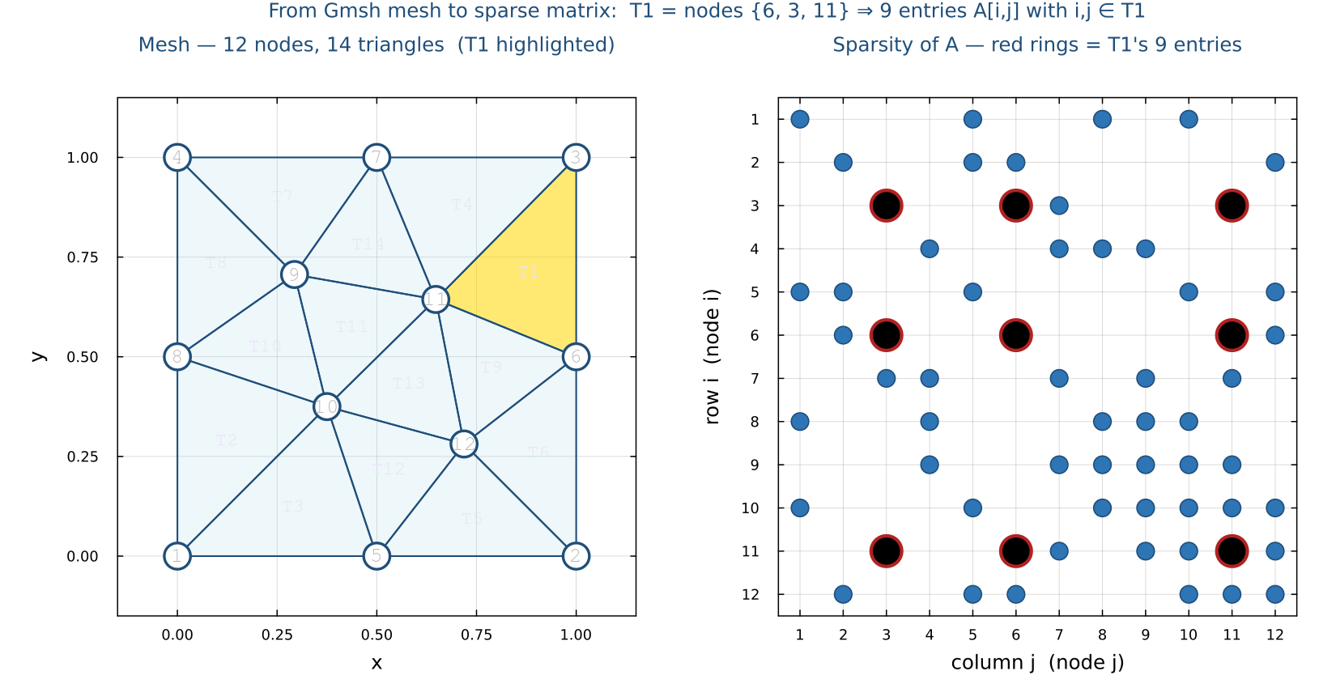
Figure 8. Left: a 9-node, 8-triangle mesh of the unit square. Right: the sparsity pattern of the assembled matrix A. An entry A[i, j] is non-zero iff nodes i and j share at least one triangle. The red rings on the right mark the nine entries contributed by triangle T1 (gold on the left), whose nodes are {1, 2, 5} — those nine entries are A[1,1], A[1,2], A[1,5], A[2,1], A[2,2], A[2,5], A[5,1], A[5,2], A[5,5].
Practical implications:
- Sparsity ≈ average node degree of the mesh — typically 6–8 neighbours in 2D, so A holds ~7n non-zeros instead of n².
- Reordering nodes (Cuthill–McKee, METIS) does not change the physics; it relabels the indices and can dramatically reduce fill-in for sparse direct solvers.
- Boundary conditions are applied by editing the rows and columns of A whose indices match the boundary node IDs — the same node-to-row mapping is reused.
- Higher-order elements (P2, P3, …) add edge/face degrees of freedom; the connectivity table just gets more rows, but the global-DOF-to-matrix-row rule is unchanged.

Step 8 — Package Design Patterns: Structs, Dispatch & Plots (was Step 6)
A well-designed Julia package separates three concerns into three types: the grid (where), the problem (what), and the solution (result). Multiple dispatch then lets you write one function name — solve, plot — and Julia picks the right method automatically based on which types you pass in. This section builds a minimal PDESolvers package from scratch to show that workflow.

6.1 The Three-Type Architecture
Grid resolution, physical parameters, and computed results change at different rates and for different reasons. Separating them into their own types makes it trivial to refine the mesh, swap the boundary condition, or compare two physics models without rewriting the solver logic:
Type | Holds | Changes when
Grid1D | n, dx, x array | you want finer resolution
HeatProblem | α, T, u0, a Grid1D | you change the physics or IC
Solution1D | x, u, t, the problem reference | solve() returns one of these

Beginner Concept Check: Structs, Instances, and Functions
If you are new to custom data types, the interaction between structs, variables, and functions can feel abstract. Let's clarify exactly how they work together:
1. What is a Struct? A struct is a custom composite data type that bundles multiple pieces of related data (called fields) together under a single name. Instead of passing ten individual variables into every function, we pack them into one structured container blueprint.
2. How to create a Struct? We write the struct keyword followed by the container name, list its internal fields with their types, and end with end. Using the Base.@kwdef macro above it automatically writes a keyword constructor with convenient default values:
Base.@kwdef struct SimpleHeatConfig
L::Float64 = 1.0 # Domain length
α::Float64 = 0.01 # Thermal diffusivity
N::Int = 100 # Grid resolution
end
3. What is the variable that is the Struct (an Instance)? The code above is just a blueprint. To use it, we call the struct's name like a function to create a concrete object in computer memory, called an instance, and assign it to a variable. We can then read its internal fields using dot notation:
# Create an instance; omitted fields automatically use defaults
my_config = SimpleHeatConfig(α=0.05, N=200)

# Access individual bundled fields using a dot (.):
println("Configured diffusivity: ", my_config.α)
println("Configured grid points: ", my_config.N)
4. How to create a Function to receive the Struct? To write a function that operates on our configuration, we define a function that accepts a single argument annotated with our custom struct type. Inside the function body, we use dot notation to unpack the exact fields we need:
function print_stability_limit(config::SimpleHeatConfig)
dx = config.L / (config.N + 1)
max_dt = 0.5 * dx^2 / config.α
println("Maximum stable time step dt: ", max_dt)
end

# Pass our struct variable into the function
print_stability_limit(my_config)
5. Structs vs. Functions: Nouns vs. Verbs. A struct holds passive state and data (e.g., domain dimensions, arrays, physical constants). A function defines active behavior and logic (e.g., loops, time-stepping, mathematical updates). Structs are the materials; functions are the machines that transform them.
6. Global Scope vs. Local Scope (Crucial for Performance). Variables defined directly in the main script body live in the global scope. Because global variables can change their data type at any time, the Julia compiler cannot optimize them, making loops in global scope very slow. Variables defined inside a function body live in a local scope. The compiler knows their exact types, compiling local operations to extremely fast machine code. Best Practice: Always wrap your solver loops and computations inside functions!
7. Where do you run these scripts? Once you write your code in a file (e.g., solver.jl), you can run it in three ways: (a) Terminal execution: run 'julia solver.jl' directly from your Linux command line. (b) REPL inclusion: open the Julia REPL and type 'include("solver.jl")' to load and execute the file. (c) VS Code execution: open the file in VS Code and press Shift+Enter to run specific blocks interactively.

6.2 The Grid Struct
Grid1D stores everything about the spatial domain. Computed fields (dx, x) are derived from n and L so callers cannot accidentally create an inconsistent grid. Base.@kwdef generates a keyword constructor with defaults — Grid1D() gives a 200-point unit interval and Grid1D(n=800, L=2.0) overrides only what you need:
# src/grids.jl
Base.@kwdef struct Grid1D
n :: Int = 200
L :: Float64 = 1.0
dx :: Float64 = L / (n + 1)
x :: Vector{Float64} = collect(range(dx, L - dx, length=n))
end

6.3 Problem Structs
Each physics model gets its own struct. Both embed a Grid1D so the solver can always reach the mesh through the problem — no extra arguments needed. Greek-letter field names (α, c) match the mathematical notation used in the PDE:
# src/problems.jl
Base.@kwdef struct HeatProblem
grid :: Grid1D = Grid1D()
α :: Float64 = 0.01 # thermal diffusivity
T :: Float64 = 1.0 # final time
u0 :: Function = x -> exp(-100*(x - 0.5)^2)
end

Base.@kwdef struct WaveProblem
grid :: Grid1D = Grid1D()
c :: Float64 = 1.0 # wave speed
T :: Float64 = 1.5
u0 :: Function = x -> sin.(π .* x)
end

6.4 The Solution Type and solve() Dispatch
Solution1D is parameterised by the problem type P so that plot() can dispatch on it at compile time — zero runtime cost. Two solve() methods share the same name; Julia selects the right one from the argument type alone:
# src/solvers.jl
struct Solution1D{P}
prob :: P
x :: Vector{Float64}
u :: Vector{Float64}
t :: Float64
end

function solve(prob::HeatProblem)
g = prob.grid
dt = 0.4 * g.dx^2 / prob.α # CFL: r = α·dt/dx² ≤ 0.5
u = prob.u0.(g.x)
for _ in 1:ceil(Int, prob.T / dt)
u[2:end-1] .+= (prob.α * dt / g.dx^2) .*
(u[3:end] .- 2 .* u[2:end-1] .+ u[1:end-2])
end
return Solution1D(prob, g.x, u, prob.T)
end

function solve(prob::WaveProblem)
g = prob.grid
dt = g.dx / prob.c # CFL = 1 (exact for leap-frog)
λ = (prob.c * dt / g.dx)^2
u_prev = prob.u0.(g.x)
u_curr = copy(u_prev); u_next = similar(u_prev)
for _ in 1:ceil(Int, prob.T / dt)
u_next[2:end-1] .= 2 .* u_curr[2:end-1] .- u_prev[2:end-1] .+
λ .* (u_curr[3:end] .- 2 .* u_curr[2:end-1] .+ u_curr[1:end-2])
u_next[[1,end]] .= 0.0 # Dirichlet BCs
u_prev, u_curr, u_next = u_curr, u_next, u_prev
end
return Solution1D(prob, g.x, u_curr, prob.T)
end

6.5 Plot Dispatch in the Project Style
Extending Plots.plot for your own types uses the same dispatch. Import the function first so you add a method to the existing generic rather than shadow it. The kwargs... passthrough lets callers override any keyword — color, linestyle, legend — without touching the defaults:
# src/visualization.jl
import Plots: plot

function plot(sol::Solution1D{HeatProblem}; kwargs...)
plot(sol.x, sol.u;
xlabel = "x",
ylabel = "u(x,t)",
title = "Heat equation α=$(sol.prob.α) t=$(sol.t)",
lw = 2,
label = "Numerical",
kwargs...)
end

function plot(sol::Solution1D{WaveProblem}; kwargs...)
plot(sol.x, sol.u;
xlabel = "x",
ylabel = "u(x,t)",
title = "Wave equation c=$(sol.prob.c) t=$(sol.t)",
lw = 2,
label = "Numerical",
kwargs...)
end

6.6 The Full Package Layout
Splitting the four concerns into four files keeps each file under 200 lines and lets you include only the solver files you need. The module entry point is the only file that contains using and export — sub-files just define functions and types:
PDESolvers/
├── Project.toml
└── src/
├── PDESolvers.jl # module entry — using, include, export
├── grids.jl # Grid1D
├── problems.jl # HeatProblem, WaveProblem
├── solvers.jl # solve(::HeatProblem), solve(::WaveProblem)
└── visualization.jl # plot(::Solution1D{P})
# src/PDESolvers.jl
module PDESolvers

using Plots

include("grids.jl")
include("problems.jl")
include("solvers.jl")
include("visualization.jl")

export Grid1D, HeatProblem, WaveProblem, Solution1D, solve

end # module PDESolvers

6.7 Calling the Package
With the types and dispatch in place, switching between physics models is a one-word change at the call site — the grid, the plot call, and the output pipeline stay identical. This is the payoff of the three-type architecture:
using PDESolvers, Plots

# -- Heat: 400-point grid, low diffusivity, run to T=0.5 --
grid = Grid1D(n=400, L=2.0)
hprob = HeatProblem(grid=grid, α=0.005, T=0.5)
hsol = solve(hprob) # dispatches to HeatProblem method
plot(hsol) # dispatches to Solution1D{HeatProblem}
savefig("heat_solution.png")

# -- Wave: same grid, different physics, identical API --
wprob = WaveProblem(grid=grid, c=1.5, T=2.0)
wsol = solve(wprob) # dispatches to WaveProblem method
plot(wsol) # dispatches to Solution1D{WaveProblem}
savefig("wave_solution.png")

6.8 Generalizing to Coupled Multi-Field Systems
Every problem in Step 7 — HeatEquation, WaveEquation, PoissonEquation — advances ONE scalar field. Many real models need two or more fields that feed into each other every time step: two temperatures exchanging heat, predator/prey populations diffusing and interacting, or the ψ (streamfunction) / ω (vorticity) pair in the Navier-Stokes solver from Step 7. What changes when a problem has more than one field?
What changes: stack every field into ONE vector and solve ONE sparse linear system per time step, instead of looping independent solves. The package's CoupledPDESystem{M,N} type does exactly this for any number M of named fields — it is the actual generalization of the two-field CoupledHeatEquation you may already have used, not just a sketch of one:
# src/types.jl — flat indexing across M named fields sharing one grid
struct Ind{M,N}
vars::NTuple{M,Symbol}
NumGrid::NTuple{M,NTuple{N,Int}}
end

# Ind(:v, i, j) → flat position of field :v at grid point (i,j)
# Ind(42) → (which field, CartesianIndex within that field)

# src/coupled.jl
Base.@kwdef struct CoupledPDESystem{M,N} <: ParabolicProblem
grid::Grid{N}
vars::NTuple{M,Symbol} # e.g. (:u, :v, :w)
α::NTuple{M,Float64} # diffusivity per field
K::NTuple{M,NTuple{M,Float64}} = ntuple(_->ntuple(_->0.0,length(vars)),length(vars)) # M×M coupling matrix
f_init::NTuple{M,Function}
Nt::Int = 1000
T::Float64 = 1.0
end

function solve(p::CoupledPDESystem{M,N}) where {M,N}
Lap = nd_laplacian(d, inner_n) # same operator PoissonEquation uses
Iden = sparse(I, n, n)
koff = [sum(p.K[i][j] for j in 1:M if j != i) for i in 1:M]
# Aᵢᵢ = I + dt(αᵢ·Lap + koffᵢ·I), Aᵢⱼ = −dt·Kᵢⱼ·I (i ≠ j)
Afact = lu(A) # ONE factorisation, reused every step
# … time-step all M fields together via Afact \\ [u₁; u₂; …; u_M] …
end
The key idea is `vars::NTuple{M,Symbol}` plus `Ind`: instead of hardcoding fields named `u` and `v` on the struct, each field gets a symbolic name, and Ind's two getindex methods translate between a name-and-grid-point ("where is :w at grid point 7?") and a flat position in the stacked (M·n)-length vector the sparse solve actually works with. `K` generalizes the single exchange rate κ to an M×M matrix: K[i][j] = 0 for every pair means M independent fields solved together purely for convenience, and nonzero entries reproduce (and extend) the two-field exchange behaviour. Note the default for K reads length(vars), not the type parameter M directly — @kwdef default expressions are evaluated in the outer constructor before M is resolved, so only previously-listed field names like vars are in scope yet.
Why coupling at the same implicit time level is necessary: if you instead time-step two fields with separate independent solves, an exchange term like κ(u−v) has to be evaluated using the OLD value of the other field, which is only first-order accurate in the coupling and can become unstable for large κ (stiff exchange). Solving every field at the same implicit time level, in one system, keeps the scheme unconditionally stable no matter how strong the coupling is — exactly the same reason Step 7's implicit heat solver beats forward Euler.
Benefit: the block-system technique reuses every piece of linear-algebra machinery already in the package — the same nd_laplacian sparse assembly and the same lu / \\ solve used by PoissonEquation and HeatEquation.solve_implicit — it just gets called on a bigger, block-structured matrix. And because CoupledPDESystem subtypes ParabolicProblem, it slots into the exact same solve()/plot() dispatch as every other problem type. CoupledHeatEquation, the original two-field type, is now a one-line convenience constructor that builds and delegates to a CoupledPDESystem with vars=(:u,:v) — the special case is a literal instance of the general one, rather than a separate implementation that has to be kept in sync by hand.
Connection to Navier-Stokes: the LidCavityFlow solver from Step 7 already advances two coupled fields, ψ and ω, every time step — but via splitting (an explicit vorticity update, then two separate sparse solves: one lu factorisation for diffusion, another for the streamfunction Poisson equation). That is a perfectly standard and efficient scheme, and — unlike CoupledHeatEquation — it stays outside CoupledPDESystem for now: it's 2-D-only and hand-rolled rather than built on nd_laplacian. As an exercise, ask what would change if ψ and ω were instead stacked into one CoupledPDESystem-style block system — you would trade two smaller factorisations for one larger one, gaining the same 'exact at the same time level' coupling this section demonstrates.
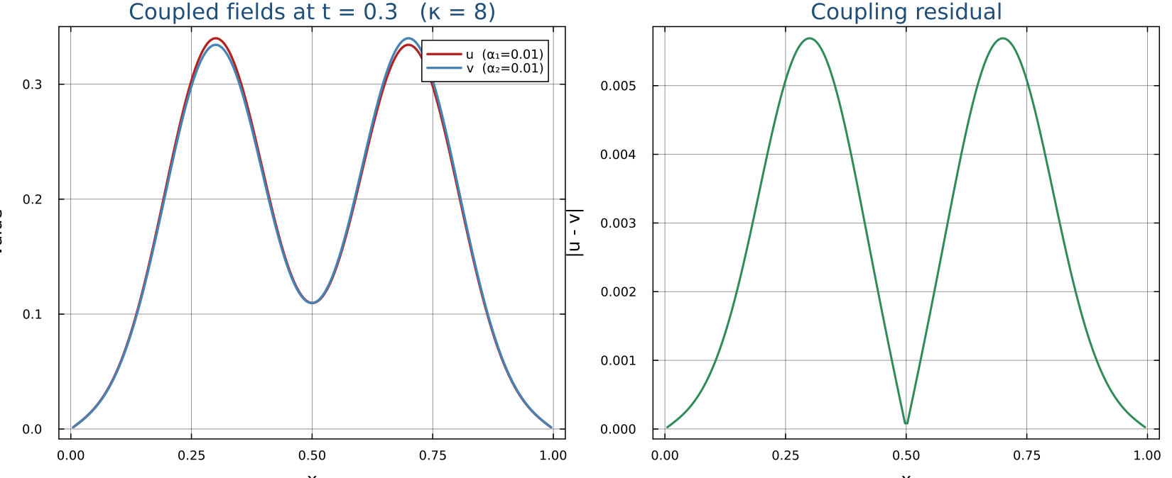
Figure. The M = 2 case: two coupled heat fields (left) starting from separate Gaussian pulses, pulled toward each other by κ while each also diffuses; the coupling residual |u−v| (right) shrinks toward zero.
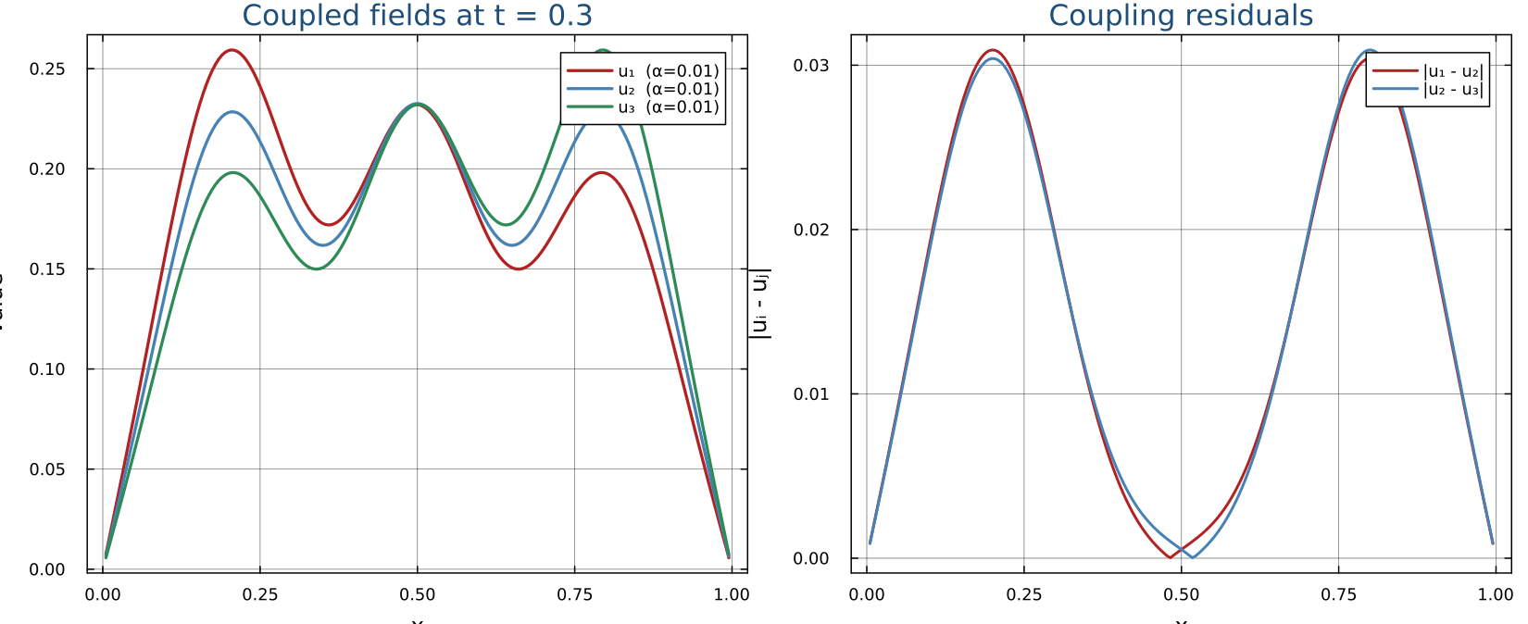
Figure. CoupledPDESystem with M = 3 named fields in a chain: field 2 exchanges heat with both 1 and 3, but 1 and 3 are not directly coupled (K[1][3] = K[3][1] = 0). The residual panel (right) shows only the two coupled pairs — the same Ind-indexed block system handles any coupling topology, not just all-to-all.

Step 9 — Connect to the HPC Cluster
ssh-keygen -t ed25519 -C "your_email@example.com"
ssh-copy-id user@cluster.example.edu
ssh user@cluster.example.edu
module load julia/1.10
julia --version
Sync your project (Project.toml + Manifest.toml) to the cluster:
rsync -avz ~/julia-pde/ user@cluster:~/julia-pde/
ssh user@cluster
cd ~/julia-pde && julia --project=. -e 'using Pkg; Pkg.instantiate()'

Step 10 — Submitting Julia PDE Jobs with Slurm
Command | Action
sbatch job.sh | Submit job
squeue -u $USER | Show your jobs
scancel JOBID | Cancel a job
sinfo | Show partitions
sacct -j JOBID | Detailed stats after run
Example heat equation job script:
#!/bin/bash
#SBATCH --job-name=heat_eq
#SBATCH --cpus-per-task=4
#SBATCH --mem=4G
#SBATCH --time=00:30:00
#SBATCH --output=heat_%j.out

module load julia/1.10
julia --threads=4 --project=. heat_equation.jl

Troubleshooting Quick Reference
Problem | Solution
wsl --install fails | Run as Admin; restart Windows
julia: command not found | source ~/.bashrc
Pkg precompile is slow | Normal first time; subsequent loads are fast
SSH publickey denied | Re-run ssh-copy-id; ask instructor
Slurm OOM kill | Increase --mem or reduce N
CFL instability (NaN) | Reduce dt; check stability condition

Step 11 — Share Your Code with Git & GitHub
You now have a working Julia project with PDE solvers and a Slurm job script. The last step is to put your code under version control with Git, and push a copy to GitHub so you can access it from anywhere (including the HPC cluster) and share it with classmates or your advisor.
What is Git? Git records snapshots of your project over time so you can see what changed, undo mistakes, and collaborate without emailing zip files. GitHub is a website that hosts those snapshots online.

11.1 Install Git (inside WSL)
Open your Ubuntu terminal and run:
sudo apt update
sudo apt install -y git
git --version # should print: git version 2.43.x or similar

11.2 Tell Git who you are (one-time setup)
Every snapshot is stamped with your name and email. Set them once and Git remembers them for every project on this computer.
git config --global user.name "Your Name"
git config --global user.email "you@example.com"
Use the same email as your GitHub account when you create one in step 11.6.

11.3 Initialise the repo in your project folder
Go to the folder that holds your Julia project (the one with Project.toml) and turn it into a Git repository:
cd ~/projects/julia-docx-tutorial # adjust to your folder
git init
git status
git init creates a hidden .git/ folder where Git stores all history. git status shows every file Git can see; right now they will all be listed as untracked.

11.4 Tell Git which files to ignore
You do NOT want to commit generated PNG figures, the large .docx, Julia's package cache, or editor temp files. Create a file named .gitignore at the top of the project with this content (one pattern per line):
# Julia
Manifest.toml
*.jl.cov
*.jl.mem
.julia/

# Generated artifacts
output/
site/output/figures/
*.docx
*.png

# OS / editor
.DS_Store
.vscode/
*.swp
Anything matching one of these patterns is hidden from Git. You can always remove a line later if you decide you do want to track that file.

11.5 Make your first commit
A commit is a labelled snapshot of every file currently staged. Stage all files, then commit with a short message:
git add .
git status # confirm what is staged
git commit -m "Initial project: Julia PDE solvers and setup guide"
Git replies with something like '[main (root-commit) 9e4c42c] Initial project ...'. That hash is the snapshot's unique ID; you can always come back to it later.
Good commit messages describe what you did and why, in the present tense. 'Add heat-equation solver and convergence test' is better than 'changes' or 'wip'.

11.6 Create a GitHub account and an empty repository
- Go to https://github.com and sign up (free).
- Click + → New repository in the top-right corner.
- Name it (for example julia-pde-tutorial), keep it public or private as you prefer.
- Do NOT tick 'Add a README' or 'Add .gitignore' — your local folder already has those.
- Click Create repository. GitHub shows a page with the URL of your new (empty) repo.

11.7 Connect your local repo to GitHub and push
On the GitHub repo page, copy the HTTPS URL (looks like https://github.com/<you>/julia-pde-tutorial.git). Then in your terminal:
git branch -M main
git remote add origin https://github.com/<your-username>/julia-pde-tutorial.git
git push -u origin main
The first time you push, GitHub will ask for your username and a personal access token (PAT) instead of a password. Create one at https://github.com/settings/tokens → Generate new token (classic), give it the 'repo' scope, and paste it where Git asks for the password. Git will cache it so you don't have to enter it again.

11.8 Day-to-day loop
From now on, every time you change something you want to keep:
git status # what changed?
git add path/to/file.jl # stage specific files (or 'git add .' for all)
git commit -m "Fix CFL bug in wave solver"
git push # send the new commits to GitHub
Refresh your GitHub repo page in the browser — you should see every file from your project, your commit message at the top, and a clickable history. From here you can 'git clone' the same repo on the HPC cluster and run the exact same code there.

