WEEK 3 TASK
Advanced Data Analysis and Visualization in Logistics
Exploring delivery performance, cost drivers and bottlenecks in a simulated 6,000-shipment network
Item | Detail
Dataset | 6,000 simulated shipments, 1 Jan – 27 Dec 2025, five origin hubs, five destination regions, four carriers, three transport modes
Tools | Python 3.12.3, pandas 3.0.2, NumPy 2.4.4, SciPy 1.17.1, Matplotlib 3.10.8, seaborn 0.13.2
Reproducibility | Random seed 42; one script (logistics_analysis.py) regenerates every number, table and figure in this report
Deliverables | This report; the full Python script; the cleaned dataset (logistics_clean.csv, 5,842 rows)

1. Executive Summary
This report simulates a year of shipments for a multi-hub Indian logistics network, validates and cleans the data, performs exploratory data analysis (EDA), and uses eight visualizations to identify where delivery performance and cost are won or lost. After cleaning, 5,842 shipments with a combined transport spend of ₹23,418,569 (₹10.12 per kg shipped) were analysed.
Headline findings
- Only 66.3% of shipments arrived on time (3,873 of 5,842; 95% CI 65.1–67.5%). Late shipments were late by 1.82 days on average.
- One carrier is the main reliability problem. CargoPlus delivers 48% on time versus 70.2–74.6% for the other three, and is also the most expensive per tonne-km in every mode (Road: ₹7.46 vs ₹6.44–6.88).
- Q4 peak season costs about 14 points of on-time performance: 56.4% in Oct–Dec versus 70.6% in the rest of the year (Welch t = 10.87, p < 0.001).
- Kolkata is the clearest bottleneck: 50.7% on-time against 67.6–70.2% at the other hubs, and the Kolkata → North lane is worst at 40% on-time (200 shipments, average delay 1.44 days).
- Air freight is 9.7% of shipments but 29.1% of spend, at a median ₹26.92 per tonne-km versus ₹6.91 for road (3.9×).
- Light shipments are expensive: 1,380 shipments under 150 kg (23.6% of volume) cost a median ₹23.17/kg versus ₹9.40/kg for 150–400 kg loads.
Recommendations (Section 8) target a rise in on-time delivery from 66.3% to roughly 71–73% and a cost reduction of about ₹2.7–3.5 million (12–15% of spend), with every figure derived from worked calculations on the data and a sensitivity range rather than a single optimistic estimate.

2. Objectives and Methodology
The analysis answers four business questions, each tied to a performance metric:
Business question | Metric | Primary visual
How reliable is delivery, and how variable? | On-time delivery (OTD) %, delay days, actual delivery days | Fig 1, Fig 2, Fig 3
What drives transport cost? | Cost per shipment, per kg, per tonne-km | Fig 4, Fig 5, Fig 6, Fig 8
Where are the bottlenecks? | Mean delay by hub × region lane | Fig 7
What should change, and what is it worth? | Scenario OTD gain (points) and cost saving (INR) | Section 8 worked calculations

The workflow follows six stages, each reproducible from the accompanying script:
- Simulate a realistic shipment dataset with documented generation rules (Section 3).
- Validate and clean with explicit before/after checks (Section 4).
- Explore with descriptive statistics, correlations and hypothesis tests (Section 5).
- Visualize with a chart type justified for each question (Section 6).
- Interpret the results for efficiency, cost and bottlenecks (Section 7).
- Recommend and quantify actions, with sensitivity ranges (Section 8).

3. Data Simulation

3.1 Dataset structure
Each row is one shipment. The table lists every variable, its type, and how it was generated.
Variable | Type | Description / generation rule
shipment_id | Text | Unique ID, SH100000 – SH105999
ship_date | Date | Day in 2025; monthly weights give a Q4 peak (Nov ≈ 11.5% of volume vs Jan ≈ 7.0%)
origin_hub | Category | Mumbai 28%, Delhi 24%, Chennai 18%, Kolkata 15%, Pune 15%
dest_region | Category | West 24%, North 22%, South 20%, Central 18%, East 16%
carrier | Category | SwiftLine 30%, RoadKing 28%, CargoPlus 24%, EcoFreight 18%
mode | Category | Road 68%, Rail 22%, Air 10%
priority | Category | Standard 82%, Express 18%
distance_km | Numeric | Hub-to-region lookup (170–2,558 km after ±6% noise)
weight_kg | Numeric | Log-normal (μ = 5.6, σ = 0.9), clipped to 20–9,000 kg
volume_m3 | Numeric | weight ÷ density, density ~ N(180, 35) kg/m³, bounded 80–400
units | Integer | weight ÷ unit weight, unit weight ~ N(12, 3) kg
transport_cost | INR | Fixed fee + mode rate × distance × chargeable tonnes × carrier factor, ×1.25 Express, ±7% noise
planned_days | Integer | ceil(distance ÷ mode speed + 1); Express is one day faster
delay_days | Integer | Gamma-distributed delay with carrier, mode, season, hub and lane effects; −1 means early
actual_days | Integer | planned_days + delay_days (minimum 1)

3.2 Why these generation rules
Rules were chosen to mimic well-known logistics behaviour so that the EDA has real structure to find: road and rail charge per tonne-km on top of a fixed handling fee, air is several times dearer, small consignments are billed on a 250 kg minimum chargeable weight, peak season degrades reliability, and one hub is congested. Because the effects were planted deliberately, they also serve as ground truth: Section 5 checks whether the EDA recovers them. A method that recovers known effects can be trusted more when applied to real data.
Code excerpt 1: shipment attributes
rng = np.random.default_rng(42) # reproducible
N = 6000
df = pd.DataFrame({
"shipment_id": [f"SH{100000+i}" for i in range(N)],
"origin_hub": rng.choice(list(hubs), N, p=list(hubs.values())),
"dest_region": rng.choice(list(regions), N, p=list(regions.values())),
"carrier": rng.choice(list(carriers), N, p=list(carriers.values())),
"mode": rng.choice(list(modes), N, p=list(modes.values())),
"priority": rng.choice(["Standard", "Express"], N, p=[0.82, 0.18]),
})
df["weight_kg"] = np.clip(rng.lognormal(5.6, 0.9, N), 20, 9000).round(1)

Code excerpt 2: cost model (0.25 t minimum chargeable weight)
rate = {"Road": 4.2, "Rail": 2.6, "Air": 16.0} # INR per tonne-km
fixed = {"Road": 900, "Rail": 1500, "Air": 3500} # INR per shipment
tonnes = df.weight_kg / 1000
df["transport_cost"] = (df["mode"].map(fixed)
+ df["mode"].map(rate) * df.distance_km * np.maximum(tonnes, 0.25))
df["transport_cost"] *= df.carrier.map(carrier_mult)
df.loc[df.priority == "Express", "transport_cost"] *= 1.25
df["transport_cost"] *= rng.normal(1.0, 0.07, N) # market noise

Code excerpt 3: delay model (planted effects)
delay_mu = np.full(N, 0.30) # baseline mean delay (days)
delay_mu += df.carrier.map({"SwiftLine": 0.0, "RoadKing": 0.05,
"CargoPlus": 0.85, "EcoFreight": 0.12})
delay_mu += df["mode"].map({"Road": 0.10, "Rail": 0.30, "Air": -0.10})
delay_mu += np.where(df.ship_date.dt.month.isin([10, 11, 12]), 0.55, 0.0)
delay_mu += np.where(df.origin_hub == "Kolkata", 0.35, 0.0)
delay_mu += np.where((df.origin_hub == "Kolkata")
& (df.dest_region == "North"), 0.60, 0.0)
df["delay_days"] = (rng.gamma(1.2, delay_mu / 1.2) - 0.65).round(0)

3.3 Sample records
Eight rows from the cleaned dataset show the structure (cost in INR, distance in km, weight in kg):
ID | Origin | Dest. | Carrier | Mode | km | kg | Cost ₹ | Plan | Act. | Delay
SH100000 | Kolkata | East | RoadKing | Road | 371 | 245.9 | 1,067 | 2 | 3 | 1
SH100001 | Delhi | North | RoadKing | Rail | 272 | 297.1 | 1,499 | 2 | 2 | 0
SH100003 | Chennai | North | EcoFreight | Road | 2,273 | 192.2 | 3,004 | 6 | 6 | 0
SH100004 | Mumbai | North | SwiftLine | Rail | 1,364 | 145.7 | 2,339 | 5 | 4 | -1
SH100005 | Pune | East | SwiftLine | Rail | 1,937 | 119.2 | 2,473 | 7 | 8 | 1
SH100006 | Kolkata | West | SwiftLine | Air | 1,953 | 198.4 | 11,144 | 3 | 2 | -1
SH100007 | Kolkata | Central | EcoFreight | Road | 1,171 | 2717.0 | 14,619 | 3 | 3 | 0
SH100009 | Delhi | Central | RoadKing | Road | 964 | 463.3 | 2,837 | 3 | 3 | 0

4. Data Validation and Cleaning
Real logistics data is rarely clean, so realistic faults were injected into the simulated file before analysis: 150 missing values, 12 sign errors, 8 keying errors and 45 duplicate rows. Cleaning was done in a fixed order and every step was verified by a before/after check.

4.1 Validation checks: before and after
Check | Before | After | Treatment
Duplicate shipment IDs | 45 | 0 | Dropped (keep first)
Missing transport_cost | 60 | 0 | Row dropped (target variable)
Missing weight_kg | 45 | 0 | Row dropped (needed for cost per kg)
Missing carrier | 25 | 0 | Row dropped (needed for carrier analysis)
Missing distance_km | 20 | 0 | Row dropped (needed for tonne-km)
Negative weight | 12 | 0 | Corrected with absolute value (clear sign error)
Extreme cost outliers | 8 | 0 | Removed (3×IQR fence, see 4.2)
actual_days < 1 | 0 | 0 | None found
Ship date outside 2025 | 0 | 0 | None found

4.2 Outlier detection and a lesson from the first attempt
Keying errors were simulated by multiplying 8 costs by 40. The first detection attempt used a single 3×IQR fence on raw cost per tonne-km across all shipments. It flagged 549 rows (9% of the data), almost all of them legitimate: fixed handling fees inflate cost per tonne-km for light shipments, and air freight is naturally dearer. Removing them would have biased every cost conclusion.
The corrected method takes the logarithm of cost per tonne-km, which stabilises skew, and applies the 3×IQR fence separately for each transport mode. It flagged exactly 8 rows, matching the 8 injected errors, with no legitimate shipment removed.
Code excerpt 4: cleaning pipeline
def outlier_mask(d):
"""3xIQR fence on log(cost per tonne-km), computed per transport mode."""
lg = np.log(d.cost_per_tkm)
mask = pd.Series(False, index=d.index)
for _, idx in d.groupby("mode").groups.items():
q1, q3 = lg.loc[idx].quantile([0.25, 0.75]); i = q3 - q1
mask.loc[idx] = (lg.loc[idx] > q3 + 3*i) | (lg.loc[idx] < q1 - 3*i)
return mask

clean = df.drop_duplicates("shipment_id").copy()
clean["weight_kg"] = clean.weight_kg.abs() # sign errors corrected
clean = clean.dropna(subset=["transport_cost", "weight_kg", "carrier", "distance_km"])
clean = clean[~outlier_mask(clean)].copy()

Worked example: why the keying error is obvious in cost per tonne-km
A Road shipment of 1,000 kg over 1,500 km should cost about ₹7,700 (Section 8.5). Recorded with a keying error (×40) it becomes ≈ ₹308,000, or ₹205 per tonne-km against a Road median of ₹6.91.
In log terms that is ln(205) = 5.32 versus ln(6.91) = 1.93, roughly 3.4 log-units above the median and beyond the Road fence, so it is flagged. A genuine light shipment such as SH100797 (Section 6.5) works out at ₹6.85 per tonne-km, so it stays inside the fence.

4.3 Row accounting and final data quality
Stage | Rows | Change
Raw file (6,000 shipments + 45 duplicates) | 6,045 | —
After removing duplicates | 6,000 | −45
After dropping rows with missing critical fields | 5,850 | −150
After outlier removal | 5,842 | −8
Final cleaned dataset | 5,842 | 97.37% of unique shipments retained

Post-cleaning integrity checks (all passed):
Integrity check | Result
actual_days = planned_days + delay_days | 5,842 / 5,842 rows
on_time flag equals (delay_days ≤ 0) | 5,842 / 5,842 rows
Cargo density (weight ÷ volume) | 79.9 – 310.1 kg/m³ (inside the 80–400 plausibility band)
Ship-date range | 2025-01-01 to 2025-12-27
Categorical domains | 3 modes (Air, Rail, Road); 4 carriers; no unexpected labels
Distance range | 170 – 2,558 km
Cost range | ₹916 – ₹155,691
Duplicates / missing values / negative weights | 0 / 0 / 0

5. Exploratory Data Analysis

5.1 Central tendency and spread
Variable | Mean | Median | Std dev | Min | Max | Skew | CV
distance_km | 1159.88 | 1117.00 | 619.97 | 170.00 | 2558.00 | 0.13 | 53.5%
weight_kg | 396.22 | 261.60 | 451.96 | 20.00 | 9000.00 | 5.46 | 114.1%
volume_m3 | 2.30 | 1.48 | 2.73 | 0.09 | 50.99 | 5.18 | 118.9%
units | 35.79 | 22.00 | 43.30 | 1.00 | 690.00 | 4.60 | 121.0%
transport_cost (₹) | 4008.66 | 2698.00 | 5184.23 | 916.00 | 155691.00 | 11.30 | 129.3%
planned_days | 3.56 | 4.00 | 1.51 | 1.00 | 8.00 | 0.38 | 42.4%
actual_days | 4.06 | 4.00 | 2.07 | 1.00 | 19.00 | 1.00 | 51.1%
delay_days | 0.51 | 0.00 | 1.26 | -1.00 | 13.00 | 2.59 | 248.0%

Code excerpt 5: descriptive statistics
num_cols = ["distance_km", "weight_kg", "volume_m3", "units",
"transport_cost", "planned_days", "actual_days", "delay_days"]
desc = clean[num_cols].describe().T
desc["median"] = clean[num_cols].median()
desc["skew"] = clean[num_cols].skew()
desc["cv_pct"] = 100 * clean[num_cols].std() / clean[num_cols].mean()

What the numbers say
- Cost and weight are heavily right-skewed. Mean cost is ₹4,009 but the median is only ₹2,698 (skew 11.3); mean weight is 396 kg against a median of 262 kg. A few large and air-freight shipments pull the mean up, so medians are the right summary for cost and weight.
- Delivery time is mildly skewed (mean 4.06 days, median 4, skew 1.00). A Shapiro–Wilk test on a 5,000-row sample rejects normality (W = 0.926, p < 0.001), so non-parametric tests are used where group distributions are compared.
- Delay has the highest relative variability (coefficient of variation 248%): the median delay is 0 days yet the worst shipment was 13 days late. Averages hide this tail, which is why on-time percentage is reported alongside mean delay.
- On-time rate is 66.3% (3,873 / 5,842). Wilson 95% interval: 65.1–67.5%.

5.2 Performance by segment
By carrier
Segment | Shipments | OTD | Mean delay (d) | Median ₹/kg | Median ₹/tonne-km
SwiftLine | 1,749 | 74.6% | 0.30 | 10.41 | 7.32
RoadKing | 1,602 | 70.9% | 0.33 | 9.37 | 6.89
EcoFreight | 1,071 | 70.2% | 0.37 | 9.94 | 6.80
CargoPlus | 1,420 | 48% | 1.07 | 11.04 | 7.79

By transport mode
Segment | Shipments | OTD | Mean delay (d) | Median ₹/kg | Median ₹/tonne-km
Road | 3,923 | 67.6% | 0.48 | 9.52 | 6.91
Rail | 1,350 | 59.5% | 0.69 | 9.11 | 6.90
Air | 569 | 73.8% | 0.29 | 37.75 | 26.92

By origin hub
Segment | Shipments | OTD | Mean delay (d) | Median ₹/kg | Median ₹/tonne-km
Mumbai | 1,686 | 70.2% | 0.39 | 9.80 | 7.68
Delhi | 1,411 | 68.2% | 0.44 | 10.08 | 7.36
Pune | 860 | 69.3% | 0.40 | 9.10 | 8.31
Chennai | 1,037 | 67.6% | 0.49 | 11.36 | 6.79
Kolkata | 848 | 50.7% | 0.99 | 10.58 | 6.36

By quarter
Segment | Shipments | OTD | Mean delay (d) | Median ₹/kg | Median ₹/tonne-km
Q1 | 1,255 | 72.1% | 0.34 | 10.16 | 7.24
Q2 | 1,322 | 75% | 0.27 | 10.17 | 7.21
Q3 | 1,505 | 65.4% | 0.49 | 10.05 | 7.10
Q4 | 1,760 | 56.4% | 0.81 | 10.28 | 7.38

5.3 Correlations
Pearson and Spearman coefficients were computed on the eight numeric variables (matrix in Figure 4). Pearson measures linear association and is sensitive to outliers; Spearman measures rank association. Comparing them shows where the relationship is non-linear or outlier-driven.
Pair | Pearson r | Spearman ρ | Reading
transport_cost ↔ weight_kg | 0.53 | 0.42 | Moderate; heavy loads drive linear cost growth
transport_cost ↔ volume_m3 | 0.52 | 0.41 | Mirrors weight (see multicollinearity below)
transport_cost ↔ distance_km | 0.28 | 0.62 | Rank correlation is more than double Pearson: mode mix and air outliers mask a real distance effect
weight_kg ↔ volume_m3 | 0.96 | n/a | Near-duplicate variables; use only one in any model
planned_days ↔ distance_km | 0.83 | n/a | Plans scale with distance, as designed
delay_days ↔ weight_kg | 0.01 | n/a | No relationship: delay is not caused by shipment size
delay_days ↔ distance_km | 0.08 | n/a | Negligible: delay is operational, not physical

The key conclusion is that no physical shipment attribute explains delay (all |r| ≤ 0.08). Delay must therefore be driven by categorical operational factors (carrier, hub, season), which the statistical tests below confirm.

5.4 Hypothesis tests
Code excerpt 6: statistical tests
from scipy import stats
groups = [g.delay_days.values for _, g in clean.groupby("carrier")]
kw = stats.kruskal(*groups) # carrier effect on delay
peak = clean[clean.month.isin([10, 11, 12])].delay_days
offp = clean[~clean.month.isin([10, 11, 12])].delay_days
tt = stats.ttest_ind(peak, offp, equal_var=False) # Welch t-test
chi = stats.chi2_contingency(pd.crosstab(clean.carrier, clean.on_time))

Hypothesis | Test | Statistic | p-value | Conclusion
Delay differs by carrier | Kruskal–Wallis | H = 323.8 | < 0.001 | Reject equality: carriers differ
OTD independent of carrier | Chi-square (df 3) | χ² = 289.8 | < 0.001 | Reject independence
Peak-season delay > off-peak | Welch t-test | t = 10.87 | < 0.001 | Mean delay 0.813 d (n = 1,760) vs 0.377 d (n = 4,082)
Delivery time is normal | Shapiro–Wilk | W = 0.926 | < 0.001 | Reject normality; use medians / rank tests

Ground-truth check. The simulation planted a CargoPlus penalty, a Q4 penalty and a Kolkata penalty. All three were recovered with high statistical significance, and no effect was found for variables that were deliberately given none (weight and delay, r = 0.01). This supports the validity of the workflow.

6. Visualizations and Interpretation
Each subsection gives the chart code, the reason for choosing that chart type, and an interpretation using the actual values.

6.1 Distribution of delivery time and delay
fig, ax = plt.subplots(1, 2, figsize=(11, 4))
sns.histplot(clean.actual_days, bins=range(1, clean.actual_days.max() + 2), ax=ax[0])
ax[0].axvline(clean.actual_days.mean(), color="red", ls="--")
ax[0].axvline(clean.actual_days.median(), color="green", ls=":")
sns.histplot(clean.delay_days, ax=ax[1], color="#e76f51")
ax[1].axvline(0, color="black", lw=1) # 0 = on plan

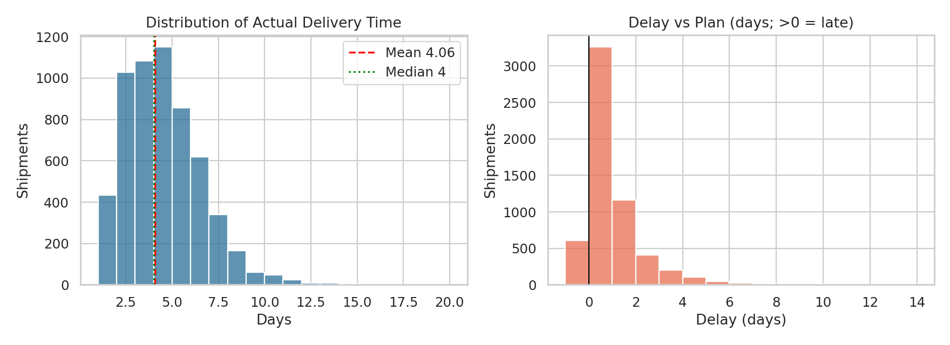
Figure 1. Left: distribution of actual delivery time. Right: delay versus plan (days).
Why a histogram: it shows the full shape of a continuous or count variable (centre, spread, skew, tail) that a single average would hide. Marking the mean and median on one axis shows skew directly.
Interpretation: Delivery time peaks at 3–5 days, with a mean of 4.06 and a median of 4 days; the long right tail reaches 19 days. The delay histogram is centred on zero but its right side is thicker than its left (early arrivals are limited to one day), giving the 66.3% on-time rate and a late-only mean of 1.82 days. Operationally, the long tail matters more than the mean: a customer promised 4 days who waits 12 has a very different experience from the average.

6.2 Carrier reliability
order = clean.groupby("carrier").delay_days.mean().sort_values().index
sns.boxplot(data=clean, x="carrier", y="delay_days", order=order, showfliers=False)
for i, c in enumerate(order):
otd = clean[clean.carrier == c].on_time.mean() * 100
ax.text(i, 5.2, f"OTD {otd:.1f}%", ha="center", fontweight="bold")

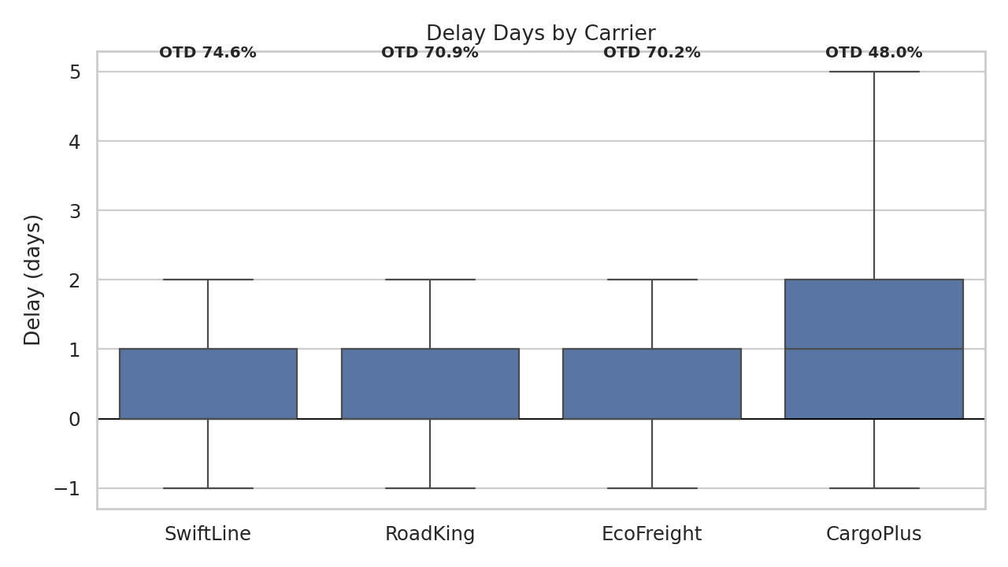
Figure 2. Delay days by carrier, ordered by mean delay, with on-time percentage labelled.
Why a box plot: it compares the full distribution (median, quartiles, range) of a continuous measure across a small number of categories, and ordering by mean delay makes the ranking immediate. Annotating OTD adds the business-relevant percentage.
Interpretation: CargoPlus has an upper quartile of 2 days late against 1 day for the other three, and 48.0% OTD (681 of 1,420; 95% CI 45.4–50.6%) against 74.6% for SwiftLine, 70.9% for RoadKing and 70.2% for EcoFreight. The three better carriers have overlapping confidence intervals (67.4–76.5%), so CargoPlus is the clear outlier, not a gradual ranking. CargoPlus carries 24.3% of shipments and 27.1% of spend (₹6,337,654).

6.3 Seasonality: volume versus on-time performance
m = clean.groupby("month").agg(n=("shipment_id", "count"), otd=("on_time", "mean"))
fig, ax1 = plt.subplots(figsize=(10, 4.5))
ax1.bar(m.index, m.n, color="#8ecae6") # volume (left axis)
ax2 = ax1.twinx()
ax2.plot(m.index, m.otd * 100, color="#d00000", marker="o") # OTD % (right axis)
ax2.set_ylim(40, 80)

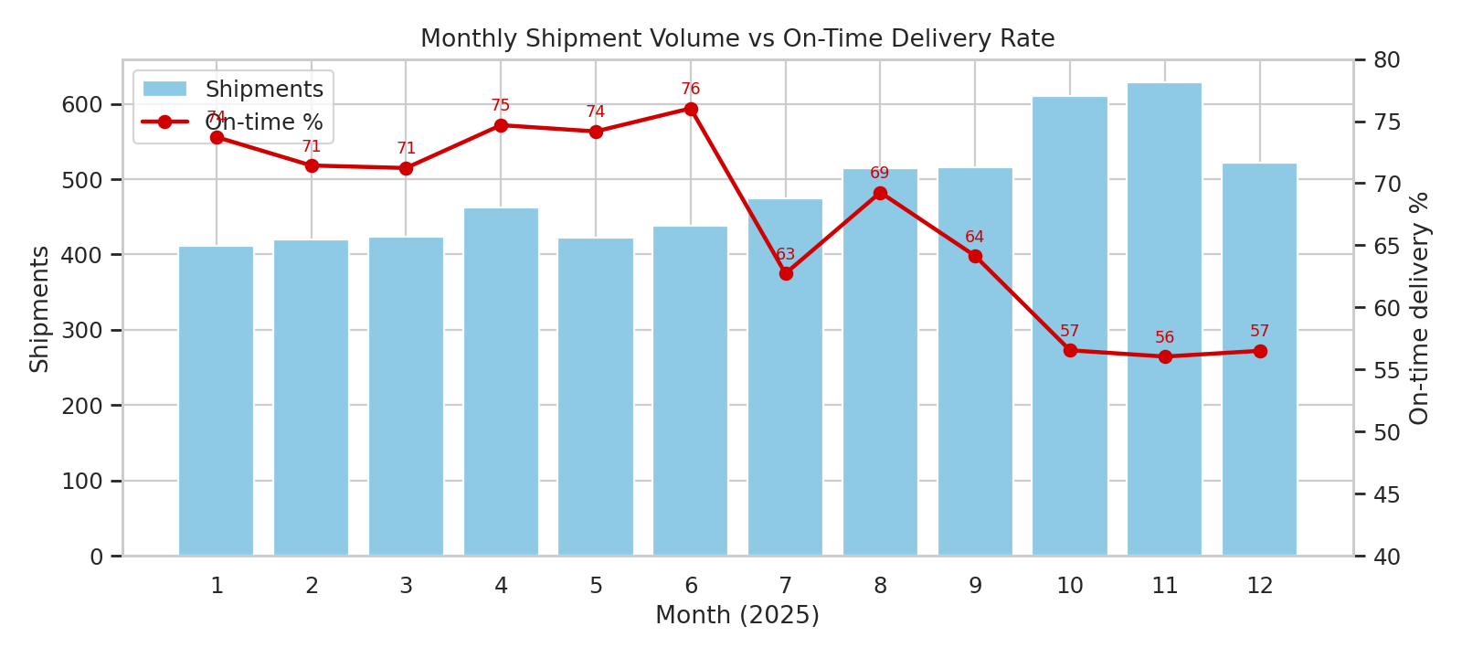
Figure 3. Monthly shipment volume (bars) and on-time delivery rate (line), 2025.
Why a bar-line combination: volume and a rate share the same time axis but have different units. A dual-axis chart lets the reader see directly whether service quality moves with load. (The OTD axis is truncated to 40–80% and labelled with values so the dips are not exaggerated.)
Interpretation: From January to June OTD stays in a 71.2–76.0% band. It falls to 62.7% in July as monsoon-season shipping starts, partly recovers to 69.3% in August, then sinks to 64.1% in September and to 56.6%, 56.1% and 56.5% in October to December. Volume rises 53% from 411 (Jan) to 628 (Nov). December volume drops to 522 yet OTD does not recover, which suggests carried-over backlog rather than instantaneous load alone (a hypothesis to confirm with real depot dwell-time data).

6.4 Correlation structure
corr = clean[num_cols].corr(method="pearson")
mask = np.triu(np.ones_like(corr, dtype=bool), k=1) # hide duplicate upper triangle
sns.heatmap(corr, annot=True, fmt=".2f", cmap="RdBu_r", center=0,
vmin=-1, vmax=1, mask=mask)

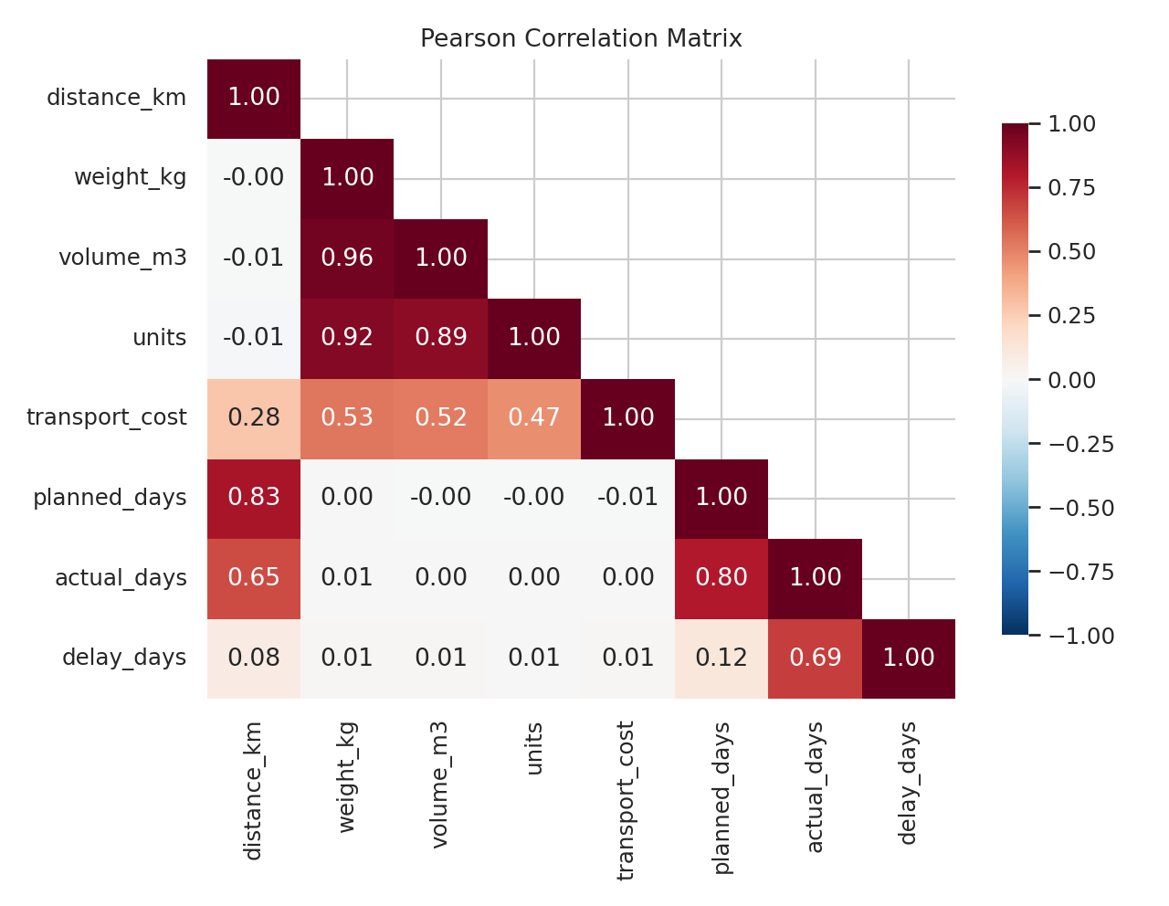
Figure 4. Pearson correlation matrix of the numeric variables.
Why a heatmap: with eight variables there are 28 pairs. A colour-coded matrix with a diverging scale centred on zero lets the reader find strong positive and negative relationships at a glance, and annotation gives exact values.
Interpretation: Three blocks are visible. (1) A size block: weight, volume and units correlate at 0.89–0.96, so they are interchangeable and should not be entered together in a regression. (2) A cost block: cost correlates 0.53 with weight, 0.52 with volume and 0.28 with distance. (3) A time block: planned days track distance (0.83) and actual days track planned days (0.80), but delay is nearly uncorrelated with every physical variable (|r| ≤ 0.12). The weak Pearson link between cost and distance (0.28) versus Spearman 0.62 is explained in the next chart.

6.5 Cost versus distance by mode
samp = clean.sample(2000, random_state=3) # sample to limit over-plotting
sns.scatterplot(data=samp, x="distance_km", y="transport_cost", hue="mode",
size="weight_kg", sizes=(8, 140), alpha=0.5)
ax.set_yscale("log") # cost spans ₹900 - ₹155,000
# Road-only linear fit: cost ~ chargeable tonne-km
road["tkm"] = np.maximum(road.weight_kg, 250) / 1000 * road.distance_km
fit = stats.linregress(road.tkm, road.transport_cost)

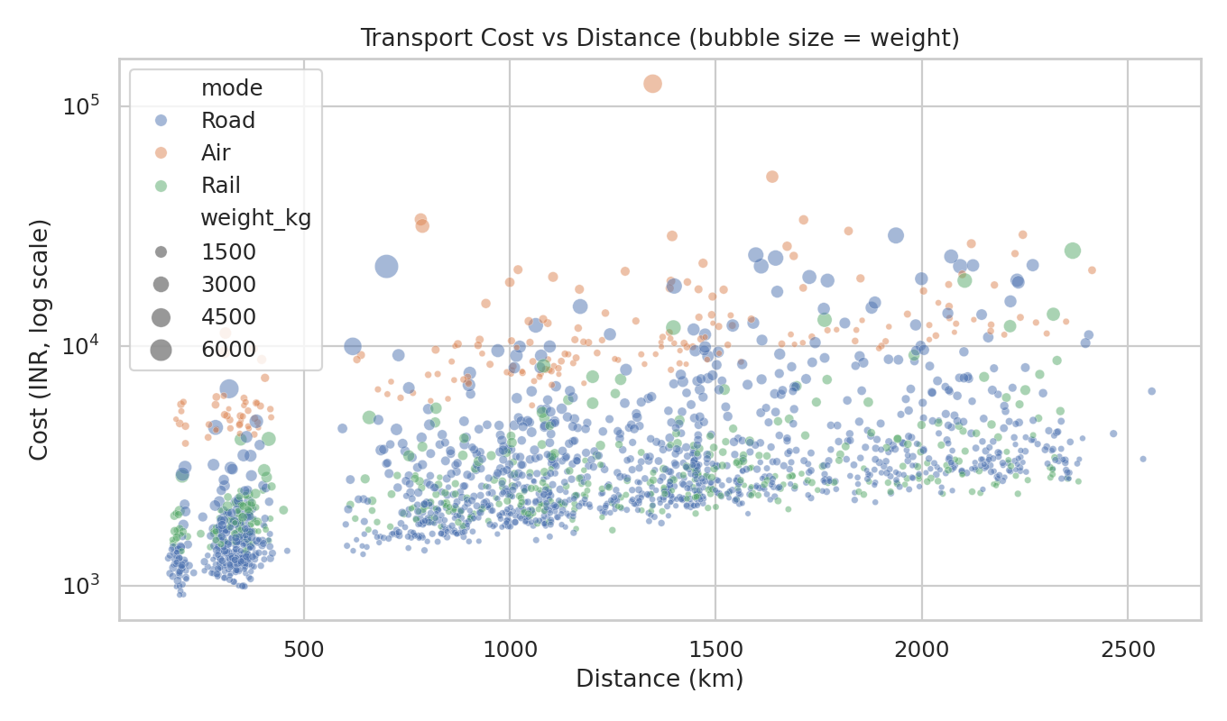
Figure 5. Transport cost versus distance, coloured by mode, bubble size = shipment weight (log y-axis).
Why a scatter plot on a log axis: the question is about a relationship between two continuous variables, and a scatter plot shows both the trend and the clusters. Costs span more than two orders of magnitude (₹916 to ₹155,691), so a log axis keeps cheap road shipments and expensive air shipments readable together. Colour separates the modes and bubble size shows weight.
Interpretation: Air forms a separate, higher band, and the lower-left corner shows a cost floor near ₹900–1,000 even for short, light trips because of fixed handling fees. Pooling the modes hides the distance effect, which is why the pooled Pearson r was low. Within Road alone (n = 3,923) cost is almost perfectly explained by chargeable tonne-km: cost ≈ ₹826.6 + ₹4.585 × tonne-km, R² = 0.9682. That is a fixed fee of about ₹827 per shipment plus ₹4.59 per tonne-km.
Worked example: reading the road cost formula (shipment SH100797)
Mumbai → North, SwiftLine, Road. Weight 97.5 kg, distance 1,399 km, billed ₹2,396.
Chargeable weight = max(97.5, 250) = 250 kg = 0.25 t, so tonne-km = 0.25 × 1,399 = 349.75.
Cost per tonne-km = 2,396 ÷ 349.75 = ₹6.85 (road median ₹6.91). Cost per kg = 2,396 ÷ 97.5 = ₹24.57, 2.6× the road median of ₹9.52/kg because the shipment is billed as 250 kg.
Model estimate = 826.6 + 4.585 × 349.75 = ₹2,430; actual is 1.4% lower, within the ±7% price noise.

6.6 Cost per kg by weight band and mode
clean["weight_band"] = pd.cut(clean.weight_kg, [0, 150, 400, 1000, 3000, 10000],
labels=["<150", "150-400", "400-1000", "1000-3000", ">3000"])
pv = clean.pivot_table(index="weight_band", columns="mode",
values="cost_per_kg", aggfunc="median", observed=True)
pv.plot(kind="bar", rot=0)

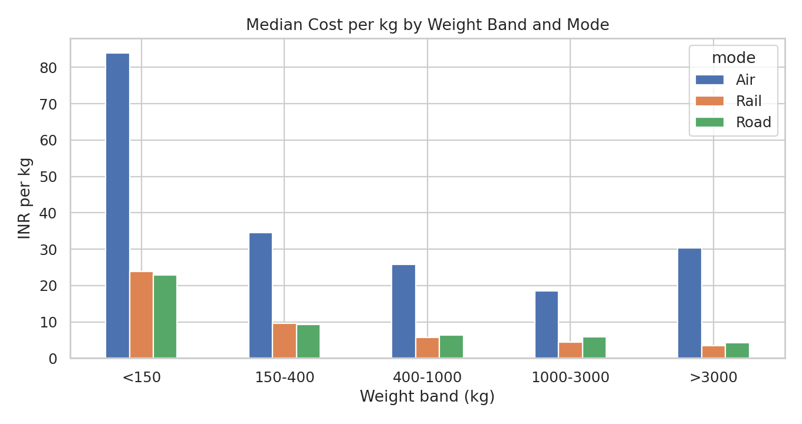
Figure 6. Median cost per kg by weight band and transport mode.
Why a grouped bar chart: the aim is to compare a summary value (median) across two categorical dimensions. Weight is binned because the question is practical (which consignment sizes are efficient?), and medians are used because cost per kg is skewed.
Interpretation: There is a strong economy of scale. On Road, cost per kg falls from ₹22.88 for loads under 150 kg to ₹9.24 (150–400 kg), ₹6.31 (400–1,000 kg), ₹5.97 (1,000–3,000 kg) and ₹4.26 above 3,000 kg, a 5.4× difference between the smallest and largest bands. Rail follows the same curve (₹23.86 to ₹3.46). Air is dearer in every band (₹83.88/kg under 150 kg); its rise in the top band reflects very few air shipments above 3,000 kg, so that bar should be read with caution.

6.7 Bottleneck detection: hub × region delay heatmap
hm = clean.pivot_table(index="origin_hub", columns="dest_region",
values="delay_days", aggfunc="mean")
sns.heatmap(hm, annot=True, fmt=".2f", cmap="YlOrRd",
cbar_kws={"label": "Mean delay (days)"})

lane = clean.groupby("lane").agg(n=("shipment_id", "count"),
otd=("on_time", "mean"), delay=("delay_days", "mean"))
lane = lane[lane.n >= 30].sort_values("delay", ascending=False) # min sample rule

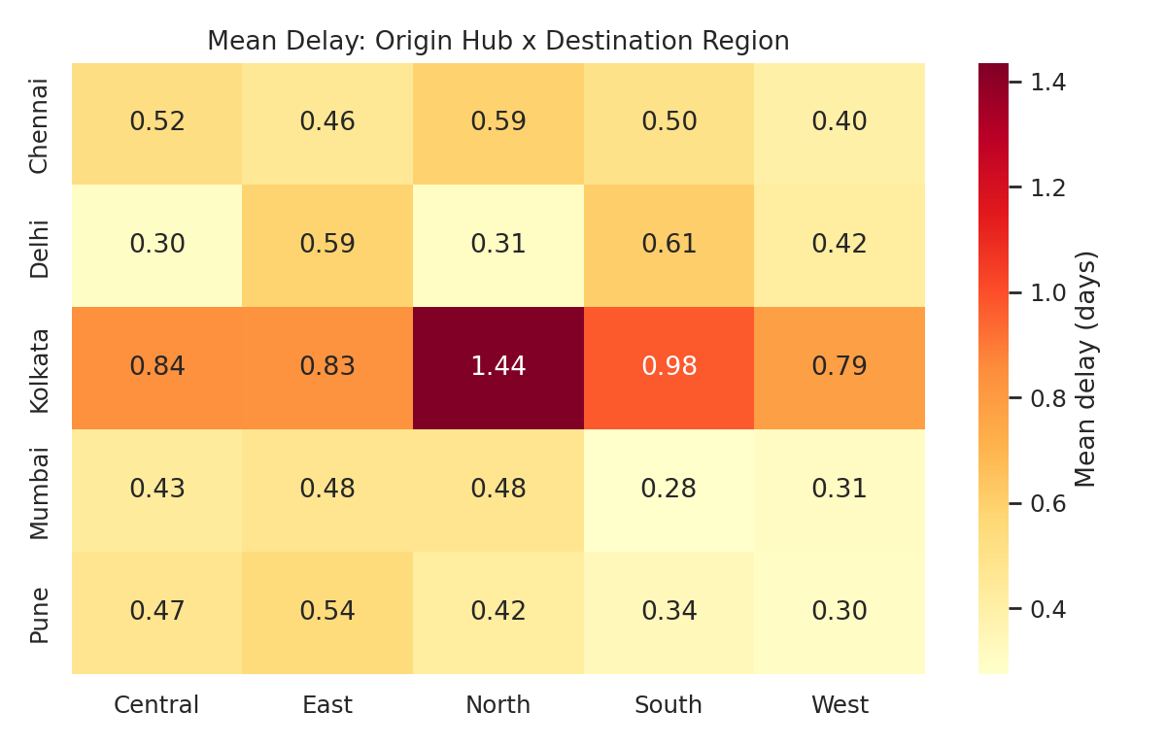
Figure 7. Mean delay (days) by origin hub and destination region.
Why a two-way heatmap: bottlenecks are usually specific to a place or a lane, not spread evenly. A matrix of origin by destination shows, in one picture, whether the problem sits in a row (an origin hub), a column (a destination) or a single cell (a lane). Lanes with fewer than 30 shipments are excluded so that no cell rests on a tiny sample.
Interpretation: The entire Kolkata row is hot (0.79–1.44 days) while every other hub's cells stay at or below 0.61. The pattern is a row effect (origin hub congestion) with one extra hotspot: Kolkata → North at 1.44 days mean delay and 40.0% OTD (n = 200), against 67.2% for the rest of the network. The next worst lanes are Kolkata → South (0.98 d; 49.1% OTD, n = 163) and Kolkata → Central (0.84 d; 57.2%, n = 145). The best lane is Mumbai → South (0.28 d; 73.1% OTD, n = 320). No destination column is consistently hot, so destinations are not the constraint.

6.8 Carrier price comparison
cm = clean.groupby(["carrier", "mode"]).cost_per_tkm.median().unstack()
cm.plot(kind="bar", rot=0)
ax.set(ylabel="INR / tonne-km")

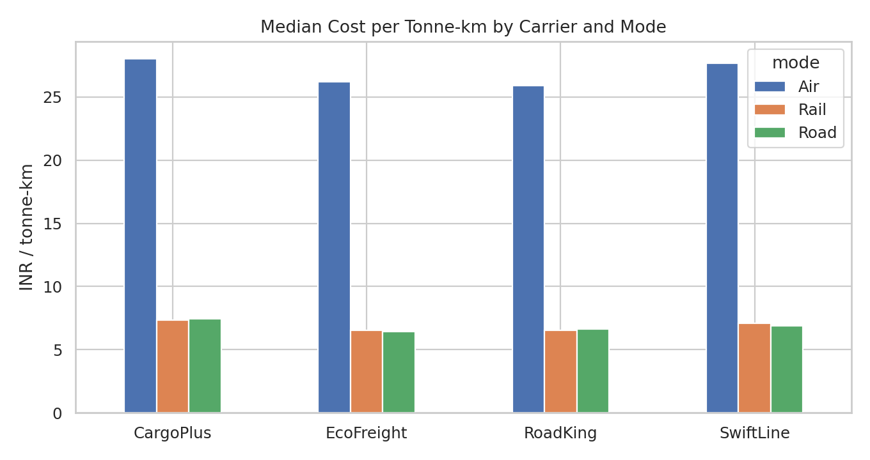
Figure 8. Median cost per tonne-km by carrier and mode.
Why this chart: comparing carriers on raw cost per shipment is misleading when their mode and weight mixes differ. Normalising to cost per tonne-km within each mode gives a like-for-like price comparison.
Interpretation: CargoPlus is the most expensive carrier in all three modes: Road ₹7.46 versus ₹6.44–6.88 for the others (up to 15.8% above EcoFreight), Rail ₹7.34 versus ₹6.51–7.10, and Air ₹28.01 versus ₹25.90–27.69. Combined with its 48.0% OTD, CargoPlus is both the costliest and the least reliable carrier, which makes it the strongest candidate for volume reallocation. EcoFreight and RoadKing are the cheapest in every mode while delivering 70% OTD.

6.9 How the visualizations support interpretation of logistics metrics
Figure | Metric interpreted | What it reveals | Decision it supports
1. Histograms | Delivery days, delay, OTD | Skew and long tail; 66.3% on time | Set service promises on percentiles, not averages
2. Box plot | Delay by carrier | CargoPlus 48.0% OTD vs 70–75% | Carrier scorecards and allocation
3. Bar + line | Volume vs OTD by month | Q4 OTD ≈ 56% as volume rises 53% | Peak-season capacity planning
4. Heatmap | Correlation matrix | Delay unrelated to size or distance | Focus on operations, not shipment profile
5. Scatter (log) | Cost vs distance | Road: ₹827 + ₹4.59/tonne-km, R² 0.968 | Quote and budget cost model
6. Grouped bars | Cost per kg by weight band | 5.4× cost penalty for <150 kg vs >3,000 kg | Consolidation and minimum-charge policy
7. Heatmap | Mean delay by lane | Kolkata hub and Kolkata → North lane | Targeted hub and lane intervention
8. Grouped bars | Cost per tonne-km by carrier | CargoPlus 10–16% above peers in Road | Rate renegotiation and reallocation

7. Analytical Insights

7.1 Operational efficiency
- Service level is below a typical 85–90% OTD benchmark at 66.3% overall, and the shortfall is concentrated rather than uniform: SwiftLine at 74.6% is the best case, Q4 at 56.4% and Kolkata at 50.7% are the weak points.
- Rail is less reliable than road (59.5% vs 67.6% OTD; mean delay 0.69 vs 0.48 days) at an almost identical cost per tonne-km (₹6.90 vs ₹6.91). Rail's cost advantage exists only for heavy loads (₹3.46/kg above 3,000 kg vs ₹4.26 for road).
- Express works but only partly: Express OTD is 72.0% versus 65.1% for Standard, a 6.9-point gain for a 25% price premium.

7.2 Cost drivers
- Mode is the largest driver. Air costs 3.9× road per tonne-km (₹26.92 vs ₹6.91) and absorbs 29.1% of spend (₹6.82 M) for 9.7% of shipments.
- Chargeable weight and fixed fees come second. Because small loads are billed at a 250 kg minimum plus a fixed fee, cost per kg falls 5.4× between the lightest and heaviest road bands.
- Carrier is third: CargoPlus charges 8–16% above the cheapest carriers for the same mode.

7.3 Bottlenecks
- Hub: Kolkata has mean delay 0.99 days and 50.7% OTD against 0.39–0.49 days and 67.6–70.2% elsewhere.
- Lane: Kolkata → North is the single worst corridor at 40.0% OTD.
- Season: October to December carries 30.1% of shipments (1,760) at 56.4% OTD.
- Carrier: CargoPlus carries 24.3% of shipments at 48.0% OTD.

8. Recommendations with Worked Calculations
Each recommendation is tied to a finding, quantified with arithmetic on the data, and tested for sensitivity. All figures are first-order estimates that assume other factors stay constant; Section 9 lists the assumptions.

8.1 Rebalance volume away from CargoPlus
Worked calculation
CargoPlus: 1,420 shipments, 681 on time = 48.0%. Other carriers combined: 72.2% on time.
Move half of CargoPlus volume (710 shipments) to the other carriers. Expected extra on-time shipments = 710 × (0.722 − 0.480) = 172.
Network OTD = (3,873 + 172) ÷ 5,842 = 69.24%, a gain of +2.94 points.
Cost side: CargoPlus median ₹7.79/tonne-km vs about ₹7.00 average for the other three. On ₹3.17 M of shifted spend this is about ₹0.3 M (≈1.3% of total) lower, an indicative value because it is median-based.

Feasibility: the other three carriers already handle 76% of volume at similar or lower rates, so no new supplier is needed. Risk: capacity at SwiftLine, RoadKing and EcoFreight must be confirmed; a staged 25% / 50% shift with weekly OTD tracking limits exposure.

8.2 Move short-haul, non-urgent air freight to road or rail
Worked calculation
Filter: Air, Standard priority, distance ≤ 1,500 km = 331 shipments, spend ₹3,063,748.
Road median cost per tonne-km ÷ Air median = 6.91 ÷ 26.92 = 0.257. Estimated saving = ₹3,063,748 × (1 − 0.257) = ₹2,277,629 (9.73% of total spend).
Sensitivity (road cost as a share of air cost): at 0.40 → ₹1,838,249 (7.85%); at 0.50 → ₹1,531,874 (6.54%).
Trade-off: transit rises by an average of 1.07 days on these lanes, and road OTD (67.6%) is about 6 points below air (73.8%).

Feasibility: because only Standard priority and lanes up to 1,500 km are included, extra transit (about one day) stays inside normal tolerance. Even the pessimistic case (road at 50% of air cost) still saves ₹1.53 M. Risk: customers with contractual air SLAs must be excluded after a customer-by-customer check.

8.3 Build a Q4 peak-season plan
Worked calculation
Q4 OTD 56.4% vs 70.6% in other months: a gap of 14.2 points on 1,760 shipments.
Recovering half of the gap (7.1 points) = 1,760 × 0.071 = 125 extra on-time shipments, or +2.14 points on the annual figure.

Actions: pre-book carrier capacity in August–September using the 2025 monthly profile (Oct–Nov volumes ≈ 1.5× January), add buffer days to Q4 promise dates, and set a weekly OTD trigger (below 62%) for escalation. Since December volume is lower than November while OTD stays flat, track backlog clearance as well as incoming volume.

8.4 Fix the Kolkata hub and the Kolkata → North lane
Worked calculation
Kolkata: 848 shipments at 50.7% OTD. If it reached the network average of 66.3%: 848 × (0.663 − 0.507) = 132 extra on-time shipments, or +2.26 points overall.
Kolkata → North alone: 200 shipments at 40.0% OTD and 1.44 days mean delay. Bringing this lane up to the network average adds about 200 × 0.263 = 53 on-time shipments.

Actions: run a dwell-time and dock-capacity audit at Kolkata, trial a second linehaul departure for the North lane, and evaluate cross-docking via Delhi. Because the delay at Kolkata is hub-wide, the root cause is more likely cut-off times or dock capacity than any destination issue.

8.5 Consolidate light shipments and enforce minimum-load rules
Worked calculation
Road and rail shipments under 150 kg: 1,380 (23.6% of shipments), spend ₹3,072,465 (13.1% of total), median ₹23.17/kg.
Comparison band 150–400 kg: median ₹9.4/kg. Total weight of the light group = 131,724 kg.
If half of this weight were consolidated to the 150–400 kg rate: 131,724 kg × (23.17 − 9.40) × 0.5 = ₹907,461 (3.87% of total spend).
Check on the road formula: a 1,000 kg load over 1,500 km costs 826.6 + 4.585 × 1,500 = ₹7,704, or ₹7.70/kg, versus ₹23 per kg for a typical small load.

Feasibility: consolidation needs scheduling discipline (for example fixed collection days per region) and customer agreement; a 50% realisation assumption is deliberately conservative.

8.6 Combined impact and implementation plan
# | Action | OTD gain (pts) | Cost saving (₹) | Effort | Timing
1 | Rebalance CargoPlus | +2.94 | ≈ 0.3 M | Medium | 0–60 days
2 | Air → road/rail (short, standard) | −0.4 (est.) | 1.53 – 2.28 M | Low | 0–30 days
3 | Q4 peak plan | +2.14 | n/a | Medium | Before Aug
4 | Kolkata hub fix | +2.26 | n/a | High | 30–120 days
5 | Light-shipment consolidation | 0 | ≈ 0.9 M | Medium | 30–90 days
 | Total (simple sum) | +7.0 net (upper bound) | ≈ 2.7 – 3.5 M (11.7 – 14.9%)

The OTD gains overlap (Q4 shipments and Kolkata shipments include CargoPlus loads), so they are not fully additive. The gross gains sum to +7.3 points (2.94 + 2.14 + 2.26); converting short-haul air to road costs about 0.4 points (331 shipments × 6.2-point OTD gap ÷ 5,842), leaving +7.0 net. Applying a 30% overlap haircut gives about +4.9 points. The expected network OTD is therefore roughly 71–73% (71.2% with the haircut, 73.3% without), up from 66.3%. The cost saving combines Actions 1, 2 and 5 only (0.3 + 1.53 to 2.28 + 0.91 = ₹2.7–3.5 M, or 11.7–14.9% of ₹23.42 M) and is stated before implementation costs.
KPIs to track: weekly OTD by carrier, hub and lane; cost per tonne-km by mode; share of Air spend; share of shipments under 150 kg; Q4 weekly OTD against the 62% trigger.

9. Limitations and Validity
- Simulated data. Effects were planted by design; the ability to recover them shows the method works, not that real networks behave identically. The workflow should be re-run on actual shipment records.
- Correlation is not causation. The simulation has known causes; in real data, the carrier effect could be confounded with lane or customer mix, and a regression with controls or a pilot should be used before contract changes.
- Scenario estimates are first-order. They assume the same shipment mix and ample capacity at alternatives. The ranges (for example ₹1.53–2.28 M for air conversion) show how sensitive the numbers are.
- Integer-day delay and a coarse distance matrix limit precision; real GPS or event-time data would allow delay to be measured in hours.
- Cost excludes warehousing, claims, fuel surcharges and customer-penalty costs, which would raise the value of OTD improvements.

10. Conclusion
The analysis shows that delivery performance in this network is driven by four identifiable operational factors (one carrier, one hub, one season and one lane) rather than by shipment size or distance, while cost is driven by mode, chargeable weight and carrier price. Eight visualizations, each matched to a specific analytical question, exposed these patterns, and the statistical tests confirmed them (p < 0.001 in every case). Acting on the five recommendations could lift on-time delivery from 66.3% to about 71–73% while cutting transport spend by an estimated ₹2.7–3.5 million, subject to validation on real data and a staged pilot.

Appendix A. Pseudocode of the Full Pipeline
Pseudocode
1. SET seed = 42; N = 6000
2. SIMULATE categorical fields (hub, region, carrier, mode, priority) by weighted sampling
3. SIMULATE ship_date with monthly weights (Q4 peak)
4. LOOKUP distance from hub x region matrix; add +/-6% noise
5. SIMULATE weight (log-normal), volume (weight / density), units
6. COMPUTE transport_cost = fixed[mode] + rate[mode] * distance * max(tonnes, 0.25)
* carrier_factor * (1.25 if Express) * noise
7. COMPUTE planned_days = ceil(distance / speed[mode] + 1)
8. SIMULATE delay_days = Gamma(mean = baseline + carrier + mode + season + hub + lane)
9. INJECT faults: 150 NaN, 12 negative weights, 8 cost x40, 45 duplicates
10. VALIDATE: duplicates, missing, negatives, dates, consistency, outliers (log fence per mode)
11. CLEAN: drop duplicates -> fix sign -> drop missing -> drop outliers
12. RE-VALIDATE: all checks must equal zero; record row retention
13. DERIVE: on_time, cost_per_kg, cost_per_tkm, month, quarter, lane
14. EDA: describe, skew, CV, group summaries, Pearson/Spearman, Kruskal, Welch, chi-square
15. PLOT: 8 figures (hist, box, bar+line, heatmap, scatter, grouped bars, heatmap, grouped bars)
16. SCENARIOS: compute OTD and cost impact with sensitivity ranges
17. EXPORT: cleaned CSV, results JSON, figures

Appendix B. Files Delivered
File | Content
Logistics_Analysis_Report.docx | This report
logistics_analysis.py | Complete script: simulation, validation, EDA, figures, scenarios
logistics_clean.csv | Cleaned dataset, 5,842 rows plus derived columns

