WEEK 4 TASK
Predictive Modeling and Optimization in Logistics Systems
Forecasting delivery time and late-delivery risk, then using the forecasts to optimize carrier allocation and delivery promises
Item | Detail
Data | 5,842 cleaned shipments from the Week 3 simulated network (Jan–Dec 2025); 4 carriers, 5 hubs, 5 regions, 3 modes
Prediction targets | Actual delivery days (regression); late-delivery probability (classification); freight cost (regression); delivery-day quantiles
Optimization | Mixed-integer linear program (MILP) for carrier allocation; quantile-based delivery promises; risk-ranked watchlist
Tools | Python 3.12.3, scikit-learn 1.8.0, SciPy 1.17.1 (milp), pandas 3.0.2, NumPy 2.4.4, seaborn 0.13.2, Matplotlib 3.10.8
Reproducibility | Seed 42; one script (w4_model.py) regenerates every number and figure; output carrier_recommendations.csv lists the recommended carrier for every shipment

1. Executive Summary
This report builds predictive models on the Week 3 logistics dataset and converts their predictions into operational decisions. The central question is: can we forecast how long a shipment will take and whether it will be late, and does that forecast let us run the network better? The answer is yes, with honest limits.
Prediction results (hold-out test set, 1,169 shipments)
- Delivery-time regression: a tuned gradient-boosting model reaches RMSE 1.18 days and R² 0.65 (95% bootstrap CI 0.607–0.699), against RMSE 1.39 and R² 0.52 for simply trusting the planned days. That is a 15.1% error reduction.
- Honest caveat on MAE: the naive plan has a lower mean absolute error (0.75 vs 0.79 days), because the median delay is zero. The models add value in the tail, in carrier-specific adjustments and in probabilities, not in the typical case (Section 5.5).
- Late-risk classifier: AUC 0.7275, Brier score 0.1936 against 0.2234 for a base-rate guess. The riskiest 10% of shipments are late 61.2% of the time (lift 1.82×).
- Cost model: R² 0.9423 on log-cost, used to price what each shipment would cost with any carrier.
Optimization results (all 5,842 shipments, out-of-fold predictions)
- Carrier allocation (MILP): under realistic capacity limits (no carrier above 30% of volume, CargoPlus cut from 24.3% to 10%), expected on-time delivery rises from 66.3% to 69.8% and freight falls by ₹0.91 M (4.1%). Net value after ₹80 per re-booked shipment is ₹0.87 M. A stretch plan (caps 38%) reaches 70.2% on-time and ₹1.08 M.
- Delivery promises: model-based promise dates keep reliability more uniform across segments. For example, the worst segment keeps 87.6% of promises with the P80 policy versus 84.3% with a flat +2-day buffer, at a shorter average promise (5.19 vs 5.56 days).
- Risk watchlist: reviewing the top 20% riskiest shipments covers 34% of all late deliveries.
Every optimization figure is a model-based estimate that rests on stated assumptions (late penalty ₹600, re-booking cost ₹80, no hidden confounding); Section 9 lists them, and Section 7 gives sensitivity ranges so no single number is taken on trust.

2. Problem Definition

2.1 Business context
The Week 3 analysis found that only 66.3% of shipments arrive on time and that delay is driven by operational factors (carrier, hub, season), not by shipment size or distance. Descriptive analysis tells us what happened. Planners now need to know what will happen to the next shipment and what to do about it before it ships. That makes this a predict-then-optimize problem.

2.2 Prediction tasks
# | Task | Target | Type | Used for
A | Forecast delivery time | actual_days | Regression | Customer ETAs, capacity planning
B | Forecast late-delivery risk | late = 1 if delay_days > 0 | Binary classification | Carrier allocation, watchlist
C | Forecast freight cost | log(transport_cost) | Regression | Pricing each carrier option
D | Forecast delivery-day quantiles | P70 / P80 / P90 / P95 of actual_days | Quantile regression | Delivery-date promises

Task A is the headline forecasting problem. Tasks B–D exist because each optimization needs a specific quantity: the allocation model needs P(late) and cost per carrier, and the promise policy needs upper quantiles rather than averages.

2.3 Success criteria defined in advance
Criterion | Threshold | Achieved | Met?
Task A: RMSE improvement over naive plan | ≥ 10% | 15.1% (1.394 → 1.184 days) | Yes
Task A: hold-out R² | ≥ 0.60 | 0.654 | Yes
Task B: AUC | ≥ 0.70 | 0.7275 | Yes
Task C: R² on log-cost | ≥ 0.90 | 0.9423 | Yes
Optimization: expected OTD gain | ≥ +3 points | +3.5 (conservative plan) | Yes
Optimization: freight saving | ≥ 3% | 4.1% (conservative plan) | Yes

3. Dataset, Features and Data Preparation

3.1 Dataset
The dataset is the cleaned Week 3 file (logistics_clean.csv): 5,842 shipments after removing duplicates, missing values and keying errors. The primary target, actual delivery days, has mean 4.063 and standard deviation 2.075 days, and 33.7% of shipments were late. The data is simulated, as in Week 3, with delay effects planted for carrier, season, hub and lane. This is useful for validation because the model should rediscover them (Section 5.6).

3.2 Features
Feature | Type | Why it is available at booking time
origin_hub, dest_region | Categorical | Known when the shipment is created
carrier, mode, priority | Categorical | Chosen at booking
distance_km, weight_kg, volume_m3, units | Numeric | Known from the order
planned_days | Numeric | Computed from distance, mode and priority at booking
month, peak_season (Oct–Dec), monsoon (Jul–Sep) | Numeric / flag | Derived from the ship date

Leakage control. delay_days, actual_days, on_time and late are outcomes and are never used as features. transport_cost is also excluded from the delivery models, because it is a consequence of the same booking decisions and adds nothing a planner could not already see from mode, distance and weight.

3.3 Preparation and train/test split
An 80/20 random split gives 4,673 training and 1,169 test shipments. All preprocessing sits inside a scikit-learn Pipeline, so scaling and one-hot encoding are learned from training folds only and cannot leak into validation folds.
Code excerpt 1: features, target and preprocessing
df["peak_season"] = df.month.isin([10, 11, 12]).astype(int)
df["monsoon"] = df.month.isin([7, 8, 9]).astype(int)
CAT = ["origin_hub", "dest_region", "carrier", "mode", "priority"]
NUM = ["distance_km", "weight_kg", "volume_m3", "units", "planned_days",
"month", "peak_season", "monsoon"]
TARGET = "actual_days" # outcomes (delay_days, on_time, late) are never features

X_tr, X_te, y_tr, y_te = train_test_split(df[CAT + NUM], df[TARGET],
test_size=0.20, random_state=42)
def prep(scale=False):
num = StandardScaler() if scale else "passthrough"
return ColumnTransformer([("cat", OneHotEncoder(handle_unknown="ignore"), CAT),
("num", num, NUM)])

4. Model Selection and Rationale
Five model families were compared against two baselines. The aim was a ladder from simple and interpretable to flexible, so that any gain from complexity can be measured rather than assumed.
Model | Why it was chosen | Main risk
Mean predictor | Floor: R² = 0 by construction | None; a sanity check
Planned days (naive) | What a planner does today: promise = plan | Ignores carrier, season and hub
Linear / Ridge regression | Transparent coefficients; strong when effects are additive | Cannot capture interactions
Decision tree (depth 6) | Readable rules; captures interactions | High variance; unstable
Random forest | Averages many trees; robust to noise | Less interpretable; slower
Gradient boosting (histogram) | Best-in-class on tabular data; handles categories and interactions; supports quantile and classification losses | Overfits small data without tuning

Deep neural networks were not considered: with fewer than 6,000 rows and 13 tabular features they are unlikely to beat boosted trees and are harder to explain to operations teams. Time-series models (ARIMA, Prophet) were also set aside because the target is a per-shipment outcome, not an aggregate series; shipment-volume forecasting would need a longer history than 12 months.
Code excerpt 2: candidate models and the naive baseline
models = {
"Linear Regression": Pipeline([("p", prep(True)), ("m", LinearRegression())]),
"Ridge (alpha=10)": Pipeline([("p", prep(True)), ("m", Ridge(alpha=10))]),
"Decision Tree": Pipeline([("p", prep()), ("m", DecisionTreeRegressor(
max_depth=6, min_samples_leaf=20, random_state=42))]),
"Random Forest": Pipeline([("p", prep()), ("m", RandomForestRegressor(
n_estimators=150, min_samples_leaf=10, random_state=42))]),
"Gradient Boosting": Pipeline([("p", prep()), ("m", HistGradientBoostingRegressor(
random_state=42))]),
}
naive_pred = X_te["planned_days"] # baseline: promise = plan

5. Evaluation and Validation

5.1 Metrics and why each was chosen
Metric | Definition | Why it is used
RMSE | √(mean of squared errors), in days | Penalizes large misses; late-delivery tails are what hurt customers. Primary metric.
MAE | Mean of absolute errors, in days | Typical error size in plain units; robust to outliers.
R² | 1 − SSE/SST | Share of delivery-time variance explained; comparable across models.
Within ±1 day | Share of rounded predictions within one day | A business-friendly accuracy measure.
ROC AUC / PR AUC | Ranking quality of P(late) | Measures how well risky shipments are ranked, independent of threshold.
Brier score | Mean squared error of probabilities | Measures probability quality, which the optimizer relies on.
Coverage (quantile) | Share of actuals ≤ predicted quantile | Checks that a P90 promise is actually kept about 90% of the time.

5.2 Validation strategy
- 5-fold cross-validation (shuffled, seed 42) on the training set for every model, reporting mean and standard deviation, so differences smaller than the fold-to-fold spread are not over-interpreted.
- Hyper-parameter tuning by exhaustive grid search with the same 5 folds: 3 learning rates × 4 depths × 2 iteration counts × 2 leaf sizes = 48 candidates, 240 model fits.
- Untouched 20% hold-out test set, used once after all choices were made.
- Bootstrap confidence intervals (1,000 resamples) on test RMSE and R².
- Temporal robustness check: train on January–October and test on November–December, to see how the model behaves when the peak season is only partly in the training data.
- Out-of-fold predictions for the optimization steps, so each shipment is scored by a model that never saw it.

5.3 Cross-validation results
Model | CV RMSE (mean ± SD) | CV MAE | CV R²
Mean predictor | 2.090 ± 0.000 | 1.614 | 0.000
Planned days (naive) | 1.349 ± 0.000 | 0.707 | 0.583
Linear Regression | 1.173 ± 0.102 | 0.783 | 0.684
Ridge (alpha=10) | 1.173 ± 0.102 | 0.782 | 0.684
Decision Tree (depth 6) | 1.227 ± 0.099 | 0.800 | 0.654
Random Forest | 1.210 ± 0.107 | 0.808 | 0.664
Gradient Boosting (default) | 1.240 ± 0.104 | 0.828 | 0.647
Gradient Boosting (MAE loss) | 1.327 ± 0.130 | 0.751 | 0.595

Code excerpt 3: cross-validation
kf = KFold(5, shuffle=True, random_state=42)
cv = cross_validate(mdl, X_tr, y_tr, cv=kf,
scoring=("neg_root_mean_squared_error", "neg_mean_absolute_error", "r2"))
rmse_mean = -cv["test_neg_root_mean_squared_error"].mean()
rmse_sd = cv["test_neg_root_mean_squared_error"].std()

Reading the table. Linear and Ridge regression (CV RMSE 1.173) are the best untuned models, ahead of random forest (1.210), the decision tree (1.227) and default gradient boosting (1.240). All models beat the naive plan (RMSE 1.349) on RMSE and R², but the spread between the best five is smaller than one fold-to-fold standard deviation (about 0.10), so those differences are not statistically meaningful. The default boosting model is worse than linear regression because, with 4,673 rows and mostly additive effects, deeper trees fit noise.

5.4 Hyper-parameter tuning
Code excerpt 4: grid search
grid = {"m__learning_rate": [0.03, 0.06, 0.1],
"m__max_depth": [2, 3, 4, 6],
"m__max_iter": [150, 300],
"m__min_samples_leaf": [20, 50]} # 3 x 4 x 2 x 2 = 48 candidates
gs = GridSearchCV(gbr, grid, cv=kf, scoring="neg_root_mean_squared_error", refit=True)
gs.fit(X_tr, y_tr) # 48 x 5 = 240 model fits
best = gs.best_estimator_

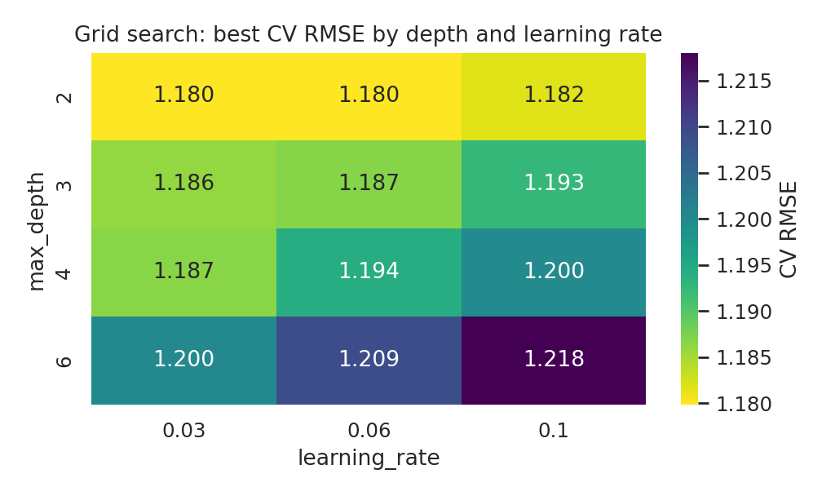
Figure 1. Grid search: best cross-validated RMSE by tree depth and learning rate.
The best configuration was learning_rate = 0.03, max_depth = 2, max_iter = 300, min_samples_leaf = 20, with a CV RMSE of 1.1798 (versus 1.240 for the default). Across all 48 candidates CV RMSE ranged from 1.1798 to 1.2637. The heat map shows a clear pattern: shallower trees and smaller learning rates are better, and error rises steadily as depth grows to 6. This is consistent with the simulation: delay is built from mostly additive effects, so deep interaction trees add variance and no signal. The tuned model's CV RMSE (1.180) is statistically indistinguishable from linear regression (1.173).

5.5 Hold-out test performance
Model | RMSE | MAE | R² | Within ±1 day
Planned days (naive) | 1.394 | 0.754 | 0.520 | 85.1%
Linear Regression | 1.192 | 0.799 | 0.649 | 87.7%
Ridge (alpha=10) | 1.192 | 0.799 | 0.649 | 87.3%
Decision Tree (depth 6) | 1.229 | 0.816 | 0.627 | 85.8%
Random Forest | 1.209 | 0.810 | 0.639 | 86.8%
Gradient Boosting (default) | 1.239 | 0.829 | 0.621 | 85.5%
Gradient Boosting (MAE loss) | 1.351 | 0.771 | 0.549 | 85.6%
Gradient Boosting (tuned) | 1.184 | 0.790 | 0.654 | 87.6%

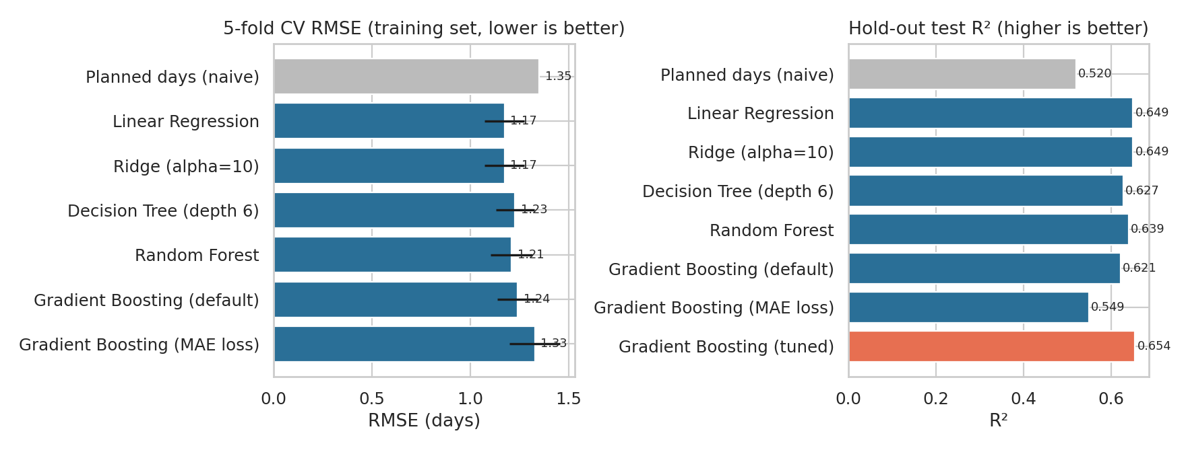
Figure 2. Left: 5-fold CV RMSE with ±1 SD bars. Right: hold-out test R² (tuned model highlighted).
Model choice. The tuned gradient-boosting model has the best hold-out RMSE (1.184) and R² (0.654), with 87.6% of predictions within one day. Its margin over linear regression (RMSE 1.192) is small and inside the noise, so linear regression is a sound, fully transparent fallback. Gradient boosting is selected as the production model because the same algorithm family also supplies the classification and quantile models used in Section 7, giving one consistent toolchain.
Uncertainty. The bootstrap 95% interval for test RMSE is 1.081–1.297 days and for R² is 0.607–0.699. The lower bound of R² (0.607) still clears the 0.60 success threshold.
Why the naive plan wins on MAE
On the test set the naive plan has MAE 0.754, lower than the tuned model's 0.790. A model trained to minimise squared error predicts the conditional mean, while MAE is minimised by the conditional median. Here delay is right-skewed with a median of 0 (Week 3), so the median delivery time equals the plan in most cases, and a mean-based model pulls predictions above it.
Training with absolute-error loss confirms this: that variant has the best MAE of any model in cross-validation (0.751 vs naive 0.707) but a much worse RMSE (1.327), and it still does not beat the plan on test MAE (0.771).
Conclusion: the model's value is not a better typical ETA. It lies in (1) cutting large misses (RMSE −15.1%), (2) flagging shipments likely to run late, and (3) pricing carrier choices. That is why the optimization in Section 7 uses probabilities and quantiles, not point ETAs.

5.6 Residuals, segment errors and what the model learned
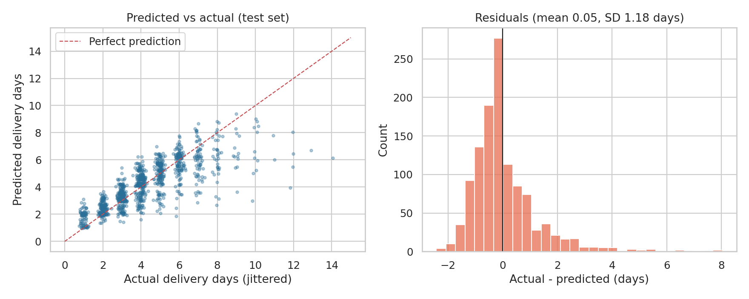
Figure 3. Left: predicted versus actual delivery days (test set, vertical jitter added). Right: residual distribution.
Residuals are centred (mean 0.0451) with a standard deviation of 1.1831 days and a right tail: the model under-predicts the few very late deliveries (up to 14 days), which no feature in the data can foresee. About 73.2% of unrounded predictions fall within ±1 day.
Segment | Test MAE (days) | Observation
Carrier: CargoPlus | 1.177 | Almost double the error of other carriers: its delays are more variable
Carrier: EcoFreight / RoadKing / SwiftLine | 0.627 / 0.659 / 0.656 | Predictable carriers
Mode: Air / Road / Rail | 0.588 / 0.790 / 0.877 | Rail is hardest to predict
Off-peak / Peak (Oct–Dec) | 0.702 / 0.991 | Error is 41% higher in peak season

Temporal check. Training on January–October (4,692 shipments) and testing on November–December (1,150) gives RMSE 1.4976, MAE 1.0055 and R² 0.5735, against a naive RMSE of 1.7577. The model still beats the plan by 14.8%, but R² falls from 0.65 to 0.57 because the peak season is only partly represented in training. Operational lesson: retrain after each peak season and monitor error by month.
Code excerpt 5: temporal validation and permutation importance
tr_t = df.month <= 10 # train Jan-Oct, test Nov-Dec
best_t.fit(df.loc[tr_t, FEATS], df.loc[tr_t, TARGET])
pt = best_t.predict(df.loc[~tr_t, FEATS])
pi = permutation_importance(best, X_te, y_te, n_repeats=15, random_state=42,
scoring="neg_root_mean_squared_error")

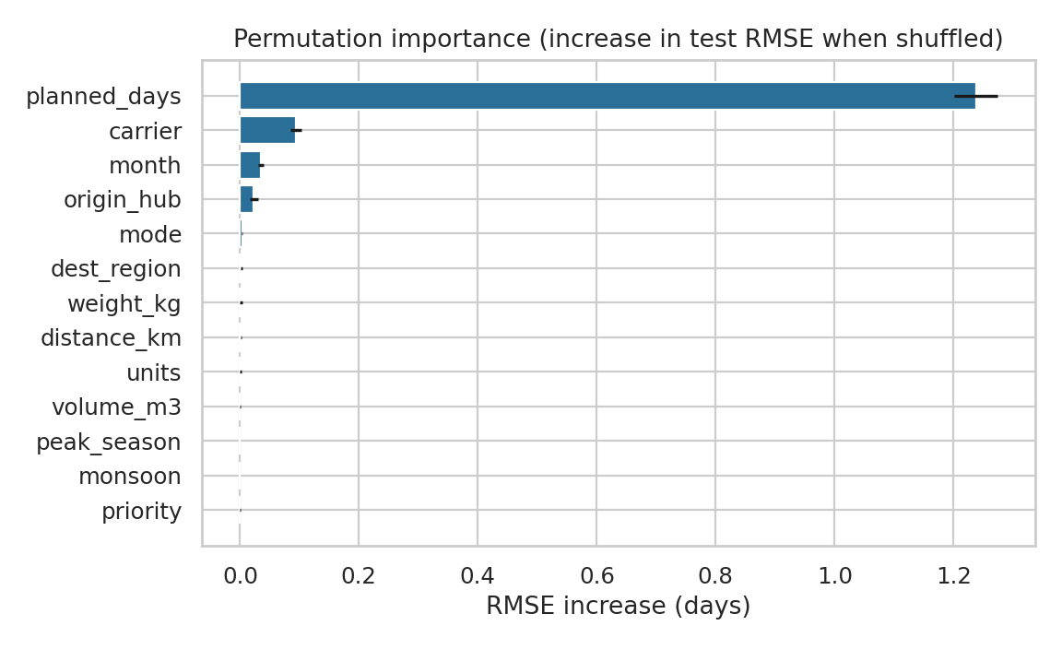
Figure 4. Permutation importance: increase in test RMSE when each feature is shuffled (mean ± SD over 15 repeats).
What drives the forecast. Shuffling planned_days raises RMSE by 1.24 days, far more than any other feature, so the plan is the backbone of the prediction. After that, carrier (+0.093), month (+0.035) and origin_hub (+0.023) are the only features with measurable value. Weight, volume, distance and units contribute essentially nothing (≤ 0.002). This recovers the planted effects: carrier, season and the congested Kolkata hub matter, and physical size does not, which matches the Week 3 correlations. Because month and origin_hub carry the peak-season and Kolkata effects, the separate peak and monsoon flags add nothing on top of them.
Worked example: one prediction from the test set
Shipment SH103212: Kolkata → North, CargoPlus, Road, Standard, 1,506 km, 110.3 kg, shipped in October.
Planned time: 4 days. Model forecast: 6.1 days (about +2 days of expected delay from the CargoPlus, Kolkata and peak-season effects together). Predicted late-risk: 68%.
Actual outcome: 9 days. The model was closer than the plan (error 2.9 days vs 5.0 days), but this shipment still ran well beyond the forecast, which illustrates the unexplained tail.

6. Supporting Models: Late-Delivery Risk and Freight Cost

6.1 Late-delivery risk classifier
Optimization needs the probability that a shipment is late, not a point forecast, so a gradient-boosting classifier was trained on the same features with a stratified 80/20 split (target late = 1 when delay_days > 0; 33.7% positive).
Code excerpt 6: late-risk classifier
clf = Pipeline([("p", prep()), ("m", HistGradientBoostingClassifier(
learning_rate=0.05, max_depth=3, max_iter=200,
min_samples_leaf=40, random_state=42))])
clf.fit(Xc_tr, yc_tr) # stratified 80/20 split
pc = clf.predict_proba(Xc_te)[:, 1]
roc_auc_score(yc_te, pc); brier_score_loss(yc_te, pc)

Metric | Model | Reference | Reading
ROC AUC | 0.7275 | 0.500 (random) | Good ranking; clears the 0.70 target
PR AUC | 0.5442 | 0.337 (base rate) | 1.6× the base rate
Brier score | 0.1936 | 0.2234 (base-rate guess) | 13% lower: better probabilities
Accuracy at 0.5 | 69.7% | 66.3% (always 'on time') | Modest; accuracy is not the target metric
Calibration | max decile gap 0.073 | 0 = perfect | Predicted risk matches observed late rate

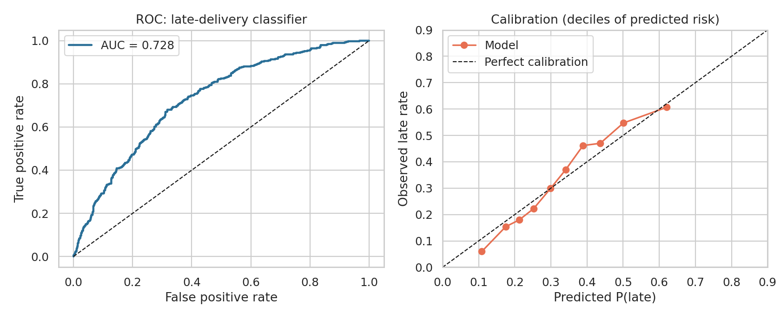
Figure 5. Left: ROC curve. Right: calibration by decile of predicted risk.
The calibration curve lies close to the diagonal (largest gap 0.073), which matters because the optimizer multiplies these probabilities by a penalty in rupees; a model that ranks well but is mis-calibrated would distort that arithmetic. As a calibration check on the optimization itself, the 1,141 shipments that Plan S3 moves away from CargoPlus were actually late 53.2% of the time, and the model predicted 52.6% for them: the prediction matched the observed outcome.

6.2 Freight-cost model
Cost was modelled as a linear regression of log(cost) on log chargeable tonne-km, mode, carrier and priority (the structure identified in Week 3). Out-of-fold R² on log-cost is 0.9423 and the mean absolute percentage error is 10.91%. The model under-predicts total spend by about 4.7% (₹22.32 M predicted versus ₹23.42 M actual) because exponentiating a log-scale prediction understates the mean. All optimization results are therefore reported as changes relative to the same model's baseline, which cancels that bias.

7. Optimization Strategies
Prediction becomes valuable only when it changes a decision. Three decisions are optimized, in decreasing order of financial impact.

7.1 Strategy A: Carrier allocation by mixed-integer programming
Decision: which carrier should handle each shipment, given each carrier's capacity? Idea: for every shipment, use the models to estimate what it would cost and how likely it would be to arrive late with each of the four carriers (a counterfactual obtained by switching the carrier feature, scored with out-of-fold models), then choose the allocation that minimizes total expected cost.
Formulation
minimize sum_i sum_j x_ij * ( c_ij + L * p_ij + s_ij )
subject to sum_j x_ij = 1 for every shipment i
lo_j * N <= sum_i x_ij <= hi_j * N for every carrier j
x_ij in {0, 1}

c_ij = predicted freight cost of shipment i with carrier j (cost model)
p_ij = predicted probability of lateness with carrier j (classifier)
L = penalty per late shipment (assumed INR 600)
s_ij = INR 80 re-booking cost if j differs from today's carrier, else 0

Code excerpt 7: counterfactual scoring and the MILP (SciPy HiGHS solver)
for j, c in enumerate(carriers): # out-of-fold counterfactuals
d_cf = df.iloc[te].copy(); d_cf["carrier"] = c
P_late[te, j] = c_m.predict_proba(d_cf[FEATS])[:, 1]
COST[te, j] = np.exp(k_m.predict(d_cf[["log_tkm", "mode", "carrier", "priority"]]))

obj = (COST + pen * P_late + switch).ravel()
# rows 0..nS-1: one carrier per shipment; rows nS..: carrier share bounds
res = milp(obj, constraints=LinearConstraint(A.tocsr(), lb, ub),
integrality=np.ones(nS * nC), bounds=Bounds(0, 1))
assign = res.x.reshape(nS, nC).round().astype(int).argmax(1)

The problem has 23,368 binary variables and 5,846 constraints, and HiGHS solves it to proven optimality (solver status 0) in seconds, so it is practical to re-run weekly.
Worked example: one shipment through the optimizer
Shipment SH102954: Delhi → East, 1,513 km, 458.2 kg, Road, Standard. Currently with CargoPlus.
CargoPlus: cost ₹4,003 + 600 × P(late) 0.55 = ₹331 + switching ₹0 → objective ₹4,333
EcoFreight: cost ₹3,449 + 600 × P(late) 0.40 = ₹240 + switching ₹80 → objective ₹3,769
RoadKing: cost ₹3,514 + 600 × P(late) 0.39 = ₹235 + switching ₹80 → objective ₹3,829
SwiftLine: cost ₹3,754 + 600 × P(late) 0.35 = ₹213 + switching ₹80 → objective ₹4,046
Left alone, EcoFreight has the lowest objective (₹3,769). Under the conservative plan EcoFreight is capped at 30% of network volume and is already full, so the solver assigns RoadKing (₹3,829), still ₹504 (11.6%) cheaper than staying with CargoPlus. This shows how the capacity constraints, not just the unit economics, shape the plan.

Scenarios
Scenario | Share % CP / Eco / RK / SL | Shipments re-booked | Expected OTD | Freight (model) | Net value*
Current allocation | 24.3 / 18.3 / 27.4 / 29.9 | 0 | 66.3% | ₹22.32 M | —
S4: Conservative, caps 30%, CP ≤ 12% | 10 / 30 / 30 / 30 | 1,989 | 69.8% | ₹21.41 M | ₹0.87 M
S3: Stretch, caps 38%, CP ≤ 12% | 5 / 38 / 38 / 19 | 2,110 | 70.2% | ₹21.21 M | ₹1.08 M
S1: Unconstrained mix, caps 40% | 0 / 40 / 40 / 20 | 2,426 | 71.2% | ₹21.14 M | ₹1.16 M
*Net value = freight saving + value of avoided late deliveries (₹600 each) − re-booking cost (₹80 per changed shipment). Every plan keeps each carrier at ≥ 5% of volume for redundancy. A scenario with CargoPlus ≤ 12% only (S2) gives the same result as S1, because the solver already drives CargoPlus to zero when it is free to.
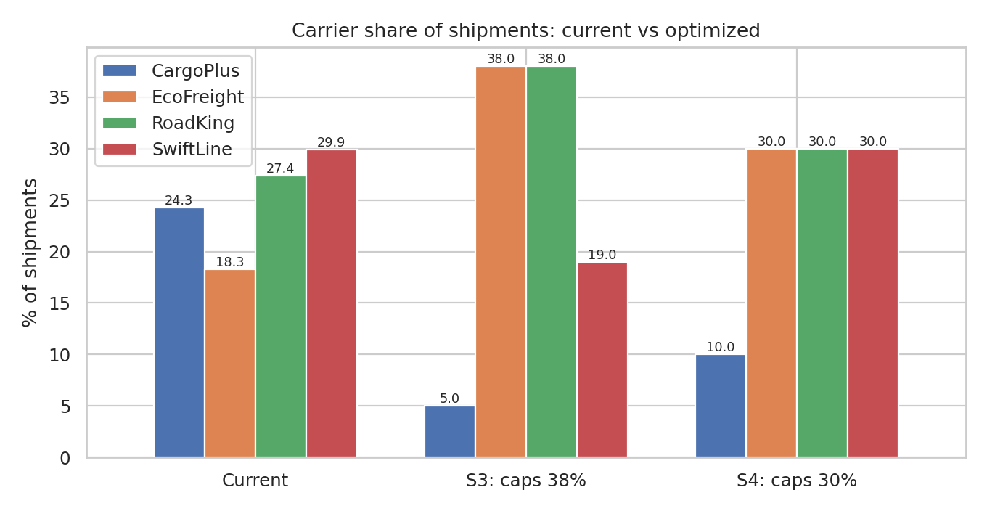
Figure 6. Carrier share of shipments: current allocation versus the stretch (S3) and conservative (S4) plans.
Reading the results. (1) CargoPlus is dominated: it is both costlier and less reliable, so it is cut to its 5% floor whenever the capacity caps allow (S3); in S4 the 30% caps on the other three carriers leave no choice but to give it 10%. Of the 1,420 shipments it handles today, S4 moves 961, whose actual late rate was 53.6% against a predicted 28.8% with their new carriers. (2) Cost drives the rest of the saving. EcoFreight and RoadKing are the cheapest carriers and are only about 4 points less reliable than SwiftLine, and at a ₹600 penalty a 4-point reliability gap is worth only ₹24 per shipment against a freight difference of about ₹250. That is why SwiftLine's share falls in S3. (3) Capacity is the binding resource. S4 needs EcoFreight to grow from 18.3% to 30% of volume (about +64%), while S3 needs it to more than double (to 38%), so S3 should be treated as a stretch target pending capacity confirmation.
S4 re-booking matrix (rows = current carrier, columns = recommended carrier; shipments):
From \ To | CargoPlus | EcoFreight | RoadKing | SwiftLine
CargoPlus | 459 | 384 | 361 | 216
EcoFreight | 54 | 845 | 0 | 172
RoadKing | 73 | 102 | 1,306 | 121
SwiftLine | 0 | 421 | 85 | 1,243

Sensitivity analysis
The recommendation depends on two assumed prices (the late penalty and the re-booking cost) and one operational limit (carrier capacity). Each was varied on its own, holding the stretch-plan constraints (S3) fixed except where stated.
Late-penalty sensitivity (S3 constraints):
Penalty ₹ / late shipment | Expected OTD | Freight vs current | Shipments re-booked | Net value
0 | 69.9% | -5.0% | 2,076 | ₹0.95 M
200 | 70.0% | -5.0% | 2,090 | ₹0.99 M
400 | 70.1% | -5.0% | 2,097 | ₹1.03 M
600 | 70.2% | -5.0% | 2,110 | ₹1.08 M
900 | 70.4% | -5.0% | 2,147 | ₹1.15 M
1,200 | 70.5% | -4.9% | 2,210 | ₹1.22 M
1,500 | 70.7% | -4.9% | 2,296 | ₹1.30 M

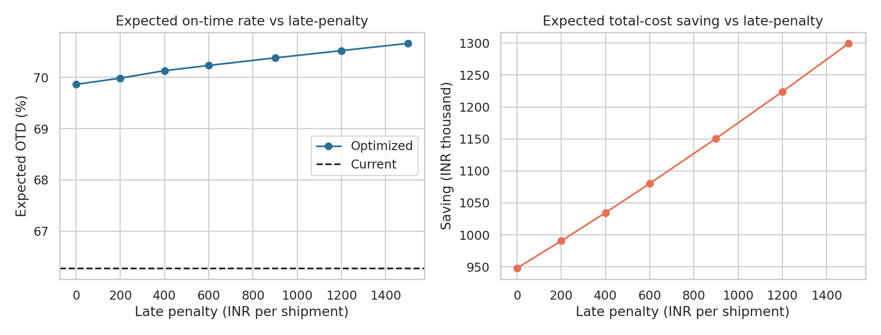
Figure 7. Expected on-time rate and net value as the late penalty varies from ₹0 to ₹1,500.
Even at a penalty of ₹0 (ignoring reliability completely) the plan lifts expected OTD by 3.6 points and saves ₹0.95 M, because the cheapest carriers also happen to be reliable. Raising the penalty from ₹0 to ₹1,500 adds only a further 0.8 points of OTD and ₹0.35 M of value. The conclusion is robust to the assumed penalty.
Re-booking cost sensitivity (S3 constraints):
Cost per re-booked shipment ₹ | Shipments re-booked | Expected OTD | Net value
0 | 4,419 (75.6%) | 70.5% | ₹1.32 M
80 | 2,110 (36.1%) | 70.2% | ₹1.08 M
200 | 1,757 (30.1%) | 70.2% | ₹0.86 M
400 | 1,341 (23.0%) | 70.2% | ₹0.56 M

With no re-booking cost the optimizer would move 76% of all shipments for small gains, which is unrealistic. A modest ₹80 charge cuts that to 36% while keeping 82% of the saving. At ₹400 per shipment the plan still saves ₹0.56 M with only 23% of shipments touched, so the plan remains attractive even if switching is expensive. In practice the first wave should target the high-value moves: CargoPlus shipments and the lanes with the largest predicted risk difference.
Capacity-cap sensitivity (CargoPlus ≤ 12%, cap applied to the other three carriers):
Cap per carrier | Share % CP / Eco / RK / SL | Expected OTD | Net value
30% | 10 / 30 / 30 / 30 | 69.8% | ₹0.87 M
34% | 5 / 34 / 34 / 27 | 70.6% | ₹1.02 M
38% | 5 / 38 / 38 / 19 | 70.2% | ₹1.08 M
45% | 5 / 45 / 45 / 5 | 69.6% | ₹1.15 M

Relaxing capacity buys more saving but pushes volume to the two cheapest carriers and away from SwiftLine, so OTD peaks at a 34% cap (70.6%) and falls to 69.6% at 45%. More freedom is therefore not always better: the optimizer trades reliability for price once the penalty is small relative to the freight difference. This is the reason to keep a reliability floor or a higher penalty when contracts are negotiated.

7.2 Strategy B: Quantile-based delivery-date promises
Decision: how many days should be promised to the customer? Promising the plan keeps only 66.3% of promises. A flat buffer fixes the average but treats every shipment alike, so slow segments still miss. A model that predicts an upper quantile of delivery time can add buffer only where it is needed.
Code excerpt 8: quantile promise model
m = HistGradientBoostingRegressor(loss="quantile", quantile=0.90, learning_rate=0.05,
max_depth=3, max_iter=200, min_samples_leaf=40, random_state=42)
promise_days = np.maximum(np.ceil(oof_pred), 1) # out-of-fold, rounded up to whole days
hit_rate = (actual_days <= promise_days).mean() # share of promises kept

Policy | Average promised days | Promises kept
Promise = planned days | 3.56 | 66.3%
Planned + 1 day (flat buffer) | 4.56 | 86.2%
Planned + 2 days (flat buffer) | 5.56 | 93.2%
Model P70 (ceil) | 4.83 | 89.2%
Model P80 (ceil) | 5.19 | 92.3%
Model P90 (ceil) | 5.94 | 96.2%
Model P95 (ceil) | 6.53 | 97.8%

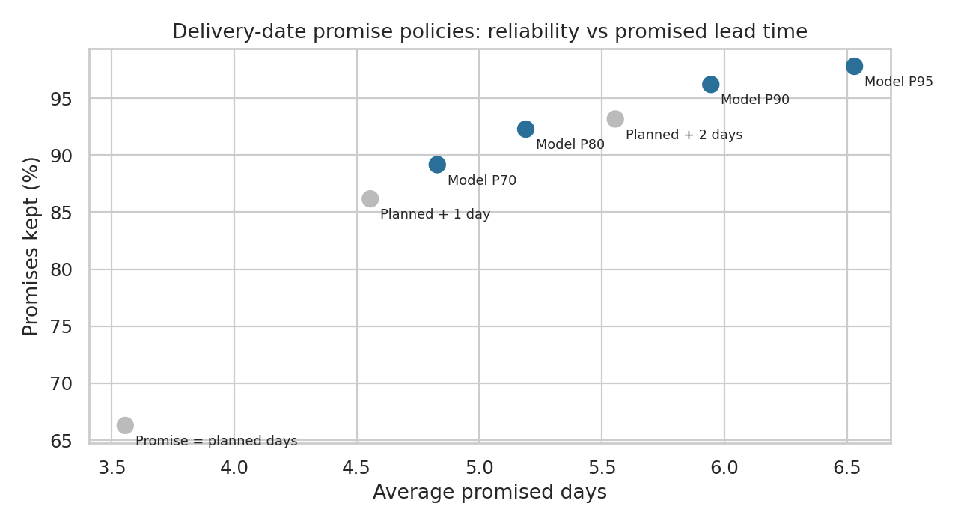
Figure 8. Reliability versus promised lead time for flat buffers (grey) and model-based quantiles (blue).
Reliability by segment (promises kept, %):
Segment | Flat +2 days | Model P80 | Model P90
Off-peak months | 94.9 | 93.5 | 96.9
Peak months (Oct–Dec) | 89.3 | 89.5 | 94.6
CargoPlus | 84.3 | 87.6 | 94.2
Kolkata hub | 86.4 | 88.9 | 94.6
Rail | 90.8 | 90.7 | 94.8
Worst carrier or hub | 84.3 | 87.6 | 94.2
Average promised days (network) | 5.56 | 5.19 | 5.94

Interpretation, stated plainly. The gain in average promise length at equal reliability is modest. Interpolating between the +1 and +2 day flat buffers, a flat policy needs about 4.99 days to keep 89.2% of promises, while the model's P70 does so at 4.83 days (−0.16 days, 3%). At around 92–93% reliability the model (P80, 5.19 days, 92.3%) is 0.37 days shorter than a flat +2 (5.56 days, 93.2%). The larger benefit is fairness across segments: with a flat +2 buffer CargoPlus and Kolkata shipments keep only 84.3% and 86.4% of promises while Mumbai keeps 95.2%, whereas P90 narrows the range to 94.2–97.1%. The peak-versus-off-peak gap shrinks from 5.6 points (flat +2) to 2.3 points (P90). Note that rounding the quantile up makes the policies slightly conservative (P90 keeps 96.2%, above its 90% nominal level), so a production version should calibrate the rounding to the target service level.

7.3 Strategy C: Risk-ranked watchlist for proactive intervention
Decision: which in-flight shipments deserve a planner's attention today? Ranking shipments by predicted late-risk lets a small team review the riskiest ones first.
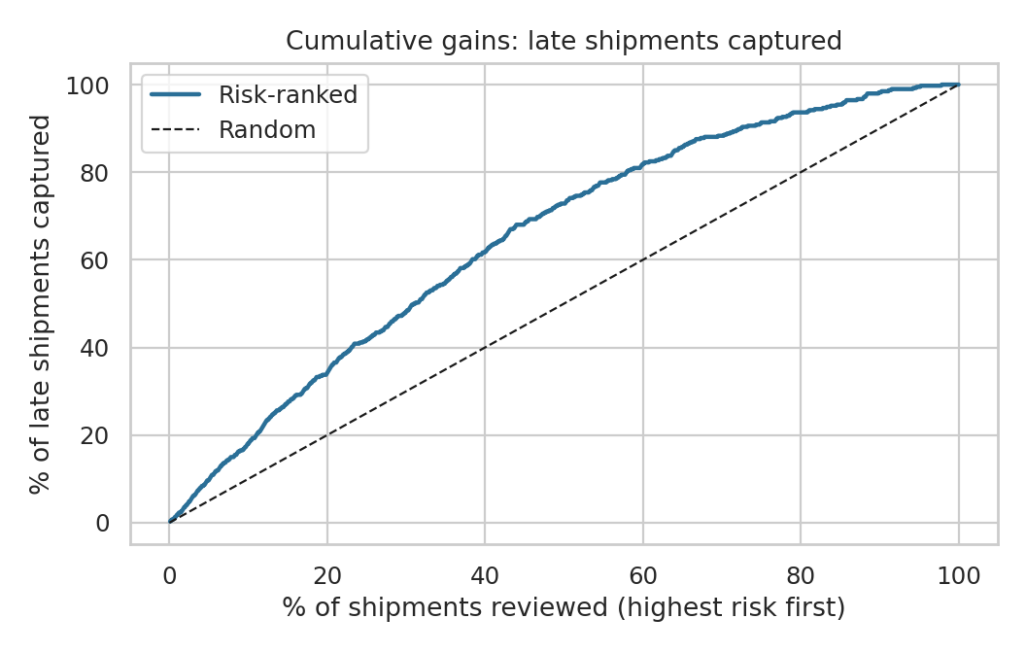
Figure 9. Cumulative gains: share of all late shipments captured when reviewing the riskiest shipments first.
Review the riskiest… | Late rate in that group | Lift vs random | Share of all late shipments captured
Top 10% | 61.2% | 1.82× | 18%
Top 20% | 57.5% | 1.71× | 34%
All shipments (random) | 33.7% | 1.00× | 100% (of 100% reviewed)

Worked example: value of a watchlist (illustrative assumption)
Across the full year there were 1,969 late shipments. The riskiest 20% (about 1,168 shipments) would contain roughly 0.34 × 1,969 = 669 late shipments, a late rate of 57.5%.
Assumption: proactive action on a flagged shipment (re-routing, a call to the carrier, or an expedite) prevents the delay in 25% of cases. Then 0.25 × 669 = 167 late deliveries avoided, worth 167 ÷ 5,842 = +2.9 OTD points. The 25% figure is not measured in this dataset and should be validated in a pilot; each 10 points of intervention success is worth about 1.1 OTD points.

7.4 Combined impact and implementation roadmap
Phase | Action | Expected result | Owner / KPI
1 (0–60 days) | Adopt Plan S4: cut CargoPlus to ~10%, grow EcoFreight / RoadKing / SwiftLine to ≤ 30% each | OTD 66.3% → 69.8%; freight −4.1%; net ₹0.87 M | Procurement; weekly OTD and cost per tonne-km by carrier
1 (0–60 days) | Switch customer promises to P80 quantiles by segment | Promise reliability above 87% in every segment | Customer service; promises kept by hub and carrier
2 (30–90 days) | Pilot the daily risk watchlist (top 10–20%) | Up to +2.9 OTD points if 25% of flagged delays are prevented | Control tower; late rate of flagged vs unflagged
3 (90–180 days) | Move toward Plan S3 after confirming EcoFreight and RoadKing capacity | OTD up to 70.2%; net ₹1.08 M | Procurement; capacity utilisation per carrier
Ongoing | Retrain monthly; re-run the MILP weekly; review prices and penalties quarterly | Models stay calibrated as conditions change | Analytics; drift and calibration reports

The three strategies act on different shipments and are not simply additive; the carrier plan improves the baseline on which the watchlist then operates. A realistic combined target is therefore an on-time rate of about 70–72% (from 66.3%), with the carrier plan delivering most of the gain and the freight saving.

8. Deployment, Monitoring and Model Governance
- Retraining: monthly, and always after the Q4 peak, because the temporal test showed R² falling to 0.57 when the peak season was under-represented.
- Drift monitoring: track MAE by carrier, hub and month; alert when error rises by more than 20% against the validation baseline, or when the distribution of planned days or carrier mix shifts.
- Calibration monitoring: compare predicted and observed late rates per decile each month; recalibrate if any decile deviates by more than 0.10.
- Safeguards for the optimizer: keep human approval for carrier changes; enforce minimum share per carrier for redundancy; re-solve rather than re-use old plans when capacities or prices change.
- Explainability: report permutation importance and the linear-regression coefficients to operations teams alongside each retrain.

9. Limitations and Assumptions
- Simulated data. The effects were planted by design. Recovering them shows the pipeline works, but real data will be noisier and will include factors absent here (weather, dock queues, driver availability, customs, GPS events). Adding them is the most likely route to a higher R².
- Irreducible noise. Delay is generated from a random (gamma) process, so R² is bounded well below 1. The facts that tuned boosting barely beats linear regression and that no further feature carries signal suggest the model is near the ceiling for this feature set.
- Counterfactuals assume no hidden confounding. The allocation model assumes a shipment moved to another carrier would experience that carrier's typical risk. In real operations, carrier performance depends on lane, customer and load mix, so a pilot with a controlled share of moved volume should precede full adoption.
- Assumed prices. The ₹600 late penalty and ₹80 re-booking cost are assumptions; the sensitivity tables show that conclusions hold across ₹0–1,500 and ₹0–400 respectively.
- Capacity and contract terms are represented only by share caps and floors. Rate changes when volumes shift (volume discounts, surge pricing) are not modelled.
- Cost model bias. Predicted spend is 4.7% below actual spend, so absolute savings are reported relative to the model's own baseline. Scaled to actual spend, the S4 freight saving would be about ₹0.95 M.
- Single year of data. Seasonal patterns are learned from one cycle; two or more years would allow genuine time-series validation.

10. Conclusion
A tuned gradient-boosting model forecasts delivery time with RMSE 1.18 days and R² 0.65, a 15% error reduction over the planned-days benchmark, and the same model family ranks late-delivery risk with AUC 0.7275. The study is candid about what the models cannot do: they do not improve the typical ETA (the plan already wins on MAE), and linear regression is almost as accurate as boosting. Their value lies in the tail, in identifying which carrier, hub and season combinations will run late, and in pricing alternatives.
Feeding those predictions into a mixed-integer program shows that reallocating volume away from CargoPlus and toward the two cheaper, reasonably reliable carriers can raise expected on-time delivery by about 3.5 to 4 points and reduce freight by about 4 to 5%, with a net value of ₹0.87 M to ₹1.08 M after re-booking costs. The result holds across wide ranges of the late penalty and re-booking cost, though it depends on carrier capacity and on the assumption that moved shipments inherit their new carrier's risk. Quantile-based delivery promises and a risk-ranked watchlist add reliability and customer-service benefits. A staged rollout, beginning with the conservative plan and a pilot to verify the counterfactual assumptions, turns the analysis into a low-risk operational improvement.

Appendix A. Pseudocode of the Full Workflow
Pseudocode
1. LOAD cleaned shipments (5,842 rows); BUILD features (month, peak, monsoon, log tonne-km)
2. SPLIT 80/20 (seed 42). DEFINE leak-free feature list (no outcome columns)
3. FOR each candidate model (Linear, Ridge, Tree, Forest, Boosting) + naive baseline:
5-fold CV on training set -> mean/SD of RMSE, MAE, R2
4. TUNE boosting with GridSearchCV (48 candidates x 5 folds) -> best parameters
5. EVALUATE once on the hold-out test set: RMSE, MAE, R2, within-1-day
6. BOOTSTRAP 1,000 resamples -> 95% CI for RMSE and R2
7. TEMPORAL CHECK: train Jan-Oct, test Nov-Dec
8. EXPLAIN: permutation importance; error by carrier, mode, season
9. TRAIN classifier for P(late); CHECK AUC, Brier, calibration, lift
10. TRAIN cost model: log(cost) ~ log tonne-km + mode + carrier + priority
11. FOR each of 5 folds:
FIT classifier + cost model on 4 folds
FOR each carrier c: set carrier = c on held-out fold -> P_late[i,c], COST[i,c]
12. SOLVE MILP: min sum x_ic * (COST + 600*P_late + 80*[c != current])
s.t. one carrier per shipment; lo_c <= share_c <= hi_c
13. RUN scenarios (S1, S3, S4) and sensitivities (penalty, re-booking cost, caps)
14. FIT quantile models (P70..P95) out-of-fold -> promise-day policies; compare with flat buffers
15. RANK shipments by P(late) -> watchlist lift table
16. EXPORT figures, results.json, carrier_recommendations.csv

Appendix B. Files Delivered
File | Content
Predictive_Modeling_Optimization_Report.docx | This report
w4_model.py | Complete script: preparation, models, tuning, validation, optimization, figures
carrier_recommendations.csv | Current and recommended carrier (Plans S3 and S4) for every shipment
logistics_clean.csv | Input dataset (Week 3 cleaned data)

