Aadhaar Enrollment Analytics Report – West Bengal

1. Problem Statement and Approach
Aadhaar serves as a foundational digital identity system in India, enabling access to government services, welfare schemes, and financial inclusion. This project aims to analyze Aadhaar enrolment data for West Bengal to understand demographic behavior, geographic disparities, and temporal trends. The analytical approach focuses on exploratory data analysis using district-level, pincode-level, and time-series datasets to uncover actionable insights that can assist UIDAI in improving operational efficiency and outreach strategies.

2. Datasets Used
The analysis uses multiple UIDAI Aadhaar datasets, including:
• west_bengal_district_level_all.csv
• west_bengal_pincode_level.csv
• west_bengal_cleaned_data.csv
• wb_month_enroll_trend.csv
Key Columns:
• district_clean
• pincode
• date
• age_0_5, age_5_17, age_18_greater
• total_enroll

3. Methodology
Data Cleaning:
• Removal of null and duplicate records
• Standardization of district names
Preprocessing:
• Aggregation at district and pincode levels
• Feature engineering for age-group totals
Tools Used:
• Python (Pandas, NumPy)
• Power BI for visual analytics
• Excel for exploratory checks

4. Data Analysis & Visualization

4.1 Age-wise Aadhaar Enrollment by District
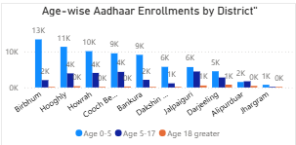
Observation: Certain districts like Murshidabad, Nadia, and Birbhum show significantly higher enrollments, driven mainly by the 0–5 age group.
Insight
- Districts like Birbhum, Hooghly, Howrah, Cooch Behar show the highest total enrollments.
- The 0–5 age group dominates in every major district.
- Adult enrollments (18+) are consistently low across all districts.
Impact
- Indicates that new Aadhaar growth is driven by children, not adults.
- Helps UIDAI focus child enrollment drives in high-growth districts.
- Supports school & hospital-based registration programs.
4.2 Contribution of Age Groups by District
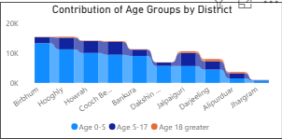
Observation: Across most districts, child enrollment dominates total Aadhaar registrations.
Insight
- Child enrollments form the base layer of total enrollment in all districts.
- Teen enrollments (5–17) add moderate volume.
- Adult enrollments are a minor contributor everywhere.
Impact
- Confirms Aadhaar adult coverage saturation.
- Suggests shifting outreach strategy from adults to newborn registrations.
- Enables resource reallocation toward pediatric Aadhaar centers.

4.3 Age Group Share Across All Pin codes
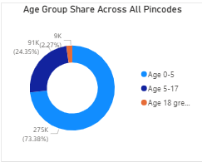Observation: Over 70% of Aadhaar enrollments come from the 0–5 age group, indicating strong child-focused adoption.
Insight
- 0–5 age group ≈ 73% of total enrollments.
- 5–17 age group ≈ 24%.
- 18+ age group < 3%.
Impact
- Strong evidence that Aadhaar growth is child-driven.
- Supports policy prioritization for early-life digital identity.
- Helps justify investment in maternal & child health center enrollment booths.

4.4 Top 10 Enrollment Districts
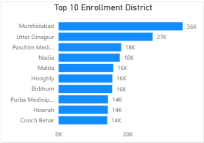
Observation: A small number of districts contribute disproportionately to overall enrollment volume.
Insight
- Murshidabad, Uttar Dinajpur, Nadia, Hooghly dominate enrollments.
- A small number of districts contribute a disproportionate share of total volume.
Impact
- Identifies enrollment hotspots for infrastructure expansion.
- Helps prioritize staffing, equipment, and outreach budgets.
- Enables performance benchmarking for low-performing districts.

4.5 Scatter Plot – Age Mix Pattern
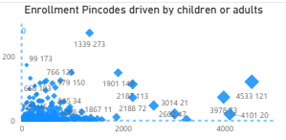
Observation: High-enrollment pin codes are largely child-driven, while adult-heavy regions are rare.
Insight
- High-enrollment pin codes cluster far right on X-axis (high child enrollments).
- Very few large bubbles appear high on Y-axis (adult-heavy zones).
- Balanced child–adult high-volume pin codes are rare.
Impact
- Confirms that high-volume locations are child-driven.
- Helps identify industrial or migrant zones (adult-heavy pin codes).
- Supports targeted adult re-enrollment or update drives in specific areas.
4.6 KPI Summary
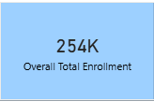
Observation: The total Aadhaar enrollment across analyzed datasets is approximately 254,000, confirming strong regional demand.
Insight
- Total Aadhaar enrollments ≈ 254,000 across all analyzed data.
- Indicates strong regional enrollment activity.
Impact
- Provides a single executive metric for leadership dashboards.
- Useful for policy reporting and progress tracking.
- Acts as a baseline for future forecasting and benchmarking.

4.7 Time-Series Enrollment Trend
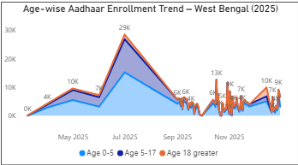
Observation: A sharp enrollment spike is observed in mid-2025, likely due to a major government enrollment drive.
Insight
- A massive enrollment spike (~29K) occurs around June–July 2025.
- Growth is mainly driven by the 0–5 age group.
- Post-spike, enrollments stabilize at a lower baseline.
- Adult enrollments remain flat throughout.
Impact
- Indicates the effect of a major government enrollment campaign.
- Helps assess campaign success and duration.
- Supports seasonal planning for future drives.
- Suggests timing future outreach around high-response months.

5. Key Insights Summary
- Aadhaar enrollment is heavily skewed toward children (0–5 age group)
• A limited number of districts and pincodes dominate total enrollments
• Adult enrollments remain comparatively low and stable
• A major enrollment surge occurred in mid-2025

6. Impact and Applicability
Administrative Impact:
• Supports targeted resource allocation
• Helps identify enrollment hotspots
• Improves outreach strategy
Social Impact:
• Encourages early-age Aadhaar adoption
• Enhances access to government benefits
• Supports inclusive digital identity coverage

7. Conclusion
This project demonstrates how Aadhaar demographic data can be transformed into meaningful operational and social insights. The findings highlight the dominance of child registrations, geographic enrollment concentration, and the impact of policy-driven enrollment drives. These insights can assist UIDAI in strategic planning, infrastructure deployment, and policy formulation.

