POC-2 : POC 2 — ConfigMap: Mounting a Single Key (subPath)
Steps:
1 . Reuse ConfigMap app-config from POC 1.
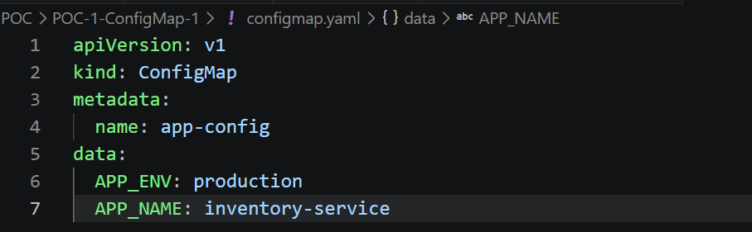
2 . Create pod config-subpath (toolbox image) that mounts only the APP_NAME key from app-config to the path /etc/app/name.txt, using subPath.
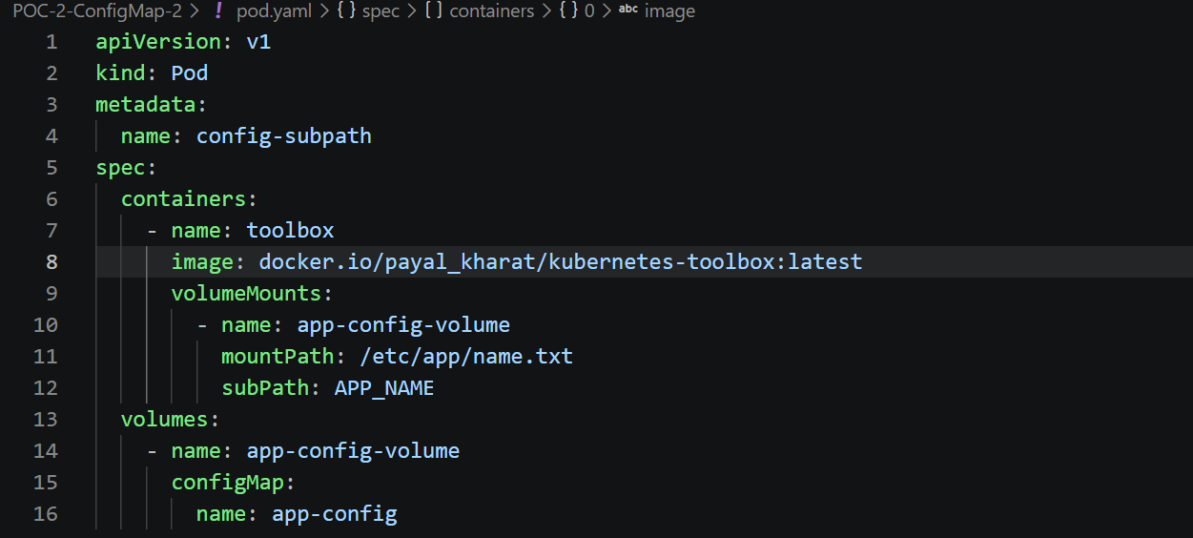
3 . Verify: kubectl exec config-subpath -- cat /etc/app/name.txt and kubectl exec config-subpath -- ls /etc/app.
