POC-3 : Secret: Volume Mount + Env Var Reference
Steps:
1 . Create Secret db-credentials with keys username and password.
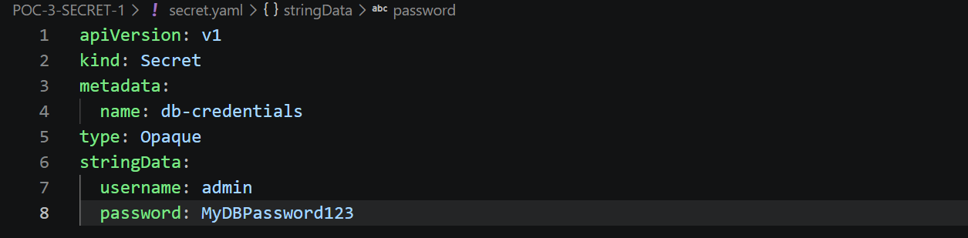
2 . Create pod secret-inspector (toolbox image), that:
  - mounts db-credentials as a volume at /etc/app/secrets
  - injects username as env var DB_USERNAME via secretKeyRef
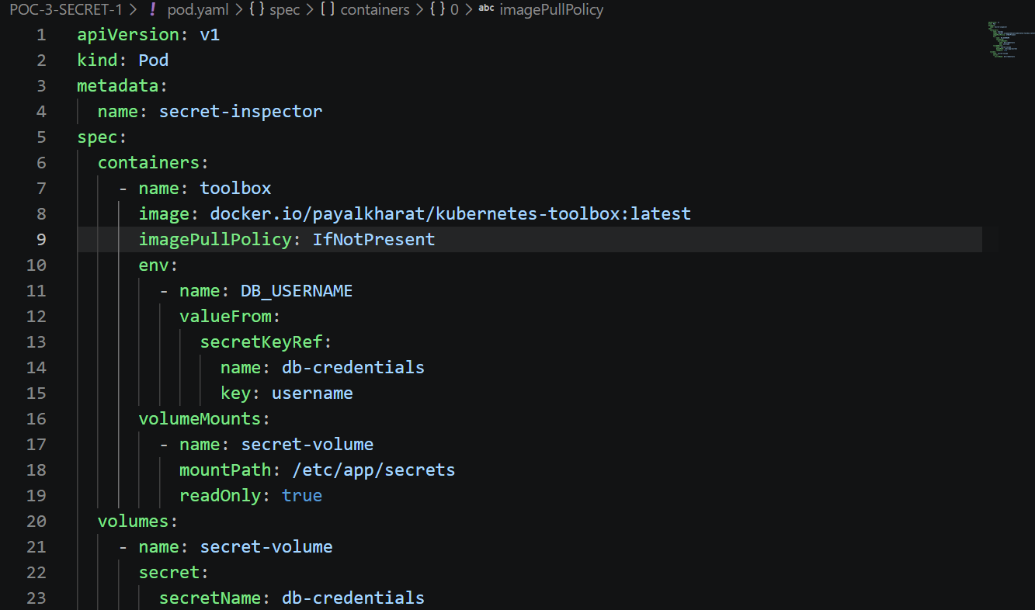
4 . Verify:
kubectl exec secret-inspector -- cat /etc/app/secrets/username.
kubectl exec secret-inspector -- cat /etc/app/secrets/password
kubectl exec secret-inspector -- printenv DB_USERNAME
kubectl exec secret-inspector -- ls -l /etc/app/secrets
