POC-4: Secret: Mounting a Single Key with Custom Permissions
Steps:
1 . Reuse Secret db-credentials.
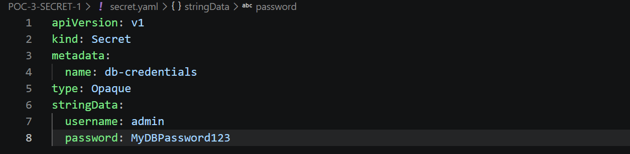

2 . Create pod secret-subpath (toolbox image) that mounts only the password key to /etc/app/secret-password, using subPath, with defaultMode: 0400.
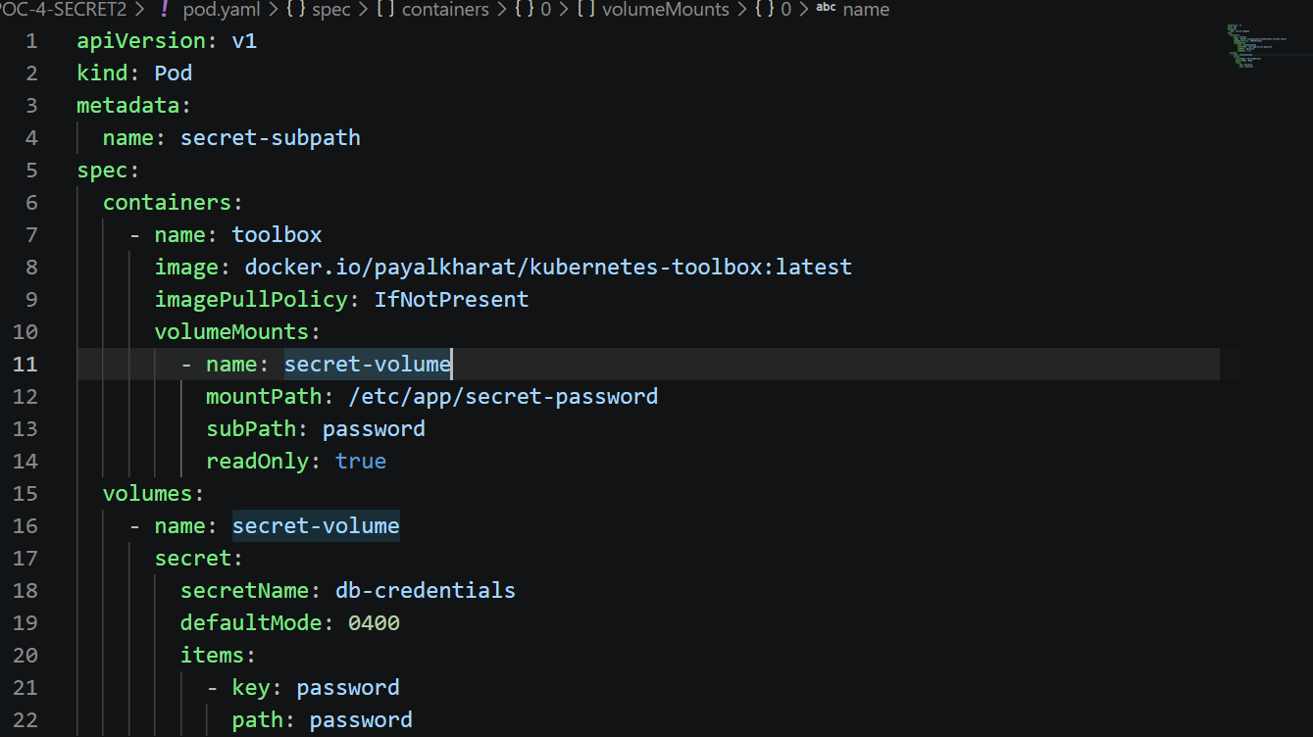

3 . Verify: kubectl exec secret-subpath -- cat /etc/app/secret-password and kubectl exec secret-subpath -- ls -l /etc/app/secret-password.
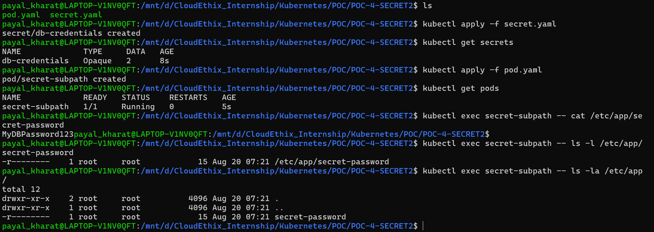
4 . Expected result: File contains the password value only; username is not present in the pod at all. File permission mode shows 0400 (read-only for owner), confirming defaultMode was applied.


