POC-7 : PV+PVC
STEPS:
1.Create a 1Gi PersistentVolume (hostPath is fine for a local cluster).
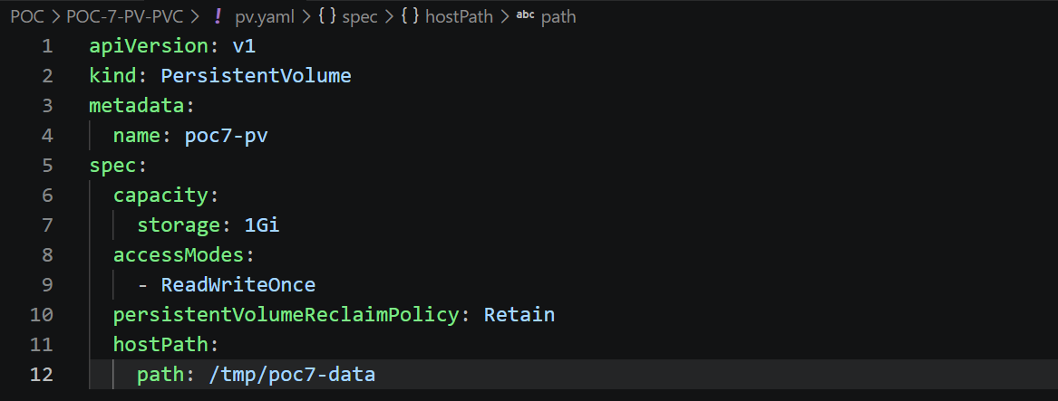
2. Create a PVC that binds to it.
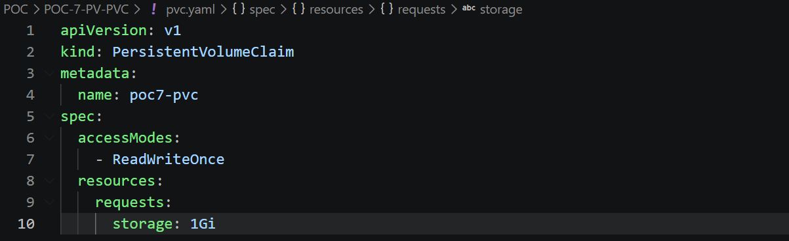
3. Create pod pvc-test (toolbox image), mounting the PVC at /data.
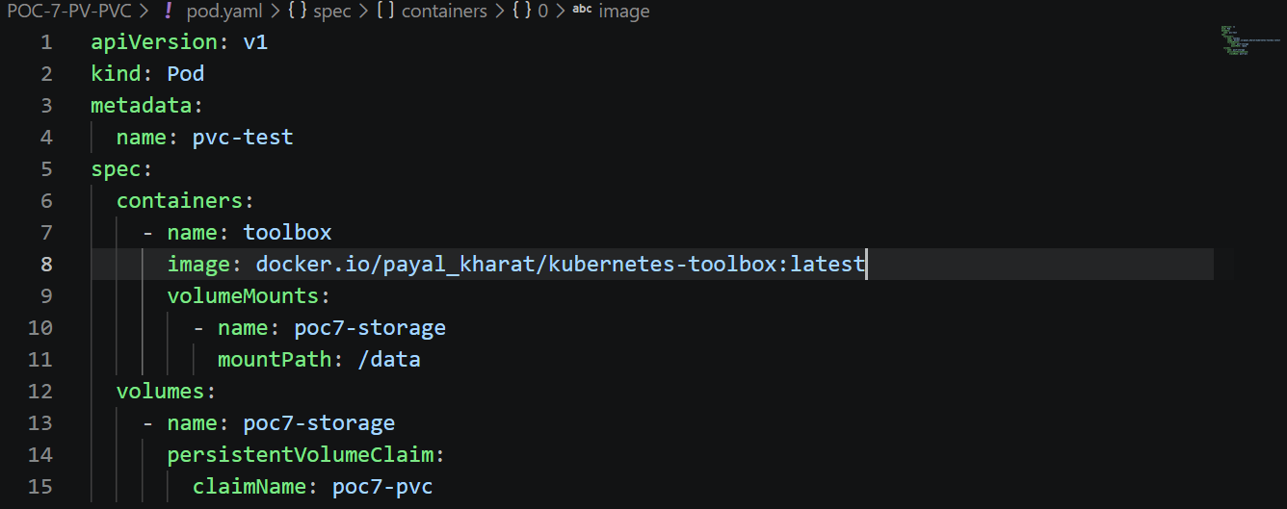

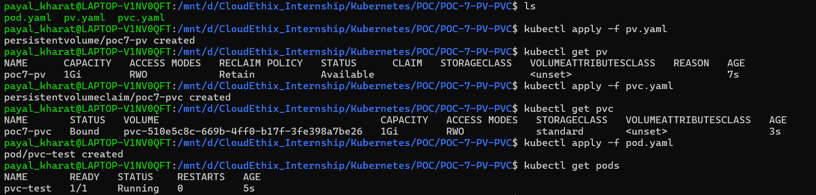
4. kubectl exec pvc-test -- sh -c 'echo hello-from-poc7 > /data/hello.txt'
5 . Delete pod pvc-test. Recreate it with the same PVC.
