POC-1 : ConfigMap: Volume Mount + Env Var Reference
Steps:
1.Create ConfigMap app-config with keys: APP_ENV=production, APP_NAME=inventory-service.
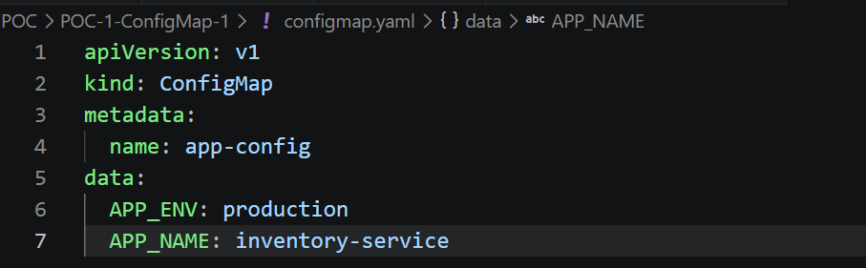
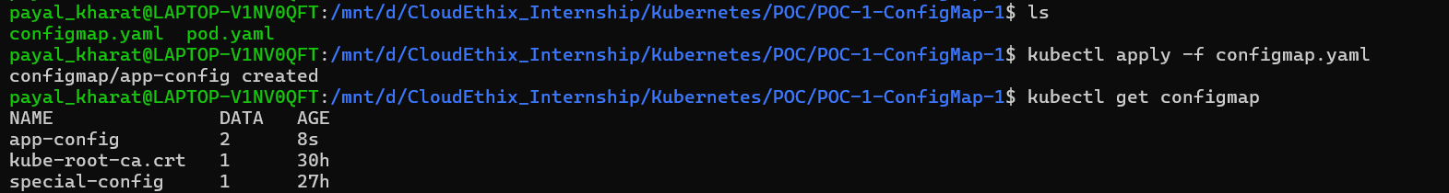
2 . Create pod config-inspector (toolbox image), that:
  - mounts app-config as a volume at /etc/app/config
  - also injects APP_ENV as an environment variable via configMapKeyRef
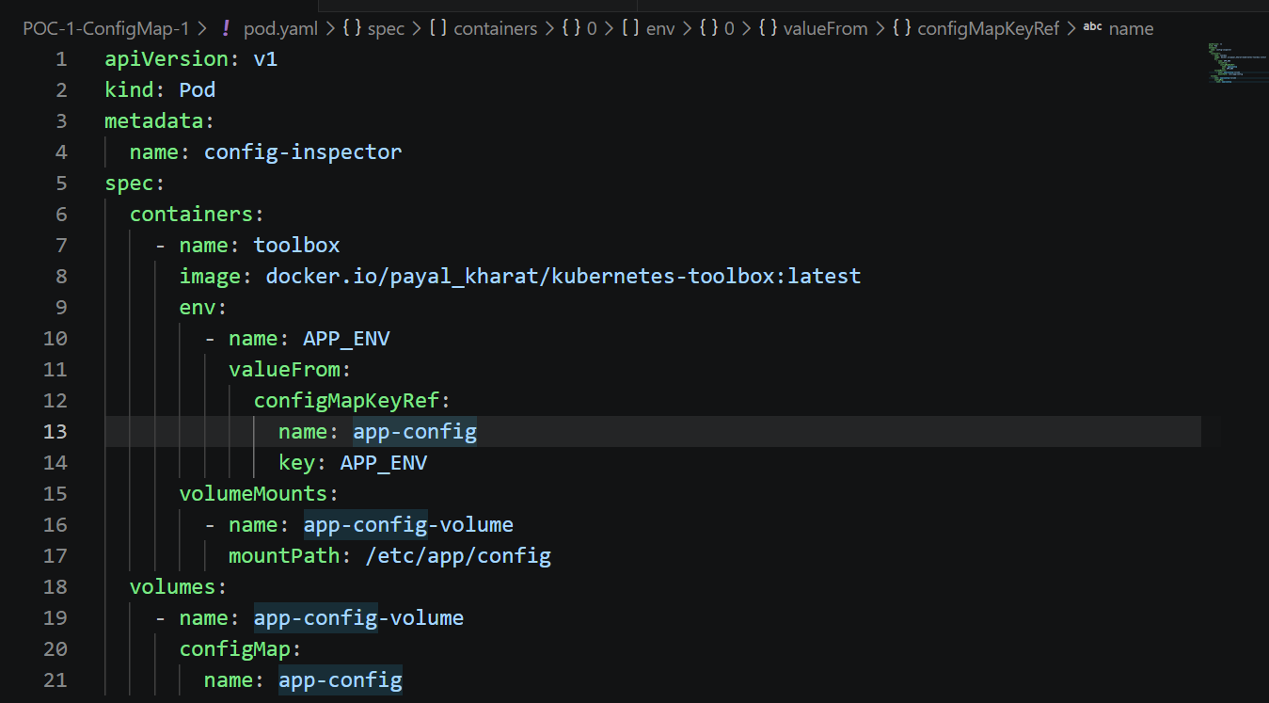

3 . Verify:
kubectl exec config-inspector -- cat /etc/app/config/APP_ENV
kubectl exec config-inspector -- printenv APP_ENV
4.Expectedresult:
/etc/app/config/APP_ENV contains production. /etc/app/config/APP_NAME also exists and contains inventory-service (mounted as a whole ConfigMap, both keys appear as files). printenv APP_ENV returns production. Only APP_ENV exists as an env var — APP_NAME does not, since it was never referenced with configMapKeyRef.
