SAMPLING DISTRIBUTION OF STATISTICAL/ESTIMATORS
payal ravindra jadhav
2025-03-12
##TOPIC 1 #QUATION 1 #FOR SAMPLE MEAN
n=c(5,15,30)
sam_mean=sam_var=numeric(length(n))
x_bar_list=list()
for (i in 1:length(n)){
X=matrix(rnorm(1000*n[i],10,1),nrow=1000,ncol=n[i])
x_bar=apply(X,1,mean)
sam_mean[i]=mean(x_bar)
sam_var[i]=var(x_bar)
x_bar_list[[i]]=x_bar
}
cbind(n,sam_mean,sam_var)
## n sam_mean sam_var
## [1,] 5 10.030798 0.19463904
## [2,] 15 9.990964 0.06254757
## [3,] 30 9.993539 0.03258272
hist(x_bar_list[[1]],col="skyblue",main="Histogram of x_bar",xlab="x_bar")
hist(x_bar_list[[2]],col="yellow",add=T)
hist(x_bar_list[[3]],col="orange",add=T)
legend("topright",legend=paste("n=",n),fill=c("skyblue","yellow","orange"))
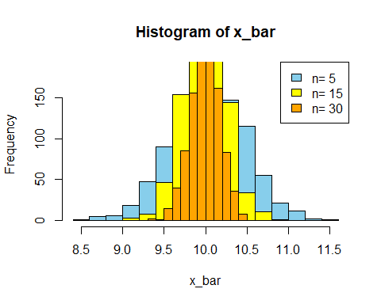 #FOR SAMPLE MEDIAN
n=c(5,15,30)
sam_median_mean=sam_median_var=numeric(length(n))
x_median_list=list()
for (i in 1:length(n)){
X=matrix(rnorm(1000*n[i],10,1),nrow=1000,ncol=n[i])
x_median=apply(X,1,median)
sam_median_mean[i]=mean(x_median)
sam_median_var[i]=var(x_median)
x_median_list[[i]]=x_median
}
cbind(n,sam_median_mean,sam_median_var)
## n sam_median_mean sam_median_var
## [1,] 5 9.986628 0.29096333
## [2,] 15 10.001088 0.10758386
## [3,] 30 10.004461 0.05229566
hist(x_median_list[[1]],col="skyblue",main="Histogram of x_median",xlab="x_median")
hist(x_median_list[[2]],col="yellow",add=T)
hist(x_median_list[[3]],col="orange",add=T)
legend("topright",legend=paste("n=",n),fill=c("skyblue","yellow","orange"))
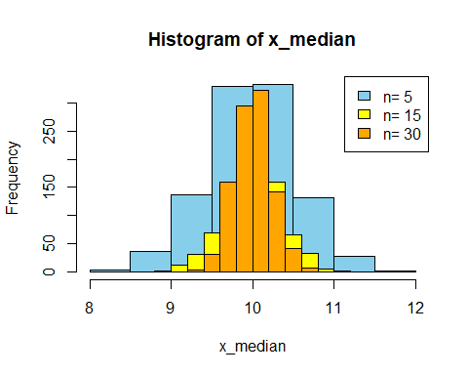 #for sample variance
n=c(5,15,30)
sam_mean=sam_var=numeric(length(n))
x_bar_list=list()
for (i in 1:length(n)){
X=matrix(rnorm(1000*n[i],10,1),nrow=1000,ncol=n[i])
x_bar=apply(X,1,var)
sam_mean[i]=mean(x_bar)
sam_var[i]=var(x_bar)
x_bar_list[[i]]=x_bar
}
cbind(n,sam_mean,sam_var)
## n sam_mean sam_var
## [1,] 5 1.0184141 0.46176917
## [2,] 15 0.9882978 0.14607599
## [3,] 30 0.9987936 0.06628559
hist(x_bar_list[[1]],col="skyblue",main="Histogram of x_bar",xlab="x_bar")
hist(x_bar_list[[2]],col="yellow",add=T)
hist(x_bar_list[[3]],col="orange",add=T)
legend("topright",legend=paste("n=",n),fill=c("skyblue","yellow","orange"))
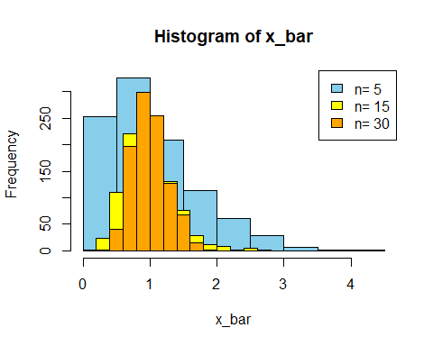 #1/n(sum(Xi-Xbar)^2)
n=c(5,15,30)
sam_mean=sam_var=numeric(length(n))
x_bar_list=list()
for (i in 1:length(n)){
X=matrix(rnorm(1000*n[i],10,1),nrow=1000,ncol=n[i])
T1=apply(X,1,var)
x_bar=((n[i]-1)/n[i]*T1)
sam_mean[i]=mean(x_bar)
sam_var[i]=var(x_bar)
x_bar_list[[i]]=x_bar
}
cbind(n,sam_mean,sam_var)
## n sam_mean sam_var
## [1,] 5 0.8036651 0.31307443
## [2,] 15 0.9589462 0.13059182
## [3,] 30 0.9711285 0.05984205
hist(x_bar_list[[1]],col="skyblue",main="Histogram of x_bar",xlab="x_bar")
hist(x_bar_list[[2]],col="yellow",add=T)
hist(x_bar_list[[3]],col="orange",add=T)
legend("topright",legend=paste("n=",n),fill=c("skyblue","yellow","orange"))
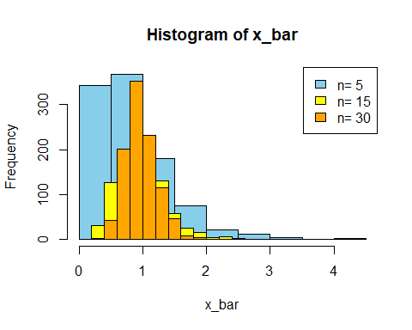
##QUATION 2 #SAMPLE MEAN(Xbar) #SAMPLE VARIANCE
n=c(5,15,30)
sam_mean_T1=sam_mean_T2=numeric(length(n))
sam_var_T1=sam_var_T2=numeric(length(n))
T1_list=list()
T2_list=list()
for (i in 1:length(n)){
x=matrix(rpois(1000*n[i],5),nrow=1000,ncol=n[i])
T1=apply(x,1,mean)
T2=apply(x,1,var)
sam_mean_T1[i]=mean(T1)
sam_mean_T2[i]=mean(T2)
sam_var_T1[i]=var(T1)
sam_var_T2[i]=var(T2)
T1_list[[i]]=T1
T2_list[[i]]=T2
}
cbind(n,sam_mean_T1,sam_mean_T2,sam_var_T1,sam_var_T2)
## n sam_mean_T1 sam_mean_T2 sam_var_T1 sam_var_T2
## [1,] 5 5.003400 4.898200 1.0342627 13.216834
## [2,] 15 5.019000 5.031800 0.3219476 3.850021
## [3,] 30 4.987967 5.055672 0.1506225 1.907306
hist(T1_list[[1]],col="skyblue",main="Histogram of T1_list",xlab="T1_list")
hist(T1_list[[2]],col="yellow",add=T)
hist(T1_list[[3]],col="orange",add=T)
legend("topright",legend=paste("n=",n),fill=c("skyblue","yellow","orange"))
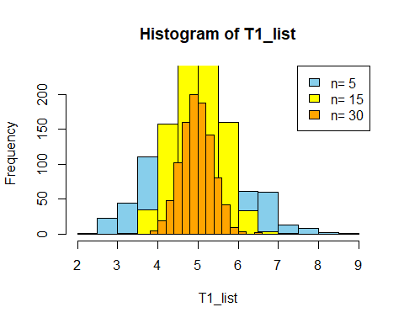
hist(T2_list[[1]],col="skyblue",main="Histogram of T2_list",xlab="T2_list")
hist(T2_list[[2]],col="yellow",add=T)
hist(T2_list[[3]],col="orange",add=T)
legend("topright",legend=paste("n=",n),fill=c("skyblue","yellow","orange"))
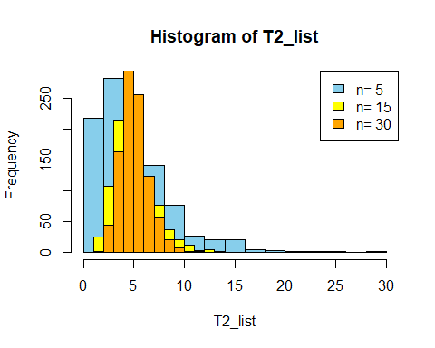
##QUATION 3 for #2xbar #x(n)
n=c(5,15,30)
sam_mean_T1=sam_mean_T2=numeric(length(n))
sam_var_T1=sam_var_T2=numeric(length(n))
T1_list=list()
T2_list=list()
for (i in 1:length(n)){
x=matrix(runif(1000*n[i],0,5),nrow=1000,ncol=n[i])
T_1=2*apply(x,1,mean)
T_2=apply(x,1,max)
sam_mean_T1[i]=mean(T_1)
sam_var_T1[i]=var(T_1)
sam_mean_T2[i]=mean(T_2)
sam_var_T2[i]=var(T_2)
T1_list[[i]]=T_1
T2_list[[i]]=T_2}
cbind(n,sam_mean_T1,sam_mean_T2,sam_var_T1,sam_var_T2)
## n sam_mean_T1 sam_mean_T2 sam_var_T1 sam_var_T2
## [1,] 5 4.898877 4.128340 1.6608533 0.48471451
## [2,] 15 4.977310 4.678303 0.5516846 0.08751465
## [3,] 30 5.016506 4.845015 0.2533689 0.02389670
hist(T1_list[[1]],col="skyblue",main="Histogram of T1_list",xlab="T1_list")
hist(T1_list[[2]],col="yellow",add=T)
hist(T1_list[[3]],col="orange",add=T)
legend("topright",legend=paste("n=",n),fill=c("skyblue","yellow","orange"))
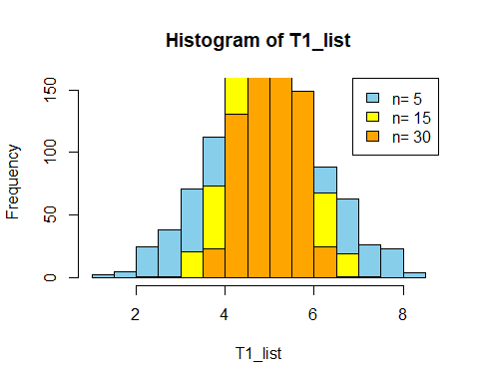
hist(T2_list[[1]],col="skyblue",main="Histogram of T2_list",xlab="T2_list")
hist(T2_list[[2]],col="yellow",add=T)
hist(T2_list[[3]],col="orange",add=T)
legend("topright",legend=paste("n=",n),fill=c("skyblue","yellow","orange"))
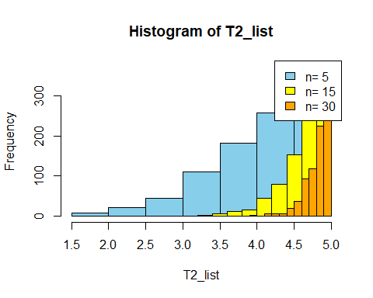 ##QUATION 4 #x(1) #xbar-1
n=c(5,15,30)
mu=2.5
sam_mean_T1=sam_mean_T2=numeric(length(n))
sam_var_T1=sam_var_T2=numeric(length(n))
T1_list=list()
T2_list=list()
for (i in 1:length(n)){
x=matrix(runif(1000*n[i],0,1),nrow=1000,ncol=n[i])
y=mu-log(1-x)
T_1=apply(y,1, min) #x(1)
T_2=apply(y,1,mean)-1 #xbar-1
sam_mean_T1[i]=mean(T_1)
sam_var_T1[i]=var(T_1)
sam_mean_T2[i]=mean(T_2)
sam_var_T2[i]=var(T_2)
T1_list[[i]]=T_1
T2_list[[i]]=T_2}
cbind(n,sam_mean_T1,sam_mean_T2,sam_var_T1,sam_var_T2)
## n sam_mean_T1 sam_mean_T2 sam_var_T1 sam_var_T2
## [1,] 5 2.692196 2.475114 0.039331173 0.20505399
## [2,] 15 2.567155 2.489996 0.004536092 0.07029385
## [3,] 30 2.535608 2.502523 0.001248503 0.03675367
hist(T1_list[[1]],col="skyblue",main="Histogram of T1_list",xlab="T1_list")
hist(T1_list[[2]],col="yellow",add=T)
hist(T1_list[[3]],col="orange",add=T)
legend("topright",legend=paste("n=",n),fill=c("skyblue","yellow","orange"))
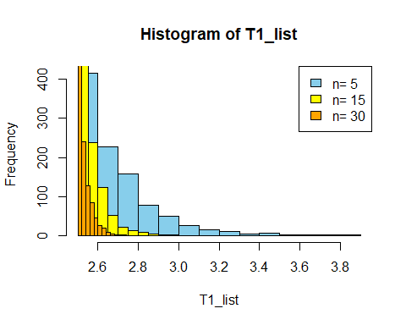
hist(T2_list[[1]],col="skyblue",main="Histogram of T2_list",xlab="T2_list")
hist(T2_list[[2]],col="yellow",add=T)
hist(T2_list[[3]],col="orange",add=T)
legend("topright",legend=paste("n=",n),fill=c("skyblue","yellow","orange"))
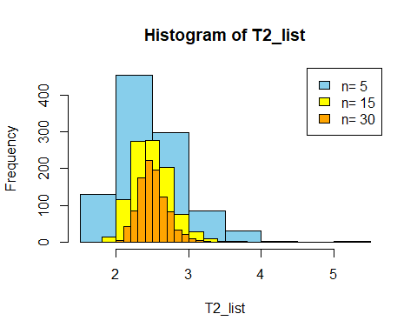
##QUATION 5 #X(1) #Xbar-X(1)
n=c(10,15,30)
sam_mean_T1=sam_var_T1=numeric(length(n))
sam_mean_T2=sam_var_T2=numeric(length(n))
mu=2
sigma=1
T1_list=list()
T2_list=list()
for (i in 1:length(n)){
x=matrix(runif(1000*n[i],0,1),nrow=1000,ncol=n[i])
y=mu-(sigma*log(1-x))
T1=apply(y,1,min)
x_bar=apply(y,1,mean)
T2=x_bar-T1
sam_mean_T1[i]=mean(T1)
sam_mean_T2[i]=mean(T2)
sam_var_T1[i]=var(T1)
sam_var_T2[i]=var(T2)
T1_list[[i]]=T1
T2_list[[i]]=T2
}
cbind(n,sam_mean_T1,sam_mean_T2,sam_var_T1,sam_var_T2)
## n sam_mean_T1 sam_mean_T2 sam_var_T1 sam_var_T2
## [1,] 10 2.099721 0.9105132 0.010345250 0.09656982
## [2,] 15 2.068330 0.9536089 0.004863716 0.06565621
## [3,] 30 2.034060 0.9629770 0.001259058 0.03050002
hist(T1_list[[1]],col="skyblue",main="Histogram of T1_list",xlab="T1_list")
hist(T1_list[[2]],col="yellow",add=T)
hist(T1_list[[3]],col="orange",add=T)
legend("topright",legend=paste("n=",n),fill=c("skyblue","yellow","orange"))
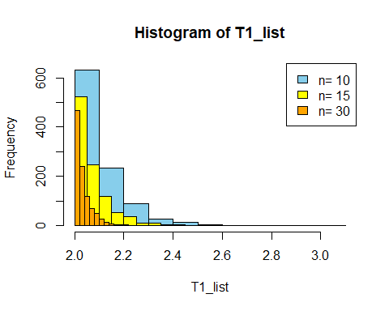
hist(T2_list[[1]],col="skyblue",main="Histogram of T2_list",xlab="T2_list")
hist(T2_list[[2]],col="yellow",add=T)
hist(T2_list[[3]],col="orange",add=T)
legend("topright",legend=paste("n=",n),fill=c("skyblue","yellow","orange"))
