Support Ticket Application

Let’s see what Role of **Admin** in this Application is.

1. Login
2. Dashboard with Status Counts
3. View All Tickets
4. Ticket History
5. Create Ticket & Create User
6. Knowledgebase
7. Delete & Restore Ticket
8. Replying on Ticket
9. Reports

**Login page**

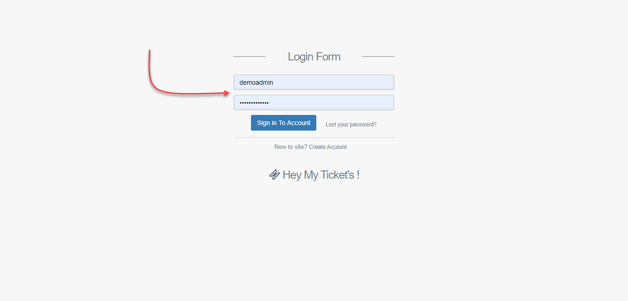

**Admin Dashboard**

After logging into Application, you are redirected to the dashboard page where you can see all tickets status in one View.

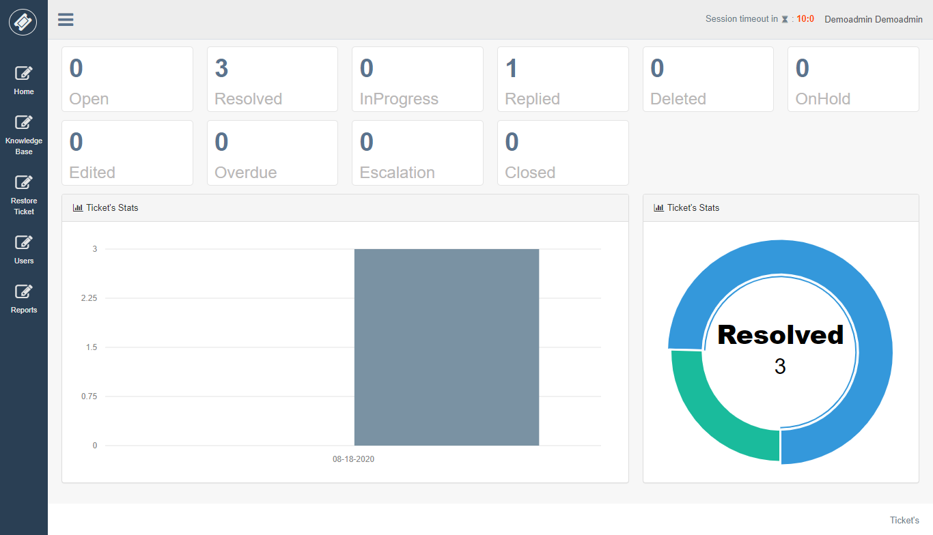

Admin can see all ticket assigned to agents.

**All Ticket’s**

List of tickets will be shown here along with search features.

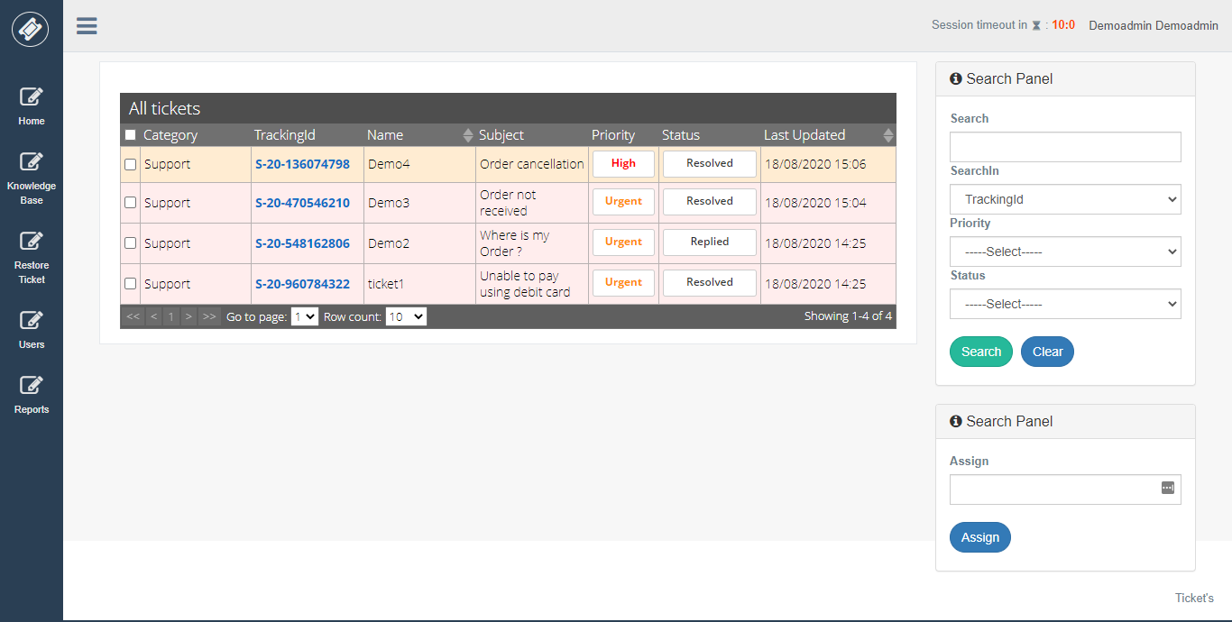

To see ticket detail view just click on Tracking id from the grid.

**Ticket Detail View**

In this View, you can see the detail information about ticket and quick options to reply ticket.

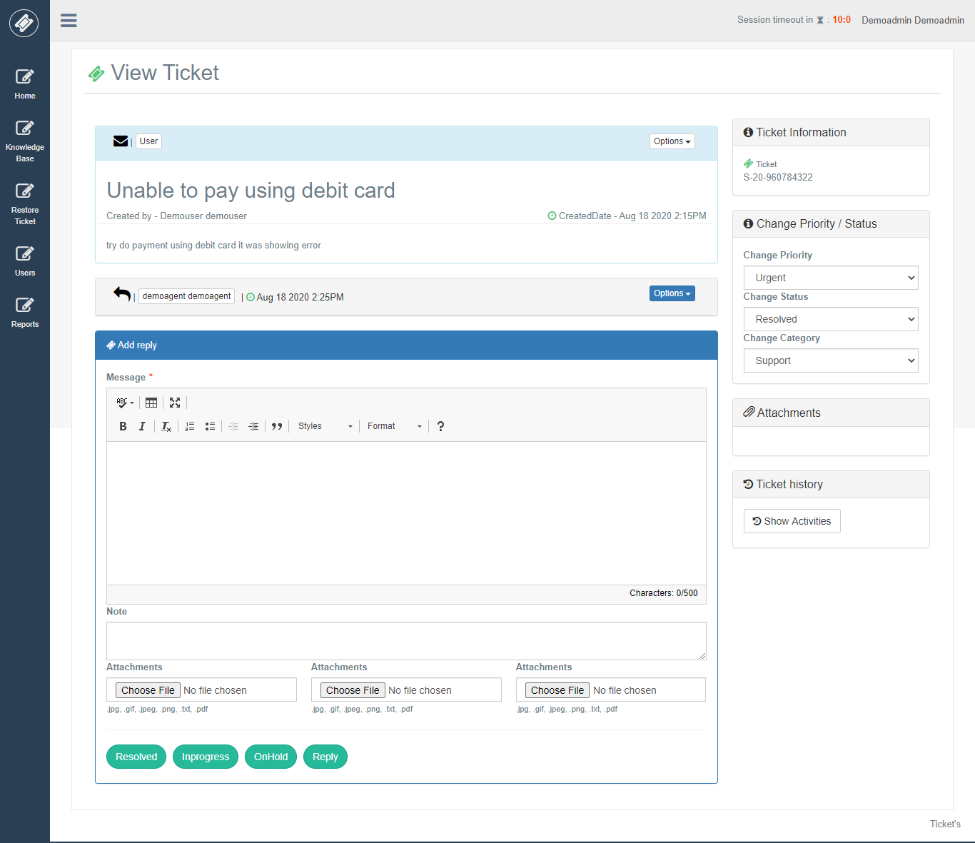

In the first panel, you can ticket details along with other information related to the ticket. In add reply panel Admin can reply on the ticket. If Admin wants to give an internal note on the ticket, then Admin can use the “Note” text area which can be View by agents and agent admin. Also, in reply, Admin can attach attachments.

There are 4 buttons to reply on ticket according to status “Resolved”, “InProgress”, “On Hold”, “Reply”.

Now to the right side of the ticket view, you can see different panels.

“**Ticket Information**” in this panel you can see ticket tracking id.

“**Change Priority / Status** “in this panel you can change Priority, Category, Status of Main Ticket.

“**Attachments**” in this panel you can see all attachment of ticket attached by User.

**Replying on Ticket**

For replying on the Admin will enter a message in Editor and click on below buttons for the demo we are going to click on “**Resolved**” button.

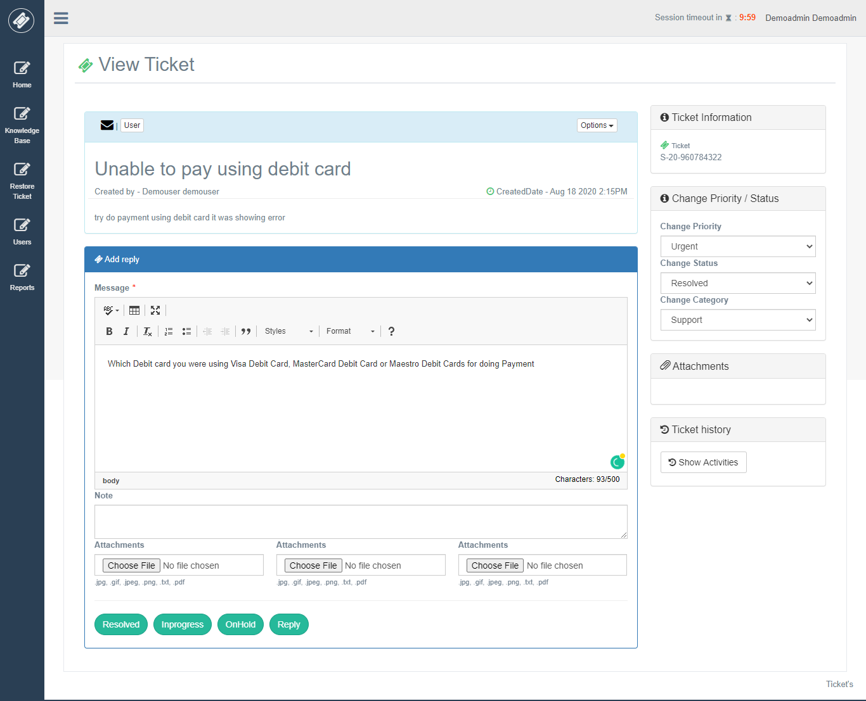

Confirmation is shown before replying on the ticket.

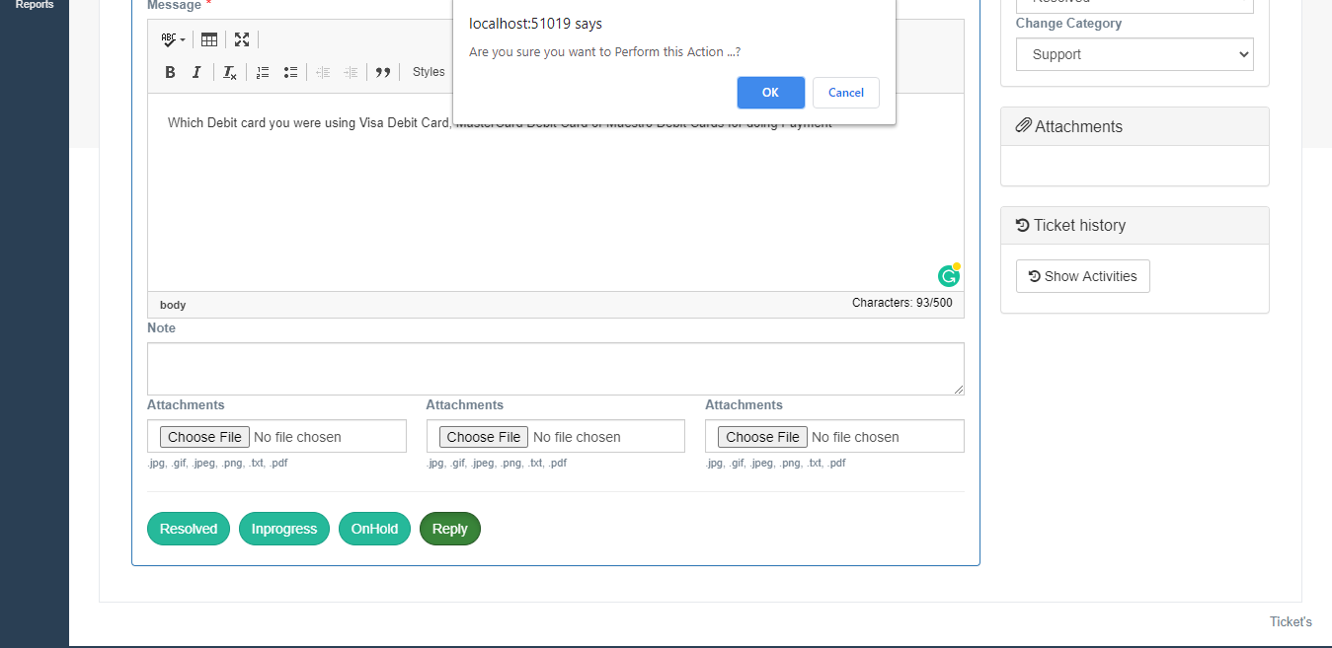

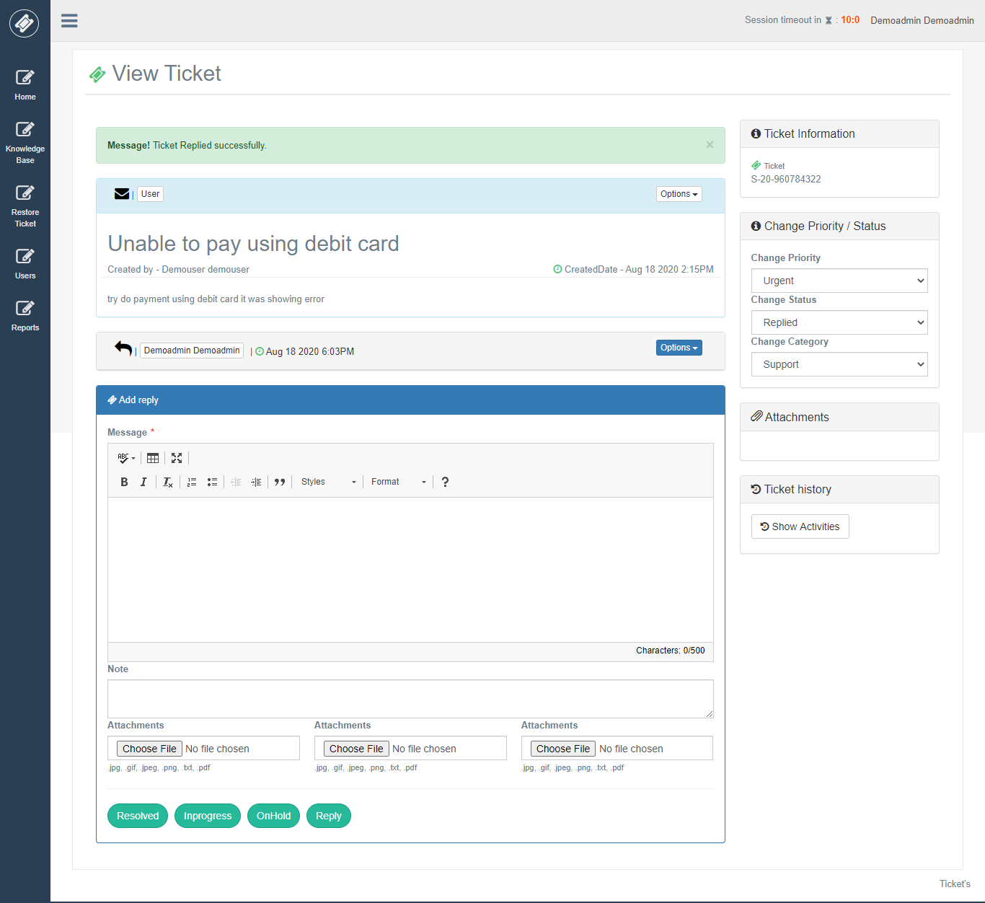

**Ticket History**

After clicking on the ticket history button, it will show all details of ticket activity.

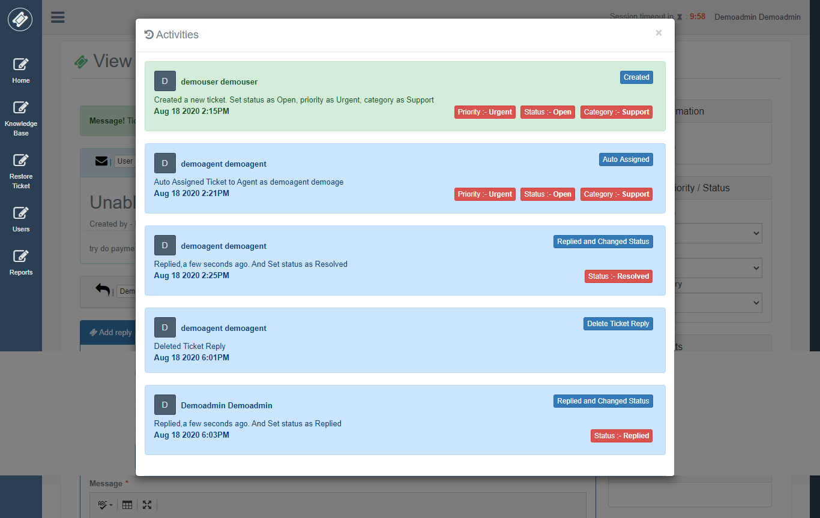

**Create Users**

If Admin wants to create a ticket then need to create User first, it does not exist else, he can choose from existing users to create a ticket.

After Admin creates, the new user Admin will get user name which is system generated in alert which he can share to User on behalf which he had created ticket. Else Admin can also see a list of all created users where he can search newly created User by him.

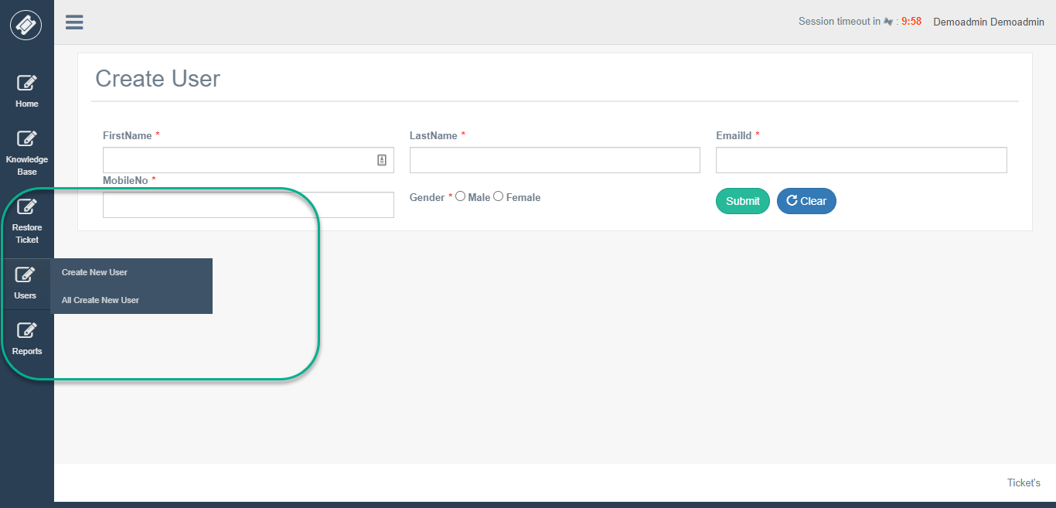

**Create Ticket feature for Agent’s**

An Admin can create a ticket for existing users or create a new user and then while Admin is creating ticket Admin can select the name of User which he has created or already exists.

After selecting a name, Admin needs to fill necessary details and choose category and priority and enter your query in the Message Editor, attach a document if you want to send.

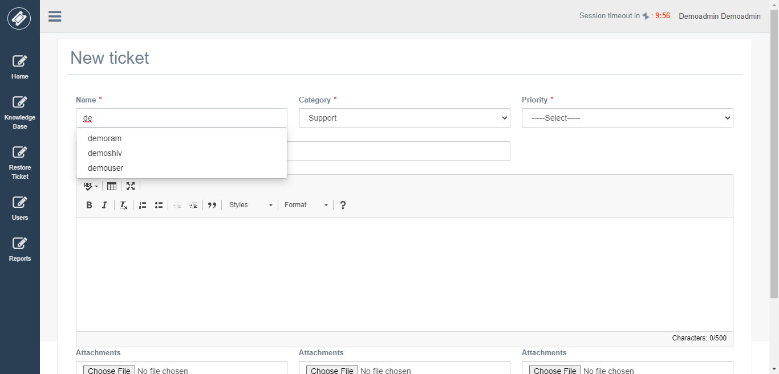

After creating a ticket, this ticket will be auto-assign to Agent according to the category chosen while creating a ticket.

**Knowledge Base**

An Admin can add new knowledge base article.

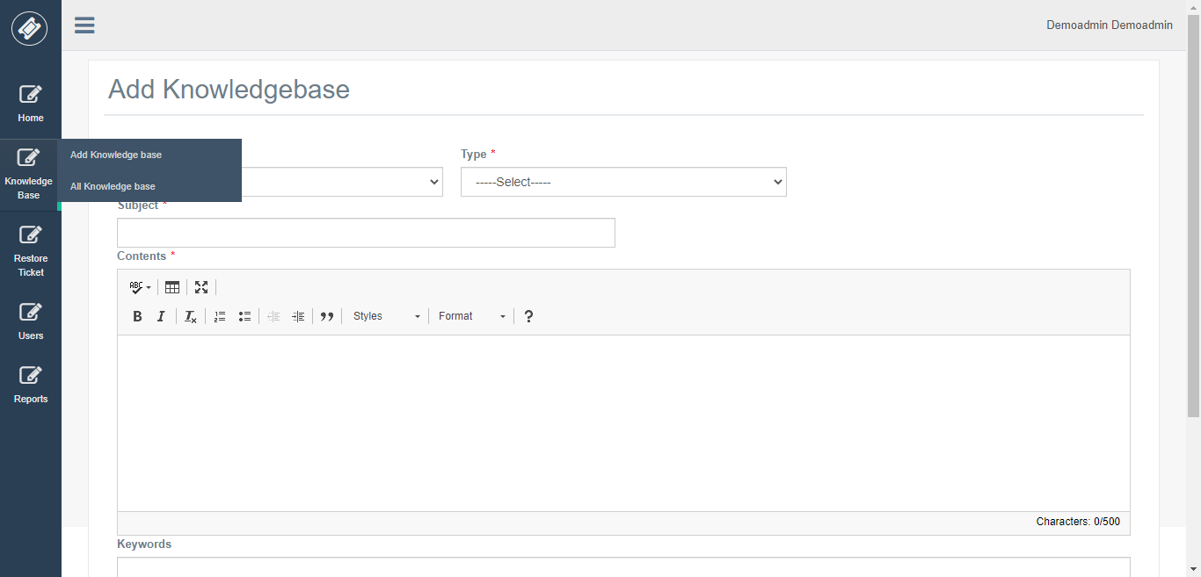

**Delete & Restore Ticket’s**

If you click on any tile, you can see all tickets with that status right.

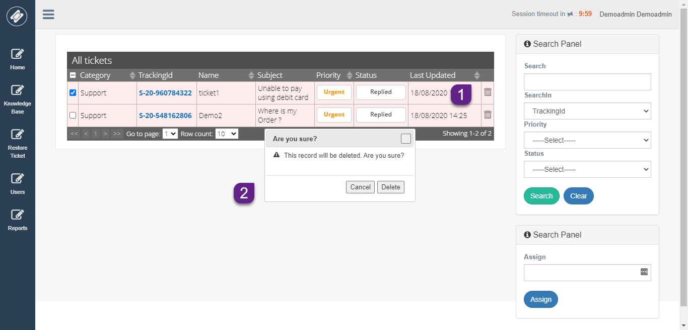

From this above View, Admin can delete ticket by clicking on delete button from the grid.

If Admin deleted ticket mistakenly, he could restore ticket by selecting Restore Ticket Menu.

On this View, you can see grid view with all deleted ticket by Admin to restore this ticket just check the checkbox of a particular row and select “Restore” button from Advance panel.

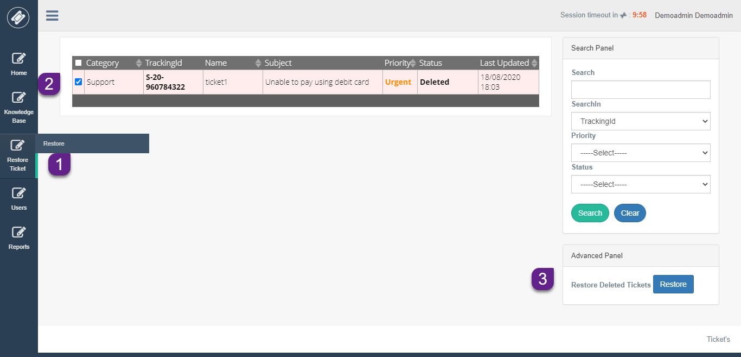

This ticket will be restored to the same status which it was before deleting.

**Reports**

Admin has a report feature. He can view the report of all category.

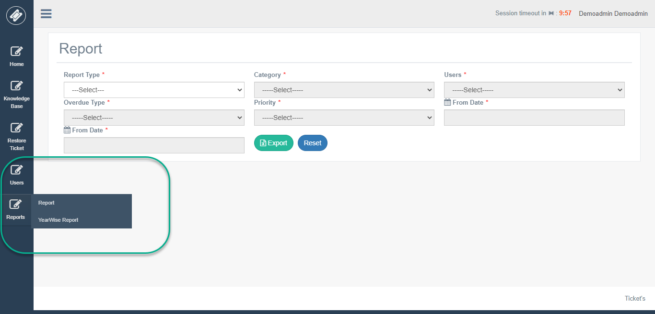

There are different types of report Admin can view.

**Report**

1. Agent Wise Ticket Status Report
2. Category Wise Ticket Status Report
3. Ticket Overdue Status Report
4. Ticket Overdue User Wise Report
5. Ticket Escalation Report
6. Ticket Deleted Report
7. Priority Wise Ticket Status Report
8. Agent Detail Report
9. User Wise Check-in Checkout Report
10. Agent Working Hours Year Wise Report

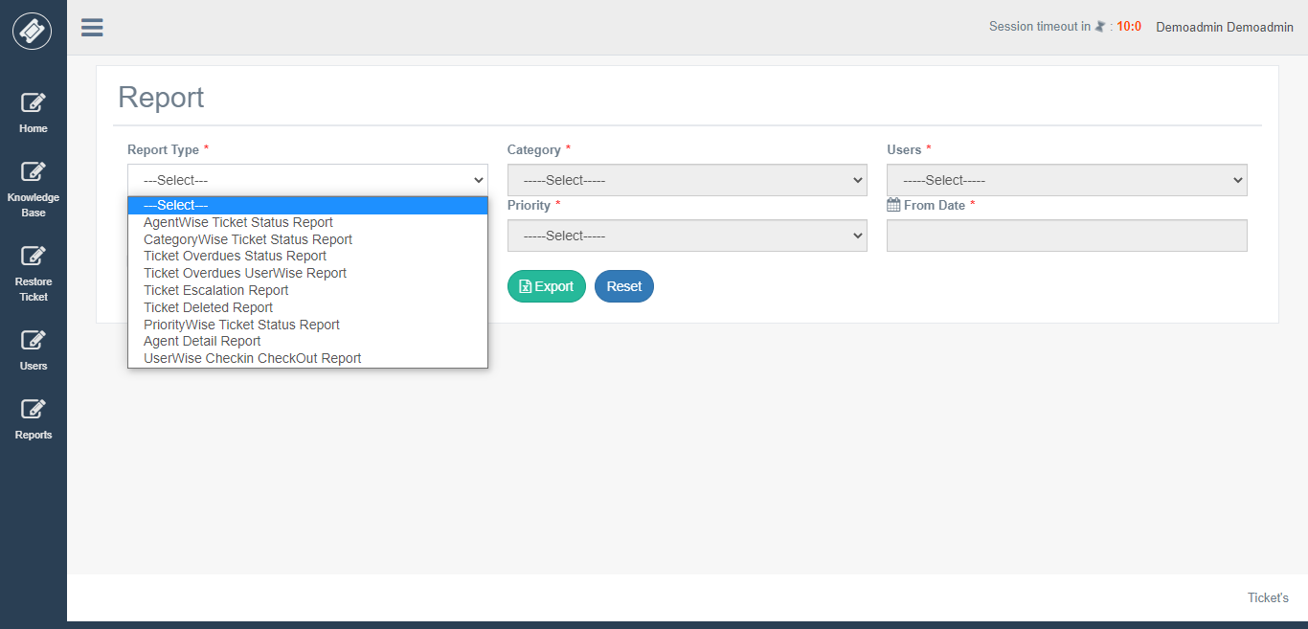

**Agent Wise Ticket Status Report**

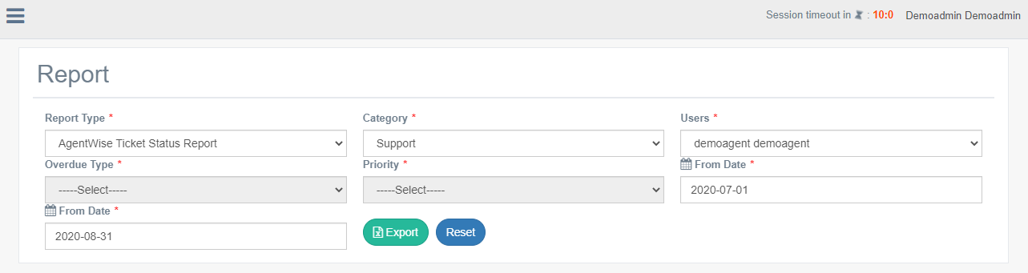

**Output**

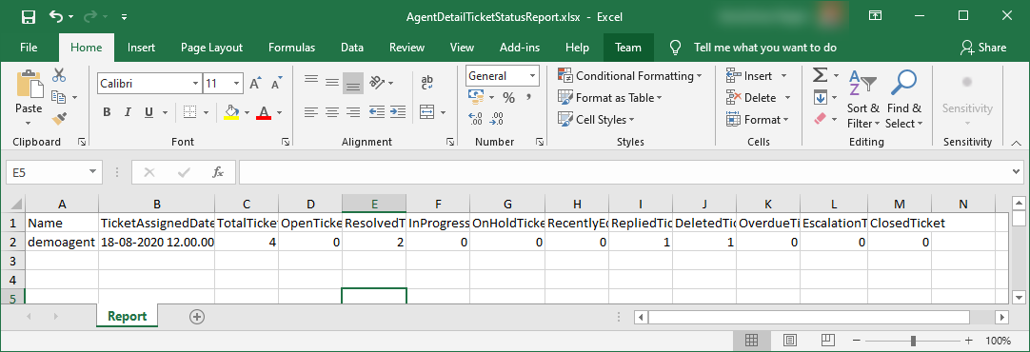

**Category Wise Ticket Status Report**

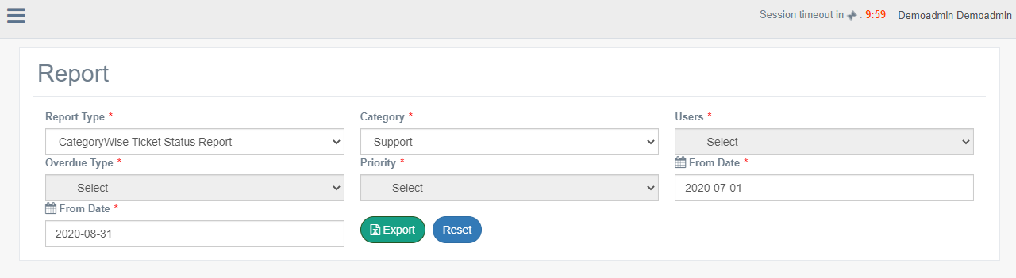

**Output**

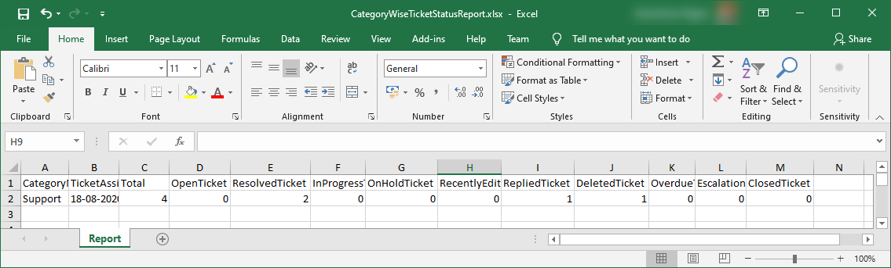

**Ticket Overdue Status Report**

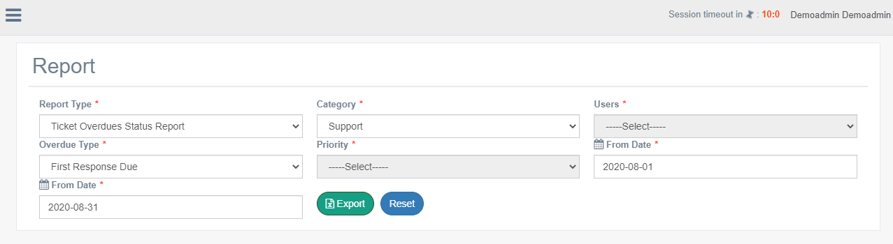

**Output**

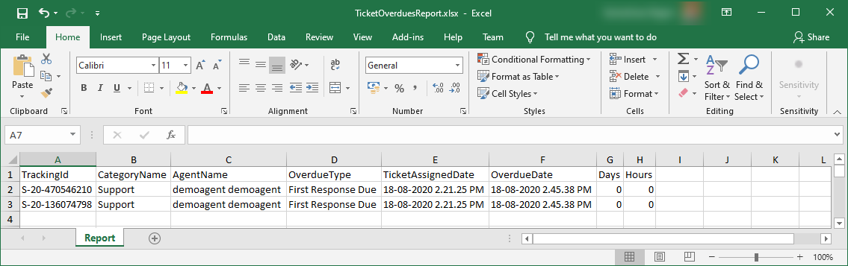

**Ticket Overdue User Wise Report**

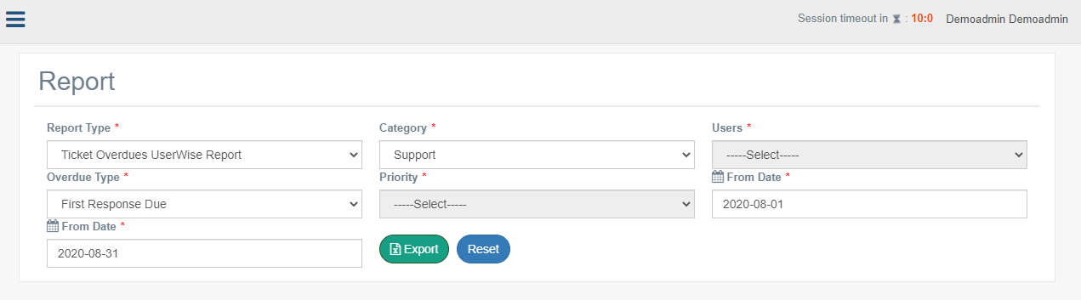

**Output**

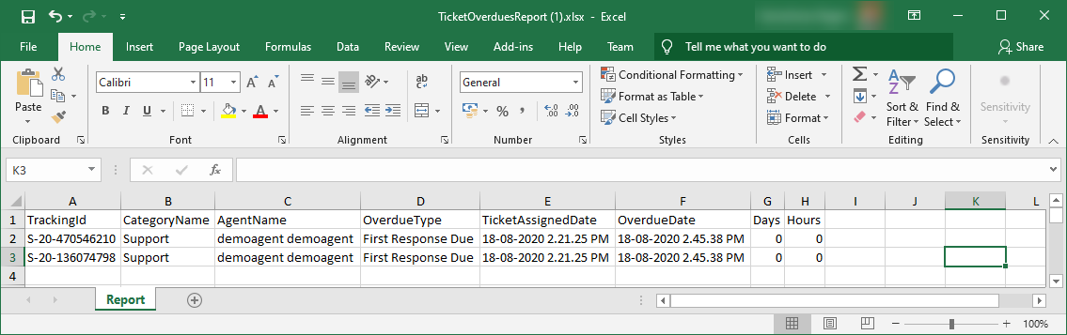

**Ticket Escalation Report**

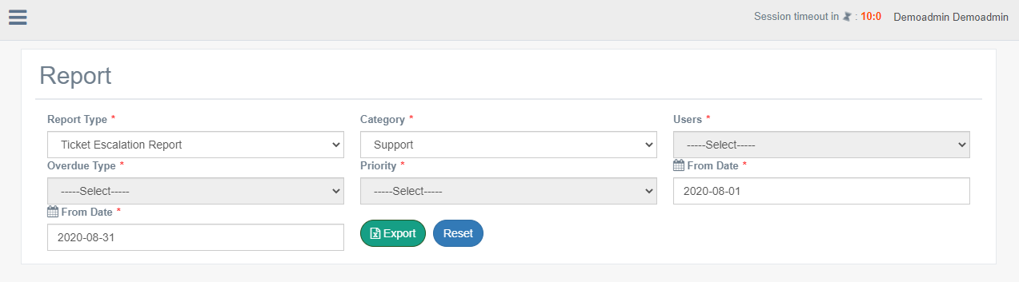

**Output**

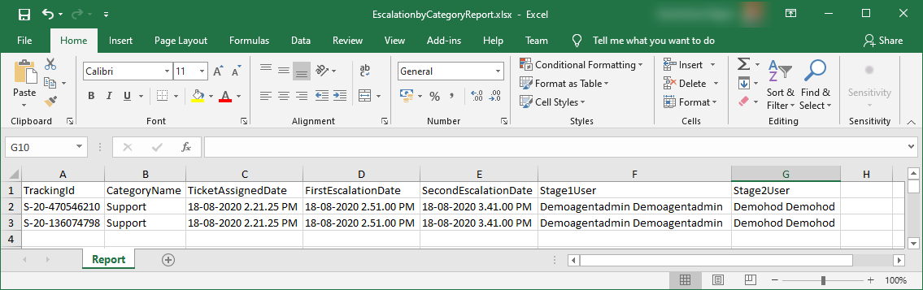

**Ticket Deleted Report**

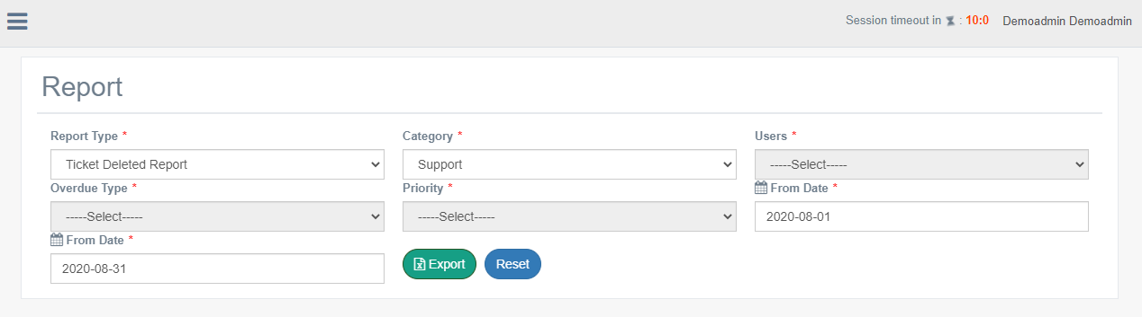

**Output**

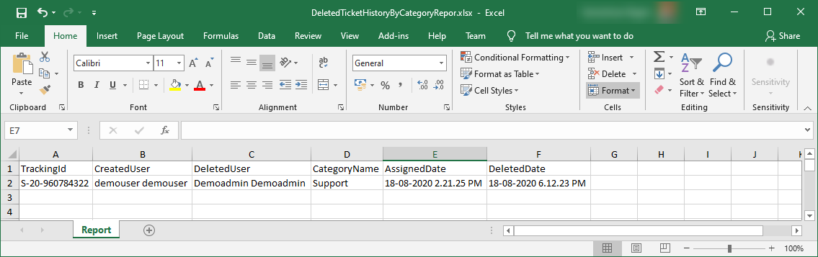

**Priority Wise Ticket Status Report**

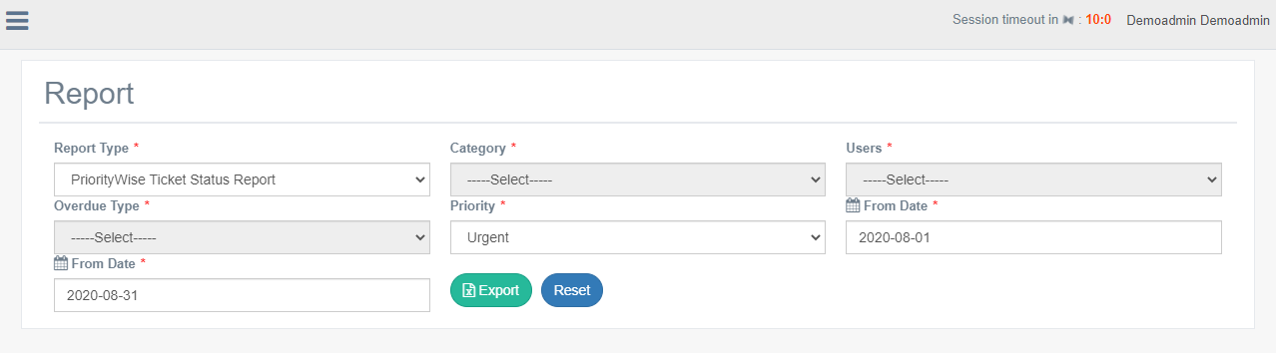

**Output**

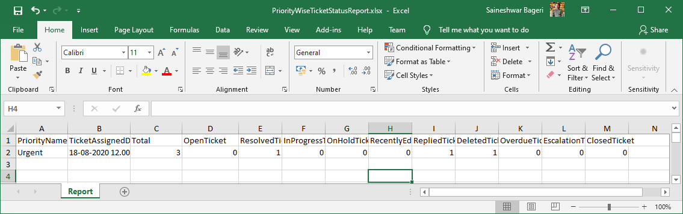

**Agent Detail Report**

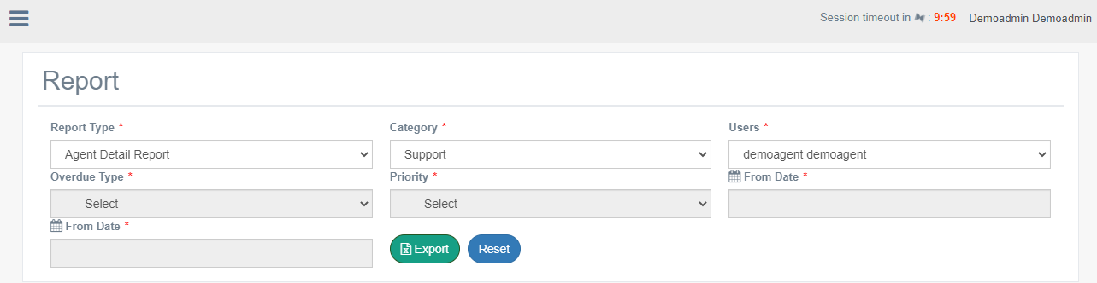

**Output**

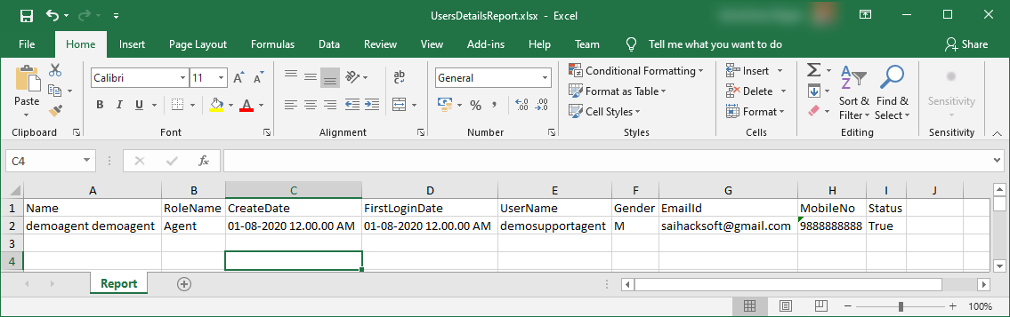

**User Wise Check-in Check-out Report**

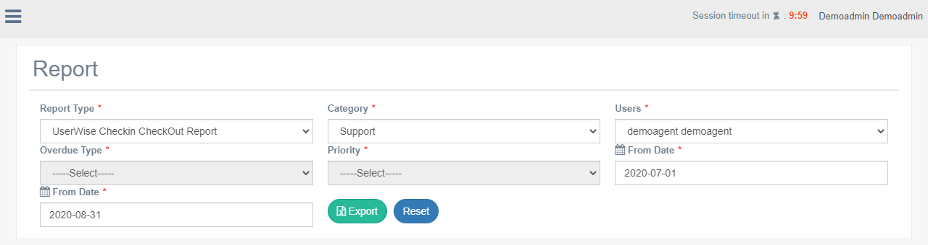

**Output**

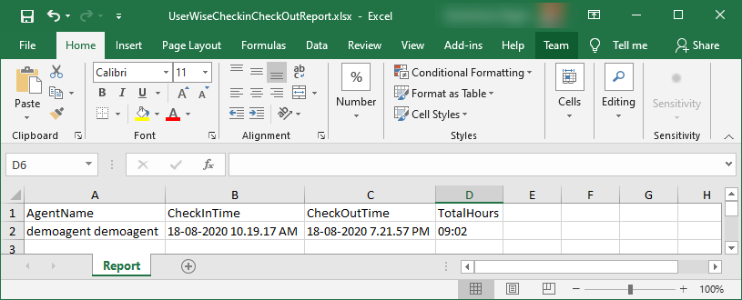

**Agent Working Hours Year Wise Report**

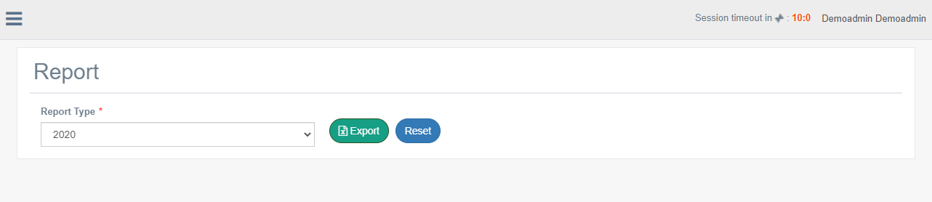

**Output**

