Support Ticket Application

Let’s see what Role of **AgentAdmin** in this Application is.

1. Login
2. Dashboard with Status Counts
3. View All Tickets
4. Ticket Detail View
5. Replying on Ticket
6. Ticket History
7. Create User
8. Create Ticket
9. Knowledgebase
10. Delete & Restore Ticket
11. Reports

**Login page**

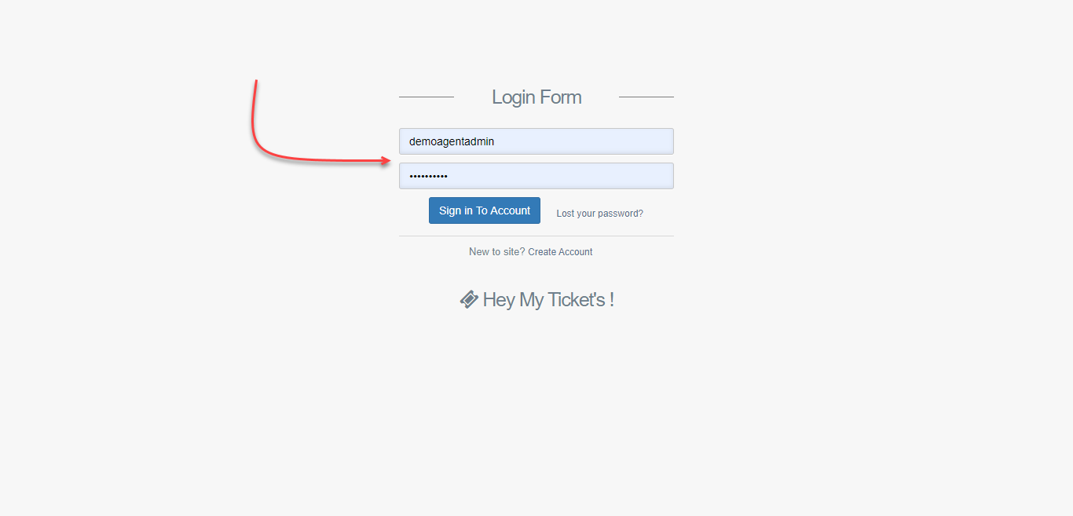

**AgentAdmin Dashboard**

After logging into Application, you are redirected to the dashboard page where you can see all tickets status in one View.

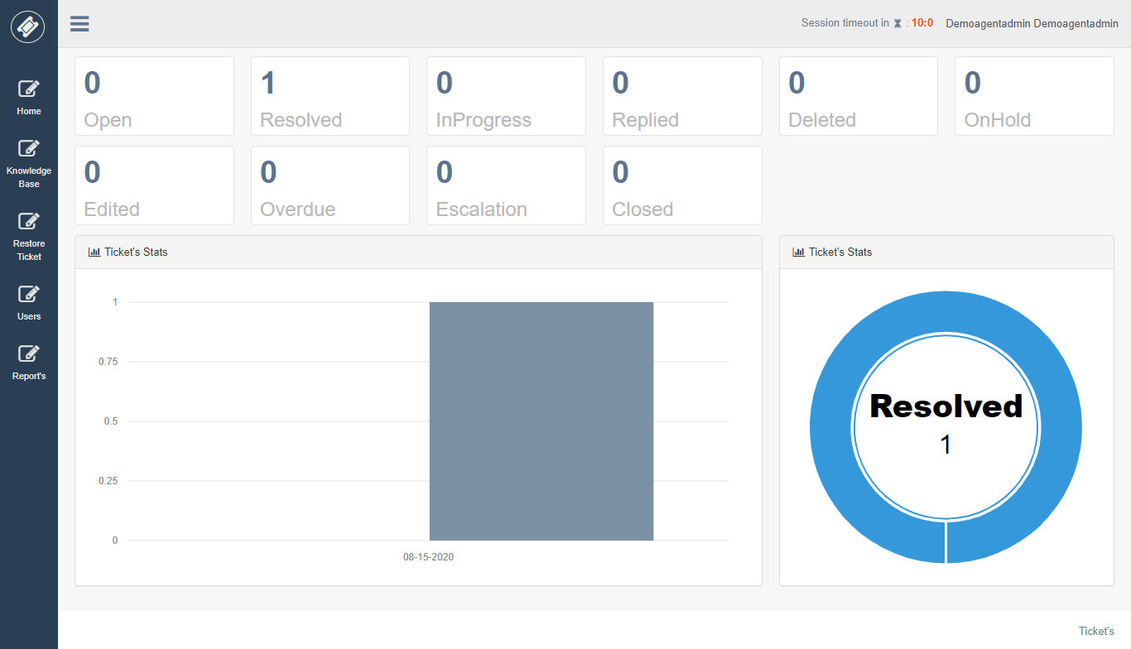

Agent admin can see all ticket assigned to agents inside his category.

**All Ticket’s**

List of tickets will be shown here along with search features.

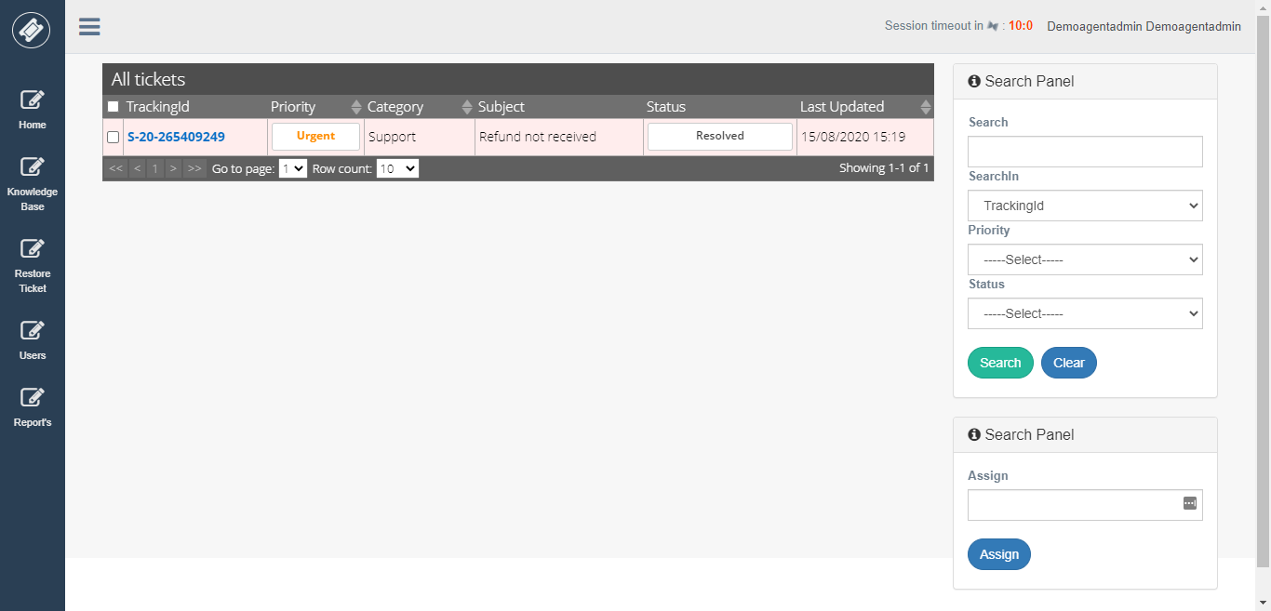

To see ticket detail view just click on Tracking id from the grid.

**Ticket Detail View**

In this View, you can see the detail information about ticket and quick options to reply ticket.

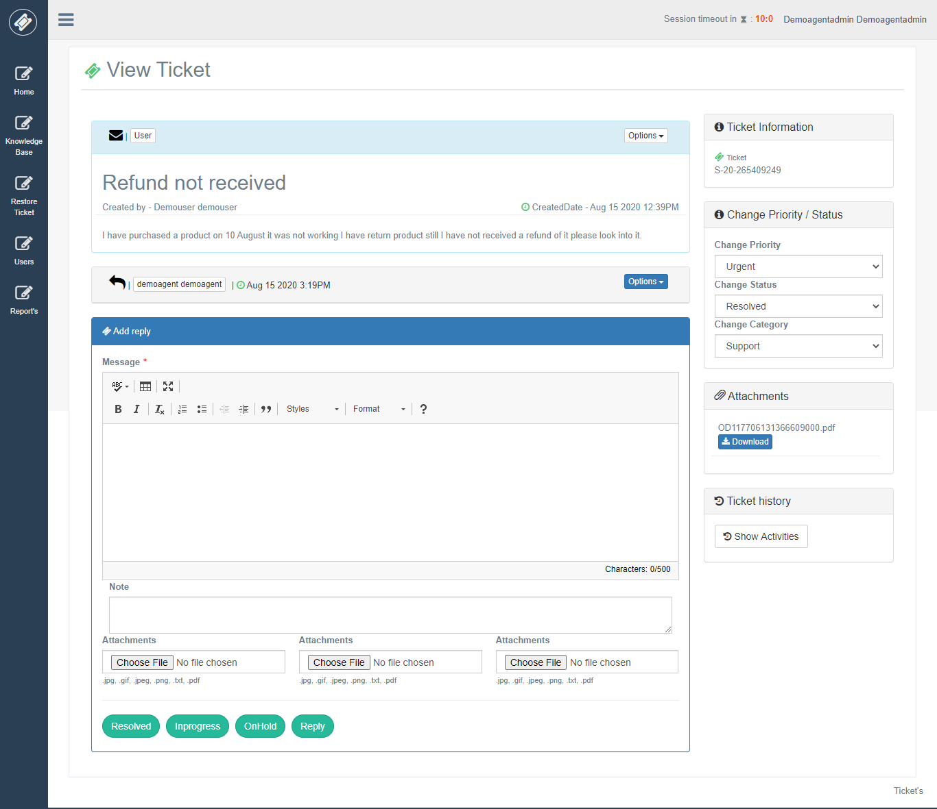

In the first panel, you can ticket details along with other information related to the ticket. In add reply panel Agent Admin can reply on the ticket. If Agent Admin wants to give an internal note on the ticket, they can use the “Note” text area which can be View by agents and agent admin. Also, in reply Agent Admin can attach attachments.

There are 4 buttons to reply on ticket according to status “Resolved”, “InProgress”, “On Hold”, “Reply”.

Now to the right side of the ticket view, you can see different panels.

“**Ticket Information**” in this panel you can see ticket tracking id.

“**Change Priority / Status** “in this panel you can change Priority, Category, Status of Main Ticket.

“**Attachments**” in this panel you can see all attachment of ticket attached by User.

**Replying on Ticket**

For replying on the ticket Agent Admin will enter a message in Editor and click on below buttons for the demo we are going to click on “**Resolved**” button.

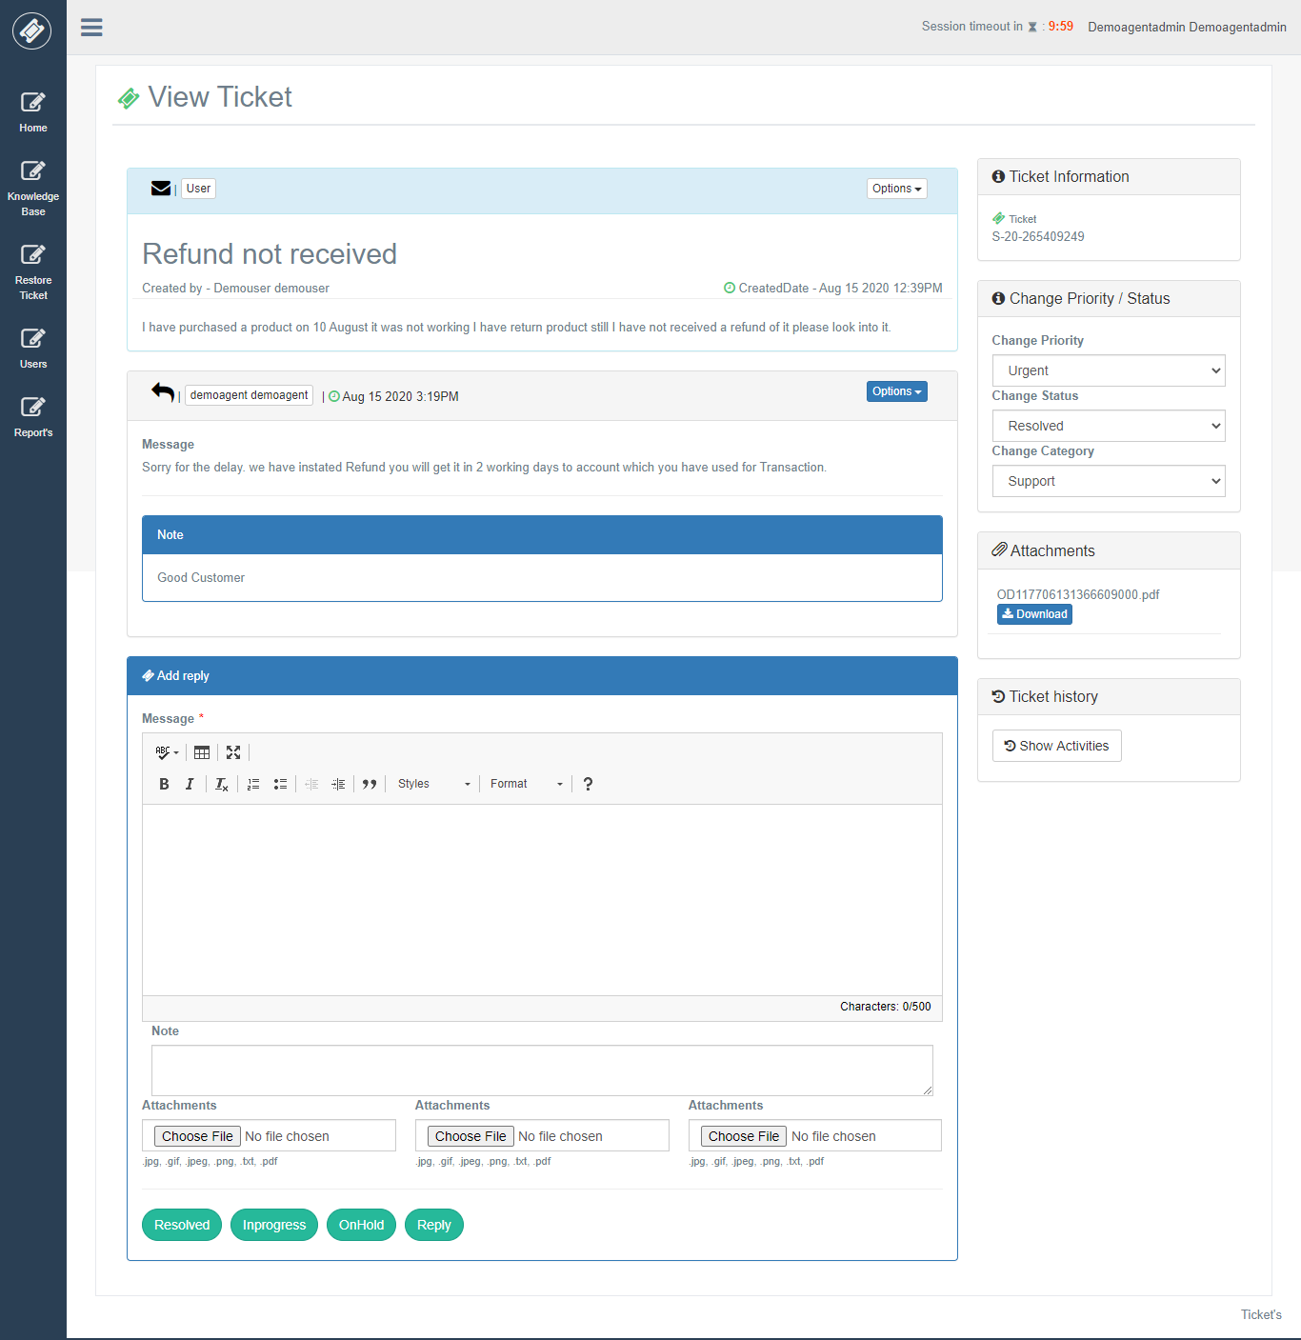

Confirmation is shown before replying on the ticket.

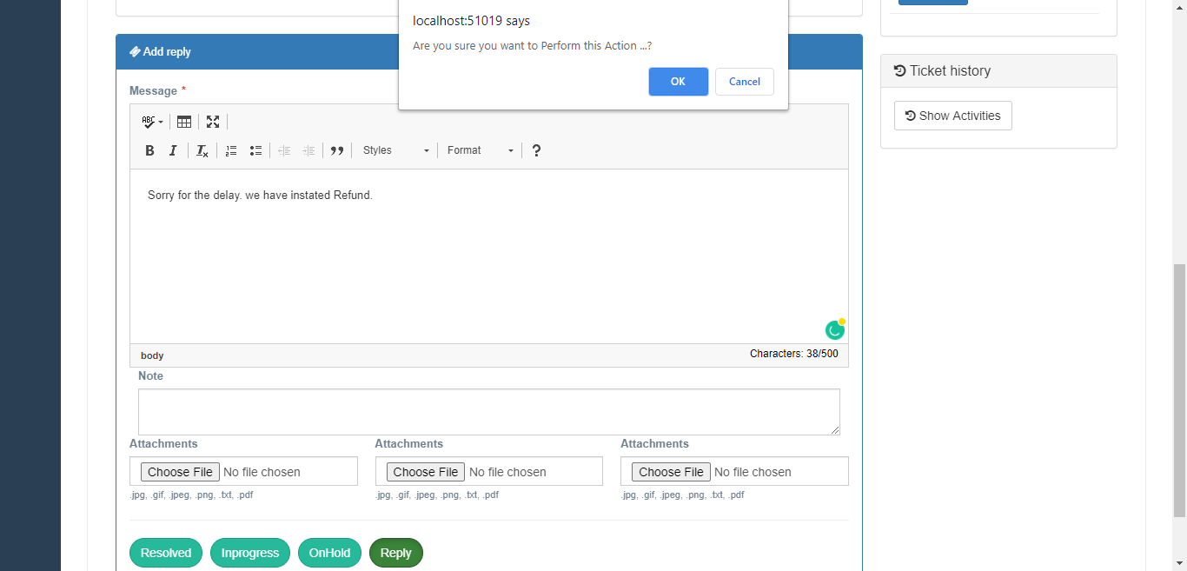

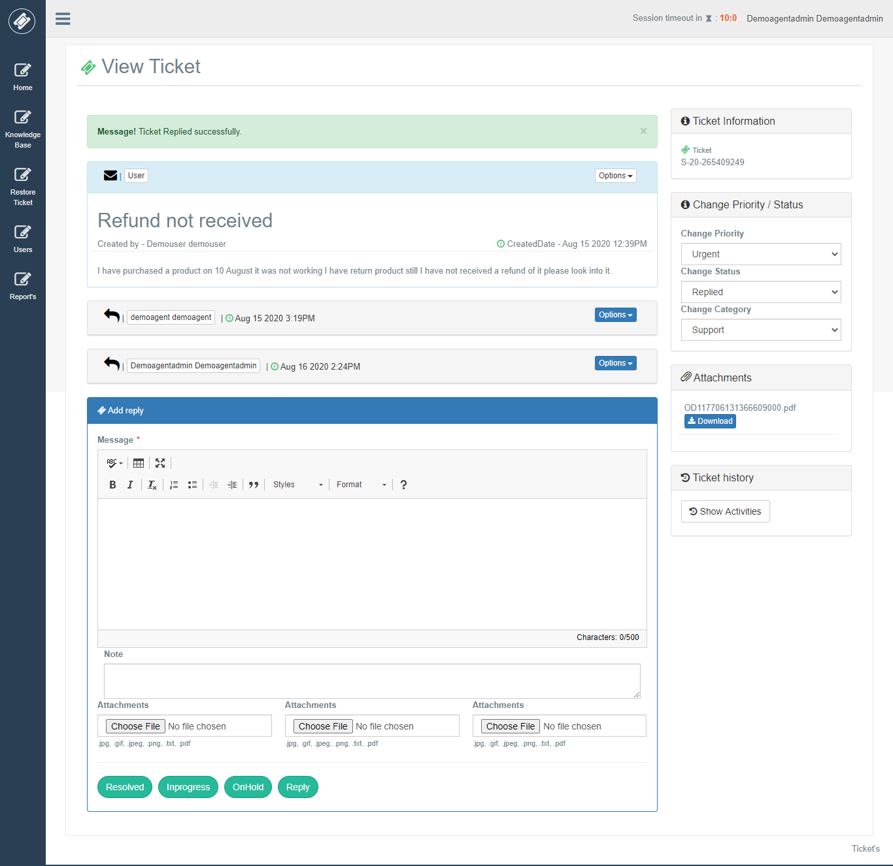

**Ticket History**

After clicking on the ticket history button, it will show all details of ticket activity.

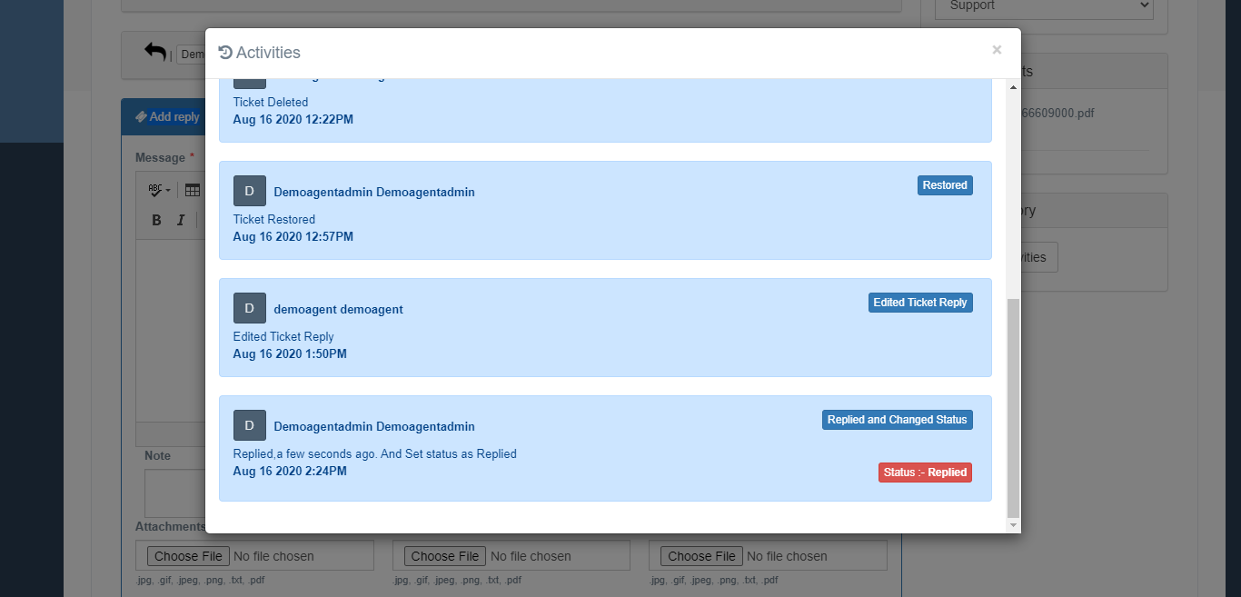

**Create Users**

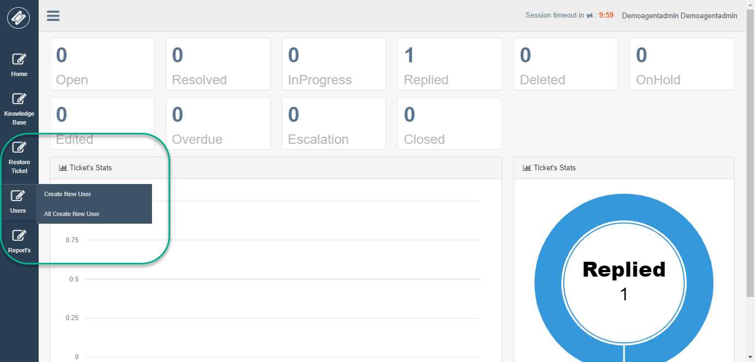

If Agent Admin wants to create a ticket then need to create User first, it does not exist else, he can choose from existing users to create a ticket.

After Agent Admin creates, the new user Agent Admin will get user name which is system generated in alert which he can share to User on behalf which he had created ticket. Else Agent Admin can also see a list of all created users where he can search newly created User by him.

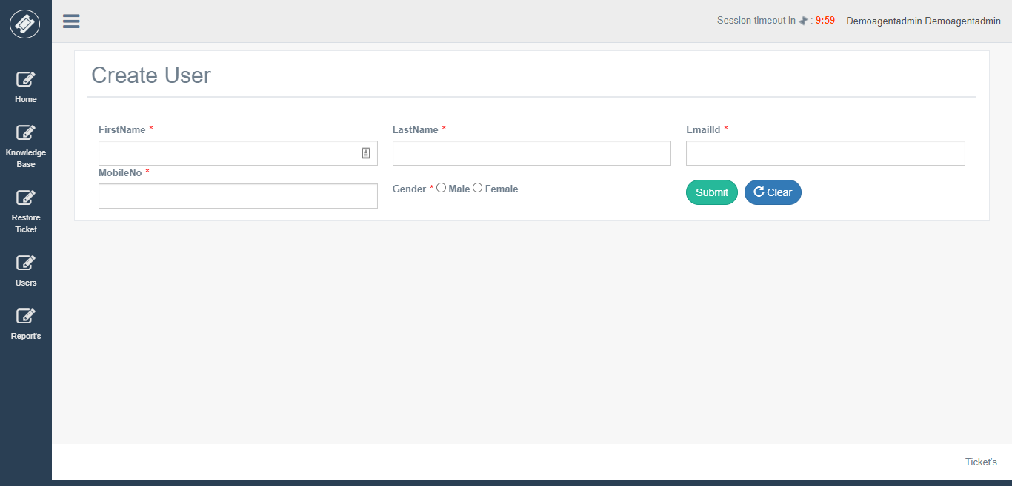

**Create Ticket feature for Agent’s**

An Agent Admin can create a ticket for existing users or create a new user and then while Agent Admin is creating ticket Agent Admin can select the name of User which he has created or already exists.

After selecting a name, Agent Admin needs to fill necessary details and choose category and priority and enter your query in the Message Editor, attach a document if you want to send.

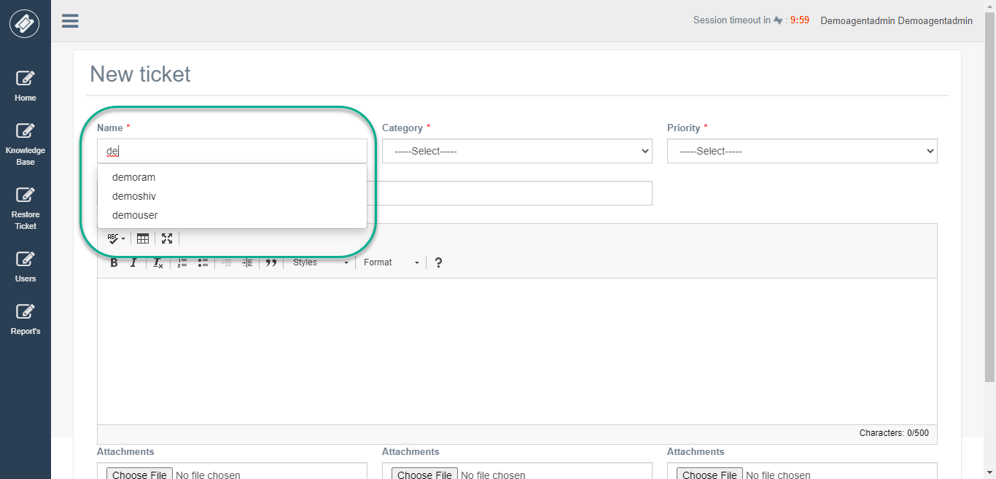

After creating a ticket, this ticket will be auto-assign to Agent according to the category chosen while creating a ticket.

**Knowledge Base**

An Agent Admin can add new knowledge base article.

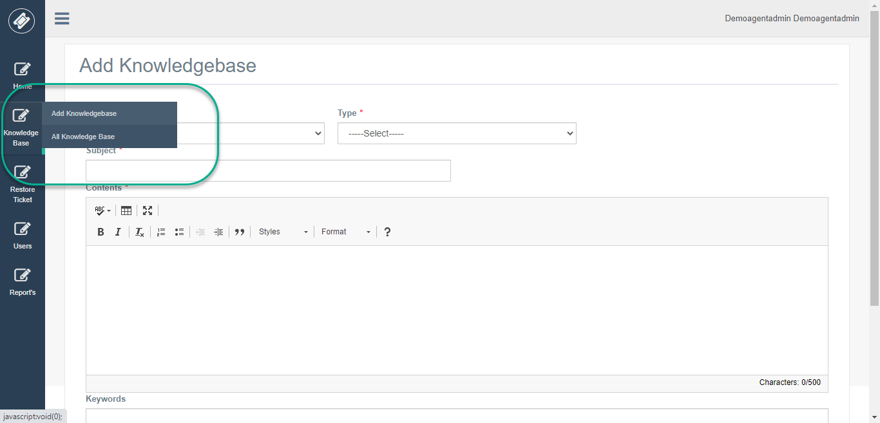

**Delete & Restore Ticket’s**

If you click on any tile, you can see all tickets with that status right.

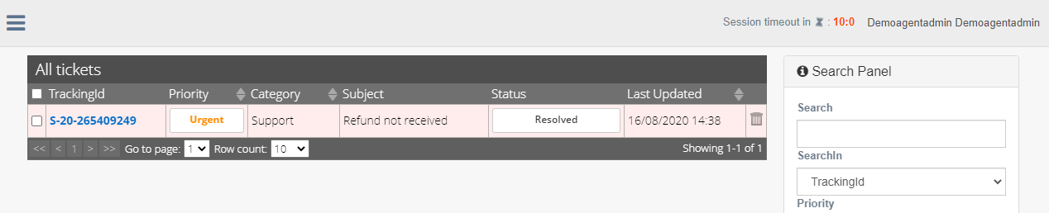

Here I have clicked on the resolved tile which is displaying records with resolved status.

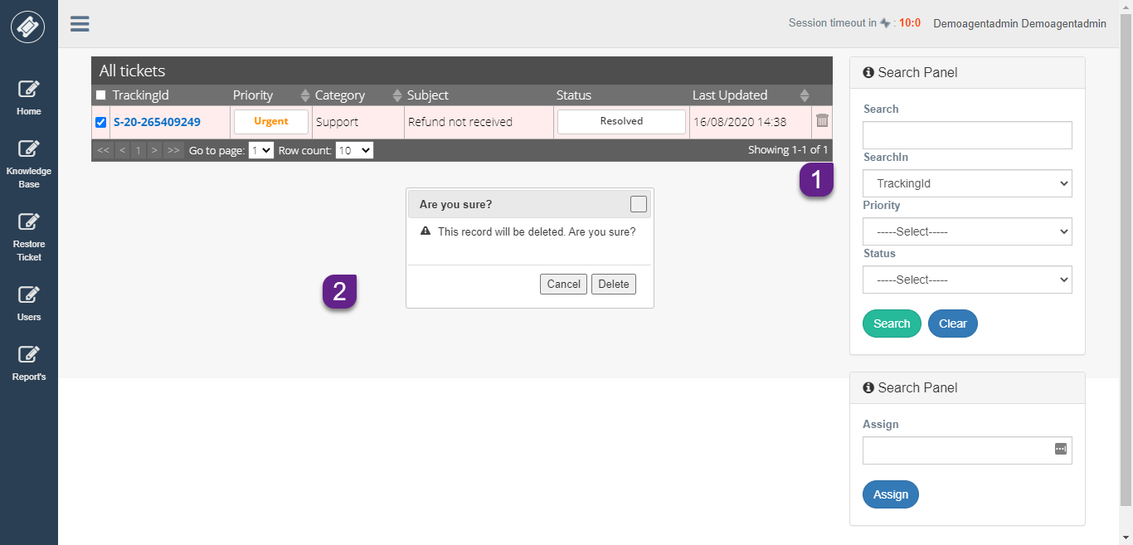

From this above View, AgentAdmin can delete ticket by clicking on delete button from the grid.

If Agent Admin deleted ticket mistakenly, he could restore ticket by selecting Restore Ticket Menu.

On this View, you can see grid view with all deleted ticket by Agent Admin to restore this ticket just check the checkbox of a particular row and select “Restore” button from Advance panel.

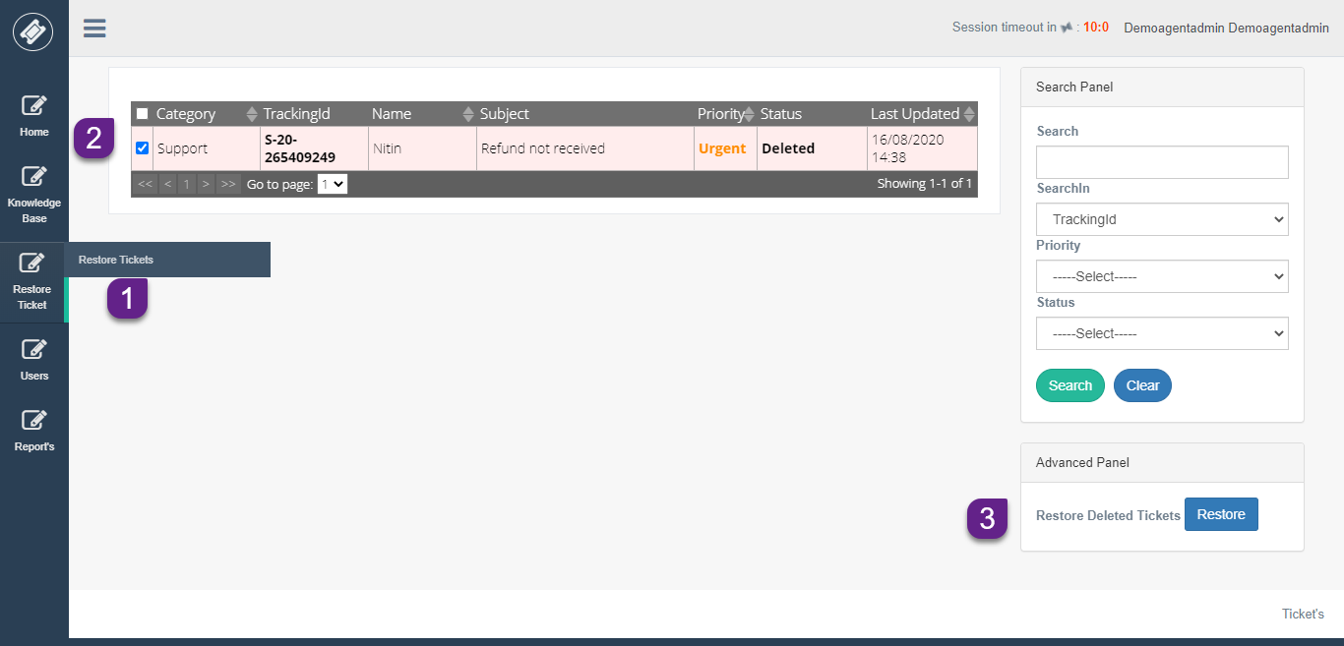

This ticket will be restored to the same status which it was before deleting.

**Reports**

Agent Admin has a report feature. He can view the report of his category. Take an example Agent Admin with report category “**support**” can see all Agents details of category “**support**”.

There are different types of report agent admin can view.

1. Agent Wise Ticket Status Report
2. Category Wise Ticket Status Report
3. Ticket Overdue Status Report
4. Ticket Overdue User Wise Report
5. Ticket Escalation Report
6. Ticket Deleted Report
7. Priority Wise Ticket Status Report
8. Agent Detail Report
9. User Wise Check-in Checkout Report

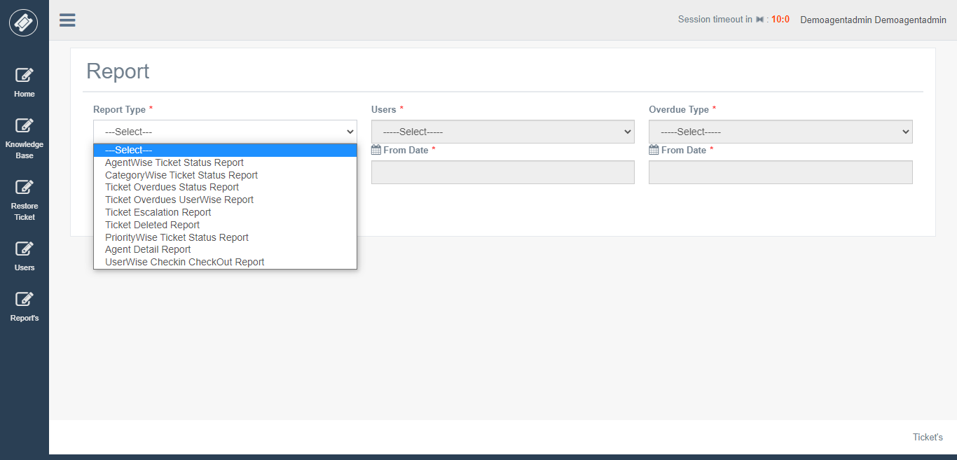

**Agent Wise Ticket Status Report**

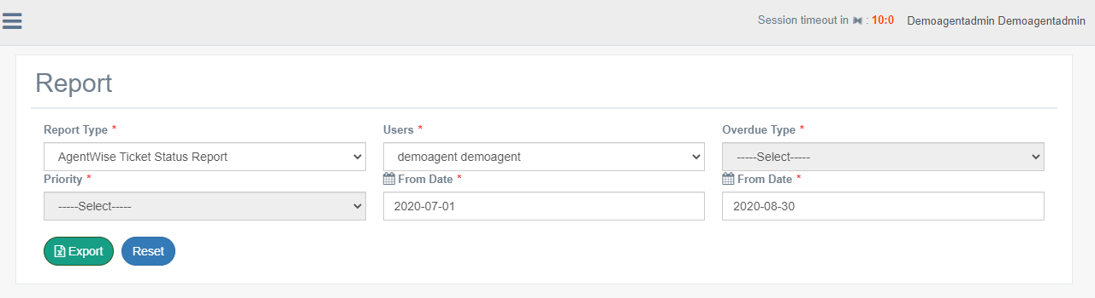

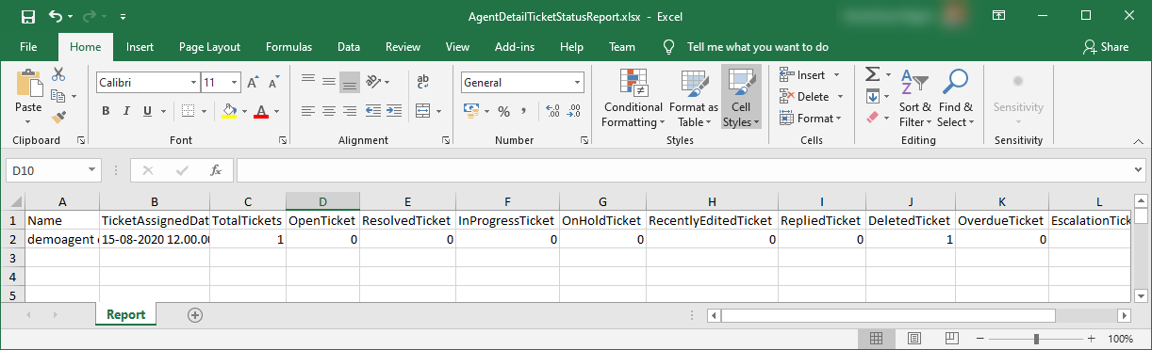

**Category Wise Ticket Status Report**

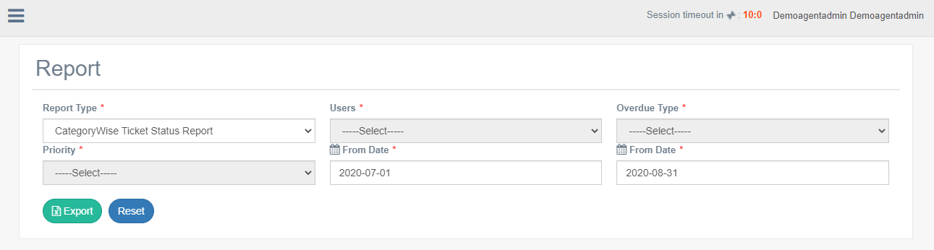

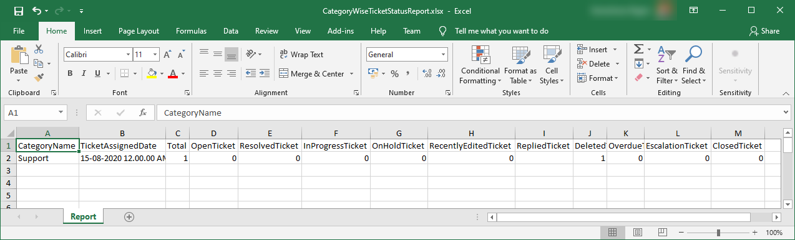

**Ticket Overdue Status Report**

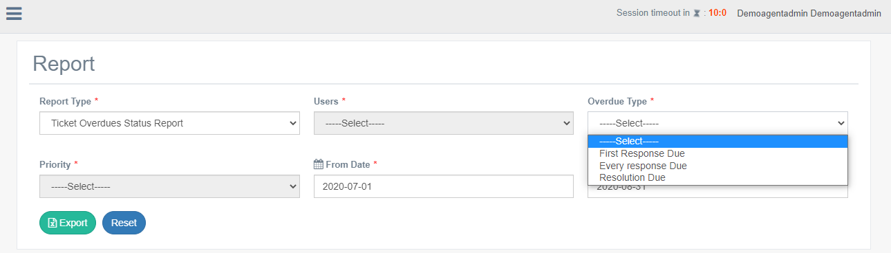

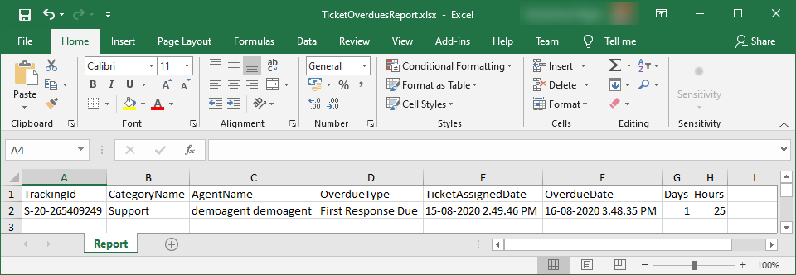

**Ticket Overdue User Wise Report**

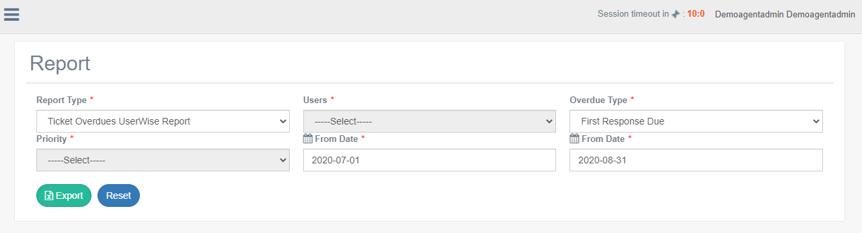

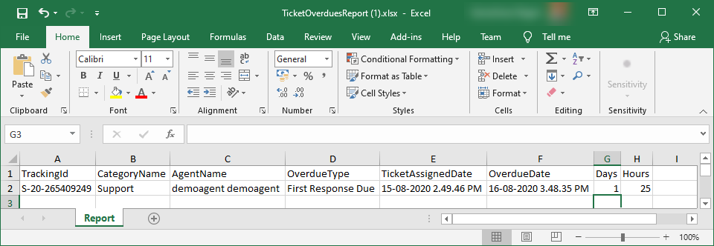

**Ticket Escalation Report**

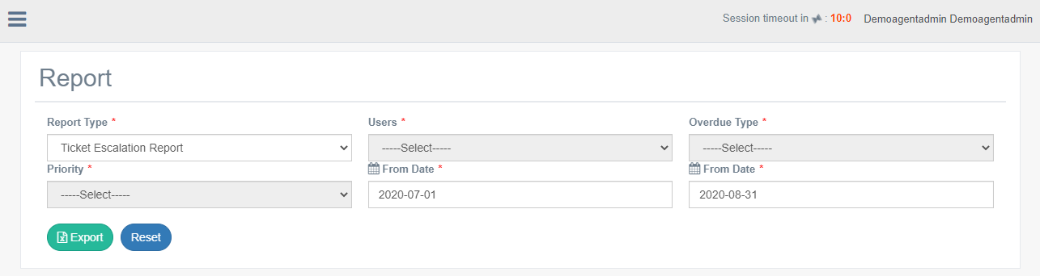

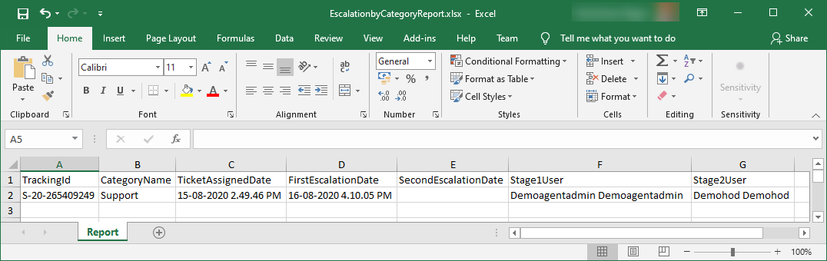

**Ticket Deleted Report**

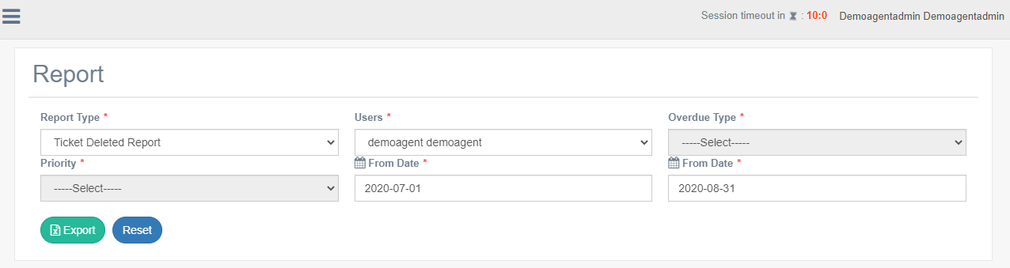

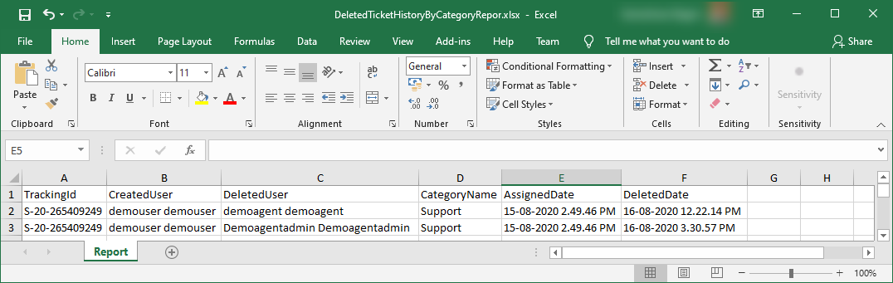

**Priority Wise Ticket Status Report**

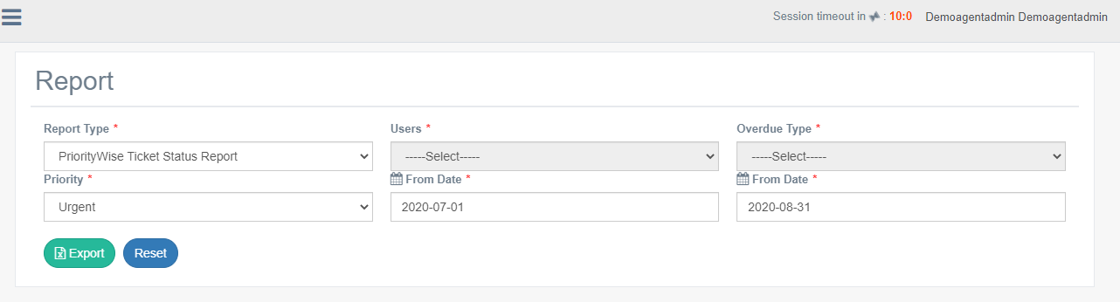

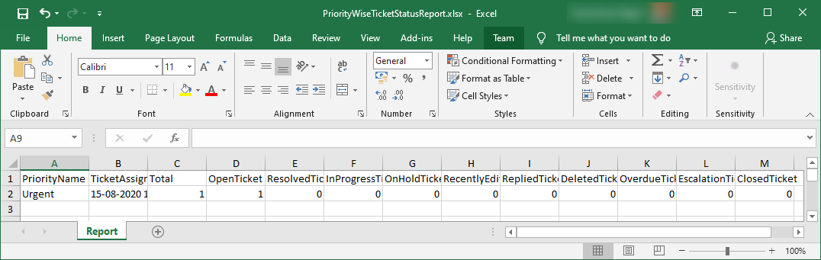

**Agent Detail Report**

