Support Ticket Application

Let’s see what Role of **Admin** in this Application is.

1. Login
2. Dashboard with Status Counts
3. View All Tickets
4. Ticket Detail View
5. Replying on Ticket
6. Ticket History
7. Knowledgebase
8. Delete & Restore Ticket’s
9. Escalation
10. Reports

**Login page**

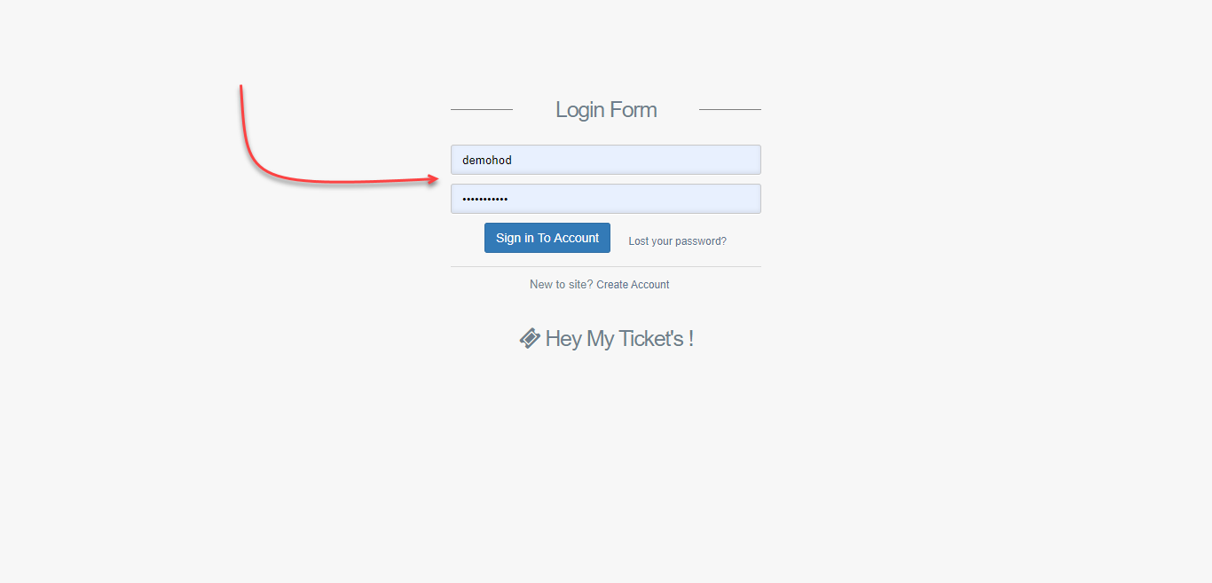

**Admin Dashboard**

After logging into Application, you are redirected to the dashboard page where you can see all tickets status in one View.

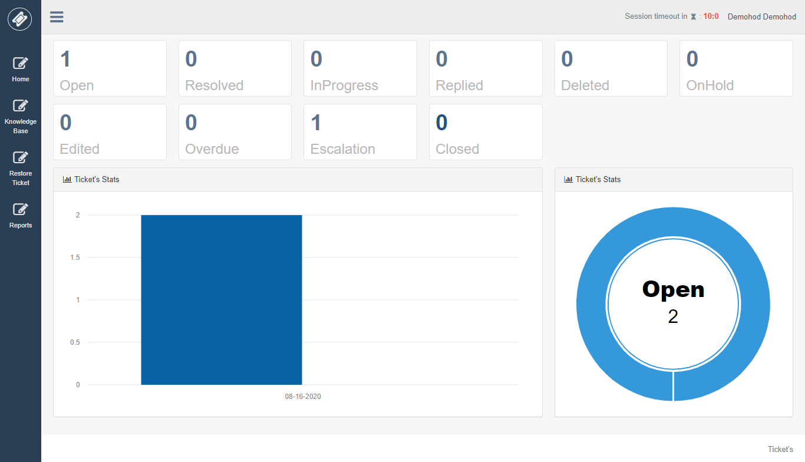

Hod can see all ticket assigned to agents inside his category.

**All Ticket’s**

List of tickets will be shown here along with search features.

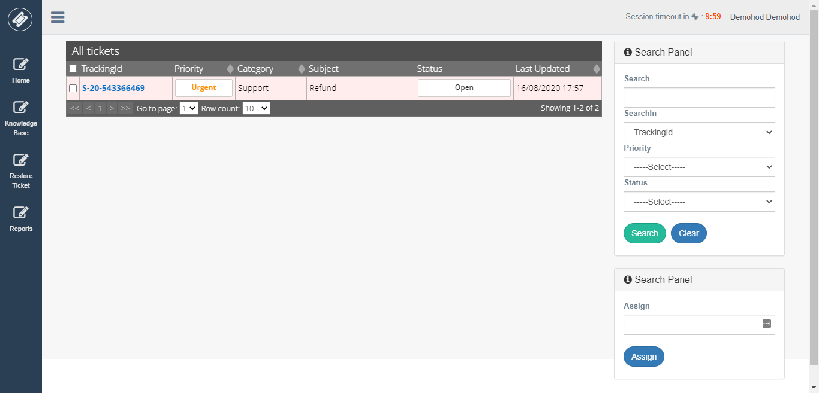

To see ticket detail view just click on Tracking id from the grid.

**Ticket Detail View**

In this View, you can see the detail information about ticket and quick options to reply ticket.

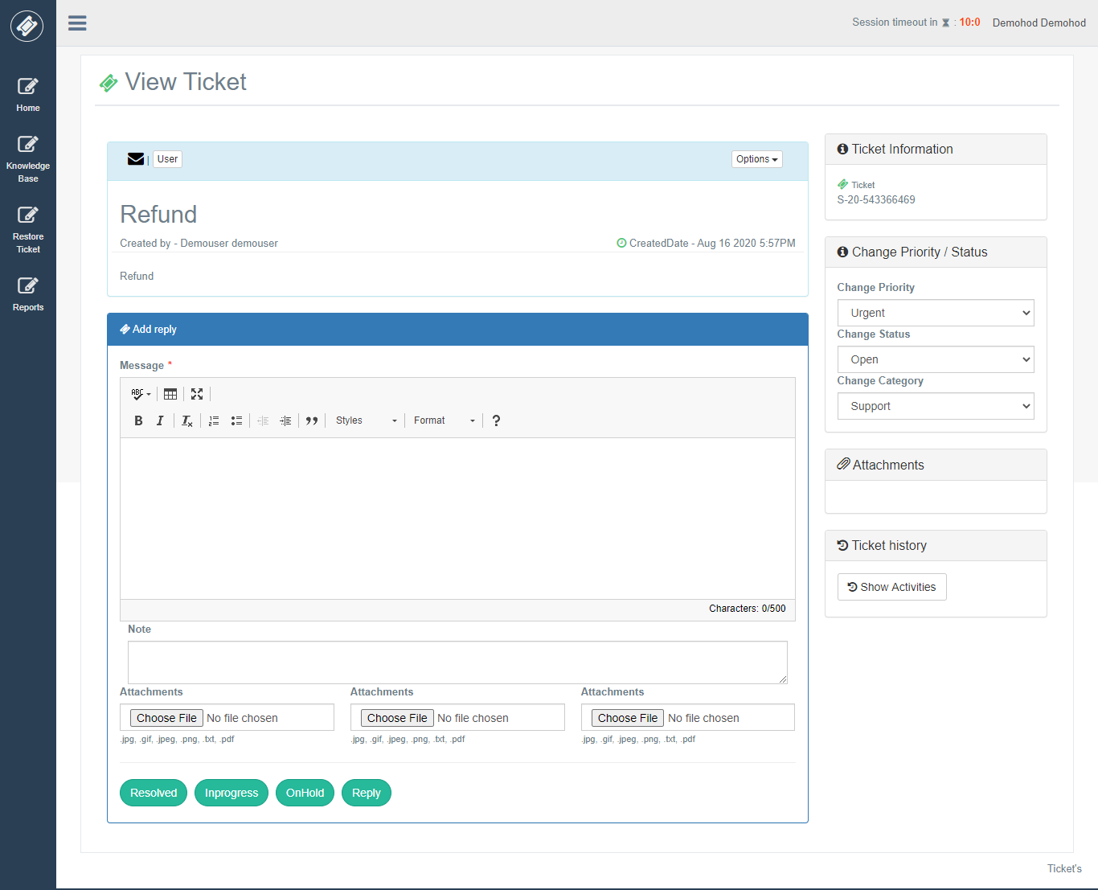

**Replying on Ticket**

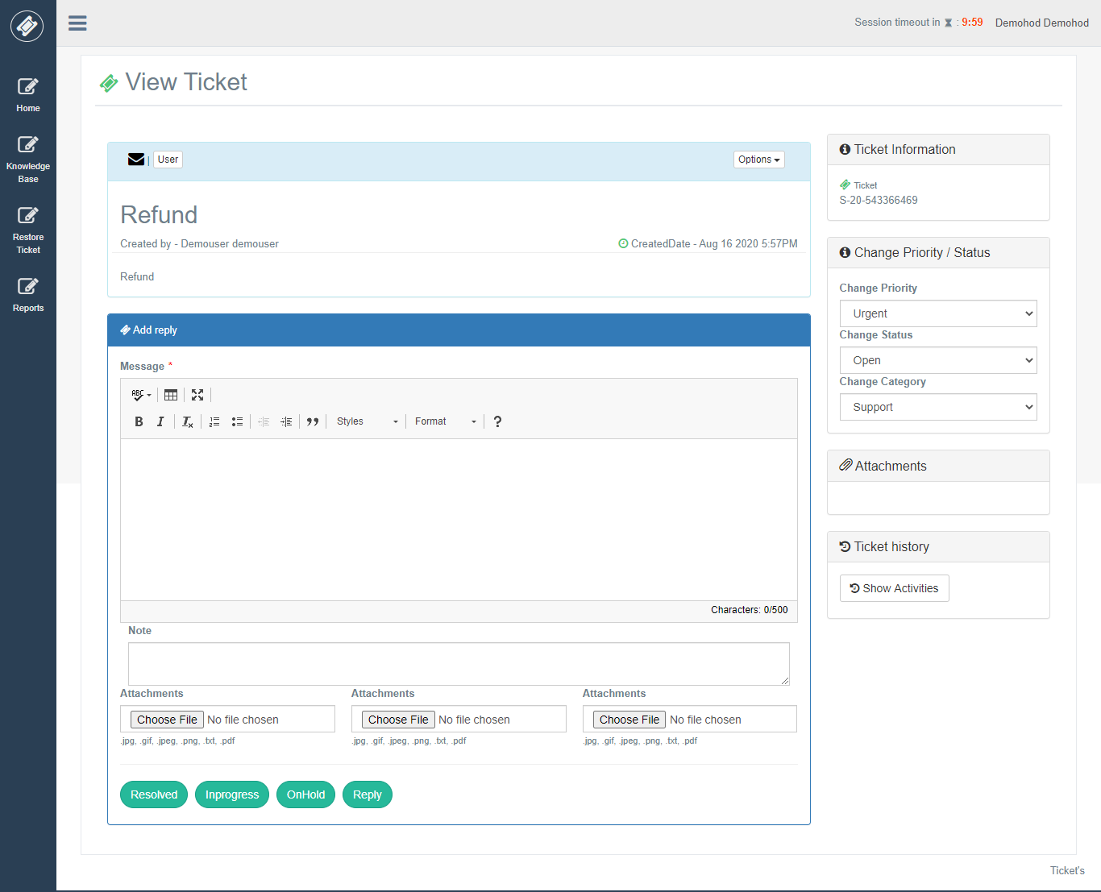

**Ticket History**

After clicking on the ticket history button, it will show all details of ticket activity.

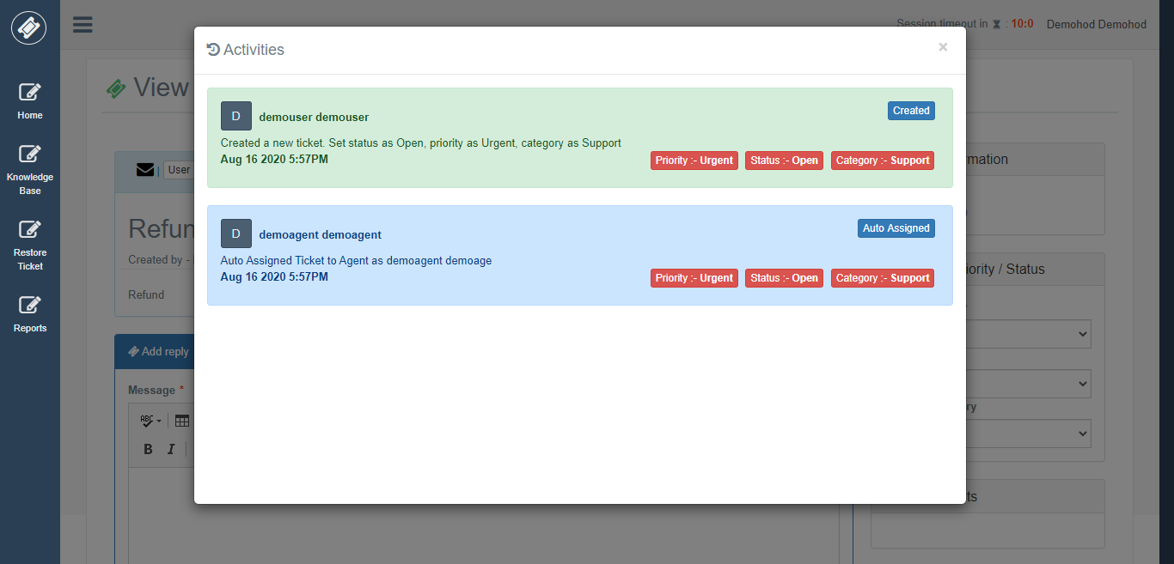

**Knowledge Base**

A HOD can add new knowledge base article.

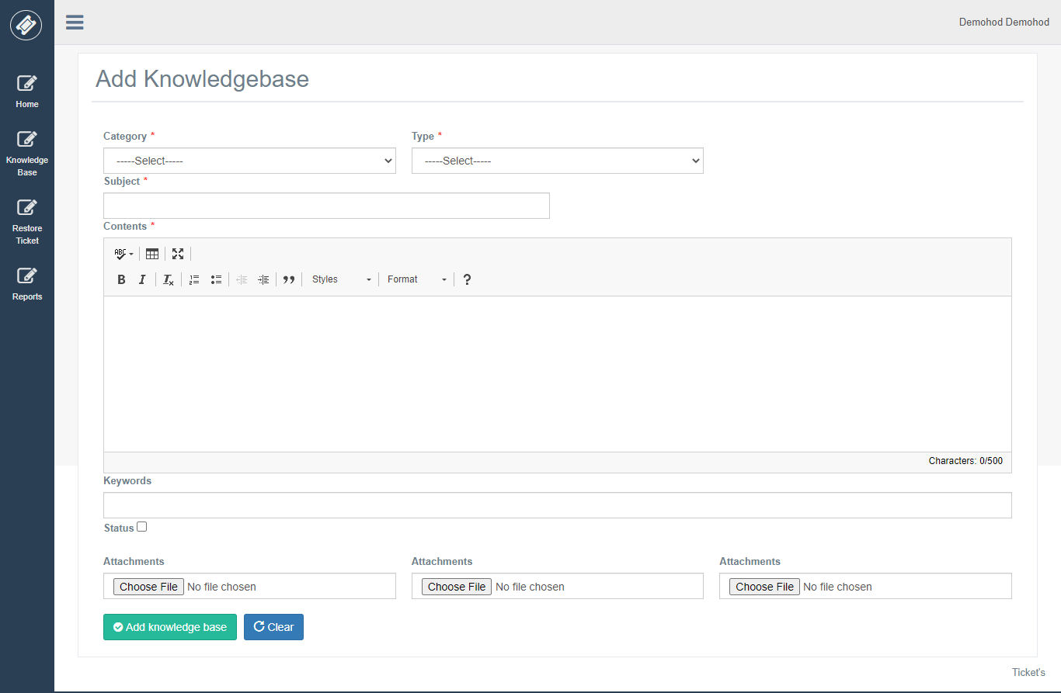

**Delete & Restore Ticket’s**

If you click on any tile, you can see all tickets with that status right.

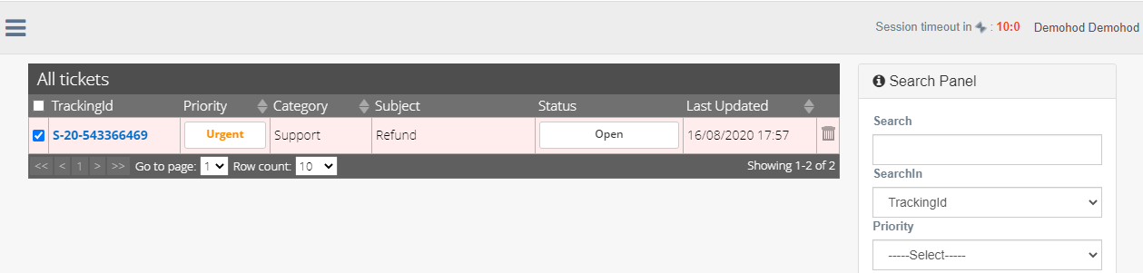

Here I have clicked on the open tile which is displaying records with open status.

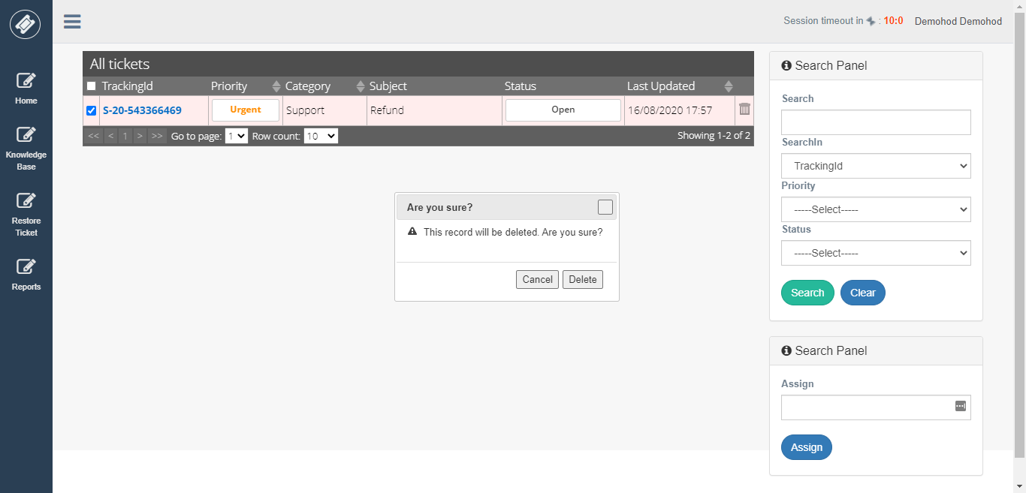

From this above View, Hod can delete ticket by clicking on delete button from the grid.

If Hod deleted ticket mistakenly, he could restore ticket by selecting Restore Ticket Menu.

On this View, you can see grid view with all deleted ticket by Hod to restore this ticket just check the checkbox of a particular row and select “Restore” button from Advance panel.

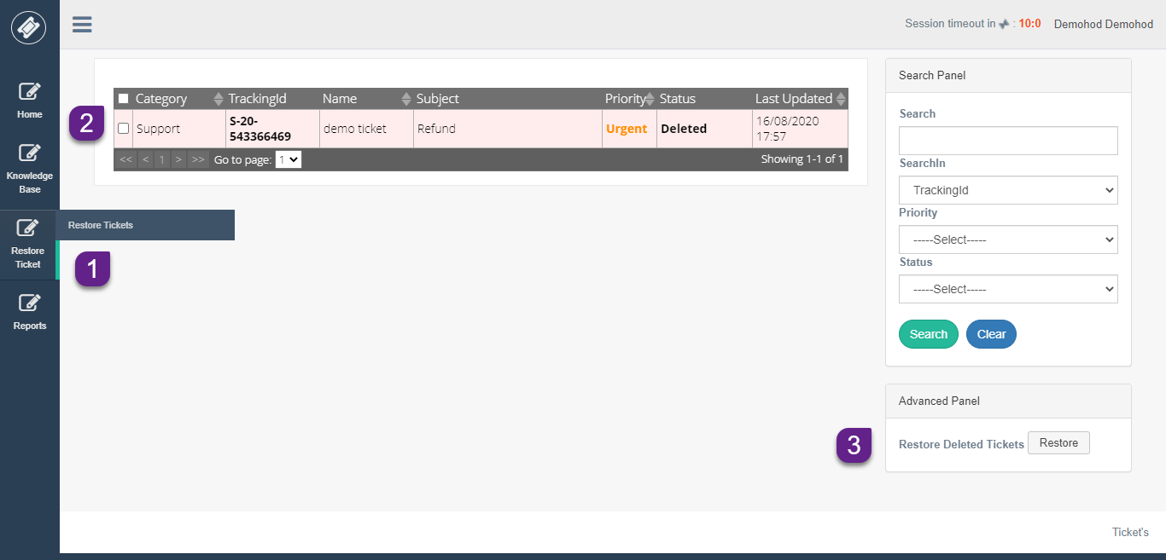

This ticket will be restored to the same status which it was before deleting.

**Escalation**

if any ticket which not answered by an Agent then it is escalated to Agent Admin and if agent admin also does not reply to ticket escalated to him then it is finally escalated to HOD shown below.

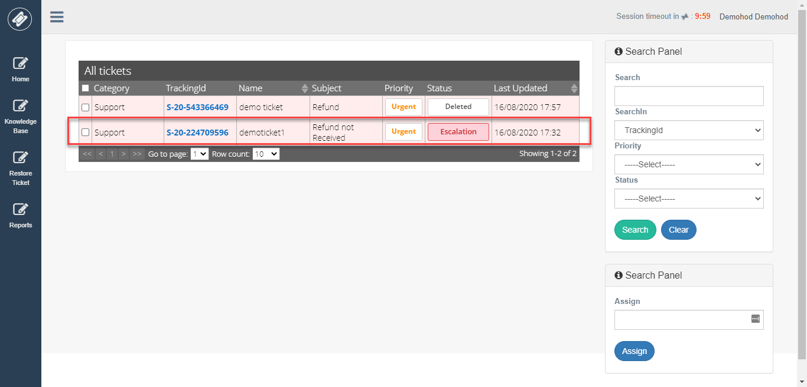

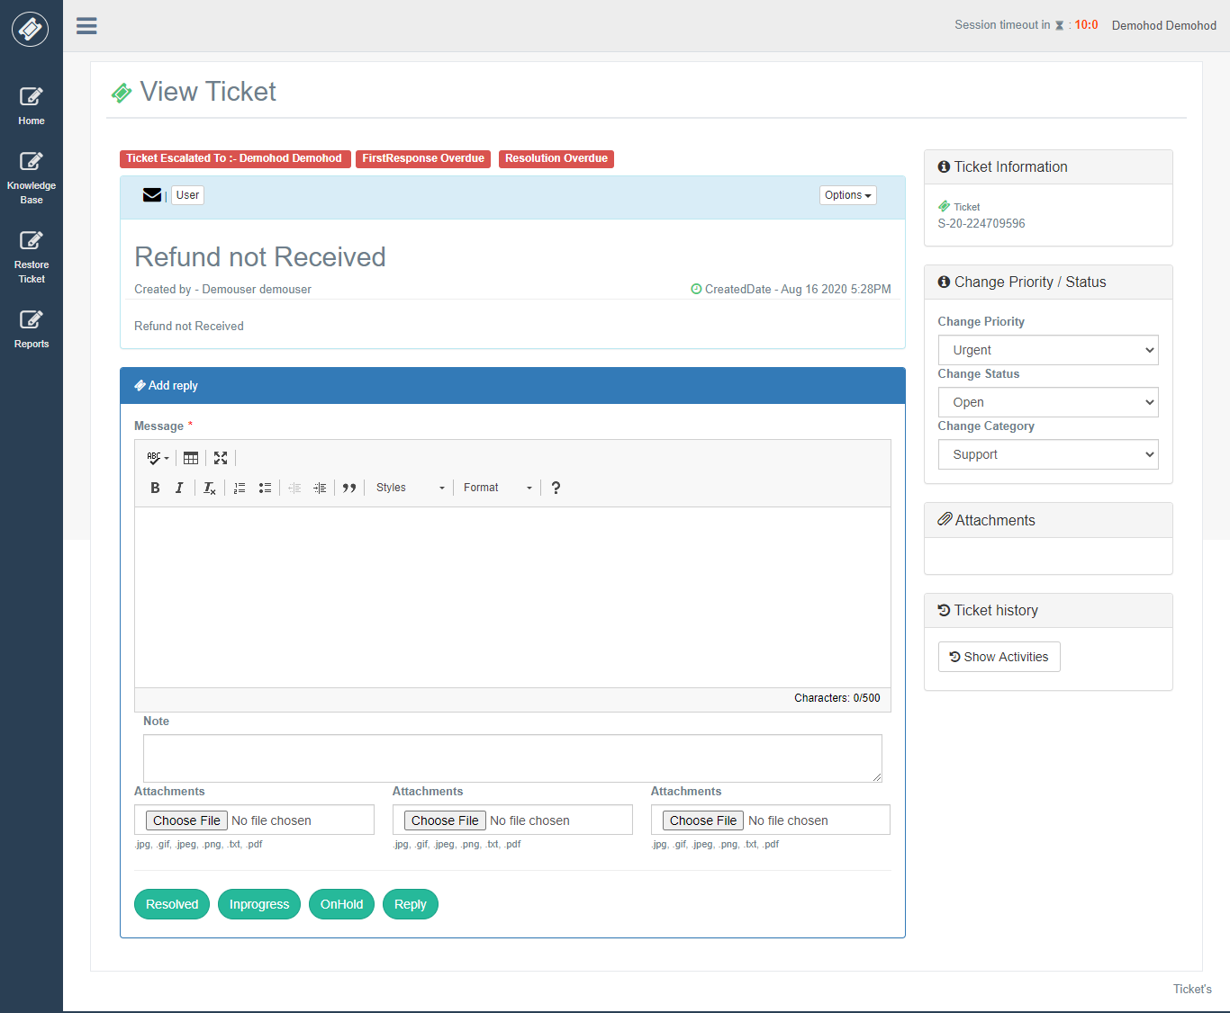

**Reports**

Hod has a report feature. He can view the report of his category. Take an example Hod with report category “**support**” can see all Agents details of category “**support**”.

There are different types of report agent admin can view.

1. Agent Wise Ticket Status Report
2. Category Wise Ticket Status Report
3. Ticket Overdue Status Report
4. Ticket Overdue User Wise Report
5. Ticket Escalation Report
6. Ticket Deleted Report
7. Priority Wise Ticket Status Report
8. Agent Detail Report
9. User Wise Check-in Checkout Report

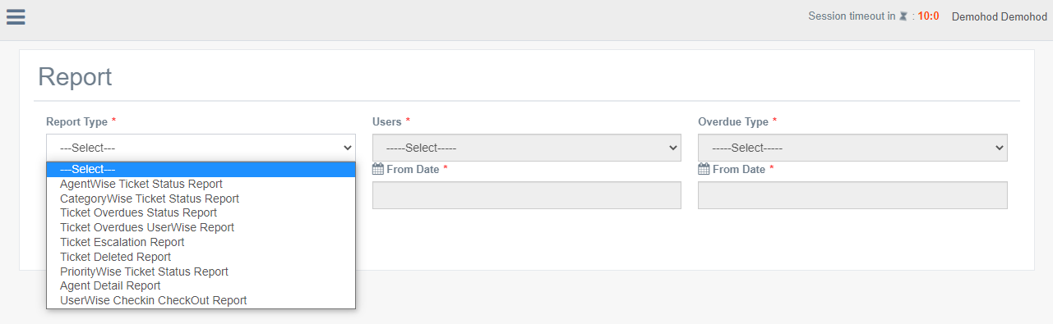

**Agent Wise Ticket Status Report**

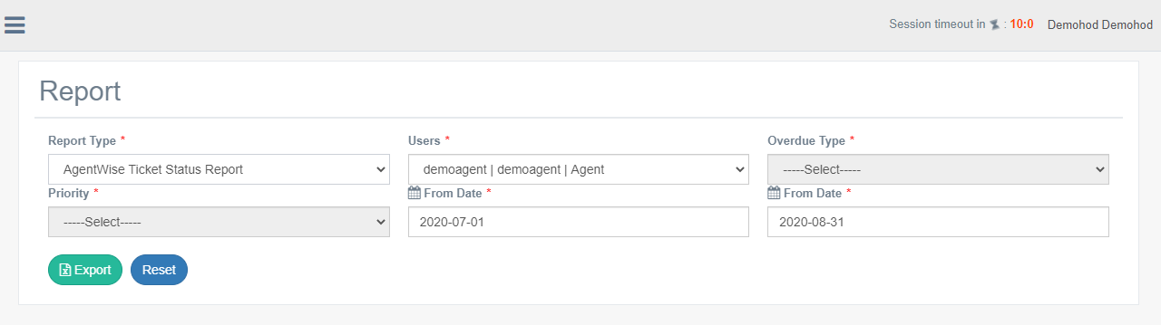

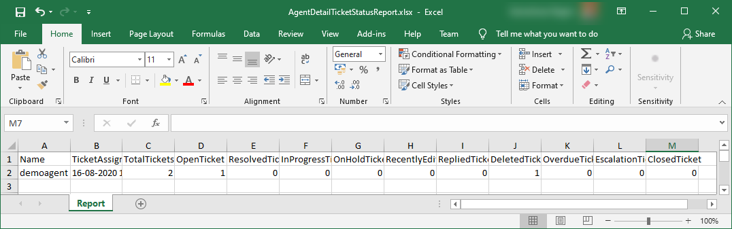

**Category Wise Ticket Status Report**

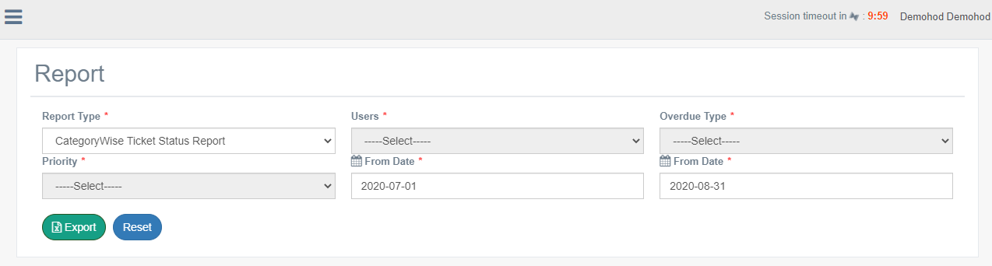

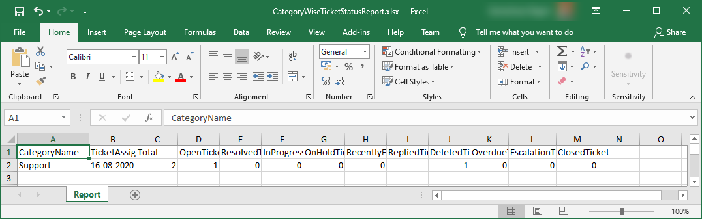

**Ticket Overdue Status Report**

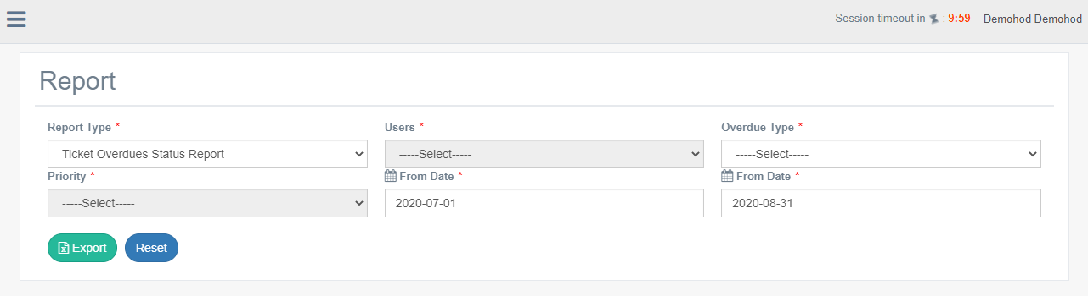

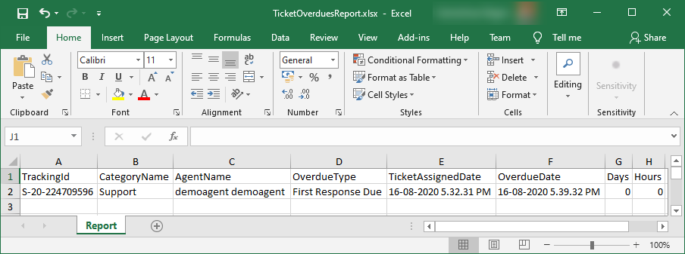

**Ticket Overdue User Wise Report**

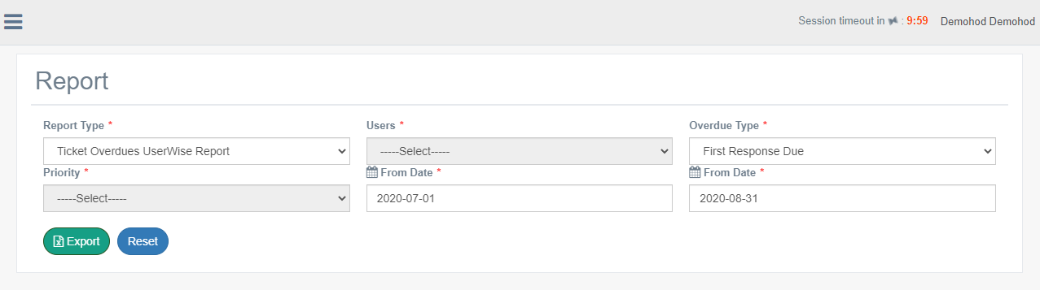

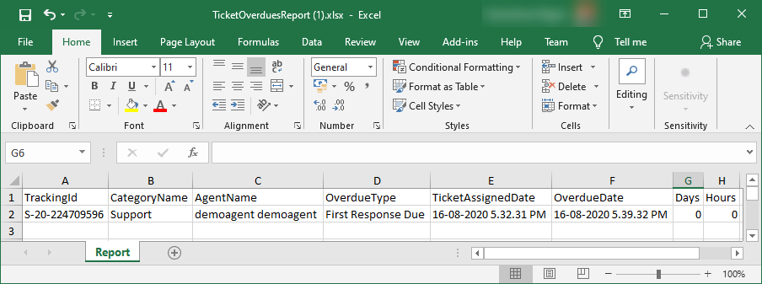

**Ticket Escalation Report**

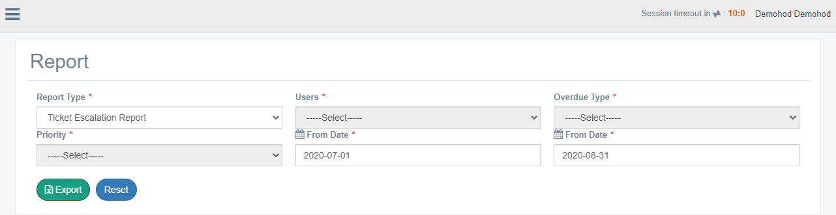

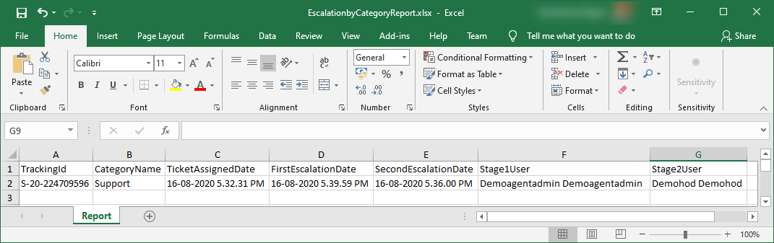

**Ticket Deleted Report**

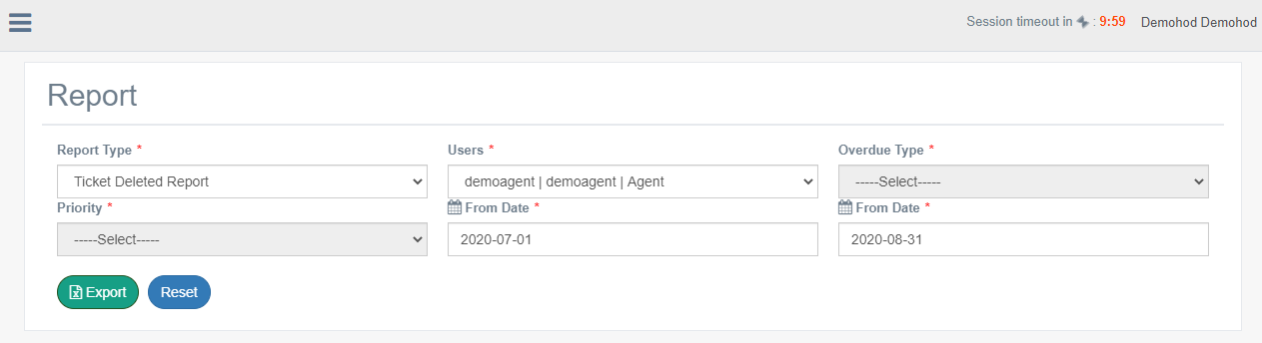

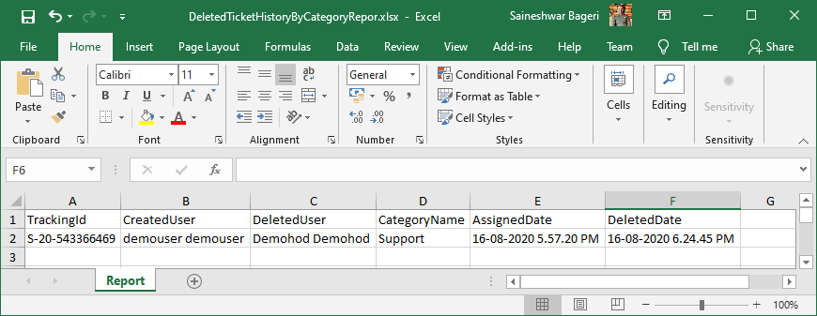

**Priority Wise Ticket Status Report**

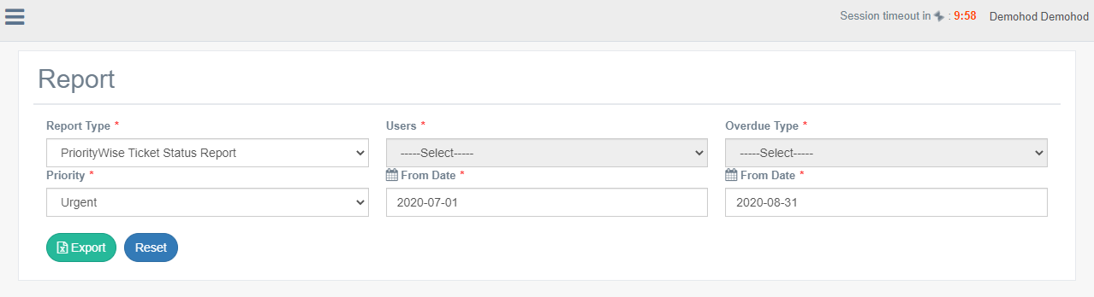

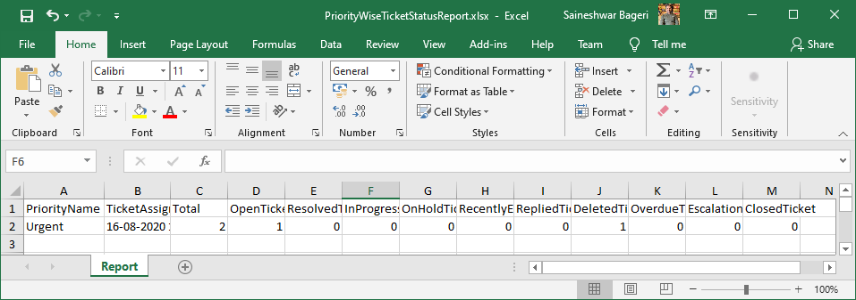

**Agent Detail Report**

