Support Ticket Application

Let’s see what Role of **Super Admin** in this Application is.

1. Login
2. Masters
3. View All Roles
4. Managing Menu Category,Menu,SubMenu
5. Adding and Managing Users (Users, Agent, Agentadmin, Hod, Admin)
6. Setting up SMTP
7. General settings
8. Adding Holiday and Managing it
9. Configuring Business Hours
10. Assign Category and Business Hours to AgentAdmin & HOD
11. Configuring SLA policies
12. Setting Default Ticket Count for Agents and Auto Closing Ticket Hours
13. Managing Cache

**Login page**

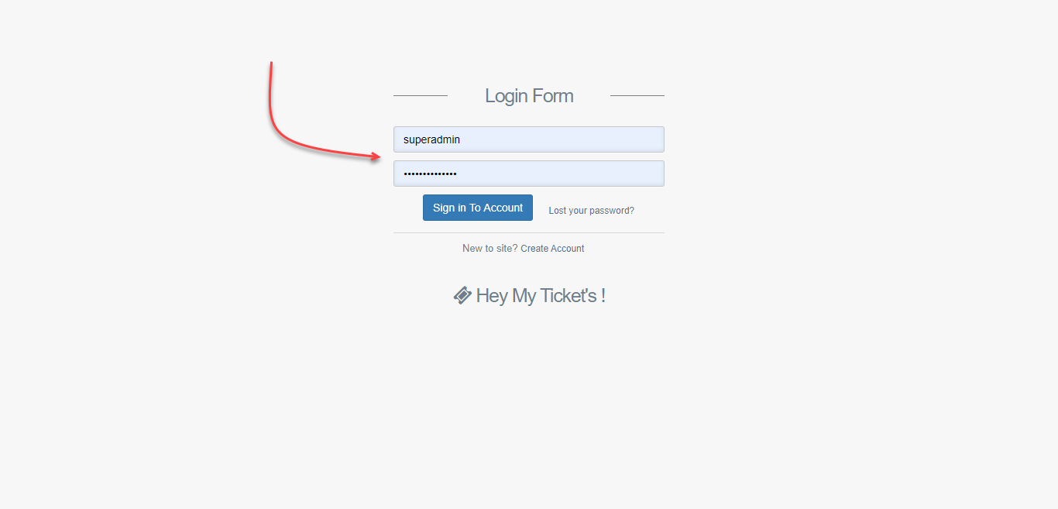

**Masters**

After logging into Application, you can see the first Menu as Masters this Menu contains all menu management part such as adding menu category, Menu, Submenu and order them according to your need. All roles are fixed to this Application; they cannot be changed.

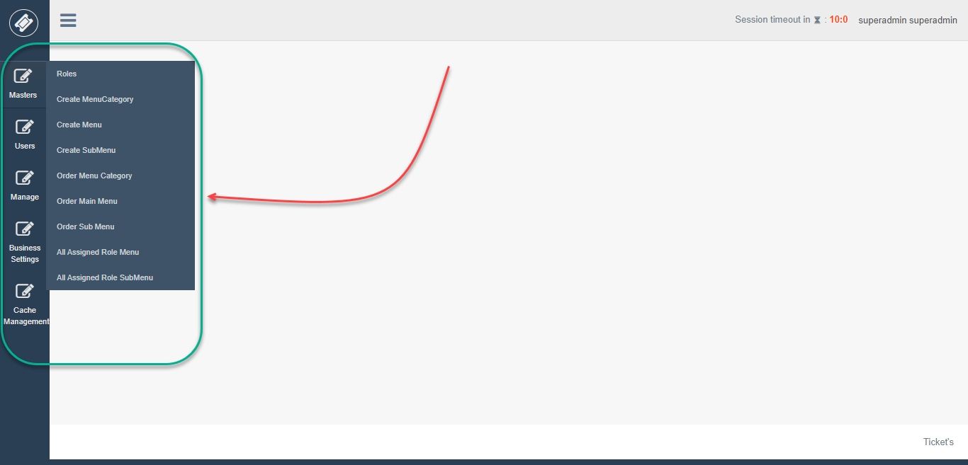

**All Roles**

Displaying all roles which are Used in Application.

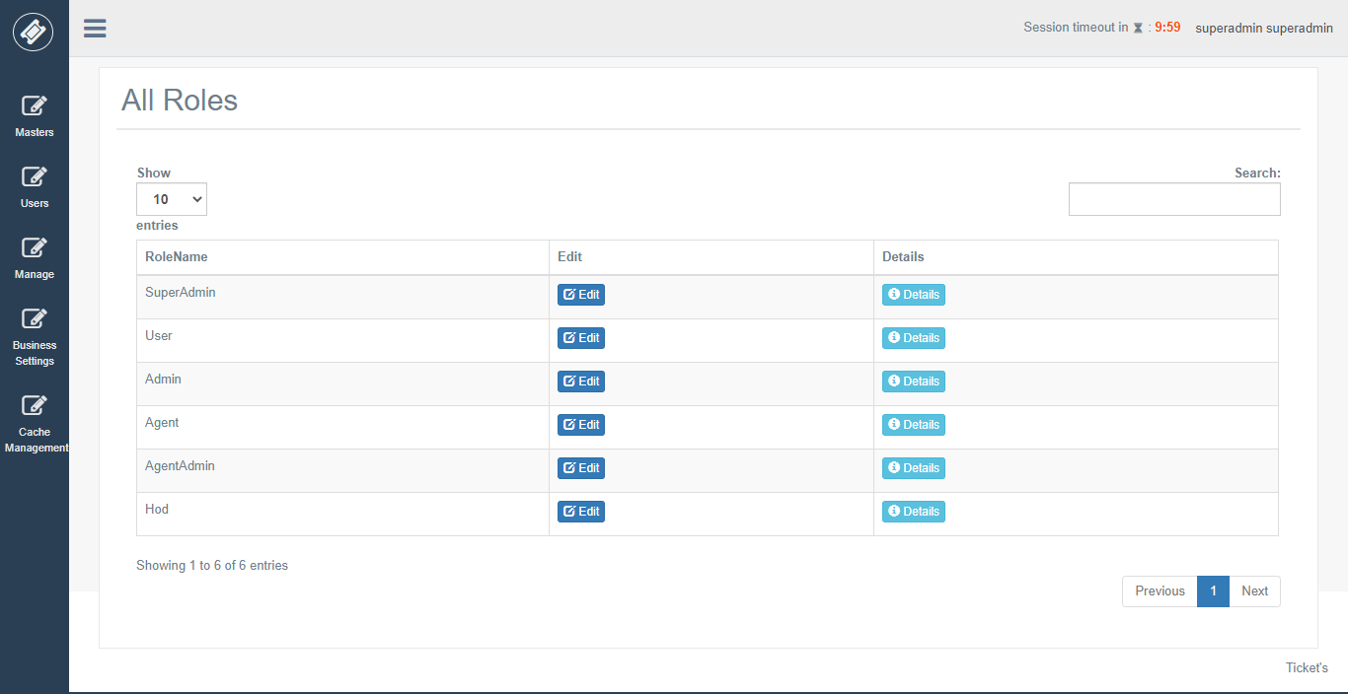

**Menu Category**

The Menu is divided into 3 parts

1. Menu category
2. Menu
3. Sub Menu

While adding a New menu category, we are assign roles along with it.

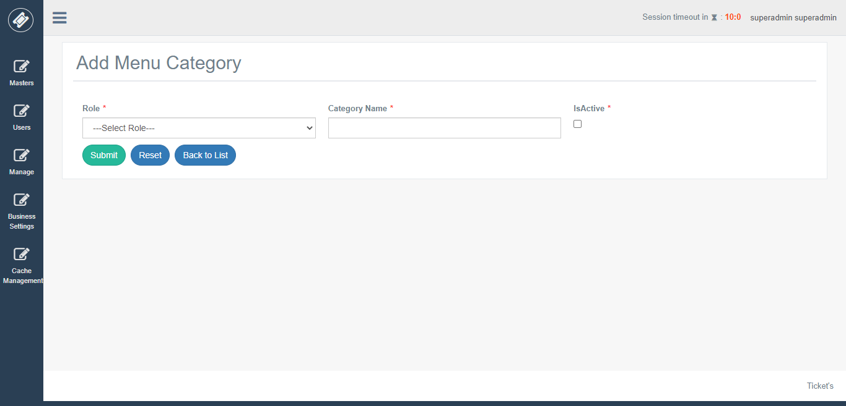

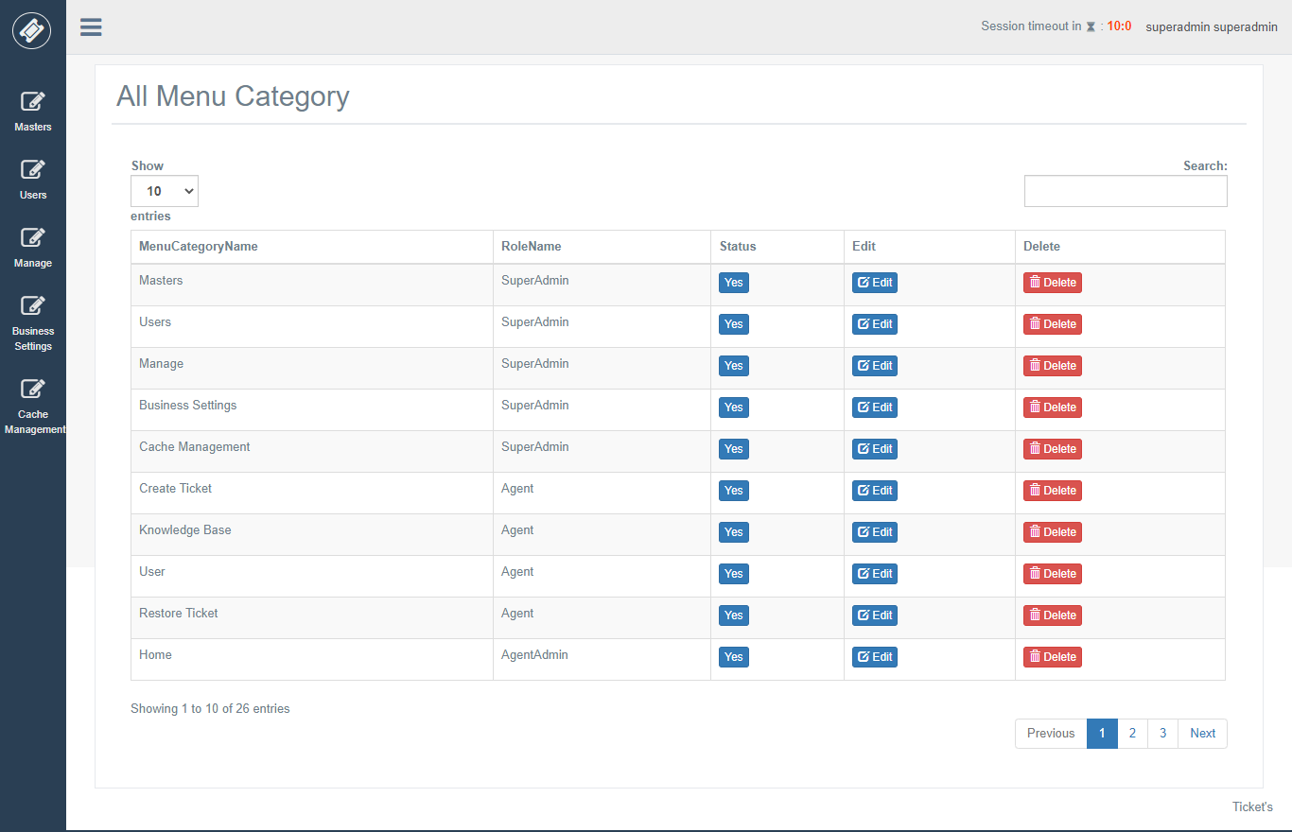

**Menu**

While adding Menu, we are going to select the role and Menu category along with that we are going to add menu name, controller name, action method and status.

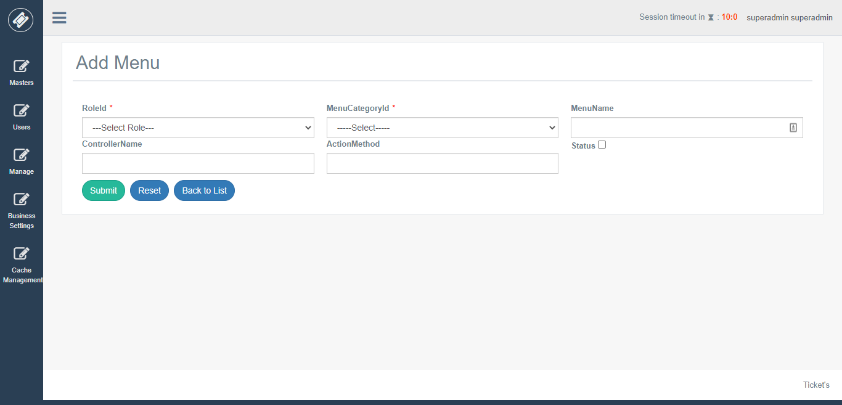

**All Menu**

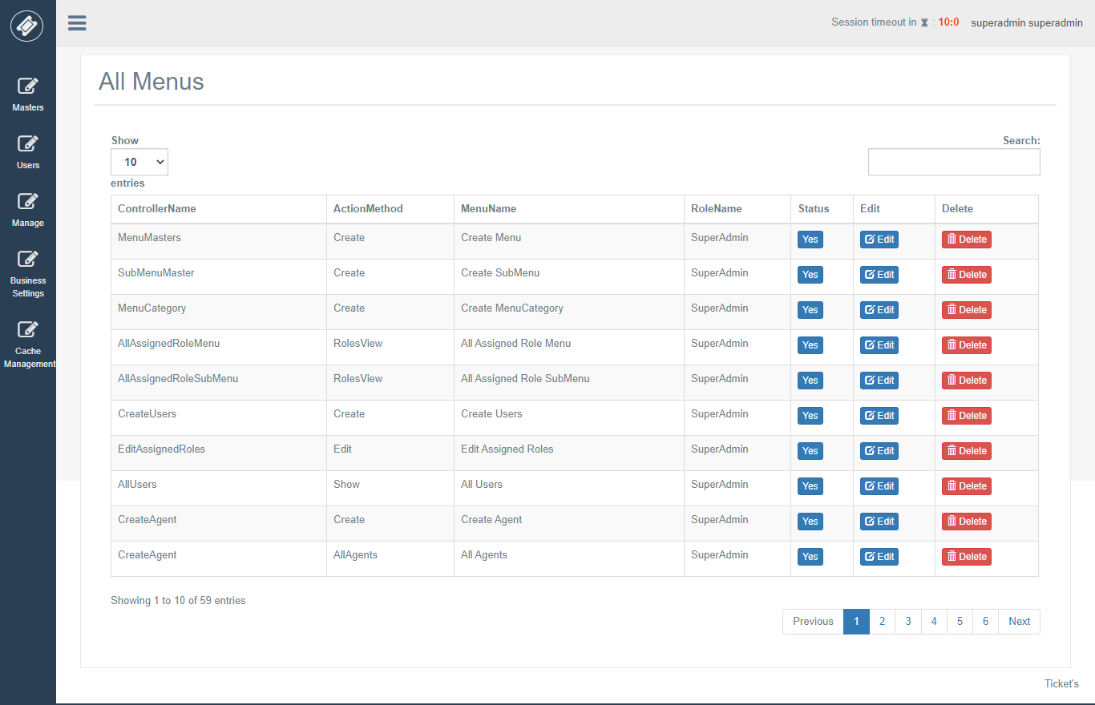

**Submenu**

While adding Submenu, we are going to select the Role and Menu category and Menu along with that we are going to add menu name, controller name, action method and status.

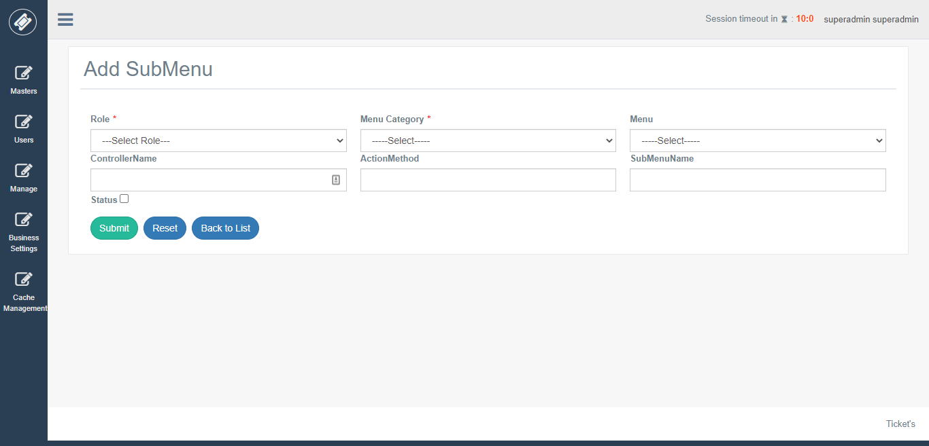

**All SubMenu**

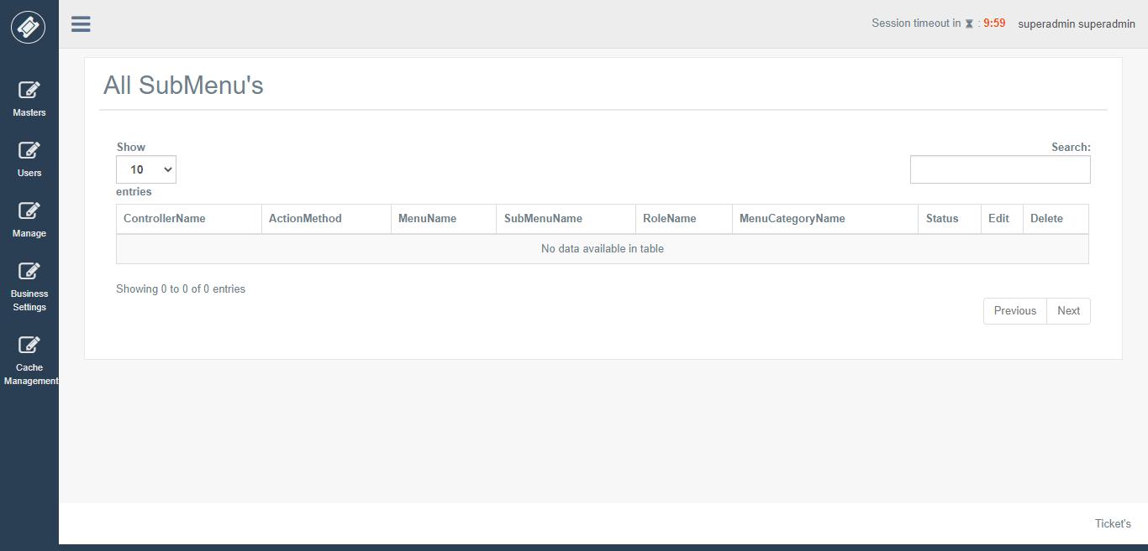

**Menu Category Ordering**

After adding Menu if you want to order or reorder as you want you can use this feature. For doing this, we need to select roles according to it. It will display menu category just drag to position you want and click on Save order button to same them.

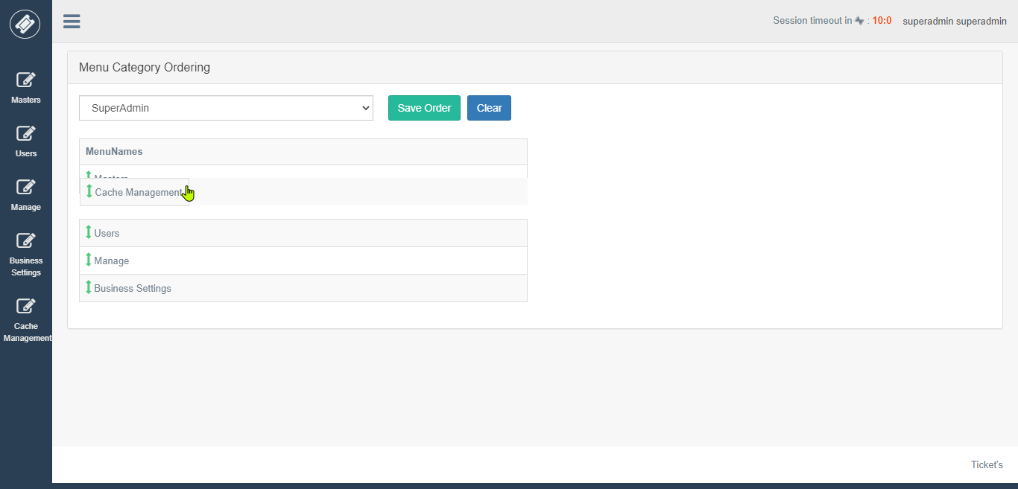

**Menu Ordering**

After adding Menu if you want to order or reorder as you want you can use this feature.

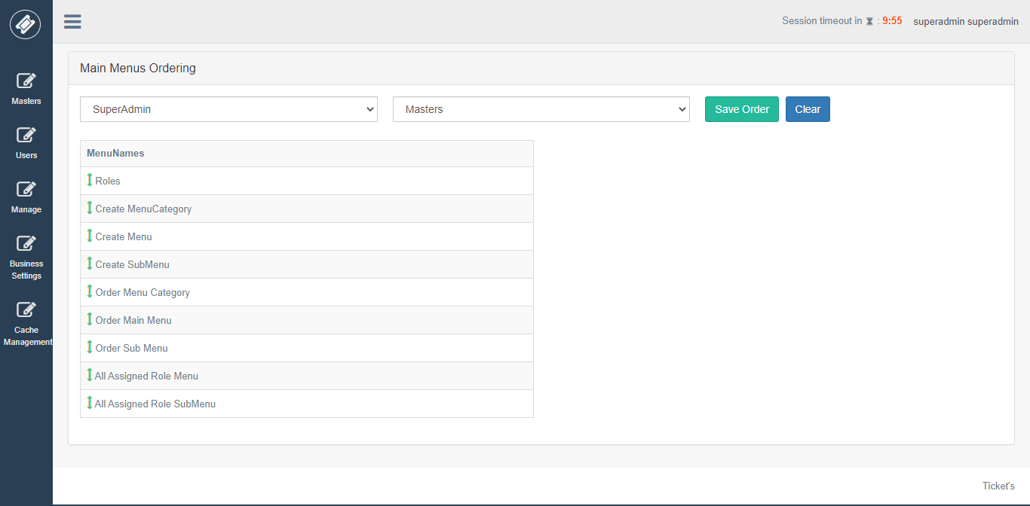

**SubMenu Ordering**

After adding Submenu if you want to order or reorder as you want you can use this feature.

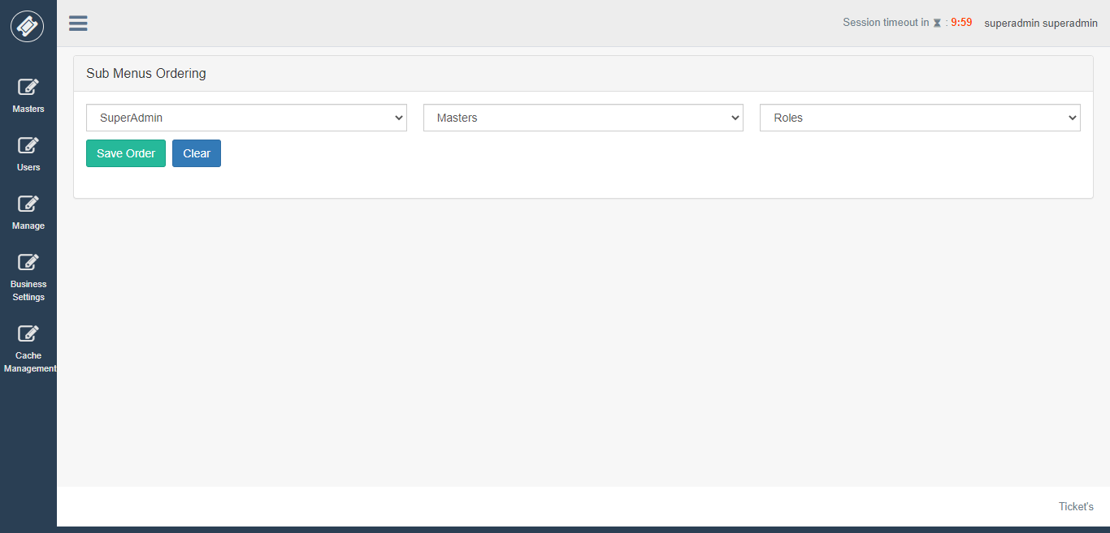

**All Assigned Menus to Role**

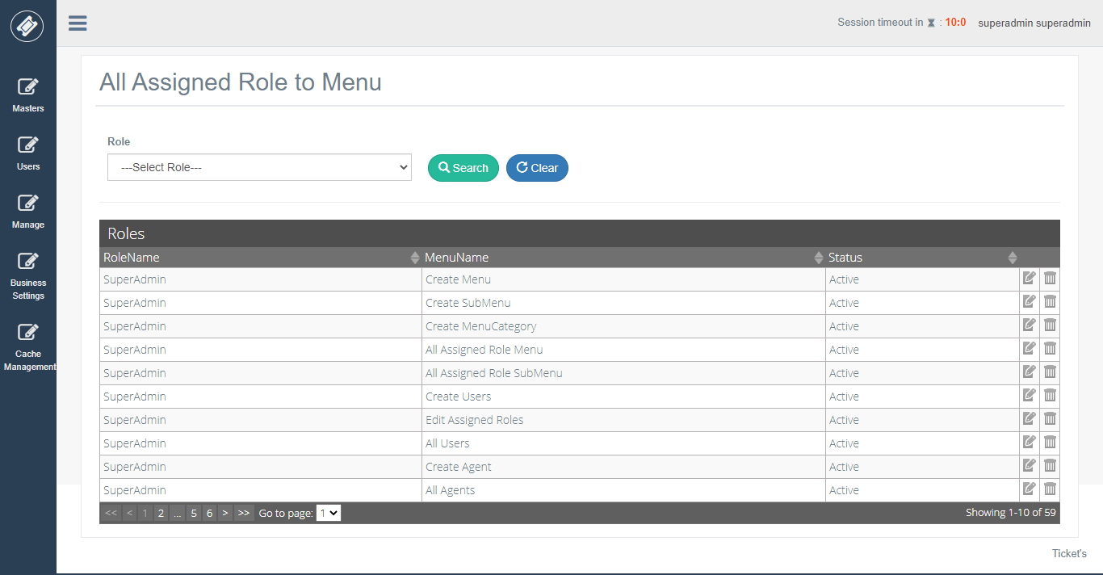

**All Assigned Submenu’s to Role**

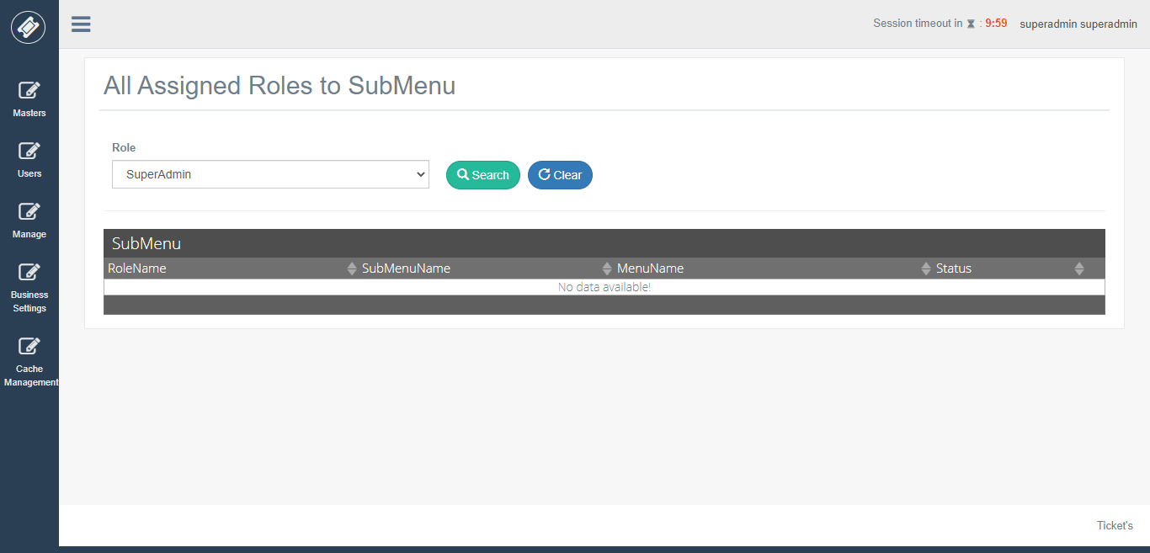

Next Menu we are going to see is Users Menu.

**Users**

In this part, we can create various users according to roles and edit assigned roles.

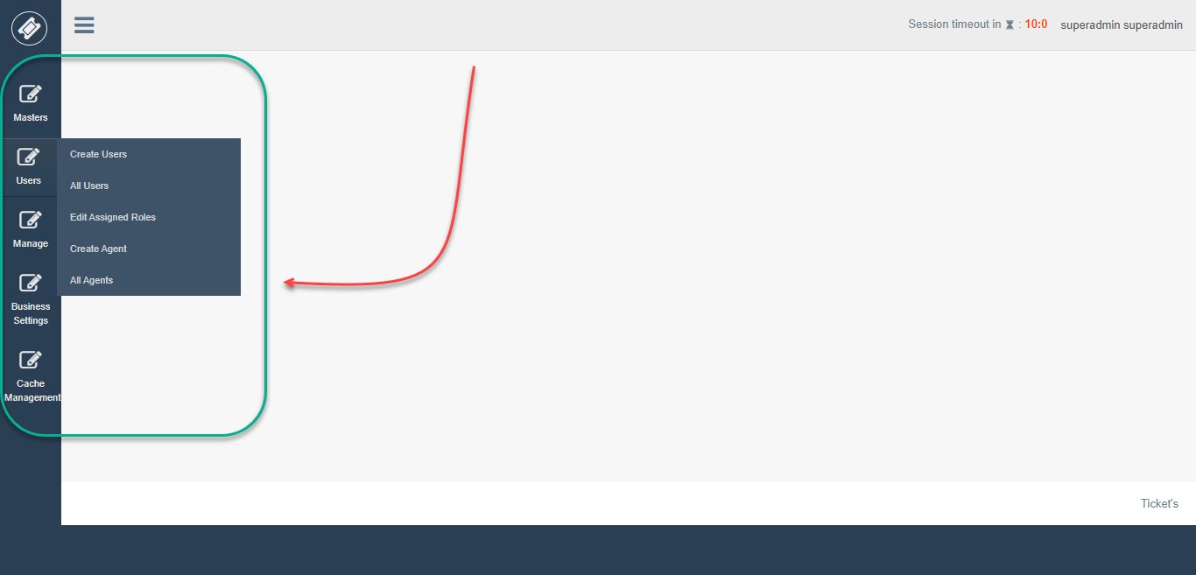

**Create Users**

On this View Superadmin can create different users and set a default password to them when users do the first login, they are forcefully asked to change password.

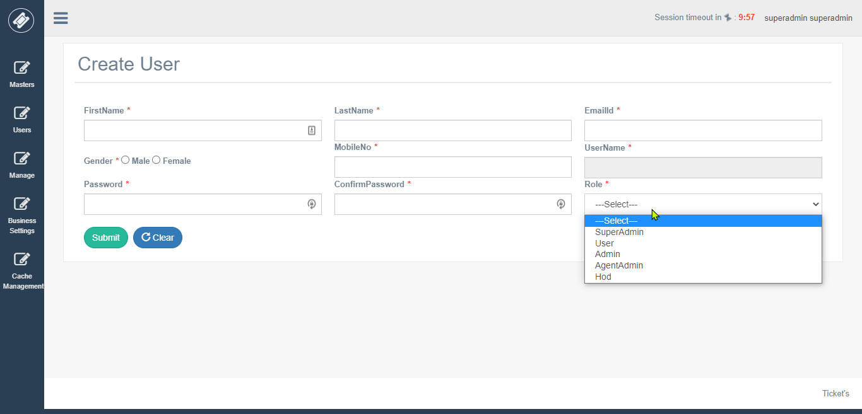

**All Users List**

All Users created in Application are displayed here.

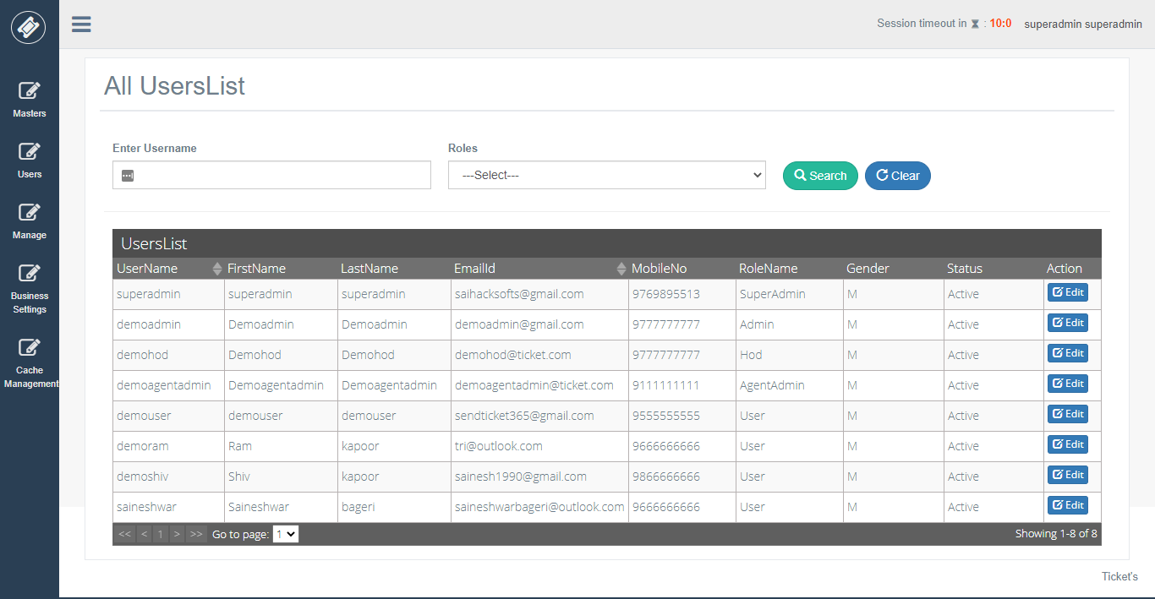

**All Assigned Role to User List**

All Roles assigned to users are displayed here.

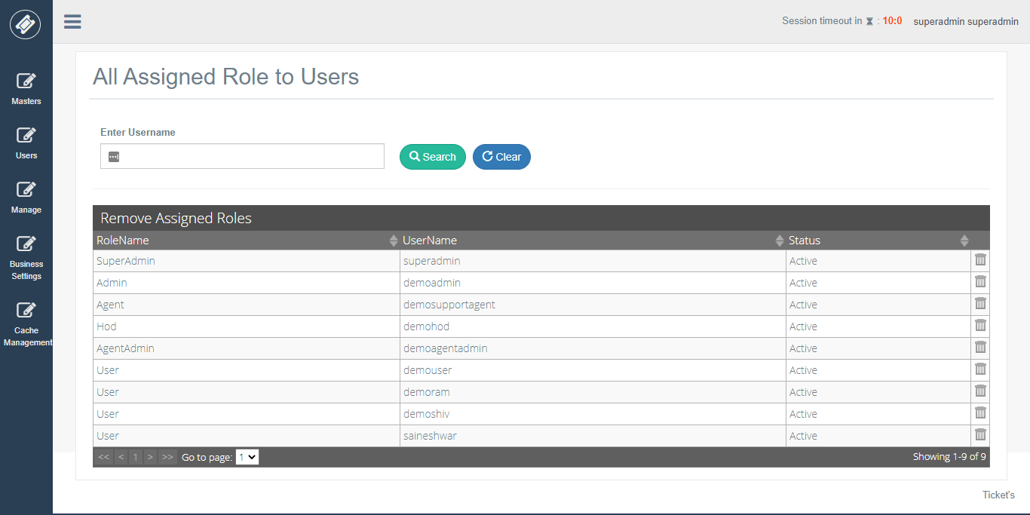

**Create Agent**

On this view, we can create agents and assign Category.

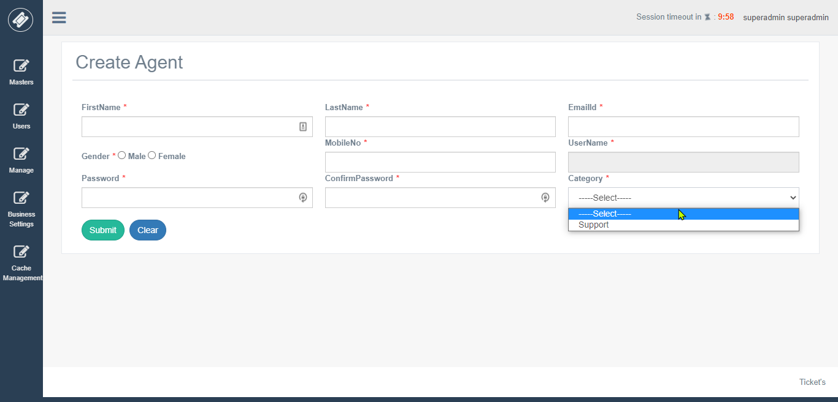

**All Agents**

On this view, we can see all agents which we have created.

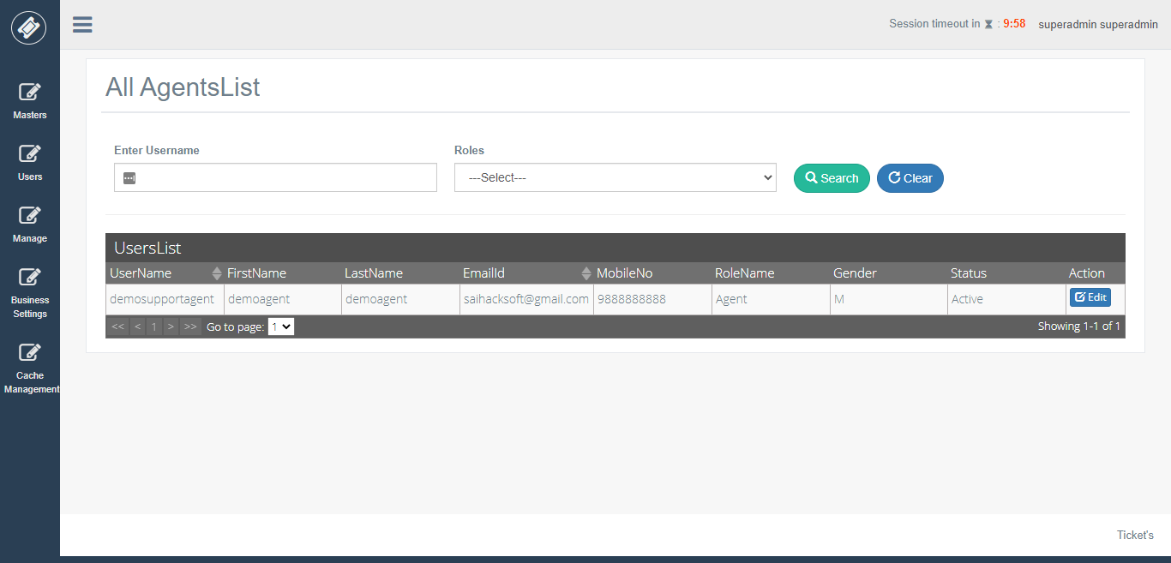

**Manage**

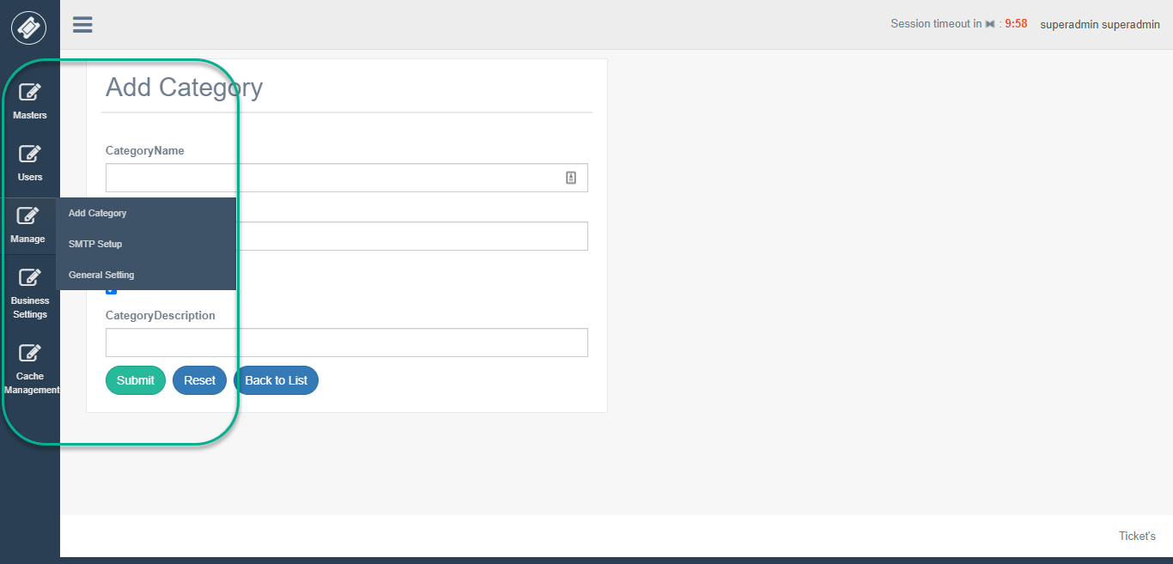

**Category**

On this view, we are creating Category.

e.g. take an example a company provide various services which are divide into categories accounts, sales, billing, payments, refund.

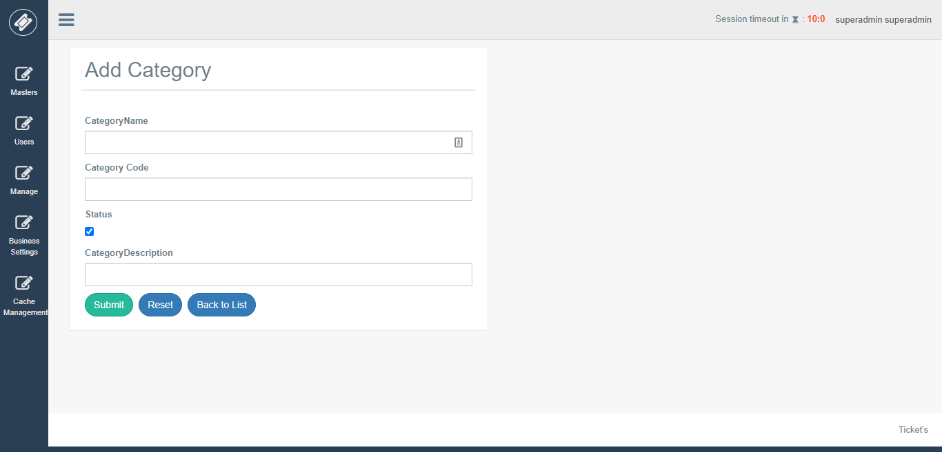

**All Categories**

Displays all added Category.

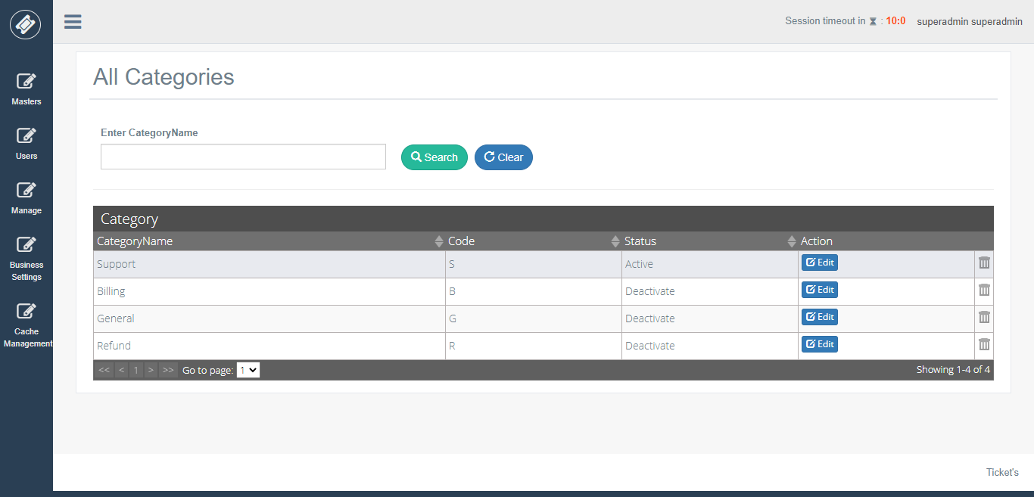

**SMTP Settings**

On this view we can configure SMTP for sending emails these settings will be used by entire Application.

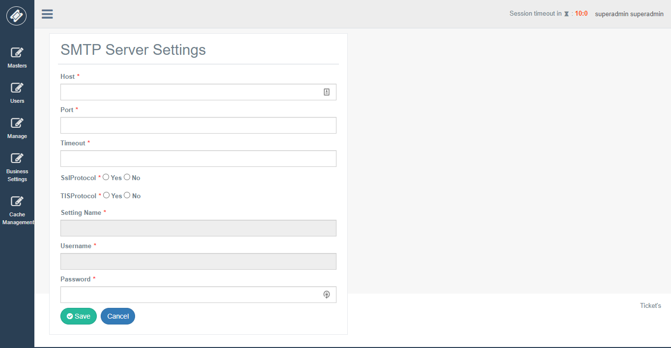

**All SMTP Settings**

This view will display all SMTP configures, and you can set default SMTP from the list.

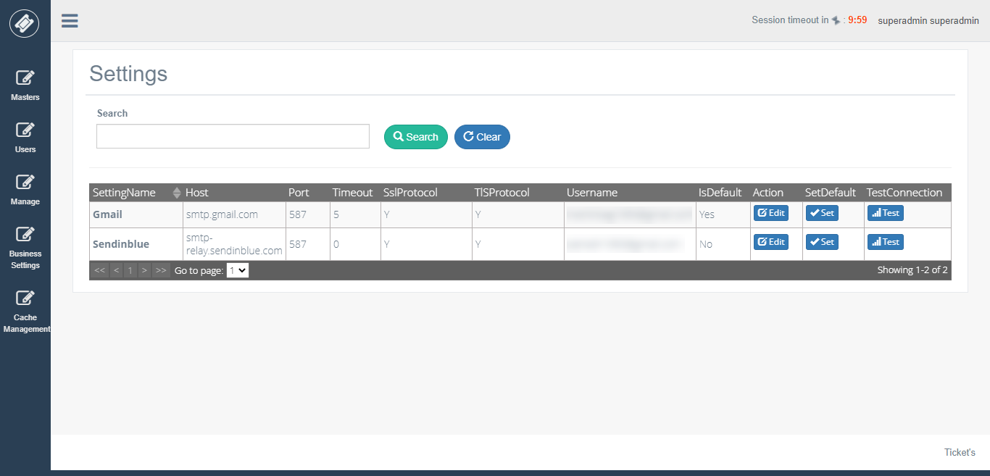

**General Settings**

Here we are taking general information of the company and also sender email is configured here along with it we can enable and disable Email / SMS / Signature feature in Application.

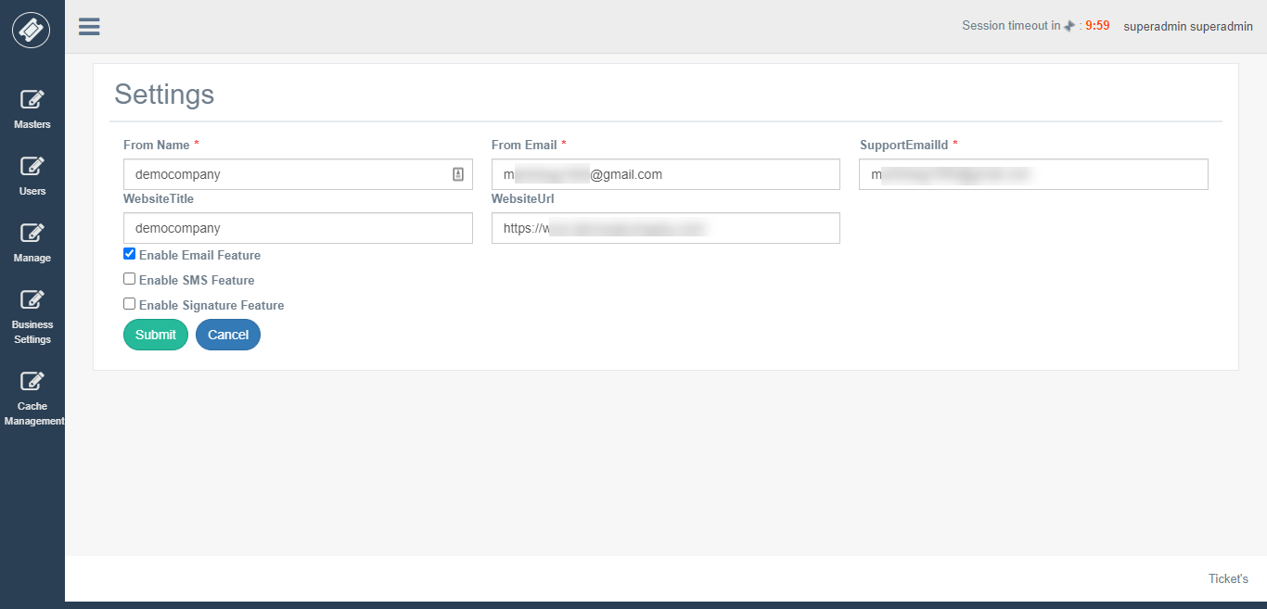

**Holiday List**

Here we need to add holidays of the entire year according to your company holiday list.

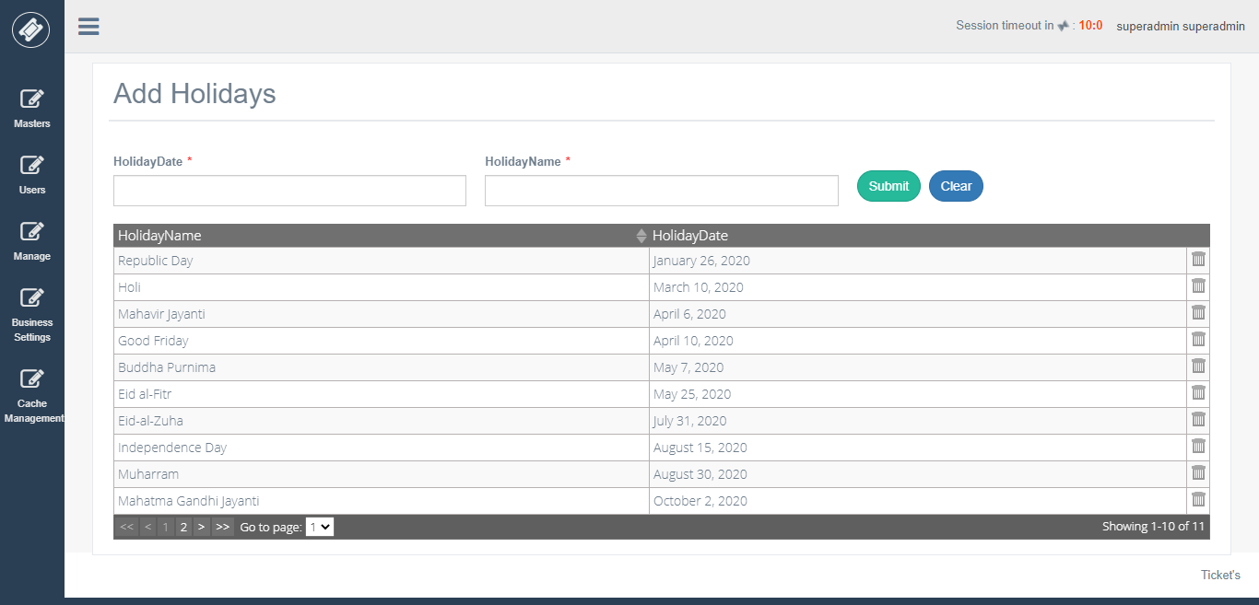

**Business Settings**

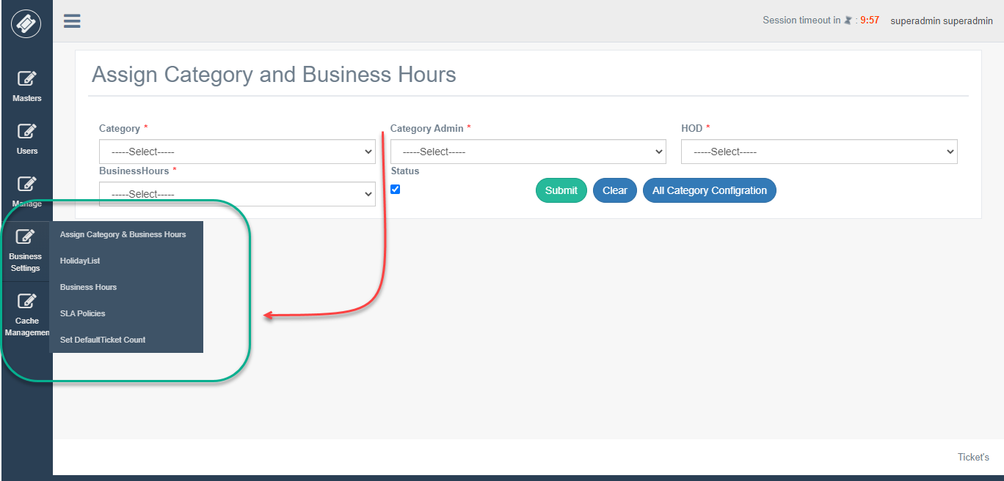

**Business Hours**

Here we are going to configure business hours for ticket application.

There are 2 types of business hours

1. 24 hrs x 7 days
2. Working days/hours (custom you can configure hours and working days)

**24 hrs x 7 days**

Here just you need to enter Name and Description and choose 24 hrs x 7 days option.

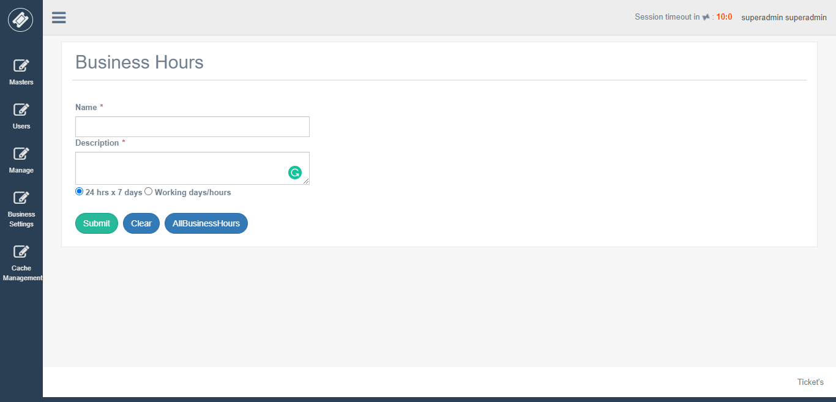

**Working days/hours**

Here just you need to enter Name and Description and choose Working days/hours option and then setting up each day starting and closing hours of your support desk.

This is the main heart of Application according to this business hour configuration your support system will work.

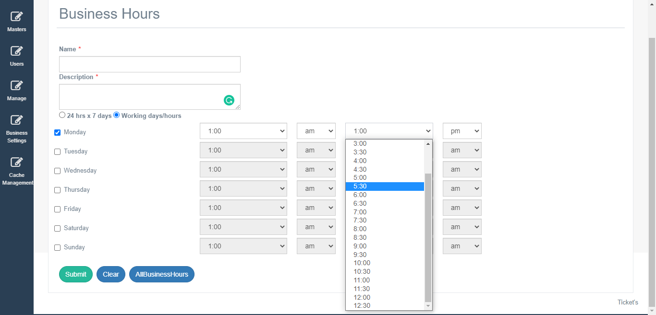

**List of All Business Hours Configured**

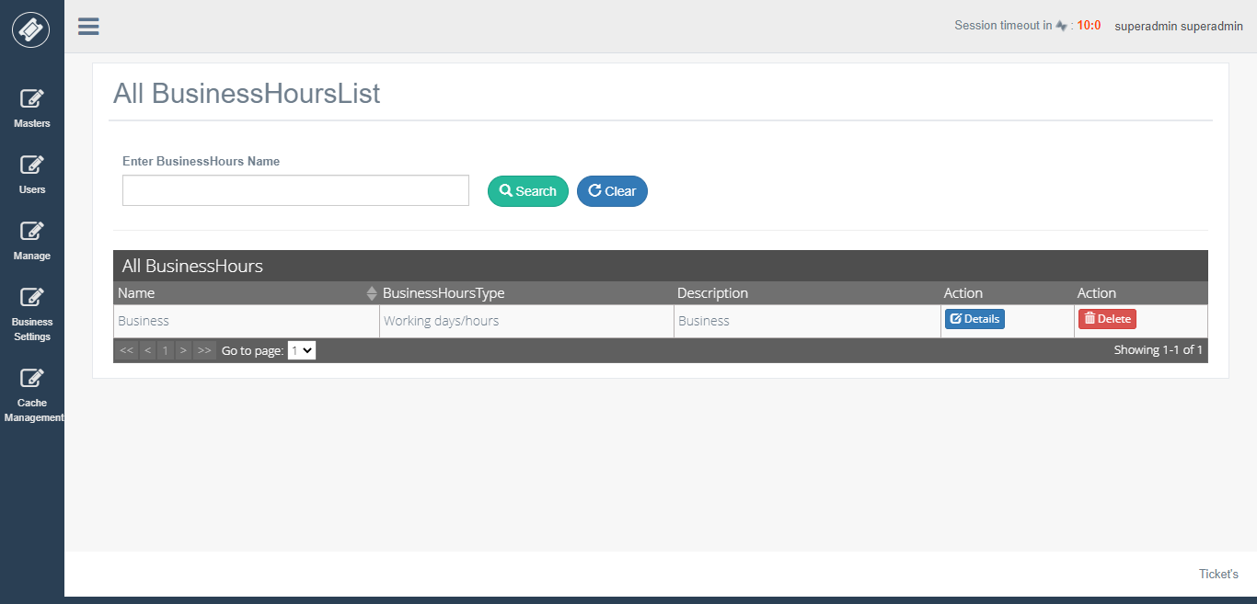

**Assign Category and Business Hours to AgentAdmin & HOD**

After configuring business hours, you can set business hours to specific Category and also assign Category to Admin, HOD.

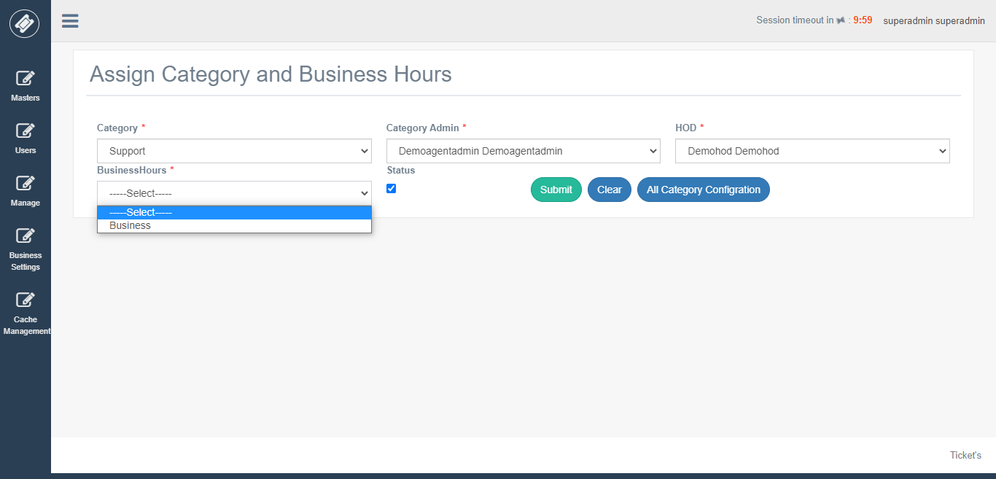

**Create SLA Policies**

Here you can setup SLA (Service-level agreement) policy.

In the priority list, we have 4 options

1. Urgent 2. High 3. Medium 4. Low.

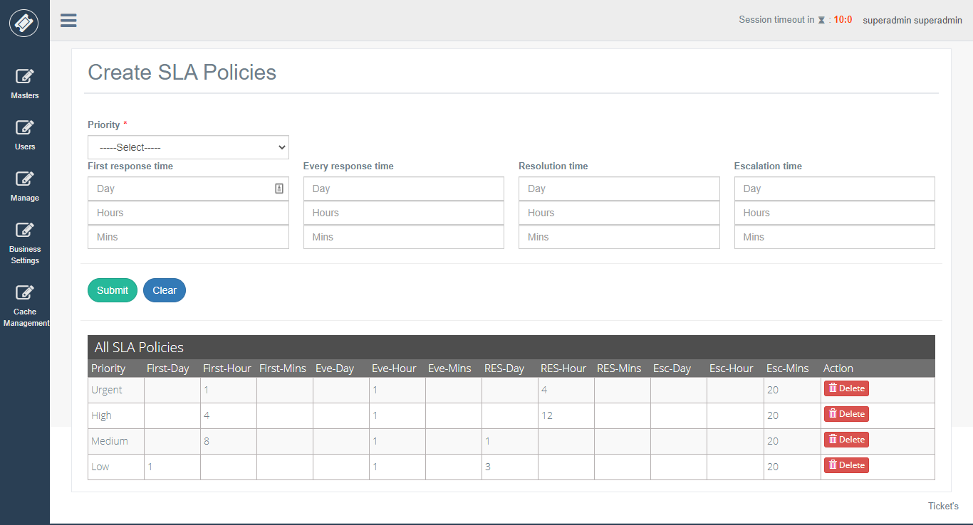

By selecting priority, we can configure first response time (first reply to the ticket), every response time (each response to the ticket), Resolution time (total completion of the ticket) and escalation time (when a ticket is not answered by an agent in given SLA time then it is escalated to agent admin and HOD ).

**Setting Default Ticket Count for Agents and Auto Closing Ticket Hours**

Default Ticket Count: - Default ticket is for each agent; each agent bucket is lower than default ticket count then a new ticket is assigned to an agent.

Auto Closing Ticket Hours: - Resolved Ticket will be auto closed after 48.

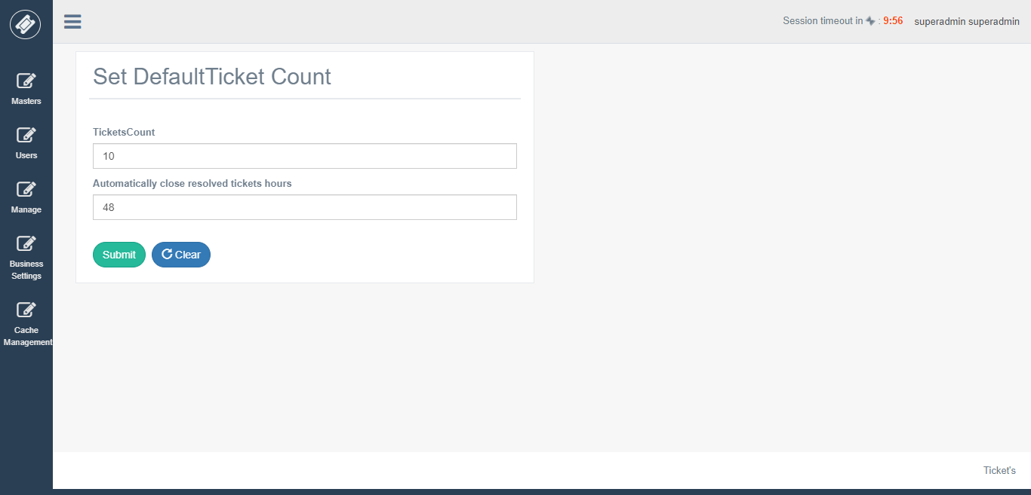

**Manage Cache**

We are using IIS Cache for entire Application. Which can be refreshed here for adding new changes into the cache.

