Support Ticket Application

Let’s see what Role of **User** in this Application is.

1. Registration
2. Login
3. Create Ticket
4. All Ticket’s
5. User Dashboard
6. See All Ticket Status and Reply to Ticket.
7. Edit Ticket
8. Print Ticket
9. Change Password
10. Update Profile

**Registration**

Users can register here by entering some necessary details.

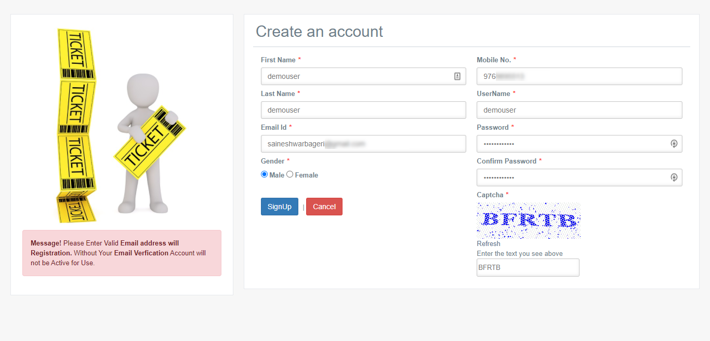

Next step after Registration is, Users, will get an email for verification on the email address which they have used for Registration.

Now to verify just click on confirm email link in the email then it will redirect to portal and show you verification message after doing verification then the only customer will be allowed to log into Application.

**Login page**

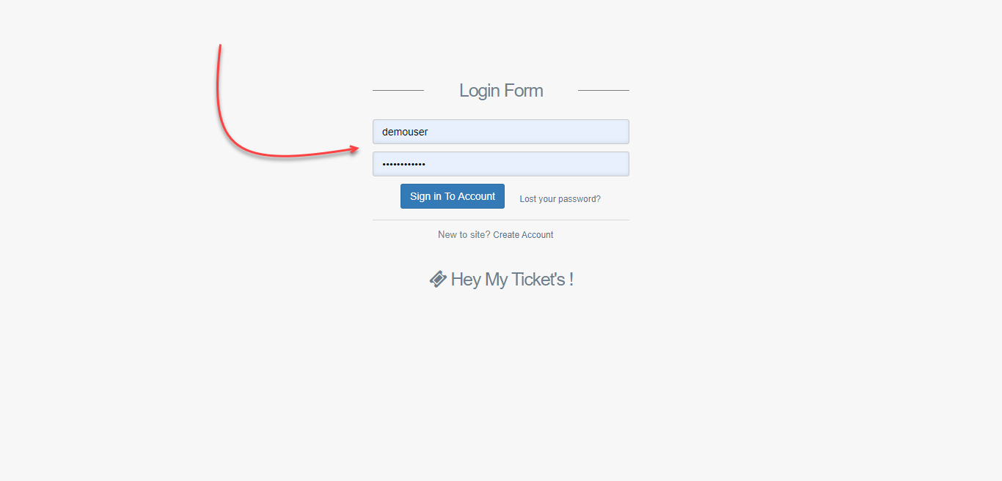

**User Dashboard**

After logging into Application, you will see a dashboard with various status counts.

**New**: - Ticket is newly created

**Resolved**: - Ticket is resolved

**InProgress and On Hold**: - Agent is working on a ticket

**Edited**: - Agent or User has edited ticket

**Deleted**: - Ticket is Deleted by Agent

**Overdue**: - Ticket is not replied by Agent in a defined time.

**Escalation**: - Ticket is not replied by Agent in defined time it is escalated to a higher authority.

**Closed**: - Ticket is resolved, and it is completed.

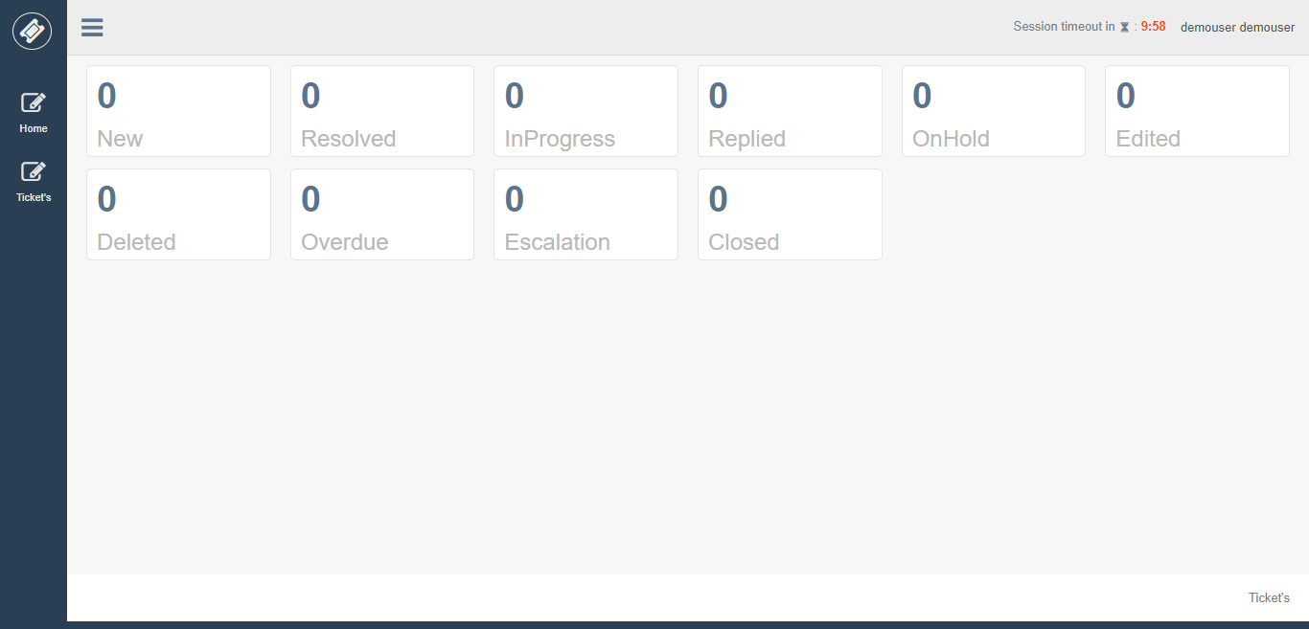

User can click on each of status tile to see all tickets with that status.

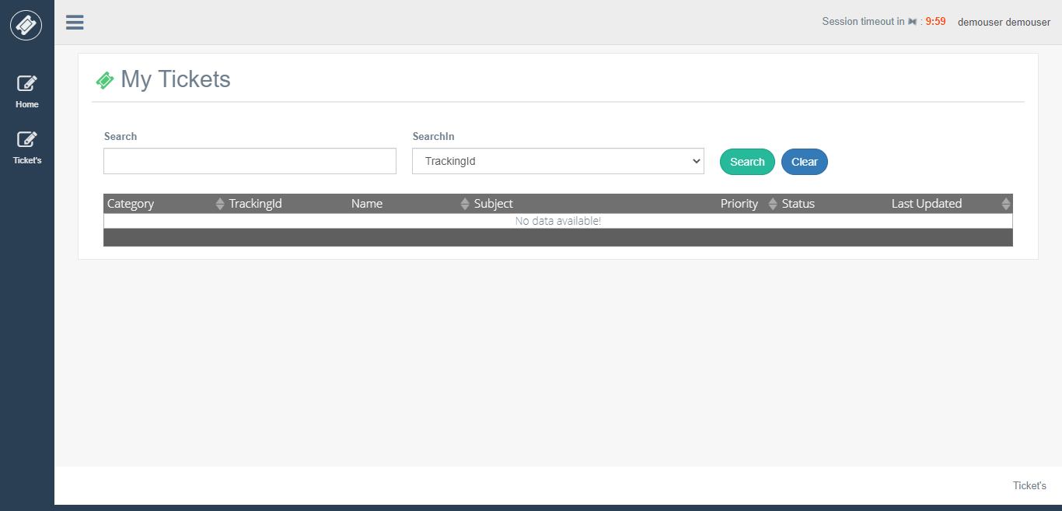

**Create Ticket**

For creating a ticket, you need to fill necessary details and choose category and priority and enter your query in the Message Editor, attach a document if you want to send.

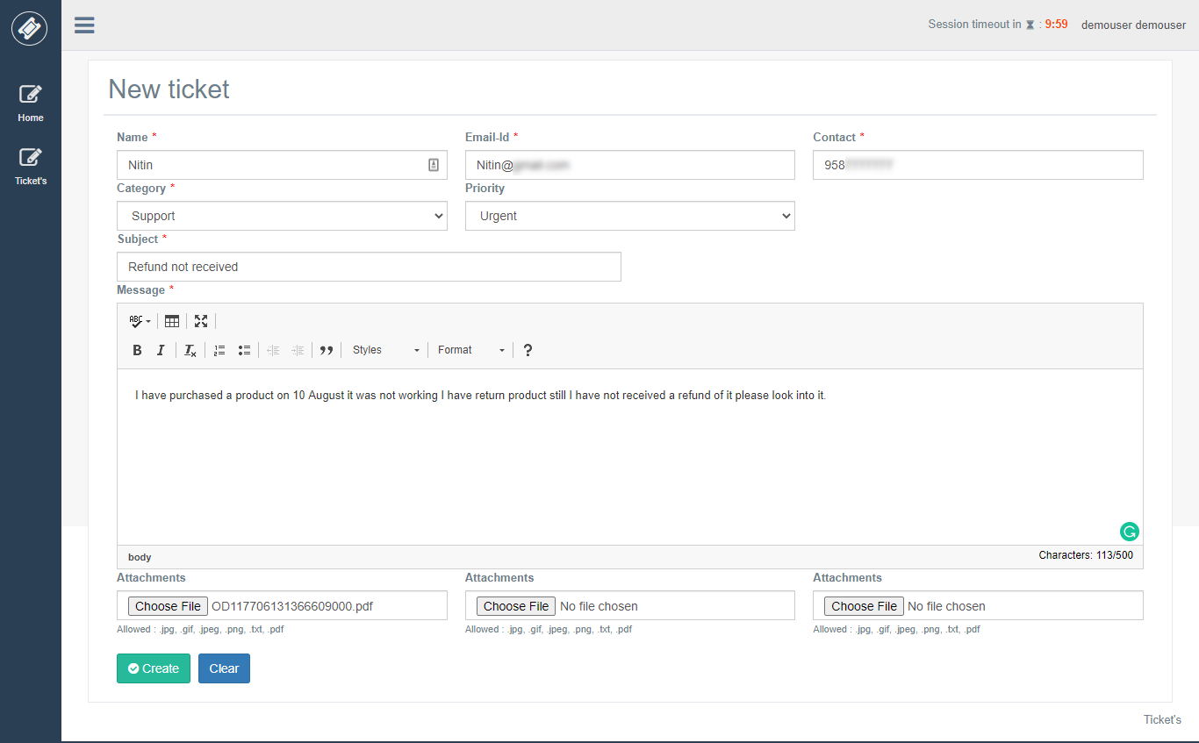

**All Tickets**

After creating a ticket, you see all tickets by select All tickets from Ticket’s Category.

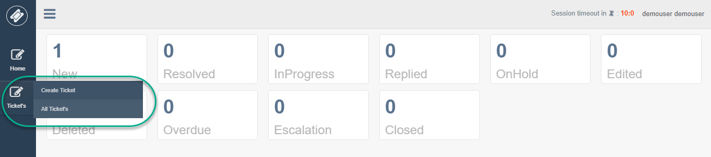

All tickets will be displayed in grid view along with a search panel to search for tickets which they have created.

Three parameter’s you can search in

1. Tracking Id
2. Name
3. Subject

Now if you see a ticket in grid view you will see priority, status, last updated values are “**Assigning Ticket**” means the ticket is still not assigned to Agent.

**Before Assigning Ticket**

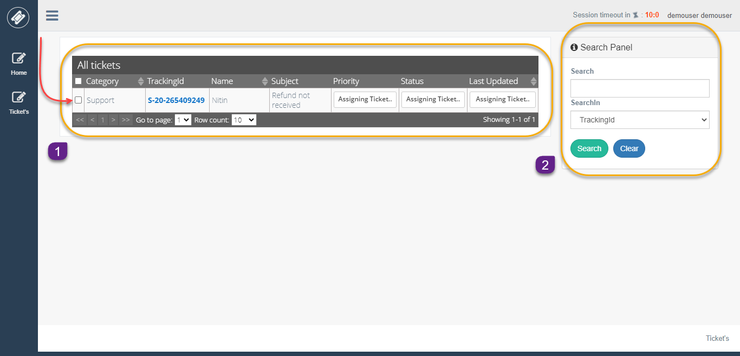

**After Assigning Ticket**

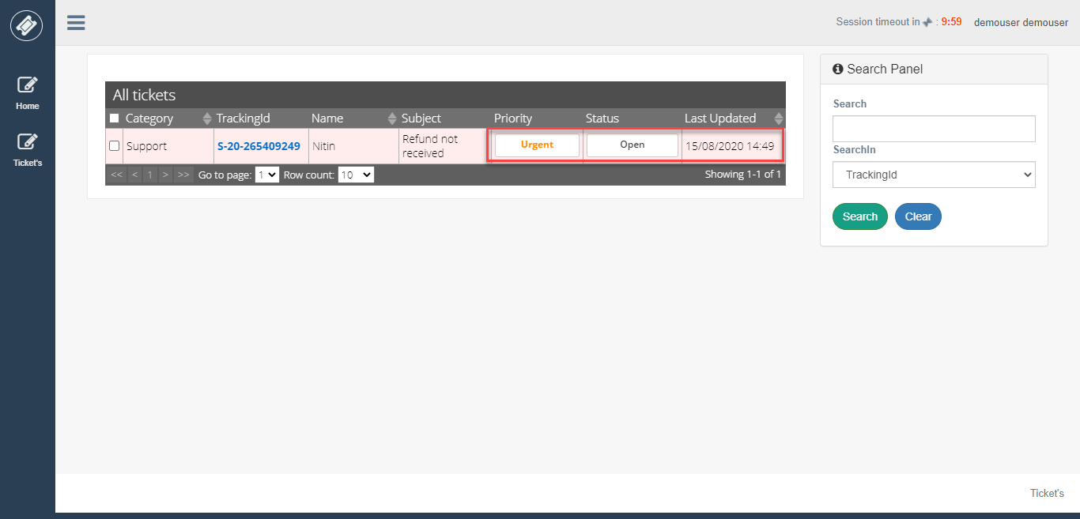

Now to see details of ticket click on Tracking Id.

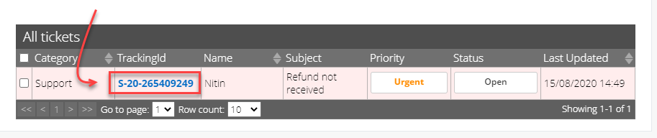

**Ticket Details View (Before Agent Reply)**

Below is ticket detail view which is not replied by Agent. You will see ticket tracking id created date along with a priority of ticket which you have set while you were creating.

Also, you can see the attachments which you have uploaded while creating a ticket.

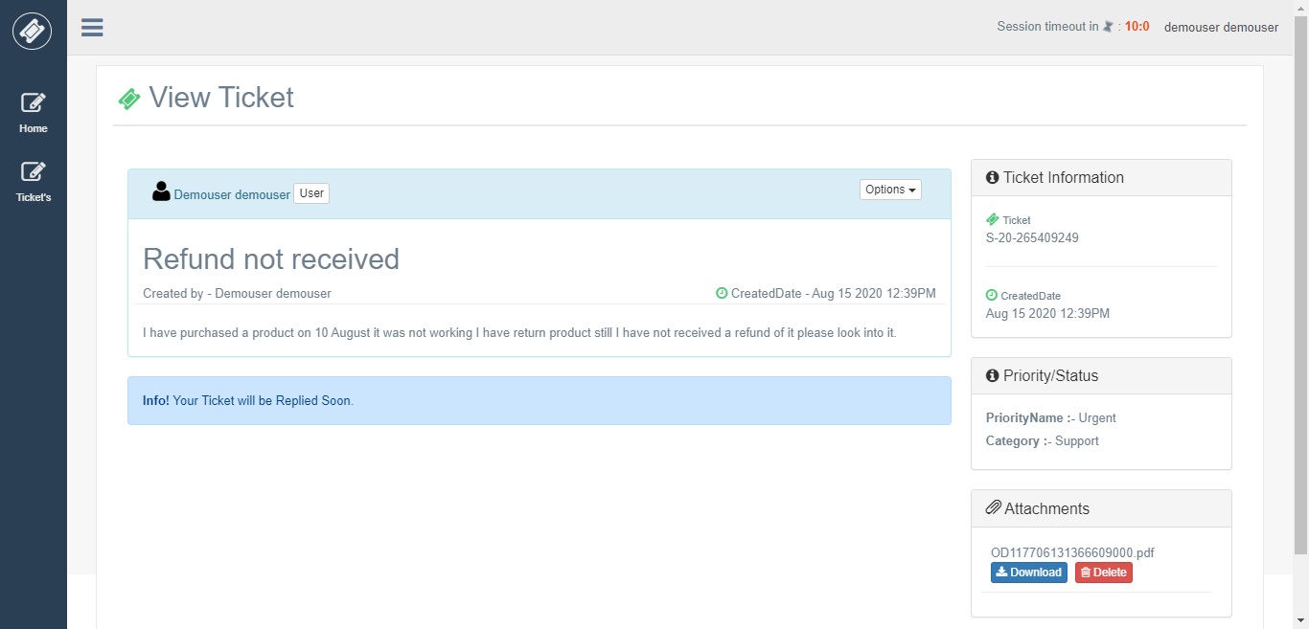

**Ticket Details View (After Agent Reply)**

After agent replies to User ticket, you will see a new panel with a response from Agent in it. Add reply option enable for replying on a ticket.

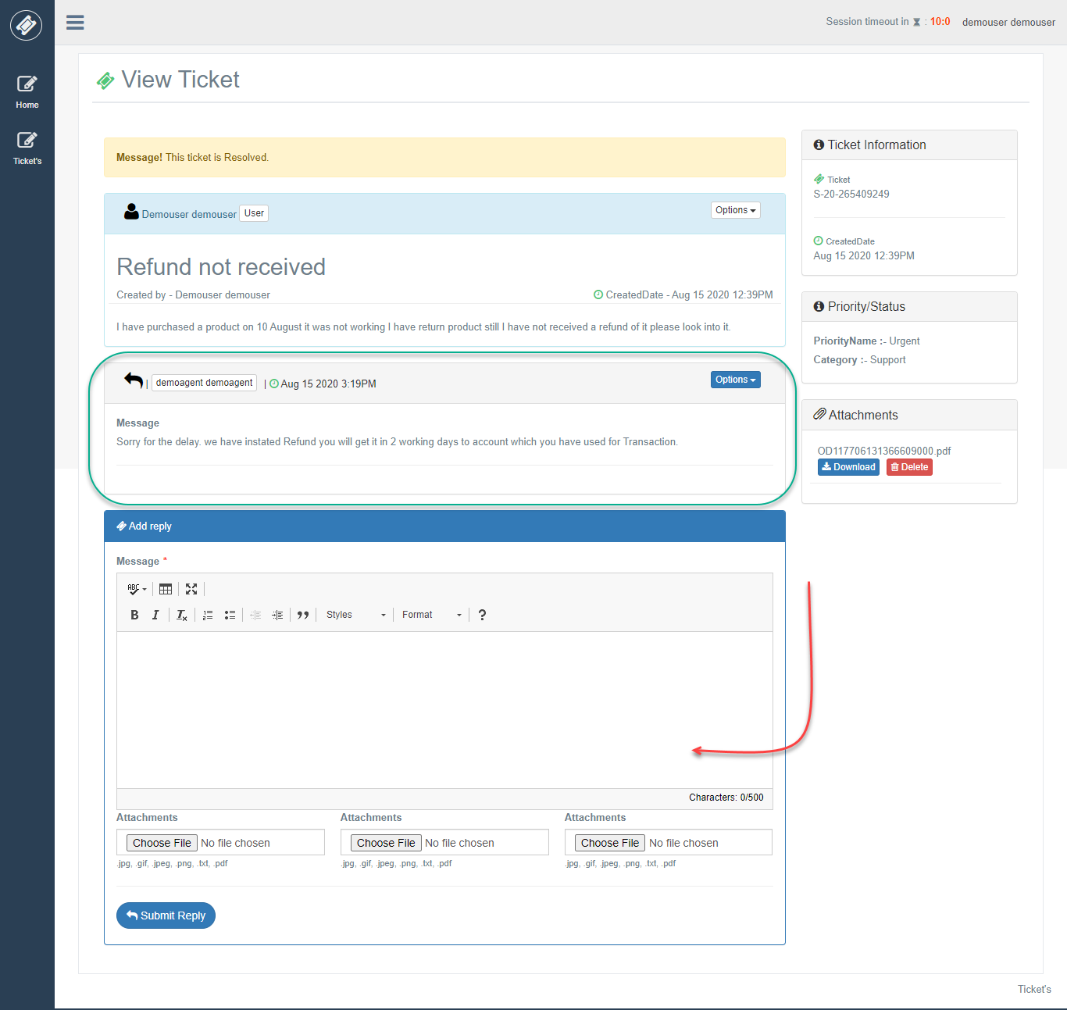

**Edit Ticket**

You can edit your ticket using option 🡪 Edit Ticket.

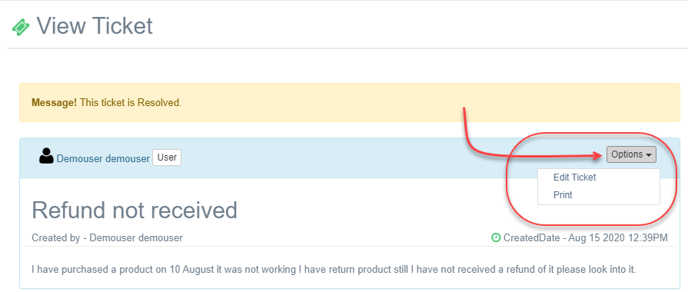

**Edit Ticket View**

After clicking on edit option, you can Edit ticket details and update them.

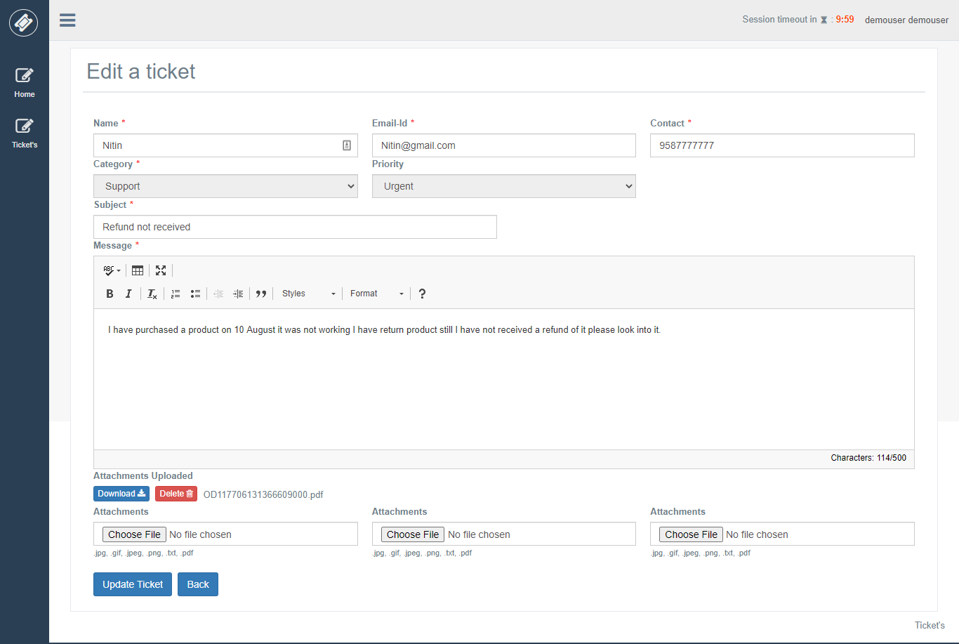

**Print Ticket**

If you want to print the ticket you can use print option by clicking on options 🡪 Print.

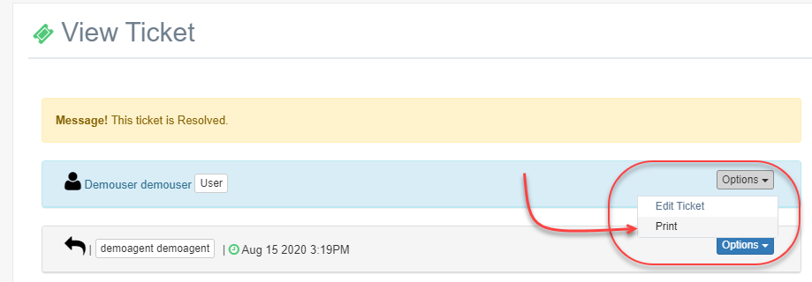

**Print View**

In print view either you can save pdf or print it directly.

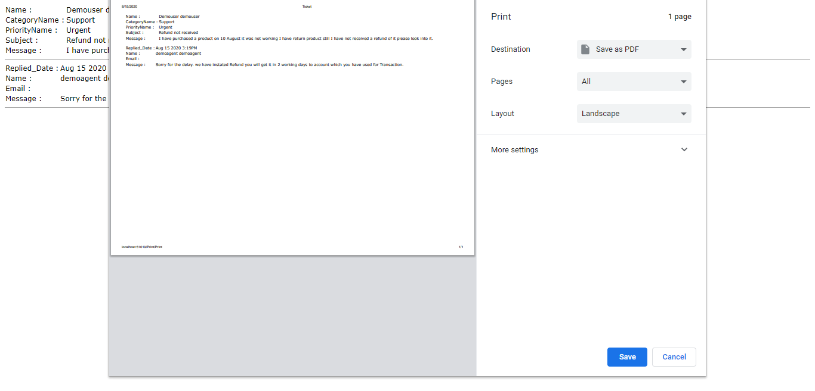

**Profile**

In the profile option, you can see your profile and edit some necessary details and update profile picture.

**Update Personal Details**

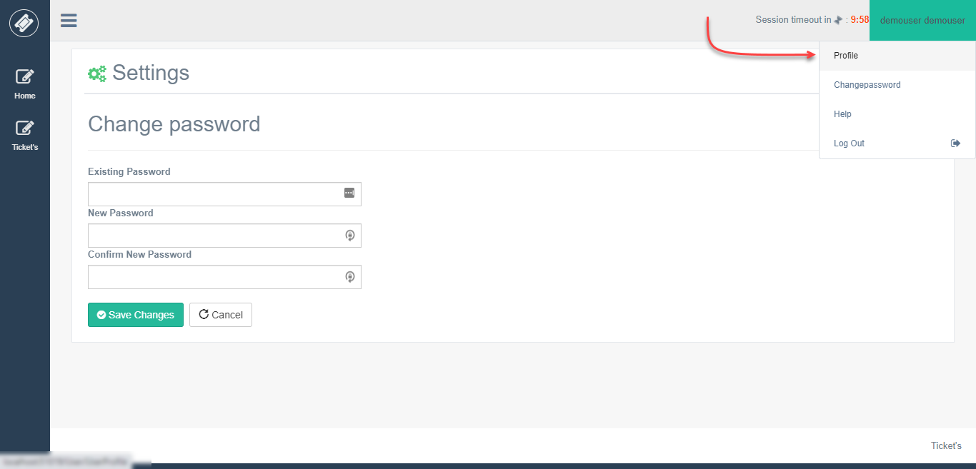

**Update profile picture**

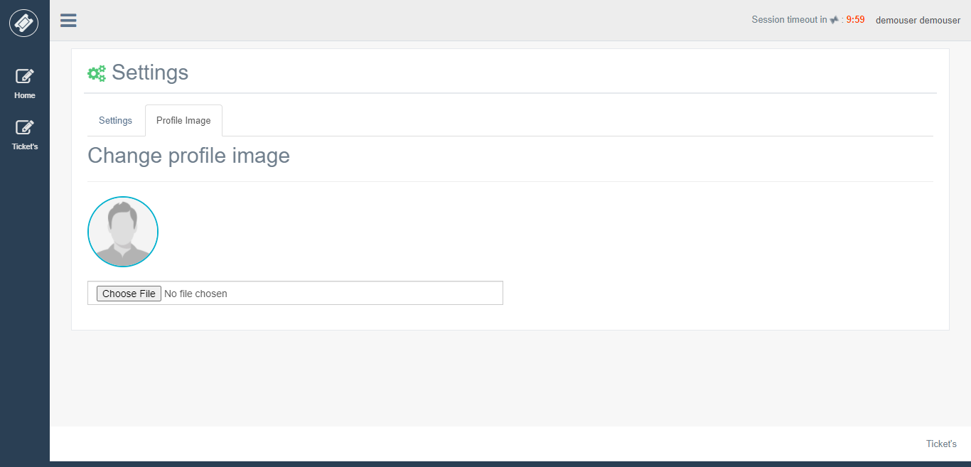

**Change Password**

