1)Unable to save/quick save requirements:

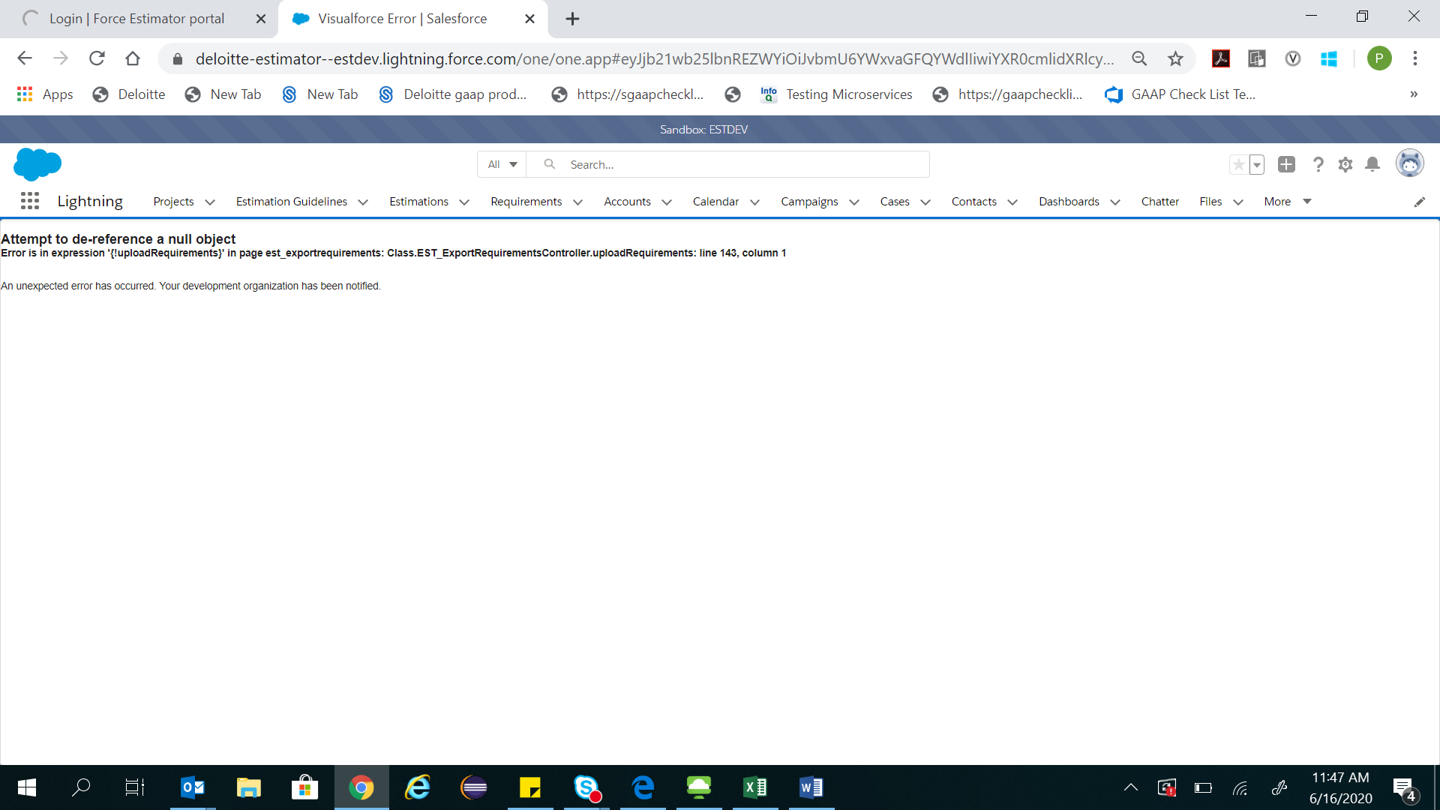

2. There is an error being displayed on the import tab:

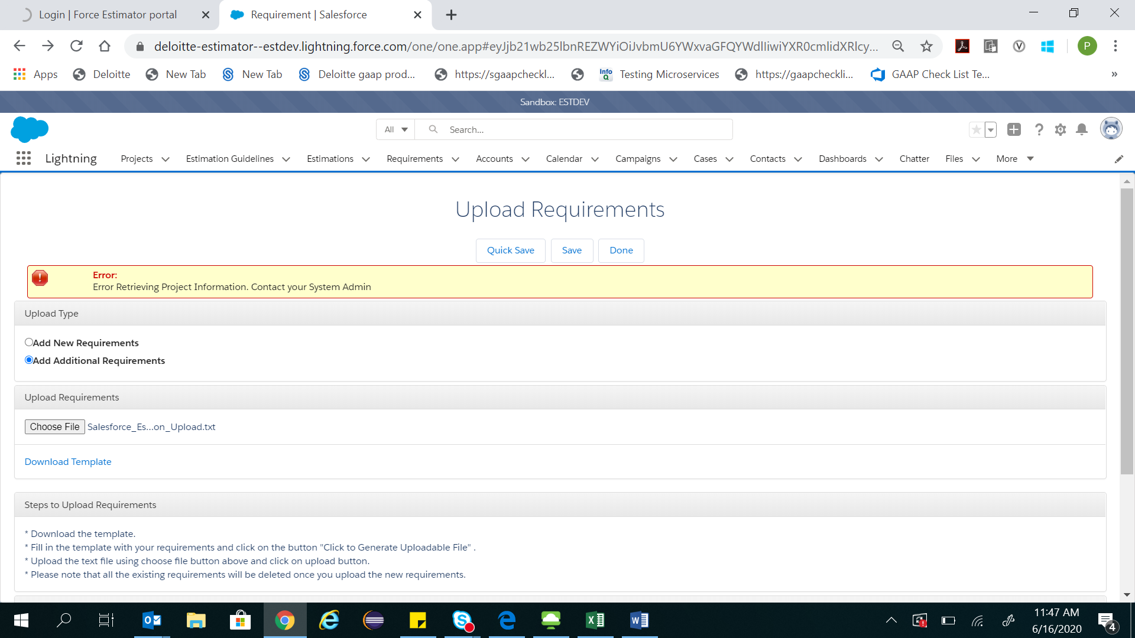

3. On trying to create a discovery estimates project, the requirement analysis tab is not present:

