1. Download template is throwing a blank page

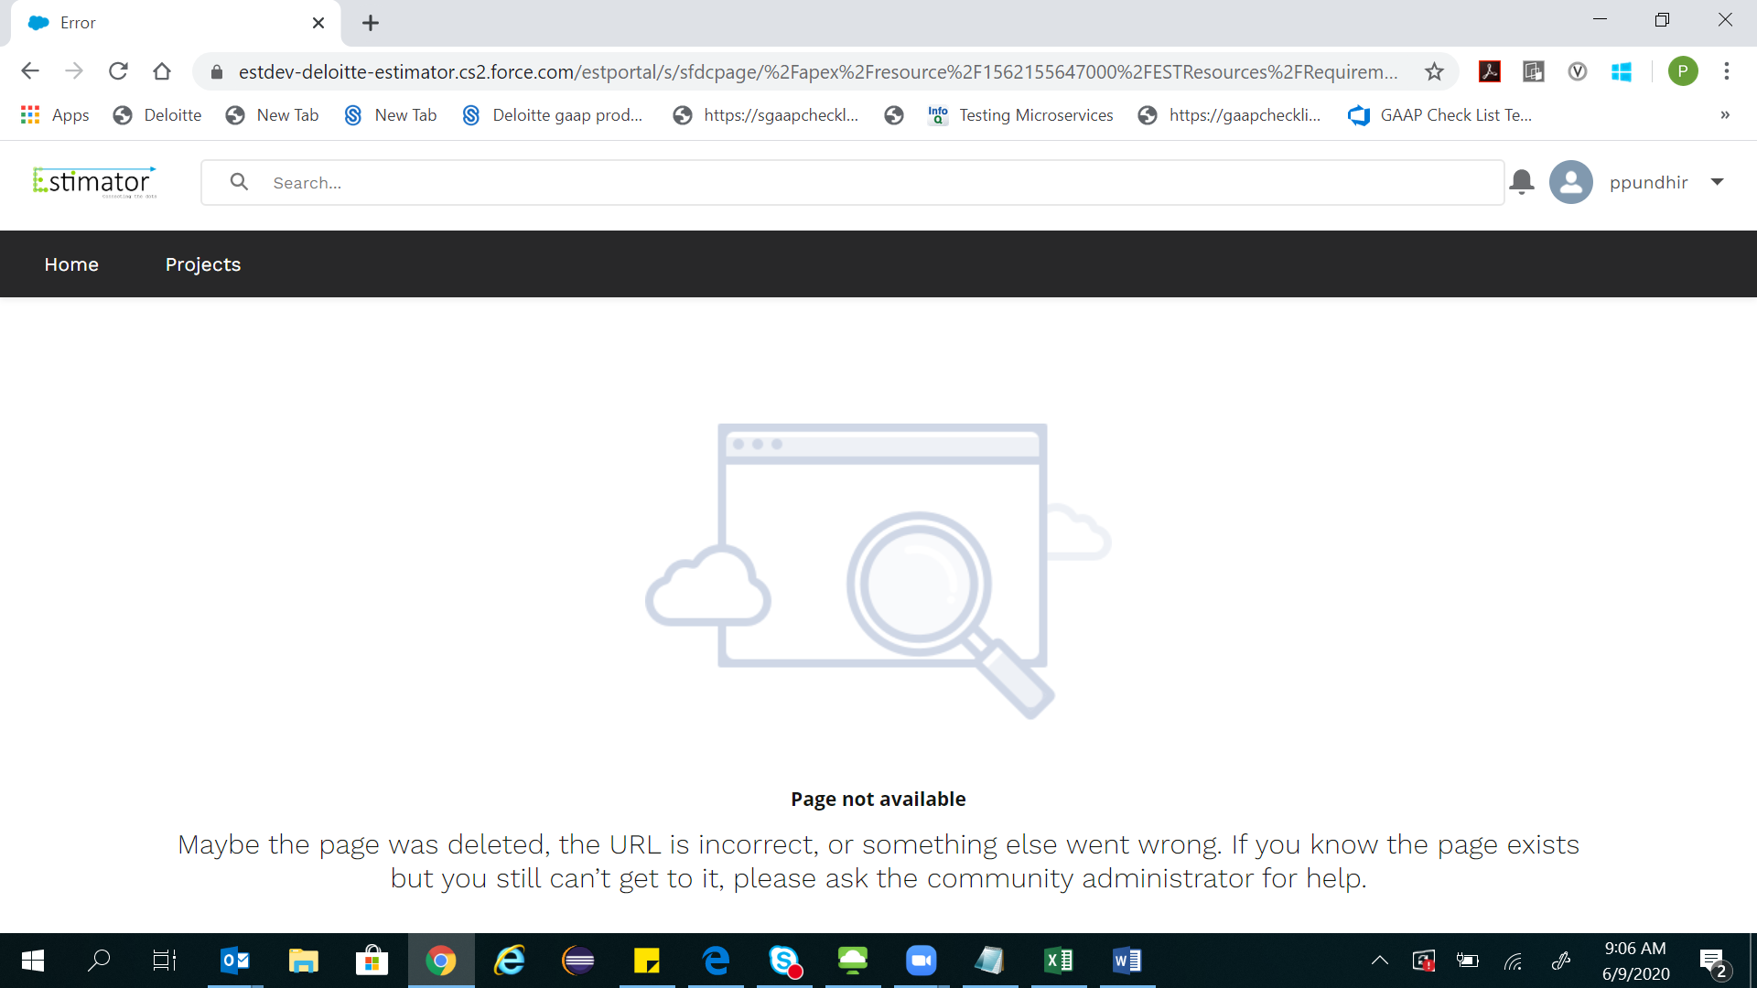

2)Clicking on done in import requirements in import tab is throwing a blank screen with service unavailable

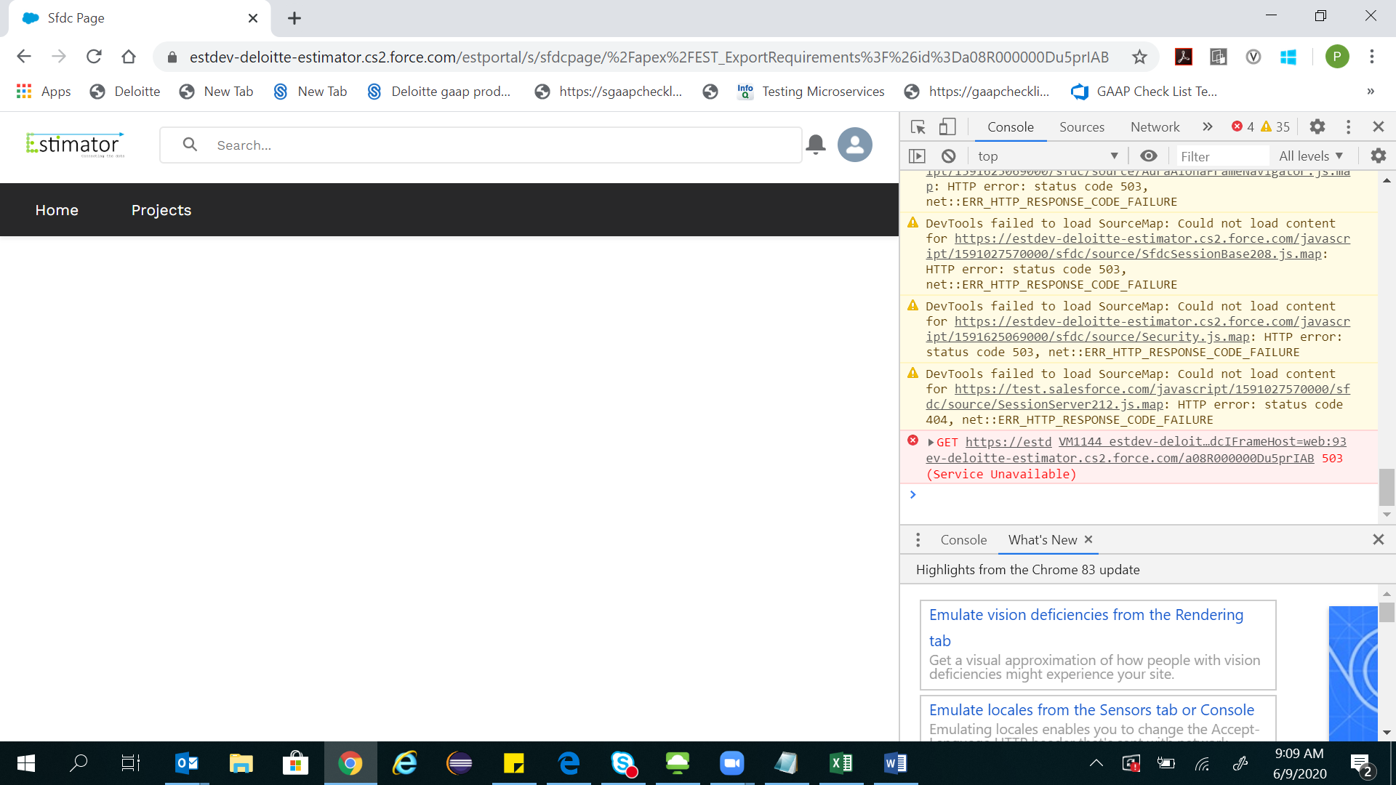

1. Story points and guidelines are blank for everything except customization in estimation guidelines

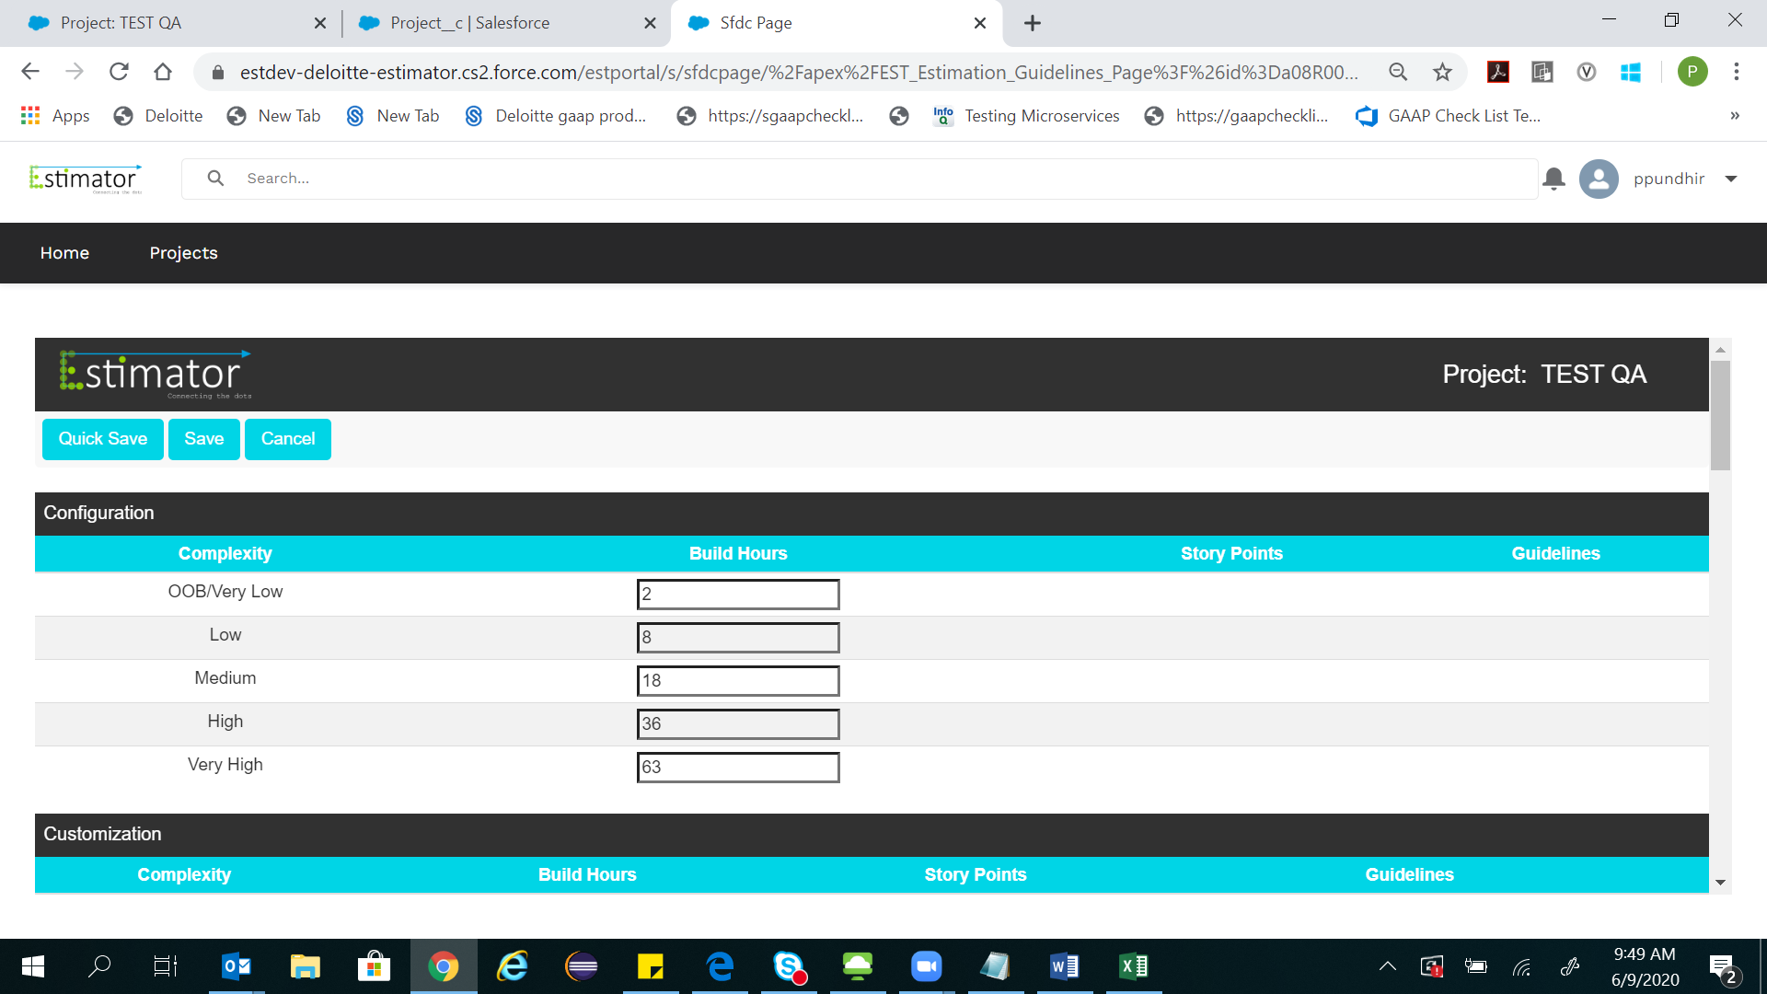

1. Unable to make any edits in guidelines from the guidelines tab
2. Agile checkbox is not appearing as checked after creating a project

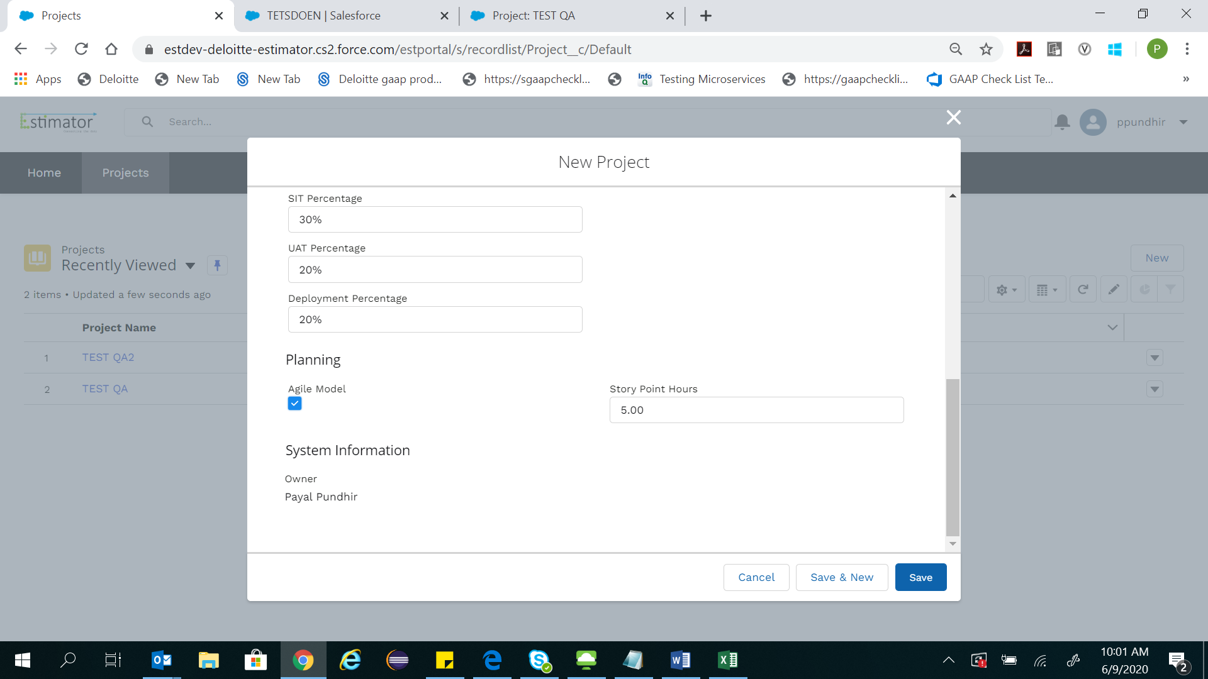

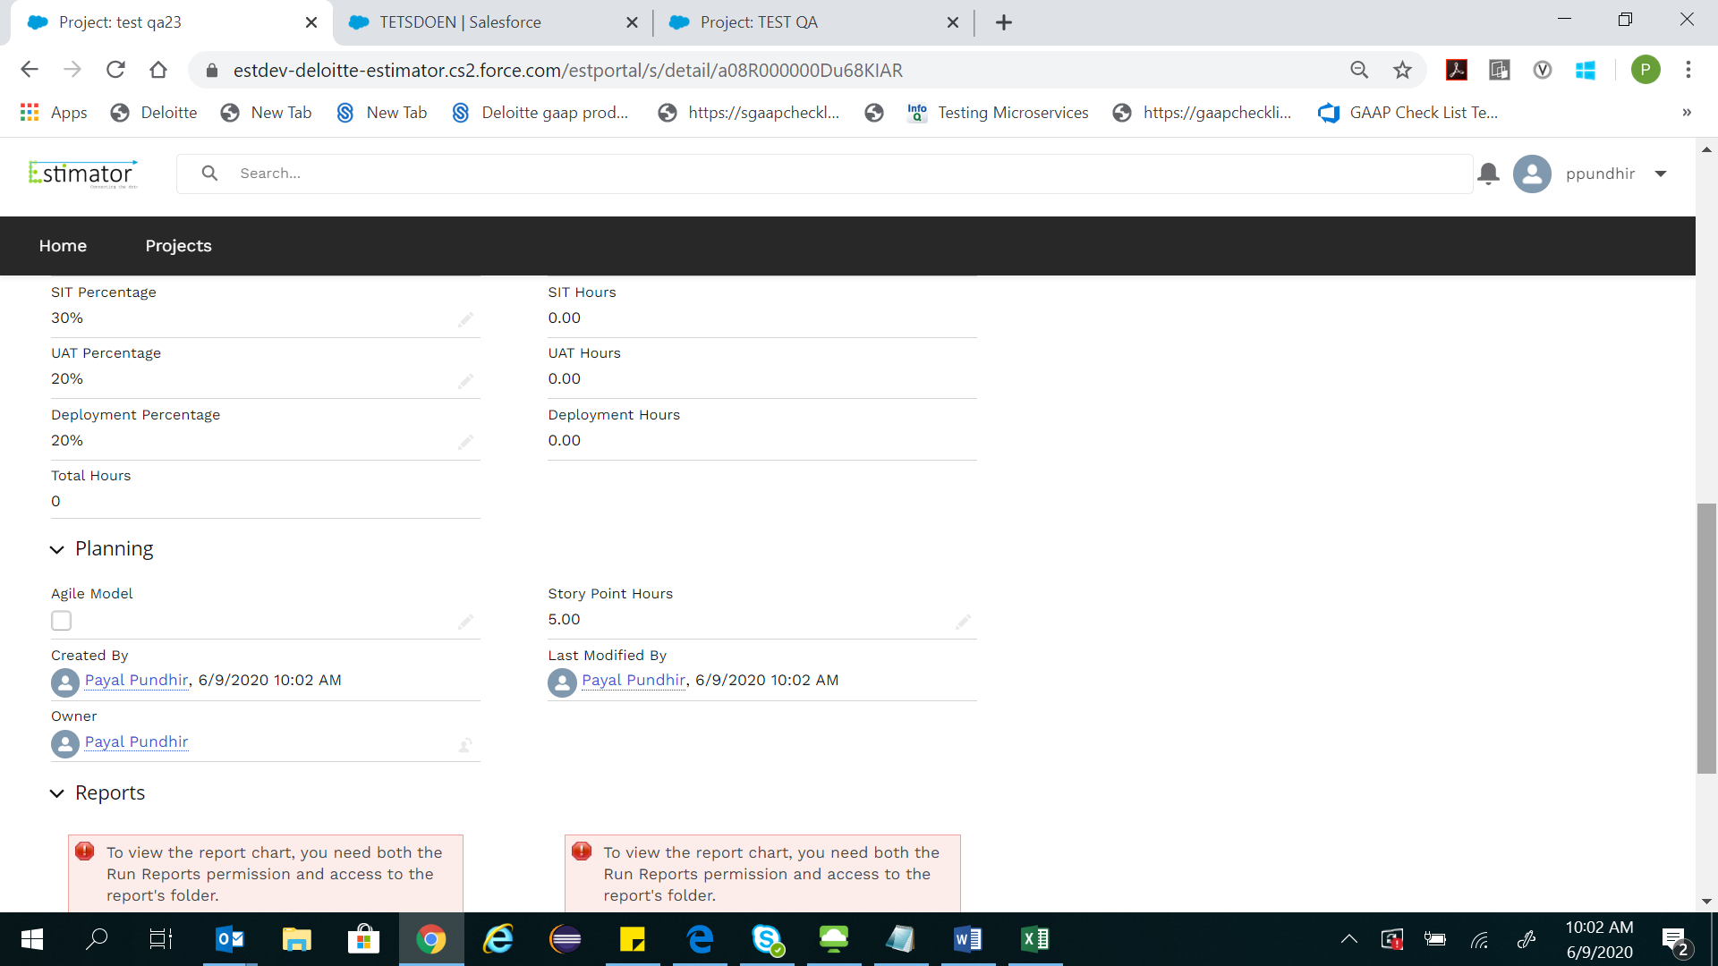

1. Clicking on reset and close throws a blank screen in requirement analysis
2. Another user is able to add additional requirements
3. Unable to export excel from requirements analysis screen

