REGIONS TABLES

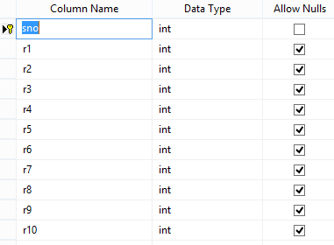

REGISTRATION TABLE

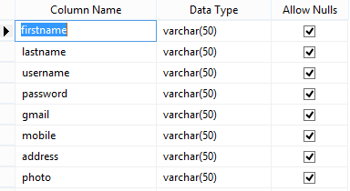

EATING DATESET

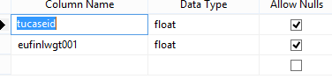

New

