HPPQ: A Parallel Package Queries Processing Approach for
Large-Scale Data
Abstract: A lot of scholars have focused on developing effective techniques for package queries, and a lot of excellent approaches have been proposed. Unfortunately, most of the existing methods focus on a small volume of data. The rapid increase in data volume means that traditional methods of package queries find it difficult to meetthe increasing requirements. To solve this problem, a novel optimization method of package queries (HPPQ) isproposed in this paper. First, the data is preprocessed into regions. Data preprocessing segments the dataset intomultiple subsets and the centroid of the subsets is used for package queries, this effectively reduces the volume of candidate results. Furthermore, an efficient heuristic algorithm is proposed (namely IPOL-HS) based on the preprocessing results. This improves the quality of the candidate results in the iterative stage and improves the convergence rate of the heuristic algorithm. Finally, a strategy called HPR is proposed, which relies on a greedy algorithm and parallel processing to accelerate the rate of query. The experimental results show that our method can significantly reduce time consumption compared with existing methods.
Key words: package queries; heuristic algorithms; parallel processing; opposition-based learning.
Existing System: Heuristic algorithm do not rely on gradient information and provide excellent performance in the problem of package queries. Compared with the exact methods, heuristic algorithms may get a suboptimal solution, but they greatly reduce the run time. However, with the rapid growth in data volume, heuristic algorithms used to solve package queries also find it difficult to meet the increasing demands of efficiency. Some scholars have used divide-and conquer algorithms to divide the problem into multiple sub-problems and improve query efficiency. But these use exact algorithms to solve the sub problems, which affect the run time to a certain extent.
Disadvantages: These existing algorithms are divided into several categories: exact algorithms, heuristic algorithms, and divide-and-conquer algorithms.All Operations not in single place.

Proposed System: It is necessary to design an efficient method of package queries for large volumes of data. In this, we present a method called HPPQ (Heuristic Parallel Package Queries), which is based on heuristic and divide-and-conquer strategies. It optimizes the method of package queries mainly through two aspects: improving the quality of the candidate solutions and accelerating the speed of query. To address these two aspects, we propose the IPOL-HS algorithm and the HPR strategy respectively.

Advantages: By Compbining heuristics,divide and conquer strategies we put all the operations at one place.

Architectuire:
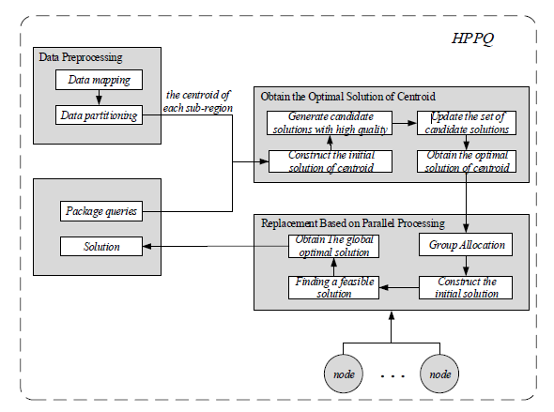

Modules:
Data Preprocessing:
Obtain Optimal Solution of Centroid
Replacement based Parallel Processing

Data Preprocessing: Data preprocessing divides similar objects into the same sub-regions, and when dealing with package queries, the data objects in each sub-region are treated as a whole. Data preprocessing mainly has two parts: data mapping and data partitioning.

Obtain Optimal Solution of Centroid: Here, we propose a heuristic algorithm based on Improved Partial Opposition-based Learning (namely IPOL-HS) to obtain the optimal solution for the centroid.

Replacement based Parallel Processing: Each replacement program needs to be calculated and if replacing the centroids with real data objects this needs to happen sequentially. This takes a lot of run time and produces more combinations. So, in this section a strategy called HPR, based on a greedy algorithm and parallel processing, is proposed to accelerate the query speed. The HPR strategy divides into two parts: group allocation and parallel processing. First, we designed an allocation algorithm to balance the node load and improve parallelism. Then, using the greedy strategy and parallel processing, we effectively replaced the centroids with data objects of corresponding subregions to get the final solution.

H/W System Configuration:-

Processor - Pentium –IV
Speed - 3.5 GHz
RAM - 4GB (min)
Hard Disk - 500GB

S/W System Configuration:-

- Operating System :Windows 8 or above
- Application Server : IIS 7.0
- Front End : ASP.Net (.Net 2015)
- Database : SQL SERVER 2014
- Database Connectivity : ADO.Net.
Future Scope: In the future, to further improve the convergence rate of the algorithm, the effect of different periods on the improved partial opposition operation probability should be considered. In addition, even though the method proposed in this paper reduces the run time required for package queries in the large-scale data environment to some extent, it still has the potential for further optimization. The parallel strategy mainly adopts parallel computing to reduce the run time, but there is no parallel strategy for obtaining the optimal solution of the centroid and no parallel replacement scheme for multiple sub-problems

Conclusion:
As a response to the requirements of large-scale data, we proposed a novel method for package queries combining heuristic methods and the divideand-conquer strategy, namely HPPQ. The method was found to reduce the number of candidate results by data preprocessing.

FEASIBILITY STUDY:
Preliminary investigation examine project feasibility, the likelihood the system will be useful to the organization. The main objective of the feasibility study is to test the Technical, Operational and Economical feasibility for adding new modules and debugging old running system. All system is feasible if they are unlimited resources and infinite time. There are aspects in the feasibility study portion of the preliminary investigation:
- Technical Feasibility
- Economical Feasibility
- Operation Feasibility

Technical Feasibility:
In the feasibility study first step is that the organization or company has to decide that what technologies are suitable to develop by considering existing system.
Here in this application used the technologies like Visual Studio 2015 and SqlServer 2014. These are free software that would be downloaded from web.
Visual Studio 2013 –it is tool or technology.

Determining Economic Feasibility:

Assessing the economic feasibility of an implementation by performing a cost/benefit analysis, which as its name suggests compares the full/real costs of the application to its full/real financial benefits. The alternatives should be evaluated on the basis of their contribution to net cash flow, the amount by which the benefits exceed the costs, because the primary objective of all investments is to improve overall organizational performance.
Type | Potential Costs | Potential Benefits
Quantitative | - Fully-burdened cost of labor (salary + benefits)  - Support costs for the application  - Expected operational costs  - Training costs for users to learn the application  - Training costs to train developers in new/updated technologies | - Reduced operating costs  - Reduced personnel costs from a reduction in staff  - Increased revenue from additional sales of your organizations products/services
Qualitative | - Increased employee dissatisfaction from fear of change | - Improved decisions as the result of access to accurate and timely information  - Raising of existing, or introduction of a new, barrier to entry within your industry to keep competition out of your market  - Positive public perception that your organization is an innovator
The table includes both qualitative factors, costs or benefits that are subjective in nature, and quantitative factors, costs or benefits for which monetary values can easily be identified. I will discuss the need to take both kinds of factors into account when performing a cost/benefit analysis.
Operational Feasibility
Not only must an application make economic and technical sense, it must also make operational sense.
Operations Issues | Support Issues
- What tools are needed to support operations?  - What skills will operators need to be trained in?  - What processes need to be created and/or updated?  - What documentation does operations need? | - What documentation will users be given?  - What training will users be given?  - How will change requests be managed?
Very often you will need to improve the existing operations, maintenance, and support infrastructure to support the operation of the new application that you intend to develop. To determine what the impact will be you will need to understand both the current operations and support infrastructure of your organization and the operations and support characteristics of your new application. To operate this application END-TO-END VMS. The user no need to require any technical knowledge that we are used to develop this project is Asp.net ,C#.net. That the application providing rich user interface by user can do the operation in flexible manner.
Functional requirement:
Outputs from computer systems are required primarily to communicate the results of processing to users. They are also used to pro vide a permanent copy of the results for later consultation. The various types of outputs in general are:
- External Outputs, whose destination is outside the organization,.
- Internal Outputs whose destination is within organization and they are the
- User’s main interface with the computer.
- Operational outputs whose use is purely within the computer department.
- Interface outputs, which involve the user in communicating directly.
- Understanding user’s preferences, expertise level and his business requirements through a friendly questionnaire.
- Input data can be in four different forms - Relational DB, text files, .xls and xml files. For testing and demo you can choose data from any domain. User-B can provide business data as input.

Non functional requirements:
- Secure access of confidential data (user’s details). SSL can be used.
- 24 X 7 availability.
- Better component design to get better performance at peak time
- Flexible service based architecture will be highly desirable for future extension

N Tier Architecture:-
Simply stated, an n-tier application helps us distribute the overall functionality into various tiers or layers:
- Presentation Layer
- Business Rules Layer
- Data Access Layer
- Database/Data Store
Each layer can be developed independently of the other provided that it adheres to the standards and communicates with the other layers as per the specifications.
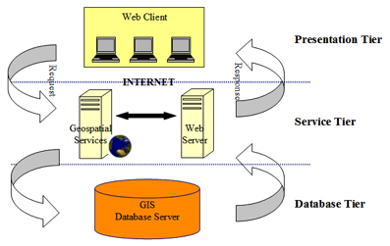

Fig 1.1-N-Tier Architecture
This is the one of the biggest advantages of the n-tier application. Each layer can potentially treat the other layer as a ‘Block-Box’.
In other words, each layer does not care how other layer processes the data as long as it sends the right data in a correct format.

- The Presentation Layer:
Also called as the client layer comprises of components that are dedicated to presenting the data to the user. For example: Windows/Web Forms and buttons, edit boxes, Text boxes, labels, grids, etc.

- The Business Rules Layer:
This layer encapsulates the Business rules or the business logic of the encapsulations. To have a separate layer for business logic is of a great advantage. This is because any changes in Business Rules can be easily handled in this layer. As long as the interface between the layers remains the same, any changes to the functionality/processing logic in this layer can be made without impacting the others. A lot of client-server apps failed to implement successfully as changing the business logic was a painful process.
- The Data Access Layer:
This layer comprises of components that help in accessing the Database. If used in the right way, this layer provides a level of abstraction for the database structures. Simply put changes made to the database, tables, etc do not affect the rest of the application because of the Data Access layer. The different application layers send the data requests to this layer and receive the response from this layer.
- The Database Layer:
This layer comprises of the Database Components such as DB Files, Tables, Views, etc. The Actual database could be created using SQL Server, Oracle, Flat files, etc.In an n-tier application, the entire application can be implemented in such a way that it is independent of the actual Database. For instance, you could change the Database Location with minimal changes to Data Access Layer. The rest of the Application should remain unaffected.

