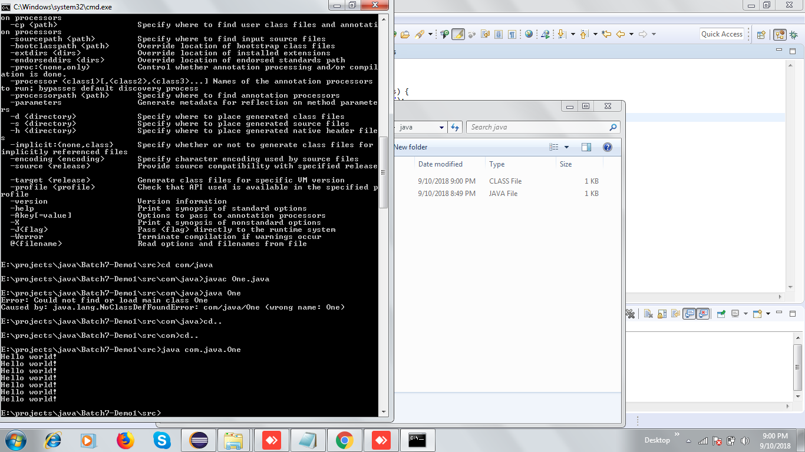

-classpath:

eclipse: Photon

IDE: Integrated Development environment

java: compile: javac

java tool

jdk1.8

core java: desktop applications:

Java sdk(desktop application: swing| jdbc| java : lang/io/) java web java ee

jdk: development kit: compiler, debugger, jre(run ur java code), javadoc, libraries

jre: libraries+ java tool+ jvm

jvm: java virtual machine: OS: memory area| execute

languages : machine language ADD registers

java : platform independent language

One.java -> bytecode (class file): machine independent: jvm

windows 32: jvm : jre -> just in time compiler : machine specific code

interpreter: execute the code

compiler: code | interpreter: line by line?

C: compiler: compiles: machine code

javac tool

java: execute

java: Object oriented programming: classes/objects:

real world

object: relationships

Ram is driving WagonR

Object: properties operations

Ram is a Person: name| address | walk() | talk()

Car: class : break| seats| mirror : drive()

Relationship: Is A| Has A

Person has a address

Ram has a Car

Manager is a Employee

Object oriented Programming : Object : relationship ( Is-a/ Has-a)

Banking application

Customers

Accounts (Saving account| checking account): deposit withdraw, check balance

Employees : Clerks | Manager| Vice president

Money | Jewellery

Account : Saving account | Checking account

Account: account number, account holder

Saving accountouble

min account balance: 20000

Checking account: 3%, min balance: 0

Saving account is a Account

Manager is a Employee

Employee has a Salary

Lotus is a flower

Ram went to open a saving account in bank PNB (Is-a has-a)

Datatype:

Numeric | character| Boolean

Decimal | non-decimal

Byte : 8bits :

10: 1010 10/2

Decimal :

binary

-128-> 127| -32768 -> 32767 | -2147483648-> 2147483647

byte (8 bits)| short (16 bits) | int (32 bits) | long 64 bits {non-decima}

8787436764L;

float (32 bits)| double(64 bits)

32.45f

Boolean: true/false

Char: ‘A’

876

Class : template| object

Ram is a person: account

Access modifiers: public, private, protected, default

Public: accessible to all: even outside the package

Private: belongs to that class , no one outside that class can access it

Default: package: all the classes within that package can access it, but no one outside the package

Protected: accessed by all classes in the same package + child classes (Inheritance) in a diff package

Class: public, default

Method/property: can use any 4 access modifiers

Primitive data-types: byte, short, int, long, float, double, char,boolean

Class : String, Wrapper classes: Byte, Short, Integer, Long, Float, Double, Boolean, Character

Generics, Collections

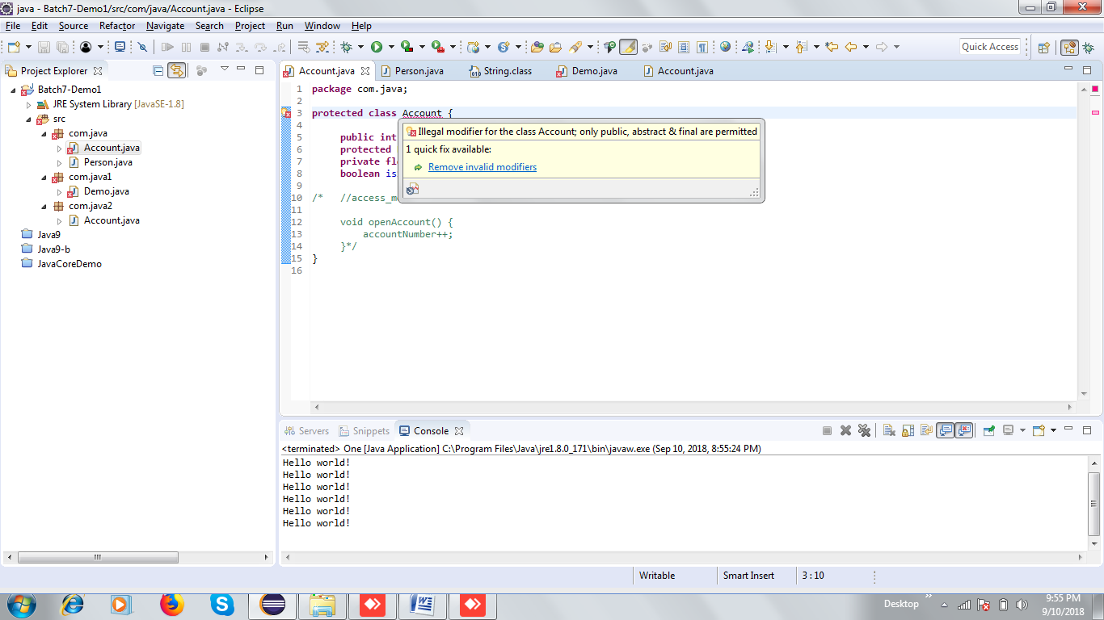

Is A: Manager is a Employee

Employee: name, id, salary, department, project

Manager: employees | band : A, name, id, salary, department, project

Class Employee {

Name

Id

salary

}

Class Manager extends Employee{

}

Access modifier:

C: procedural/functional?

Add()

**Modifiers:**

**Final:**

1. Variable: value cannot be changed

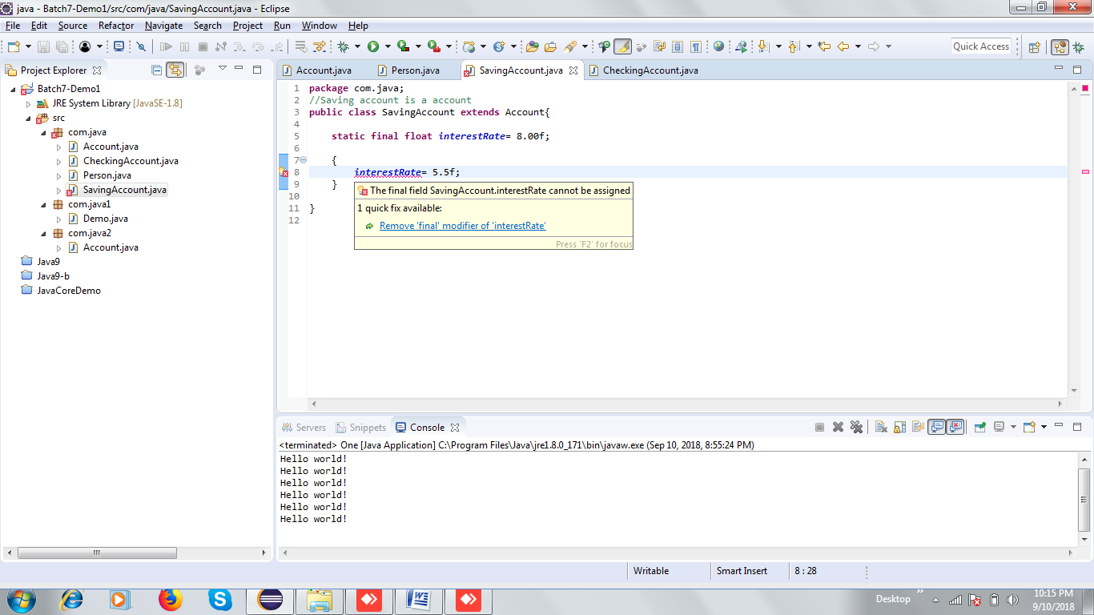

1. Method: It cannot be overridden
2. Class: class cannot be inherited

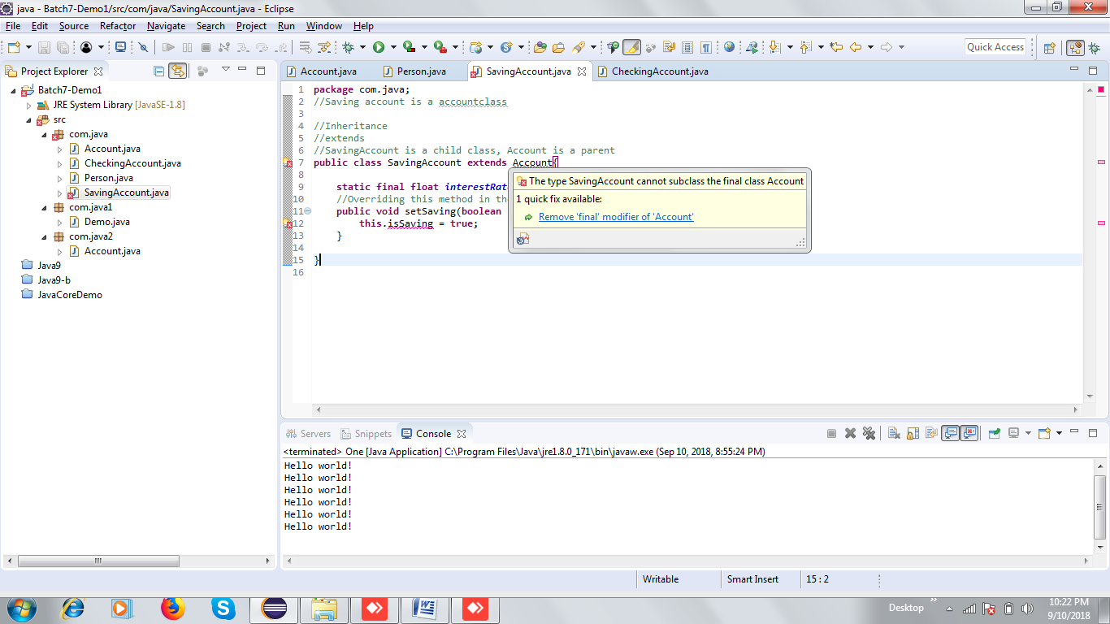

**Static:**

It belongs to a class

1. Variable: belongs to a class and not to a particular object, all the objects can access this value
2. Method
3. Block

Types of variable:

1. Local : needs to be initialize
2. Instance: 0/ false, 0.0f, 0.0: object
3. Static/ class variable: : 0/ false, 0.0f, 0.0

Static variable/methods , since they belong to a class, can be accessed by a class reference. U can also access them using a object reference but they do not belong to a particular object

**Constructor:**

New object

Name: classname

No return type

y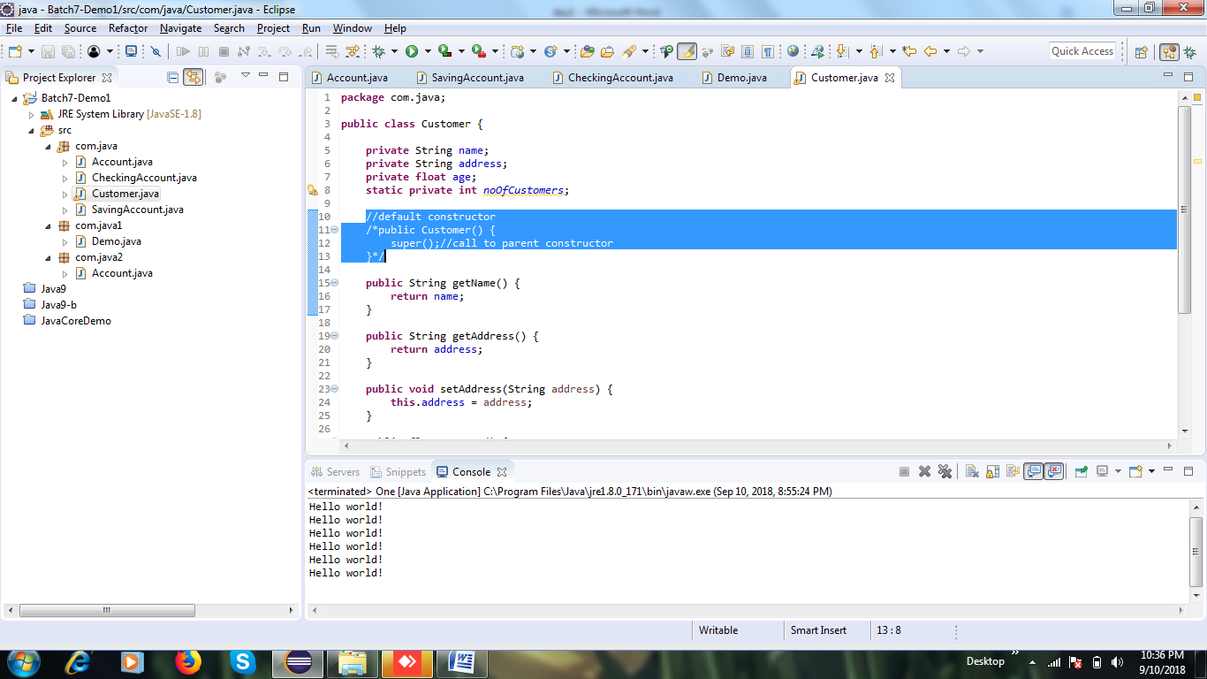

All java classes extend from Object class

**Defining constant in java**

Final variable: once I give it a value, value cannot be changed

Static variable:

//Object oriented programming language: class/ object/ relationship (is-a/ has-a)

//access modifiers, static, final

//constructor

//inheritance

