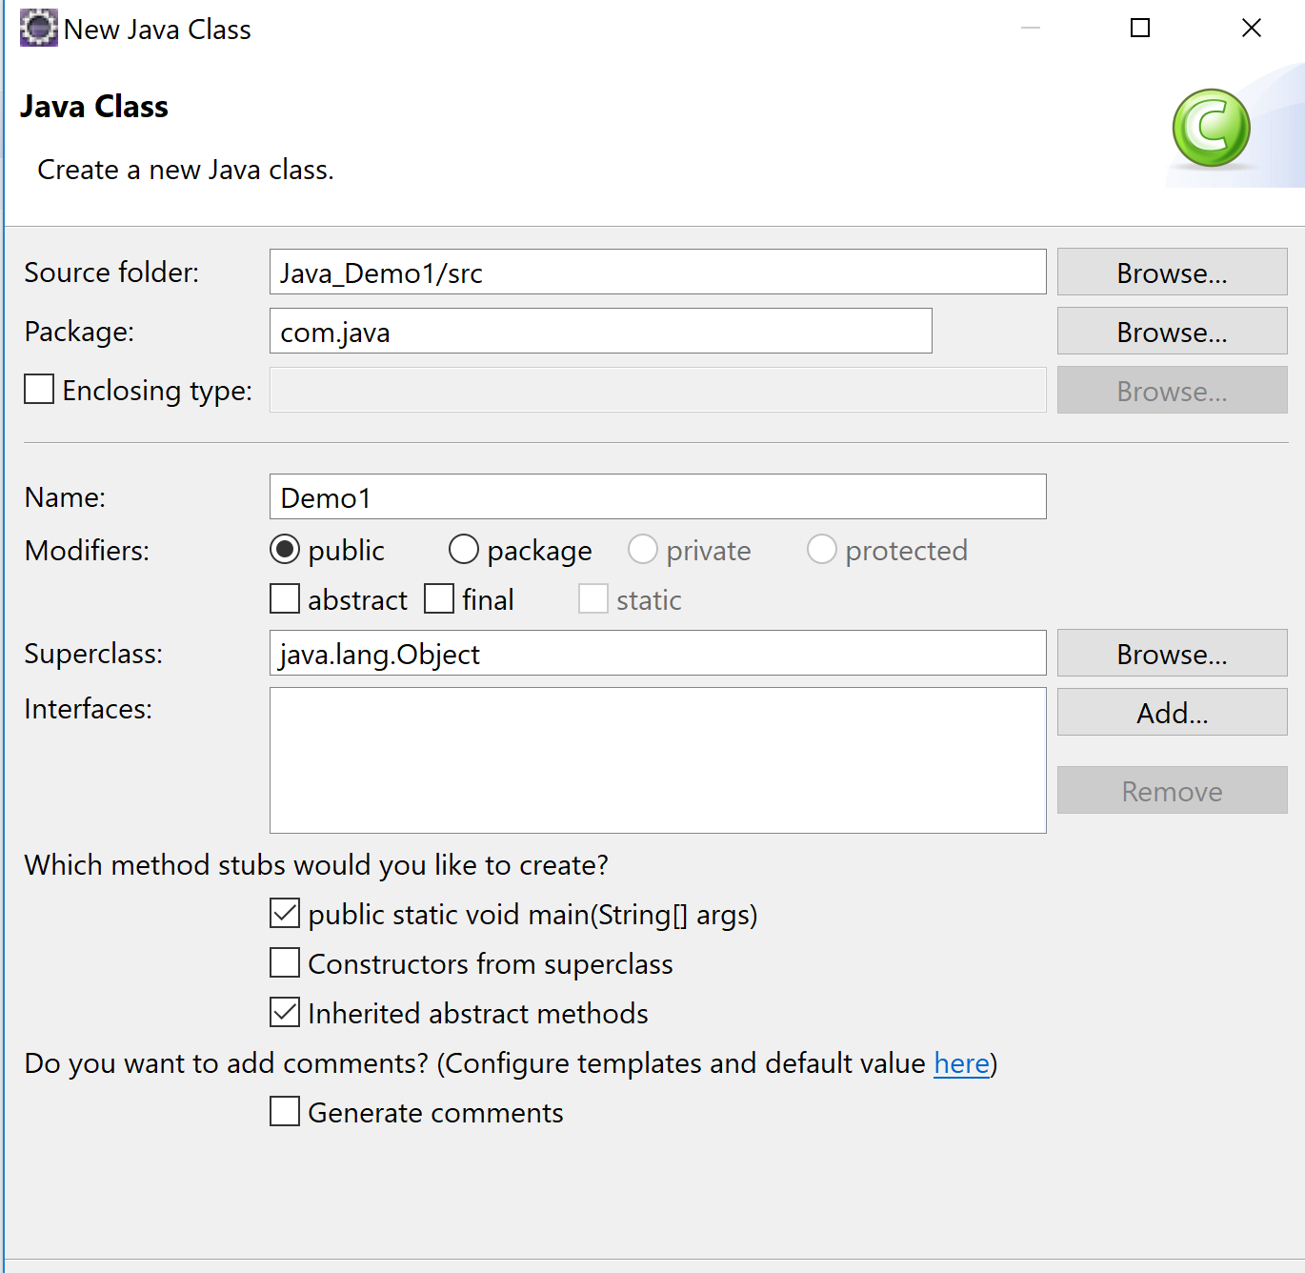

Variables in java:

1. Local variable: variable within the scope of a block {}

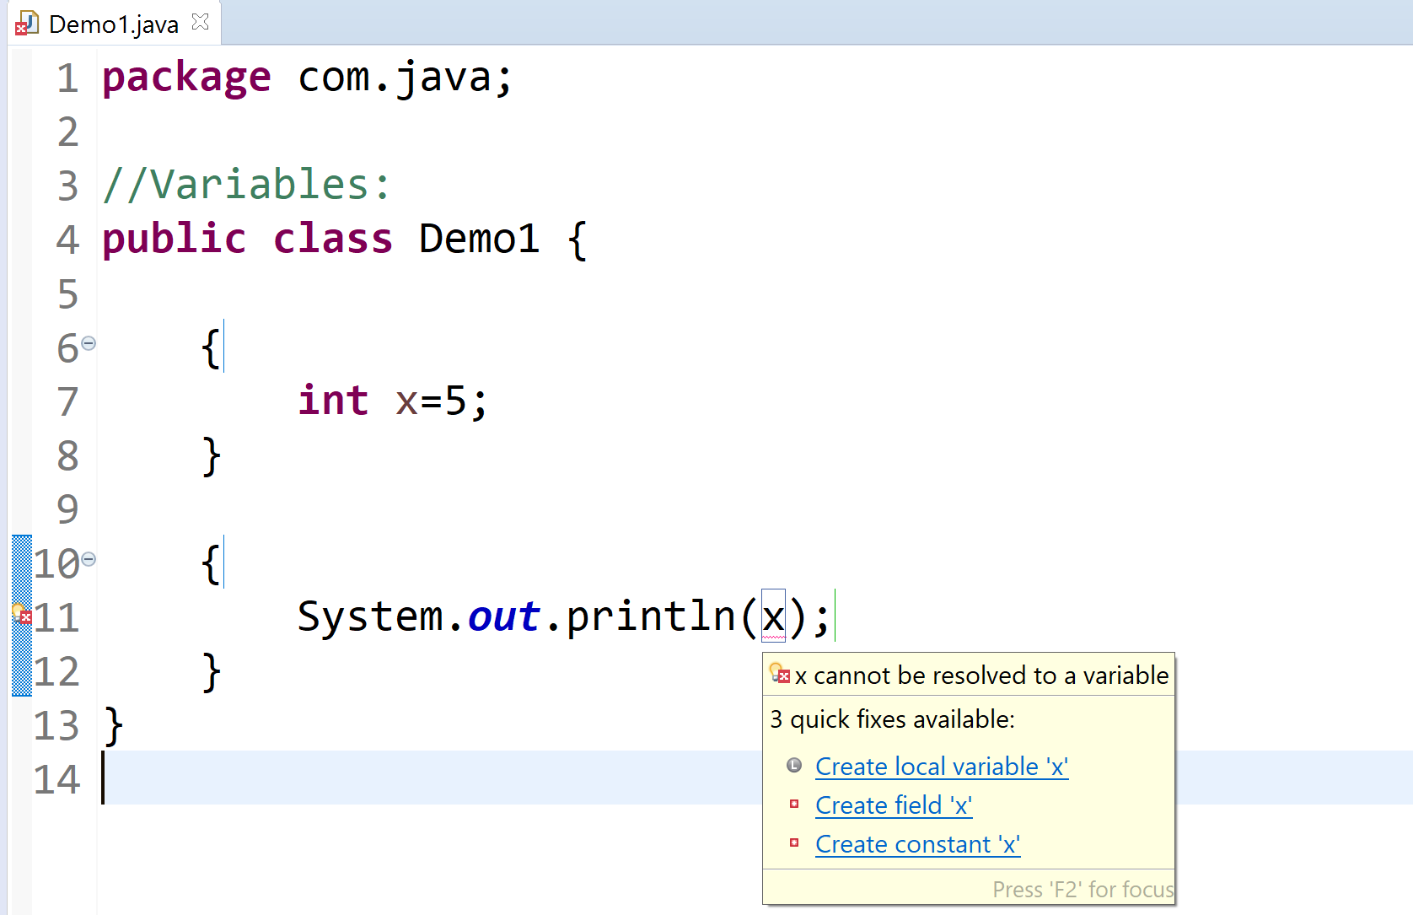

Scope is only within the block in which it has been defined.

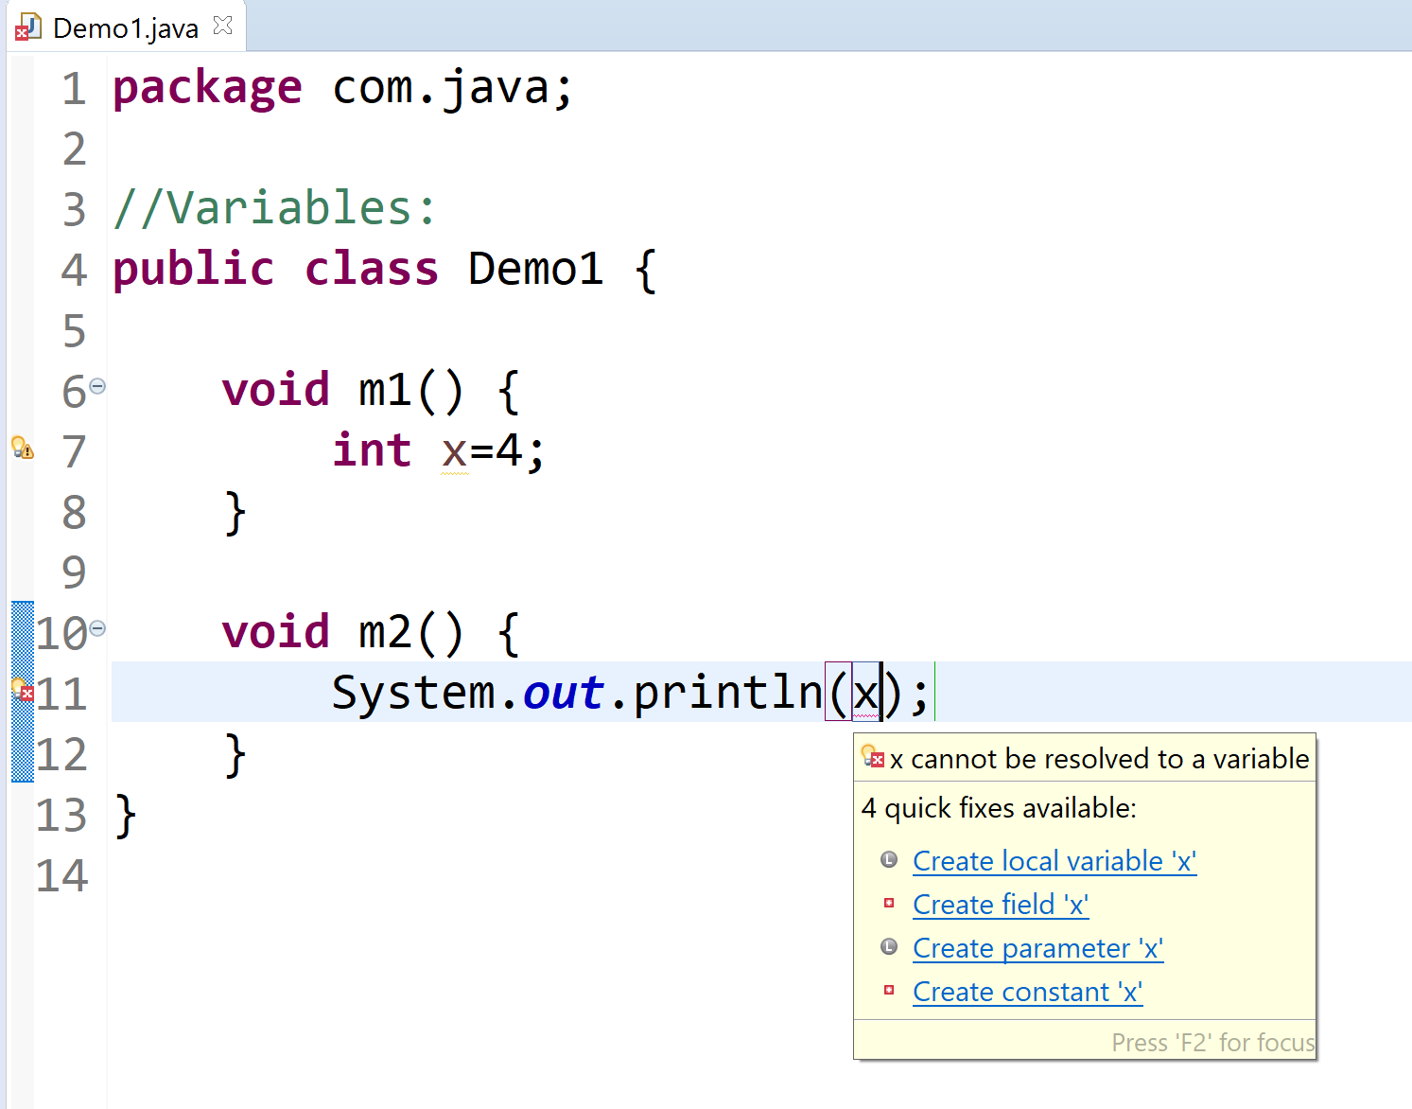

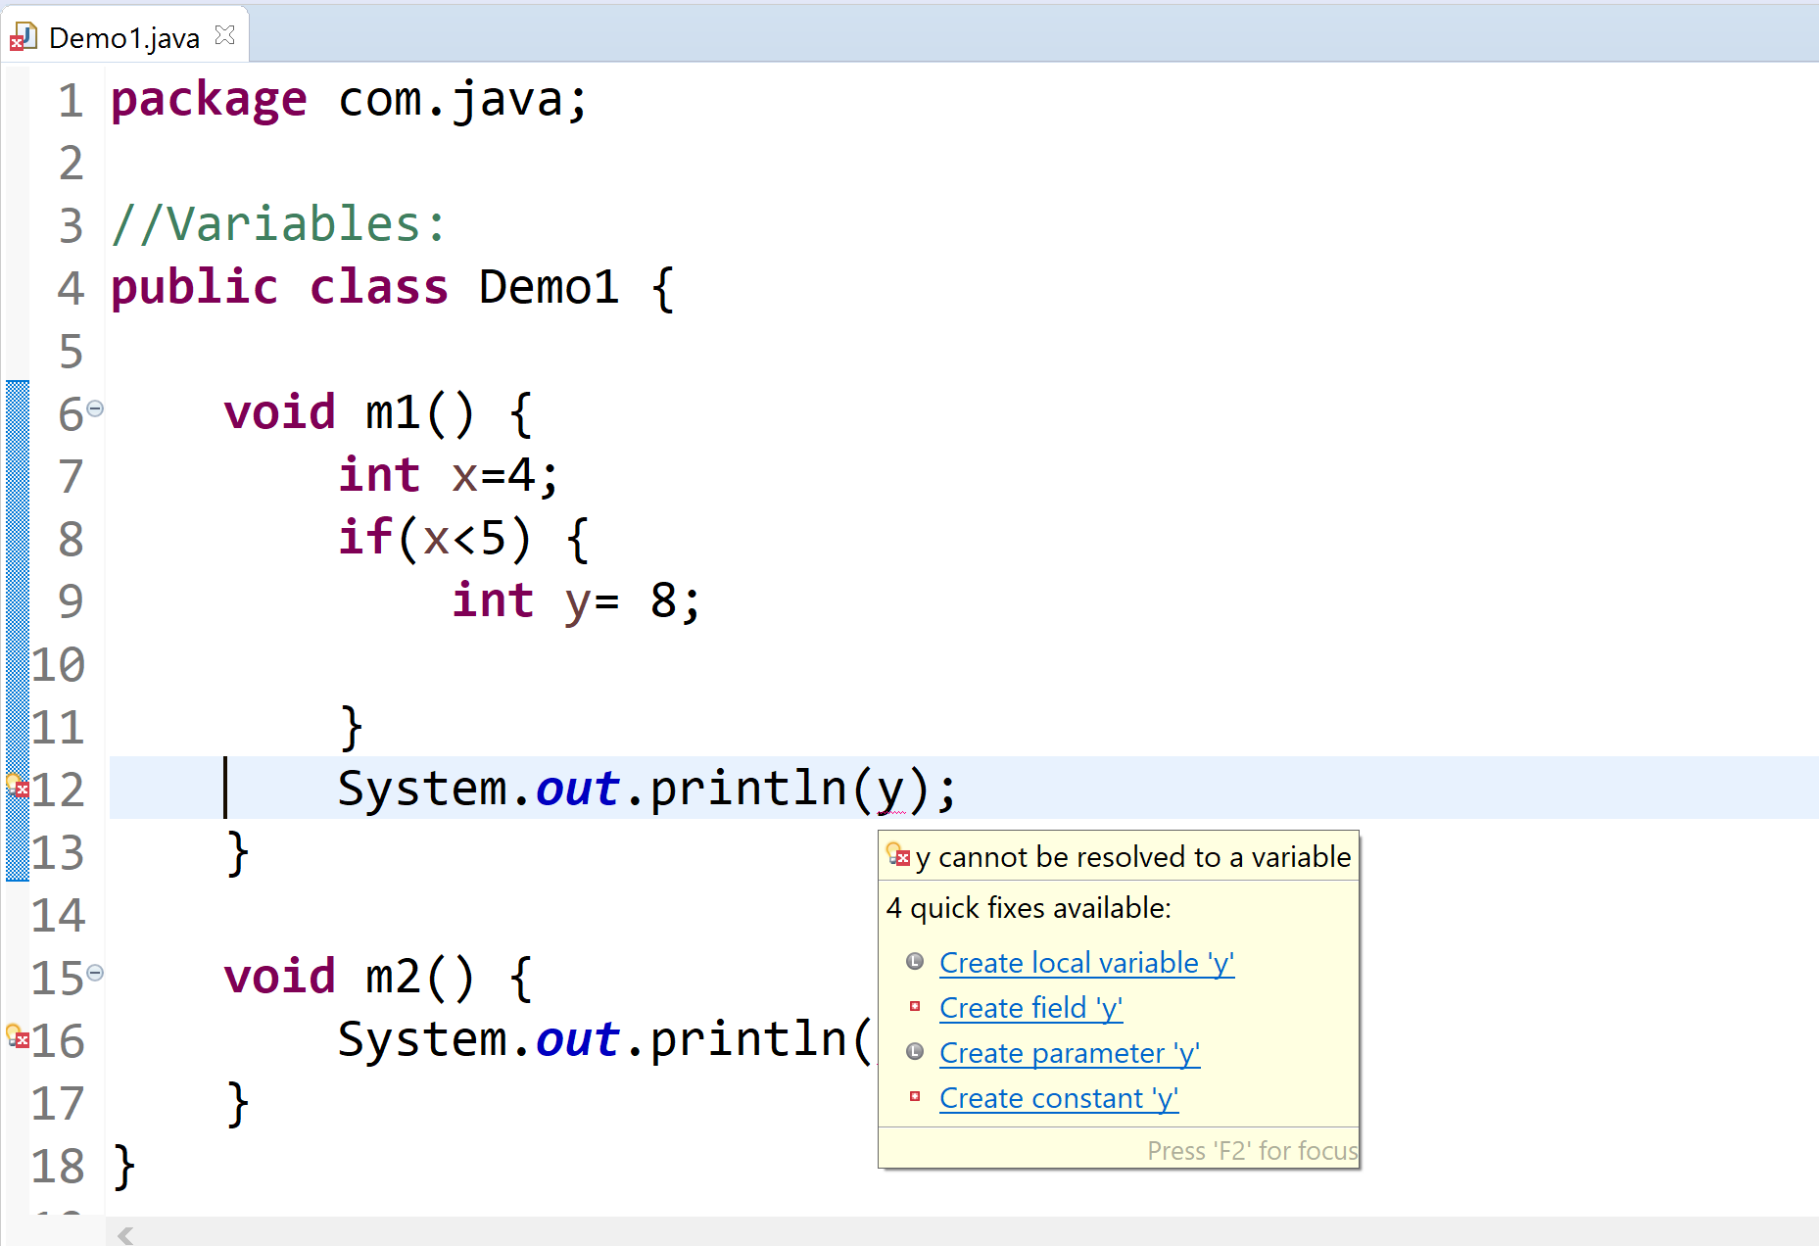

Local variables should be initialized before u use them.

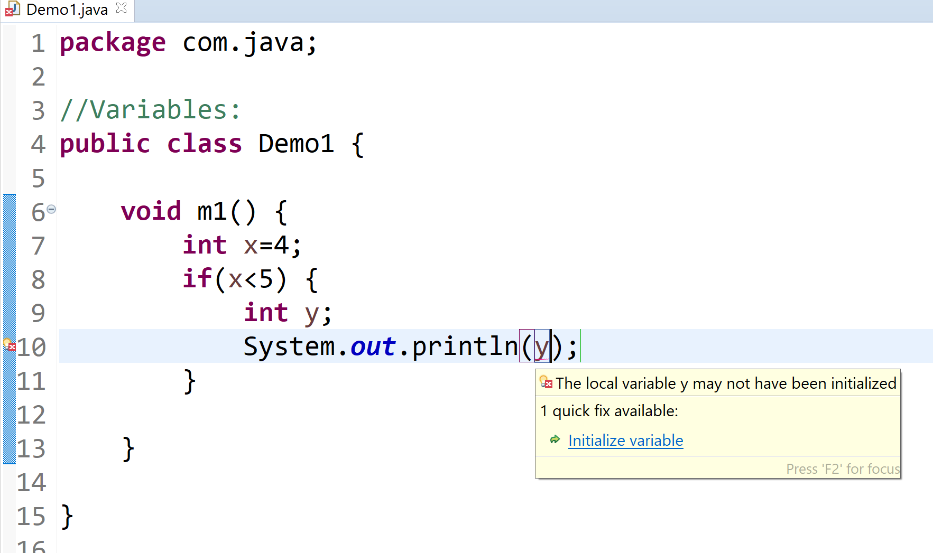

void m1(){

int x;

x += 5;

Sysout(x);

}

1. Instance variable

class A{

{

int x; //local

}

int y;//instance

}

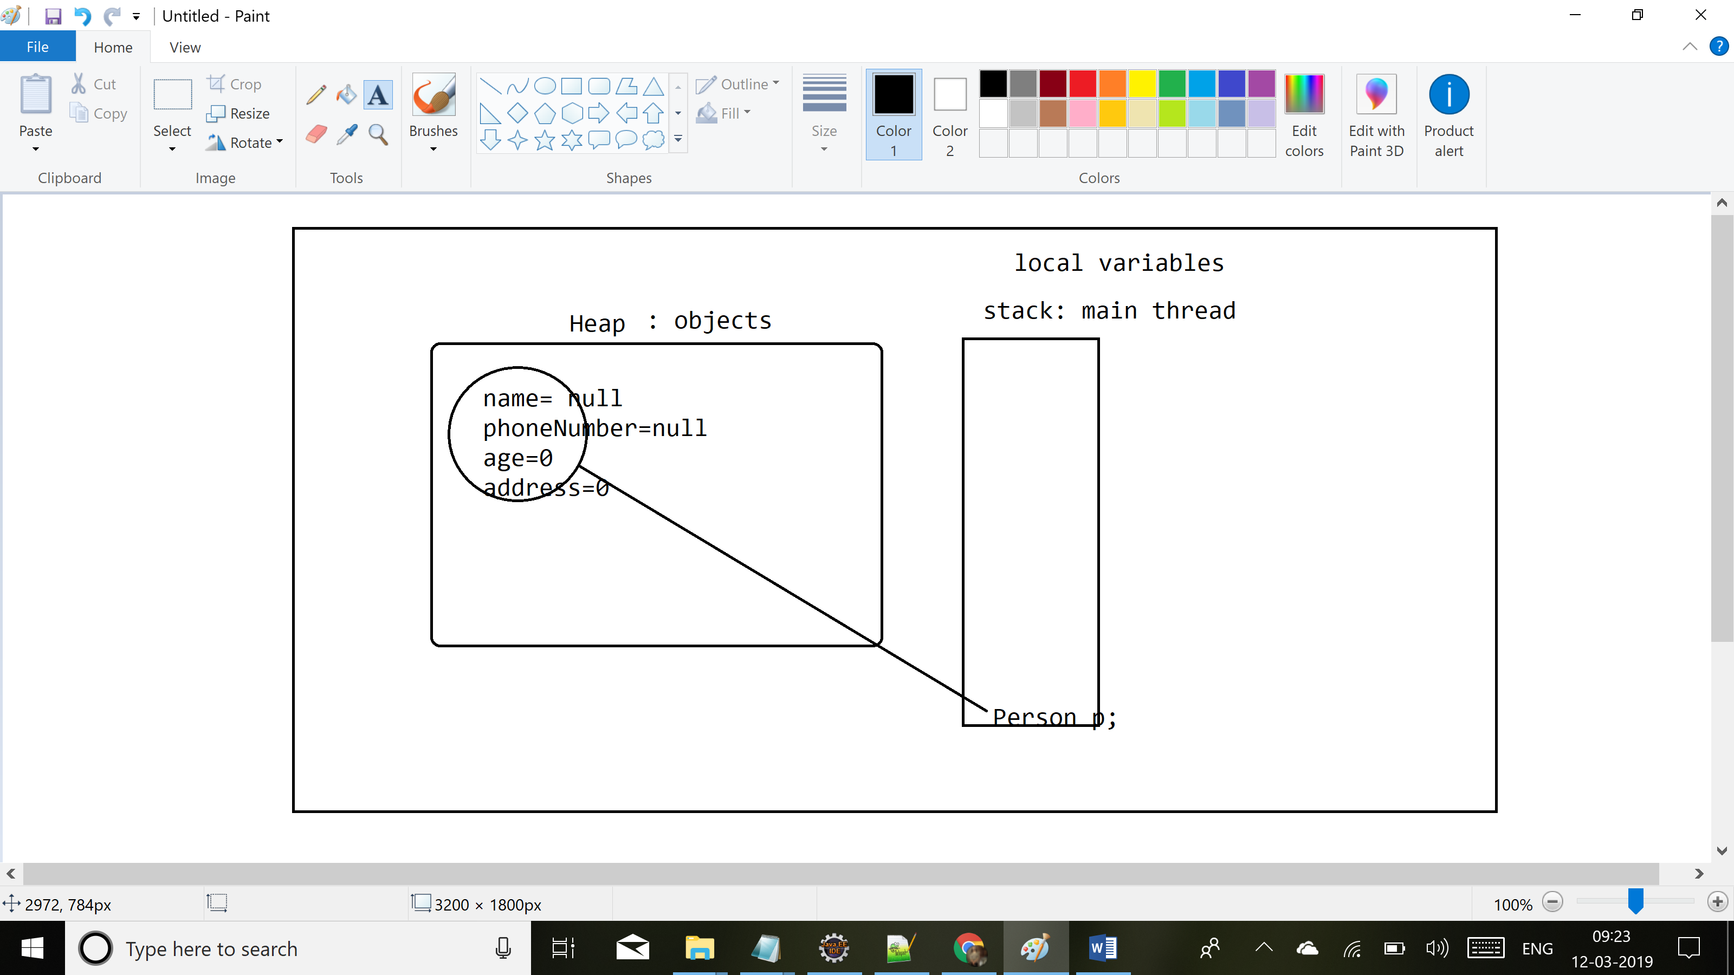

1. Class Variable

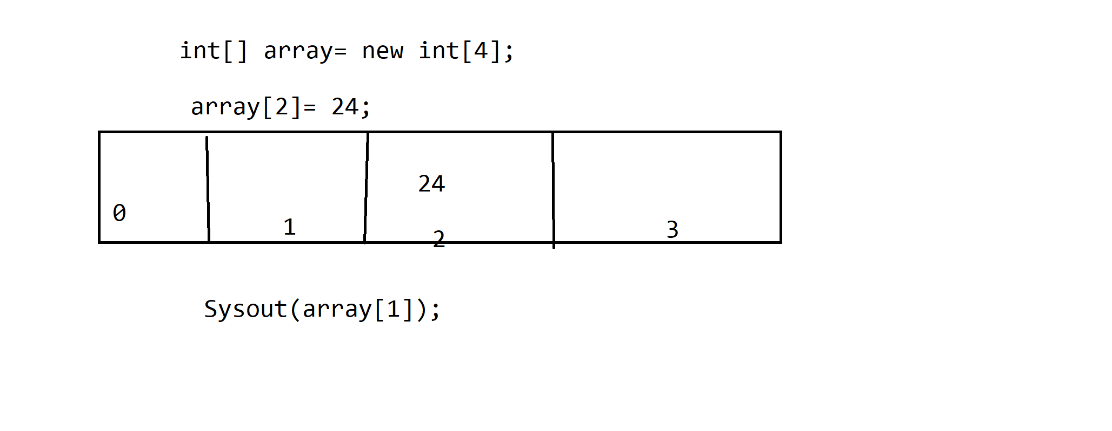

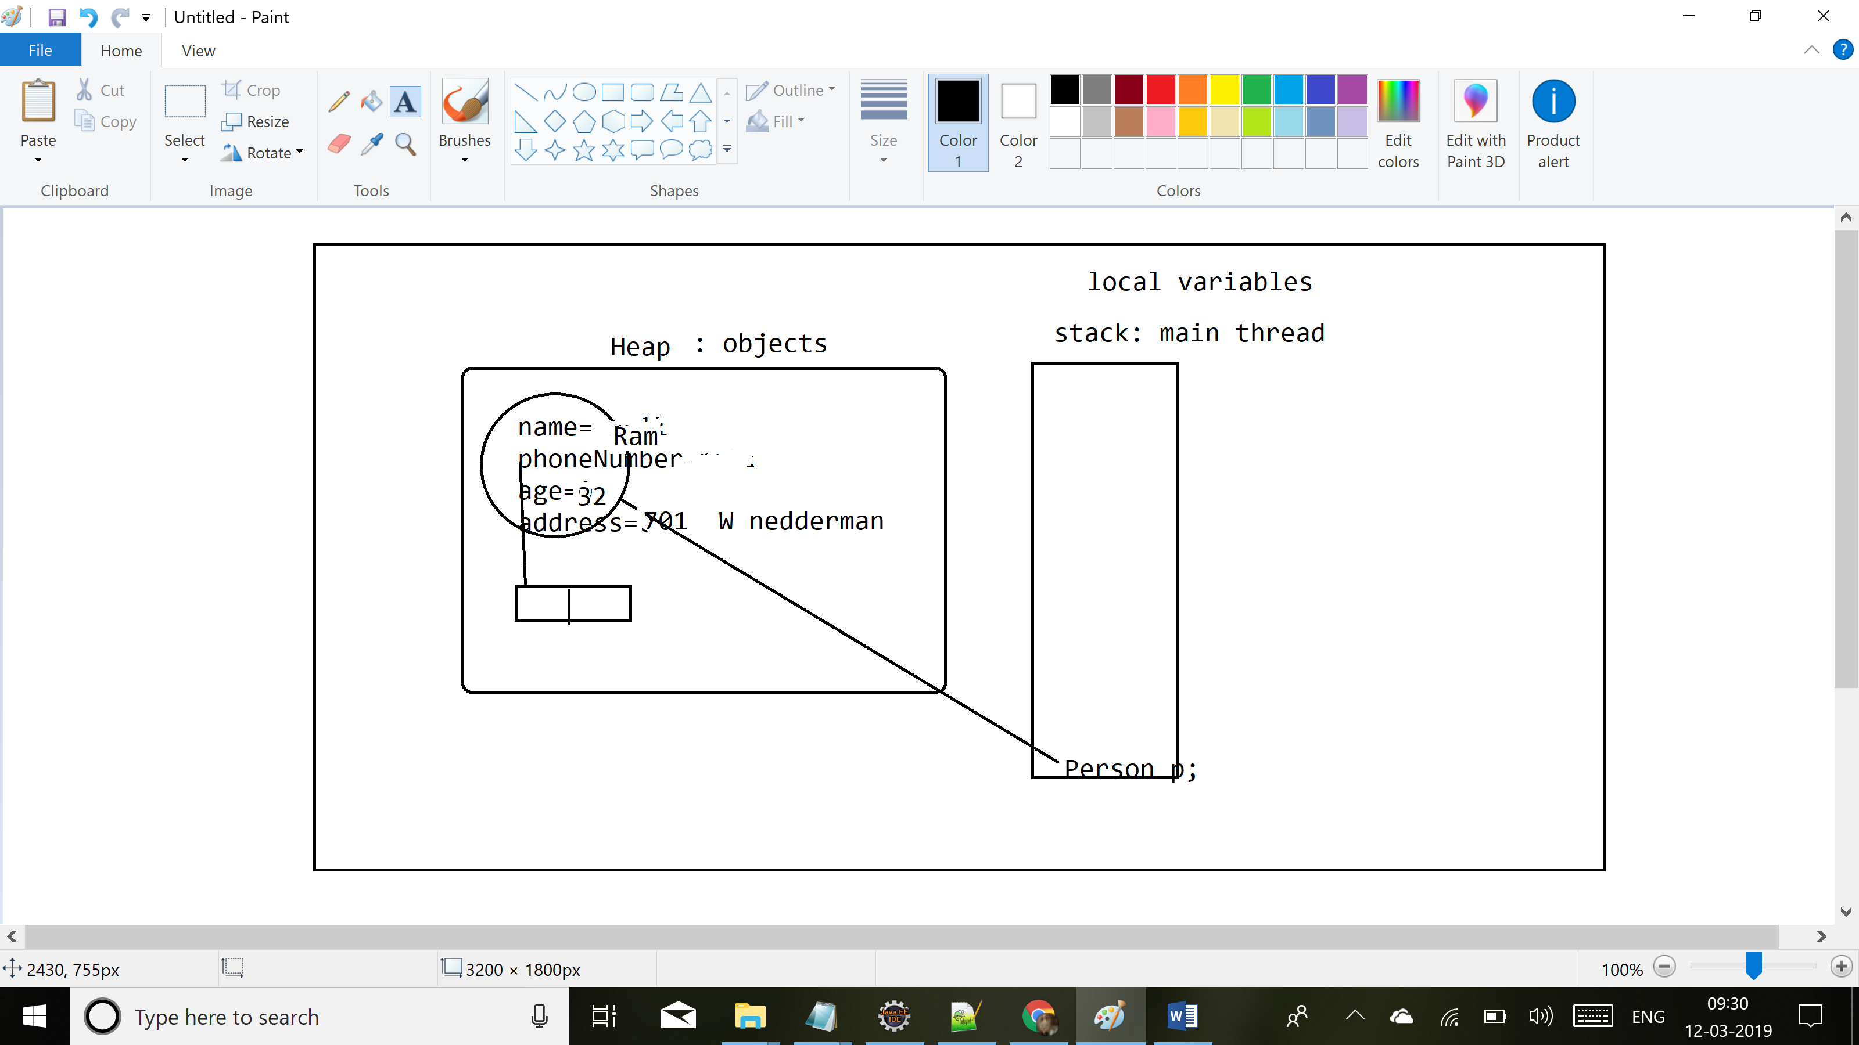

Rules for creating a class:

1. In a file you can have more than 1 class. But you cannot have more than 1 public class.
2. If you have a public class, name of the file should be same as the public class. If you don’t have any public class, file can be given any name.
3. The main method should be inside your public class else JVM will not be able to find this class.

Object class in Java: superclass/parent class for all the classes in Java.

toString() method is called automatically when u try to print the object.

toString(): className@hexadecimal representation of memory address

Override the toString() method to print the details.

Class: templates: properties, methods

Object of the class: new operator: initialize the values for it.

Objects and we have relationship between these objects

Ram is driving Mercedes Benz

Has A | Is A

Class Person {

String name;} //has A : person has a name

Class Person extends Object{

}

//Person is an Object

Access Modifiers: Class/method/ property/ constructor

1. Public: anyone can access this class
2. Default: only accessible in the same package
3. //A class can only have public/ default access.
4. **class** XYZ{
5. **int** x; //accessible only in same package
6. **public** **int** y; //to all
7. **protected** **int** z; //in the same package by all and
8. //child classes in a diff package but only through child reference.
9. **private** **int** w; //only within this class
10. }

Package com.java;

Class A{}

Package com.java1;

Public Class B{

Public static void main(String arg[]){

A a;

}

}

Constructor:

New Person(): calling the constructor of the Person class

1. It has the same name as the class
2. It has no return type
3. It can have any number of arguments
4. It can have any access modifier
5. If I don’t provide a constructor, compiler will add a default constructor to my class.
6. No arguments
7. Access modifier is same as that of the class.
8. If in my class, I provide any constructor, compiler will not add the default constructor.
9. By-default, the first line in any constructor is a call to the parent default constructor.
10. If you yourself make a call to the super class constructor using the super keyword, passing in arguments, it will call the parent class constructor taking in the args, instead of calling default constructor.
11. You can have more than 1 constructor in a class.
12. In a constructor either you make a call to this class constructor or a super class constructor in your first line. But u cannot do both.

Class A{

A(){}

A(int a){ Sysout(1);super();}

}

Super():call to parent class constructor

This(): call ur class default constructor

Example:

class A{

A(){

this(5);

Sysout(2);

}

A(int i){

this.i= i;

Sysout(1);

}

int i;

}

A obj= new A(); // 1 2