What is JDK,JRE,JVM

Is JVM, a compiler or interpreter ?

Why Java don't use pointers ?

What are various types of Class loaders used by JVM ?  
 How are classes loaded by JVM ?  
Which memory areas does instance and static variables use ?  
 What is PermGen or Permanent Generation ?  
What is metaspace ?

Describe what happens when an object is created in Java.

Different types of memory used by JVM ?

Does Java Pass by Value or Pass by Reference

What are native methods?

Lab work:

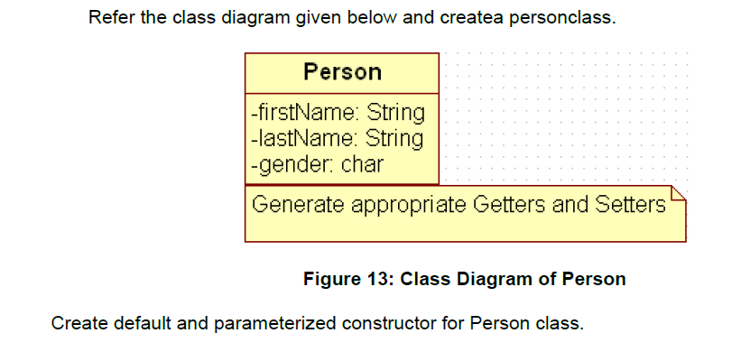

Also Create “PersonMain.java” program and write code for following operations:

a) Create an object of Person class and specify person details through constructor.

b): Modify to accept phone number of a person. Create a new method to implement the same and also define method for displaying persondetails.

c): Modify the above program, to accept only ‘M’ or ‘F’ as gender field values. Use Enumeration for implementing the same

--After spring--

d) Add a method called calculateAge which should accept person’s date of birth and calculate age of a person.

e) Add a method called getFullName(String firstName, String lastName) which should return full name of a person

f) Display person details with age and fullname.

.

|  |
| --- |
| Write a program to accept a number from user as a command line argument and check whether the given number is positive or negative number. |
|  |
|  |