**Software Requirement Specification For**

**Online Shopping Cart Version 3.0**

## Table of Contents

1. Introduction 2
   1. Purpose 2
   2. Scope 2
   3. Overview 2
2. Overall Description 2
   1. Product Perspective 3
   2. Product Functions 3
      1. User Management Requirements 3
      2. Technical Requirements 3
   3. Constraints 3
3. Specific Requirements 4
4. User Characteristics 4
5. Functional Requirement 4
6. Project Flow & Diagram 7
7. User Interface (UI) with Functions 9
8. System Features 18

# Introduction

This document is a Software Requirement Specification (SRS) for **OnlineShoppingCart Version 3.0** project. This is the initial draft for the SRS and it will be used for the extensions.

# Purpose

The purpose of this document is to specify complete description of the **OnlineShoppingCart Version 3.0** to be developed. It is basis for agreement between company and developer about the product to be developed. Through this document, the workload needed for development, validation and verification will ease. To be specific, this document is going to describe functionality, external interfaces, performance, attributes and the design constraints of the system which is going to be developed. Therefore, intended reader groups for this software requirement specification are company and developer.

# Scope

Shopping online is about to explode. Retailers of all types are expanding product offerings, adding in-store pickup, free shipping and experimenting with social media. It’s getting harder to tell pure play Internet retailers from the bricks and mortar shops with online portals, and all of them are reinventing how we’ll shop online in the future.

# Overview

We are going to focus on describing the system in terms of product perspective, product functions, user characteristics, assumptions and dependencies on the following section of this document. Next, we will address specific requirements of the system, which will enclose external interface requirements, requirements of the system, performance requirements, and other requirements.

# Overall Description

This section gives background information about specific requirements of the **OnlineShoppingCart Version 3.0** to be developed in brief. Although we will not describe every requirement in detail, this section will describe the factors that affect the final product.

# Product Perspective

Shop the Online Megastore with the **OnlineShoppingCart Version 3.0** mobile app. Choose from the massive selection of original products in Fashion, Electronics, Books, Mobiles and other categories. Get timely alerts on great deals with substantial discounts, every day!

# Product Functions

This new product, **OnlineShoppingCart Version 3.0**, must have number of features, which will allow users to use functionalities that have been explained above. Required functionalities of the product Fashion, Electronics, Books, Mobiles and other categories.

# User Management Requirements

This category of requirements is related to user authentication mechanism of users. Users will perform all the functionality over this authentication account using his/her credentials in a role based management system.

# Technical Requirements

The technical requirements include HTML5, CSS3, JavaScript, Bootstrap, Spring MVC, Hibernate, Oracle 12c, angular

# Constraints

Developers of the product should be aware of the main feature of the intended product.

# Specific Requirements

With this section and later, we will describe the requirements of the application in detail. Basically, we will categorize requirements into two which are namely functional requirements and non-functional requirements. Requirements of the product will be detailed under this section with brief information and later sample input-output preview will be given.

# User Characteristics

The users of this online shopping-cart application are all customers who would shop to test the application. These users are anyone with shopping experience and the know-how to browse through a shopping-cart application.

The users should be able to perform the following functions using this system:

* View, browse, and select a category on the home screen.
* View, add items in the cart.
* Delete items from the cart.
* Check out the items from the application or continue shopping.
* Sign-on/login using a username and password.
* Logout Functionality
* Website should support Internationalization 2 Locales (English, Chinese).

1. **Functional Requirements**
2. **Login, Registration, Logout**

**FR_1:** The users shall login or register using the user authentication form.

**FR_2:** The users shall not login or register if the information is incomplete or invalid. (Both client and server-side validations needs to be done).

**FR_3:** New user can register themselves to the application.

**FR_4:** Users can logout anytime once they are logged in.

1. **View Categories and Items:** The users shall be able to see the home page of the online shopping-cart application when they first run the program. The users shall be able to view the different categories, select categories, browse through the items in each category, and add items to the shopping cart and also view more information about each item.The users shall be able to view their shopping cart after they have logged in.

**FR_05:** The users shall be able to view items in different categories, but maximum 5 items on a page, and should implement pagination to display other items. So, User can see different page numbers at the bottom which will help him view all items.

**FR_06:** The users shall be able to view items in different categories.

**FR_07:** The users shall be able to view more information about an item before adding it to the cart.

**FR_08:** The users shall be able add items to the cart.

**FR_09:** The users shall be able to search for a particular item.

1. **View Shopping Cart:** After browsing through the items and adding items to the shopping cart, the users should be able to view the items in the shopping cart. The users shall be able to check out or continue shopping. The users shall be able to delete items from the cart.

**FR_10:** The users shall be able to view the items added to the cart and delete items.

**FR_11:** The users shall be able to check out with the current items in the cart.

**FR_12:** The users shall be able to continue shopping.

**FR_13:** The users shall be able to see the items in the cart anytime he logs in to the application.

1. **Checkout Items**

**FR_14:** The users shall place a checkout by clicking the “Place Order” button and logout.

1. **Project Diagrams & Flow**

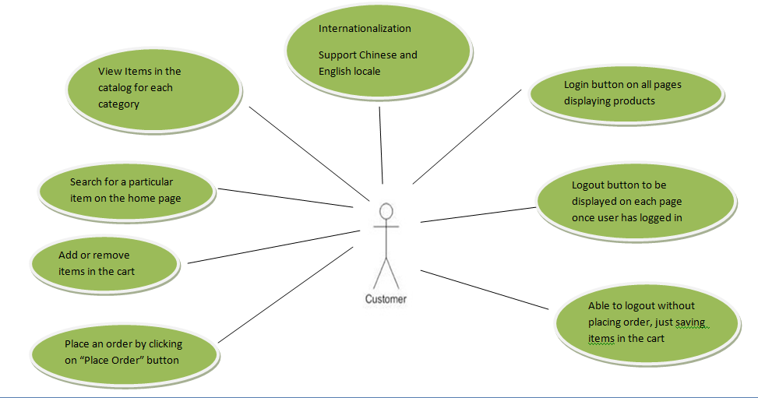

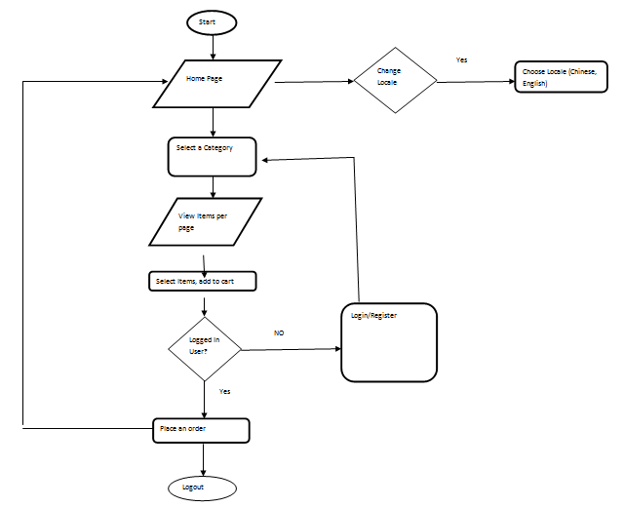

1. **User Interface (UI) Design with Functions:**
   1. **Login Screen**

**A screenshot of a cell phone

Description generated with very high confidence**

* + 1. **Descriptions:** User enters User name and password. If login is successful then go to next screen.
  1. **Registration Screen**

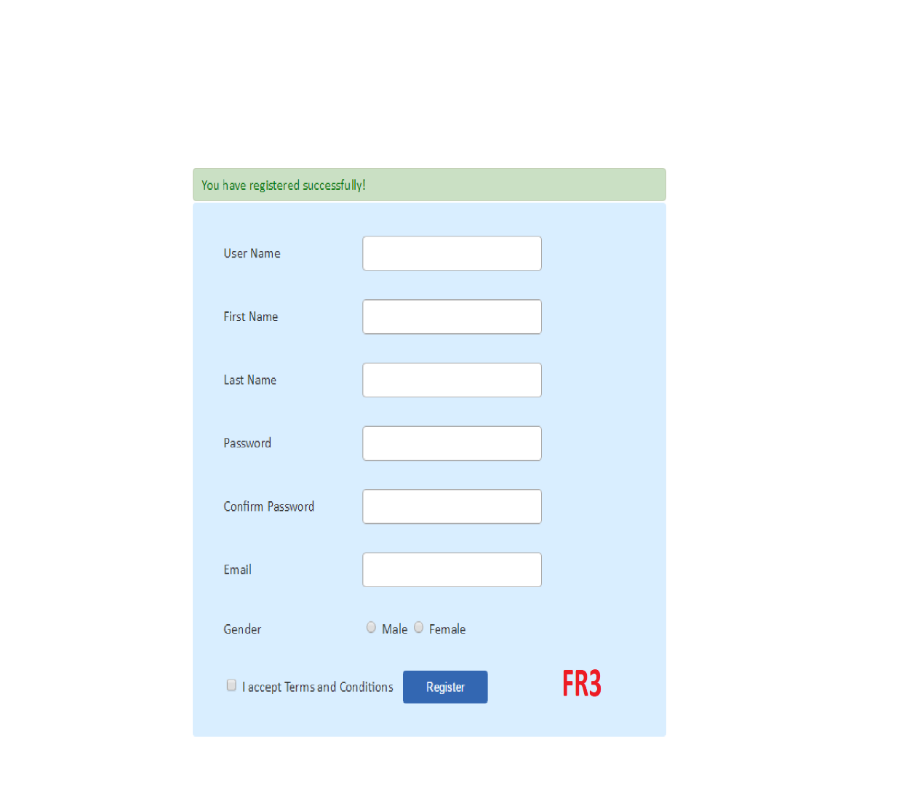

* + 1. **Description:** New users can register themselves with the website using registration form.
  1. **Category Screen**

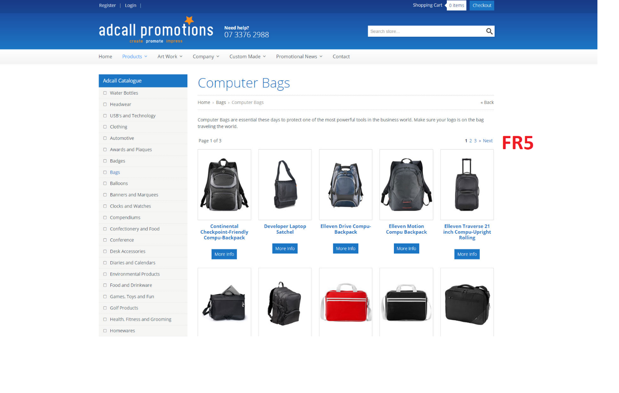

* + 1. **Descriptions:** Users should be able to see Category and items in home screen with Pagination

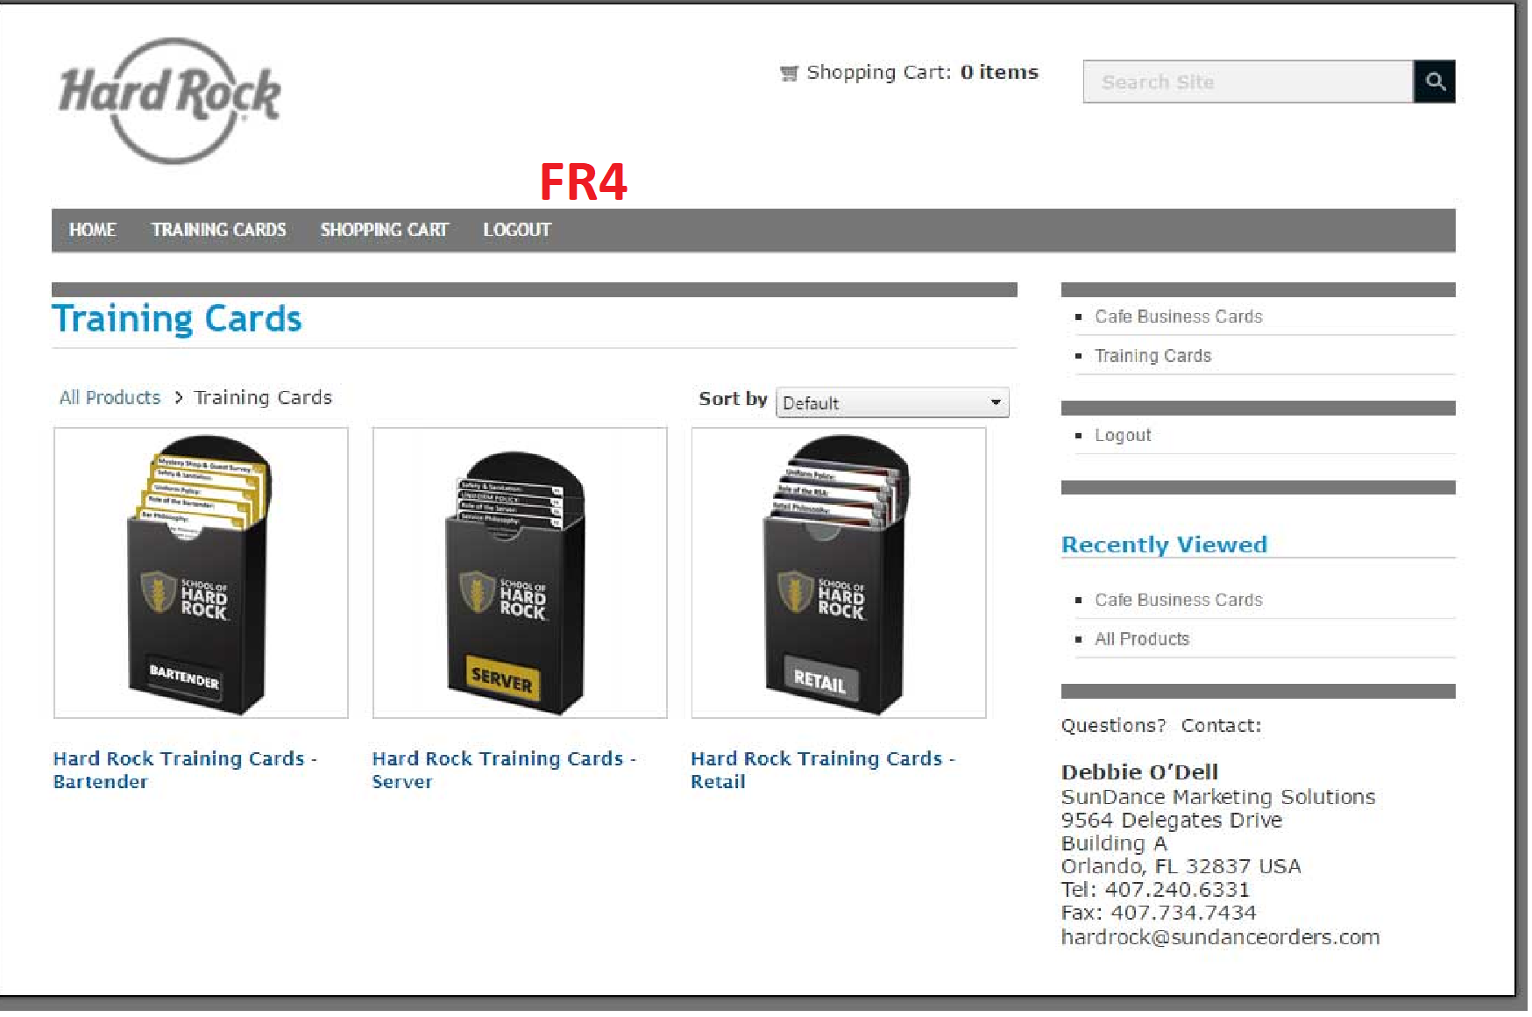

* + 1. **Descriptions:** Users should be able to see logout button anytime after they login to the application
  1. **Product item detail's Screen**

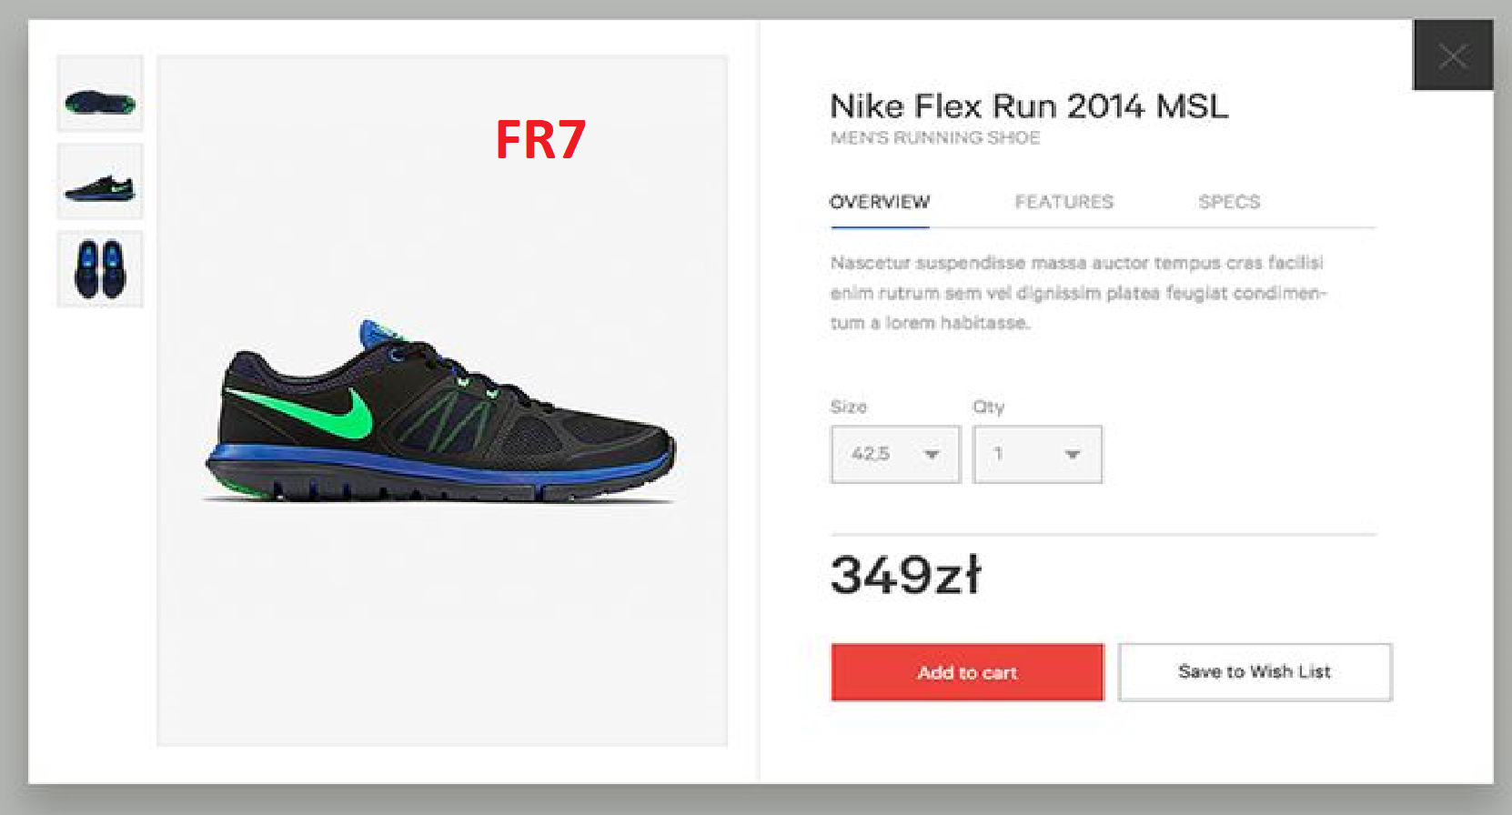

* + 1. **Descriptions:** Users should be able to see each items description and add to cart if they like.

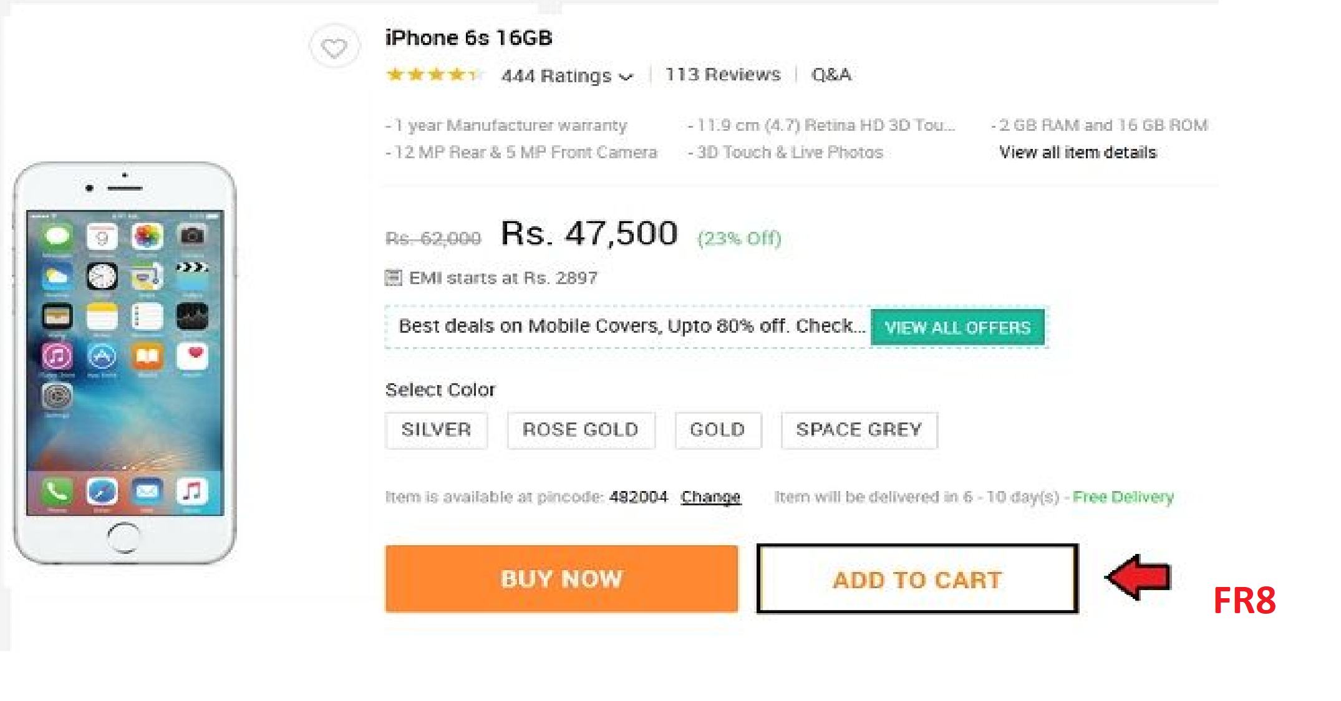

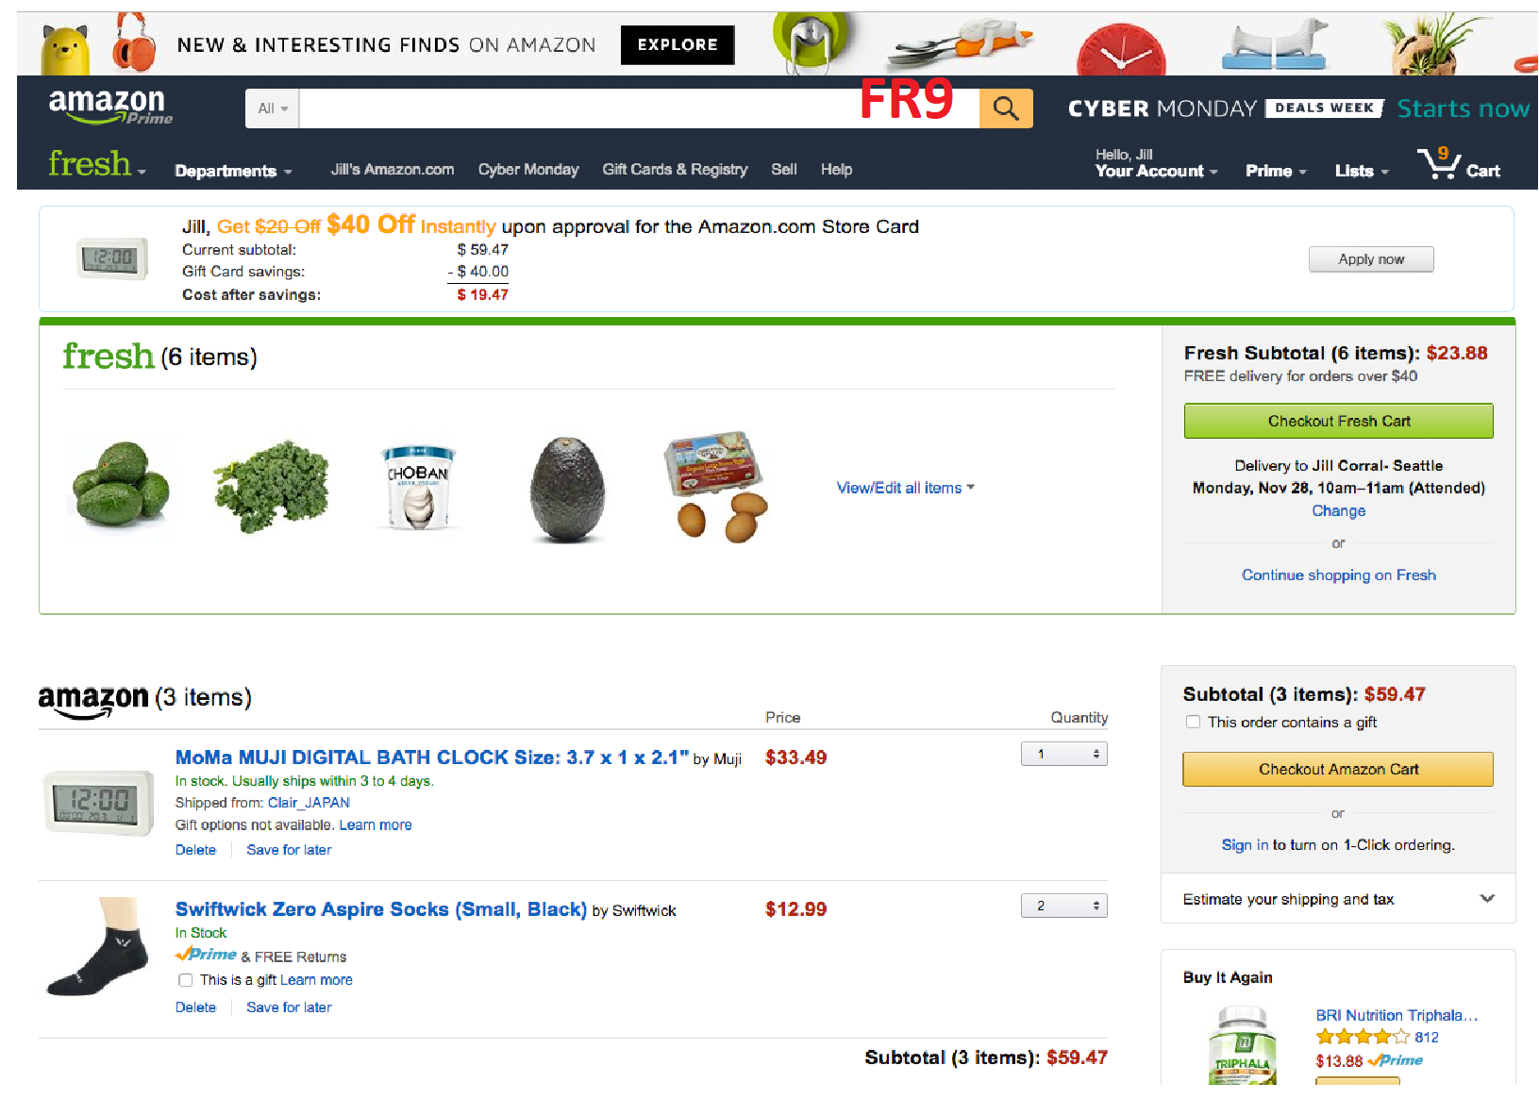

* + 1. **Descriptions:** Users should be able to search for a particular item
  1. **Shopping Cart**

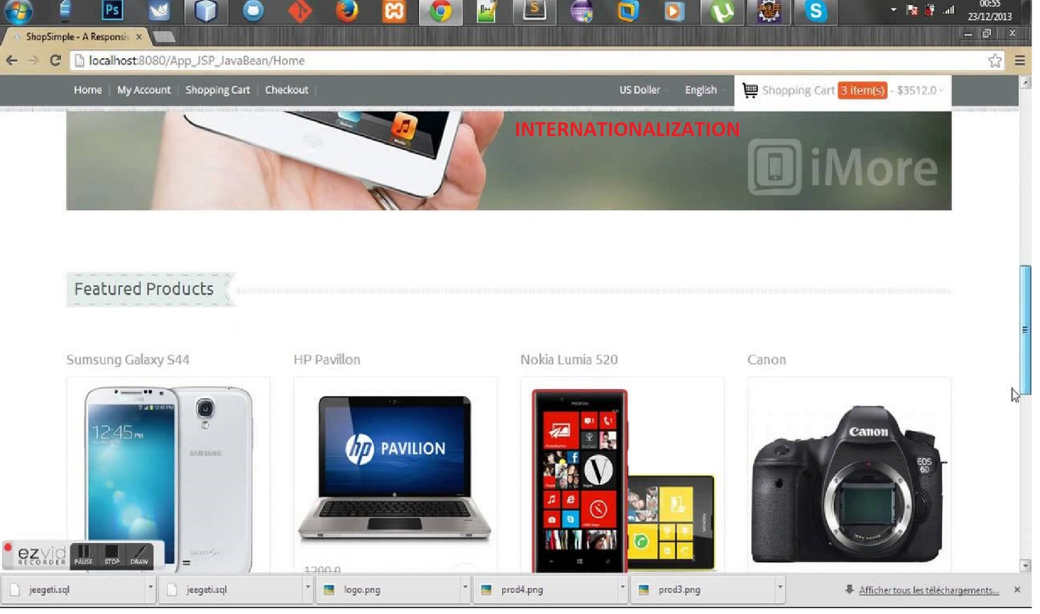

LOGOUT

* + 1. **Descriptions:** Users should be able to see view website in English and Chinese

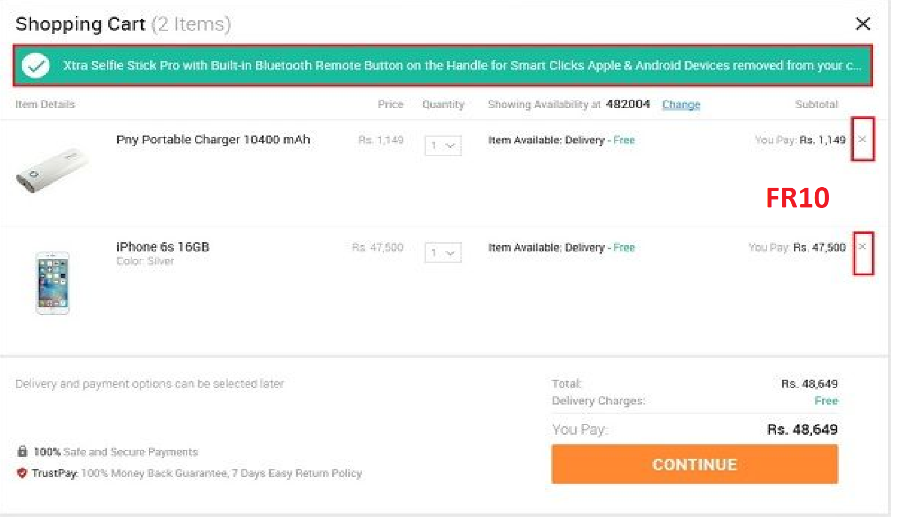

* + 1. **Descriptions:** Users should be able to view and delete items from cart anytime

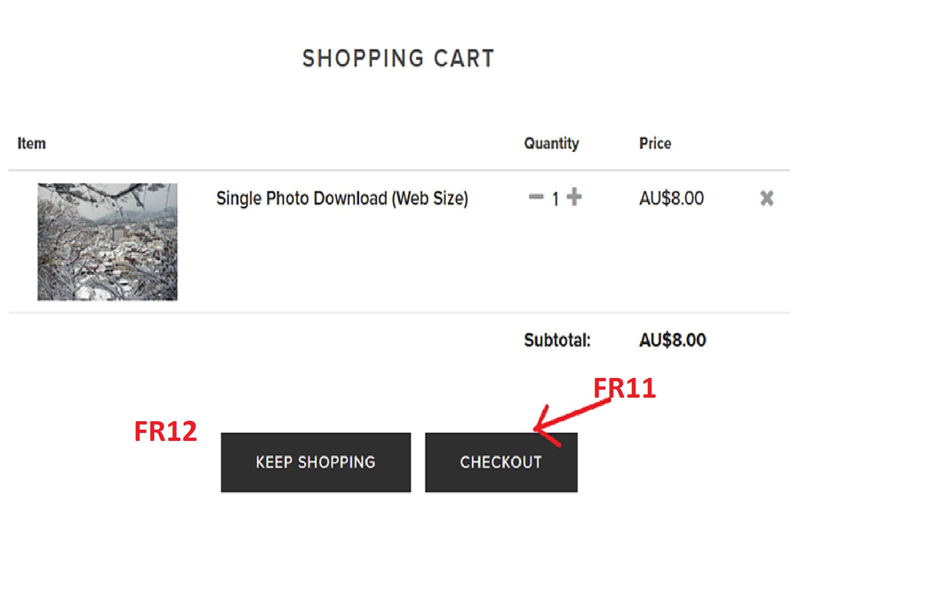

* + 1. **Descriptions:** Users should be able to checkout or continue shopping from shopping cart
  1. **Check out Screen**

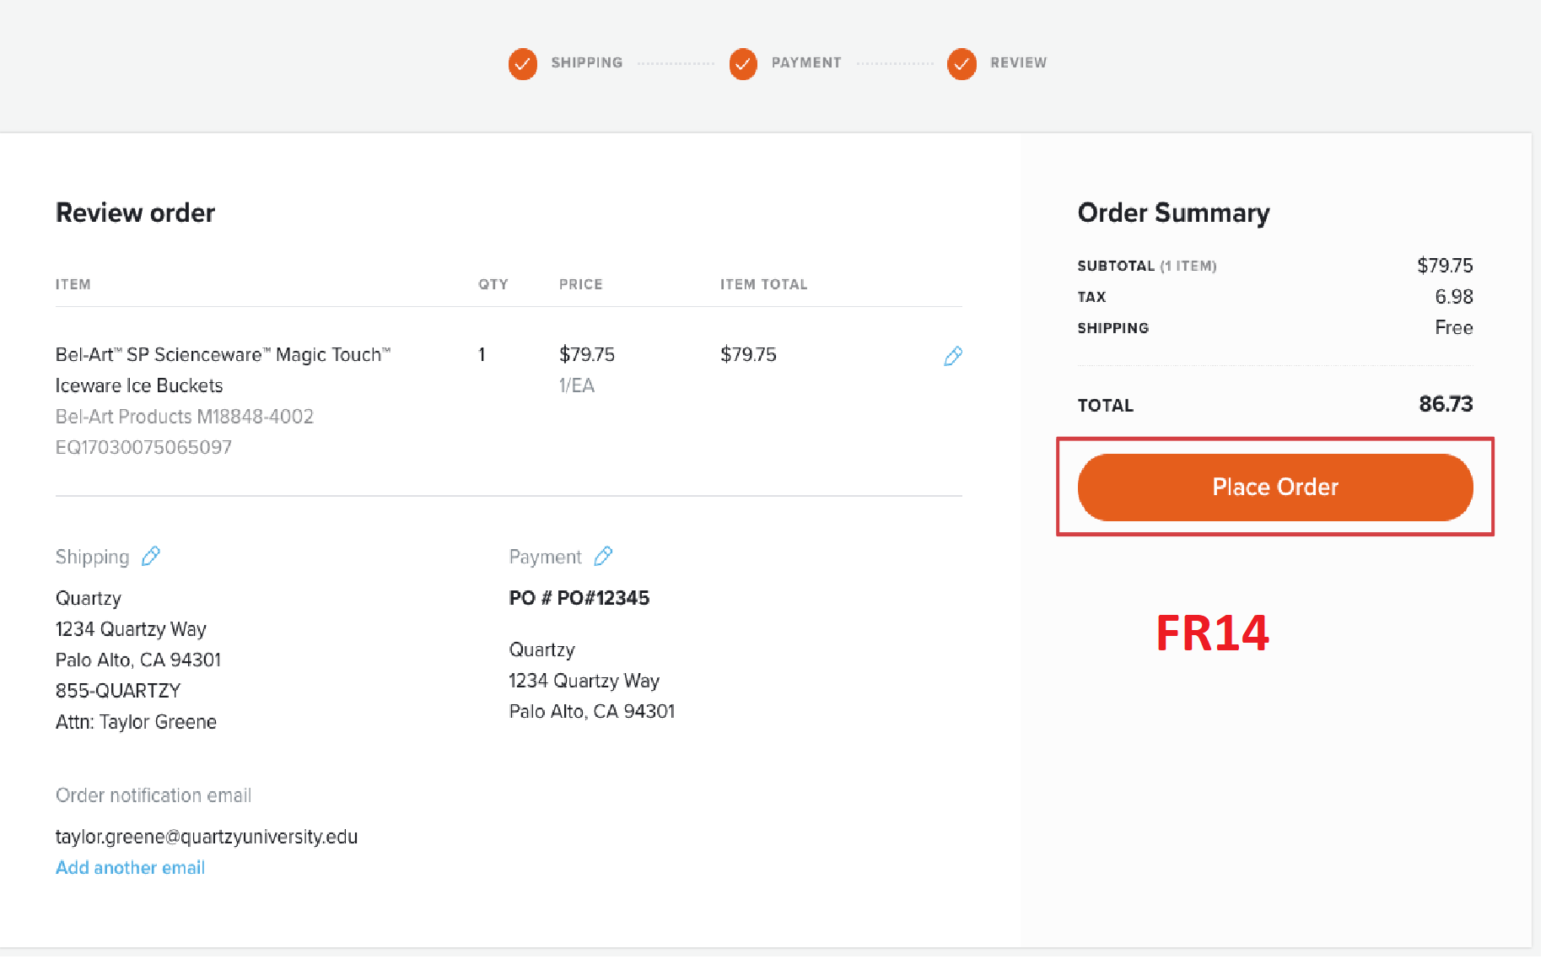

* + 1. **Descriptions:** While items are in the shopping cart users can check out any item since session is persisted. After checkout is made users can logout safely out of account.Update the database to mark the item as sold, and payment should be credited to the account.

# System Features

In this subsection, we will examine the features and entire flow of the system in detail by categorizing them according to their functionality. For each of the feature, we will give an introduction, purpose, flow diagram and the sample output window. Introduction part will give basic background information about the feature. After that, we will show a diagram for the feature representing flow of events.