Spring:

Loose coupling

Interfaces

**Spring containers:**

1. BeanFactory: core containers
2. ApplicationContext: core containers: advanced container: beanpostprocessor, internationalization
3. WebApplicationContext: web container: web application (built on top of your core container)

**Xml config,Java Config, Annotations**

**Xml config:**

2 ways of doing dependency injection: constructor(mandatory)/ setter (optional)

<constructor-arg>: constructor

<property>: setter method

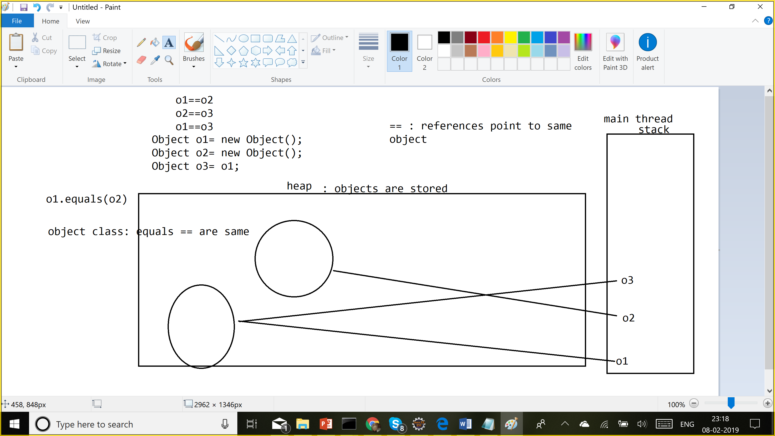

BeanFactory: lazy loading: It will only create the object when u do getBean()

ApplicationContext: Eager loading for singletons but lazy loading for prototype beans

connectionPool: singleton scope

**Java config:**

Instead of creating xml file, we are going to do it in a java class

