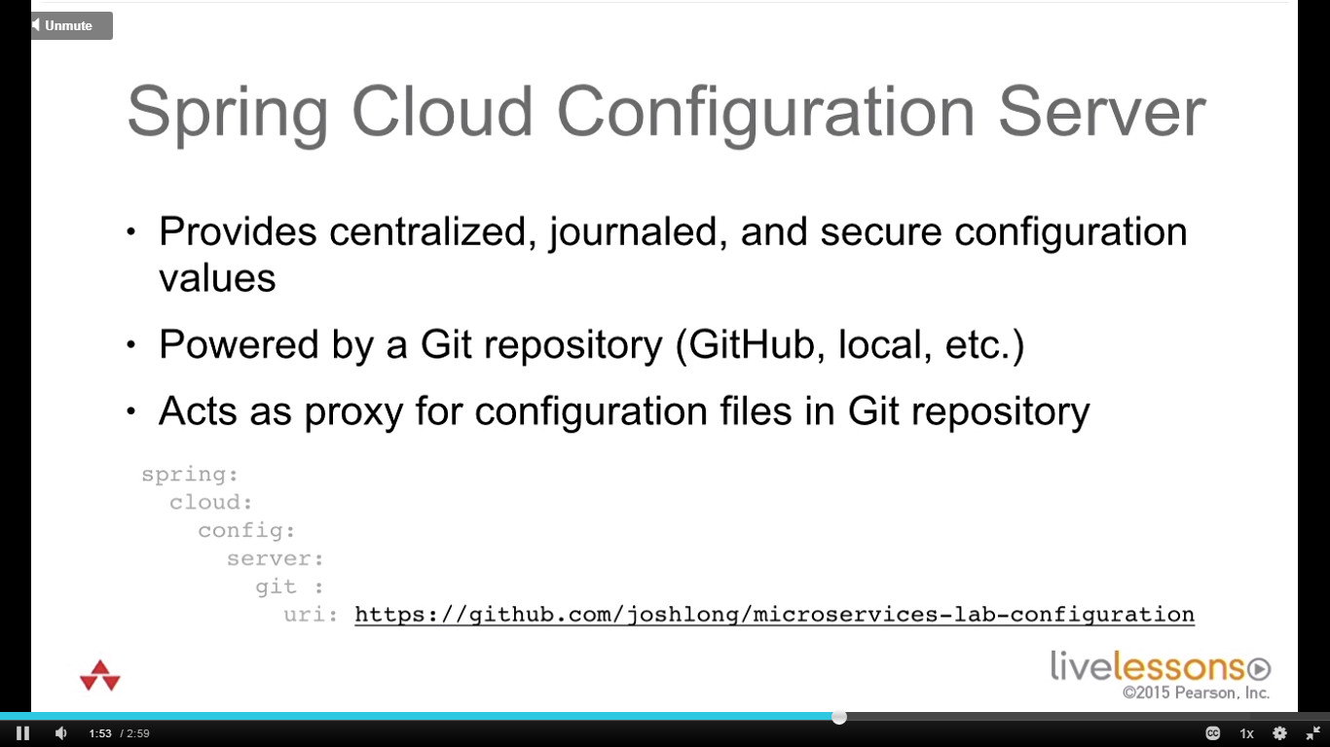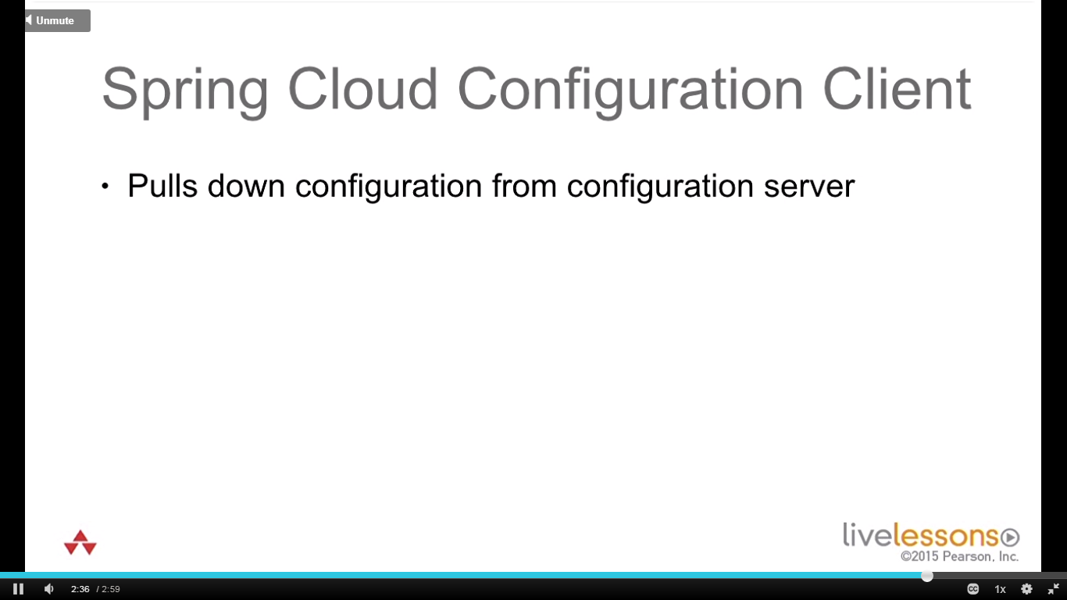

**@RefreshScope:**

Beans can be annotated with @refreshscope, makes it a proxy and then beans can be asked to refresh on an event in applicationContext which have been annotated with this annotation. Event could be like message on queue/ rabbitmq event bus notification/ rest endpoint/ jmx. Older bean discarded. Clients get proxy for that bean. Without need for service to go down.

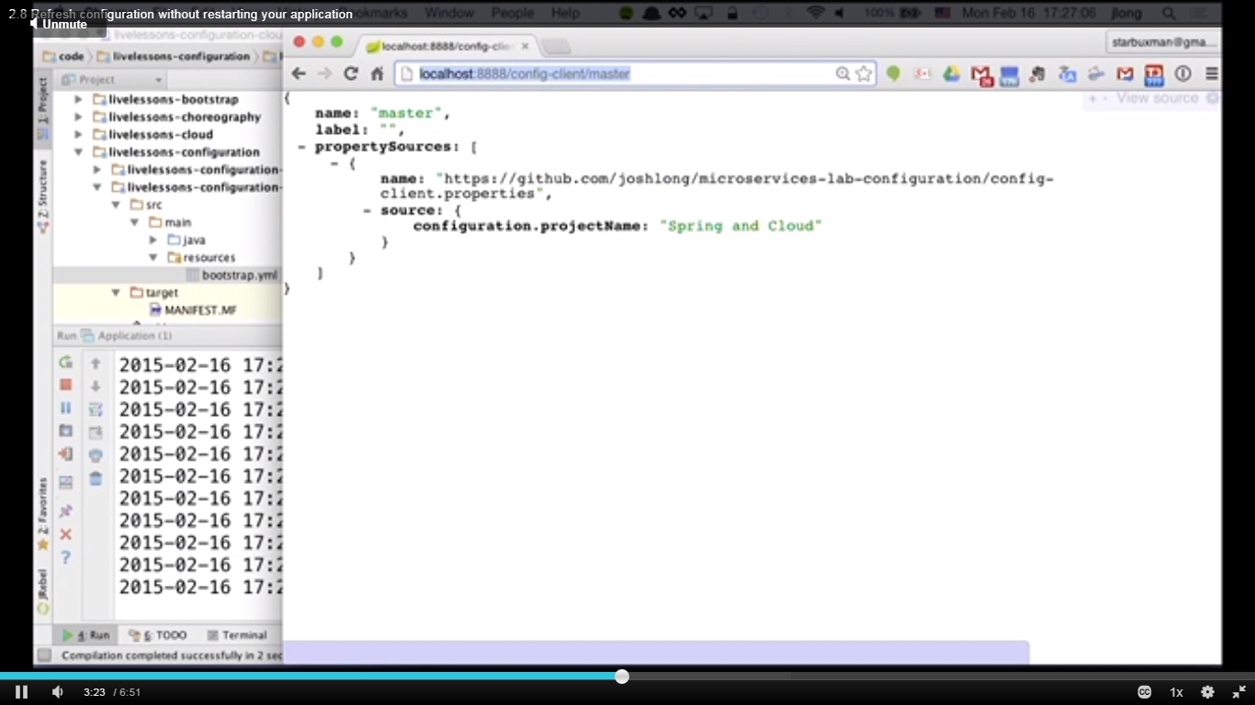

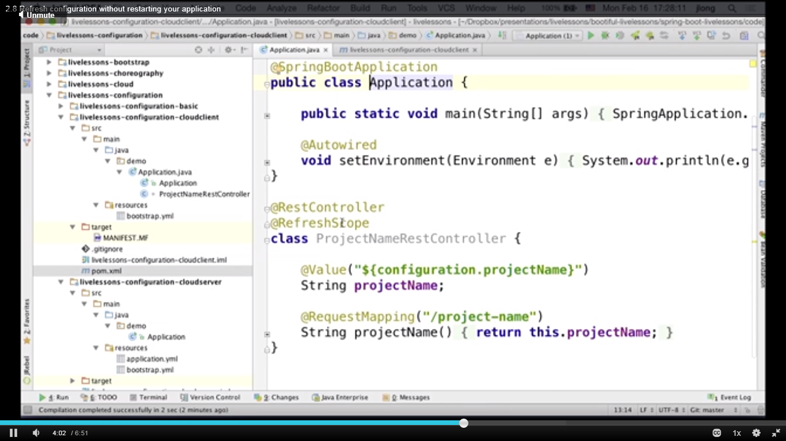

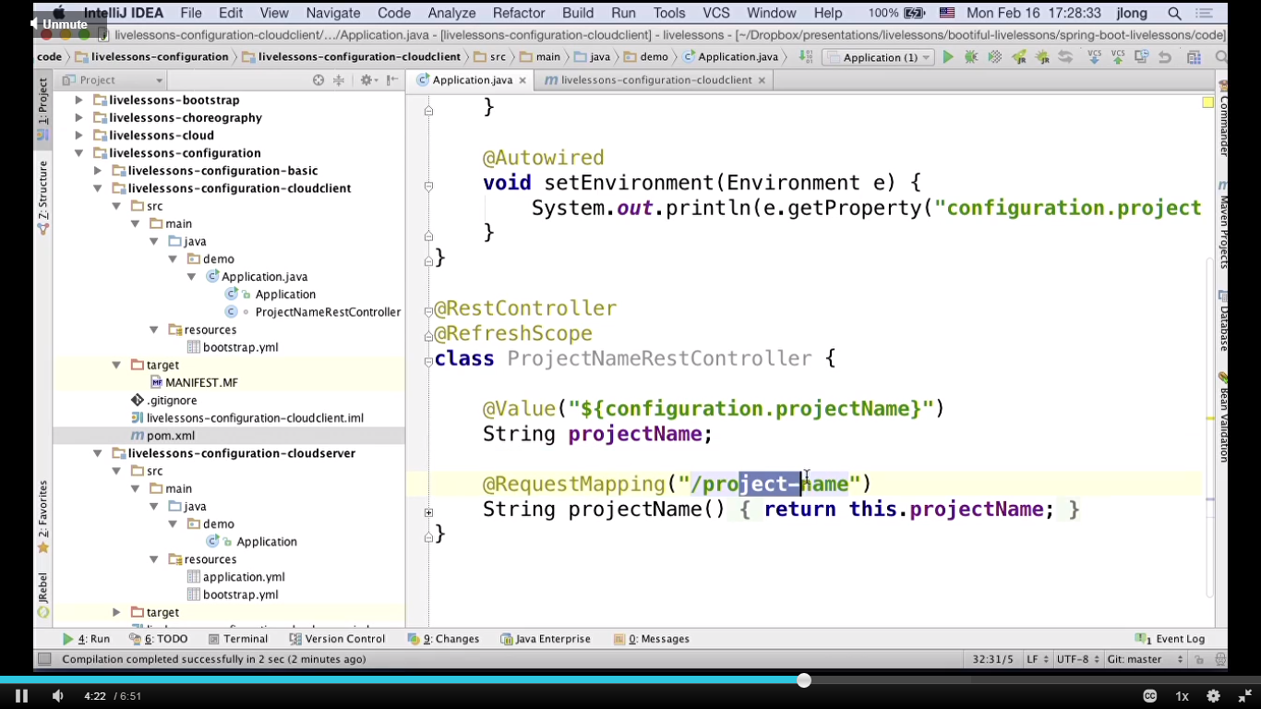

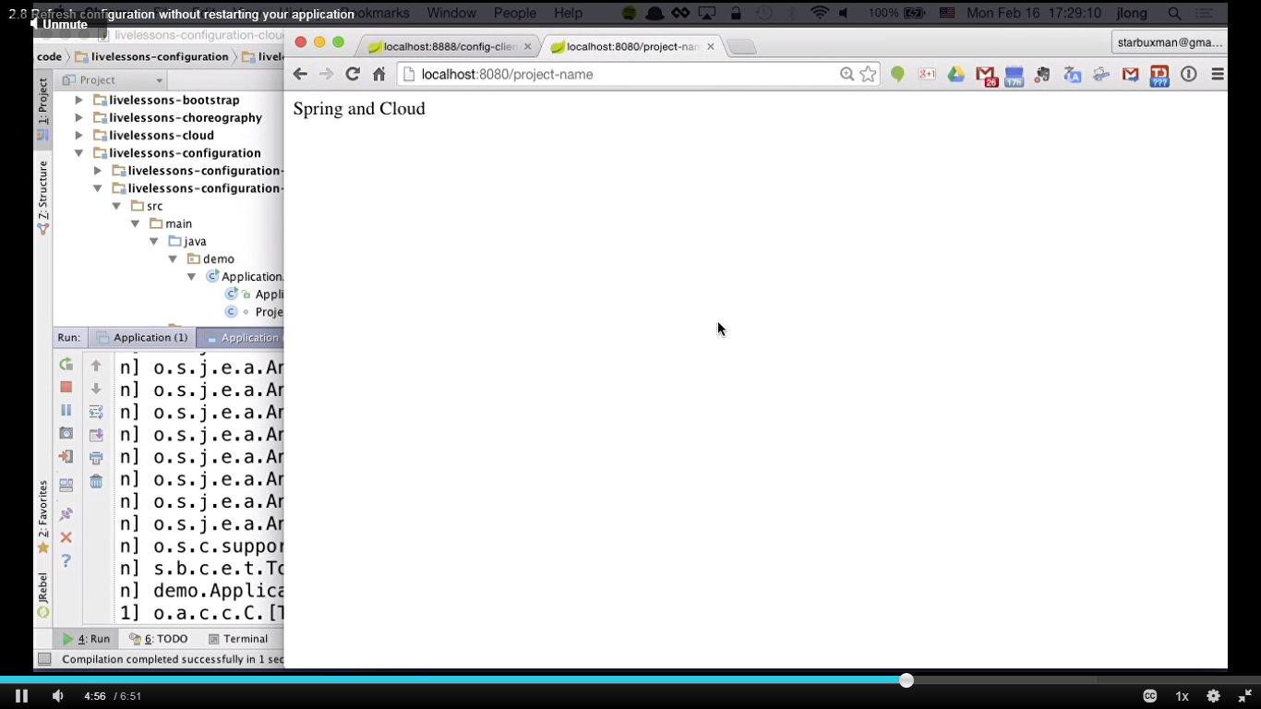

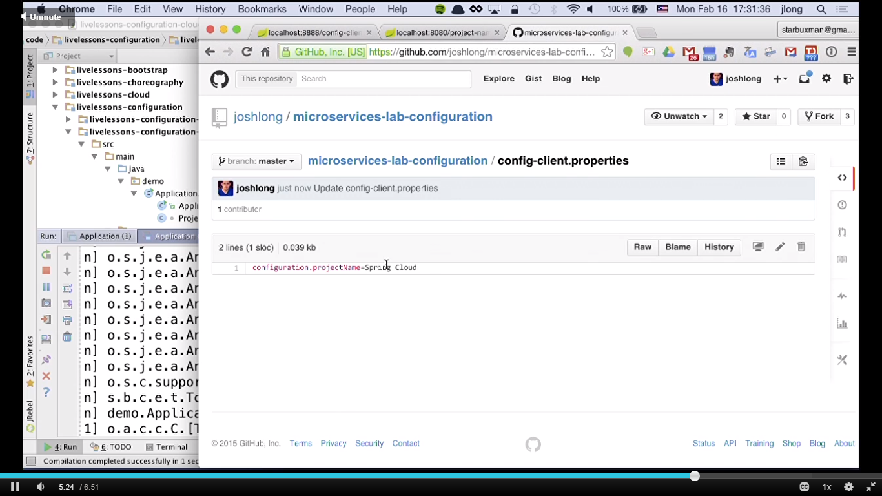

Hit refresh on config server

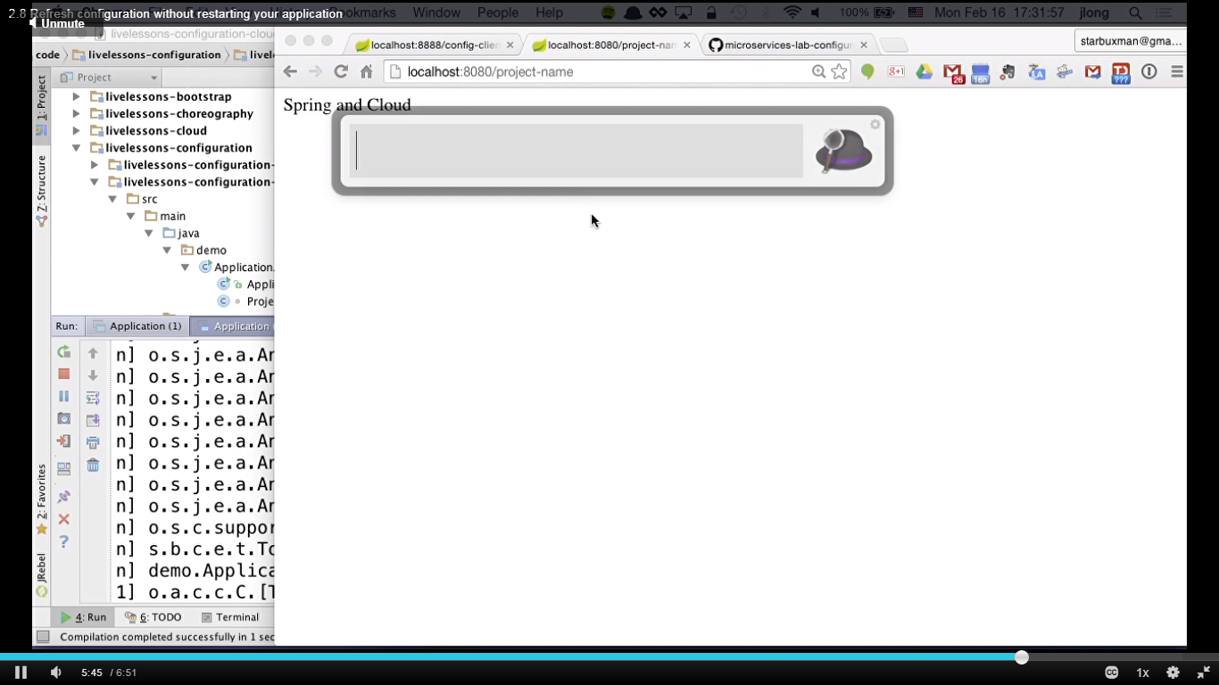

Empty post request on refresh url. Client running on 8080.

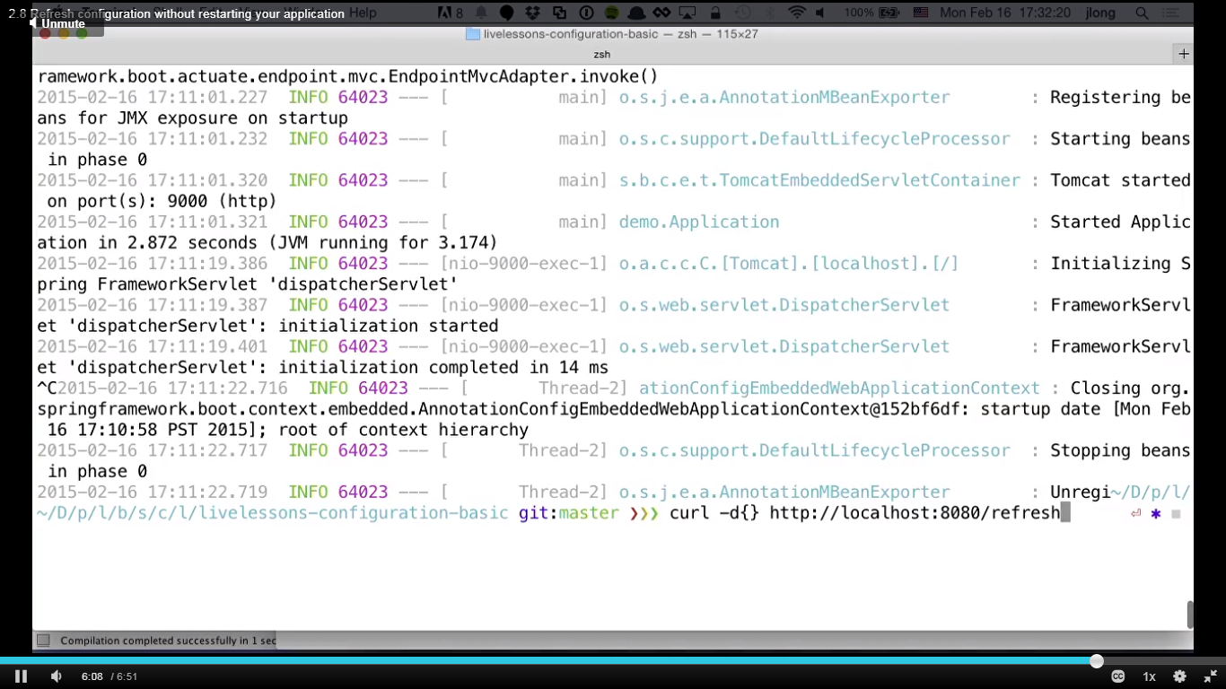

Not reflected on client until this post request sent.