machine+ tomcat+ deploy our application

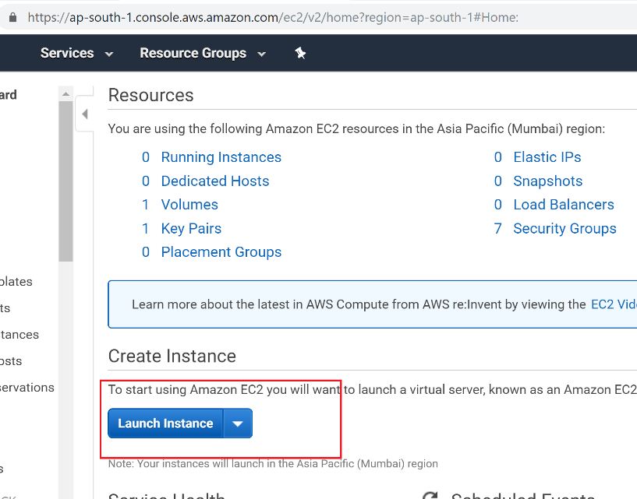

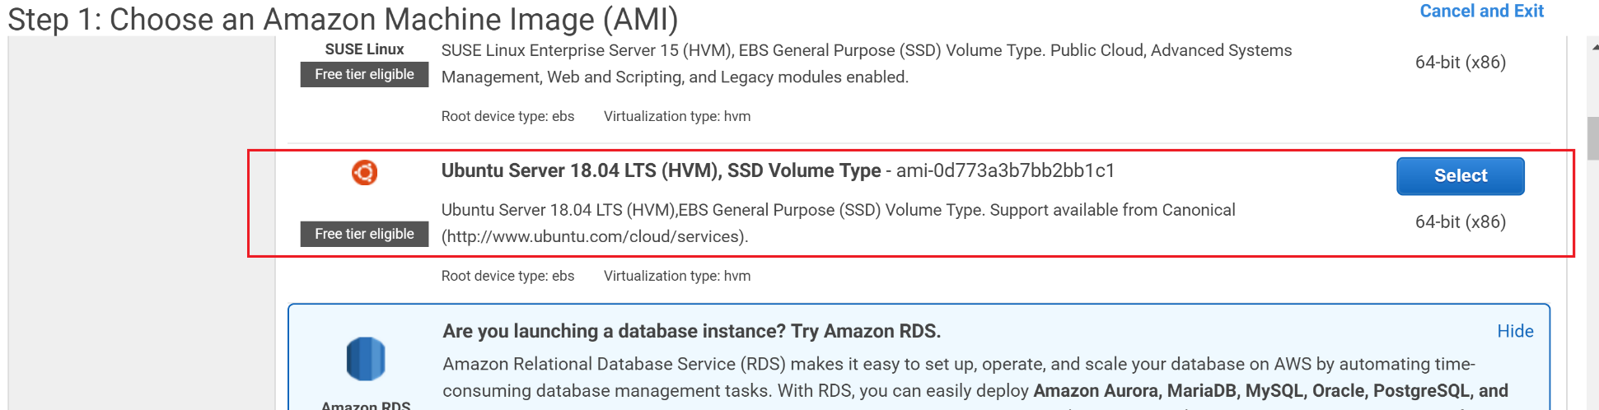

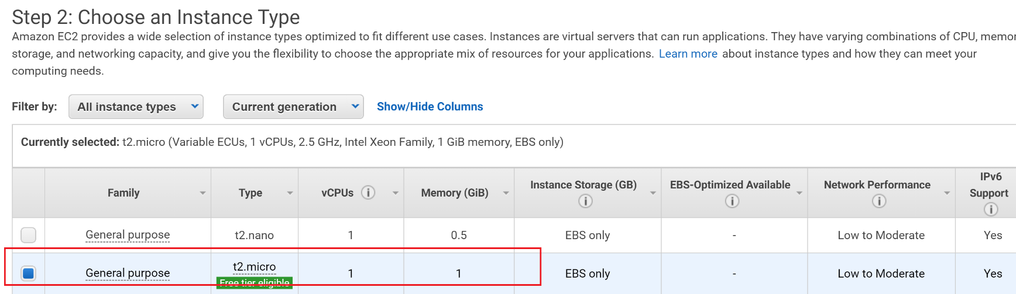

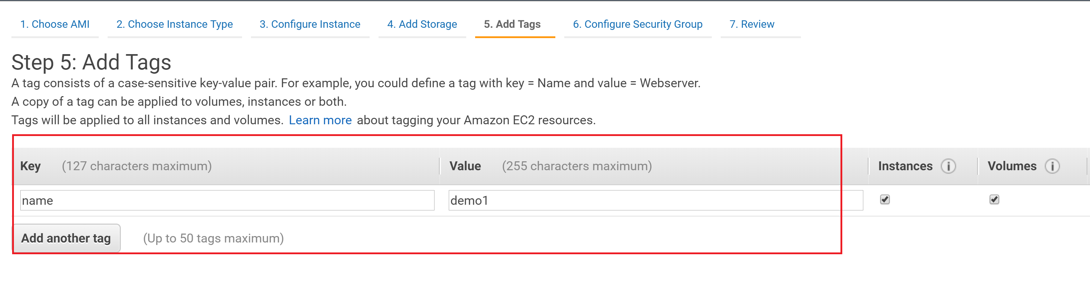

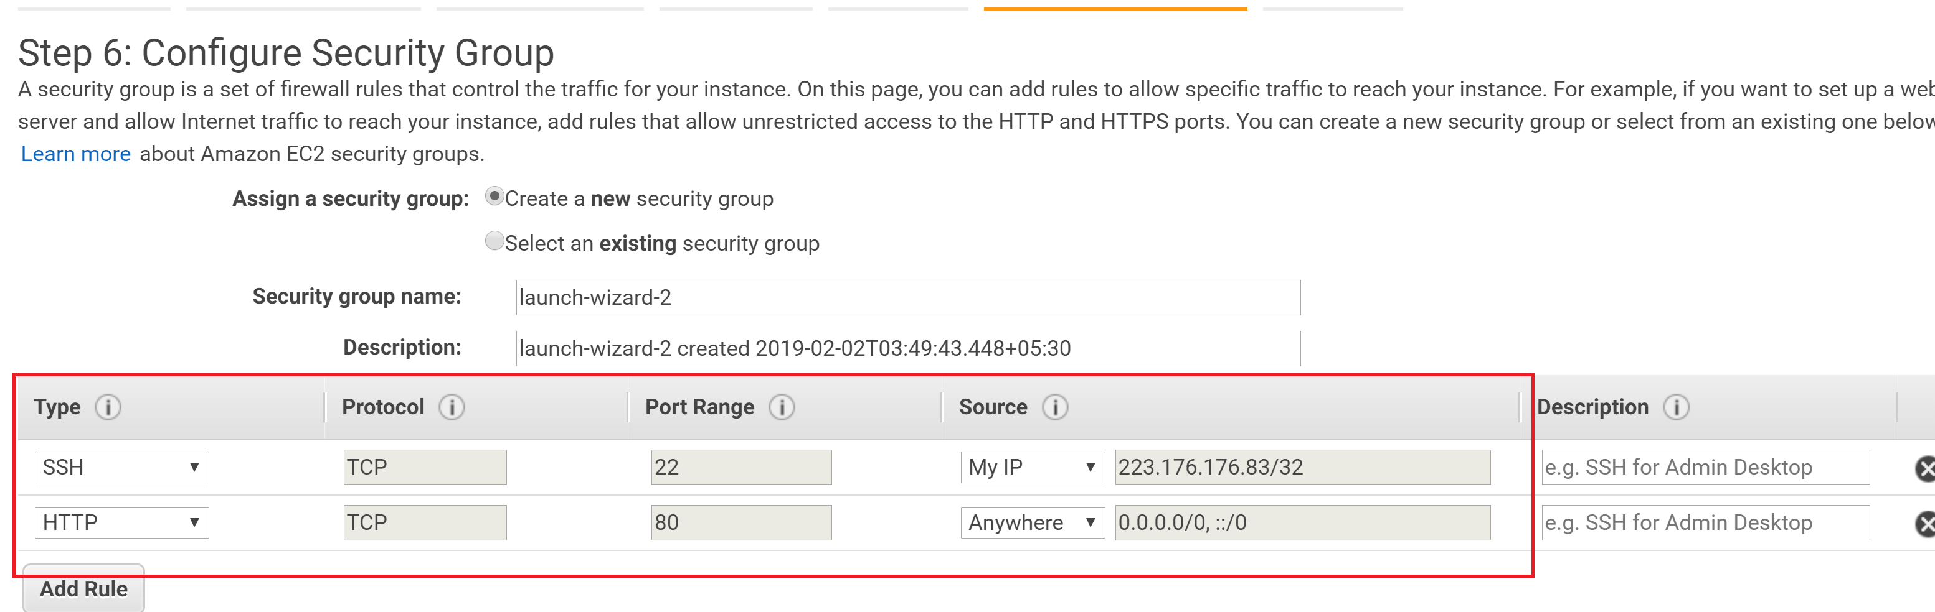

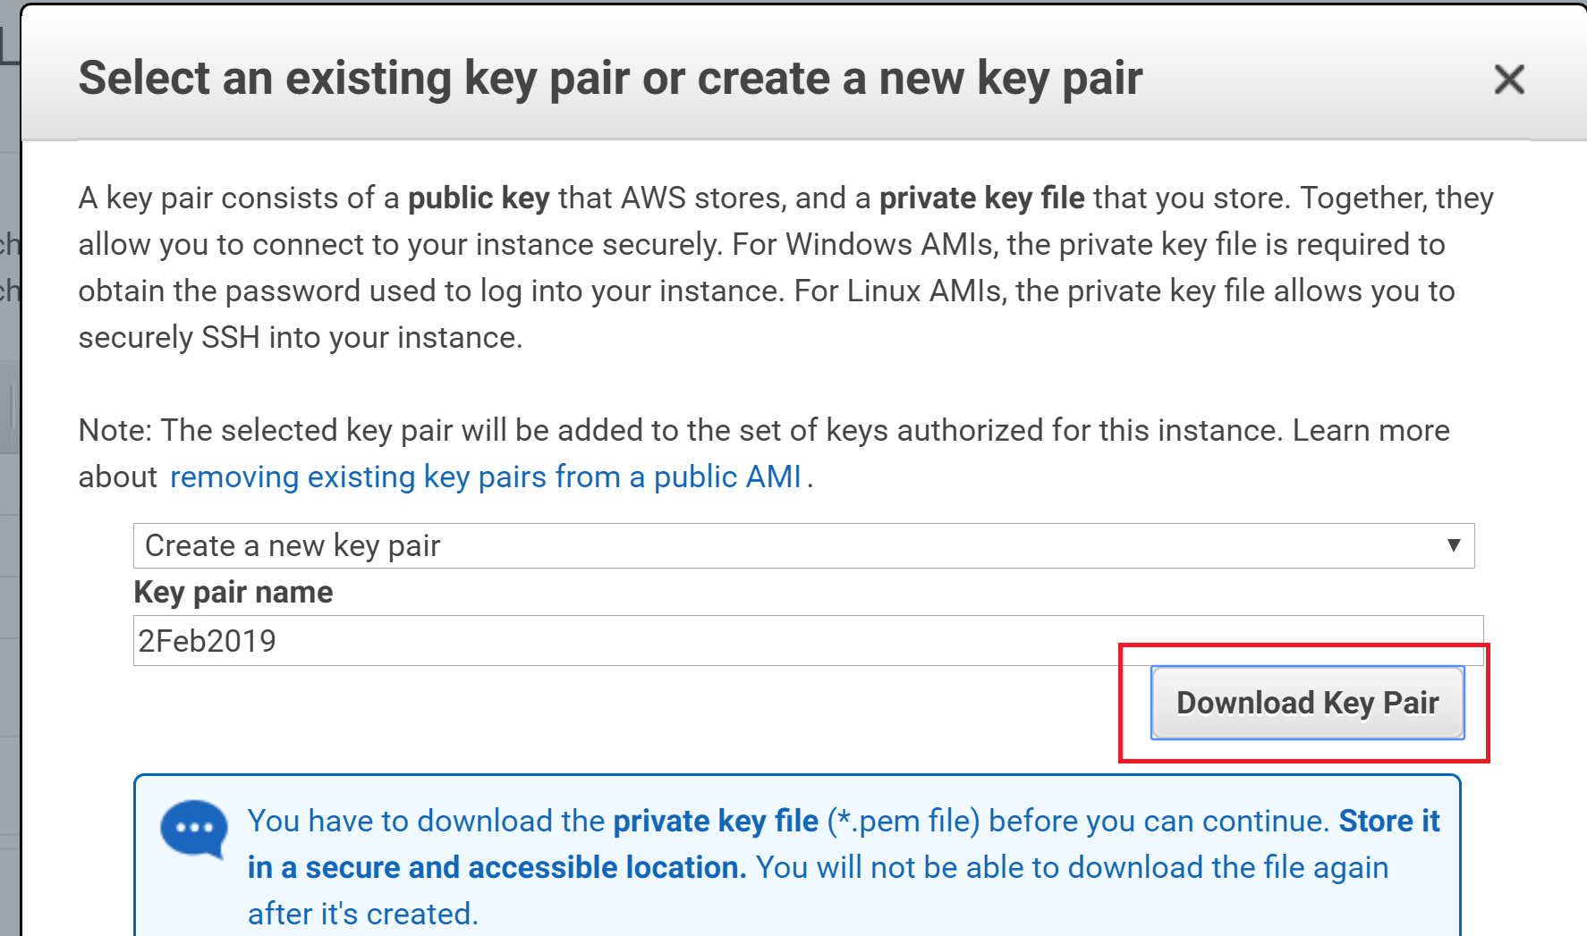

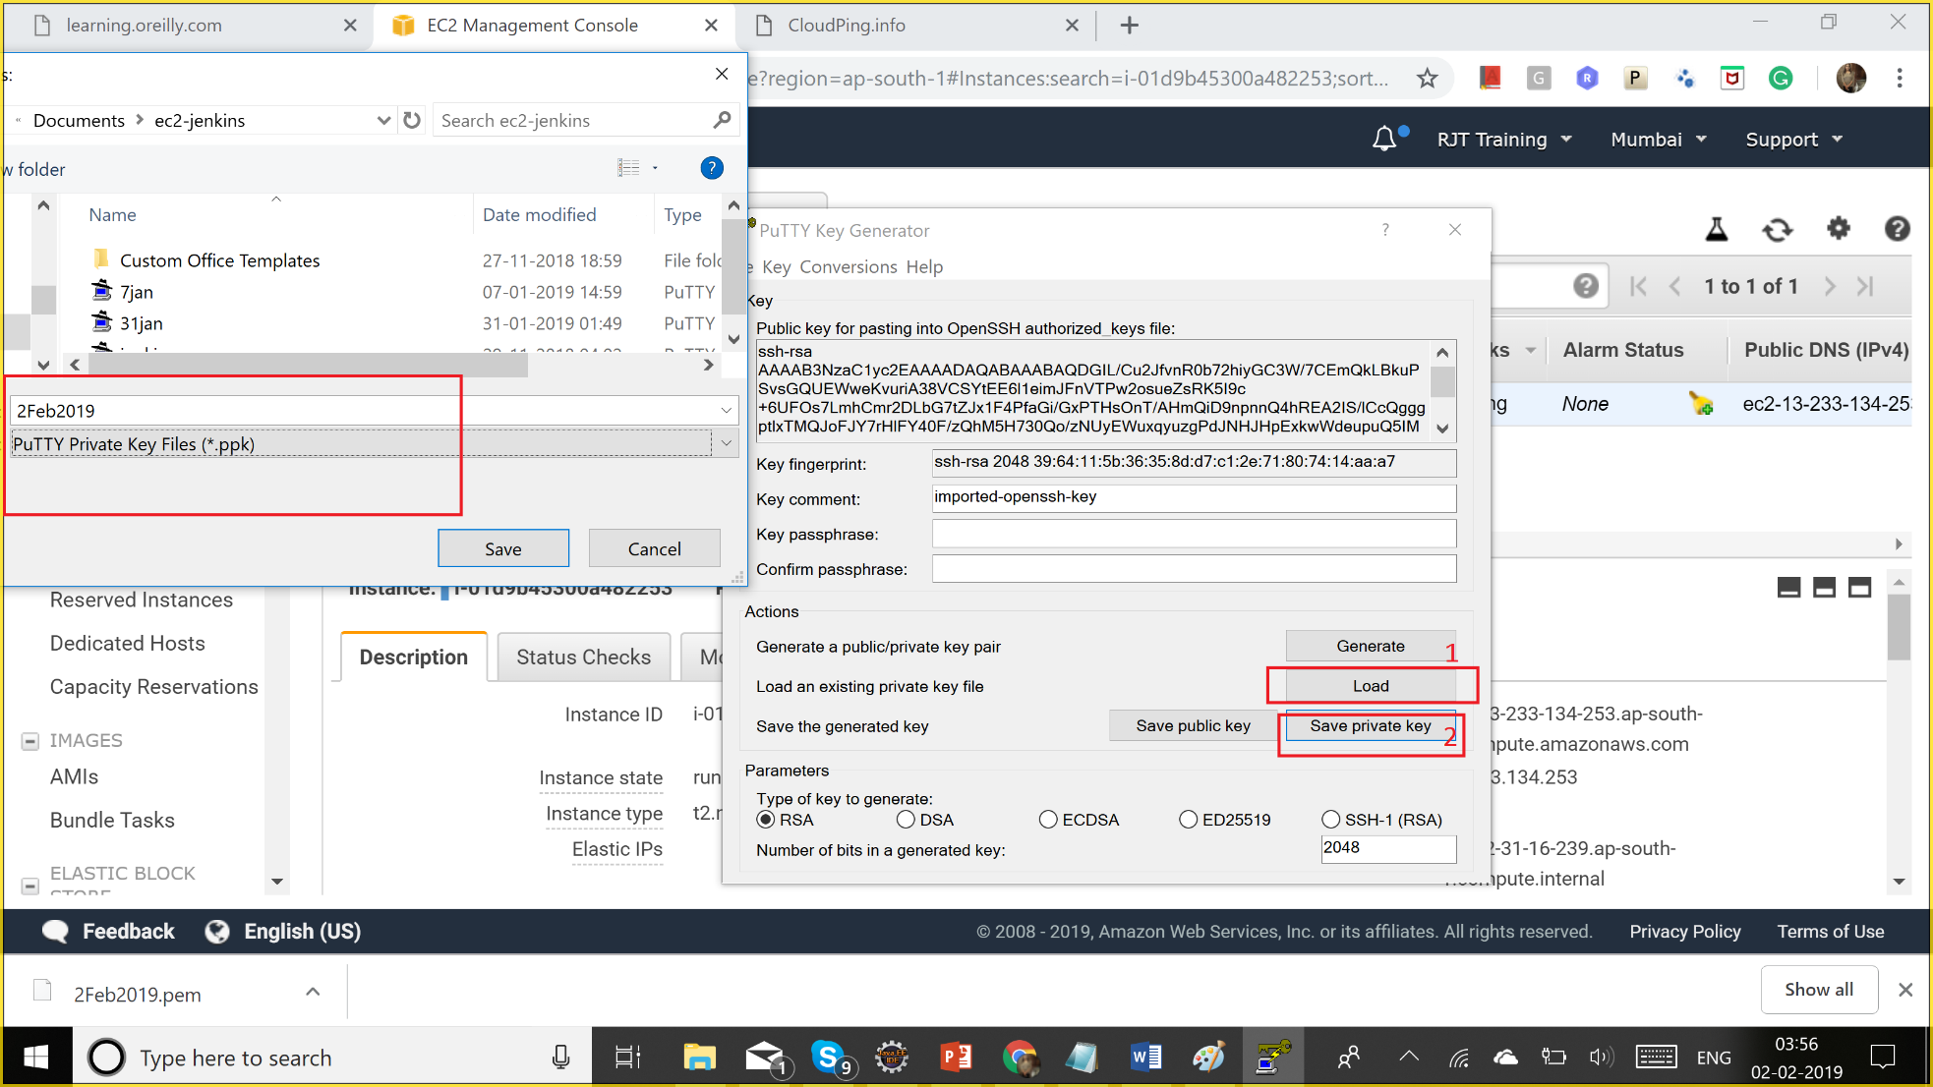

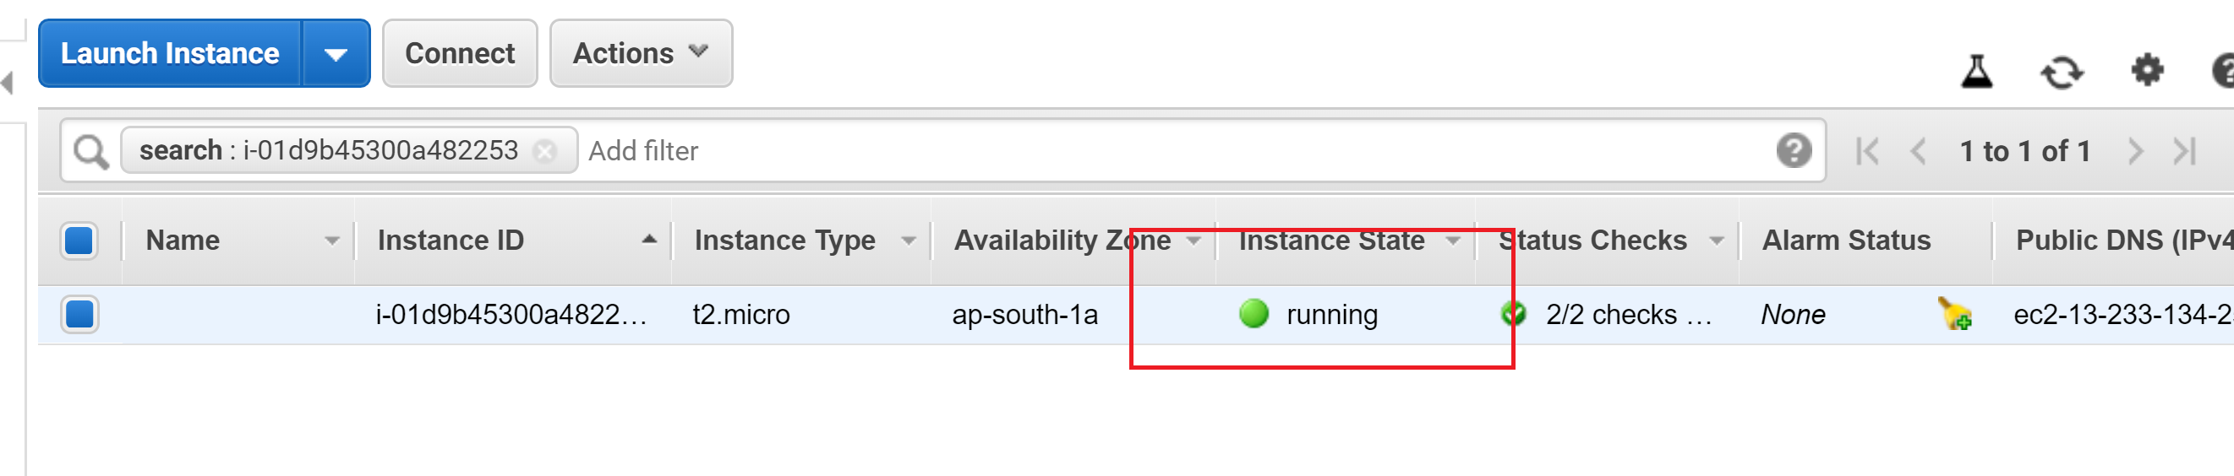

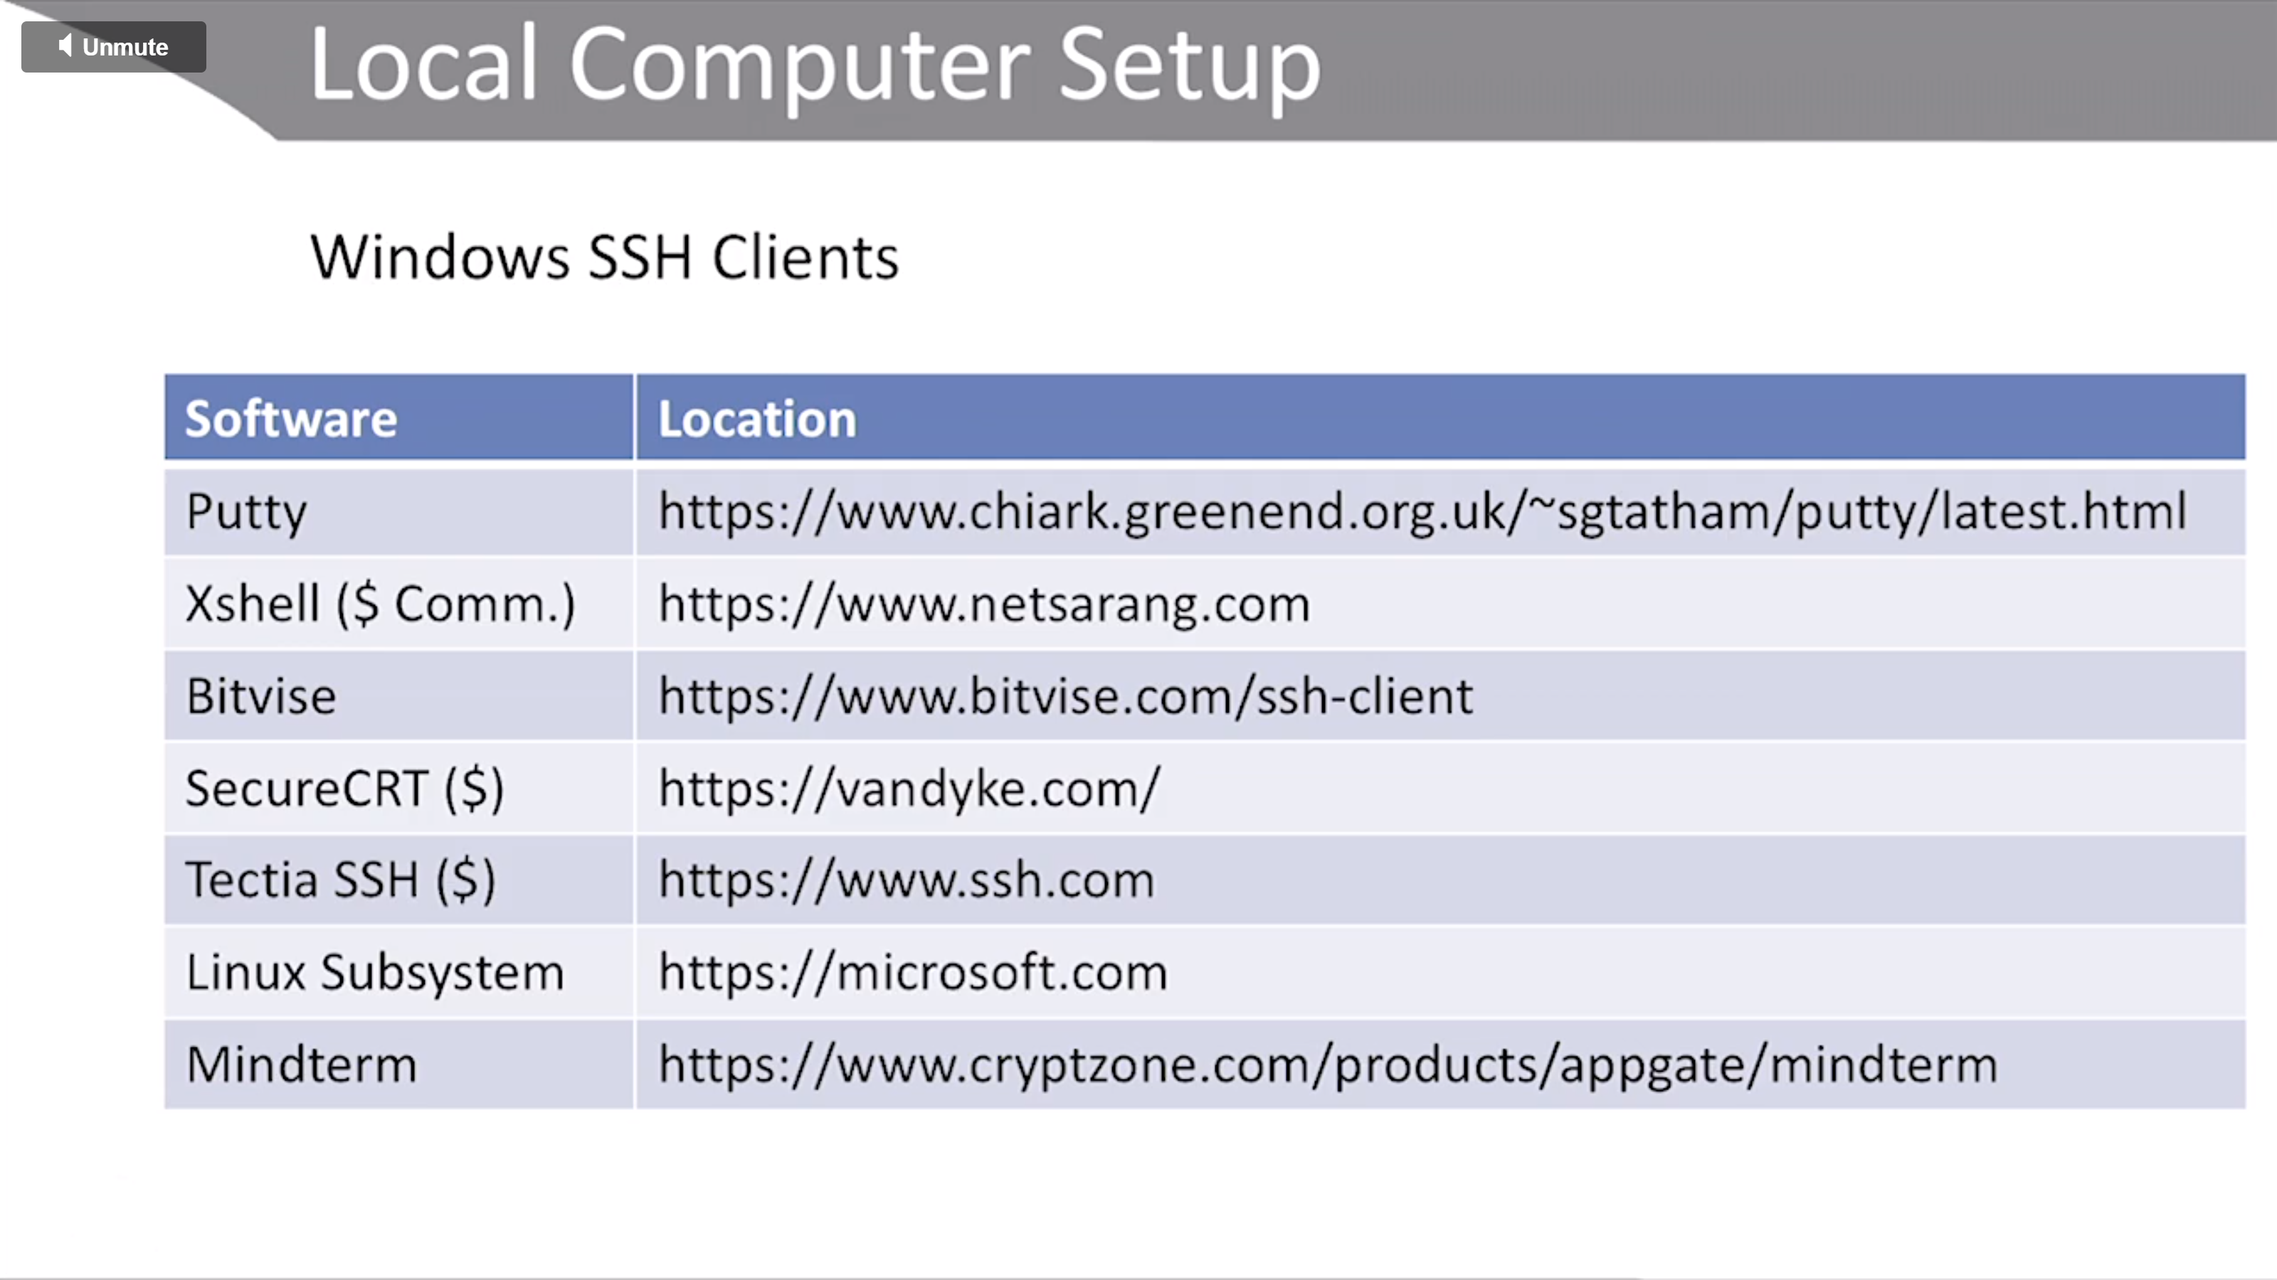

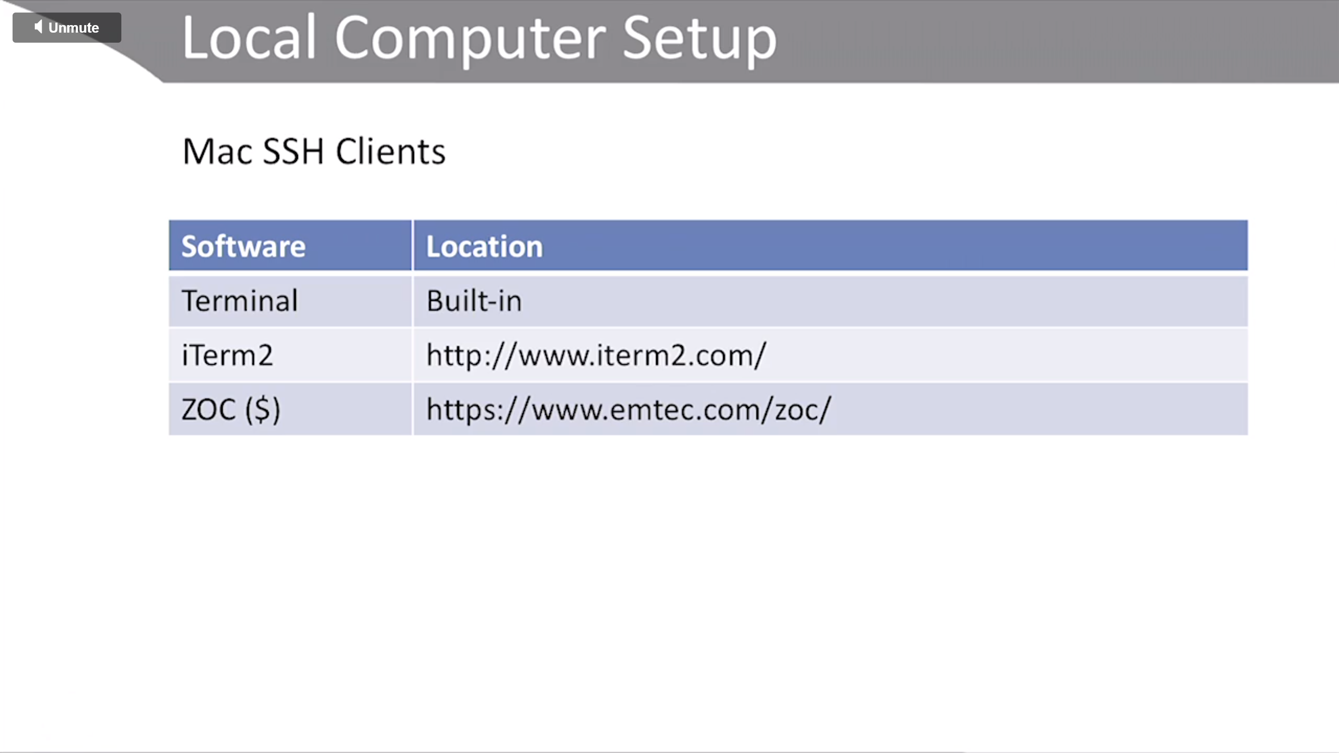

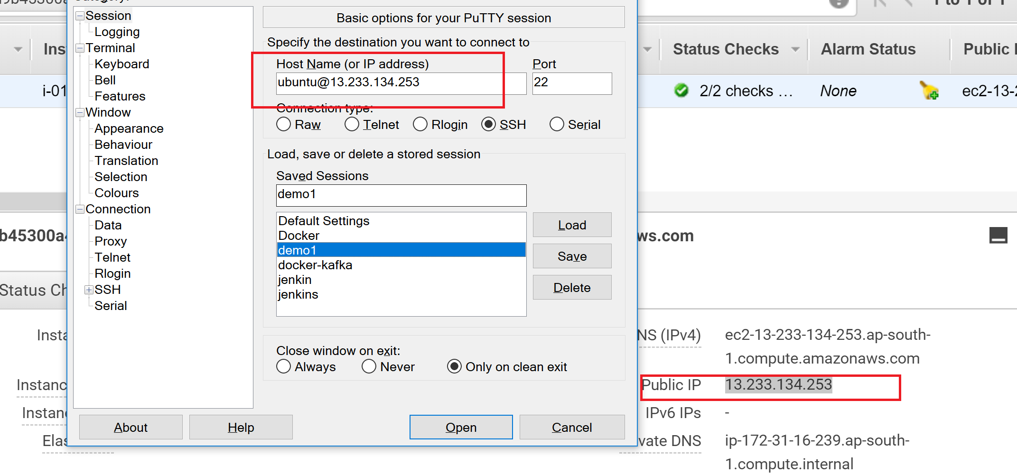

Ubuntu: ubuntu

Linux: ec2-user

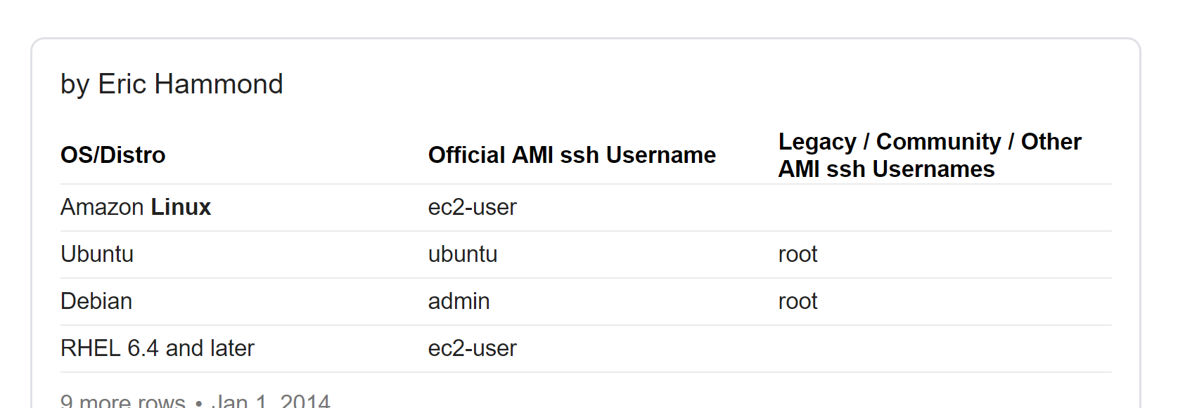

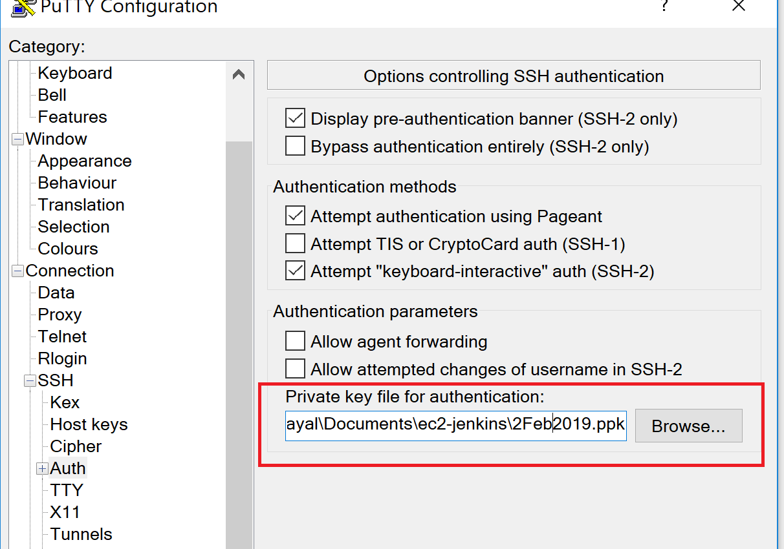

<https://linuxize.com/post/how-to-install-tomcat-9-on-ubuntu-18-04/>

sudo apt update

sudo apt-get install openjdk-8-jdk

sudo useradd -r -m -U -d /opt/tomcat -s /bin/false tomcat

wget http://www-eu.apache.org/dist/tomcat/tomcat-9/v9.0.14/bin/apache-tomcat-9.0.14.tar.gz -P /tmp

sudo tar xf /tmp/apache-tomcat-9\*.tar.gz -C /opt/tomcat

sudo ln -s /opt/tomcat/apache-tomcat-9.0.14 /opt/tomcat/latest

sudo chown -RH tomcat: /opt/tomcat/latest

sudo chmod o+x /opt/tomcat/latest/bin/

<https://tecadmin.net/install-tomcat-9-on-ubuntu/>