# ­­­­­­­­­­­­Assessment Parameters

* Complete flow of the application with exception handling -70%
* Comments/best practice, coding standards- 10%
* Execution of the application (Output) – 20%
* ScreenShot should be submitted along with the solution
* The solution(Project) created by the trainee should have the name like AppName_Empid Ex:ABCCorp_675467
* Code with compilation errors will not be considered for evaluation

**On-Line Ticket Booking Application:**

**Requirement:**MagicWorld is an online ticket booking system that enables users to book magic shows which are scheduled in different locations. A user can view the availability of seats in the show and book the show ticket.. Design the web application for the same using Spring, Hibernate. For client validations use jquery/ javascript. Use bootstrap for enriching the presentation.

success.jsp

error.jsp

bookNow.jsp

showDetails.jsp

Show

DB

<<DAO>>

ShowDAO

<<Controller>>

ShowController

<<Service>>

ShowService

index.jsp

Failure.jsp

Failure.jsp

Failure.jsp

bookShow.jsp

1. Develop index.jsp and invoke ShowController class. The **ShowController.java(Controller)** will fetch Showdetails from database and store it in List<Show>.Which is then stored in session and displayed in **showDetails.jsp** as shown below **(15 Marks)**

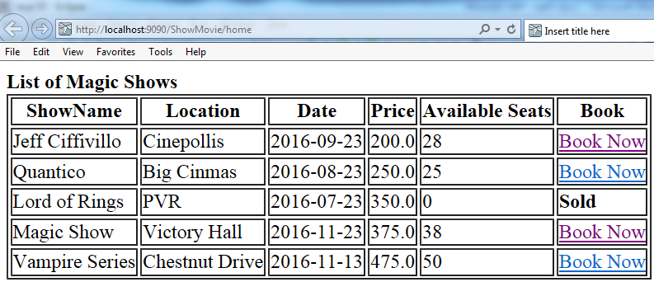

* If number of seats available for a particular show is greater than 0, then display “Book Now” link
* If number of seats available for a particular show is less than or equal to 0, then display “Sold” keyword.

1. Once “BookNow” link is clicked, navigate to **bookNow.jsp** page as shown below: **(10 marks)**

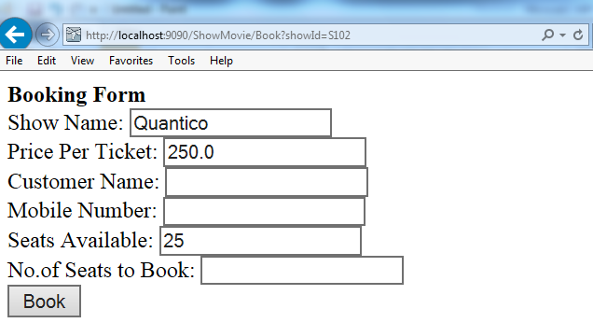

* ShowName, Price per Ticket and Seats Available needs to be populated

Perform following validations: (**10 marks**)

* All fields are mandatory.
* Name should accept only alphabets.
* Mobile Number should be valid of 10 digits.
* No. of seats to book should be positive digit and it should not accept number greater than number of seats available

**Note:** Validation for form data should be done at Client side (Java script or HTML5) wherever applicable. Also in the server side so that if in the browser javascript is disabled, it should be doing validations on server side.

Refer below screen after entering valid details:

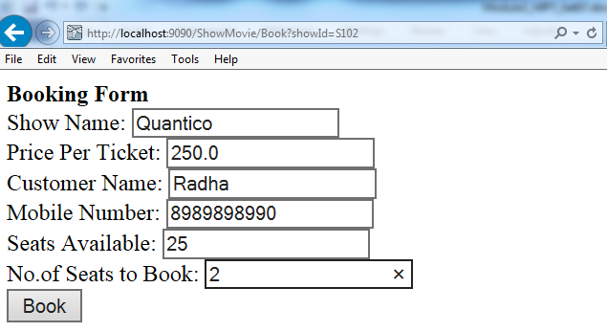

1. After the Book button is clicked:
   1. Update the seat column value as (No of seats available –No of seats wants to book) in shows table for the particular show. (**15 marks**)
   2. Also make the update in the payment table to record payment received.
2. When updation has been done successfully, then display the success page as shown below (**10 marks**)

Refer **success.jsp** as below:

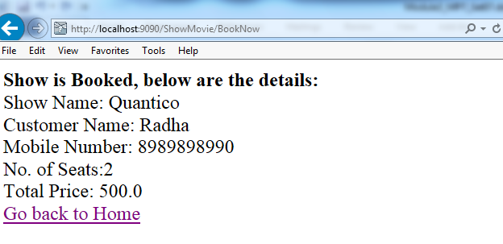

1. Ensure the usage of MVC pattern with Layered Architecture. **(5 marks)**
2. If tickets are not booked then navigate to error.jsp with appropriate error message.
3. Use appropriate custom exceptions in jsp and controllers where necessary . Nowhere it should lead to breaking your application (**5 marks**)
4. At each screen, except the login screen, provide a logout button to enable logging out and clearing the session. **(10 marks)**
5. If a user refreshes a page, make sure payment is not happening twice

If a user clicks on back button, he should not have to refill the details since they would be stored in the session. **(10 marks)**

Design the database as per your requirement. **(10 marks)**