Android studio: free open source ide, written in java and has integrated gradle build system.

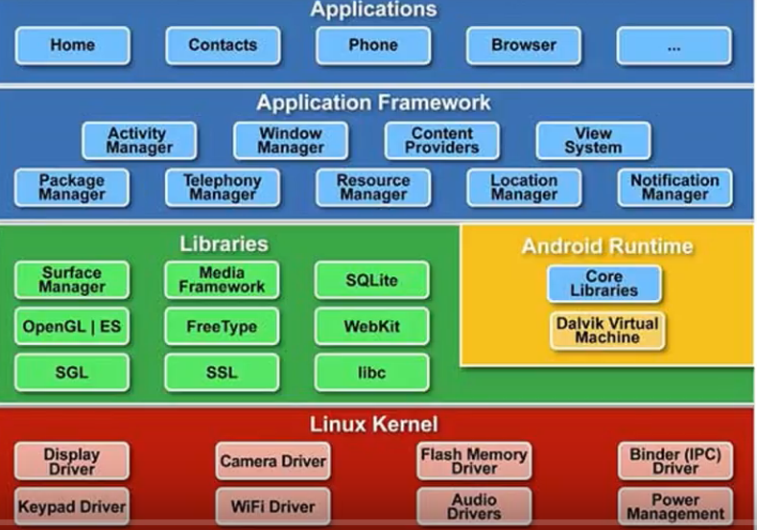

openGL: graphics

SGL: 2d graphics

Media framework: vm layers

SQLite: to write database

Runtime library:

Dalvik VM: to run with limited CPU

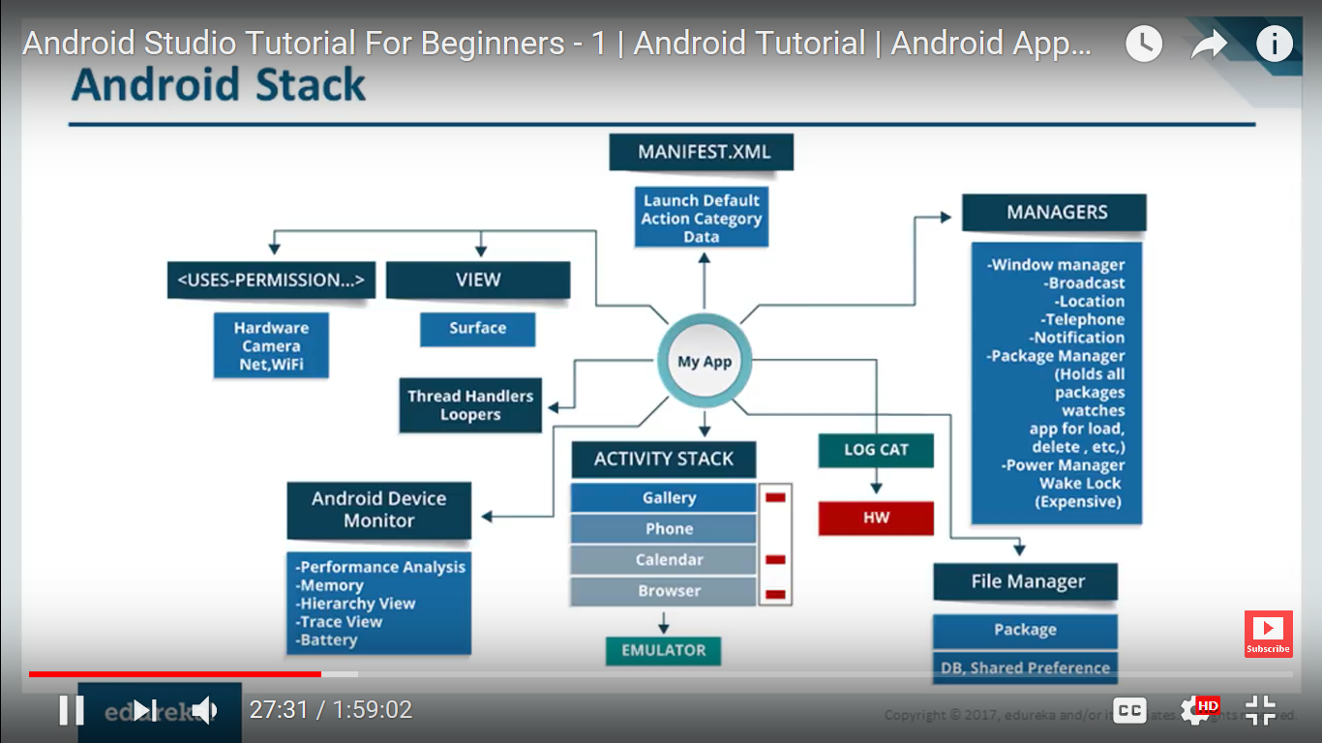

Activity stack: applications running on phone

View on top of application

Downloading app from play store, needs phone camera.. permissions: what hardware it will use. Else will stop from getting downloaded.

Applications use multithreading. 70% of android threads, 30% java threads

Log Cat: Monitoring all applications, all variables we are using. Why application is sluggish. Used in debug mode. In running mode, will dump all information which can be reviewed later.

File Manager: Integral part of file system. Has files which cannot be seen by users. Database, shared preferences.

Emulator: 95% of phone. Can run applications on emulator. But cannot run some apps on emulator like sensor..

Manager: performance analysis, memory consumption, time consumed. Harness test needs to be cleared.

ARP (Android runtime platform): compile only modified code than compiling whole code. JIT compiler:

Hardware:

.so files can be created with hardware. NDK (nature development kit)

HAL: hardware abstraction layer. .so files Server running on top of hardware.

**Installation of Android studio:**

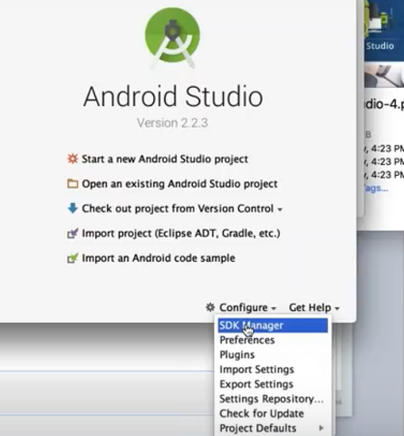

SDK tools:

Intel emulator x86 accelerator, cmake, lldbs, google play

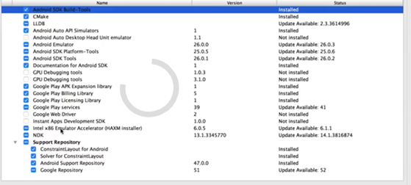

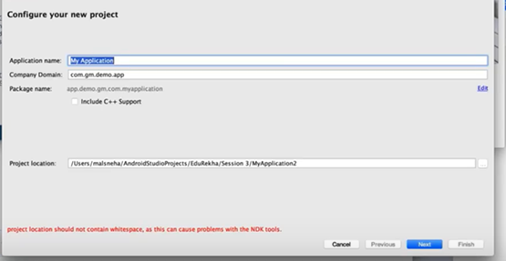

Company domain: package name in reverse order

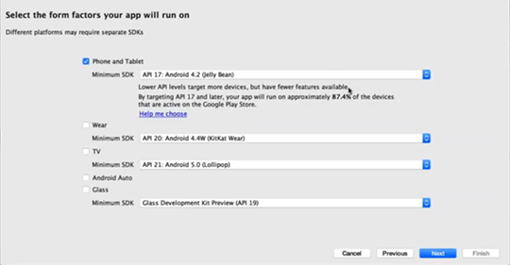

Empty activity

Activity has a view running on top of it.

Activity name: MainActivity

Layout name: layout_main

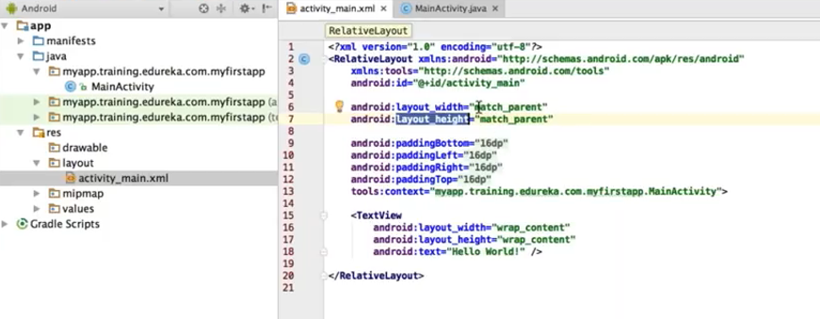

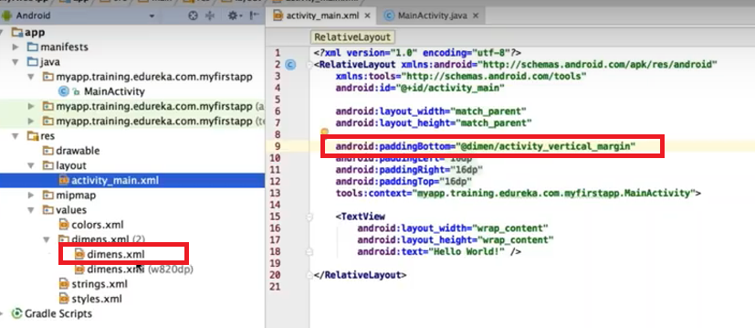

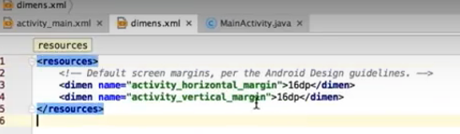

Tools:context => package-name

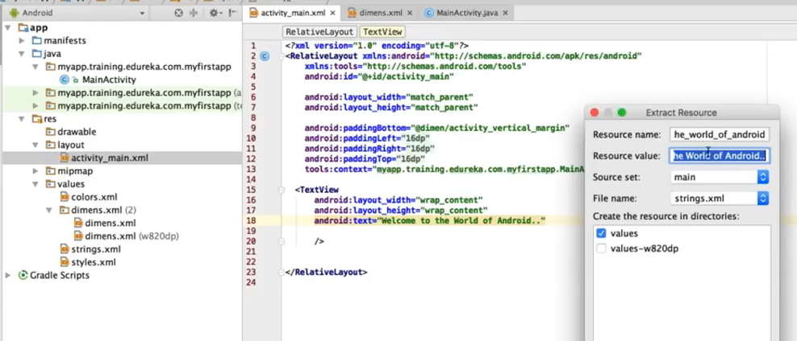

Wrap_content: as per the length and height of the letters.

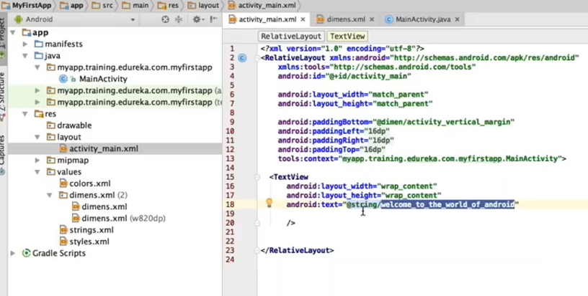

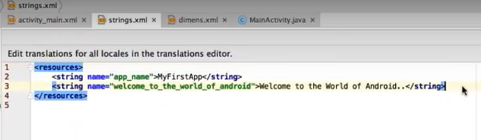

Dp: density pixel

Sp: used with text

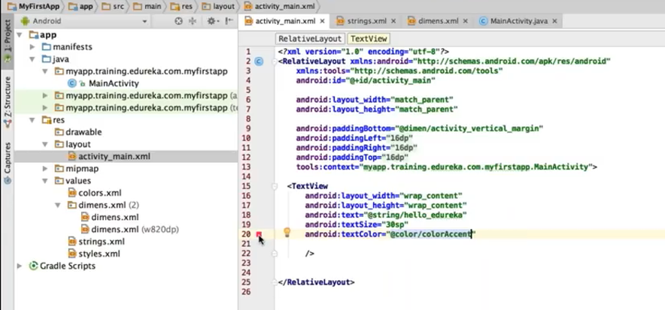

Linear layout: all widgets, one below the other. Needs orientation: by default it’s horizontal.

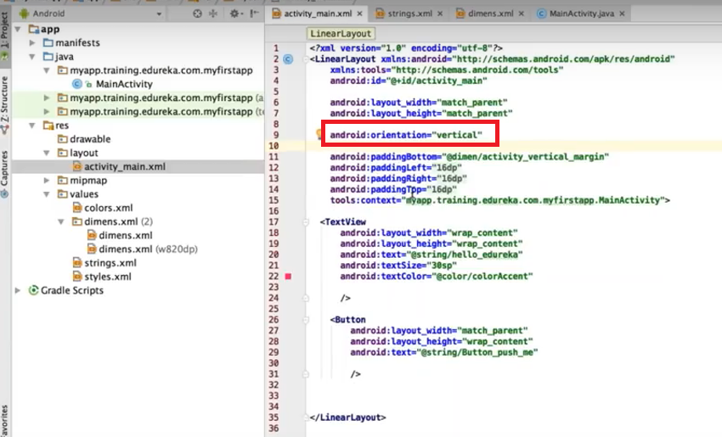

**Compile program:**

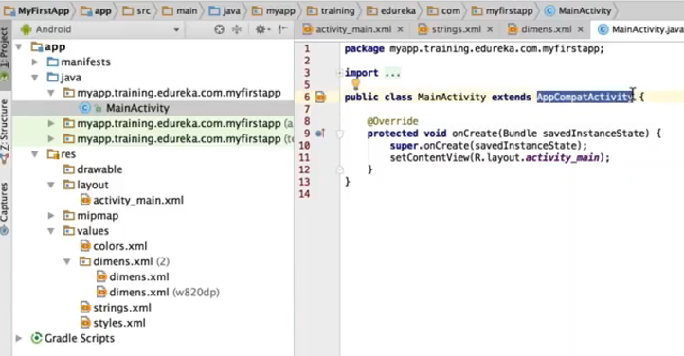

onCreate(): like a constructor for main application

Here we write core business logic. View is brought on top of activity on call of setContentView.

R means resources folder (res)

**To bring up emulator:**

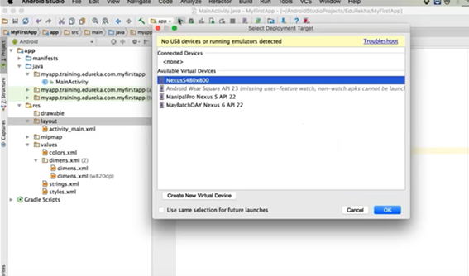

Can choose one or click on “Create New Virtual Device”

Like Nexus 6

Lollipop 5.1

Any name in avd name

If emulator sdk was installed, will come up.

An application can have different activities. Activities interacts with user to do some task like dial phone number, send email..

Activities are presented in a floating window (widgets) or embedded inside other activity. Application can have multiple activities, loosely bound to each other

**Activity Lifecycle**

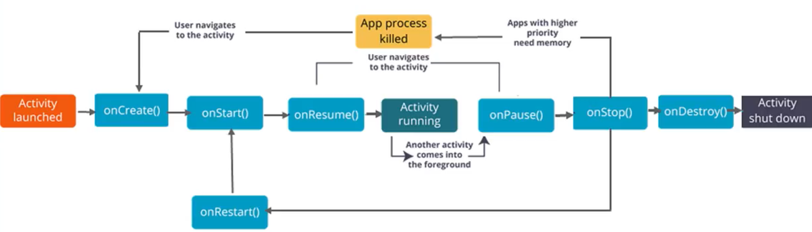

To debug an app:

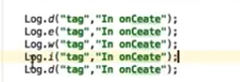

D: debug

E: error

W: warning

I: information

Goto **Android Monitor:**

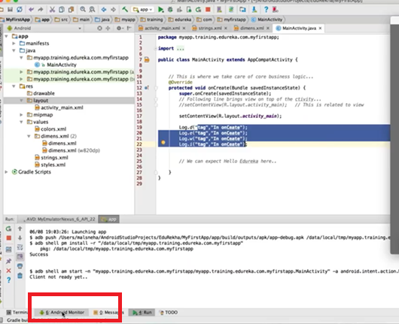

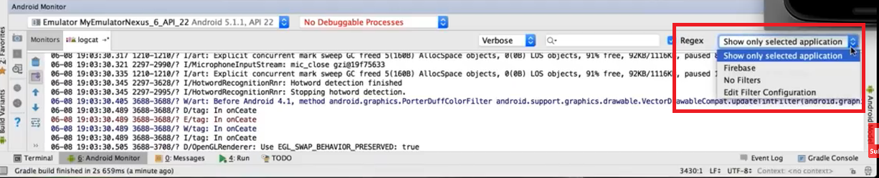

To show only application specific logs: “show only selected application”

Type tag keyword in search box

**https://developers.android.com** : future reference