Jboss integration and soa development plugin in ide

Fuse project: camel-archetype-blueprint

Eclipse: Install new software

**Name:**  
*JBoss Fuse Tooling (Luna)*  
**Location:**

*http://download.jboss.org/jbosstools/updates/integration/luna/integration-stack/fuse-tooling/7.3.0/all/repo/*

There are three features available from that update site:  
  
*JBoss Fuse Camel Editor Feature:*  
This feature gives you the route editor for [**Apache Camel**](http://camel.apache.org/) Routes, a new project wizard to setup new integration modules and the option to launch your new routes locally for testing purposes.  
  
*JBoss Fuse Runtimes Feature:*  
This allows you to monitor your routes, trace messages, edit remote routes and there are also Fabric bits available to work with Fuse Fabric.  
  
*JBoss Fuse Server Extension Feature:*  
When installing this feature you will get server adapters for [**Apache ServiceMix**](http://servicemix.apache.org/), [**Apache Karaf**](http://karaf.apache.org/)**,** [**Fabric8**](http://fabric8.io/) and [**JBoss Fuse**](http://www.jboss.org/products/fuse/overview/)runtimes. It allows you to start / stop those servers and to connect to their shell. Deployment options are also available.

Click the **Yes** button to restart Eclipse. When the restart is done you will be able to select the **Fuse Integration**perspective from the perspectives list.

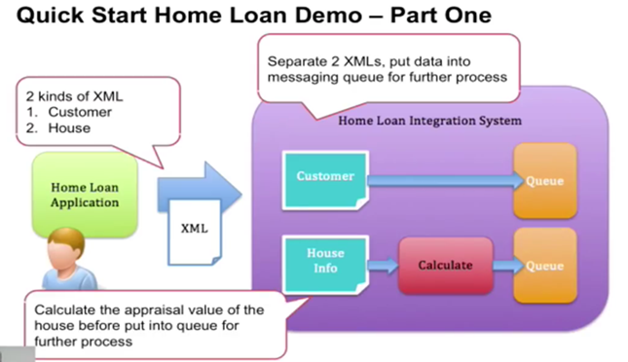

Read xml , send it to corresponding queue, then upload customer data in db.

Home loan demo: get xml from customer and house. One from house, calculate value of house and put on queue. Other from customer directly placed on queue. Get 2 xml, separate them based on content and customer xml to be sent to queue , house info xml processed , calculated and then sent to queue.

**Step 1**

In jboss fuse,

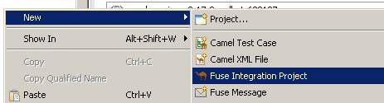

Project name: HomeLoanFuseDataReceiver

Archetype: camel-blueprint