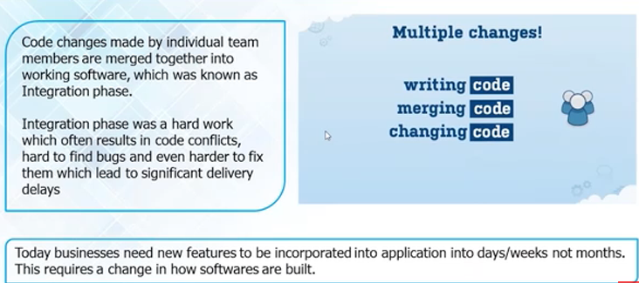

Possible steps executed by Jenkins are for example:

* perform a software build using a build system like Apache Maven or Gradle
* execute a shell script
* archive a build result
* running software tests
* Jenkins monitors the execution of the steps and allows to stop the process, if one of the steps fails. Jenkins can also send out notification in case of a build success or failure.
* Jenkins can be extended by additional plug-ins. For example, you can install plug-ins to support building and testing Android applications.

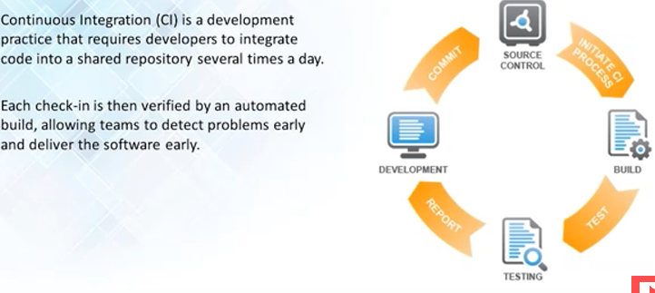

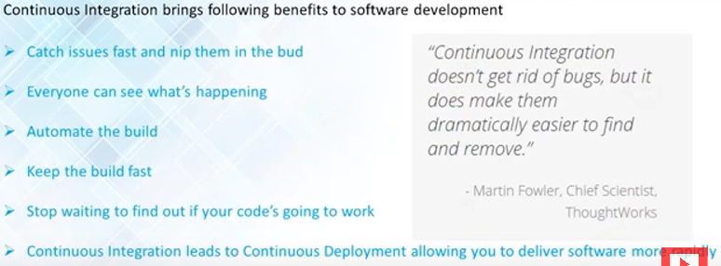

Syntax, semantics, unit tests, functional tests, dependency test

Maven plugin, github plugin, sonar, mercury, code revision system, code review system: gerrit,

Free, open source

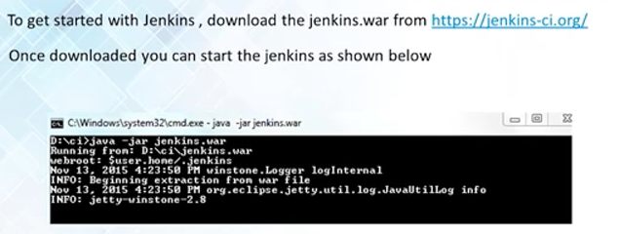

Install plugin for what u need

Pipeline, junit plugin, credentials plugin, ant plugin, gradle plugin, git, subversion, ldap plugin, email extension,

Create new job/ new item: blue success, red failure, grey aborted/ not started yet.

Any server that supports war file, can start Jenkins will run on 8080

Manage jenkins -> Configure system : do the settings, jdk installation,

security

To make maven run with git: