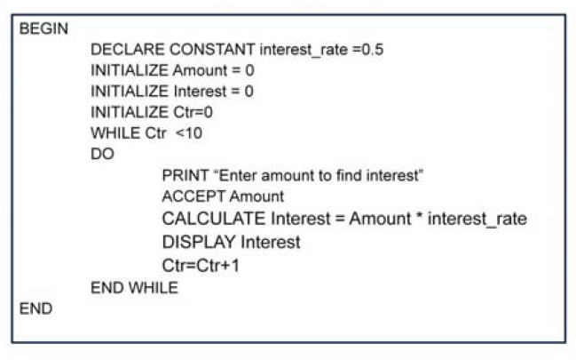BEGIN

DECLARE num AS INTEGER

INITIALIZE num TO 0

PROMPT “Enter the number” AND STORE IN num

IF(num > 0) THEN

DISPLAY “Positive Number"

ELSE

DISPLAY “NegativeNumber”

ENDIF

END

seats_allocated = 0

DO

GET booking

PRINT ticket

ADD 1 to seats_allocated

UNTIL (seats_allocated < 60)

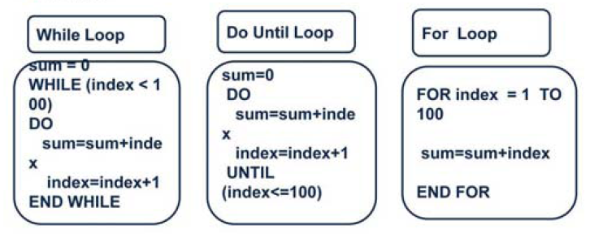

BEGIN

WHILE(TRUE)

PRINT "Enter a NUMBER"

ACCEPT num

IF (REMAINDER of num/2 = 0) THEN

PRINT "Number is EVEN"

ELSE

PRINT "Number is ODD“

END IF

PRINT "Enter u'r Choice , Continue with another number?[Y/N]"

ACCEPT choice

IF(choice='Y') THEN

cycle

ELSE

exit

END WHILE

END

BEGIN

DECLARE num AS INTEGER

PROMPT “Enter a number” AND STORE IN num

IF ( num== 0 )THEN

PRINT "The value you entered was zero.“

ELSE IF ( num< 0 ) THEN

PRINT "The value is negative.“

ELSE

PRINT "The value is positive.“

END IF

END

BEGIN

DECLARE num, count, sum AS INTEGER

PROMPT "Enter the value of n" AND STORE IN num

FOR COUNT = 1 TO num

sum+=count;

END FOR

PRINT "Sum is " + sum

END

if (foo->next==NULL && number < limit && limit

<=SIZE && node_active(this_input)) {...

begin

declare

initialize

prompt/

accept amount

print/ display

calculate

BEGIN

DECLARE num AS INTEGER

INITIALIZE num TO 0

PROMPT “Enter the number” AND STORE IN num

IF(num > 0) THEN

DISPLAY “Positive Number"

ELSE

DISPLAY “NegativeNumber”

ENDIF

END

datatype: character, integer, real, boolean

record employee

declare empNo as integer

declare emp_name as string

declare salary as integer

end record

BEGIN

WHILE(TRUE)

PRINT "Enter a NUMBER"

ACCEPT num

IF (REMAINDER of num/2 = 0) THEN

PRINT "Number is EVEN"

ELSE

PRINT "Number is ODD“

END IF

PRINT "Enter u'r Choice , Continue with another number?[Y/N]"

ACCEPT choice

IF(choice='Y') THEN

cycle

ELSE

exit

END WHILE

END

BEGIN

DECLARE num AS INTEGER

PROMPT “Enter a number” AND STORE IN num

IF ( num== 0 )THEN

PRINT "The value you entered was zero.“

ELSE IF ( num< 0 ) THEN

PRINT "The value is negative.“

ELSE

PRINT "The value is positive.“

END IF

END

BEGIN

DECLARE num, count, sum AS INTEGER

PROMPT "Enter the value of n" AND STORE IN num

FOR COUNT = 1 TO num

sum+=count;

END FOR

PRINT "Sum is " + sum

END