Setting up a GitLab Runner for GitLab Running as Docker on Windows Docker Desktop

Scenario
- You have GitLab CE/EE running in Docker on Windows via Docker Desktop.
- You want to add a GitLab Runner (could be Shell, Docker, or Docker-in-Docker executor).

1. Prepare GitLab Server Info
- Ensure your GitLab instance is accessible from your Windows system, e.g., http://localhost.
- Log in as an admin/maintainer to get the registration token:
- Navigate to: GitLab → Project → Settings → CI/CD → Runners section → Expand "Set up a specific Runner manually"
- Copy the URL (e.g., http://localhost/) and the Registration Token.

2. Install GitLab Runner

Option 1: Use Docker (Recommended & Portable)
1. Open PowerShell or CMD.
2. Pull GitLab Runner image:
docker pull gitlab/gitlab-runner:latest
3. Create a directory for Runner config (optional but good for persistence):
mkdir C:\gitlab-runner
4. Run GitLab Runner container:
docker run -d --name gitlab-runner --restart always ^
-v C:\gitlab-runner:/etc/gitlab-runner ^
-v //var/run/docker.sock:/var/run/docker.sock ^
gitlab/gitlab-runner:latest

== Use the below for current setup of docker desktop
docker run -d --name gitlab-runner --restart always ^
-v C:\gitlab-runner:/etc/gitlab-runner ^
-e DOCKER_HOST=tcp://host.docker.internal:2375 ^
gitlab/gitlab-runner:latest
> Note: Replace C:\gitlab-runner with your preferred local folder.

3. Login to the runner on the cli

$ docker exec -it gitlab-runner bash

Root@1bb15ba:/# gitlab-runner register

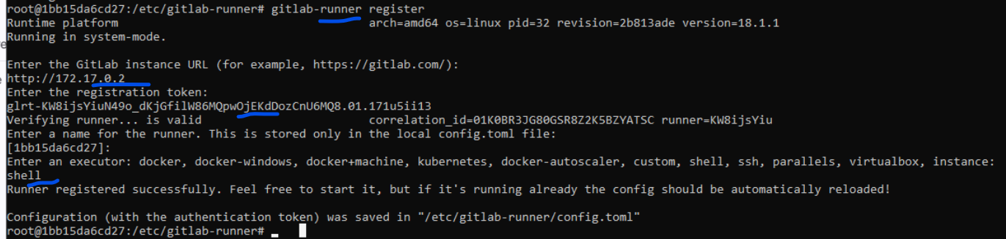

4. Verify Runner Registration
- Go to GitLab → Project → Settings → CI/CD → Runners.
- You should see your new runner listed as online.

5. Use the Runner in Your .gitlab-ci.yml
Example for a Docker runner:
stages:
- test
job1:
stage: test
script:
- echo "GitLab Runner setup on Windows Docker Desktop!"

Summary Table
Step | Command/Action
Pull runner image | docker pull gitlab/gitlab-runner:latest
Start runner container | docker run -d --name gitlab-runner ...
Register runner | docker run --rm -it -v ... gitlab/gitlab-runner register
Verify | Check in GitLab CI/CD Settings → Runners

Troubleshooting Tips
- If you get errors like "Runner not connecting", make sure Docker can reach your GitLab container (especially if using custom networks or ports).
- For Docker-in-Docker (DinD), you might need special configs (let me know if you want this setup).
Let me know if you need:
- Shell executor details
- Docker-in-Docker example
- A complete .gitlab-ci.yml with stages!

Tips:

Make sure the hostname of the gitlab server is resolving on the gitlab runner.
“localhost” will not work , if configured as “external_url”
Or
Use the ipaddress of the Host machine (wndows) , tha tis the actual ip.
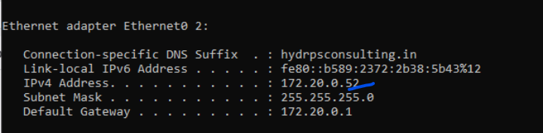
Check if it reachable from gitlab server and runner
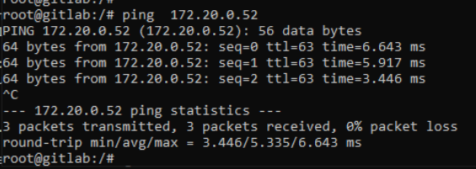
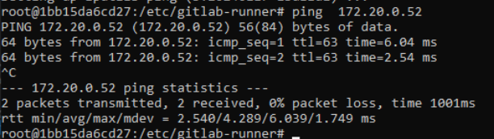
Make sure the gitlab.rb file is updated with the same

