Difference in jsp and servlets

JSP model1 architecture, JSP model2 architecture?  
What are the JSP lifecycle phases?

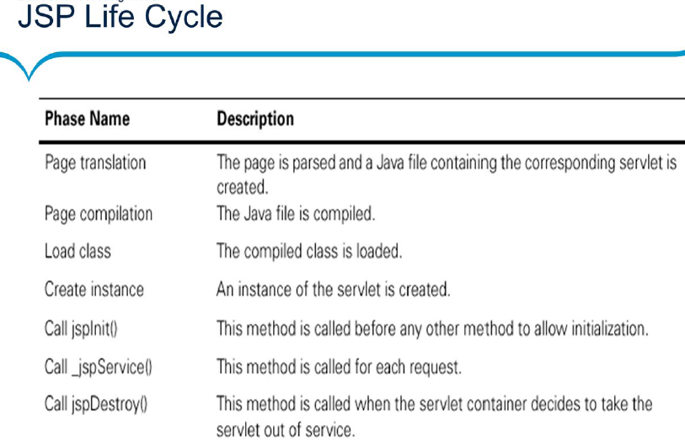  
Which JSP lifecycle methods can be overridden?  
How can we avoid direct access of JSP pages from client browser?  
What are different types of comments in JSP? Diff in jsp comment and html comment  
What is Scriptlet, Expression and local and global variable Declaration in JSP?  
What are JSP implicit objects?  
Can we use JSP implicit objects in a method defined in JSP Declaration?

Which implicit object is not available in normal JSP pages?  
What are the benefits of PageContext implicit object?  
How do we configure init params for JSP?  
Why use of scripting elements in JSP is discouraged?  
Can we define a class in a JSP Page?  
How can we disable java code or scripting in JSP page?  
Explain JSP Action Elements or Action Tags?  
What is difference between include directive and jsp:include action?  
What is JSP Expression Language and what are it’s benefits?  
What are JSP EL implicit objects and how it’s different from JSP implicit Objects?  
How to use JSP EL to get HTTP method name?  
What is JSP Standard Tag Library, provide some example usage?  
What are the types of JSTL tags?  
What is JSP Custom Tag and what are it’s components?  
Give an example where you need JSP Custom Tag?  
Why don’t we need to configure JSP standard tags in web.xml?  
How can we handle exceptions thrown by JSP service method?  
How do we catch exception and process it using JSTL?  
How do we print “<br> creates a new line in HTML” in JSP?  
What is jsp-config in deployment descriptor?  
How to ignore the EL expression evaluation in a JSP?  
When will Container initialize multiple JSP/Servlet Objects?  
Can we use JavaScript with JSP Pages?  
How can we prevent implicit session creation in JSP?  
What is difference between JspWriter and Servlet PrintWriter?  
How can we extend JSP technology?  
Provide some JSP Best Practices?

JSTL core library?