What is different between web server and application server?  
Which HTTP method is non-idempotent?  
What is the difference between GET and POST method?  
What is MIME Type?  
What is a web application and what is it’s directory structure?  
What is a servlet?  
What are common tasks performed by Servlet Container?  
What is ServletConfig object?  
What is ServletContext object?  
What is difference between ServletConfig and ServletContext?  
What is Request Dispatcher?  
What is difference between PrintWriter and ServletOutputStream?  
Can we get PrintWriter and ServletOutputStream both in a servlet?  
How can we create deadlock situation in servlet?  
What is the use of servlet wrapper classes?  
What is SingleThreadModel interface?

Do we need to override service() method?  
Is it good idea to create servlet constructor?  
What is difference between GenericServlet and HttpServlet?  
What is the inter-servlet communication?  
Are Servlets Thread Safe? How to achieve thread safety in servlets?  
What is servlet attributes and their scope?  
How do we call one servlet from another servlet?  
How can we invoke another servlet in a different application?  
What is difference between ServletResponse sendRedirect() and RequestDispatcher forward() method?  
Why HttpServlet class is declared abstract?  
What are the phases of servlet life cycle?  
What are life cycle methods of a servlet?  
why we should override only no-agrs init() method.  
What is URL Encoding?  
What are different methods of session management in servlets?  
What is URL Rewriting?  
How does Cookies work in Servlets?  
How to notify an object in session when session is invalidated or timed-out?  
What is the difference between encodeRedirectUrl and encodeURL?  
Why do we have servlet filters?  
What is the effective way to make sure all the servlets are accessible only when user has a valid session?  
Why do we have servlet listeners?  
How to handle exceptions thrown by application with another servlet?  
What is a deployment descriptor?  
How to make sure a servlet is loaded at the application startup?  
How to get the actual path of servlet in server?  
How to get the server information in a servlet?  
Write a servlet to upload file on server.  
How do we go with database connection and log4j integration in servlet?  
How to get the IP address of client in servlet?  
What are important features of Servlet 3?  
What are different ways for servlet authentication?  
How can we achieve transport layer security for our web application?

**Servlet Request methods like**

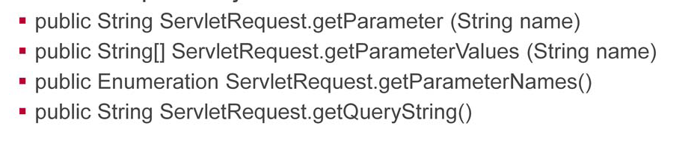

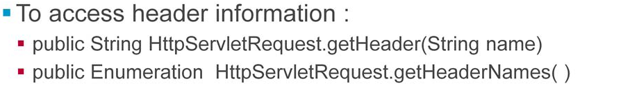

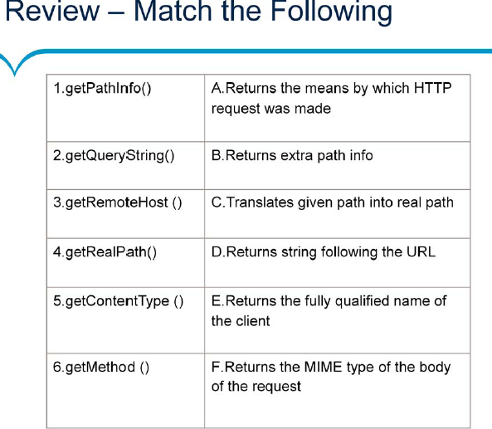

**Various Response methods like**

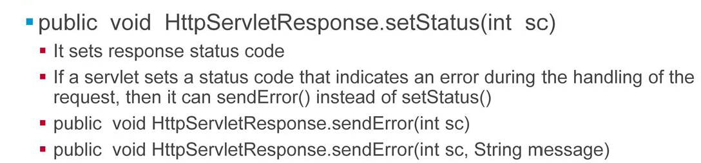

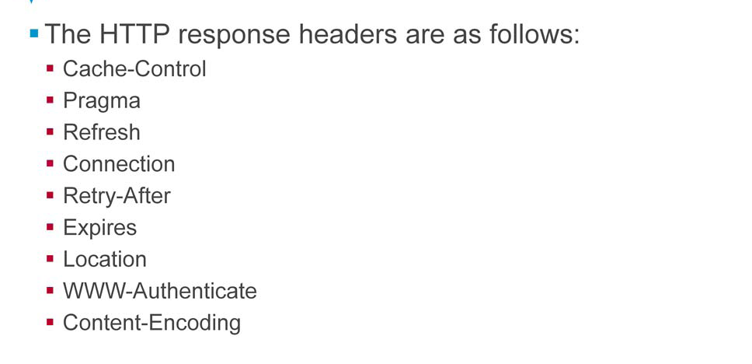

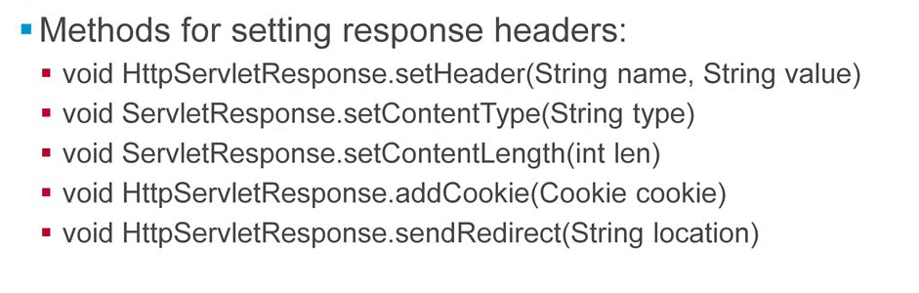

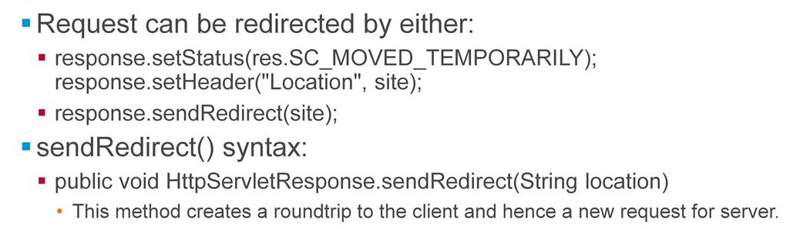

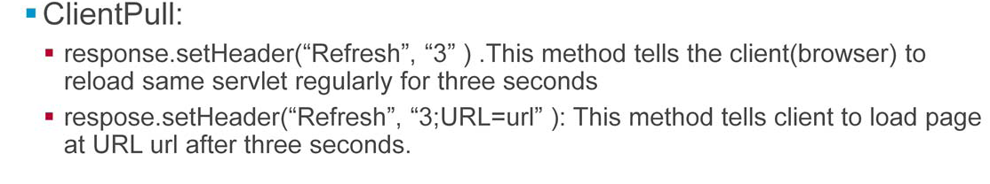

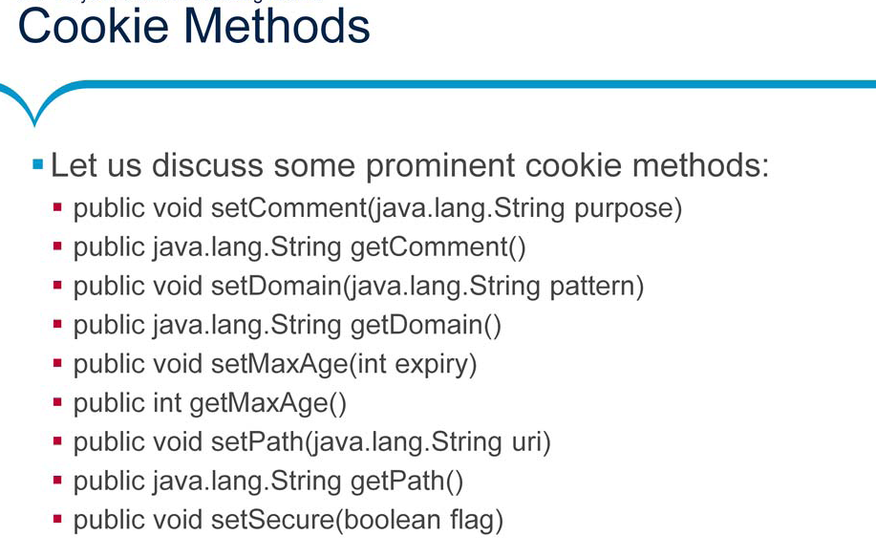

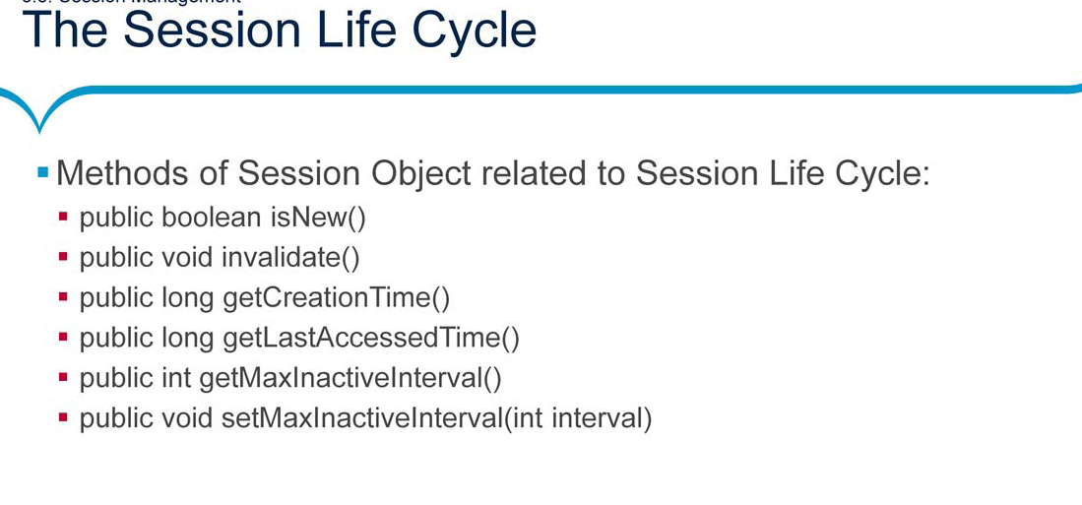

**Lab work: Do these using annotations and java configurations only. No web.xml**

Q1) Create a Servlet program that will print the system date and time.

Note: The Servlet should be invoked in the following ways:

• On clicking of Hyper Link in html page

• On clicking of button in html page

• On typing the servlet URL pattern directly in Address bar of browser

2.1: Design a login Page accepting username and password in HTML. The credentials need to be authenticated in Servlet. The credentials could be validated by using hard coded values for username and password. If user is valid then display HTML page as “Success” and display HTML page as “Failure” if user is invalid. Note:

• Checking could be done by using private method inside servlet.

• The redirection to HTML pages is done using response.sendRedirect(String URLPattern) method

Refer below figure for HTML Login Page:

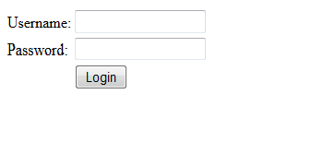

In extension to the previous assignment print the following details extracted from the ‘Request’ object….

1. MIME type accepted by the client

2. The locale setting

3. Data transferred in bytes

2.2: Consider a webpage which is displaying live stock market status. For such type of page, you would need to refresh your web page regularly using refresh or reload button with your browser. Java Servlet makes this job easy by providing you a mechanism where you can make a webpage in such a way that it would refresh automatically after a given interval. Consider the servlet code snippet below and complete the blank space left for automatic refresh to happen and auto-load page after 5 seconds. Refer below figure:

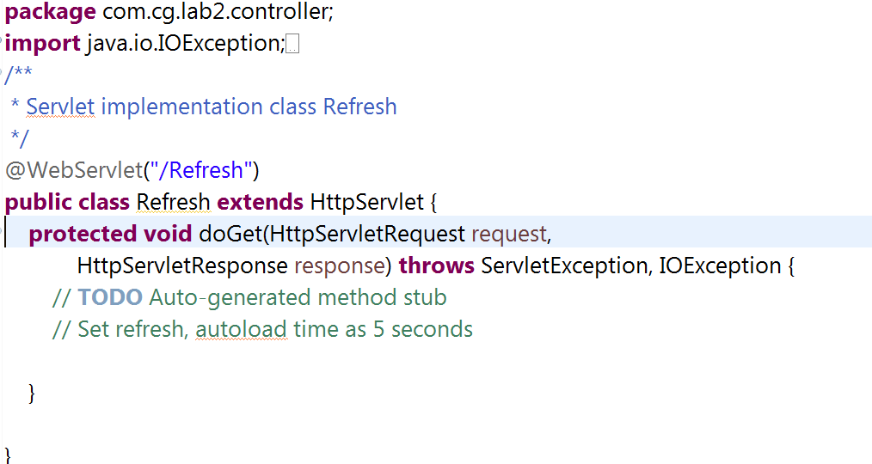

Q) Create a servlet that will redirect the current web application to google.co.in

Q) Design a registration page in HTML. Refer below figure.

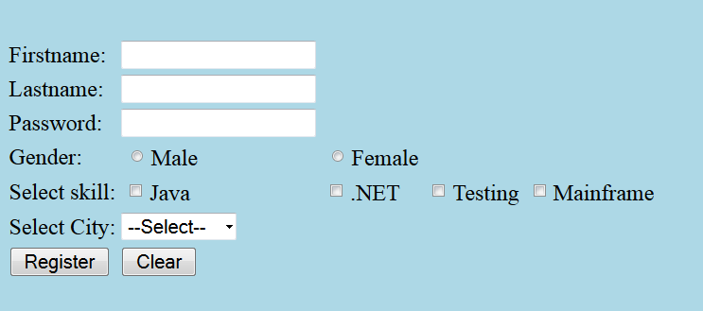

All the details entered in HTML page should be accepted by the Servlet. The Servlet should connect via Connection Pool to database and store the user registration details in database table.

After the user details are inserted successfully in table (RegisteredUsers), display the message “Registration done!!!” in HTML page . Display “Registration failed!!!” in case of any exception . **Note:**

• The redirection to HTML page is done using response.sendRedirect (String URLPattern) method

• The application needs to be developed using Layered architecture approach

• User can select more than one skillset, values of which should be concatenated

and stored in skillset column

**Database Table used:**

RegisteredUsers

CREATE TABLE RegisteredUsers ( firstname VARCHAR (20), lastname VARCHAR (30), password VARCHAR (12) UNIQUE, gender CHAR, skillset VARCHAR (40), city VARCHAR (12));

Refer below figure for layered architecture:.

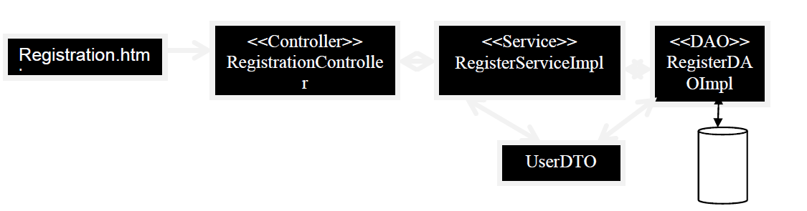

Q) Modify the above question and print all the users’ registered details on next page.

**Note:**

• Make use of RequestDispatcher.forward(String URLPattern) method to navigate to next page

• To store all the users’ details make use of Request Scope

Q) Rima is working in State electricity board project (eBill application) and is being given the requirement to accept the details online and calculate the net electricity bill amount and persist the details in database.

Refer the below script:

CREATE TABLE Consumers( consumer_num NUMBER(6) PRIMARY KEY, consumer_name VARCHAR2(20) NOT NULL, address VARCHAR2(30) );

INSERT INTO Consumers VALUES(100001,'Sumeet','Shivaji Nagar, Pune');

INSERT INTO Consumers VALUES(100002,'Meenal','M G Colony Panvel, Mumbai');

INSERT INTO Consumers VALUES(100003,'Neeraj','Whitefield, Bangalore');

INSERT INTO Consumers VALUES(100004,'Arul','Karapakkam, Chennai');

CREATE TABLE BillDetails( bill_num NUMBER(6) PRIMARY KEY, consumer_num NUMBER(6) REFERENCES Consumers(consumer_num), cur_reading NUMBER(5,2), unitConsumed NUMBER(5,2), netAmount NUMBER(5,2), bill_date DATE DEFAULT SYSDATE);

CREATE SEQUENCE seq_bill_num START WITH 100;

After login the admin user should be able to view the following UI:

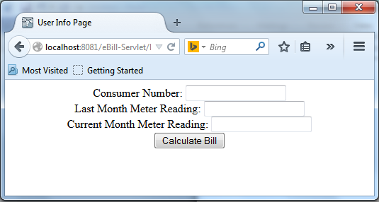

Following Client side validations need to be performed:

o All fields are mandatory

o Consumer number can contain only numbers i.e. 6 digit , Consumer number cannot start with 0

o Last Month and Current Month meter reading can take decimal values, maximum 2 digits after decimal point and should not be negative

o Current Month meter reading cannot be less than Last Month meter reading

**Refer below figure with valid details**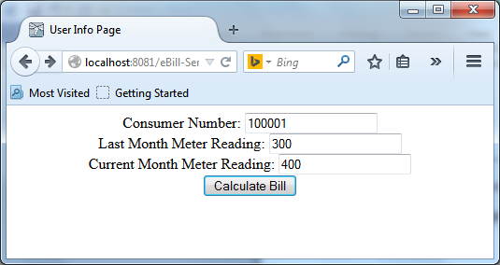

After user enters the valid details Units consumed and Net bill amount need to be calculated in servlet:

**Refer below calculations:**

Units consumed = (Last month meter reading) – (Current month meter reading)

Net Amount = Unit consumed * 1.15 + Fixed Charge

Assume Fixed Charge is always Rs.100.

After calculating the electricity bill, bill details needs to be inserted into the database table billdetails.

**Note:**

1. Bill_id should be auto generated by sequence.

2. Bill_date should be current date.

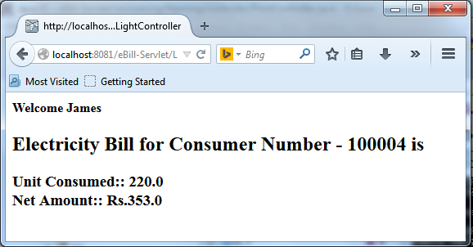

Following figure displayed the error in case of invalid consumer number entered

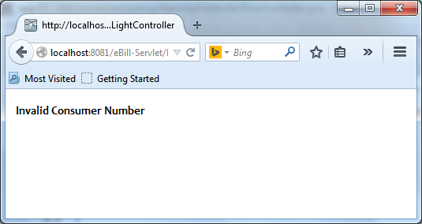

Layered architecture to be followed

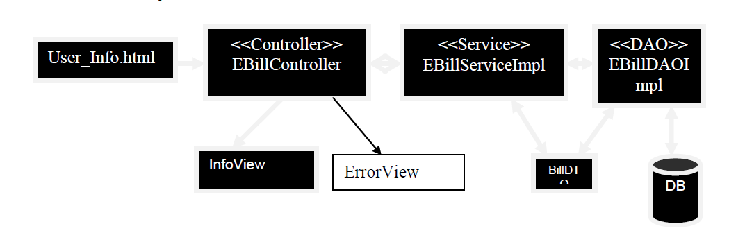

Q) Consider below filter code snippet, many servlet requests are passing through this Filter. If servlets are invoked then predict the output

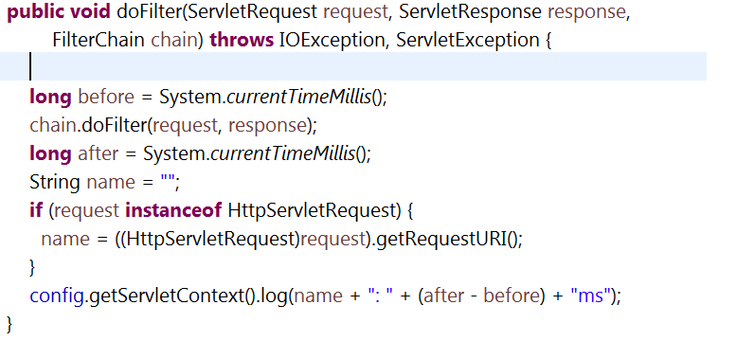

Q) Implementing a **Remember Me** assignment with **cookies**.

A user wants to login to an application, but first is being presented with a welcome page. The welcome page has a “remember me” check box. When user clicks on checkbox and says “remember me” the next time when he access the application he / she should be shown the Login Page directly and not Welcome Page. If the user does not click on “remember me” checkbox then next time when he access the application he / she should be shown the Welcome Page and on click of contine button display the Login Page.

See below code snippets and fill in the blank spaces left with cookie / servlet related code.

Welcome.html looks as below

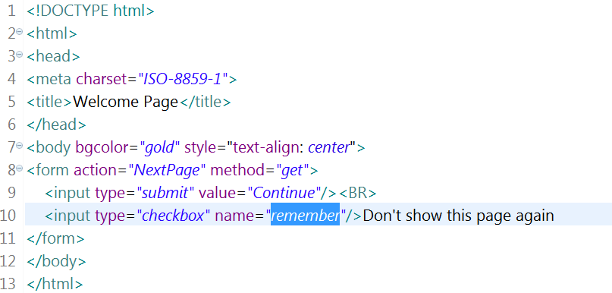

**Note**: This servlet has to be the first page to execute to check for the availability of cookies. CheckServlet.java code snippet as below: Here from doGet (request, response) method doPost (request, response) is invoked

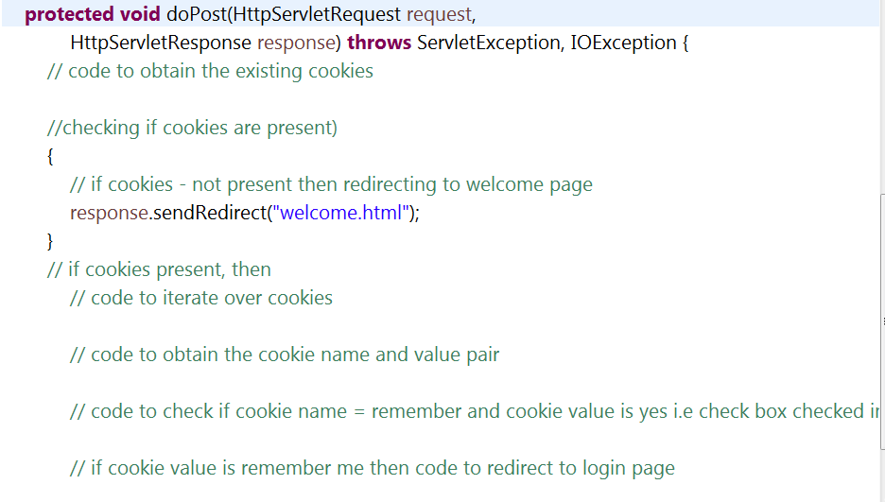

Refer NextPage Servlet below to create a cookie. Here from doPost (request, response) method doGet (request, response) is invoked.

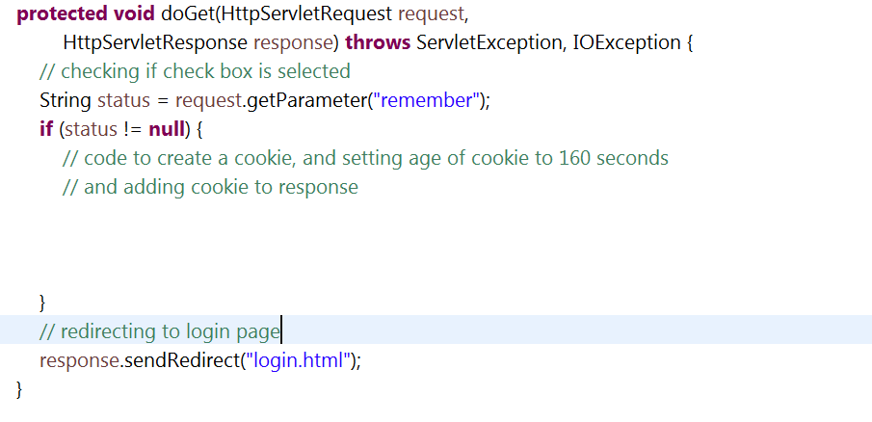

Below is login.html page

