Task 1 - QA Bug Report
Bug 1: Demo Website Returns 404 Error
Bug ID: BUG-001
Title: Demo website displays "404 Not Found" error
URL: https://demo.realworld.io
Severity: High
Priority: High
Steps to Reproduce:
- Open the website https://demo.realworld.io
- Wait for the page to load
Expected Result:
The website homepage should load successfully and allow users to access the application.
Actual Result:
The website displays a "404 Not Found" error page.
Status: Open
Environment:
- Browser: Google Chrome
- OS: Windows 11
Screenshot:
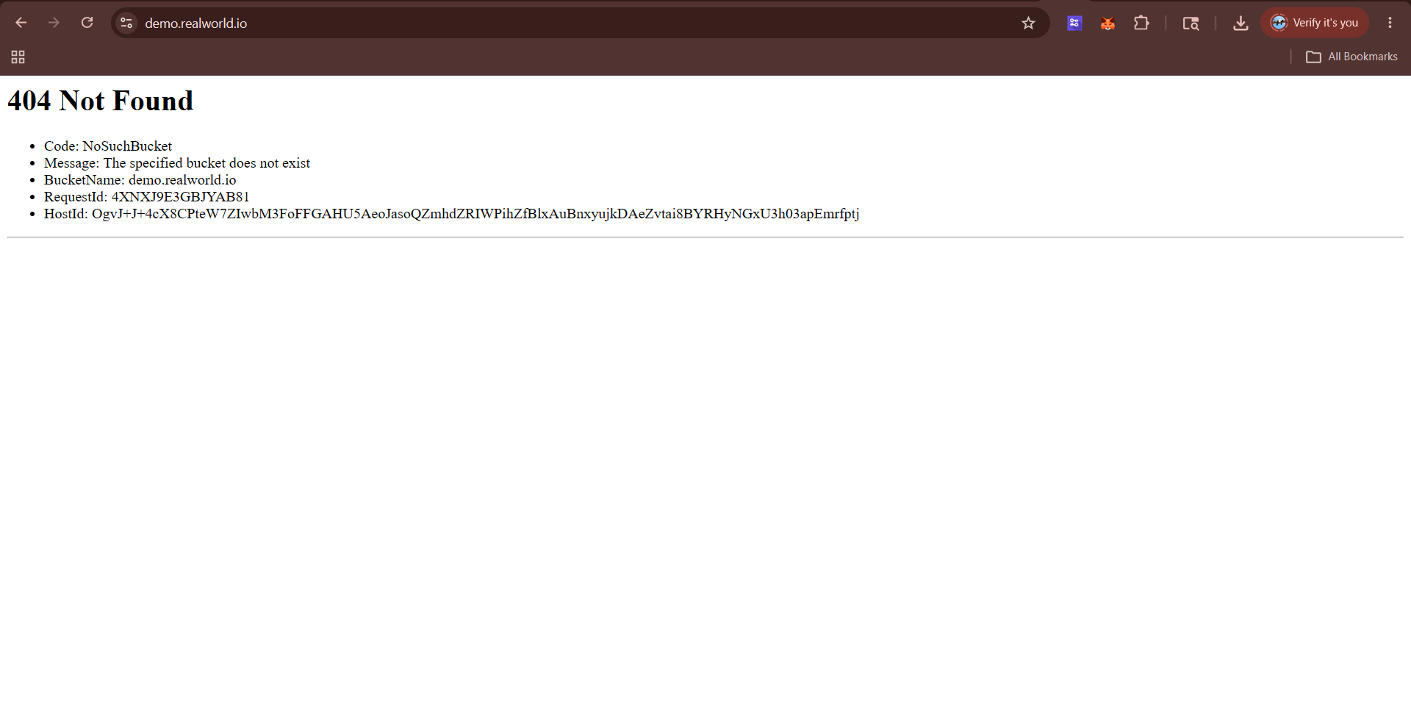
Comments:
The application is inaccessible because the demo URL returns a 404 error.

Bug 2
Title: Homepage inaccessible
Severity: High
Expected: Homepage should load successfully
Actual: Homepage is not accessible
Bug 3
Title: User signup cannot be tested
Severity: High
Expected: User should be able to register
Actual: Signup feature unavailable
Bug 4
Title: Login functionality unavailable
Severity: High
Expected: User should be able to login
Actual: Login page unavailable
Bug 5
Title: Content management unavailable
Severity: Medium
Expected: User should be able to create, edit and delete content
Actual: Features cannot be accessed
Root Cause Analysis
The application returns a 404 error because the hosting configuration appears to be broken. Since the homepage is unavailable, users cannot access the application's main features. Signup, login, content creation, editing, and deletion cannot be tested. This appears to be a deployment or infrastructure issue rather than a frontend UI issue. The application should be redeployed and the hosting configuration should be verified. Monitoring and alerting should also be added to detect outages quickly.

