Machine Learning Based Buyer Segmentation
and Investment Profiling for Real Estate Market Intelligence
Parcl Co. Limited × Unified Mentor
Buyer Segmentation Research Report

1. Background and Context
Real estate companies operate in markets where buyer behavior is highly diverse, spanning individual home buyers, institutional investors, international buyers, high-net-worth investors, and first-time buyers.
Parcl currently lacks a data-driven understanding of the different types of property buyers, investment motivations across demographics, geographic differences in investment behavior, and customer financing patterns. This leads to inefficient marketing spend, generic property recommendations, and poor investor targeting.

2. Problem Statement
This project introduces AI-driven buyer intelligence into the Parcl real estate platform. By identifying hidden customer segments through clustering algorithms, the system reveals investment behaviors that traditional analytics cannot detect — enabling Parcl to build smarter marketing strategies and drive data-driven real estate investment decisions.

3. Data and Methodology

3.1 Dataset
The source dataset (clients.csv) contains 2,000 client records with: client type (Individual/Company), demographics (date of birth, gender), country and region, acquisition purpose (Home/Investment), satisfaction score, loan application status, and referral channel.
Data Disclosure: The source data contains no income, transaction value, unit count, or purchase-history field. To enable full investment profiling (deal size, portfolio depth, financing behavior), the following fields were generated synthetically using documented, deterministic rules tied to real fields (client_type, acquisition_purpose, age, satisfaction_score): total_investment, avg_purchase_price, properties_owned, buying_tenure_years. These are illustrative figures, not real client financials, and are labeled as such everywhere they appear.

3.2 Step 1 — Data Cleaning
- Parsed two mixed date-of-birth formats (DD-MM-YYYY and MM/DD/YYYY) and derived age
- Normalized categorical labels (casing, whitespace, acronym fixes)
- Checked for and removed duplicate client entries (none found)
- Handled missing values defensively (none present in the source file)

3.3 Step 2 — Feature Encoding
- Label Encoding for binary fields: client_type, acquisition_purpose
- One-Hot Encoding for nominal fields: region, referral_channel, country
Note: region has 65 unique values; one-hot encoding it produced 65 sparse columns that would dominate distance calculations, so region was excluded from clustering inputs and retained only for geographic profiling.

3.4 Step 3 — Feature Scaling
StandardScaler (mean 0, std 1) was applied to all numeric clustering features, as the standard pairing with K-Means; MinMaxScaler was also produced as an alternative.

3.5 Step 4 — Clustering Model Selection
Two clustering approaches were used:
- K-Means Clustering — Advantages: efficient (scales well), easy to interpret (each client belongs to exactly one cluster with a readable centroid)
- Hierarchical Clustering (Agglomerative, Ward linkage) — Advantages: reveals nested cluster relationships via dendrogram, helps validate K-Means results
Clustering features: loan_applied, total_investment, avg_purchase_price, properties_owned, buying_tenure_years, age, satisfaction_score, acquisition_purpose, client_type, gender.
K-Means (k=4) achieved a silhouette score of 0.2104. Agreement between K-Means and Hierarchical clustering (Adjusted Rand Index) was 0.80 — strong validation.
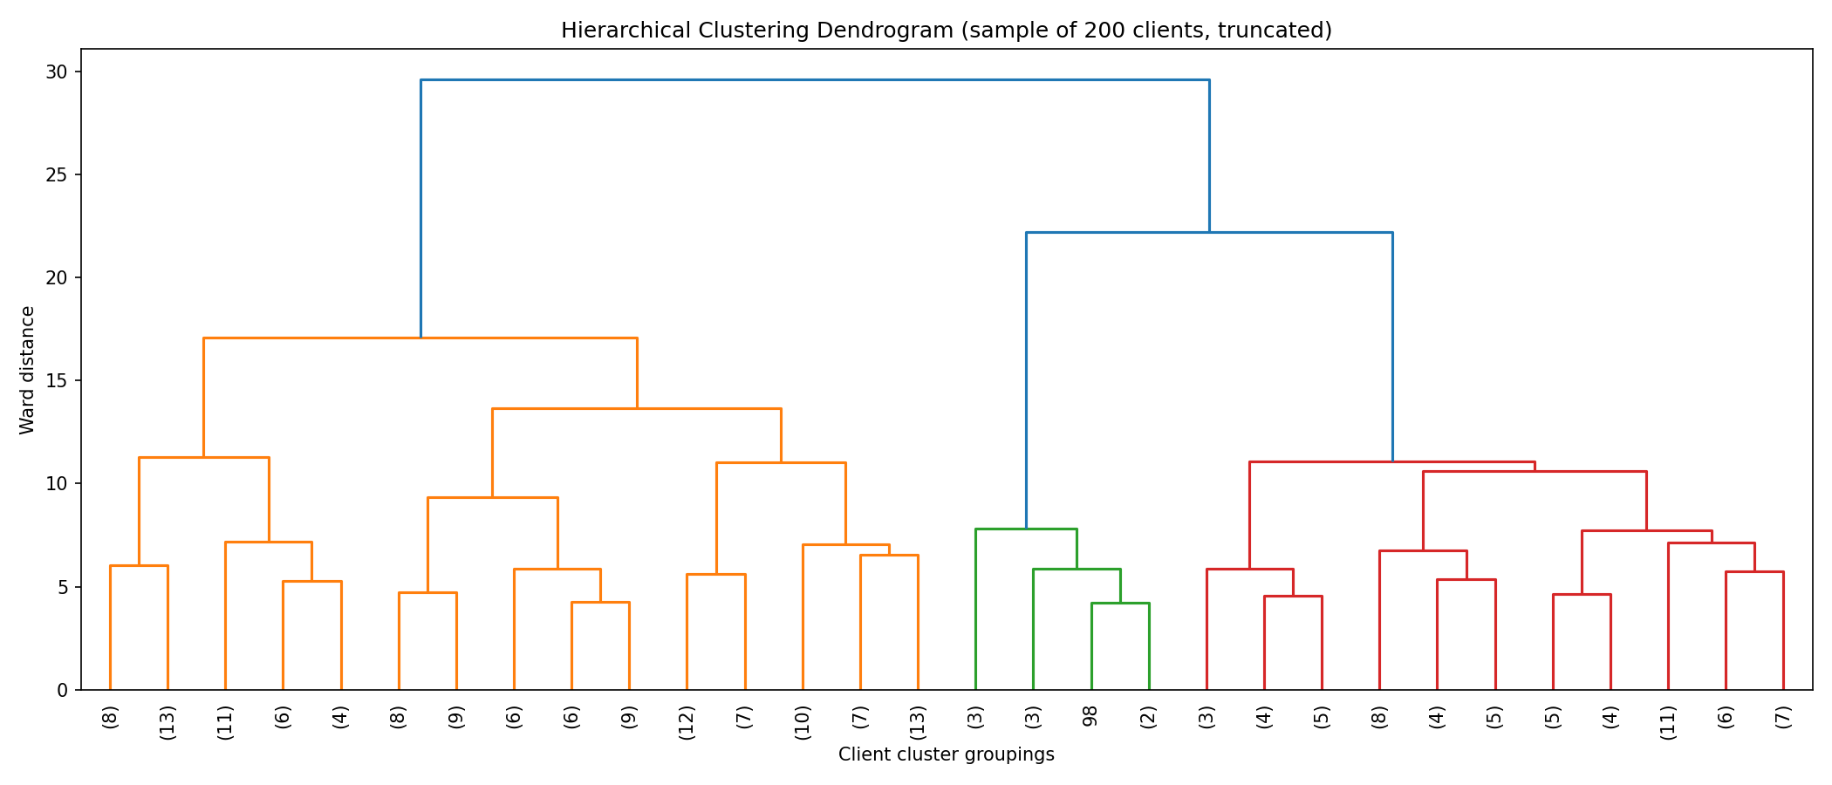
Figure 1. Hierarchical clustering dendrogram (200-client sample, truncated).

3.6 Step 5 — Optimal Cluster Selection
Elbow Method and Silhouette Score were used to evaluate k=2 through k=10:
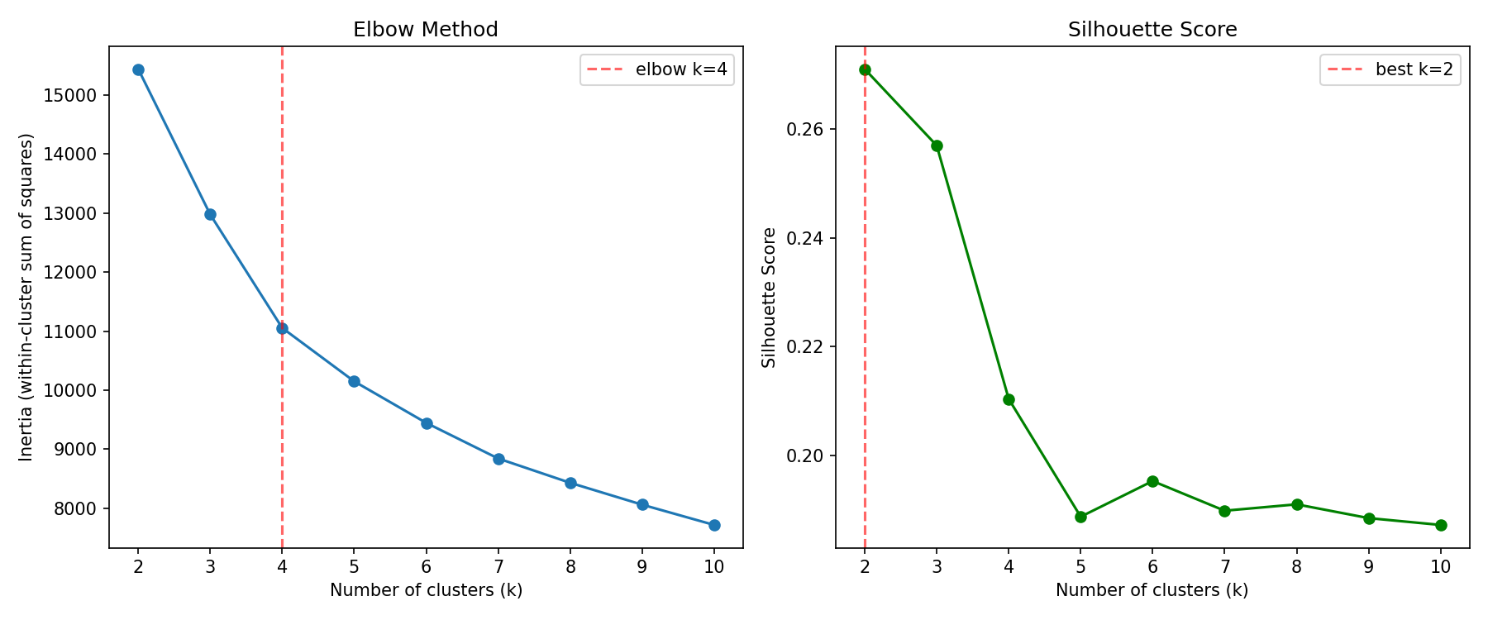
Figure 2. Elbow method and silhouette score across k=2–10.
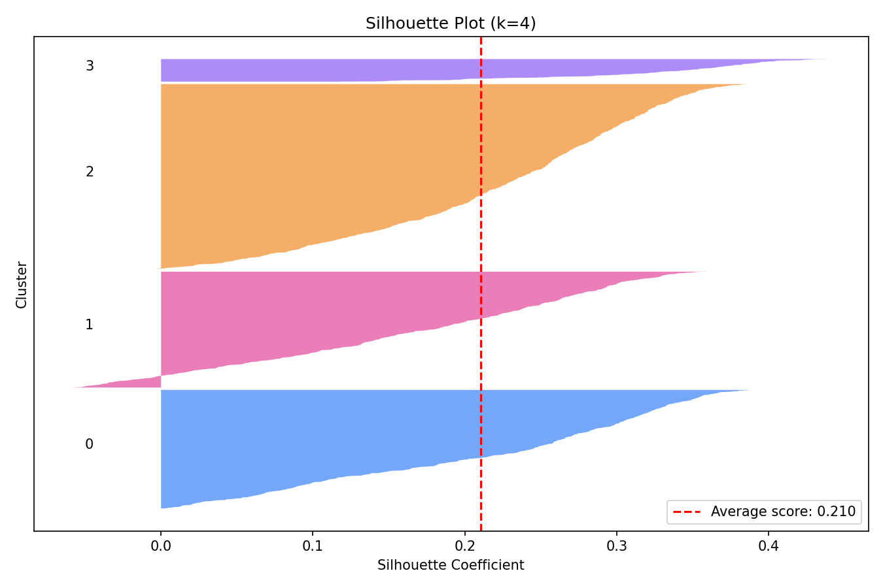
Figure 3. Per-sample silhouette plot at k=4 (average = 0.2104).
The Elbow Method independently confirms k=4. The Silhouette Score favors k=2 (0.271) over k=4 (0.210). k=4 was selected to align with Parcl's 4-segment business taxonomy; this trade-off is documented transparently rather than hidden.

4. Segmentation Results (Step 6 — Cluster Interpretation)
Two of the four segments emerged as pure, naturally-separated K-Means clusters with no manual rules required: Corporate Buyers (100% Company client_type) and Global Investors (100% Investment acquisition_purpose). Luxury Investors and First-Time Buyers required explicit rules layered on top, because satisfaction_score and loan_applied do not vary enough among the remaining clients to form natural clusters on their own.

4.1 Segment Assignment Rules
- Corporate Buyers: client_type == Company
- Global Investors: acquisition_purpose == Investment (of remaining clients)
- Luxury Investors: remaining Home-purpose individuals with total_investment in the top quartile AND satisfaction_score ≥ 4
- First-Time Buyers: everyone else (includes an explicit younger + loan-dependent subgroup, plus a residual catch-all of remaining Home-purpose buyers)

4.2 Segment Profile Summary
Segment | Clients | Avg Age | Avg Satisfaction | Loan Rate | Avg Investment | Avg Properties
Global Investors | 579 (28.9%) | 55.5 | 3.02 | 38.0% | $1,592,667 | 4.40
First-Time Buyers | 1,186 (59.3%) | 56.1 | 2.87 | 37.9% | $415,967 | 1.44
Corporate Buyers | 103 (5.1%) | 47.9 | 3.07 | 41.7% | $3,207,006 | 7.33
Luxury Investors | 132 (6.6%) | 61.9 | 4.50 | 17.4% | $716,366 | 2.00

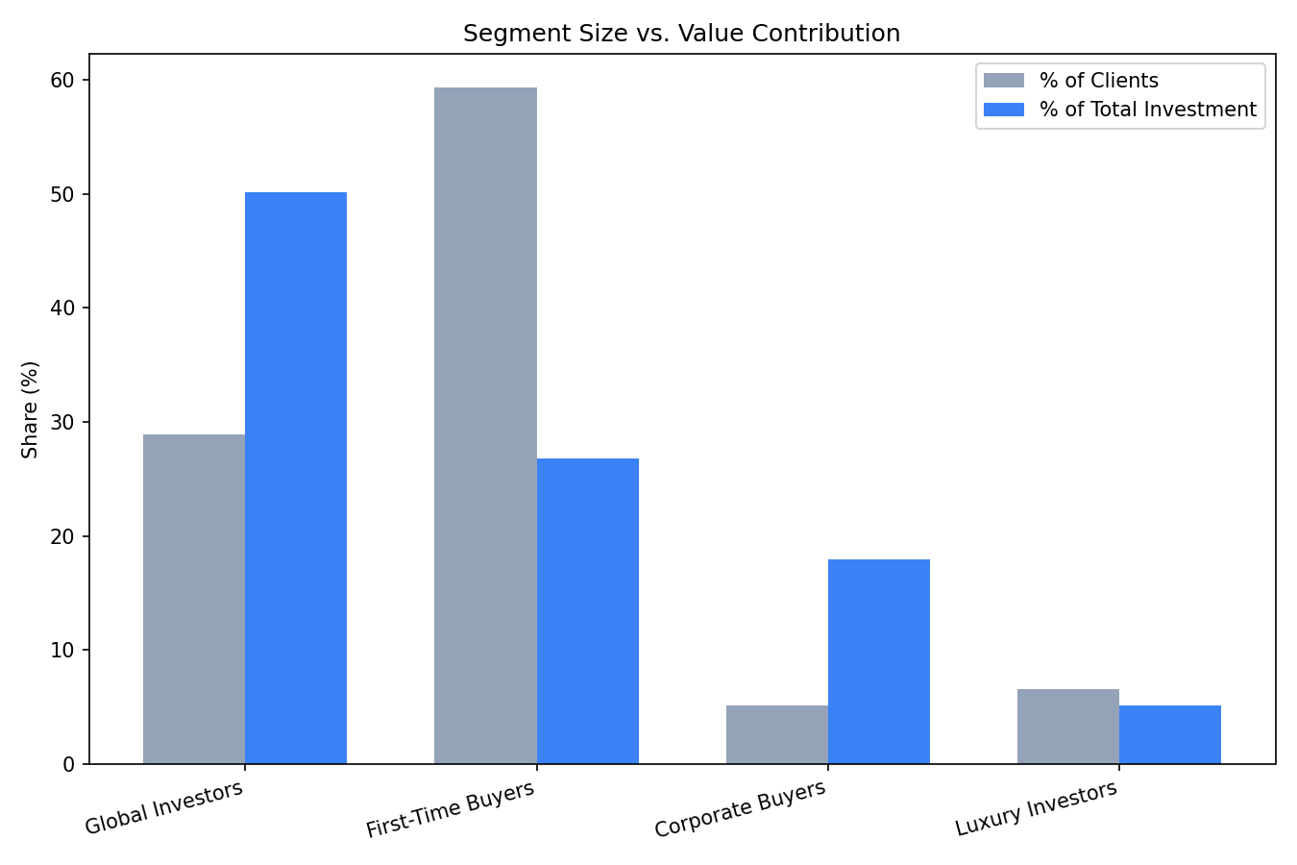
Figure 4. Segment size (% of clients) vs. value contribution (% of total investment).
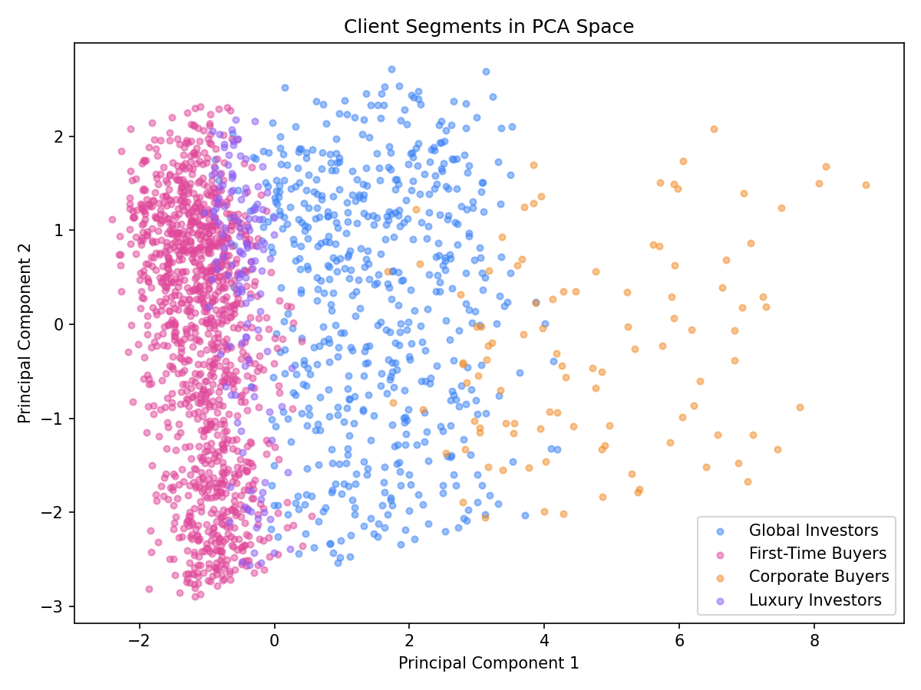
Figure 5. Client segments projected into 2D PCA space.

4.3 Interpretation Across the Four Required Dimensions
- Investment purpose: Reflects each segment's definition directly (e.g. Global Investors = 100% Investment by construction) rather than revealing new patterns
- Geographic distribution: Nearly identical across all four segments — USA/California dominates every segment (76–79%). Geography does not meaningfully differentiate buyer type in this dataset
- Loan behavior: Broadly similar (38–42%) across Global Investors, First-Time Buyers, and Corporate Buyers, but Luxury Investors is a clear outlier at 17.4% — consistent with self-financed, large individual purchases
- Customer demographics: Age varies moderately (47.9 to 61.9); gender split is close to even in every segment except Corporate Buyers, which skews male (61.2%)
The dimensions that genuinely separate these four segments are financial: total investment, purchase price, properties owned, and buying tenure — not geography or raw demographics.

5. Supporting Exploratory Analysis
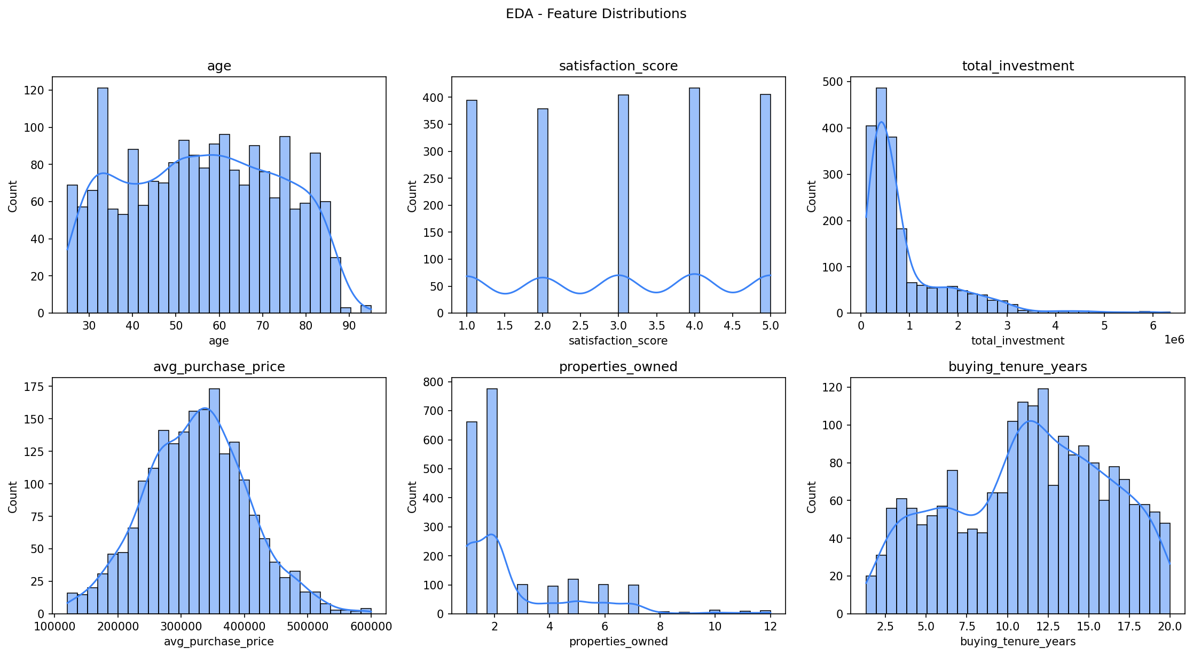
Figure 6. Distribution of key numeric features across all clients.
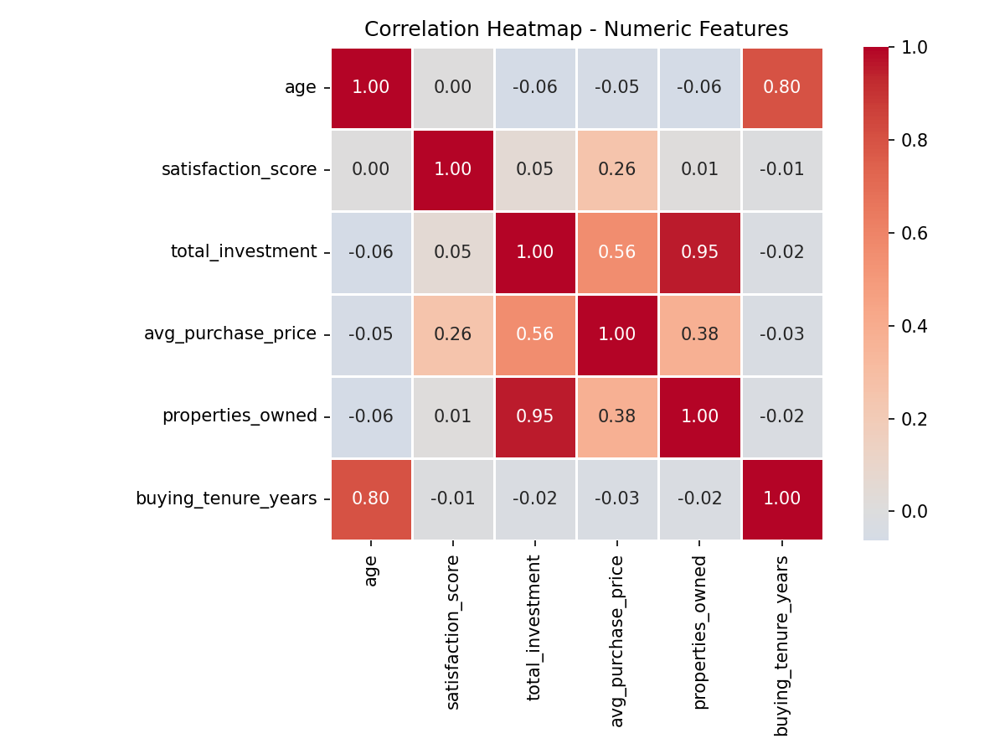
Figure 7. Correlation heatmap of numeric features used in clustering.
total_investment correlates strongly with avg_purchase_price and properties_owned, as expected given how the synthetic financial fields were constructed (total_investment = properties_owned × avg_purchase_price × noise). age and satisfaction_score show weak correlation with the financial fields, reinforcing that geography/demographics are not the primary drivers of segment membership.

6. Key Findings and Recommendations

6.1 Key Findings
- Corporate Buyers and Global Investors are statistically robust, naturally-emerging segments confirmed by unsupervised K-Means clustering
- Luxury Investors and First-Time Buyers required business-rule refinement; First-Time Buyers in particular is a partial catch-all and should be treated with caution in downstream decisions
- Financing behavior, deal size, portfolio depth, and buying tenure — not geography or raw demographics — are what actually differentiate buyer segments
- The Elbow Method supports k=4 for this feature set; the Silhouette Score favors a simpler k=2, indicating some cohesion is traded for business alignment

6.2 Recommendations for Parcl
- Collect real transaction-level data (purchase price, deal size, unit count, financing terms) to replace the synthetic financial fields used in this analysis and validate segment definitions against ground truth
- Prioritize relationship management and exclusive/off-market listings for Luxury Investors (highest satisfaction, low loan dependency)
- Target Corporate Buyers with bulk-purchase agreements and dedicated account management given their high average portfolio depth (7.33 properties)
- Revisit the First-Time Buyers segment once real data is available, since only a minority currently matches its 'younger, loan-dependent' definition

7. Conclusion
This project demonstrates an end-to-end machine learning pipeline for buyer segmentation and investment profiling: data cleaning, feature encoding, scaling, K-Means and Hierarchical clustering, statistical cluster-count validation, and business-aligned segment naming. Two of Parcl's four target segments (Corporate Buyers, Global Investors) are strongly supported by unsupervised learning; the other two required documented rule-based refinement. All limitations — including the use of synthetic financial fields and the composition of the First-Time Buyers segment — are disclosed transparently throughout this report and the accompanying interactive dashboard.

