AWS AI/ML and Generative AI
Complete Notes from the Lesson Screenshots
Comprehensive study document with diagrams, examples, comparison tables, and screenshot appendix

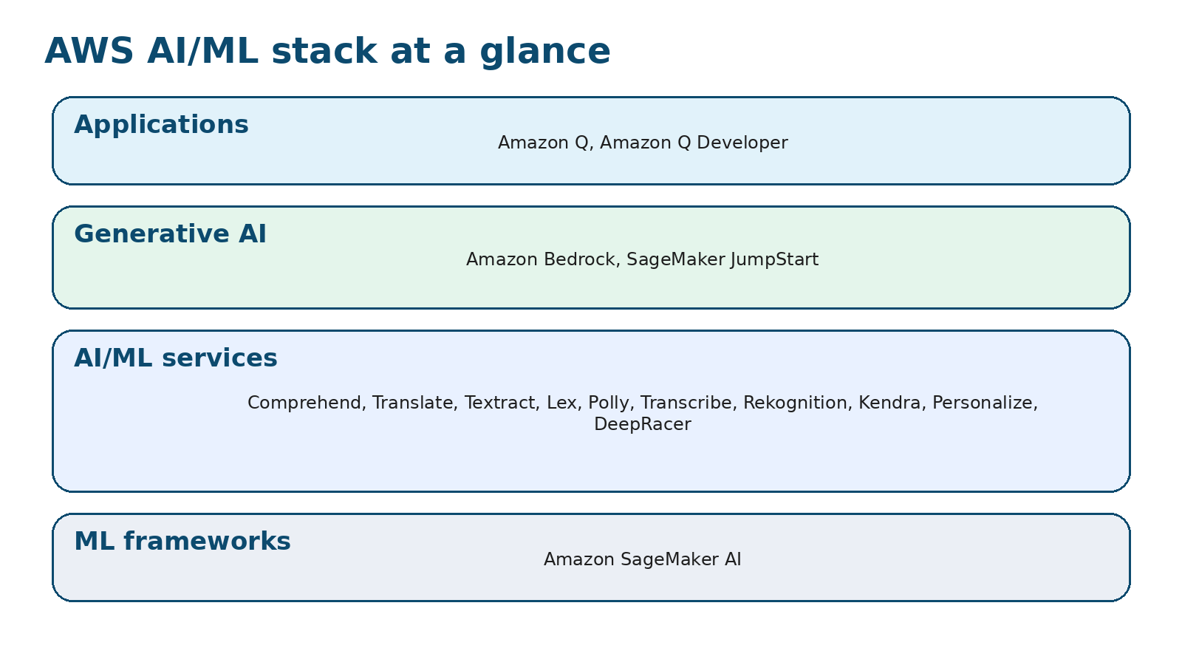
Figure 1. Reconstructed overview of the AWS AI/ML stack based on the lesson screenshots.
How to use this document: Sections 1-6 are study notes. Appendix A reproduces the lesson screenshots in contact-sheet form. Appendix B summarizes the earlier quiz concepts so your notes cover the full image set you shared.

1. What the lesson is about
AWS presents a full stack for artificial intelligence, machine learning, and generative AI. The stack ranges from the infrastructure and frameworks needed to build models, to ready-to-use services for text, speech, vision, search, recommendations, and reinforcement learning, to generative AI platforms and end-user applications.
The lesson emphasizes three ideas: first, AWS covers the full lifecycle from building and training to deployment and application use; second, many services are fully managed, which reduces operational effort; third, choosing among services involves trade-offs around cost, performance, responsiveness, regional coverage, availability, and customization.

1.1 Learning goals captured from the screenshots
- Understand the layers of the AWS AI/ML stack.
- Know what each named AWS service is used for.
- Recognize where traditional ML ends and generative AI services begin.
- Understand the advantages of AWS solutions, especially security, privacy, enterprise readiness, and managed infrastructure.
- Remember the major cost considerations when selecting AWS AI services.

2. AWS AI/ML stack overview
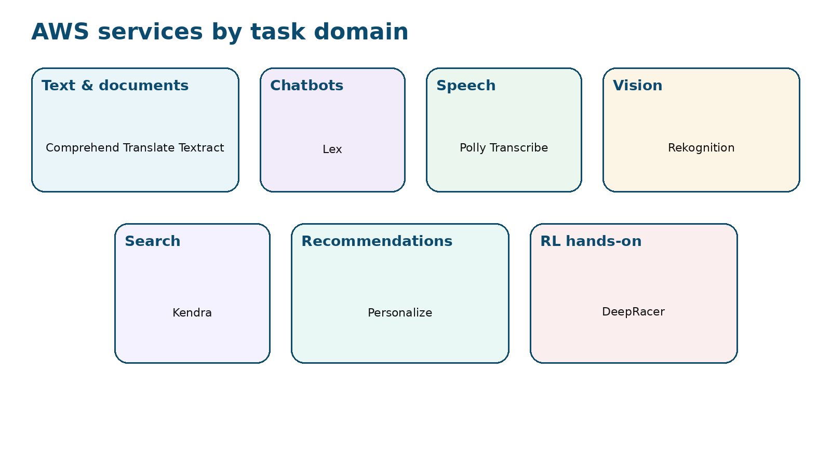
Figure 2. Reconstructed domain map of the AWS AI/ML services layer.
The screenshots organize AWS capabilities into four broad levels: ML frameworks, AI/ML services, generative AI services, and applications. A simple way to remember the logic is build, use, generate, and apply.
Layer | Main role | Representative services | What you choose it for
ML frameworks | Build, train, and deploy custom ML models | Amazon SageMaker AI | When you want a full ML toolset and control over model development.
AI/ML services | Use prebuilt AI capabilities through managed services | Comprehend, Translate, Textract, Lex, Polly, Transcribe, Rekognition, Kendra, Personalize, DeepRacer | When you want task-specific AI without creating every model yourself.
Generative AI | Access and adapt foundation models and generative tools | SageMaker JumpStart, Amazon Bedrock | When you need foundation models, rapid experimentation, or generative AI workflows.
Applications | Use packaged AI assistants for work and software development | Amazon Q, Amazon Q Developer | When you want business assistance or code productivity features.

3. ML frameworks layer: Amazon SageMaker AI
The lesson states that the ML frameworks layer plays a crucial role in the development and deployment of machine learning models, and that Amazon SageMaker AI sits at the core of this layer.

3.1 What Amazon SageMaker AI does
- Builds, trains, and deploys ML models for many different use cases.
- Provides fully managed infrastructure, tools, and workflows.
- Removes the heavy lifting from the ML process.
- Offers a single toolset so models can move into production faster, with less effort and lower cost.
- Supports efficient work with LLMs and other foundation models, in addition to traditional ML.

3.2 Why SageMaker matters in this stack
SageMaker is the layer you choose when you need an end-to-end ML environment rather than a single narrow feature. It is for building your own models or managing the workflow around models in a more controlled way. The screenshots also note that Amazon SageMaker AI is the new name for the legacy Amazon SageMaker service, and that it specifically handles traditional ML workflows such as building, training, and deploying models.

3.3 Example
Example use case: a company that wants to build and train a custom fraud-detection model could use SageMaker AI to prepare training workflows, train the model, and deploy it into production. This example is consistent with the lesson’s description that SageMaker AI supports full ML workflows, though the fraud use case itself is illustrative.

4. AI/ML services layer: detailed service notes
The AI/ML services layer gives developers ready-to-use AI capabilities without requiring extensive infrastructure management or deep specialized model-building expertise. The services are grouped by domain below.

4.1 Text and document services

Amazon Comprehend
Uses ML and NLP to uncover insights and relationships in unstructured text. The screenshots explicitly list these functions: identifies the language of the text; extracts key phrases, places, people, brands, or events; understands how positive or negative the text is; analyzes text using tokenization and parts of speech; and automatically organizes a collection of text files by topic.
When to choose it: Useful when you need language understanding from text corpora, customer feedback, reports, emails, or other unstructured text.
Illustrative example: A review analysis workflow could use Comprehend to detect language, find product names, and estimate sentiment. The review analysis scenario is illustrative; the capabilities themselves come directly from the lesson.

Amazon Translate
A neural machine translation service that delivers fast, high-quality, and affordable language translation. The lesson contrasts neural machine translation with traditional statistical and rule-based translation, saying the neural approach is more accurate and more natural sounding. The screenshots also mention use cases such as localizing websites and applications, translating large volumes of text for analysis, and enabling cross-lingual communication.
When to choose it: Use when the task is language conversion rather than general text analysis.
Illustrative example: A company expanding to new markets could translate its support articles and app interface for multilingual users.

Amazon Textract
Automatically extracts text and data from scanned documents. The screenshots stress that Textract goes beyond optical character recognition by also identifying the contents of fields in forms and information stored in tables.
When to choose it: Use when input is a scanned or photographed document and you need structured extraction rather than only plain text output.
Illustrative example: An operations team could pull table values and form fields from scanned invoices or application forms.

4.2 Conversational AI

Amazon Lex
A fully managed AI service used to design, build, test, and deploy conversational interfaces into applications using voice and text. It provides automatic speech recognition for converting speech to text and natural language understanding for recognizing user intent. The screenshots add that the same deep learning technologies that power Amazon Alexa are available through Lex, and that it can be used for conversational bots and voice-enabled interactive voice response systems.
When to choose it: Use when you need a chatbot or voice bot that can both hear or read an input and interpret intent.
Illustrative example: A customer service bot could capture a spoken request, convert it to text, identify the intent, and return an answer or action.

4.3 Speech services

Amazon Polly
Turns text into lifelike speech. The lesson notes that Polly uses advanced deep learning technologies to synthesize human-like voices and offers many voices across dozens of languages.
When to choose it: Use when text must be read aloud naturally.
Illustrative example: A learning application could read written content aloud in different languages.

Amazon Transcribe
An automatic speech recognition service for converting speech to text. It supports audio files such as WAV and MP3, can add a timestamp for every word, can process live audio streams in real time, and is designed to handle variation in volume, pitch, and speaking rate. The screenshots list business uses such as transcribing customer service calls, generating subtitles for audio and video content, and supporting text-based analysis of audio or video content.
When to choose it: Use when spoken content needs to become searchable or analyzable text.
Illustrative example: A media team could generate subtitles from video interviews, or a support team could transcribe calls for later search and analysis.

4.4 Vision and retrieval services

Amazon Rekognition
Facilitates image and video analysis using deep learning technology. The lesson says Rekognition can identify objects, people, text, scenes, and activities in images and videos; detect inappropriate content; and provide facial analysis and facial search capabilities. Example application areas named in the screenshots include user verification, people counting, and public safety use cases.
When to choose it: Use when images or video must be analyzed at scale.
Illustrative example: A moderation pipeline could detect objectionable visual content or count objects and activities in uploaded media.

Amazon Kendra
An intelligent search service powered by ML. The lesson describes it as reimagining enterprise search for websites and applications, allowing employees and customers to find content even when it is scattered across multiple repositories or locations in the organization.
When to choose it: Use when information is distributed across many enterprise data sources and users need strong search and retrieval.
Illustrative example: An internal knowledge portal could use Kendra to search across policies, manuals, FAQs, and content repositories.

4.5 Recommendations and reinforcement learning

Amazon Personalize
An ML service that creates individualized recommendations for customers using application activity streams such as page views, signups, and purchases, along with an inventory of recommendable items such as products, videos, music, or articles. The screenshots add that additional demographic information can also be included, and that Personalize processes the data, identifies what matters, chooses algorithms, and optimizes a personalization model for the customer’s own data.
When to choose it: Use when recommendations need to be customized per user.
Illustrative example: An online store could recommend products based on browsing and purchase behavior.

AWS DeepRacer
A one-eighteenth-scale race car used to get hands-on experience with reinforcement learning. The lesson explicitly says reinforcement learning differs from other ML methods, learns complex behavior without labeled training data, and makes short-term decisions while optimizing for a longer-term goal.
When to choose it: Use when the objective is to learn or demonstrate reinforcement learning concepts in a practical way.
Illustrative example: A team learning RL could experiment with policies that decide how a car steers and accelerates over time to optimize lap performance.

4.6 Fast comparison table for revision
Service | Main input | Main output | Best remembered as
Comprehend | Text | Text insights | Understand text
Translate | Text | Translated text | Convert language
Textract | Scanned document | Extracted text, forms, tables | Read documents structurally
Lex | Text or speech | Conversational response | Build chat and voice bots
Polly | Text | Speech | Make text speak
Transcribe | Speech | Text transcript | Make speech searchable
Rekognition | Image or video | Detected labels, faces, scenes, activities | See visual content
Kendra | Enterprise content sources | Search results | Search across repositories
Personalize | Behavior plus item metadata | Personalized recommendations | Recommend the next best item
DeepRacer | Environment feedback | Learned policy or RL experience | Hands-on reinforcement learning

5. Generative AI layer and applications
The generative AI services layer is described in the screenshots as a suite of tools and services specifically designed for generative AI tasks. It expands the stack beyond classic predictive or analytic services into foundation models, rapid experimentation, and productivity applications.

Amazon SageMaker JumpStart
Helps users quickly get started with ML. The screenshots say it provides solutions for common use cases that can be rapidly deployed, are fully customizable, make use of AWS CloudFormation templates and reference architectures, and support one-click deployment and fine-tuning of more than 150 popular open-source models, including models for natural language processing, object detection, and image classification.
When to choose it: Choose it when you want to accelerate setup and avoid starting every project from zero.
Illustrative example: A team could use JumpStart to deploy a baseline NLP model and then fine-tune it for its own data.

Amazon Bedrock
A fully managed service that makes foundation models from Amazon and leading AI startups available through an API. The lesson says the Bedrock serverless experience allows users to get started quickly, experiment with foundation models, privately customize them with their own data, and integrate and deploy them into AWS applications.
When to choose it: Choose it when you need access to foundation models without managing the underlying model hosting infrastructure yourself.
Illustrative example: A business could prototype a generative AI assistant with Bedrock and then customize it using internal documents or data.

Amazon Q
An AI-powered assistant for work. The screenshots say Amazon Q can deliver fast, relevant answers to pressing questions, solve problems, generate content, and take actions using knowledge from company information repositories, code, and enterprise systems.
When to choose it: Choose it when the user-facing need is a work assistant connected to organizational knowledge.
Illustrative example: An employee could ask Amazon Q for guidance grounded in internal documents and systems.

Amazon Q Developer
Designed to improve developer productivity. The screenshots say it provides ML-powered code recommendations, works with languages such as C#, Java, JavaScript, Python, and TypeScript, integrates with multiple IDEs, and can generate entire functions and logical code blocks, often more than ten to fifteen lines long.
When to choose it: Choose it when the main objective is coding assistance, code generation, and faster software development.
Illustrative example: A developer could use Amazon Q Developer inside an IDE to generate a code block or suggest a function skeleton.

6. Advantages, benefits, and cost considerations

6.1 Advantages and benefits highlighted by the lesson
- AWS supports organizations of many sizes, from small startups to very large companies.
- AWS offers strong security and privacy features to keep data safe.
- The screenshots emphasize secure and compliant infrastructure, industry-specific compliance attributes, and the shared responsibility model.
- AWS provides services and tools that support responsible and safe development and deployment of both traditional AI and generative AI solutions.
- The platform allows custom AI applications to be built and grown over time, and these applications can be tailored to specific business needs.
- AWS offers breadth across infrastructure, tools, managed services, foundation model access, and application-level assistants.

6.2 Cost considerations named in the screenshots
The lesson warns that choosing AWS AI services requires balancing performance, cost, and business requirements. The screenshots explicitly name the following dimensions.
- Responsiveness and availability
- Redundancy and regional coverage
- Performance
- Token-based pricing
- Provisioned throughput
- Custom models
The lesson also states that these trade-offs can affect responsiveness, availability, redundancy, performance, regional coverage, pricing models, throughput, and the ability to use custom models. In other words, the best service choice is not determined by capability alone; it also depends on your workload pattern and operational requirements.

6.3 Interpreting the cost factors
Responsiveness and availability: If an application must respond very quickly and remain reliably accessible, the chosen architecture may cost more than a slower or less critical workload.
Redundancy and regional coverage: Deploying across more than one region or maintaining additional redundancy can improve resilience, but it can also raise cost.
Performance: Higher model performance, faster throughput, or lower latency often require more expensive configurations or services.
Token-based pricing: For generative AI services, usage-based pricing can scale directly with the amount of input and output text processed.
Provisioned throughput: Reserving throughput can be useful for steady or high-volume demand, but it changes the pricing profile compared with purely on-demand usage.
Custom models: Customization can improve fit for a use case, but it may introduce additional setup, tuning, evaluation, and operational cost.

7. Appendix B: concept notes from the earlier quiz screenshots
These concept summaries are included because you asked for notes from the beginning of the shared screenshots, not only the AWS lesson pages. They align with the earlier multiple-choice images.

Neural networks
Neural networks are deep learning models made of interconnected nodes that learn patterns from data. In the earlier quiz image, the correct description was that they are inspired by the human brain and can recognize patterns in images such as handwritten digits.

Reinforcement learning
Reinforcement learning is the approach in which an agent learns by trial and error through interaction with an environment and receives rewards for good actions. The self-driving car example from the quiz matched reinforcement learning.

Embeddings
Embeddings are numerical vector representations of words or tokens, and semantically similar items tend to have similar vectors. They are not the same thing as basic preprocessing or tokenization.

Fine-tuning
Fine-tuning means taking a pre-trained language model and continuing training on task-specific data so it becomes better at a particular task. It is not training from scratch.

Multimodal models
Multimodal models are designed to work with more than one type of data, such as text, images, and audio. In the quiz screenshot, they were the best match for a model that can recognize and interpret different forms of input data.

Appendix A: screenshot appendix
The following pages include contact-sheet versions of the screenshots you shared. They are included as a reference copy inside the study document so the notes remain traceable to the source images.
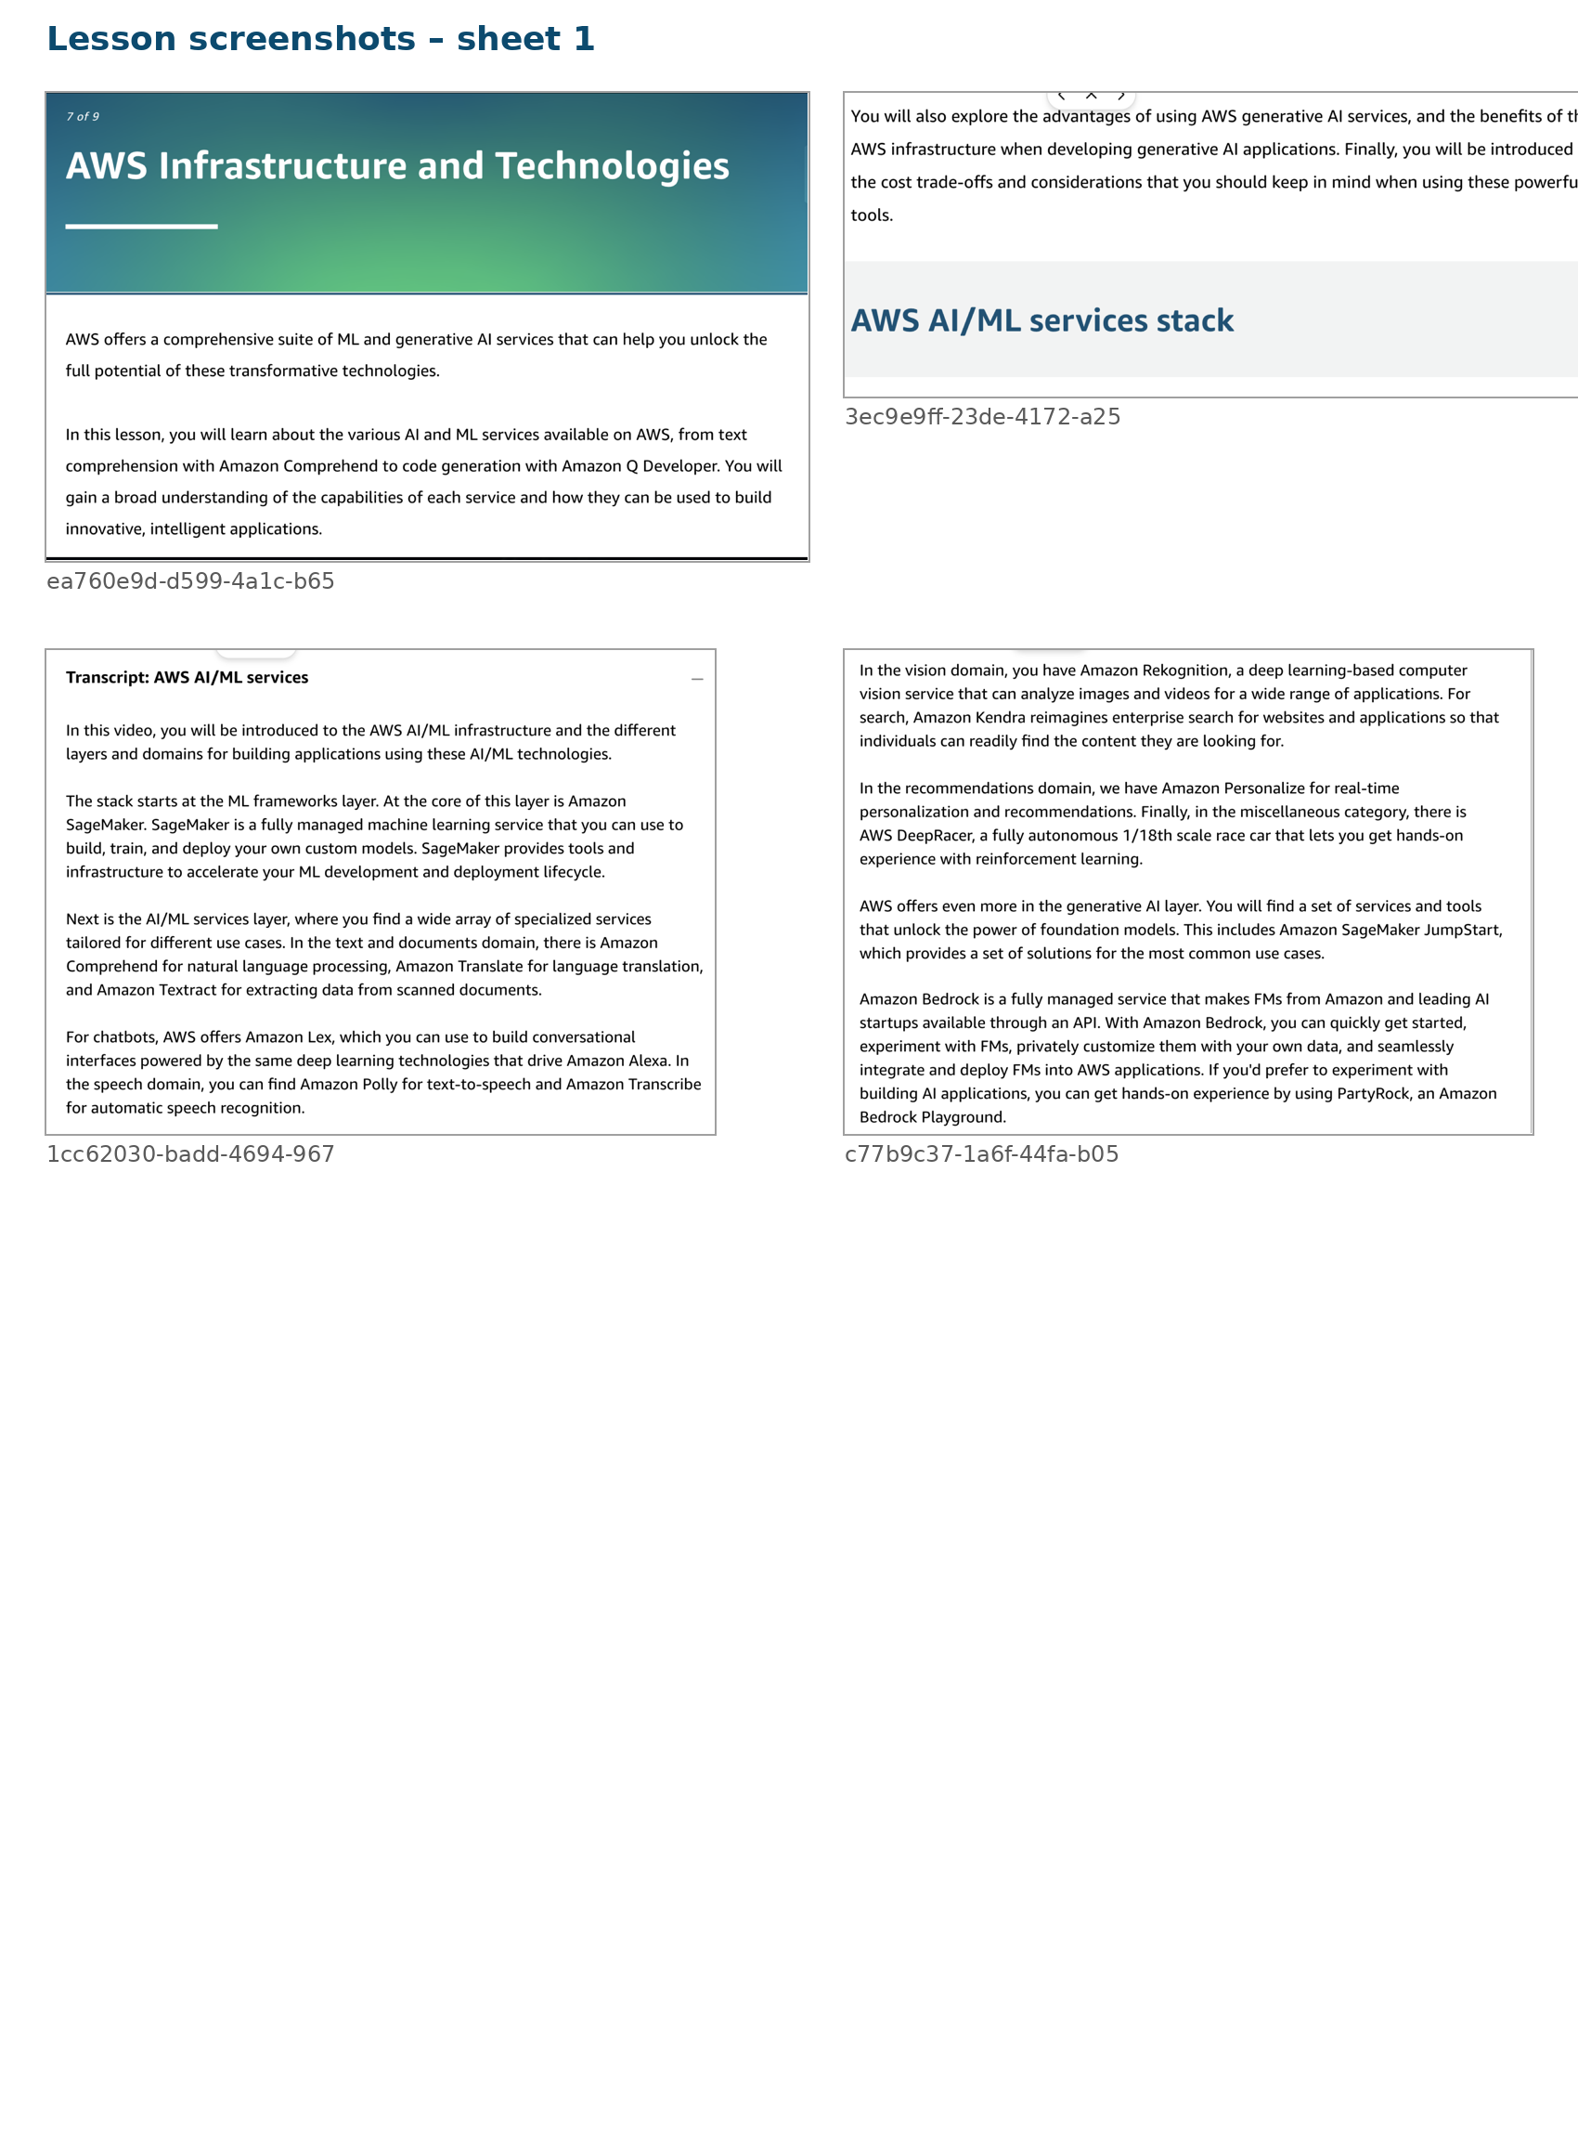
Lesson screenshot contact sheet: lesson_sheet_1.png

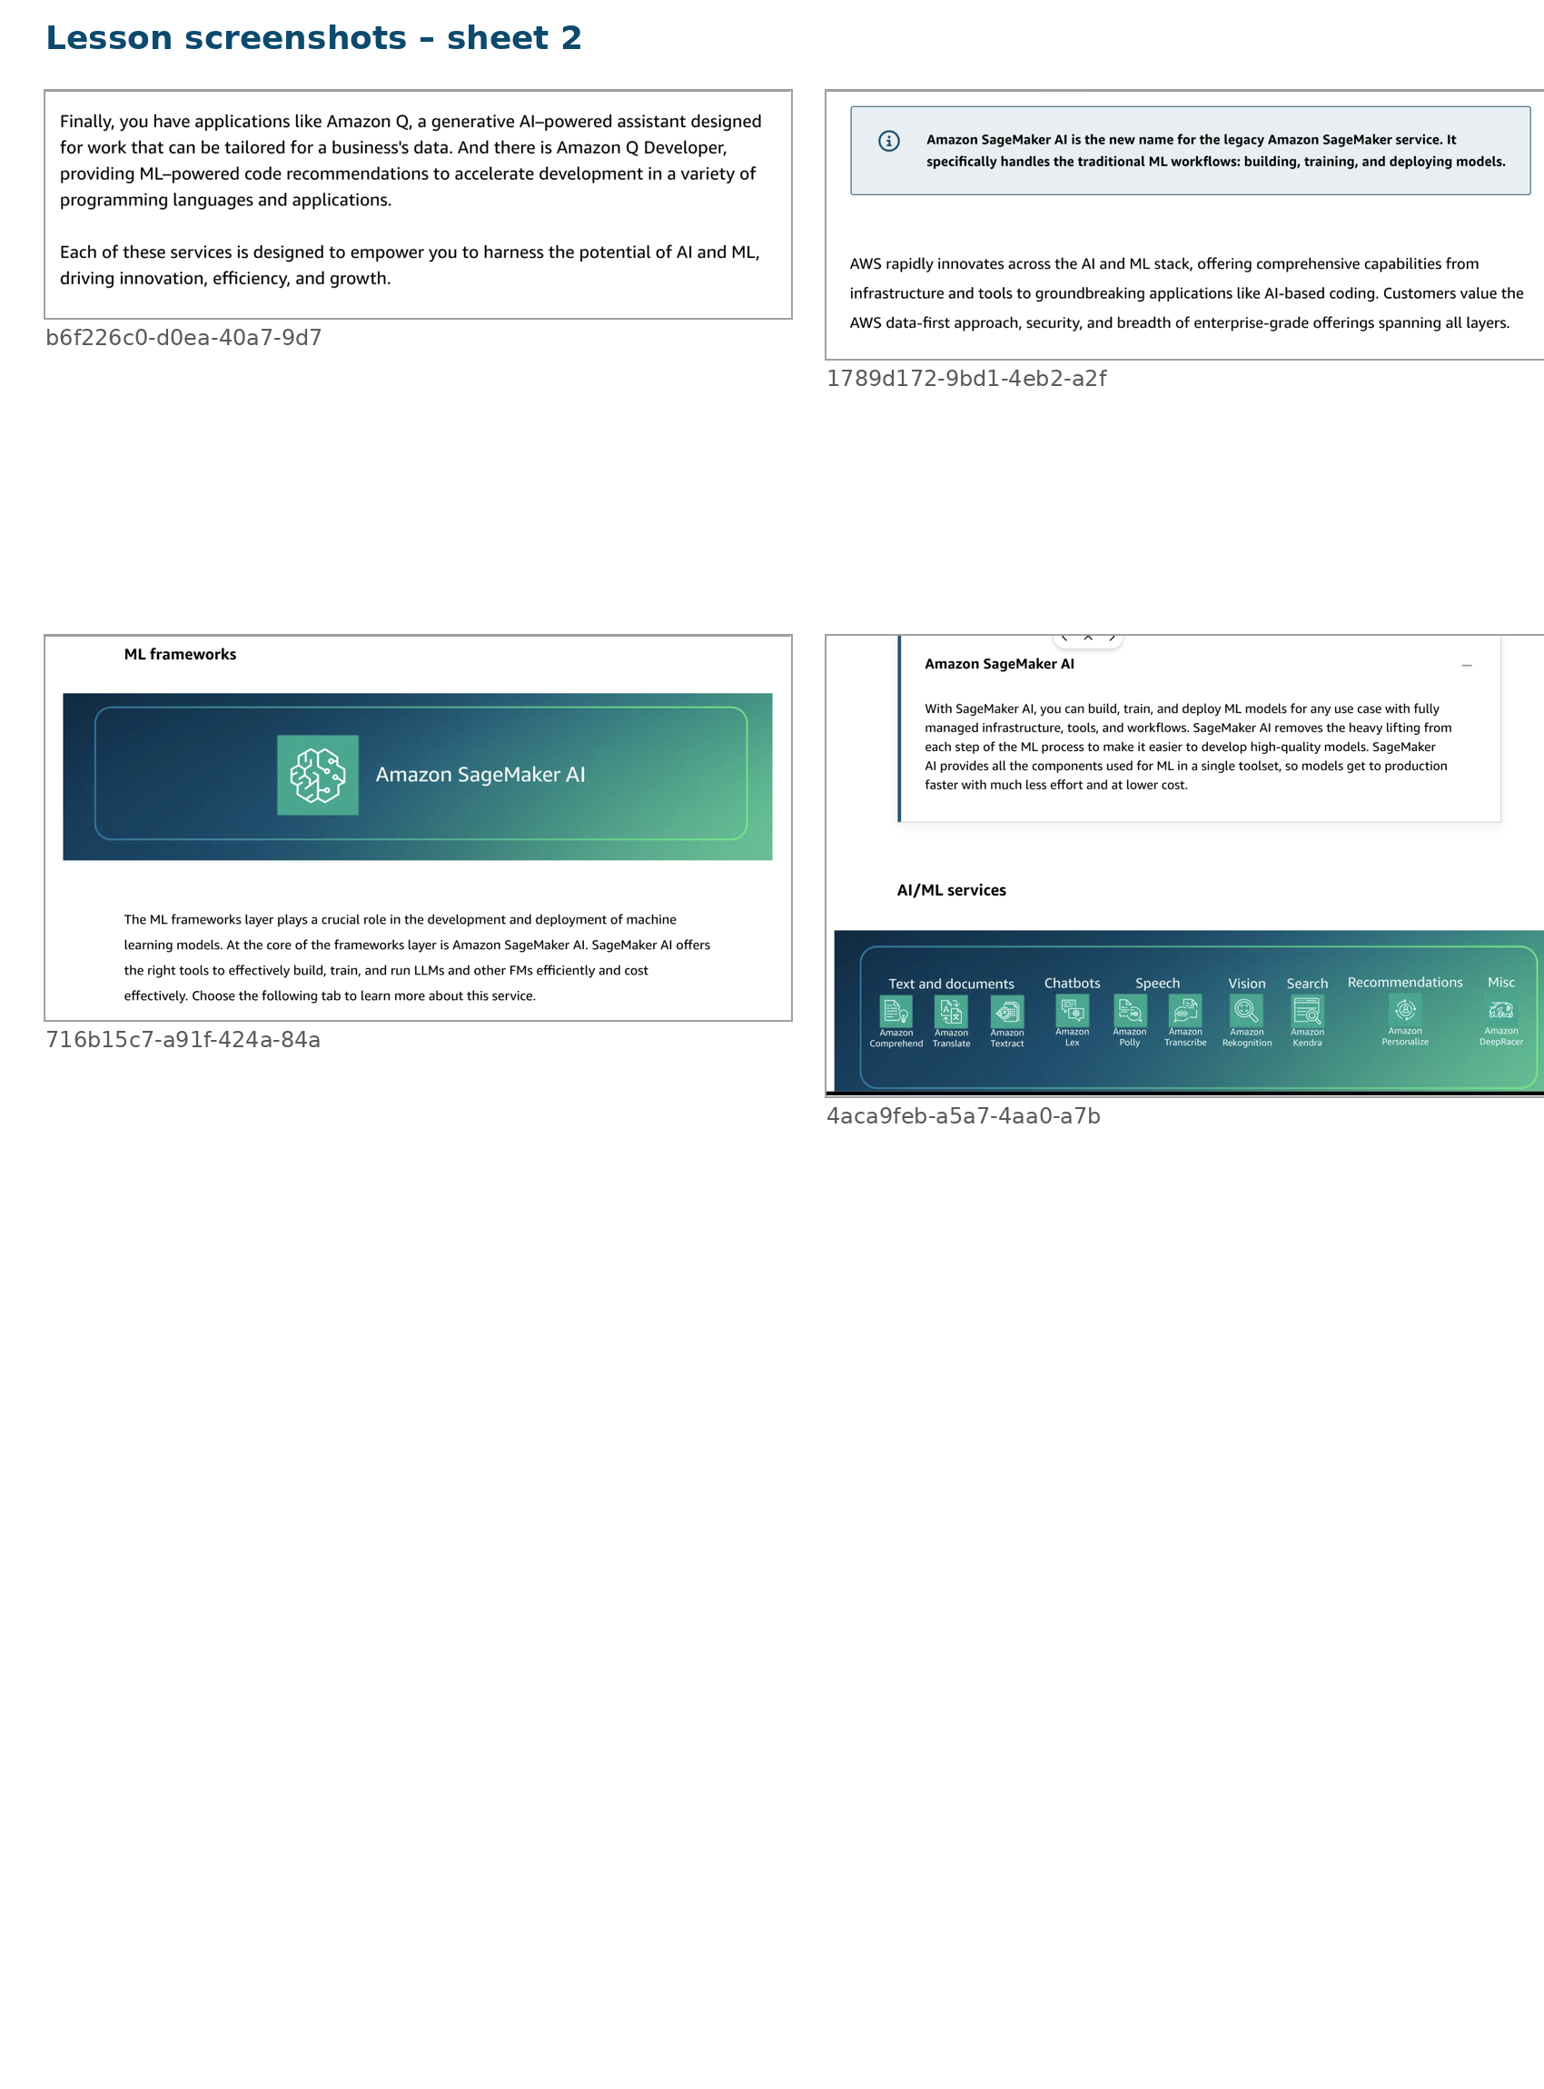
Lesson screenshot contact sheet: lesson_sheet_2.png

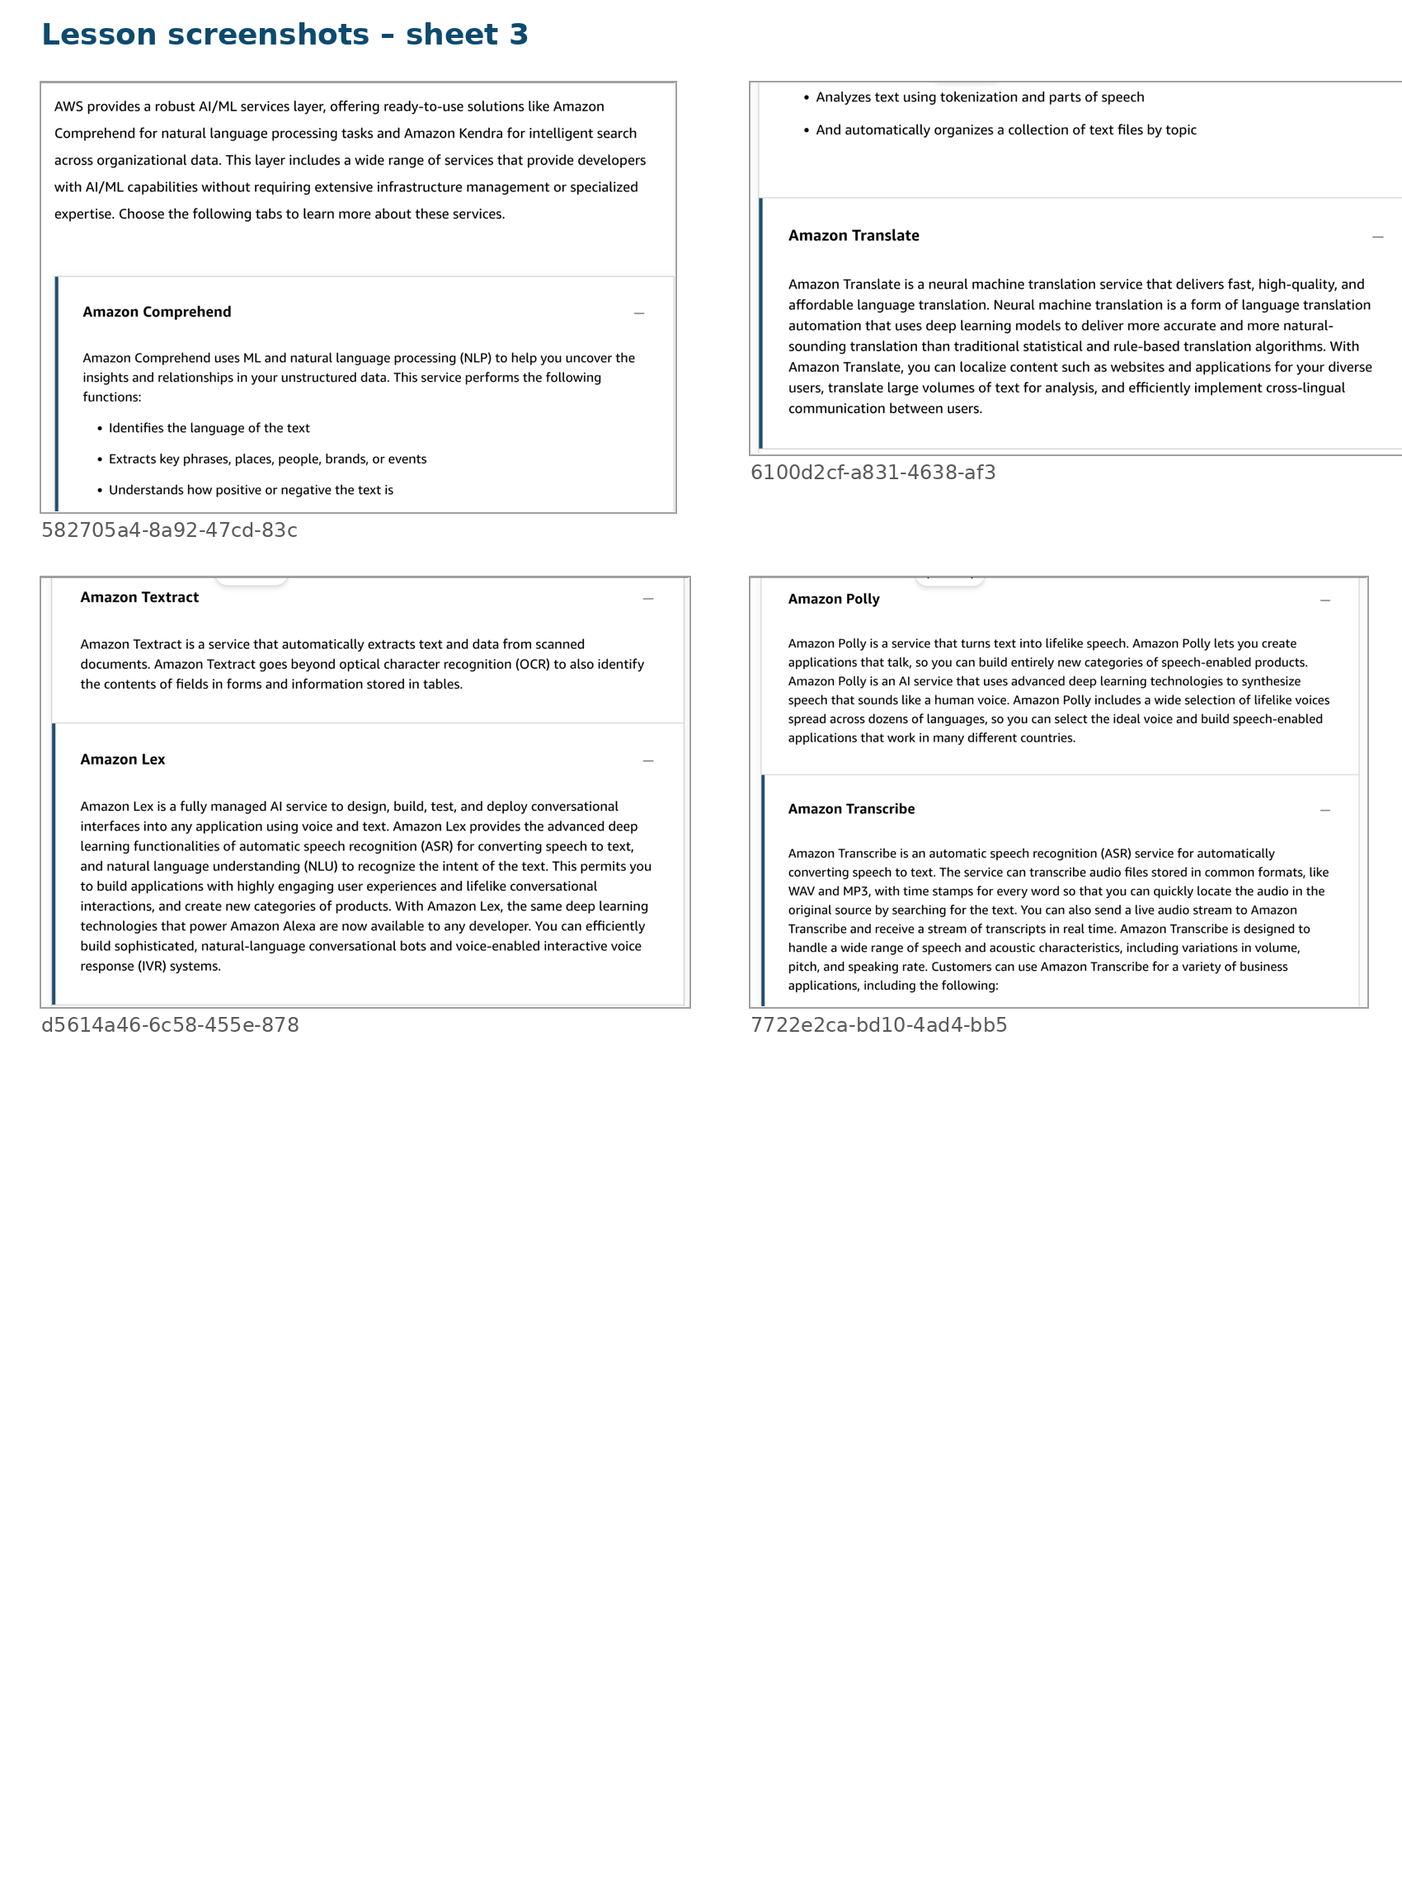
Lesson screenshot contact sheet: lesson_sheet_3.png

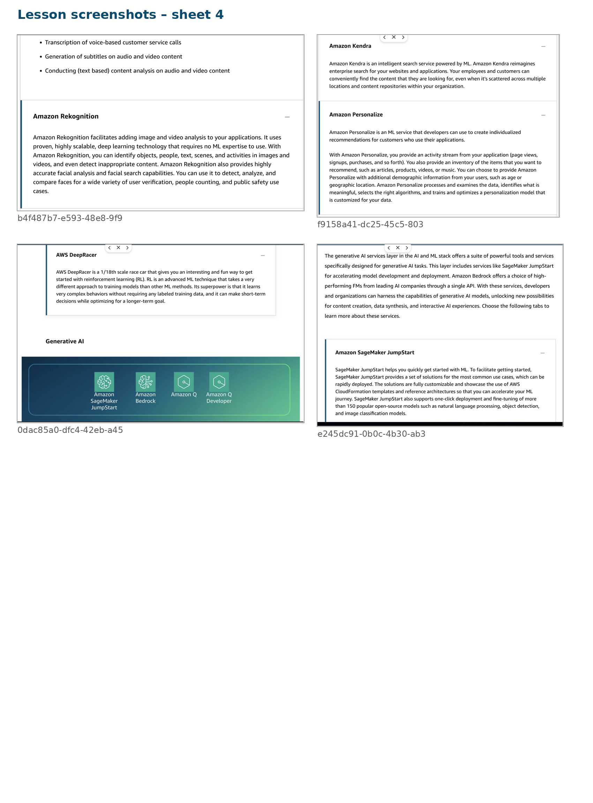
Lesson screenshot contact sheet: lesson_sheet_4.png

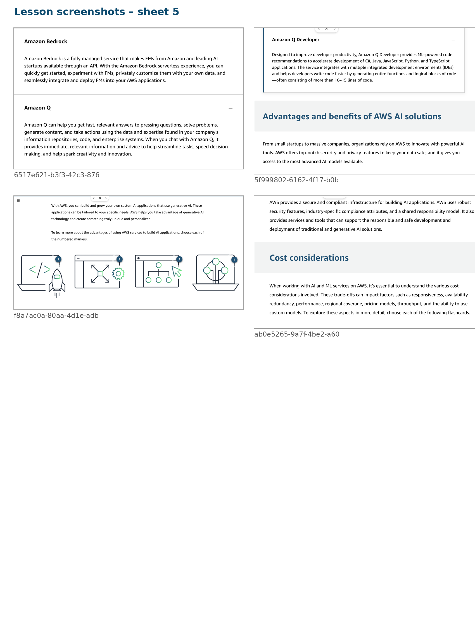
Lesson screenshot contact sheet: lesson_sheet_5.png

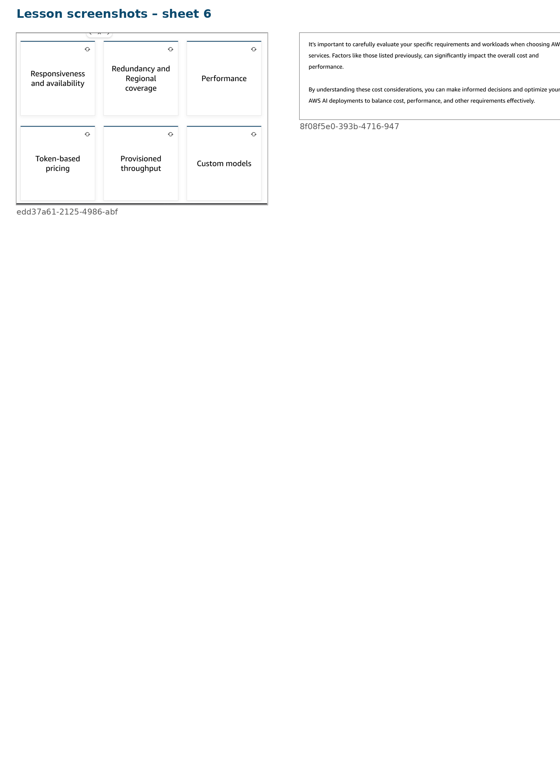
Lesson screenshot contact sheet: lesson_sheet_6.png

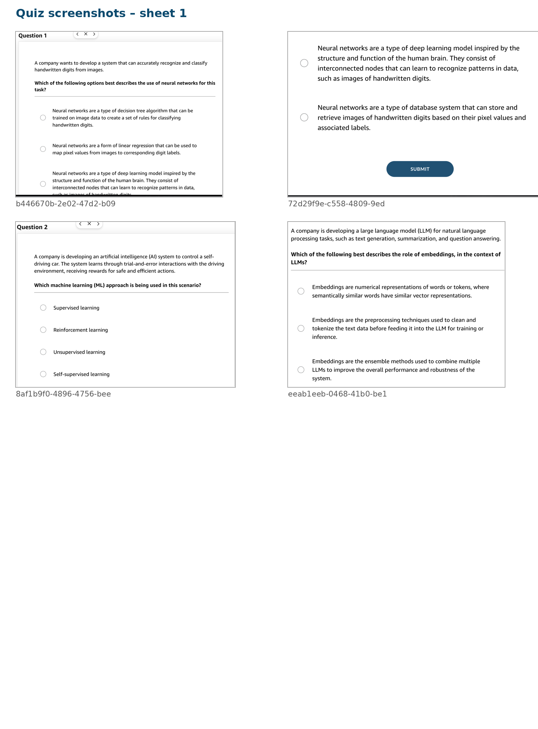
Quiz screenshot contact sheet: quiz_sheet_1.png

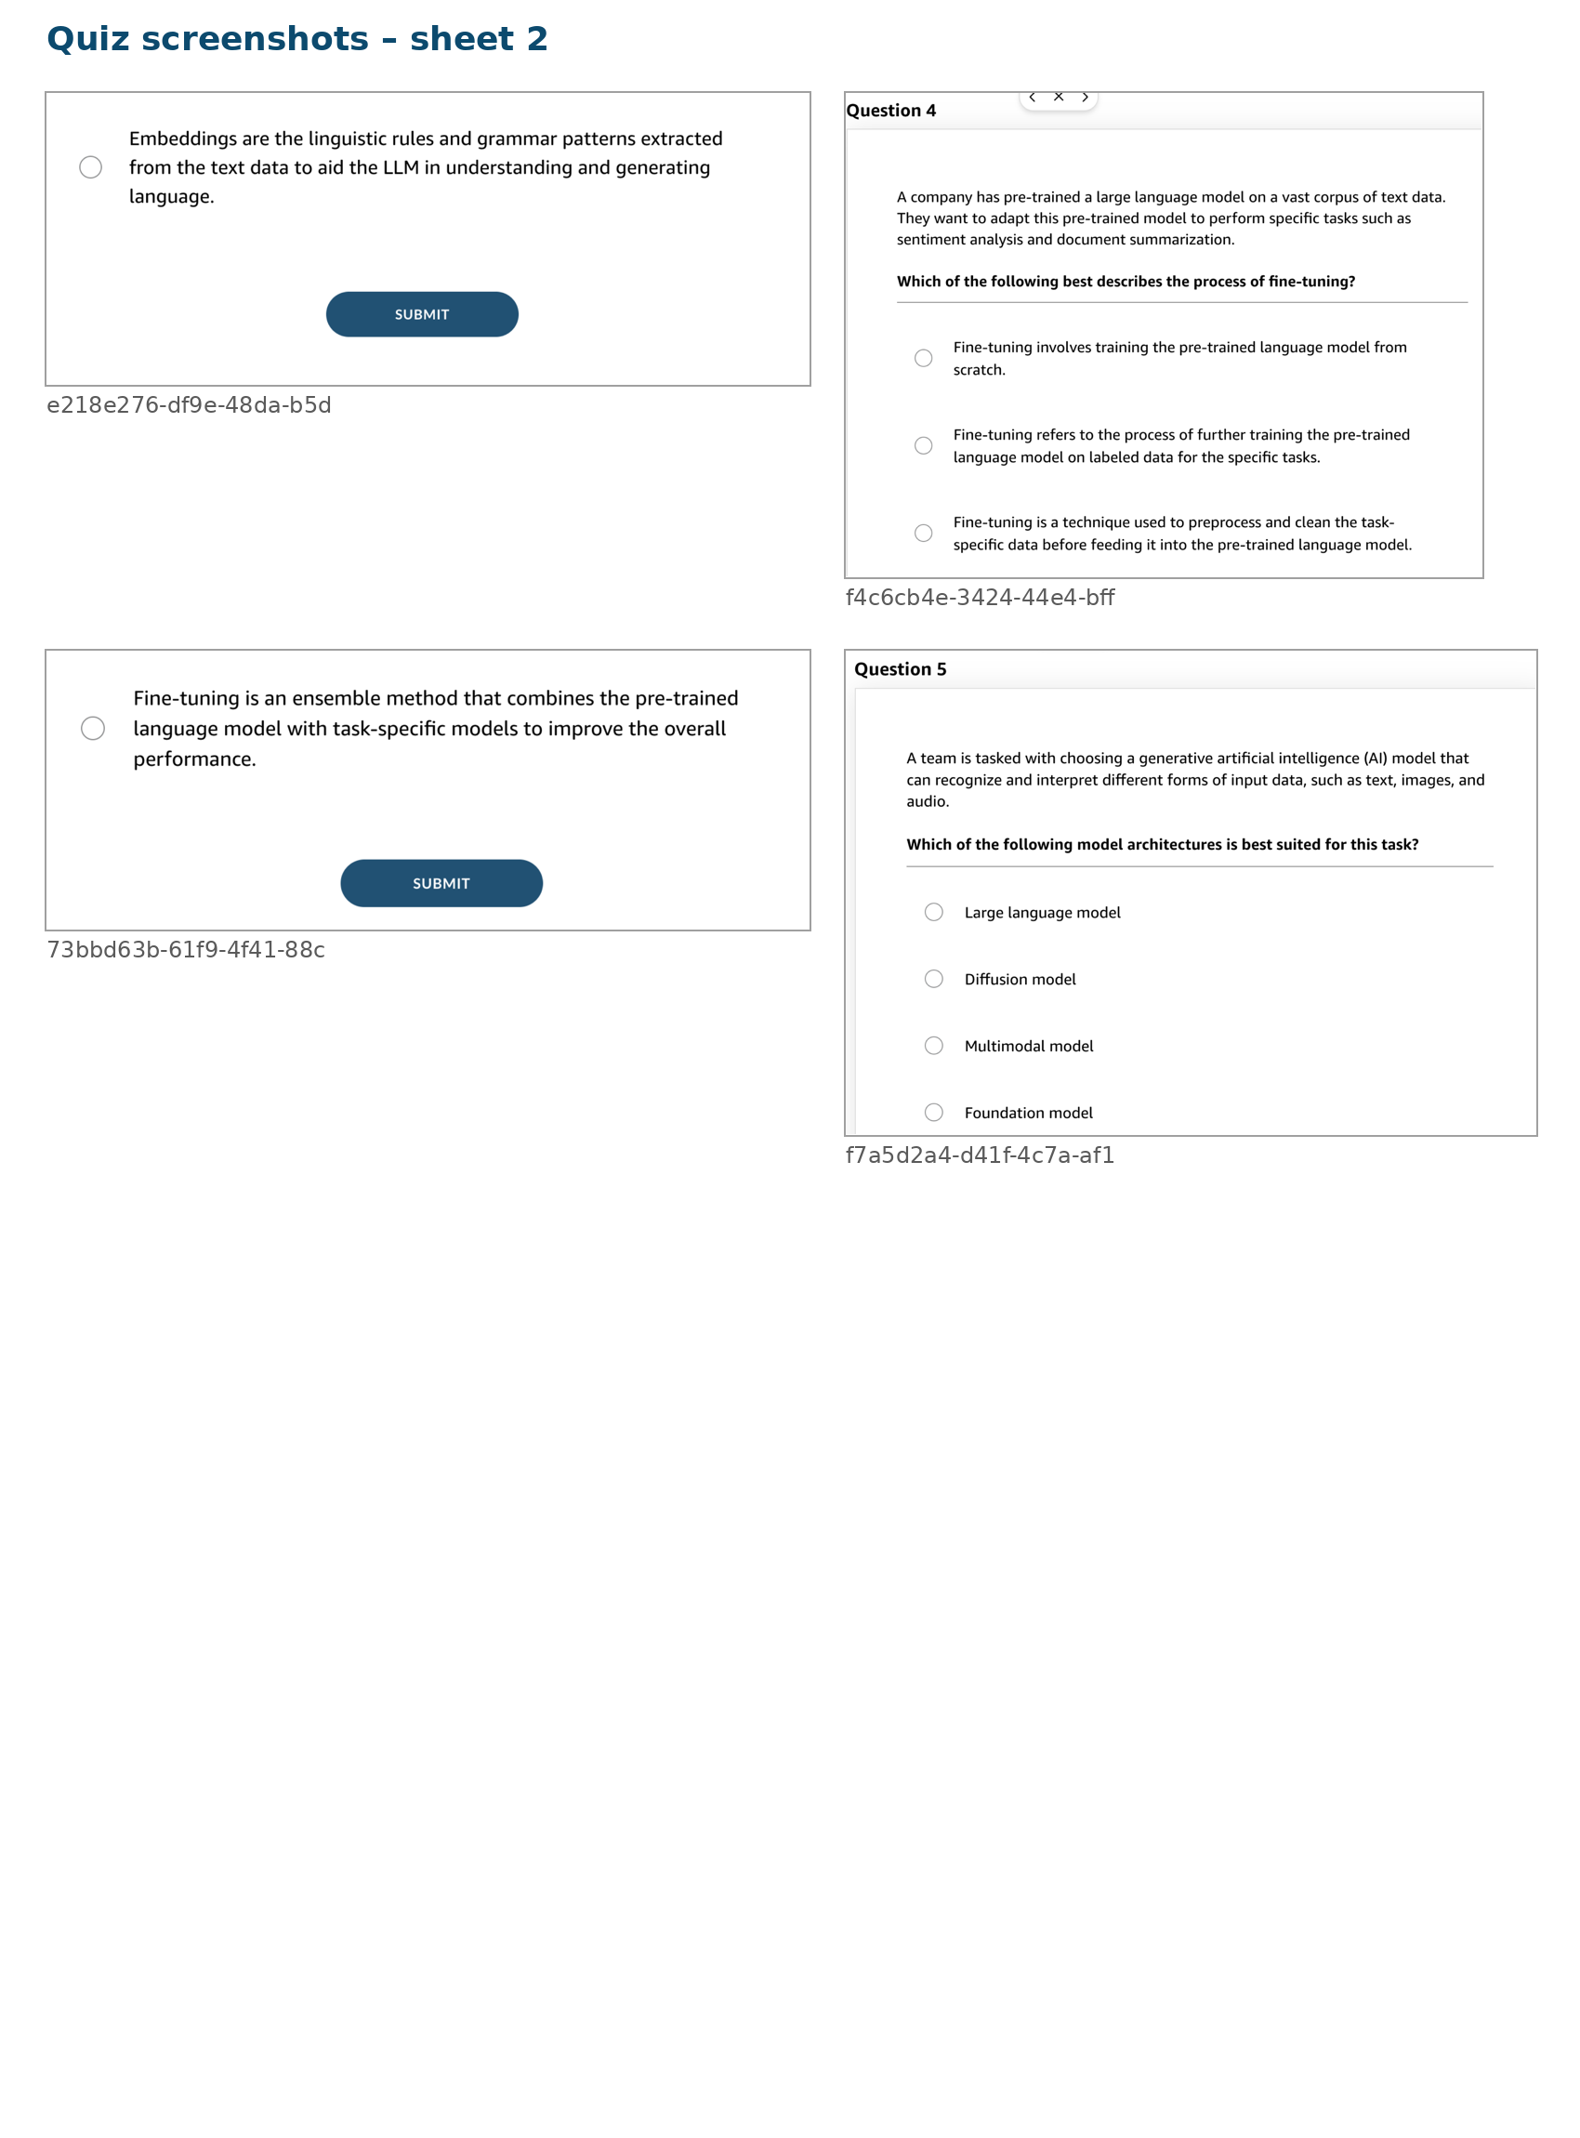
Quiz screenshot contact sheet: quiz_sheet_2.png

Final rapid-revision summary
- Amazon SageMaker AI: end-to-end managed ML workflow.
- Comprehend: understand text.
- Translate: convert language.
- Textract: extract text, forms, and tables from scanned documents.
- Lex: build chatbots and voice bots.
- Polly: text to speech.
- Transcribe: speech to text.
- Rekognition: image and video analysis.
- Kendra: intelligent enterprise search.
- Personalize: individualized recommendations.
- DeepRacer: reinforcement learning practice.
- JumpStart: fast start and model fine-tuning templates.
- Bedrock: access and customize foundation models through an API.
- Amazon Q: work assistant.
- Amazon Q Developer: coding assistant.
- Key AWS strengths: managed infrastructure, security, compliance, breadth, and support for both classic AI/ML and generative AI.
- Key trade-offs: cost versus responsiveness, availability, performance, regional coverage, throughput, and model customization.

