**Internship Report**

**on**

**Smart Parking Management System**

Submitted

**In Partial Fulfilment of the Requirements for the**

**Mini Project (KEC-554)**

**by**

**Anu Sharma (2000040310006)**

**Arzoo Goyal (2000040310008)**

**Payal Mohnani (2000040310032)**

Under the Supervision of

**Er. Thakurendra Singh**

(Assistant Prof., ECE Dept.)



To The

**P.G. Department of Electronics & Communication Engineering**

**RAJA BALWANT SINGH ENGINEERING TECHNICAL**

**CAMPUS**

**BICHPURI, AGRA**

**December 2022**

**Abstract**

In the parking lot near us, the staff is present to manage the space and the entry-exit of the vehicles. But with growing, Car parking increases with the number of car users.

Therefore, in these modern days finding car parking is a big issue in congested cities. There are too many vehicles on the road but not enough parking spaces.

The main aim of this project is to reduce the traffic in the parking place. Normally we can see in the multiplexes, cinema halls, large industries, and function halls there is problem they have to go and search which line is empty and which line having place to park the vehicle, for parking then they need workers for parking in correct position it is the money consumed process. Hence, to avoid this problem Smart Parking Management System project is implemented which can provide confusion-free, easy parking and time effective systems.

This project helps the car’s driver to park their car with minimum wastage of time with accurate information of the availability of the space to park.

**List of Figures**

|  |  |  |
| --- | --- | --- |
| S.No | Name of Figure | Page Number |
| 1. | Arduino UNO | 8 |
| 2. | 20x4 LCD Display | 9 |
| 3. | IR Sensor Module | 9 |
| 4. | I2C LCD Module | 10 |
| 5. | Mini Servo Motor SG-90 | 10 |
| 6. | Jumper Wires | 11 |
| 7. | Pictorial Representation | 13 |
| 8. | Circuit Diagram | 14 |
| 9. | Prototype Testing | 15 |
| 10. | Final Project | 15 |

**Table of Content**

|  |  |
| --- | --- |
| Content | Page Number |
| List of Figures | 3 |
| Table of content | 4 |
| Introduction | 5 |
| Literature review | 6 |
| Methodology Used | 7 |
| Components Used with Specifications | 8 |
| Project Details | 11 |
| Conclusion | 16 |
| References | 17 |
| Future Scope | 19 |

# **Introduction**

Now-a-days one of the biggest problems is when we enter a parking area then we realize that there are no empty parking slots to park our cars. Another biggest problem is after entering in a big parking area we confused to find the empty parking slot to park our car. Sometimes maybe we all have been facing these two problems that wasted our important time.

An “Automatic car parking system using Arduino UNO” is a project provides us to deal with the problems discussed before.

Using this type of systems at heavy rush places gives us the convenience from congestions, unavoidable interrupts, wastage of time and facilitates comfort.

This smart parking system project consists of [Arduino](https://www.electroduino.com/arduino-tutorial-1-introduction-to-arduino-board/), eight [IR sensors](https://www.electroduino.com/what-is-ir-sensor-module-how-ir-sensor-module-works/), one servo motor, one [LCD display](https://www.electroduino.com/16x2-lcd-display-module-how-its-works/) and an i2c module.

Here the Arduino is the main microcontroller that controls the whole system. Two IR sensors are used at the entry and exit gates to detect vehicle entry and exit in the parking area. And other six IR sensors are used to detect the parking slot availability. The servo motor is placed at the entry and exit gate that is used to open and close the gates. Also, an [LCD display](https://www.electroduino.com/16x2-lcd-display-module-how-its-works/) is placed at the entrance, which is used to show the availability of parking slots in the parking area.

This automation provides us easiness for requirement of less human force. So further in the series we will discuss about the implementations of the project.

**Literature Review**

The existing parking systems simply gather the available information of vacant parking lots using various sensor networks, and update the data to direct drivers. But the problem lies here, this system will not be able to direct the drivers to their respective parking slots. Blind searching is a common way by which drivers look out for vacant spaces when there is no availability of parking information. The drivers keep searching for empty parking spaces within a close distance to their end location. The drivers will not stop looking around until they find an empty space and keep extending the searching area. To tackle the problem of “many-vehicles-chase-single-slot”, the way of sharing the information about the parking slots is modified. The designers intentionally decrease the number of available slots while publishing the information, they act as buffer slots. When there are many vehicles wanting to park in a limited amount of available space, this system will have some extra spaces reserved in order to avoid a conflict. But it is a difficult task to estimate the number of the buffer spaces required. If the reserved space is too small, then we cannot overcome the problem of “many-vehicles-chase-single-slot”. If the buffer is too large, then parking space cannot be utilized effectively. Walking distance and Traffic volume are two performance metrics that address these issues.

Iris-net has proposed a system which uses cameras, microphones and motion detectors. These sensors are used to detect the availability of vacant parking spaces. It also acquires real time information about vacant parking slots through their web applications. But the problem is that it generates huge amount of data. One of the main limitations of this system is high energy consumption and it also suffers from technical aspects.

E-parking system makes use of latest technologies to merge reservation of parking slots and the payment systems. A driver can utilize this system to get information about the availability of vacant parking spaces, to reserve a parking space at his desired location and also to make the payment when leaving.

The above system can be accessed through a smartphone, or through web. But still there is a requirement of conventional detectors to detect the status of the parking slot. Automated parking system makes a way for an efficient use of limited number of parking spaces.

**Methodology Used**

The Project “Smart parking management system” is based on the interfacing of some components such as sensors, motors etc. with Arduino microcontroller. This system work as counter and finder. Counter is used to count the vacant spaces and finder select and show vacant space. Along with saving time, it also helps with security purpose, as well as it reduces human labor.

This project is divided into three parts: sensors, controller and display. Here we are using infrared communication because it can support LOS (line of sight communication). The sensor would observe an interruption and provide an input to the controller which would increment or decrement the vacancy slot count depending upon entering or exiting of the vehicle. Moreover, this interrupt determines the occupied and vacant slots. Counting is displayed on a 20×4 LCD through the controller. When a vehicle enters in the lot, IR sensor will detect the vehicle. We have used 2 IR sensors at the door. These two are placed on the door frame. And other 4 sensors are placed at the slot to determine if the slot is vacant or occupied.

**Components Used with Specifications**

* Arduino UNO:

The Arduino UNO R3 is a ATmega328P based Microcontroller board with the following specifications:

* Digital input and output pins-14
* Operating Voltage of the Arduino is 5V
* Analog I/P pins are 6
* Digital input & output pins (PWM)-6
* Flash Memory: 32 KB of which 0.5 KB used by bootloader
* Power Sources: DC Power Jack & USB Port

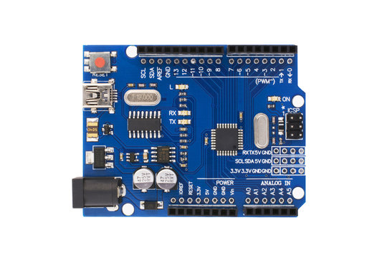

* 20×4 LCD Display

LCD Display is used to display number of vacant slots and vacancy places. It is very thin technology based on combination of liquid and crystal. Liquid state produces an image for display.

* Character LCD 20x4
* 5x8 dots includes cursor
* Bulit-in controller
* Negative voltage (optional) for +3V power supply
* 1/16 duty cycle
* Interfacing can be done using I2C
* 4-bit and 8-bit parallel interface
* Operating voltage of 5V power.
* 1x16 Male header strip, which is used to connect peripheral devices.

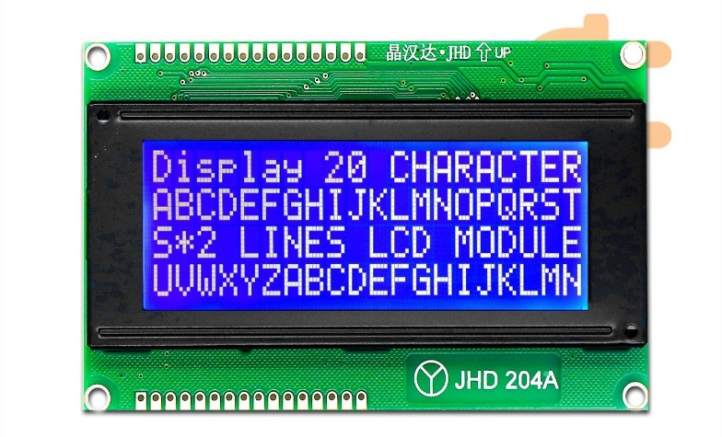

* IR Sensor Module

An infrared sensor is an electronic device, that emits in order to sense some aspects of the surroundings. An IR sensor consists of IR transmitter and receiver. Following are the specifications of IR sensor used here:

* The operating voltage is 5VDC.
* I/O pins voltage: 3.3V & 5V.
* Supply current of 20mA.
* Range of 20 cm

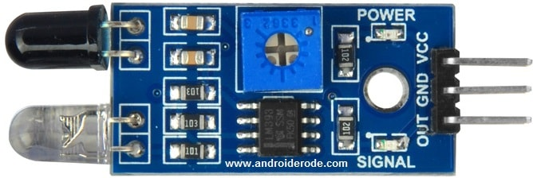

* I2C LCD Module

I2C LCD is an easy-to-use display module. The I2C protocol is used to establish communication between two or more ICs (Integrated Circuits), hence why it's known as Inter-Integrated Circuit (I2C) communication. However, I2C could also be used as a communication protocol between two ICs that are located on the same PCB.

* Here, I2C LCD Module is used to interface LCD and Arduino.
* I2C Module has an inbuilt I2C chip.
* It converts I2C serial data to parallel data for the LCD display.
* Adjustable backlight intensity and contrast 5V operation.
* Operating voltage of 5V.

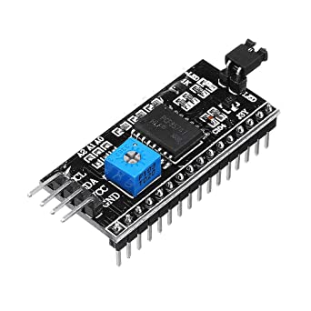

* Mini Servo Motor SG-90

Micro Servo Motor SG90 is a tiny and lightweight server motor with high output power. The servo can rotate approximately 180 degrees (90 in each direction) and works just like the standard kinds but smaller. Servos can be controlled using Servo code, hardware, or a library. Here, it opens and closes the entry-exit barrier. It can lift 3.75lb positioned 1cm from the center of the Shaft.

* Model: SG90.
* Weight: 9 gm.
* Operating voltage: 3.0V~ 7.2V.
* Servo Plug: JR.
* Stall torque @4.8V : 1.2kg-cm.
* Stall torque @6.6V : 1.6kg-cm.
* Analog drive circuitry.
* A low-cost device



* Jumper Wires

Jumper wires are used to make temporary connection between various components.

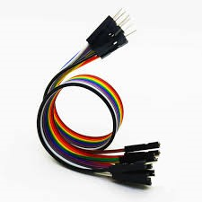

**Project Details**

This “Smart Parking Management System” project mainly consists of Arduino, IR sensors, servo motor, and LCD display.

Arduino is the main microcontroller that controls the whole system.

Two IR sensors are used at the entry and exit gates to detect vehicle entry and exit in the parking area. And other four IR sensors are used to detect the parking slot availability.

The servo motor is placed at the entry and exit gate that is used to open and close the gates.

Also, an LCD display is placed at the entrance, which is used to show the availability of parking slots in the parking area.

When a vehicle arrives at the gate of the parking area, the display continuously shows the number of empty slots.

If there have any empty slots then the system opens the entry gate by the servo motor. After entering the car into the parking area, when it will occupy a slot, then the display shows this slot is full.

If there is no empty parking slot then the system displays all slots are full and does not open the gate.

Pictorial Representation:

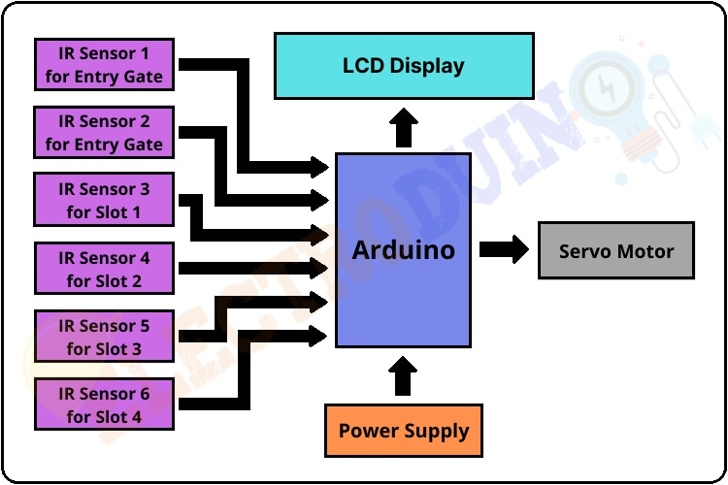

There are four parking slots in this project. IR Sensor-3, 4, 5, and 6 are placed at slot-1, 2, 3, and 4 respectively.

IR sensor-1 and 2 are placed at the entry and exit gate respectively. A servo motor is used to operate the common single entry and exit gate. The LCD display is placed near the entry gate.

The system used IR sensor-3, 4, 5, and 6 to detect whether the parking slot is empty or not and IR sensor-1, and 2 for detecting vehicles arriving or not at the gate.

In the beginning, when all parking slots are empty, then the LCD display shows all slots are empty. When a vehicle arrives at the gate of the parking area then the IR sensor-1 detects the vehicle and the system allowed to enter that vehicle by opening the servo barrier. After entering into the parking area when that vehicle occupies a slot then the LED display shows that the slot is full.

In this way, this system automatically allows 4 vehicles. In case the parking is full, the system blocked the entrance gate by closing the servo barrier. And the LED display shows that slot-1, 2, 3, and 4 all are full.

When a vehicle leaves a slot and arrives at the gate of the parking area then the IR sensor-2 detects that vehicle and the system open the servo barrier. Then the LED display shows that the slot is empty. The system will again allow entering a new vehicle.

In this way, parking lot can be managed.

**Circuit Diagram:**

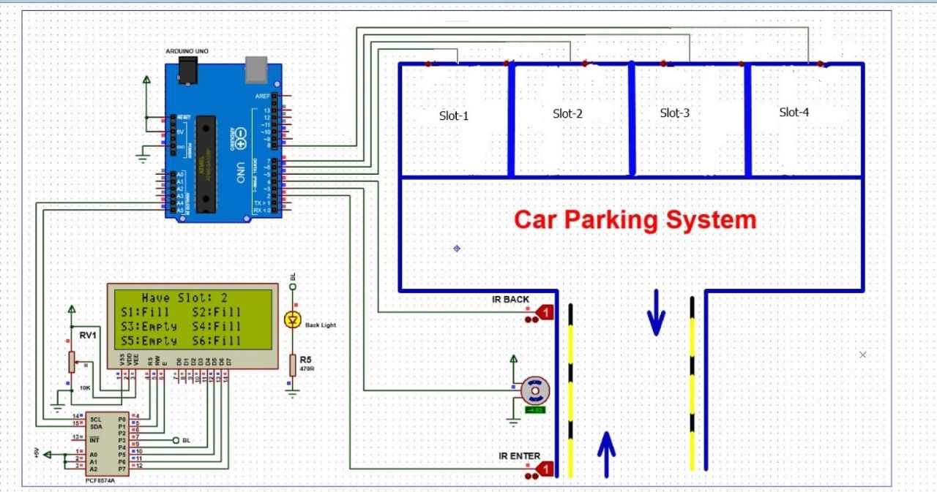

Prototype Testing:

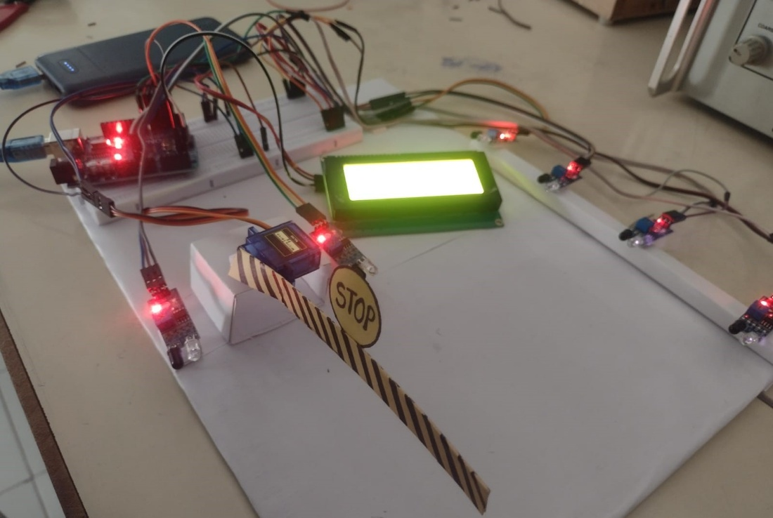

**Final** **Project**:

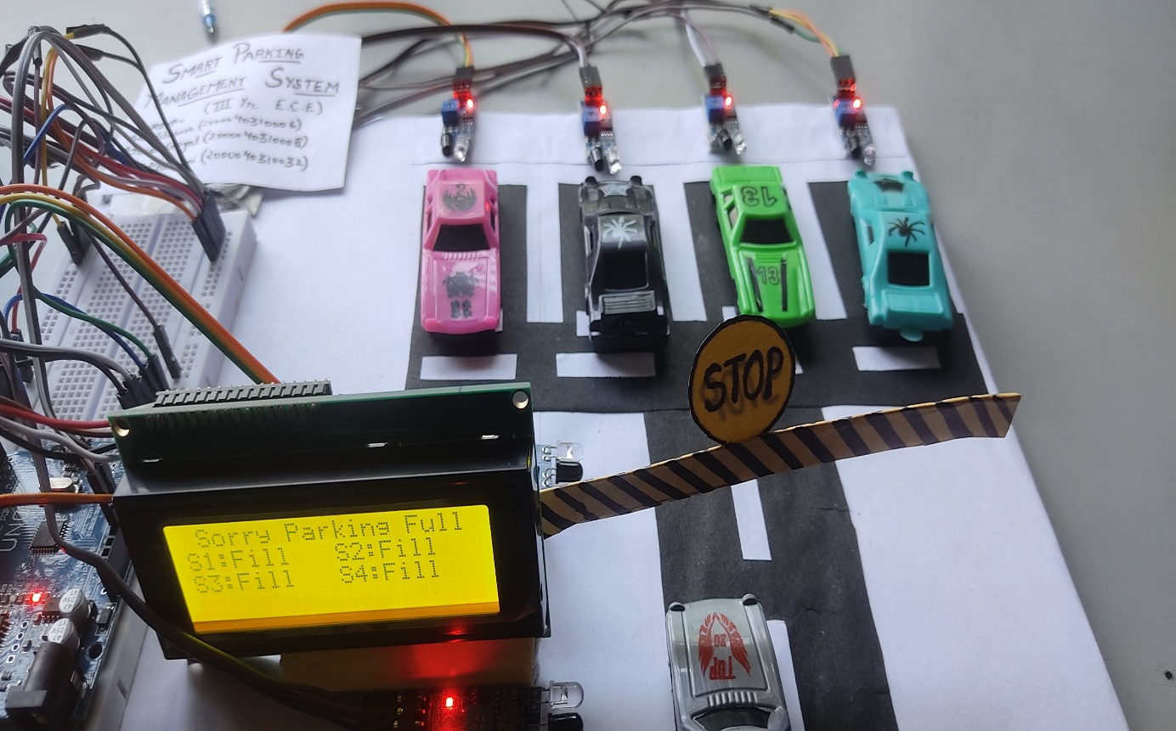

**Conclusion**

Smart Parking Management System proposed here is the minimum intrusive approach to reduce the traffic congestion. The services provided by smart parking have become the essence of building smart cities. The proposed system has several advantages, including detecting parking spaces using the Internet of Things, therefore reducing search traffic. The system benefits from avoiding wasting time and reducing pollution and fuel consumption. It provides better security. Moreover, it enhances user experience.

**References**

* Faiz Ibrahim Shaikh, Pratik Nirnay Jadhav, Saideep Pradeep Bandarkar, Omkar Pradip Kulkarni, Nikhil Kumar, B. Shardoor "Smart Parking System Based on Embedded System and Sensor Network", International Journal of Computer Applications (0975 8887) Volume 140 - No.12, April 2016 International Journal of Pure and Applied Mathematics Special Issue 171. <https://www.ijcaonline.org/research/volume140/number12/shaikh-2016-ijca-909532.pdf>
* Thanh Nam Pham1, Ming-Fong Tsai1, Duc Binh Nguyen1, Chyi-Ren Dow1, And Der-Jiunn Deng2 "A Cloud-Based Smart-Parking System Based on Internet-of-Things Technologies", IEEE Access, Received July 24, 2015, accepted August 16, 2015, date of publication September 9, 2015, date of current version September 23, 2015. <https://www.researchgate.net/publication/335807455_Smart_Parking_Management_System>
* El Mouatezbillah Karbab, Djamel Djenouri, Sahar Boulkaboul, Antoine Bagula, CERIST Research Center, Algiers, Algeria University of the Western Cape, Cape town, South Africa,"Car Park Management with Networked Wireless Sensors and Active RFID", 978-1-4799-8802-0/15 02015 IEEE. <https://www.ijcseonline.org/full_paper_view.php?paper_id=4387>
* Mr. Basavaraju S R "Automatic Smart Parking System using Internet of Things (IOT)", (International Journal of Scientific and Research Publications, Volume 5, Issue 12, December 2015). <https://www.ijsrp.org/research-paper-1215/ijsrp-p4898.pdf>
* M. M. Rashid, A. Musa, M. Ataur Rahman, and N. Farahana, A. Farhana, "Automatic Parking Management System and Parking Fee Collection Based on Number Plate Recognition.", International Journal of Machine Learning and Computing, Vol. 2, No. 2, April 2012, Published 2014. <https://www.researchgate.net/publication/281060377_Automatic_Parking_Management_System_and_Parking_Fee_Collection_Based_on_Number_Plate_Recognition>
* Hilal Al-Kharusi, Ibrahim Al-Bahadly, "Intelligent Parking Management System Based on Image Processing", World Journal of Engineering and Technology, 2014, 2, 55-67. <https://file.scirp.org/pdf/WJET_2014050611391380.pdf>
* X. Zhao, K. Zhao, and F. Hai, "An algorithm of parking planning for smart parking system," in Proc. 11th World Congr. Intell. Control Autom. (WCICA), 2014, pp. 4965 4969. <https://www.ijcaonline.org/archives/volume177/number46/31219-2020919984>
* L. Mainetti, L. Palano, L. Patrono, M. L. Stefanizzi, and R. Vergallo, Integration of RFID and WSN technologies in a smart parking system, "in Proc. 22nd Int. Conf. Softw ., Telecommun. Comput. Netw. (SoftCOM), 2014, pp. 104 110. <https://www.semanticscholar.org/paper/Integration-of-RFID-and-WSN-technologies-in-a-Smart-Mainetti-Palano/0adc719ea4147083c04753b19a5ce4259e144c24>
* Harmeet Singh, Chetan Anand, Vinay Kumar, Ankit Sharma, "Automated Parking System With Bluetooth Access", International Journal Of Engineering And Computer Science ISSN:2319-7242, Volume 3 Issue 5, May 2014, Page No. 57735775. <https://www.academia.edu/es/43902376/IJERT_Smart_Mobile_Application_for_Vehicle_Parking>
* C. Shiyao, W. Ming, L. Chen, and R Na, "The research and implement of the intelligent parking reservation management system based on ZigBee technology," in Proc. 6th Int. Conf. Meas. Technol. Mechatronics Autom. (ICMTMA), 2014, pp. 741_744. <https://dokumen.tips/engineering/a-cloud-based-smart-parking-system-based-on-internet-of-things-technologies.html>

**Future Scope**

The future scope to adopt this Smart Parking Management System so that the availability of spaces could be displayed on a smartphone Application or even on a satellite navigation device so that drivers will always be aware of whether there are free spaces are not. And also upload data to the database when any new vehicle enters or a vehicle exits the parking lot.

The system can be updated further to allow slot booking facility, and viewing parking lot maps through the phone application to allow the client to track their vehicle in the parking lot without searching for a certain slot in any direction.

The system can be made multilevel.