CREATE TABLE STUDENTS(

StudentName varchar2(50),

StudentRollNo varchar2(15) ,

S_Class varchar2(50),

Age number(2),

FathersName varchar2(50),

CONSTRAINT s_pk PRIMARY KEY (StudentRollNo)

);

SELECT * from STUDENTS;

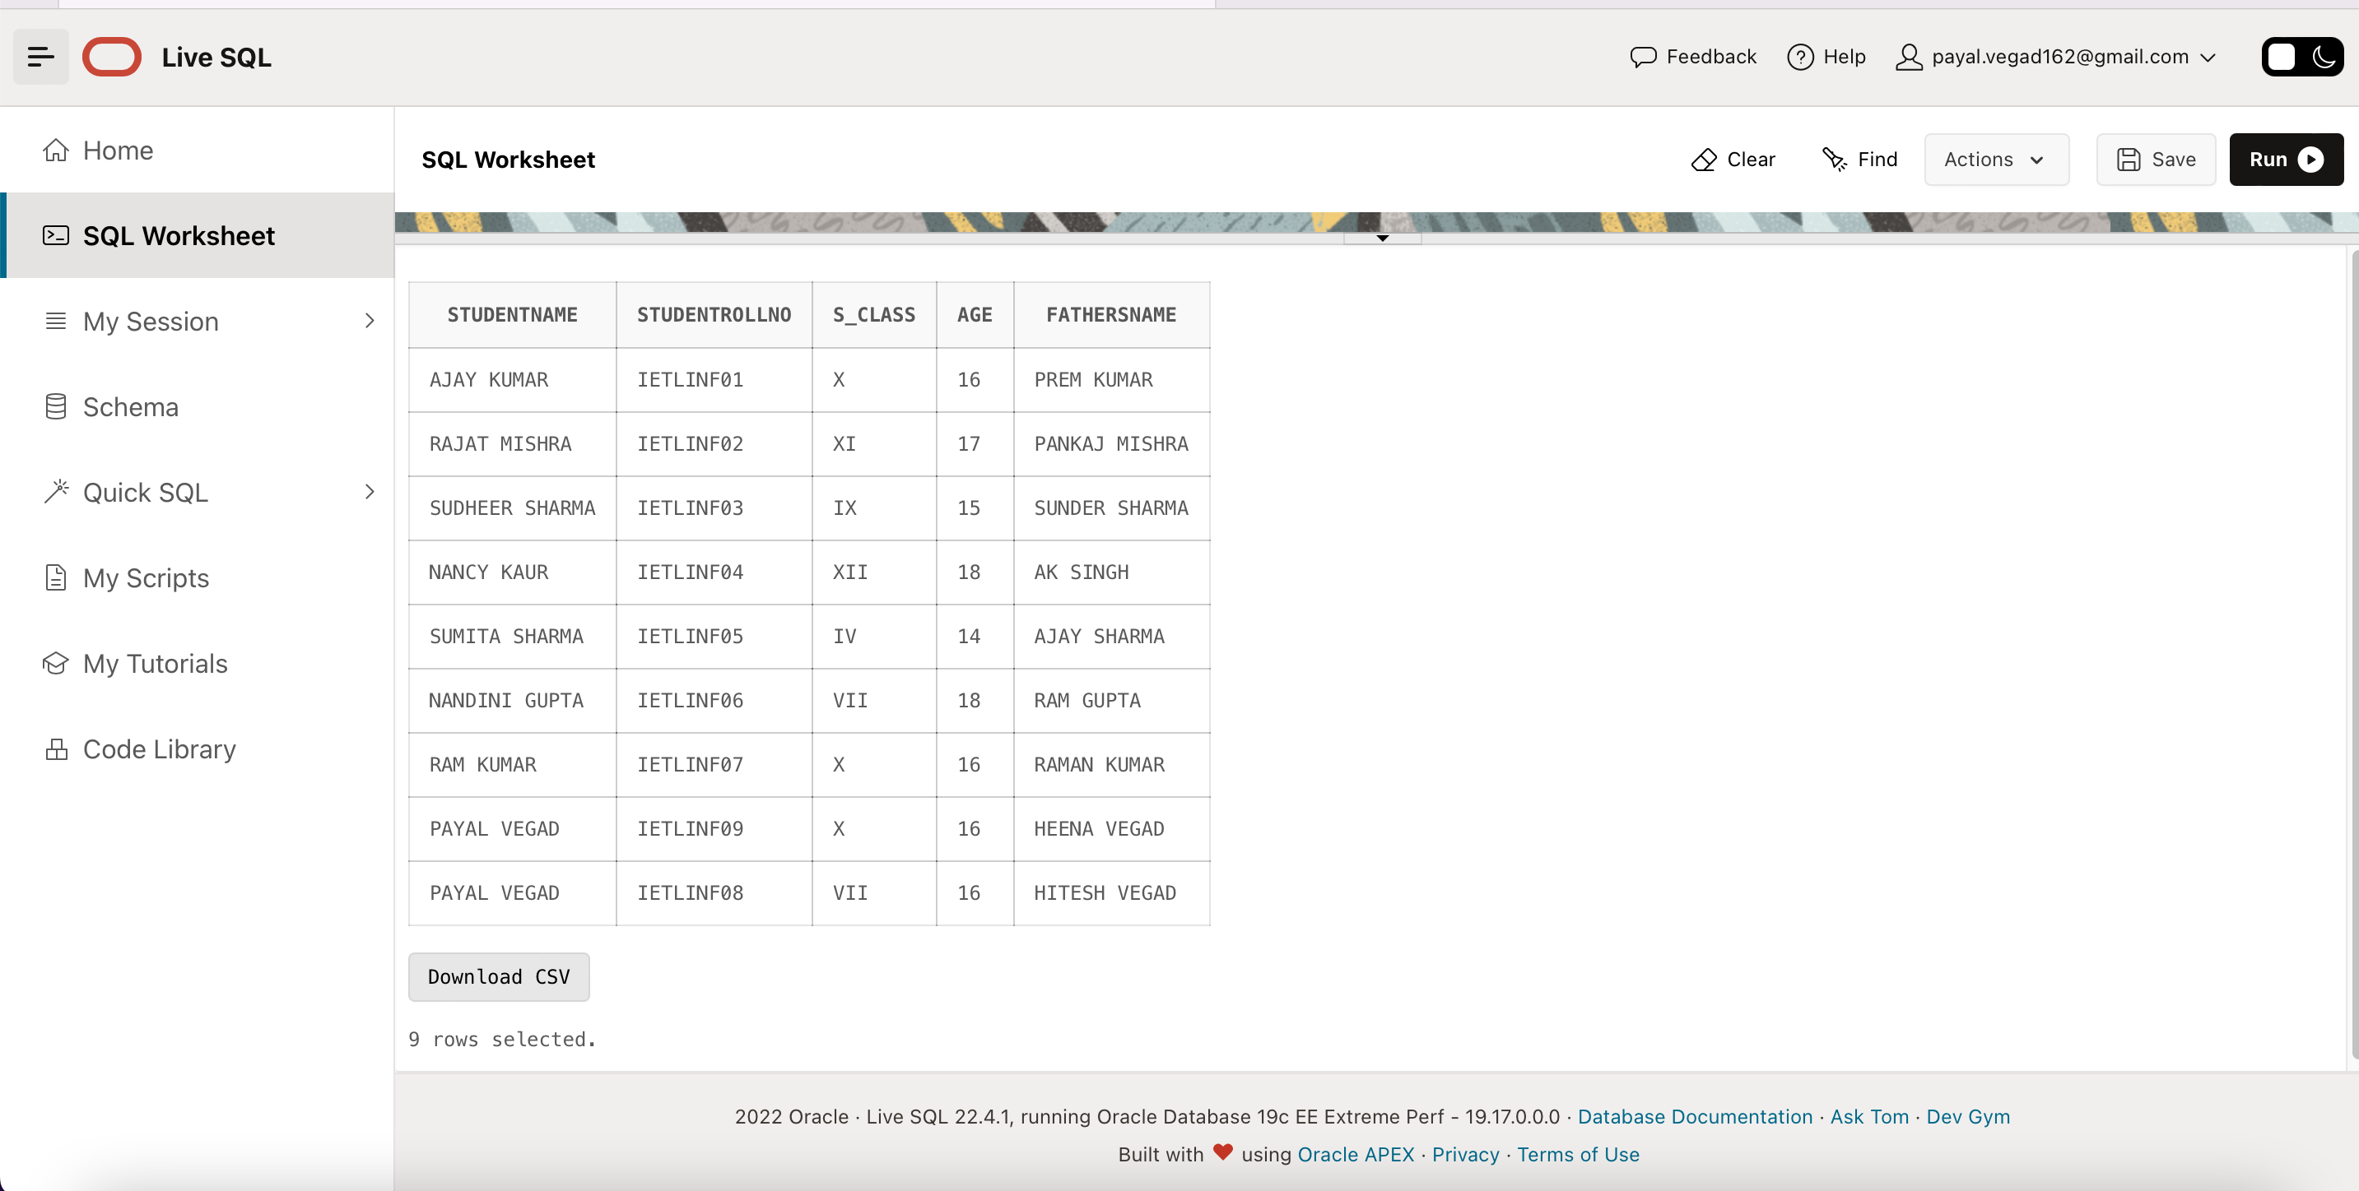

INSERT INTO STUDENTS VALUES ('AJAY KUMAR','IETLINF01','X',16,'PREM KUMAR');

INSERT INTO STUDENTS VALUES ('RAJAT MISHRA','IETLINF02','XI',17,'PANKAJ MISHRA');

INSERT INTO STUDENTS VALUES ('SUDHEER SHARMA','IETLINF03','IX',15,'SUNDER SHARMA');

INSERT INTO STUDENTS VALUES ('NANCY KAUR','IETLINF04','XII',18,'AK SINGH');

INSERT INTO STUDENTS VALUES ('SUMITA SHARMA','IETLINF05','IV',14,'AJAY SHARMA');

INSERT INTO STUDENTS VALUES ('NANDINI GUPTA','IETLINF06','VII',18,'RAM GUPTA');

INSERT INTO STUDENTS VALUES ('RAM KUMAR','IETLINF07','X',16,'RAMAN KUMAR');

INSERT INTO STUDENTS VALUES ('PAYAL VEGAD','IETLINF08','VII',16,'HITESH VEGAD');

INSERT INTO STUDENTS VALUES ('PAYAL VEGAD','IETLINF09','X',16,'HEENA VEGAD');

--2- Write sql query to find out total number of students in each class.

SELECT S_CLASS, COUNT(StudentRollNo) AS TOTAL_STUDENTS from STUDENTS

GROUP BY S_CLASS ORDER BY TOTAL_STUDENTS DESC;

--3- Write sql query to find out average age of students in each class.

SELECT S_CLASS, AVG(Age) AS AVERAGE_AGE_PER_CLASS from STUDENTS

GROUP BY S_CLASS;

--4- Write sql query to find out the number of students having same roll no.

-- HAVE MADE STUDENT ROLL NUMBER AS PRIMARY KEY SO NO DUPLICATE ROLLNUMBER

SELECT COUNT(StudentRollNo) from STUDENTS

GROUP BY StudentRollNo HAVING COUNT(StudentRollNo) > 1 ;

--5- Write sql query to view the duplicate name of a student from the table.

SELECT StudentName from STUDENTS

GROUP BY StudentName HAVING COUNT(StudentName) > 1 ;

