“Prévu” – UNICEF Advocacy Database

UNICEF advocates for progress on major issues relevant to its major focus areas. These initiatives are managed by issue owners. Issues include vaccination/health, elimination of violence against children, education, sanitation, gender equality, and climate change.

To create progress, issue owners define objectives which together form a strategy. From objectives, UNICEF makes specific requests (“asks”) of various actors (countries, international organizations, etc) to advance objectives. Actors have opinions about major issues, and individual asks, and different actors have different degrees of influence in the world. This layer of advocacy is strategy and position. The other layer is tactical and action: engaging individuals whenever there is opportunity to raise asks. It could be that goals/asks are known but it is unclear who the actors are who could help, or it could be that the actors are known and there are opportunities for engagement, but the goals/asks are unclear.

UNICEF has a major challenge in managing advocacy efforts from a high-level, and identifying areas where working together across different issues/opportunities could be beneficial. Currently, advocacy efforts are managed by individuals using their own means, usually Excel spreadsheets or disparate project management tools. The goal is to centralize and unify advocacy efforts, and visualize and report on all present and future activity in order to better craft strategies and tactics.

# Requirements

* Ability to define actors, which can be individual people, countries, or groups of countries/people.
* Ability to define issues, and create objectives for each issue
* Ability to create asks for each objective, and ability to associate that ask with one or more actors.
  + One ask can pertain to many objectives
* Actors can express opinions on major issues, and have varying degrees of influence
* Ability to create opportunities, where one or more actors will be present
* Ability to create individual events for each opportunities, where one or more actors will be present
* Ability to associate a new/existing ask to one or more actors at a particular event
  + Ability to bridge issue/objective/ask & actor with opportunity/event/actor & ask. Ability to show missing relationships (e.g asks without actors, actors at events without asks)
* Ability to track the progress of asks and objectives using statuses
* Ability to generate reports (visualize) advocacy efforts, which allow things like filtering by actor (and attributes of actors like influence or opinions), and drawing all the relationships
* Ability to assign asks to messengers, issues to issue owners
* Notion of time throughout – data created, data updated; milestones/deadlines/expiration dates where relevant (e.g. opportunities have start/end datetime, objectives and asks can have deadlines
* Actor overview/dashboard. Upcoming opportunities/events, past/present/future asks and opinions, issue opinions, and influence.
* Issue overview/dashboard. Objectives, asks and actors and opinions (and upcoming events for that ask when available), asks without actors, actors with opinions on issue without asks, actors without opinions on issue
* Opportunity overview/dashboard. Ordered opportunities (upcoming at top, completed at bottom), with association actors, events and actors, event/actor/ask/resolution
* A dumb access system. Maybe HTTP-Auth on IIS, or maybe a stupid login-screen with a hard-coded, single login.

## Nice-to-have

* Intelligent indicators when creating entities/drawing relationships. For example if an actor will be present at an opportunity’s event, and there is already an ask of that actor, a suggestion should be made to make that ask of that actor at the event.
* Dependencies among objective (e.g. objective C can’t be done until objective B is ‘completed’)
* Knowledge of actor relationships. E.g. when there is an opportunity with G8 nations, and there is an outstanding ask of France (a G8 member), suggest making that ask of France at that event.
  + Whenever examining an individual nation/person, include information about all the actors with which the nation is affiliated
  + Ability to treat an ask of an organization as an ask of each of its component members
* Comparing the opinions on asks of organizations vs their component countries. If G8 feels a certain way about a certain issue, how does France feel?
* Notion of opinion vs demonstration. A nation may express strong opinions but fail repeatedly to deliver meaningful action or fulfill promises
* Workflows. E.g. after an event where an ask is made, update the ask’s status

# Proposed entities and relationships

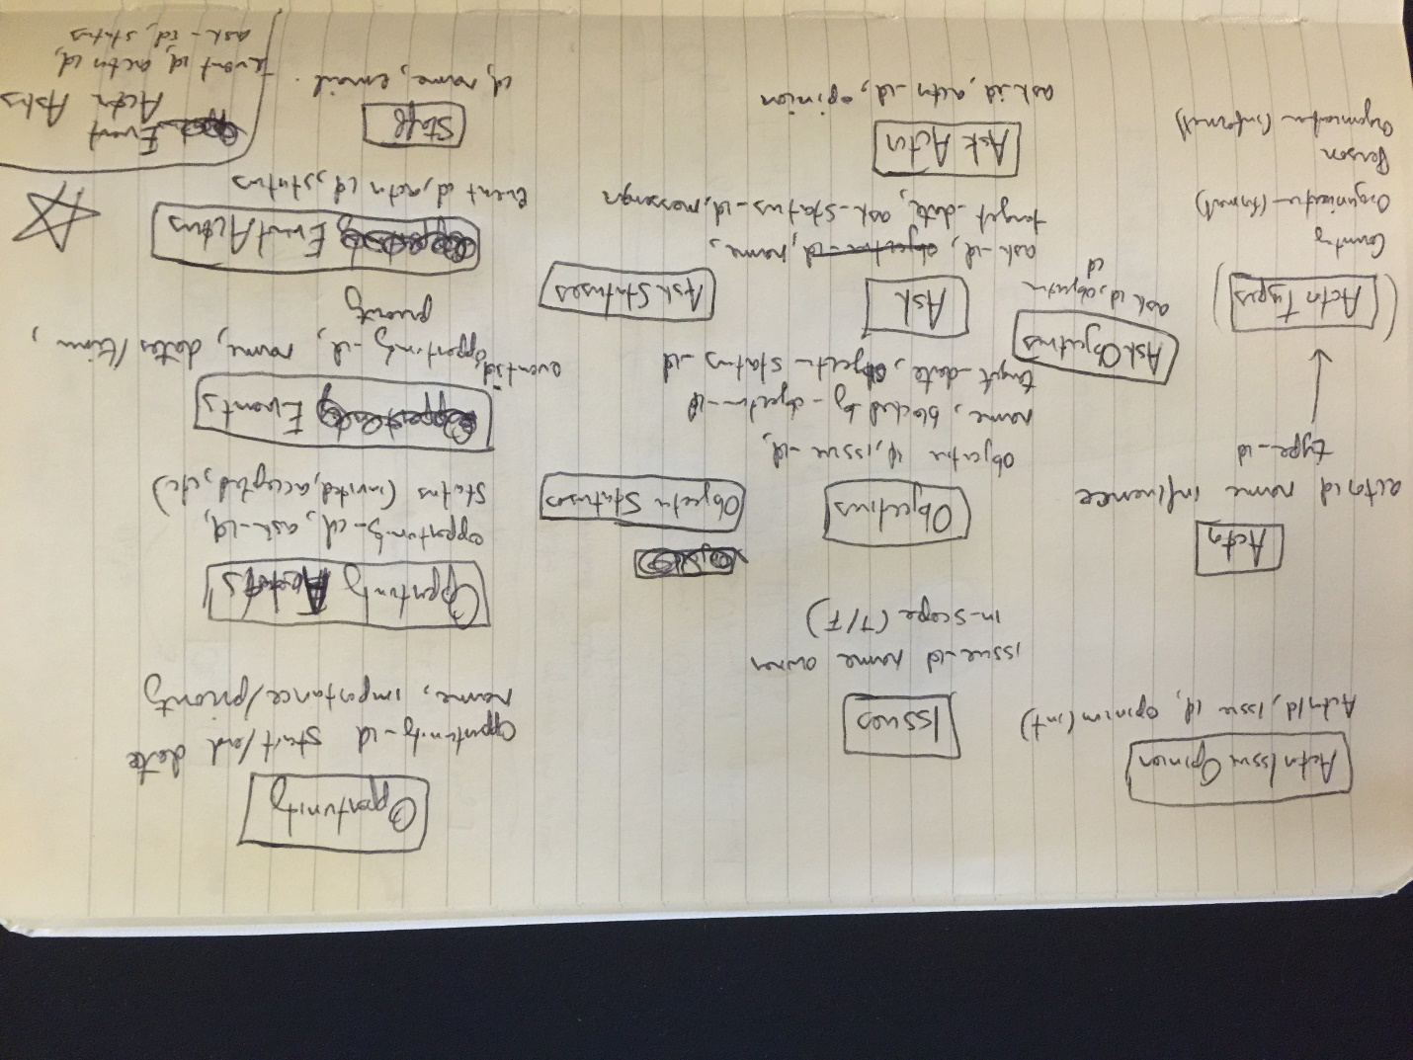

# Architectural Overview

* Source control in github ([www.github.com](http://www.github.com)) in a private repository named Prevu owned by account payamazadi
* Framework: .NET MVC 4 backed by MySQL
* Server: Windows Server 2012 with IIS in Amazon EC2. MySQL installed on that same instance and accessible from any machine provided the machine’s IP is whitelisted in EC2 security. Same security for RDP connections. Single administrator account.
* Deployment: Visual Studio Web Deploy (uses same credentials as RDP)
  + <http://martinbuberl.com/blog/deploy-aspnet-mvc-on-amazon-ec2-with-web-deploy/>
* Requirements for local environment:
  + Can run code locally and set connection string to use production database remotely
  + Can run code and database locally, which requires the following:
    - MySQL Server, MySQL workbench, and MySQL for Visual Studio. These are all available in a single installer: MySQL Community Workbench
      * <http://dev.mysql.com/get/Downloads/MySQLInstaller/mysql-installer-web-community-5.6.23.0.msi>

# Related Brainstorming

