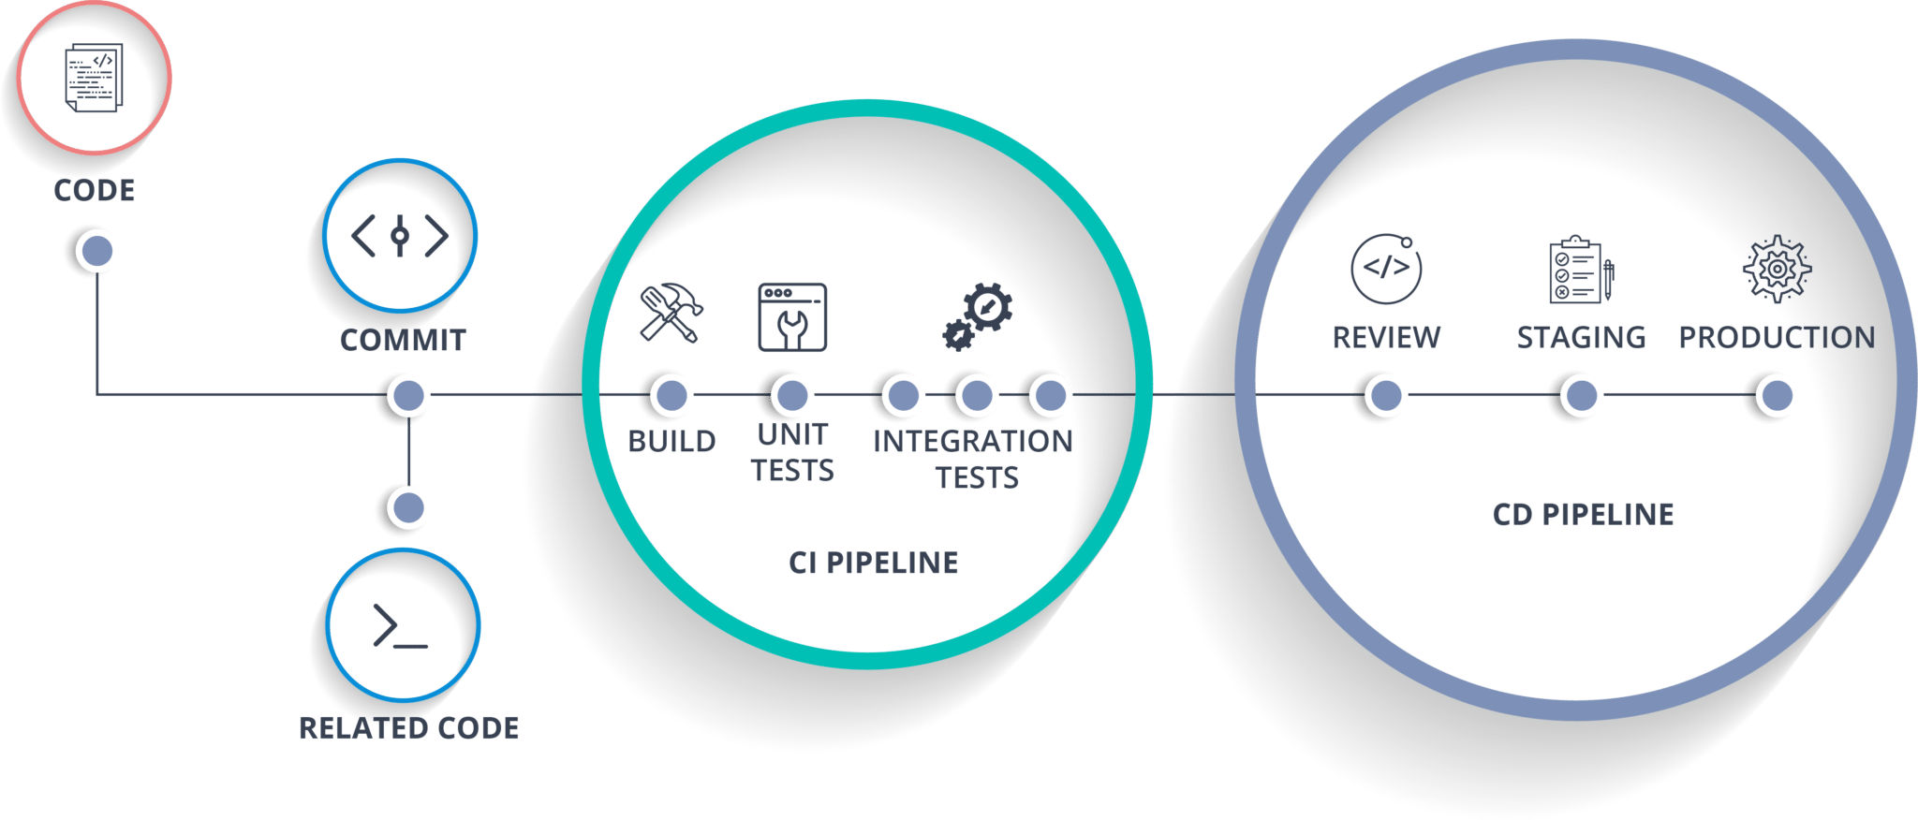**CI/CD**

CI stands for Continuous

Integration and CD stands

for Continuous Delivery/

Continuous Deployment.

You can think of it as a process similar to a software development lifecycle.

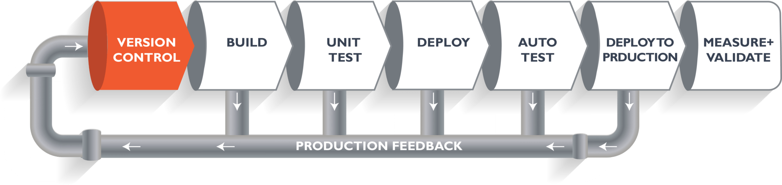

The above pipeline is a logical demonstration of how software will move along the various stages in this lifecycle before it is delivered to the customer or before it is live in production

* The above dynamics is implemented as a CI/CD pipelines predominantly in Hudson/Jenkins (refer for details).
* Imagine you're going to build a web application which is going to be deployed on live web servers. You will have a set of developers responsible for writing the code.  Now, when this code is committed into a **version control system (such as git, svn)** by the team of developers. Next, it goes through the **build phase**, which is the first phase of the pipeline.
* Suppose we have Java code and it needs to be compiled before execution. Through the version control phase, it goes to the build phase, where it is compiled.
* Once the build phase is over, then you move on to the **testing phase**. In this phase, we have various kinds of testing. One of them is the unit test.
* When the test is completed, you move on to the **deploy phase**, where you deploy it into a staging or a test server.
* Once the code is deployed successfully, you can run another sanity test. If everything is accepted, then it can be deployed to production.
* Meanwhile, in every step, if there is an error, you can shoot an email back to the development team so that they can fix it. Then they will push it into the version control system and it goes back into the pipeline.
* This lifecycle continues until we get code/a product which can be deployed to the production server where we measure and validate the code.
* The entire architecture is built once and played over as required. Jenkins as a tool enables the development and execution of this flow in software development.

(Follow the Jenkins Documentation)