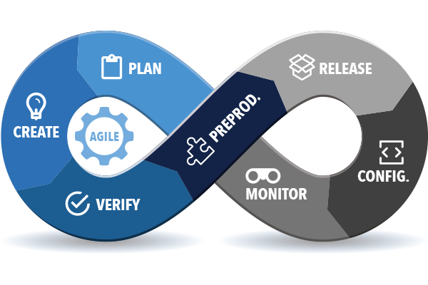**DevOps**

DevOps is a methodology that is focused on integration of developers and operations teams in order to improve collaboration and productivity by automating infrastructure, automating workflows and continuously measuring application performance, thus enabling:

* Innovate faster
* More responsive to business
* Better Collaboration
* Better quality
* More frequent releases
* The development and operations teams are in frequent touch with each other over the quality, health, bug fixes and versioning of the application, what’s more is all these tasks are automated to bring about a seamless flow in software delivery and application maintenance. Automation is at the crux of DevOps.
* DevOps as software development approach involves continuous integration (CI), continuous development, continuous deployment (CD), and continuous monitoring of the software throughout its development lifecycle.
* The gist of DevOps is brought by the use of sophisticated tools and services; Git/Bit bucket (version controlling systems), Amazon Web Services (AWS), Jenkins Pipelines, Dockers are to name a few