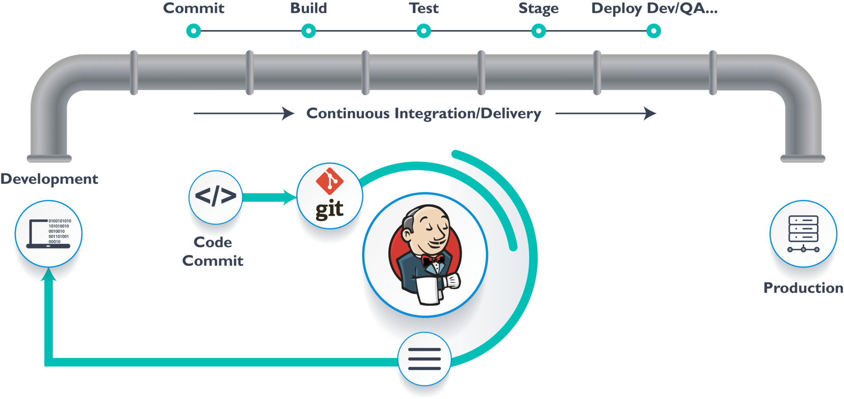**Jenkins**

* To implement the

Entire DevOps

process, we will

automate the

pipeline in order to

make the entire

software development

lifecycle in DevOps/automated mode. For this, we will need automation tools.

* **Jenkins** provides us with various interfaces and tools in order to automate the entire process.
* We have a Git repository where the development team will commit the code. From Git, Jenkins pulls the code and then Jenkins moves it into the **commit phase**, where the code is committed from every branch. The **build phase** is where we compile the code. If it is Java code, we use tools like maven in Jenkins and then compile that code, which can be deployed to run a series of tests.
* To install Jenkins
* Download jenkins.war file from the Jenkins.io site (<http://mirrors.jenkins.io/war-stable/latest/jenkins.war>).
* Open up a terminal in the download directory.
* Run java -jar jenkins.war --httpPort=8080 (by default 8080)
* Browse to http://localhost:8080.
* Most of the above tasks are featured and facilitated by appropriate **Plugins** e.g. Plugin for Git SCM Checkout, triggering an Email Post informing the status of the build to the concerned parties, etc. This is done with **manage plugins** tab in the Jenkins UI.
* Automation in Jenkins starts with a Jenkins Job