**MODEL SUMMARY**

Model: "sequential_2"

_________________________________________________________________

Layer (type) Output Shape Param #

=================================================================

conv2d_5 (Conv2D) (None, 150, 150, 32) 2432

_________________________________________________________________

max_pooling2d_5 (MaxPooling2 (None, 75, 75, 32) 0

_________________________________________________________________

conv2d_6 (Conv2D) (None, 75, 75, 64) 18496

_________________________________________________________________

max_pooling2d_6 (MaxPooling2 (None, 37, 37, 64) 0

_________________________________________________________________

conv2d_7 (Conv2D) (None, 37, 37, 96) 55392

_________________________________________________________________

max_pooling2d_7 (MaxPooling2 (None, 18, 18, 96) 0

_________________________________________________________________

conv2d_8 (Conv2D) (None, 18, 18, 96) 83040

_________________________________________________________________

max_pooling2d_8 (MaxPooling2 (None, 9, 9, 96) 0

_________________________________________________________________

flatten_2 (Flatten) (None, 7776) 0

_________________________________________________________________

dense_3 (Dense) (None, 512) 3981824

_________________________________________________________________

activation_2 (Activation) (None, 512) 0

_________________________________________________________________

dense_4 (Dense) (None, 10) 5130

=================================================================

Total params: 4,146,314

Trainable params: 4,146,314

Non-trainable params: 0

**HYPERPARAMETERS**

1. Padding = same
2. Batch size = 10
3. Epochs = 20

**IMAGES CLASSES**

1. Bike

2. Domestic Dog

3. Fish

4. Tiger Cat

5. Sturgeon

6. Liger

7. Rock Hopper

8. Snow Leopard

9. Ship

10. Bicycle

**CONFUSION MATRIX**

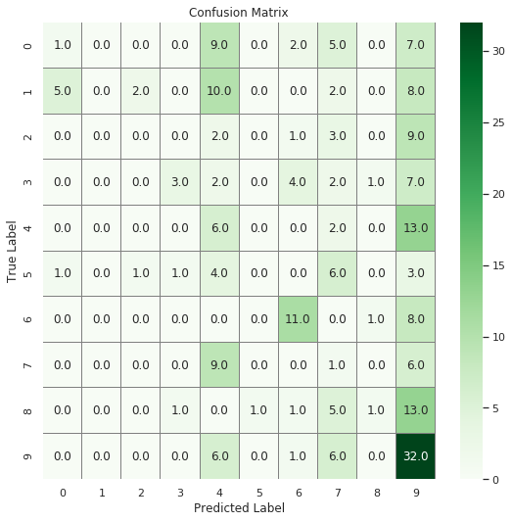

**PLOT OF HISTORY**

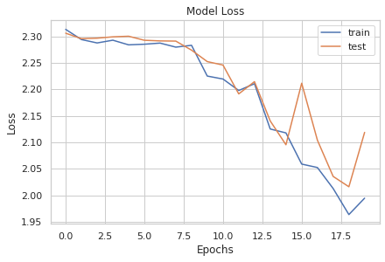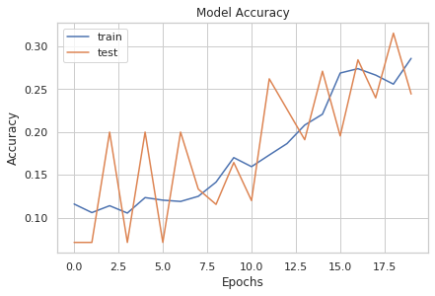

**TRAIN-VALIDATION-SPLIT RATIO**

1.9993: 2.1187

**BEST AUGMENTATION SETTINGS**

datagen = ImageDataGenerator(

        featurewise_center=False,  # set input mean to 0 over the dataset

        samplewise_center=False,  # set each sample mean to 0

        featurewise_std_normalization=False,  # divide inputs by std of the dataset

        samplewise_std_normalization=False,  # divide each input by its std

        zca_whitening=False,  # apply ZCA whitening

        rotation_range=10,  # randomly rotate images in the range (degrees, 0 to 180)

        zoom_range = 0.1, # Randomly zoom image

        width_shift_range=0.2,  # randomly shift images horizontally (fraction of total width)

        height_shift_range=0.2,  # randomly shift images vertically (fraction of total height)

        horizontal_flip=True,  # randomly flip images

        vertical_flip=False)  # randomly flip images