DATA ANALYTICS REPORT
Telecom Customer Churn Analysis
Predicting At-Risk Customers to Support Proactive Retention Strategy

Prepared by: Mohammad Mijanur Rahman
Role: Data Analyst | Python, SQL, ML & Data Visualization
Date: July 05, 2026
Dataset: Telecom Customer Churn Prediction Data

Executive Summary
Customer churn — the loss of subscribers to competitors — is one of the most direct threats to recurring revenue in the telecom industry. This report presents an exploratory data analysis of a telecom customer base to identify which customers are most likely to churn, what factors drive that risk, and how the company can act on these findings to protect revenue.
The analysis was performed in Python using Pandas, NumPy, Matplotlib, and Seaborn. It examines churn distribution, demographic and contract-based churn patterns, and the statistical relationship between churn and key account attributes such as tenure, monthly charges, and senior citizen status.

Metric | Headline Finding
Overall churn rate | Right-skewed — the majority of customers stay, but a substantial minority churn
Strongest churn predictor | Tenure (correlation – 0.35): longer-tenured customers are far less likely to churn
Highest-risk contract type | Month-to-month contracts show substantially higher churn than annual contracts
Pricing effect | Higher monthly charges are weakly associated with increased churn (+0.19)
Demographic effect | Senior citizens show a weak, marginal increase in churn risk (+0.15)

1. Business Problem
A telecom company wants to predict which customers are likely to leave (churn) so it can proactively retain them. Acquiring a new customer typically costs significantly more than retaining an existing one, making early identification of at-risk accounts a high-value business capability. This analysis lays the groundwork for a churn prediction model by first understanding which factors are most strongly associated with customer attrition.

2. Business Questions
The analysis was scoped around three core business questions:
Q1 | Which customers are most likely to churn?
Q2 | What factors influence or contribute to churn?
Q3 | Can we build a model to predict churn accurately?

3. Dataset & Methodology

Data Source
The dataset used for this analysis is a Telecom Customer Churn dataset containing account-level records for 7,043 customers, including service subscriptions, billing information, tenure, and churn status.

Fields Analyzed

- customerID — unique identifier for each customer
- Gender, SeniorCitizen, Partner, Dependents — demographic attributes
- Tenure — number of months the customer has stayed with the company
- PhoneService, MultipleLines, InternetService — core service subscriptions
- OnlineSecurity, OnlineBackup, DeviceProtection, TechSupport, StreamingTV, StreamingMovies — add-on services
- Contract — Month-to-month, One year, or Two year
- PaperlessBilling, PaymentMethod — billing attributes
- MonthlyCharges, TotalCharges — billing amounts
- Churn — target variable (Yes = customer left, No = customer stayed)

Data Cleaning & Preparation
Missing values, duplicate records, and outliers were identified and handled to ensure the dataset was suitable for reliable statistical analysis and downstream modeling.

Tools & Technologies
Python · Pandas · NumPy · Matplotlib · Seaborn, executed in a Colab notebook.

4. Key Findings
The sections below walk through each dimension of the analysis with the supporting visualization and its business implication.

4.1 Churn Distribution
The overall distribution of churn is right-skewed: most customers remain with the company, but a substantial minority — roughly one in four — have churned.
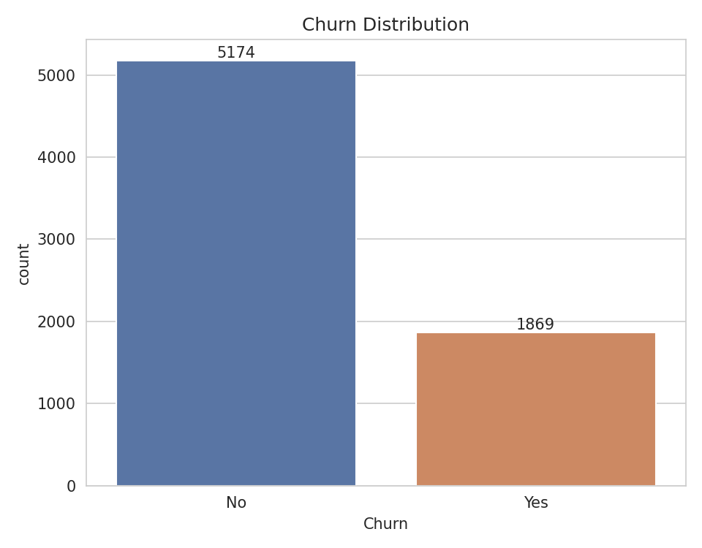
Figure 1. Overall churn distribution (No vs. Yes)
■ Business Value
- A meaningful share of the customer base is churning, representing a direct and quantifiable revenue risk.
- Even modest improvements in retention translate into significant recurring-revenue protection at this scale.

4.2 Gender-wise Churn
Churn was examined by gender to check for demographic skew. Male and female customers show closely comparable churn rates, indicating gender is not a meaningful differentiator of churn risk on its own.
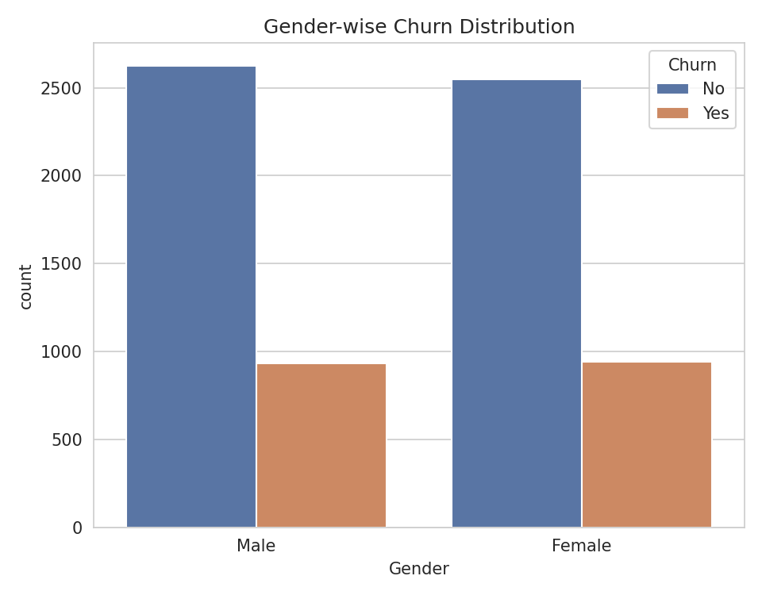
Figure 2. Churn distribution by gender
■ Business Value
- Gender is not a useful lever for retention targeting — churn risk is essentially balanced across male and female customers.
- Retention strategy should instead prioritize account-level factors such as contract type and tenure.

4.3 Contract-wise Churn
Contract type shows the clearest behavioral pattern in the data: customers on month-to-month contracts churn at a substantially higher rate than those on one-year or two-year contracts.
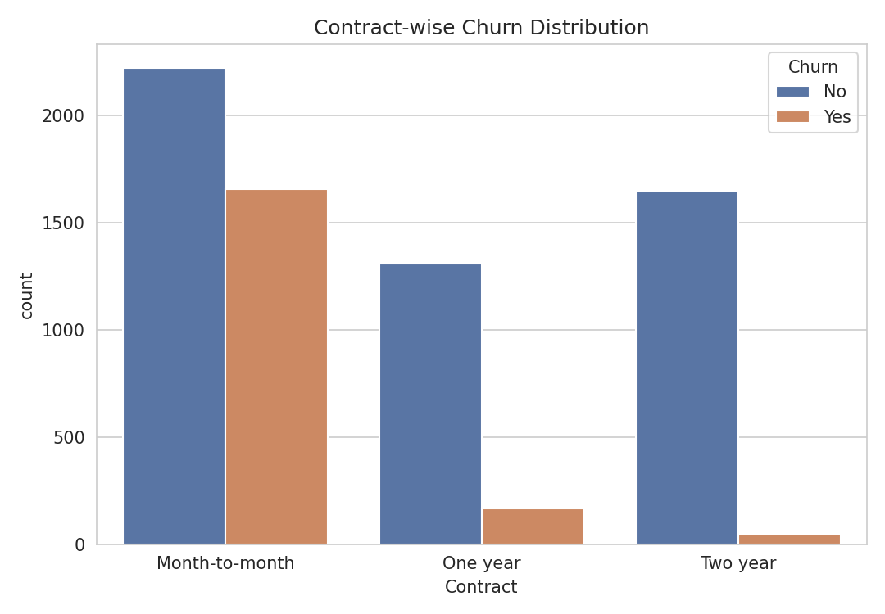
Figure 3. Churn distribution by contract type
■ Business Value
- Month-to-month customers represent the highest-risk segment and the best near-term target for retention campaigns.
- Incentivizing migration to longer-term contracts (discounts, loyalty perks) is a direct, actionable lever to reduce churn.

4.4 Correlation with Churn
A correlation analysis was run against the numeric account attributes to quantify which factors move most closely with churn.

Feature | Correlation with Churn
Churn | 1.000000
MonthlyCharges | 0.193356
SeniorCitizen | 0.150889
Tenure | –0.352229

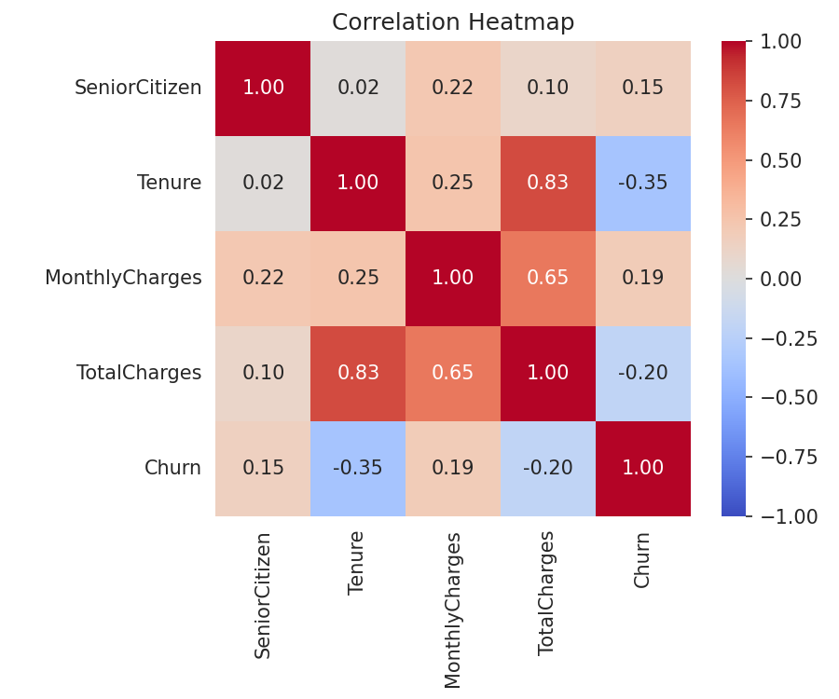
Figure 4. Correlation heatmap across key numeric account attributes
■ Business Value
- Tenure has, by a clear margin, the strongest relationship with churn — longer-tenured customers are far less likely to leave.
- MonthlyCharges and SeniorCitizen show weaker positive relationships with churn and are secondary risk signals.
- These correlations provide a validated feature set for building a predictive churn model.

5. Consolidated Business Insights
- Churn distribution is right-skewed, with a substantial minority of customers churning — a material and quantifiable revenue risk.
- Customers on month-to-month contracts show markedly higher churn than those on annual contracts.
- Tenure (–0.35) has the strongest relationship with churn of any numeric attribute — longer service duration reduces churn risk.
- MonthlyCharges (+0.19) and SeniorCitizen (+0.15) show weak positive relationships with churn and act as secondary risk indicators.
- Gender shows no meaningful difference in churn rate and is not a useful targeting variable.

6. Recommendations
- Focus on keeping customers who have month-to-month contracts, as they are more likely to leave.
- Offer discounts, reward programs, or bundled services to encourage customers to switch from month-to-month to annual contracts.
- Pay special attention to new customers, especially during their first few months, because they have a higher risk of churning.
- Keep an eye on customers with higher monthly charges and provide extra support or highlight the value of your services to improve customer satisfaction.

7. Conclusion
This exploratory analysis confirms that customer churn at this telecom company is not random: it is concentrated among short-tenure, month-to-month customers, with pricing and senior-citizen status acting as secondary risk factors. Tenure stands out as the single strongest predictor of churn. These findings provide a validated foundation for building a predictive churn model and for designing targeted, cost-effective retention strategies that focus resources on the customers most likely to leave.

8. Appendix

Technologies Used
Python · Pandas · NumPy · Matplotlib · Seaborn

Data Source
Telecom Customer Churn Prediction dataset.

Analysis Notebook
Google Colab notebook:
https://colab.research.google.com/drive/1aAbzICplr3eH4idGwD2DPbW59YV-Xw3d#scrollTo=8gXIJnbHJUjY

Author
Mohammad Mijanur Rahman — Data Analytics | Python | SQL | Machine Learning | Data Visualization

