SALES PERFORMANCE
ANALYSIS REPORT

Revenue, Profitability & Product Performance Insights
Prepared using Python, PySpark SQL, Pandas & Seaborn
Dataset: Sample Superstore / Supermarket Sales (Kaggle)
July 2026

1. Business Problem
A retail company sought to understand its sales performance in order to identify revenue trends, top-performing products, customer purchasing behavior, and opportunities to improve profitability. This report summarizes the exploratory data analysis (EDA) conducted using Python, PySpark SQL, Pandas, NumPy, Matplotlib, and Seaborn.

2. Business Questions
- What are the total sales, profit, and quantity sold?
- Which regions generate the highest revenue?
- Which product categories are the most profitable?
- Which customer segments generate the highest sales?
- Which products should be promoted or discontinued?

3. Dataset Overview
Source: Kaggle — Sample Supermarket Dataset (bravehart101/sample-supermarket-dataset)
Key fields: Ship Mode, Segment, Country, City, State, Postal Code, Region, Category, Sub-Category, Sales, Quantity, Discount, Profit.

4. Data Cleaning
- Removed duplicate records to prevent double-counting of transactions.
- Handled missing values to ensure accuracy of aggregated metrics.

5. Key Performance Indicators
The table below summarizes headline profit and sales figures derived from the analysis.
$286,397  Total Profit (All Regions) | West  Top Region | Technology  Top Category | Consumer  Top Segment

6. Regional Revenue Performance
Profit was aggregated by region using PySpark SQL. The West region is the strongest performer, generating $108,418 in profit — nearly 2.4x the profit of the Central region, the weakest performer.
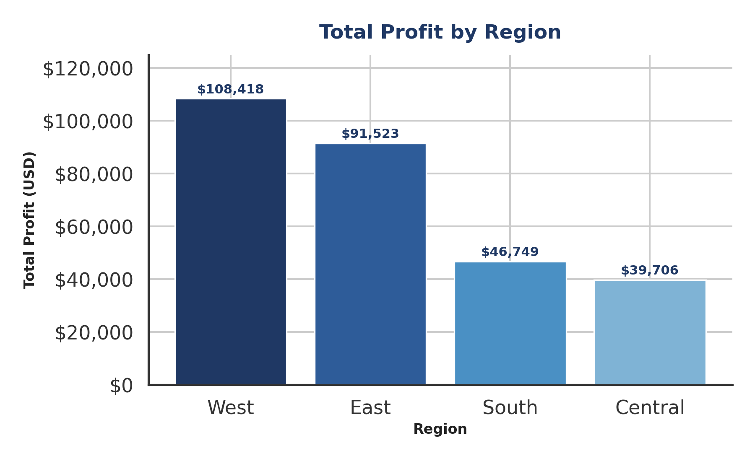
Figure 1. Total Profit by Region
Region | Total Profit (USD) | Share of Total Profit
West | $108,418.45 | 37.9%
East | $91,522.78 | 32.0%
South | $46,749.43 | 16.3%
Central | $39,706.36 | 13.9%

7. Category Profitability
Technology is the most profitable category at $145,455, closely followed by Office Supplies at $122,491. Furniture trails significantly at just $18,451 — suggesting thin margins, high discounting, or elevated return/shipping costs relative to the other categories.
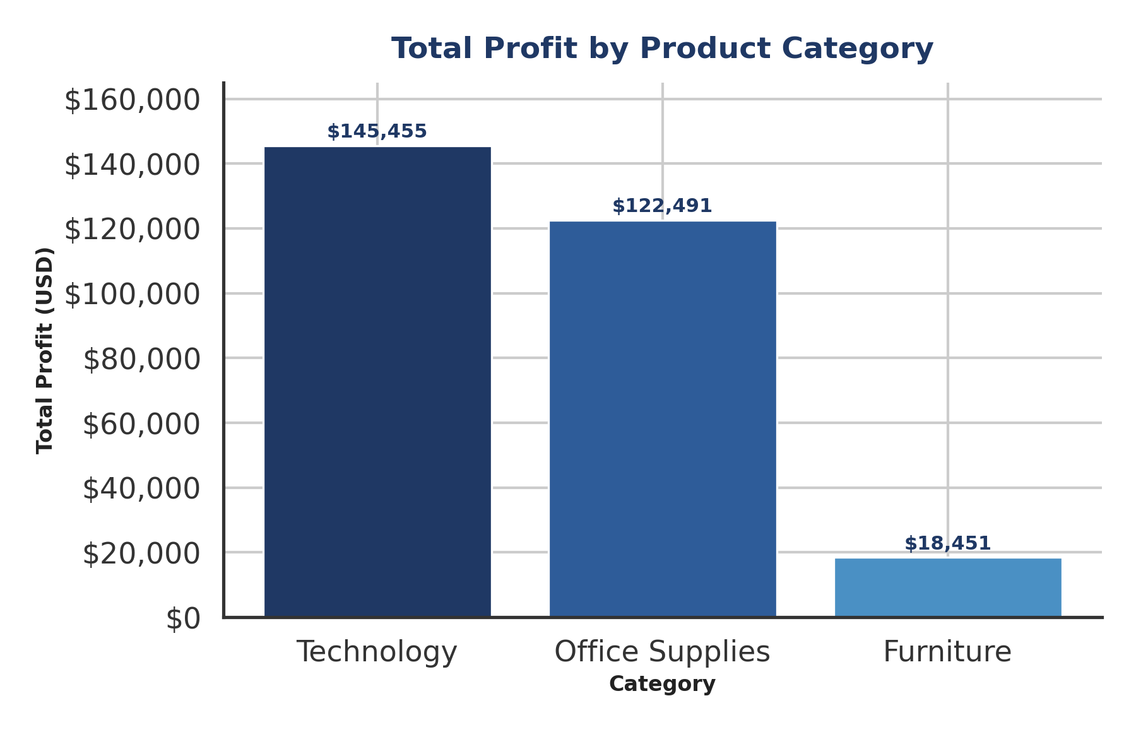
Figure 2. Total Profit by Product Category

8. Segment Performance
The Consumer segment leads total sales at $1.16M, more than the Corporate ($0.71M) and Home Office ($0.43M) segments combined trail behind. This indicates the Consumer segment is the primary revenue driver and should remain the focus of retention and upsell strategies.
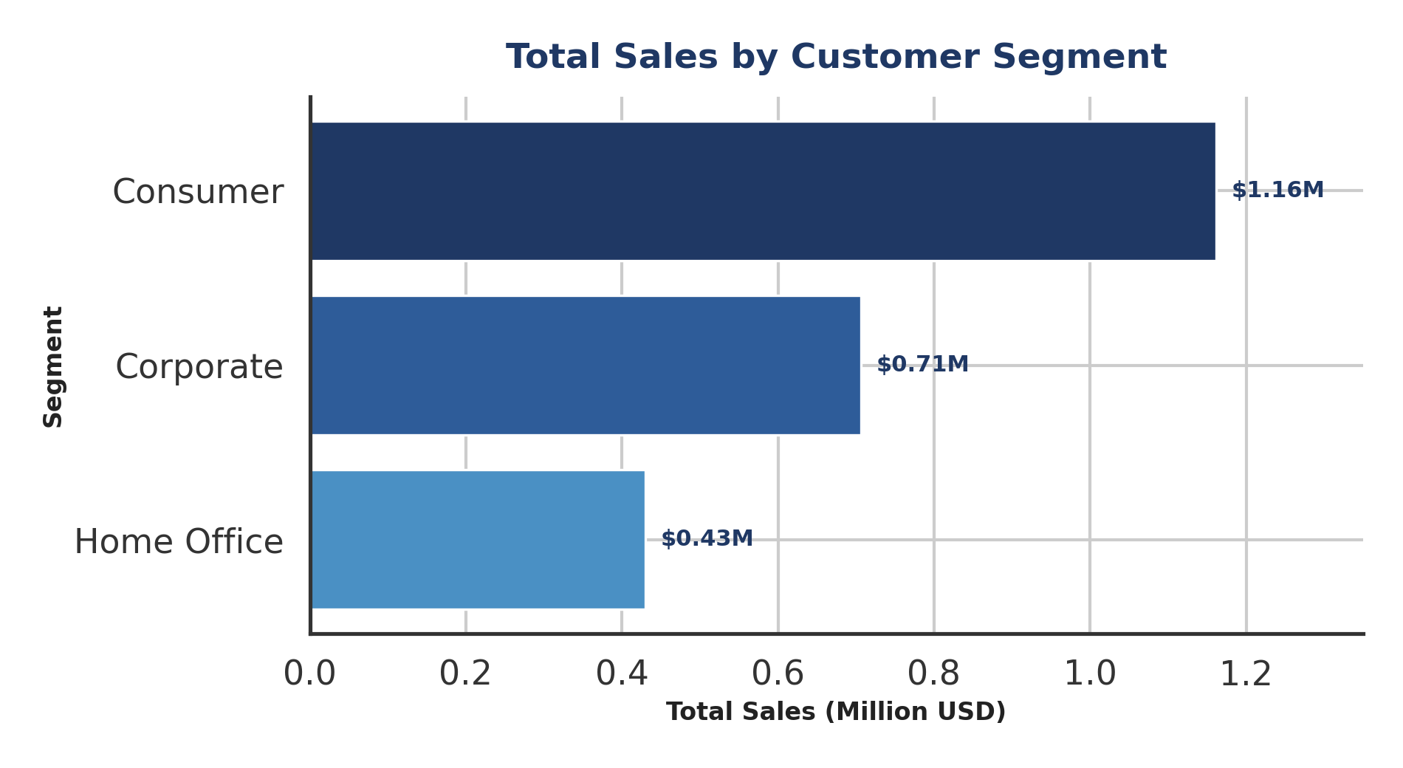
Figure 3. Total Sales by Customer Segment

9. Product Promotion & Discontinuation Candidates
Ranking sub-categories by total quantity sold highlights the weakest-moving products. Copiers (234 units), Machines (440 units), and Supplies (647 units) sell in the lowest volumes and are candidates for review — whether through bundling and promotional pricing to stimulate demand, or discontinuation if profit margins do not justify continued inventory investment.
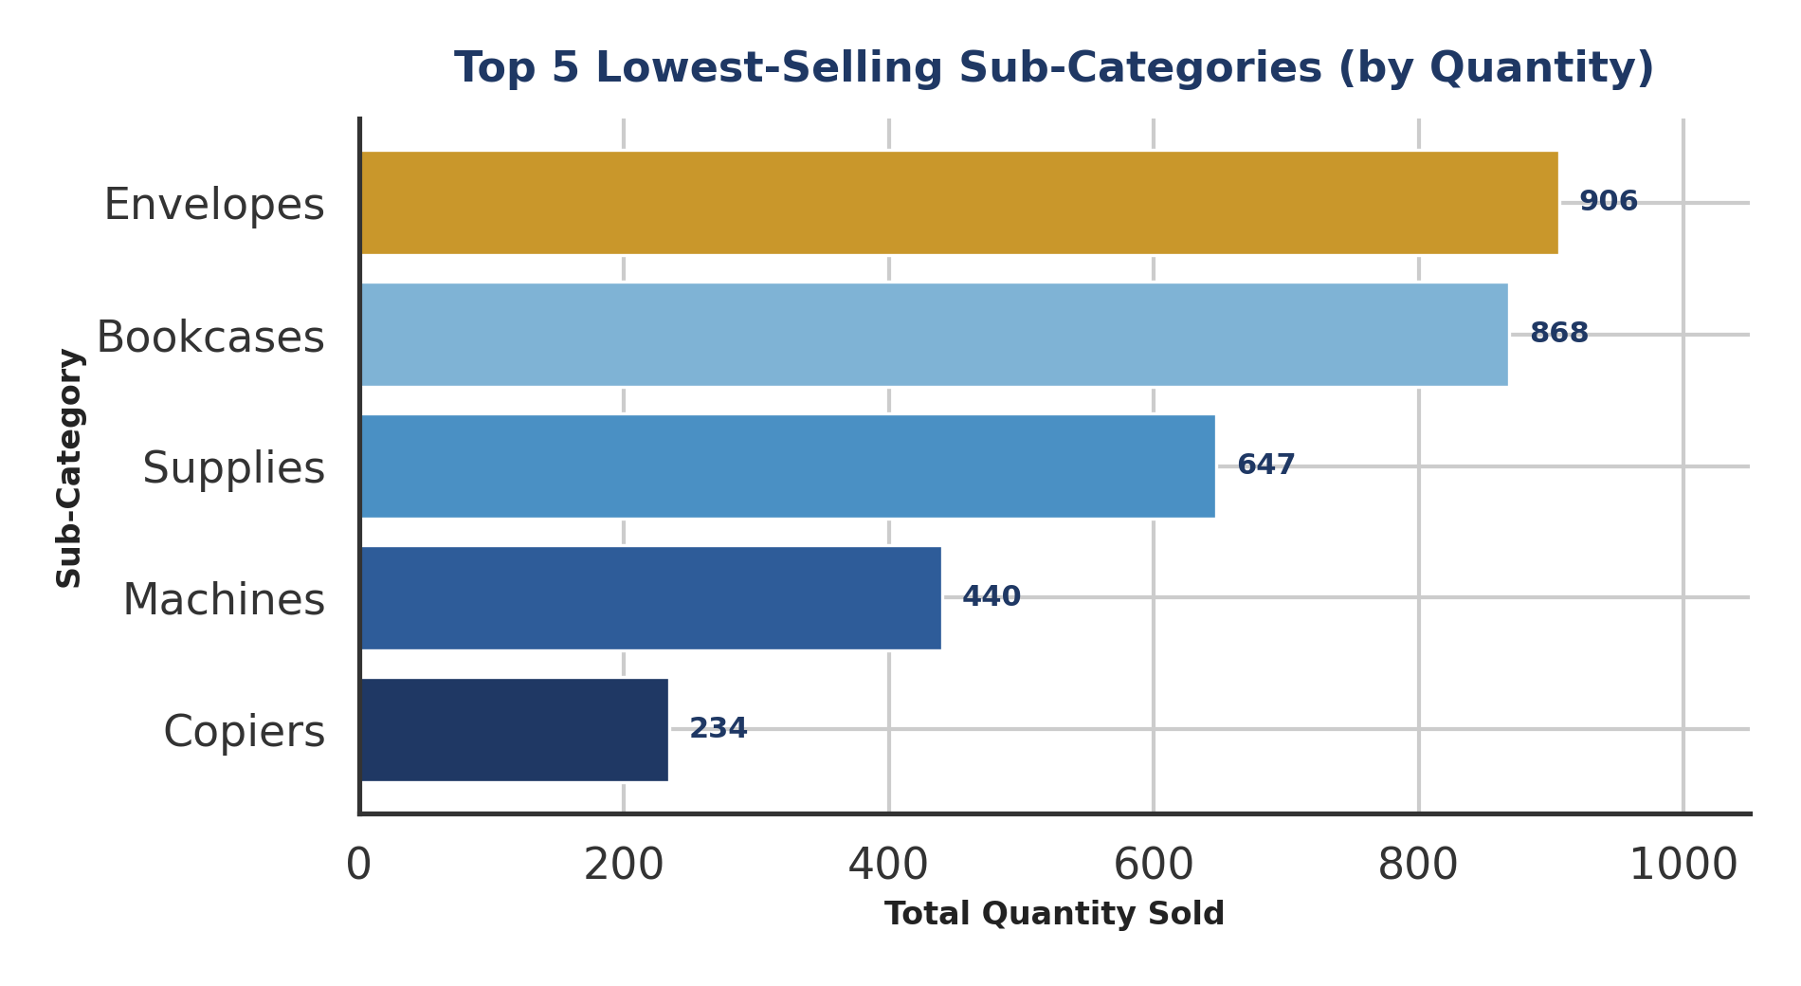
Figure 4. Top 5 Lowest-Selling Sub-Categories by Quantity

10. Key Insights
- The West region drives the largest share of profit; Central underperforms and warrants investigation into pricing, discount levels, or logistics costs.
- Technology and Office Supplies together generate over 93% of total profit — Furniture's contribution is disproportionately small relative to likely inventory investment.
- The Consumer segment is the dominant revenue source and should anchor marketing and loyalty initiatives.
- Copiers, Machines, and Supplies have the lowest sales volume and should be evaluated for targeted promotions or phased discontinuation.

11. Recommendations
- Investigate discounting practices in the Central and South regions to close the profit gap with West and East.
- Reassess Furniture pricing and discount strategy — review whether high shipping or return costs are eroding margin.
- Design targeted promotions (bundling, seasonal discounts) for Copiers and Machines before considering discontinuation.
- Promotional campaigns should focus on the Consumer segment as the top priority.

12. Tools & Methodology
Analysis was performed using Python with PySpark SQL for aggregation queries, Pandas/NumPy for data manipulation, and Matplotlib/Seaborn for visualization. Data cleaning included duplicate removal and missing-value handling prior to analysis.

