DATA ANALYTICS REPORT
Netflix Content Library
Exploratory Data Analysis — Strategic Findings for Content Acquisition & Regional Expansion

Prepared by: Mohammad Mijanur Rahman
Role: Data Analyst | Python, SQL, ML & Data Visualization
Date: July 11, 2026
Source Dataset: Kaggle — Netflix Movies and TV Shows

Executive Summary
Netflix operates one of the world's largest streaming content libraries, spanning thousands of movies and TV shows across genres, countries, and ratings. This report presents an exploratory data analysis (EDA) of the Netflix content catalog, undertaken to surface actionable insights that can inform content acquisition strategy, regional expansion planning, and audience segmentation.
The analysis was performed in Python using Pandas, NumPy, Matplotlib, and Seaborn on the public Kaggle “Netflix Movies and TV Shows” dataset. Key findings show that movies significantly outnumber TV shows in the catalog, the United States remains the dominant content-producing market, TV-MA is the most common content rating, and the platform underwent its most aggressive catalog expansion between 2018 and 2020.

Metric | Headline Finding
Content mix | Movies dominate the catalog; TV Shows are a small minority
Top content source | United States, followed by India and the United Kingdom
Most common rating | TV-MA (mature audiences)
Peak growth period | 2018 – 2020
Leading genre | Drama & International Movies
Most prolific director | Raúl Campos (with Jan Suter)

1. Business Problem
Netflix's content library is vast and continuously growing. To make informed decisions about content acquisition, production, and regional expansion, Netflix needs a clear, data-driven understanding of the trends within its existing catalog — including content type, country of origin, genre popularity, audience ratings, and growth trajectory over time. This analysis was commissioned to translate raw catalog data into strategic insight that supports those decisions.

2. Business Questions
The analysis was scoped around seven core business questions:
Q1 | Which countries produce the most Netflix content?
Q2 | What is the ratio of Movies vs. TV Shows?
Q3 | Which genres are the most popular?
Q4 | Which years had the highest number of content additions?
Q5 | How has Netflix’s content library evolved over time?
Q6 | Which content ratings are the most common?
Q7 | Which directors have produced the highest number of Movies and TV Shows?

3. Dataset & Methodology

Data Source
The dataset used for this analysis is the publicly available “Netflix Movies and TV Shows” dataset from Kaggle, containing catalog-level metadata for titles listed on the platform.

Fields Analyzed

- Show ID
- Content Type (Movie / TV Show)
- Title
- Director
- Cast
- Country
- Date Added
- Release Year
- Rating
- Duration
- Genre (Listed In)
- Description

Data Cleaning & Preparation
Before analysis, the dataset was cleaned and standardized using the following steps:
- Removed duplicate records
- Handled missing values
- Converted the date_added field to a proper datetime format
- Extracted a dedicated Year Added field for time-series analysis
- Split multiple countries listed on a single title into separate values where necessary
- Standardized text formatting and removed unnecessary whitespace

Tools & Technologies
Python · Pandas · NumPy · Matplotlib · Seaborn, executed in a Colab notebook.

4. Key Findings
The sections below walk through each business question with the supporting visualization and the resulting business implication.

4.1 Content Mix: Movies vs. TV Shows
Netflix's catalog is overwhelmingly composed of movies, with TV shows representing a small fraction of total titles.
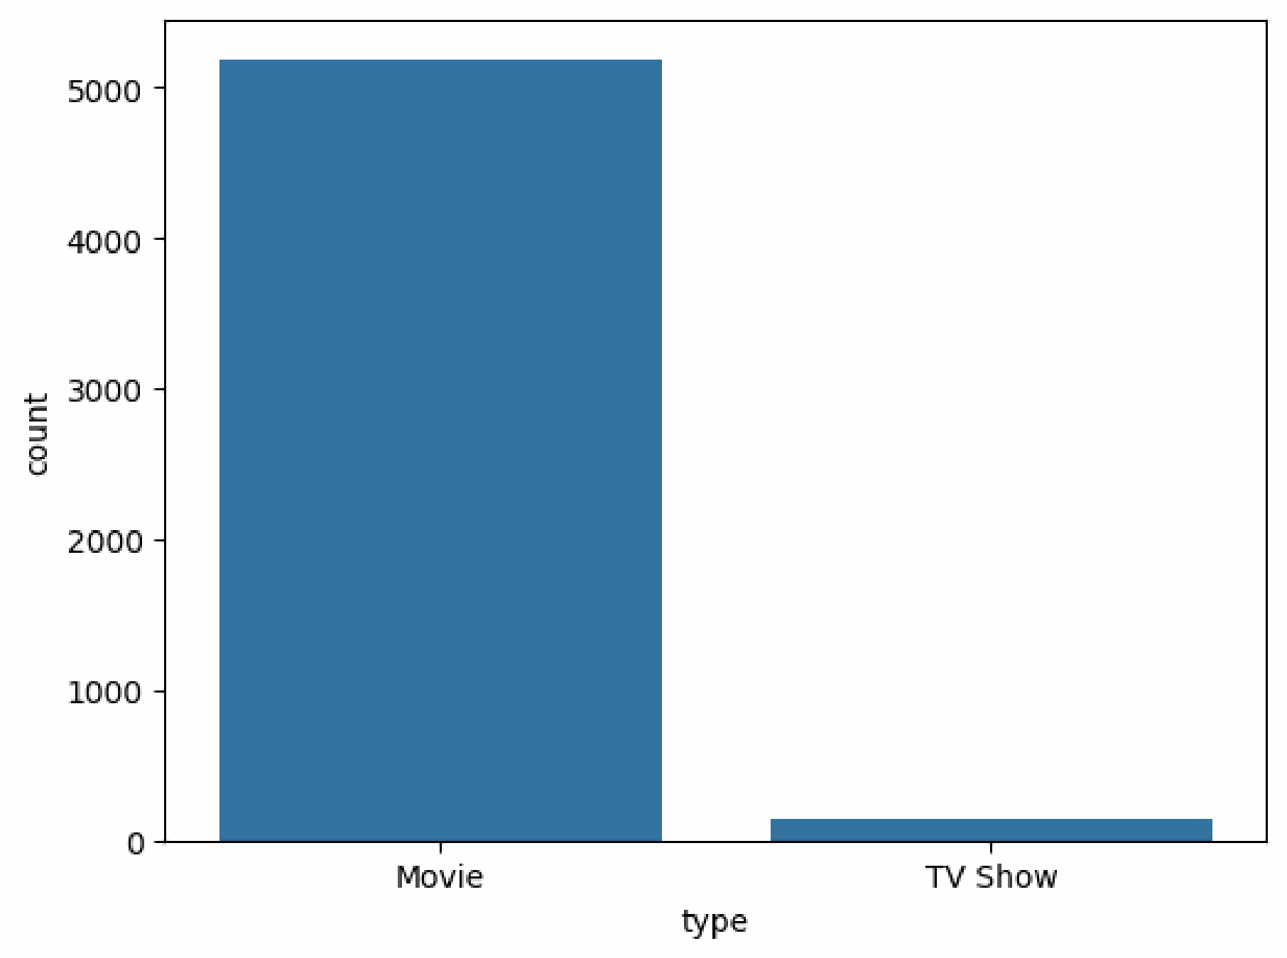
Figure 1. Distribution of content type (Movie vs. TV Show)
■ Business Value
- Movies make up the large majority of the catalog, while TV shows remain a comparatively small collection.
- Signals a historical content strategy weighted toward film licensing and acquisition over serialized originals.

4.2 Top Content-Producing Countries
The United States contributes by far the largest share of Netflix's catalog, followed at a distance by India, the United Kingdom, Canada, and other markets.
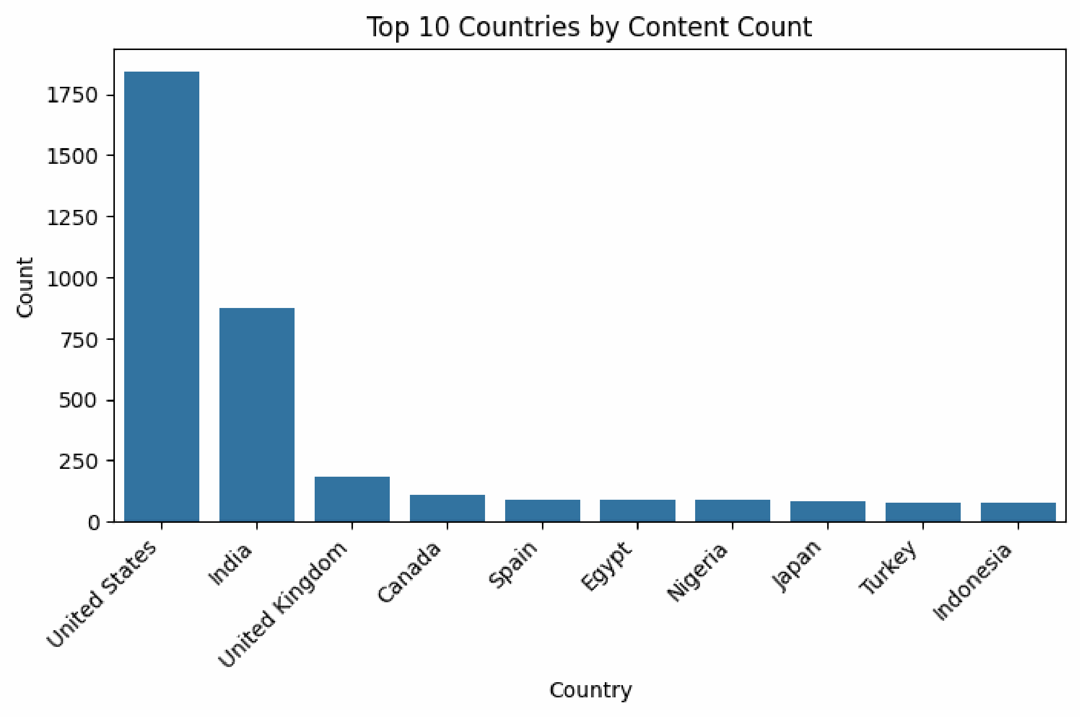
Figure 2. Top 10 countries by content count
■ Business Value
- Strong dependence on U.S. productions creates concentration risk in a single content market.
- Clear white space for further investment in regional content across India, the UK, Canada, and other growing markets.

4.3 Most Common Content Ratings
TV-MA is the single most frequent content rating in the catalog, well ahead of TV-14 and R.
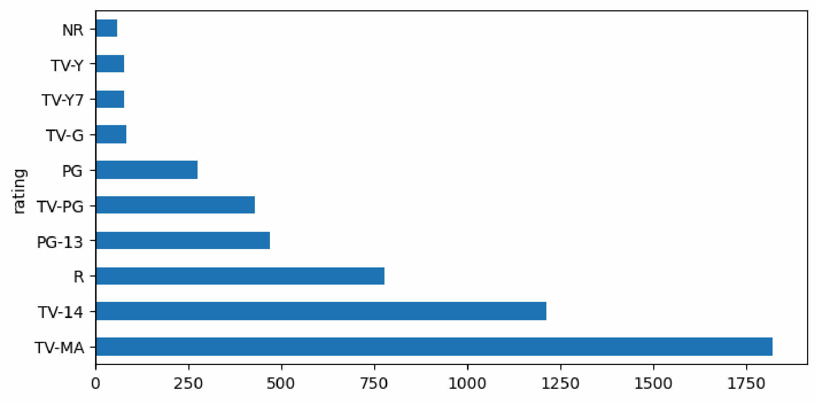
Figure 3. Distribution of the ten most common content ratings
■ Business Value
- Adult-oriented (mature audience) content dominates the platform's catalog composition.
- Rating distribution is a useful input for audience segmentation and for tuning recommendation systems by household profile.

4.4 Most Popular Genres
Drama and International Movies are the most frequently listed genre combination, followed closely by Stand-Up Comedy and Comedy/Drama/International blends.
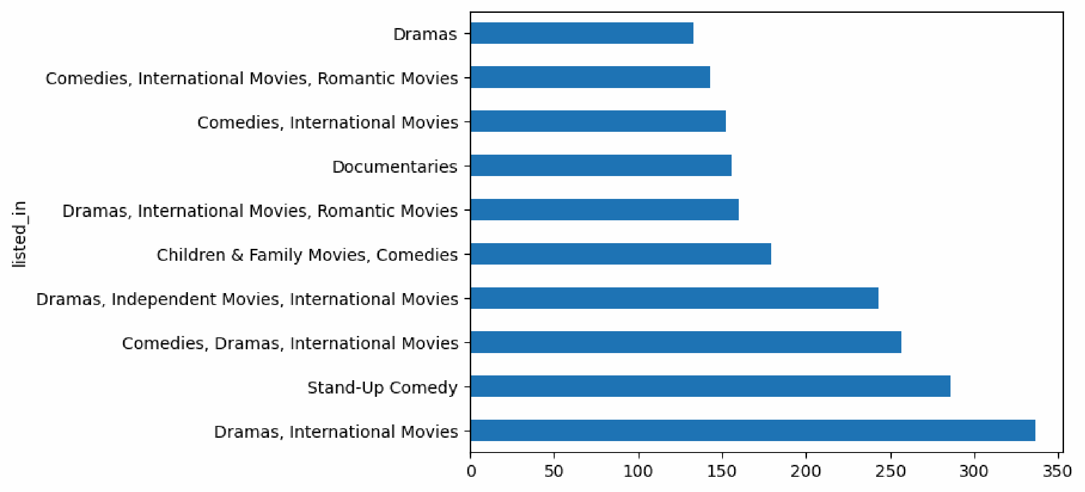
Figure 4. Top 10 genre combinations by title count
■ Business Value
- Strong and consistent viewer demand for dramatic and international content, alongside notable interest in Stand-Up Comedy.
- These genres should remain priority areas for continued content investment.

4.5 Content Additions by Year
The number of titles added to the platform rose sharply through 2018–2020, marking Netflix's most aggressive period of catalog growth before tapering afterward.
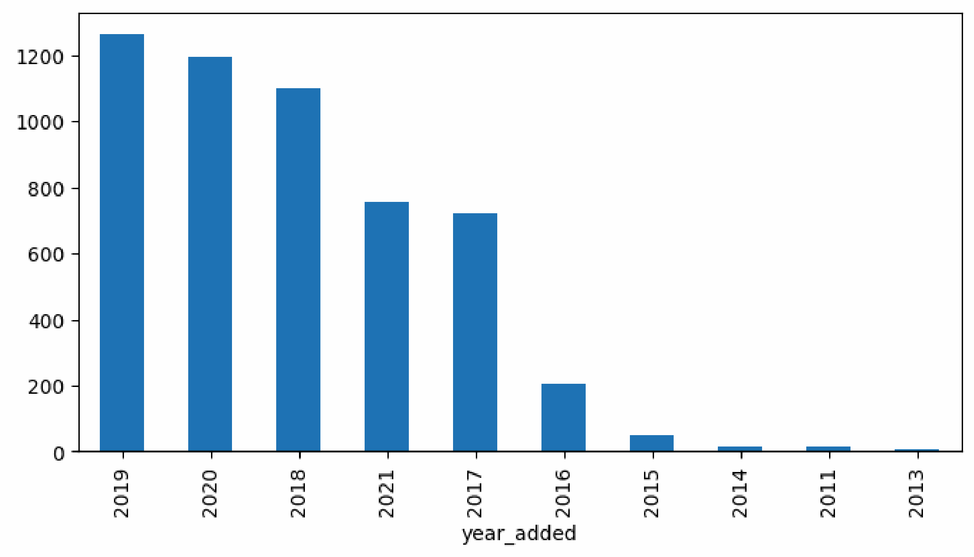
Figure 5. Titles added per year (top 10 years)
■ Business Value
- 2018–2020 represents a period of aggressive investment in content acquisition.
- Reflects a significant increase in platform catalog diversity during this window.

4.6 Catalog Growth Over Time (by Release Year)
Viewed by original release year rather than date added, the catalog shows a long tail of older titles and a steep concentration of content released between roughly 2015 and 2020.
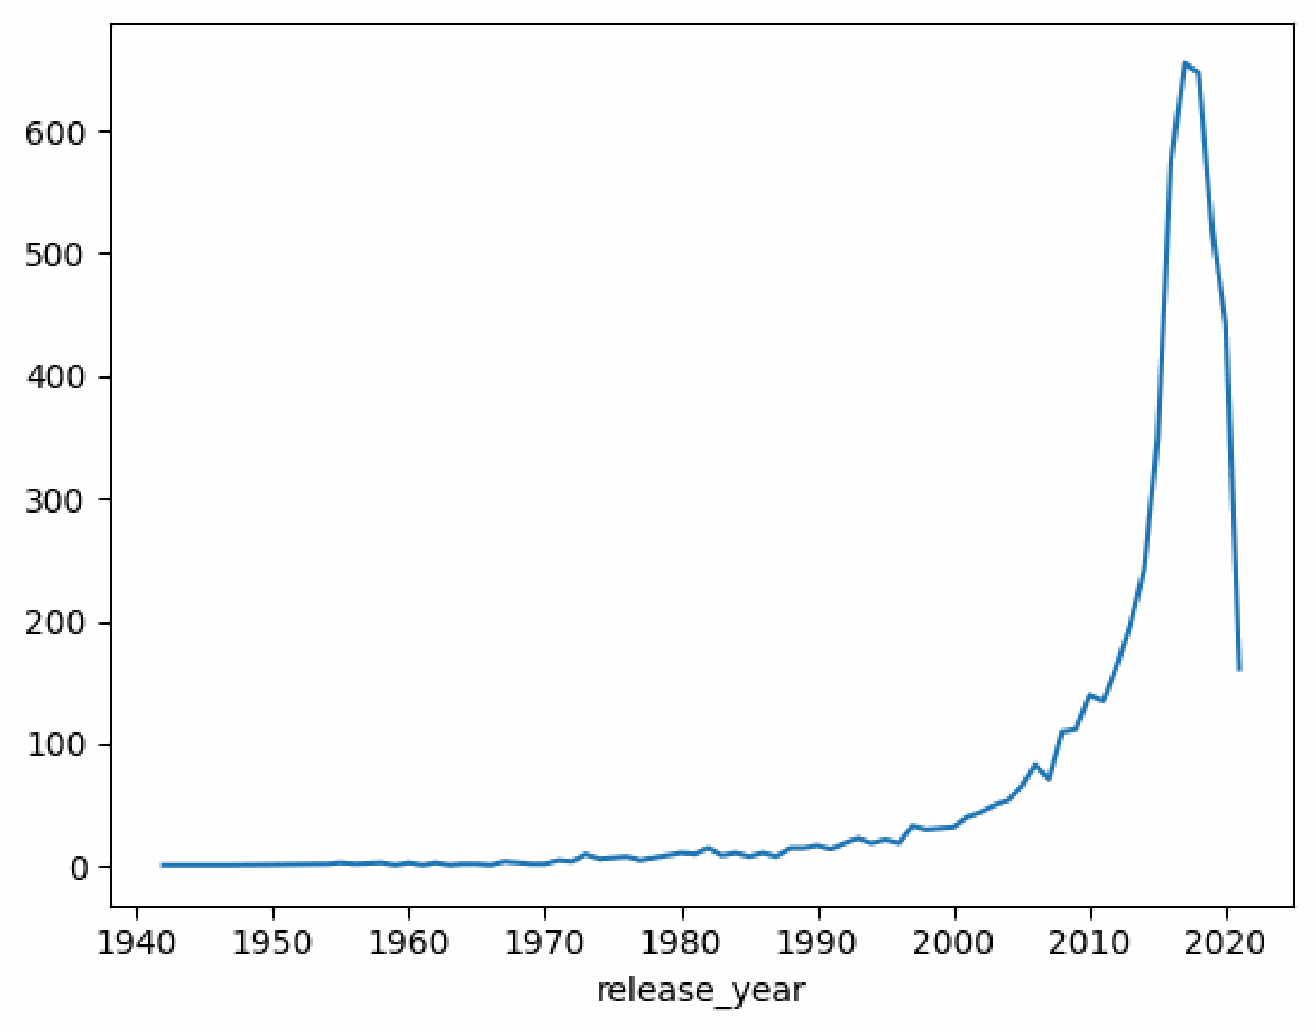
Figure 6. Title count by original release year
■ Business Value
- Confirms that the platform's catalog skews heavily toward recently produced content.
- Useful baseline for benchmarking the freshness of the library against competitor platforms.

4.7 Top Directors
Raúl Campos and Jan Suter appear as the most prolific director credit in the catalog, followed by Marcus Raboy, Jay Karas, and Cathy Garcia-Molina — several of whom are strongly associated with stand-up comedy specials.
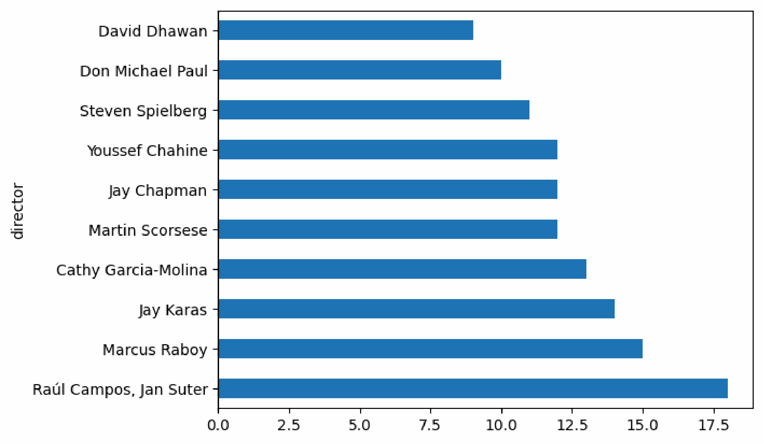
Figure 7. Top 10 directors by number of titles
■ Business Value
- Highlights key recurring creative partners, particularly within the stand-up comedy genre.
- Useful for talent-relationship and content-pipeline planning.

4.8 Movie Duration Analysis
Most movies on the platform cluster around a runtime of roughly 90–100 minutes, with a long tail of longer-format titles becoming progressively rarer.
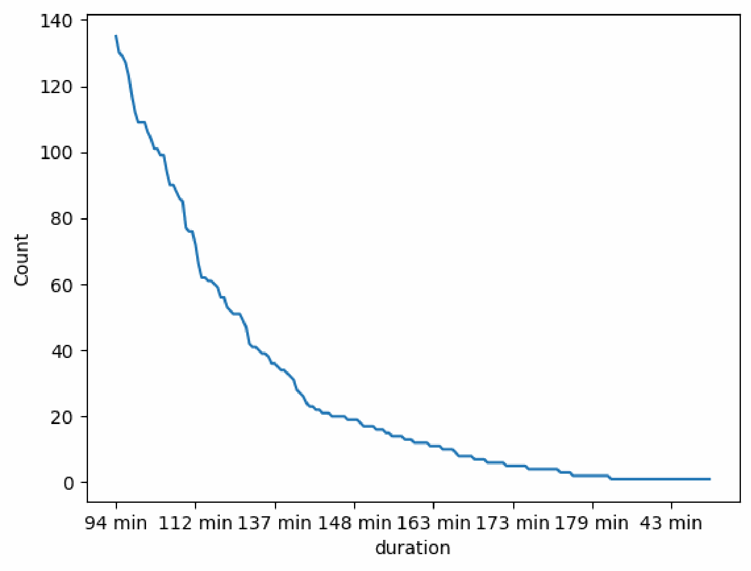
Figure 8. Distribution of movie duration (minutes)
■ Business Value
- Standard feature-length runtime dominates the movie catalog, consistent with mainstream theatrical and streaming norms.
- Useful reference point when evaluating the runtime profile of newly licensed or produced titles.

5. Consolidated Business Insights
Bringing the individual findings together, six insights stand out as most relevant to content strategy:
- Movies dominate the Netflix catalog, with TV Shows representing a comparatively small share of total titles.
- The United States contributes the largest share of content, followed by India and the United Kingdom.
- TV-MA is the most common content rating, indicating a catalog weighted toward mature audiences.
- Netflix underwent rapid catalog expansion between 2018 and 2020, its most aggressive growth window.
- Drama and International Movies are the most popular genres, with Stand-Up Comedy also performing strongly.
- Raúl Campos and Jan Suter are among the platform’s most prolific directors, reflecting a deep investment in stand-up comedy content.

6. Recommendations
- Diversify content sourcing beyond the U.S. market to reduce geographic concentration risk and capture growth in India, the UK, and other expanding markets.
- Continue investing in Drama, International, and Stand-Up Comedy titles, which show the strongest and most consistent audience demand.
- Use the TV-MA-heavy rating profile to refine recommendation algorithms and household-level content targeting.
- Benchmark future acquisition pace against the 2018–2020 growth period to plan capacity and budget for renewed expansion phases.
- Maintain strategic relationships with high-output creative partners such as Raúl Campos and Jan Suter for recurring content pipelines.

7. Conclusion
This exploratory analysis of the Netflix content catalog confirms several clear and actionable patterns: a movie-heavy, U.S.-centric, mature-audience catalog that grew most rapidly between 2018 and 2020, with Drama, International, and Stand-Up Comedy as its strongest genres. These insights provide a solid, data-driven foundation for decisions on content acquisition, production planning, regional market expansion, and personalized recommendation strategy.

8. Appendix

Technologies Used
Python · Pandas · NumPy · Matplotlib · Seaborn

Data Source
Kaggle — Netflix Movies and TV Shows: https://www.kaggle.com/datasets/shivamb/netflix-shows

Analysis Notebook
Google Colab notebook:
https://colab.research.google.com/drive/1aAbzICplr3eH4idGwD2DPbW59YV-Xw3d#scrollTo=LQOLj8XX-wLw

Author
Mohammad Mijanur Rahman — Data Analytics | Python | SQL | Machine Learning | Data Visualization

