**Commands**

Build: **gradlew build -x test**

Start: **gradlew jettyRun**

Stop: **gradlew jettyStop**

Test: **gradlew test**

> Find test result in

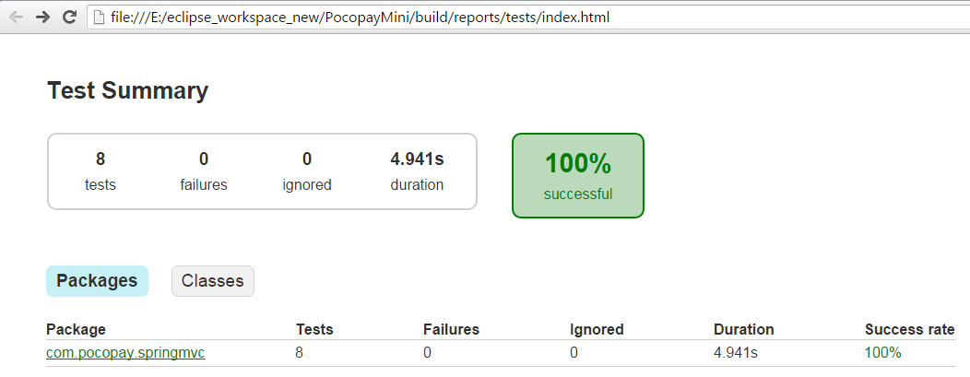

**> API Description**

|  |  |
| --- | --- |
| Create Account < Successful Creation> [*http://localhost:8090/pocopay/v1/account/*](http://localhost:8090/pocopay/v1/account/) | |
| Request | Response <*new resource location in header*> |
|  |  |
|  |  |
| Create Payment < Duplicate request> [*http://localhost:8090/pocopay/v1/payment/*](http://localhost:8090/pocopay/v1/payment/) | |
| Request | Response |
|  |  |
|  | |

|  |  |  |
| --- | --- | --- |
| Create Payment: [*http://localhost:8090/pocopay/v1/payment/*](http://localhost:8090/pocopay/v1/payment/) | | |
| Request | | Response <*new resource location in header*> |
|  | |  |
|  | |  |
| Create Payment: [*http://localhost:8090/pocopay/v1/payment/*](http://localhost:8090/pocopay/v1/payment/) | | |
| Request | Response | |
|  |  | |
| Get All payment from source account ID: 1  http://localhost:8090/pocopay/v1/account/1/transaction/ | | |
|  | | |